Distinct speech functions are spatially organized within the human insula.
Introduction
Human speech depends on coordinated activity across a distributed brain network. Within this network, the insula has long been implicated by clinical and physiological evidence. lesions and electrical stimulation to can disrupt speech, while neuroimaging and intracranial recordings reveal its engagement across a range of speech tasks. Despite this extensive evidence, studies have assigned the insula diverse from speech perception to motor planning and sometimes conflicting functional roles, and some even denying the insular contribution. How these speech contributions are organized within the human insula remains unresolved.
Studies of the insula have yielded diverse and sometimes conflicting accounts of its contribution to speech. Clinical and neuroimaging evidence has long supported a role in speech motor control, including associations between insular damage and motor speech disorders, stimulation-induced speech arrest, and activation during articulatory tasks. Responses to heard and self-generated speech have also motivated accounts emphasizing sensory feedback monitoring. Neuroimaging studies further implicate the insula in verbal working memory, showing sensitivity to phonological memory load and activity during the maintenance and manipulation of verbal information. However, specific functional interpretations remain contested. Limited pre-articulatory activity and a lack of sensitivity to articulatory complexity in some studies have challenged the proposed role of the insula in articulatory planning. These findings leave unresolved how the proposed motor, sensory and cognitive contributions relate to one another within the insula. Understanding how these contributions are organized across insular populations and expressed as speech unfolds is central to developing a coherent account of insular function.
To determine how speech-related functions are organized within the human insula, we obtained large-scale intracranial EEG recordings during a battery of speech and language tasks. These tasks separated sensory input from speech output and varied input modality and response demands, allowing us to examine insular responses across processing stages and behavioral contexts. Using a data-driven decomposition approach, we identified sensory, sustained and motor components with distinct temporal dynamics and partially overlapping spatial distributions. These components differed in their sensitivity to input modality and behavioral context. Complementary analyses linked this functional differentiation to speech-related representations, behavior and activity in the broader speech network. Together, these findings reveal a spatially differentiated functional architecture underlying the insula’s contributions across multiple stages of speech.

Results
- Human insula is extensively recruited during speech
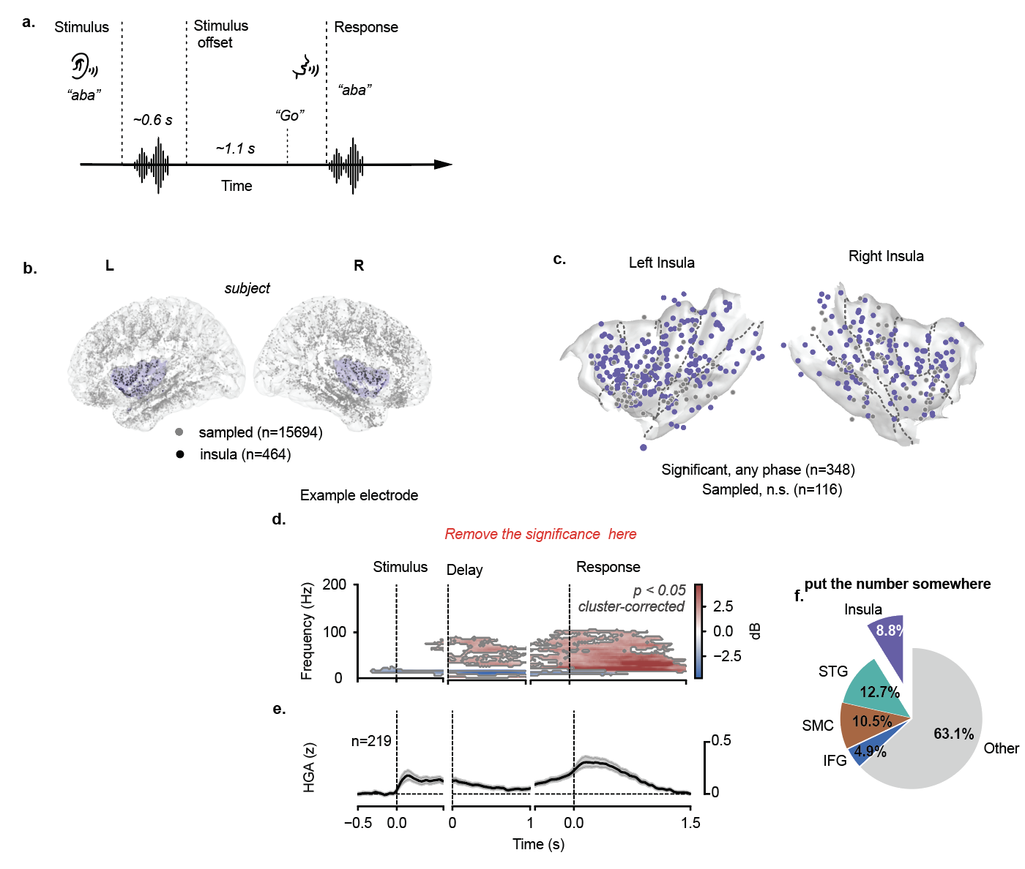

To examine the insular contribution, we recorded insula activity during a set of speech task which shared the same task structure of speech repetition tasks. Patients undergoing epilepsy monitoring were ask to listen to a syllable, a word or a pseudoword (~0.6 s), wait for the go cue to repeat. We extracted neural activation in the high gamma band (70-140 Hz) with bipolar re-referencing and align them to three behavior events (stimulus onset, offset and articulation onset). We collected a total of 89 subject with 173917 electrodes, of which 464 of bipolar pairs (left n, right m). Using significant test with time-permed clusters correction, we identified 348 of those electrodes were activated during any of the speech process (Fig 1c). In Fig d, we showed the temporal frequency representation for a single electrode and the averaged high gamma across all the significant activation. Results showed that insula activates for the entire speech repetition process spanning from the stimulus, delay and the response phase. Compares to all the significant electrodes in the entire brain, insula takes a total of 8.8%, comparable to the canonical speech regions like STG, SMC and IFG, which suggest that insula plays a fair contribution to the speech process.

- Insular speech activity comprises sensory, sustained and motor components
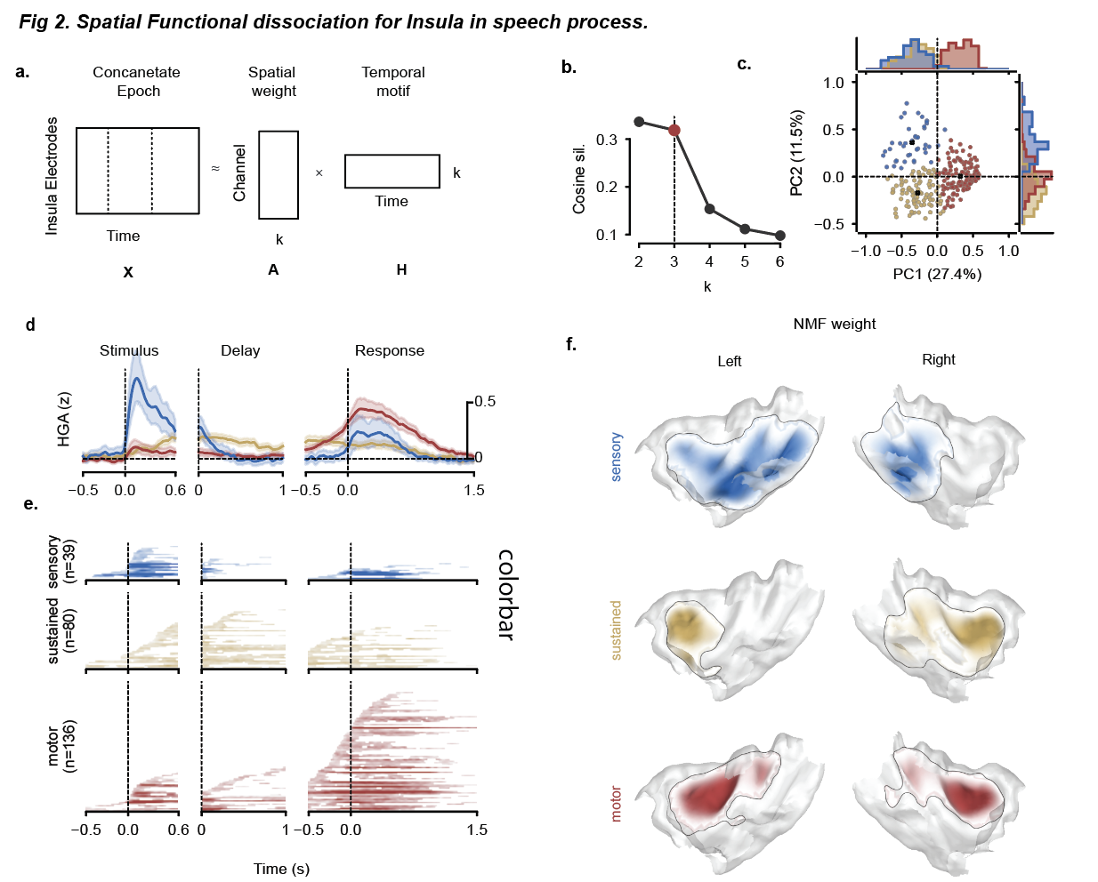
To further understand the different role of speech underlying this insular activation, we then used unsupervised non-negative matrix decomposition to decompose. Averaged insular activation under three event aligned epoch were concatenated along the time dimension and get decomposed to time and spatial components that minimized the reconstruction error. The number of components is chosen to be 3 due to various criterions. The three components showed distinct spatial-temporal characteristics. The three components were named as sensory, sustain and motor because they showed activation during the stimulus, delay and response window. The three components showed overlapping but preferrable spatial distributions. In fig 2f, we visualize the spatial weight projected to the insula surface, results show that the sensory component is more preferable in posterior insula cortex, sustained component is localized in dorsal anterior and motor is in mid anterior part. Further, results showed that none of the components are lateralized.

- Insular speech activities are dissociated by input modality and upcoming goals
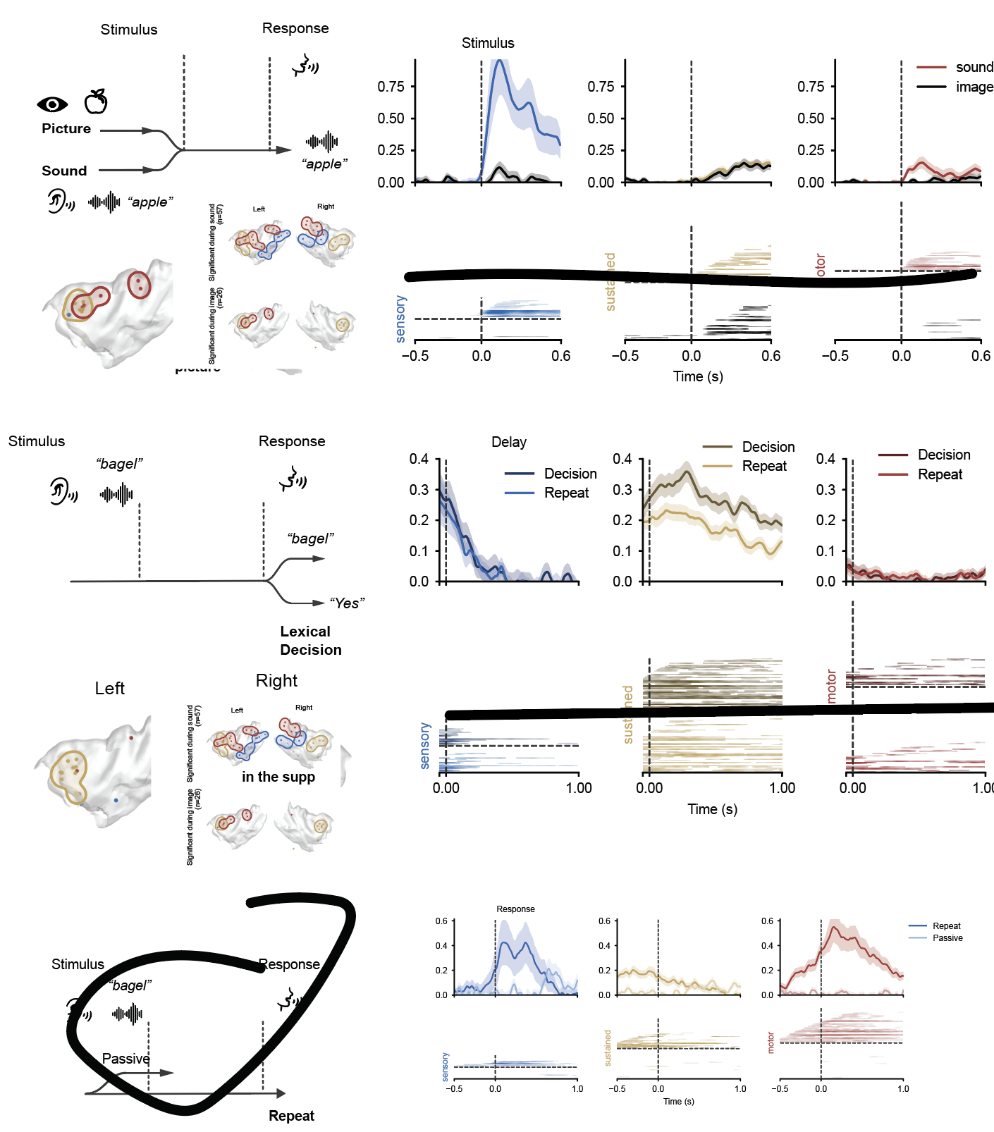
We next examined how input modality and response demands influenced the three insular response components. We first varied input modality while retaining a spoken response: participants either repeated a heard word or named a pictured object (Fig. 3a). During stimulus presentation, sensory and motor components showed larger responses to spoken words than to pictures (stats). In contrast, the sustained component responded to both spoken words and pictures. These findings indicate that sustained activity can be recruited through both auditory and visual routes to speech production.

We next varied response demands while keeping the auditory input unchanged. Participants listened to words or pseudowords and, following a delay, either repeated the stimulus or verbally indicated whether it was a real word by saying “yes”. During the delay, the sustained component showed greater activity for lexical decisions than for repetition (Fig. 3c; [statistical comparison]). Thus, sustained insular activity was modulated by the task demands imposed on the same auditory input. Neither sensory nor motor components showed a significant difference between conditions during this interval. The greater sustained activity during lexical decisions indicates sensitivity to the cognitive demands of the upcoming response, consistent with a role in the cognitive control of speech.

- Insula activities contain phoneme-articulatory to lexical information
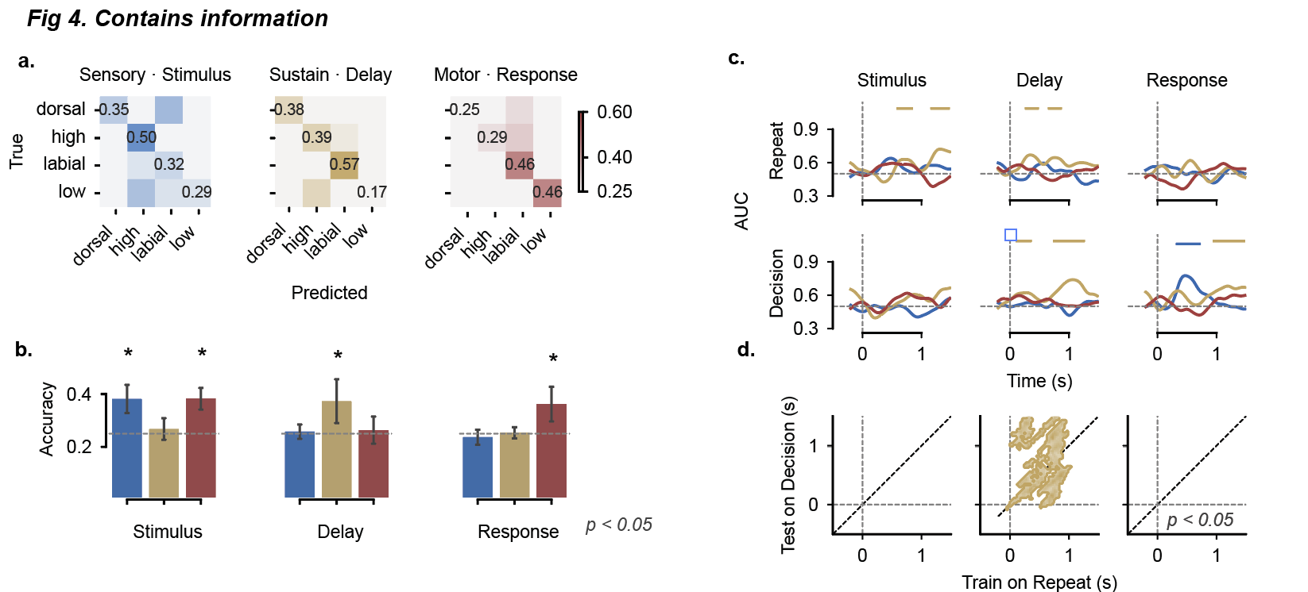
We next asked what speech-related information was represented in the three insular components. Using activity from sites assigned to each component, we trained classifiers to distinguish four articulatory categories of the initial phoneme during delayed repetition. Classification exceeded chance during stimulus presentation in sensory and motor populations, during the delay in sustained populations, and during the response in motor populations (Fig. 4a,b; chance, 25%; permutation tests, P < 0.05). Thus, articulatory-category information was available at different stages of the task, including the interval between auditory input and speech output. The result is consistent with the decoding result of recent studies (list papers), showing that insula activity is not a general activation during speech, but contains fundamental information. Although it’s weaker compares to other canonical language regions, but it definitely contains information.
Beside fundamental phoneme-articulatory information, we then ask whether the insular activity contains higher level lexical-semantic information. We performed decoding analysis to distinguish word from pseudowords. Time-resolved decoding revealed lexical-status information is only present in sustained populations during the delay in both repetition and lexical-decision trials (Fig. 4c). To exclude the confound like xxx, we performed the cross-decoding procedure where we train on the repetition trials and test whether it’s generalized to the decision trials. Results revealed that such lexical-semantic information is generalizable across conditions during delay period, indicates that that sustained activity carried lexical-status information even when an explicit lexical judgment was not required.
Together, these results show that insular populations carry articulatory-category and lexical-status information, with sustained populations retaining decodable speech-related information between input and output.
- Motor-related insular activity predicts speech reaction time
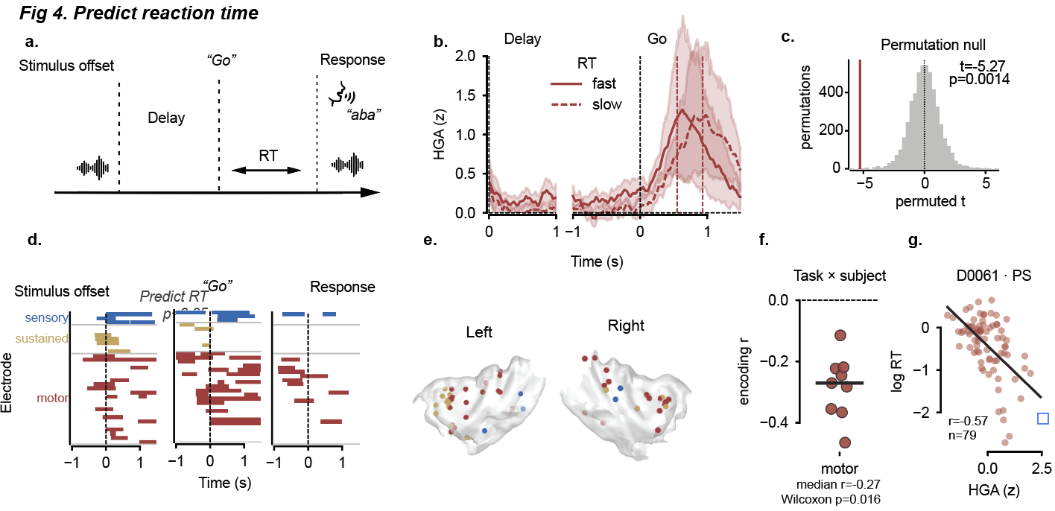
We next asked whether insular activity was related to the preparation and initiation of speech. To address this question, we tested whether trial-to-trial fluctuations in high-gamma activity predicted the latency of the subsequent spoken response, measured from the go cue to articulation onset. Using cross-validated regression, we predicted reaction time from high-gamma activity for each insula electrode and perform statistical testing with the trial-shuffled baseline. In results, we observed that motor component contains a large proportion of electrode can significantly predict reaction time articulation onset, including few sustain and sensory. (Fig. 4d). Predictive sites were distributed in mid insula across both hemispheres (Fig. 4e). Activity profiles grouped by response speed further illustrated this relationship around the go cue (Fig. 4b).
To characterize the relationship between activity magnitude and response speed, we examined motor sites and time windows identified by the prediction analysis. Higher mean high-gamma activity was associated with shorter reaction times (median r = −0.27; Fig. 4f), as illustrated by the trial-level relationship in an individual participant (Fig. 4g). Together, these results showed that insular participate in the speech planning network.
- Insular response profiles recur across the broader speech network
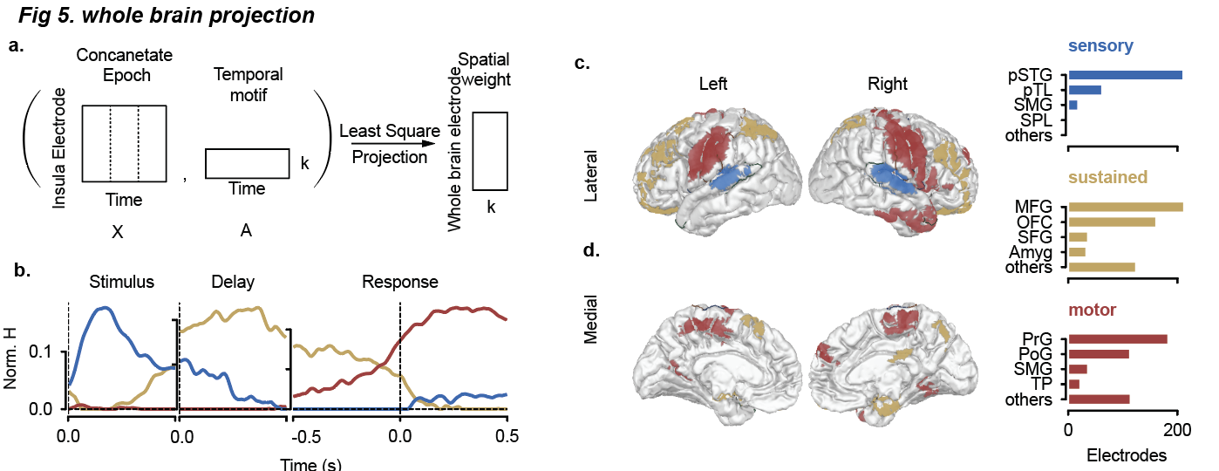
Finally, we asked how does this insula activity is related to the brain-wide speech network. Due to the sparsity of intracranial sampling, we chose to project the three temporal components derived from insula to the significant activation on the cortex. For each electrode’s significant activity on the cortex, we calculated the spatial weight based on non-negative least squares (Fig. 5a). The weight denotes how activity of each electrode resembles the template of insula (Fig 5b).
Mapping these contributions revealed different anatomical distributions for the three profiles (Fig. 5c, d). The sensory profile was prominent in posterior superior temporal and adjacent temporal regions, whereas the sustained profile was expressed across frontal regions, including the middle frontal gyrus and orbitofrontal cortex. The motor profile was prominent in precentral and postcentral regions.
Together, these findings place the functional differentiation within the insula in the context of distributed speech-related activity.
Discussion
Understand the long-lasting controversial
Cell type, ccep, connectome
What does it tell for speech

Methods
- Participants
89 patients undergoing pharmaco-resistant epilepsy at Duke University Medical Center (DUMC) participated in the study ([sex distribution]; age range, [range] years; mean ± s.d., [mean ± s.d.] years). Participants were [language background], with [handedness distribution]. Intracranial electrodes were implanted for [clinical indication], and electrode placement was determined by [placement criteria]. Participants were included if [inclusion criteria] and excluded if [exclusion criteria]. Of the overall cohort, [N] participants had insular electrode coverage. The samples included in individual analyses were determined by [analysis-specific eligibility criteria].
All patients were written informed consent was obtained in accordance with the Institutional Review Boards at the DUMC.

- Speech task
Participants performed speech and language tasks with a common delayed-response structure. On each trial, an auditory or visual stimulus was presented, followed by a delay. Participants withheld their verbal response until a go cue. Task-specific sample sizes, recording-site coverage and contributions to individual analyses are summarized in Supplementary Table [X].
**Phoneme sequence task.** Participants listened to three-phoneme sequences and repeated them aloud after a delay. The stimulus set comprised 52 sequences with consonant–vowel–consonant or vowel–consonant–vowel structures (for example, “gab” and “uga”). Each trial began with a visual “Listen” cue, followed by an auditory presentation of the target sequence. After a delay of approximately 1–1.25 s following stimulus presentation, a visual “Speak” cue instructed participants to repeat the sequence in the same order. Participants withheld their response until the speak cue. Task-specific participant numbers, recording-site coverage and contributions to individual analyses are provided in Supplementary Table [X].
Delayed repetition and lexical decision task Participants listened to spoken words or pseudowords and either repeated the stimulus or judged its lexical status. Each trial began with a visual cue indicating the response requirement (“Repeat” or “Yes/No”), followed by the auditory stimulus. After a delay of approximately 1–1.25 s, a visual “Speak” cue instructed participants to respond aloud. In repetition trials, participants reproduced the stimulus; in lexical-decision trials, they responded “yes” for words and “no” for pseudowords. Participants withheld their response until the speak cue.
Picture naming and word repetition task. Participants were presented with pictures, spoken words referring to the same set of 4 items (star/apple/umbrella/?). Two kinds of condition was included, passive and repetition. A cue at the beginning of each trial indicated whether a verbal response was required. In response trials, participants named the picture, repeated the spoken word or read the written word aloud after a go cue. Stimulus presentation was followed by a delay of approximately 1–1.25 s before the cue. In passive trials, participants viewed or listened to the stimulus without making a verbal response. The auditory and picture conditions provided corresponding target words across input modalities.
Single-word repetition task. Participants listened to individual spoken words and repeated them aloud after a delay. The single-word stimuli comprised “heat”, “hoot”, “hot” and “hut”, which shared their initial and final consonants and differed in the intervening vowel. Repetition trials began with a visual “Listen” cue, followed by the auditory stimulus. After a delay of approximately 0.75–1 s, a visual “Speak” cue instructed participants to repeat the word aloud.

- Neural recording and preprocessing
Intracranial EEG signals were acquired using [recording system and manufacturer] at a sampling rate of [sampling rate] Hz. Speech responses were recorded using [audio recording system], and task events and audio recordings were synchronized with neural signals using [synchronization procedure]. Channels identified as unsuitable for analysis according to [channel exclusion criteria] were excluded. Line noise was attenuated using notch filters at 60, 120 and 240 Hz. Muscle channel are been hand picked. Signals were re-referenced using bipolar derivations between adjacent contacts along each electrode shaft.
High-gamma activity was extracted over 70–200 Hz using a filter bank and Hilbert transformation. Amplitude envelopes were computed within sub-bands and summed to obtain a high-gamma amplitude time series for each bipolar channel. Task epochs were extracted with an additional 0.5 s on either side of each analysis interval to reduce edge effects during filtering. The additional samples were subsequently removed, and high-gamma amplitude was resampled to 128 Hz.
Neural activity was aligned to stimulus onset, stimulus offset (delay), and articulation onset, as appropriate for each analysis. High-gamma amplitude was standardized separately for each channel using the mean and standard deviation calculated across trials and time points within a 500-ms baseline preceding the condition-specific trial-start or instruction event. The same baseline estimates were applied to all task phases within a condition. After standardization, trial–channel epochs were marked as missing if their maximum absolute amplitude exceeded the channel-wise mean absolute amplitude by more than 15 standard deviations, calculated across trials and time points. This procedure excluded the affected channel’s entire epoch while retaining data from other channels on the same trial.
Task-related increases in high-gamma amplitude were assessed relative to baseline using one-sided, cluster-based permutation tests with 5,000 permutations. Tests were performed on amplitude envelopes after z-score normalization for each electrode. Adjacent time points exceeding the cluster-forming threshold of [threshold] were grouped into temporal clusters. Cluster significance was evaluated against the permutation distribution of the maximum cluster duration, using a cluster-level threshold of [threshold]. For preprocessing-level channel selection, recording sites were retained if at least one time point within the specified phase window satisfied both the cluster criterion and a pointwise P < 0.05.

- Electrode localization and anatomical labeling
Individual electrode contacts were localized using [imaging modalities, registration procedure and localization software]. Cortical surfaces were reconstructed from each participant’s structural MRI using FreeSurfer [version]. Contact coordinates were represented in native anatomical space, and each bipolar recording site was assigned the midpoint between its two constituent contacts.
Anatomical labels were obtained from participant-specific volumetric segmentations generated by propagating the Hammersmith atlas database into individual anatomical space using multi-atlas registration and label fusion (MAPER). Labels were sampled at both constituent contacts and the midpoint of each bipolar pair. Only electrode pairs with both insula labels are preserved. Regional assignments were determined from the corresponding anatomical labels, excluding white-matter, unknown labels from the regional consensus. Pairs with a single remaining regional assignment were classified as unmixed, whereas pairs spanning multiple anatomical regions were classified as mixed.
For group-level visualization, recording-site coordinates were transformed to the common cvs_avg35_inMNI152 template using [registration procedure and software version]. Surface projections were used for visualization, while anatomical assignments were retained from the participant-specific volumetric segmentations.

- Data-driven decomposition and spatial organization
We used non-negative matrix factorization (NMF) to identify temporal response components in insular high-gamma activity. Only data from repetition conditions at insular recording sites exhibiting significant high-gamma responses were included. For each site, activity was averaged across trials and tasks. Responses were aligned to stimulus onset, stimulus offset and articulation onset, using windows of 0–0.6 s, 0–1 s and 0–1 s, respectively. These windows were chosen to approximate the average durations of the stimulus, delay and utterance. The three epochs were concatenated along the time dimension to form a channel-by-time matrix for NMF.
Before decomposition, negative values were set to zero and normalized to unit Euclidean norm, emphasizing temporal response shape rather than absolute amplitude. The resulting matrix was factorized into a non-negative channel-by-component weight matrix and a non-negative component-by-time matrix. NMF was fitted using coordinate descent to minimize squared reconstruction error. We retained the solution with the lowest reconstruction error across 20 initializations.
The number of components was selected using consensus clustering across repeated subsamples of recording sites. For each candidate rank from two to six, we fitted NMF to 200 subsamples, each containing 80% of sites selected without replacement. Consensus matrices quantified how often pairs of sites were assigned to the same component when sampled together. We applied average-linkage hierarchical clustering to the corresponding dissimilarity matrices and selected the rank with the highest cophenetic correlation, yielding three components.
The three components were termed sensory, sustained and motor based on their temporal waveforms, reflecting stimulus-related responses, activity persisting through the delay, and responses associated with speech production, respectively. To visualize their spatial distributions, electrode coordinates were mapped to a common anatomical template. Component weights were displayed separately on the insular surface using Gaussian smoothing (σ = 5 mm). Vertices farther than 6 mm from the nearest recording site were masked, and maps were displayed above 40% of the maximum density within each component and hemisphere.
- Decoding
We decoded the articulatory category of the initial phoneme during delayed repetition, distinguishing dorsal consonants (/g/, /k/), labial consonants (/b/, /p/, /v/), high vowels (/i/, /u/) and low vowels (/a/, /ae/). Analyses were performed separately for sensory, sustained and motor populations using sites with significant responses in the corresponding task phase. Features comprised all channel-by-time samples within windows of 0–0.5 s after stimulus onset, 0–0.7 s after stimulus offset and 0–1 s after articulation onset.
Classification was performed using a linear support vector machine (C = 1) with stratified fivefold cross-validation. Within each training fold, features were standardized and reduced using principal component analysis, retaining components that explained 80% of the variance. The fitted transformations and classifier were then applied to held-out trials. Performance was quantified using balanced accuracy, with a chance level of 25%. Cross-validation was repeated with 30 different partitions to assess stability; reported accuracy and row-normalized confusion matrices were obtained from the first repetition.
Statistical significance was assessed against a null distribution generated using 200 label permutations with the same fivefold partition as the first cross-validation repetition. For each permutation, training labels were shuffled within each fold and the classification pipeline was refitted, while test labels remained unchanged. Accuracy was averaged across folds to obtain one null score per permutation. One-sided P values were calculated as the number of null scores greater than or equal to the observed score, plus one, divided by 201. Decoding was considered significant at P < 0.05 for each population–phase combination.
We decoded lexical status (words versus pseudowords) separately within sensory, sustained and motor populations during repetition and lexical-decision trials. Single-trial high-gamma activity was pooled across participants by matching stimulus identity and presentation number. Decoding used 300-ms sliding windows advanced in nominal 30-ms steps. Within each window, activity was averaged over five consecutive temporal bins and concatenated across recording sites. Features were standardized using the training data and classified using linear discriminant analysis with automatic covariance shrinkage. We used stratified fivefold cross-validation grouped by stimulus identity, keeping all presentations of each word or pseudoword in the same fold. Decision values were standardized within each test fold before pooling held-out predictions to calculate the area under the receiver operating characteristic curve (AUC; chance, 0.5). Time points denote window endpoints.
To assess cross-task generalization during the delay, classifiers were trained on repetition trials and tested on lexical-decision trials using recording sites and stimulus presentations shared between conditions. The same stimulus-grouped cross-validation scheme ensured that test items were absent from the training set. Classifiers fitted at each training time window were evaluated at every test time window, yielding a training-time-by-test-time AUC matrix.
Null distributions were generated using 5,000 permutations of lexical-status labels across unique stimulus items, with all presentations of an item retaining the same permuted label. Cross-validation partitions were held fixed, and classifiers were refitted and evaluated using the permuted labels. For cross-task decoding, the same label permutation was applied to both conditions. Pointwise significance was assessed using the proportion of null AUC values at least as large as the observed value, with a plus-one correction. Adjacent points with P < 0.05 formed candidate clusters. Sliding-window results were corrected using the maximum temporal cluster length in each permutation. Cross-task matrices used two-dimensional clusters, including diagonal adjacency, with cluster mass defined as the sum of AUC above 0.5. Observed clusters were compared with the corresponding maximum-cluster null distributions at P < 0.05. Correction was performed separately for each population–phase–condition time course or population-specific cross-task matrix.
- Predict reaction time
Reaction time (RT) was defined as the interval between the go cue and articulation onset. Trials RTs shorter than 50 ms or longer than 2s were excluded, and RTs were natural-log-transformed before analysis. Ridge regression models were fitted separately for each participant, task and insular recording site using repetition trials. Features comprised high-gamma amplitude samples within approximately 200-ms windows advanced by three samples at 128 Hz (23.4 ms). Analyses were performed on activity aligned to stimulus offset, the go cue and articulation onset.
Prediction was evaluated using cross-validation grouped by stimulus identity, keeping all presentations of an item in the same fold. The outer cross-validation used up to ten folds, depending on the number of available items. Missing features were replaced with training-set medians, and features were standardized using the outer training set. Regularization strength was selected from ten logarithmically spaced values between 10⁻³ and 10³ using up to five inner, item-grouped folds. Performance was quantified as the Pearson correlation between observed log RTs and predictions pooled across held-out trials.
Null distributions were generated using 1,000 permutations of trial-level RTs within each outer training fold. Test RTs and cross-validation partitions remained unchanged, and regularization was reselected for each permutation. Adjacent windows with pointwise P ≤ 0.05 formed temporal clusters. Cluster significance was evaluated against the maximum cluster length across all tested sites and epochs within each participant and task. Clusters with corrected P ≤ 0.05 and positive prediction correlations were considered significant.
To characterize the direction of the HGA–RT relationship, we selected, for each site and task, the significantly predictive go-aligned window with the highest prediction correlation among windows beginning before the go cue. Mean HGA within this window was correlated with log RT across trials. Electrode-level correlations were summarized by their median within each participant, task and functional population, then across tasks within each participant, and assessed against zero using a one-sided Wilcoxon signed-rank test. For trial-level displays, window-averaged HGA was standardized within each electrode and averaged across selected electrodes. A complementary permutation analysis shuffled RTs within each participant and task 5,000 times and compared the observed one-sample t statistic of participant-level correlations with its lower-tail null distribution. Selected sites and windows remained fixed during this analysis. Fast and slow trials were defined by a median split of RT within each participant, task and functional population.

- Whole-brain projection of insular temporal profiles
To examine how insular temporal profiles were expressed across the brain, we fitted high-gamma activity at speech-responsive recording sites using the three temporal components identified by insular NMF. Trial- and task-averaged responses from repetition conditions were concatenated using the same temporal windows and preprocessing as the insular decomposition. The temporal profiles were held fixed, and non-negative least squares was used to estimate their contributions to each electrode’s activity, minimizing the squared reconstruction error. This yielded three non-negative weights per electrode without re-estimating the temporal components.
For spatial visualization, projection weights were normalized within each electrode and weighted by the fraction of signal energy explained by the reconstruction. Component specificity was defined relative to the larger contribution of the other two components. Specificity values were mapped onto a common cortical surface using Gaussian spatial averaging within participants, followed by equal-weight averaging across participants. Maps excluded electrodes used to derive the insular templates and displayed regions preferentially expressing each temporal profile. Regional distributions were summarized by electrode counts within these territories.

