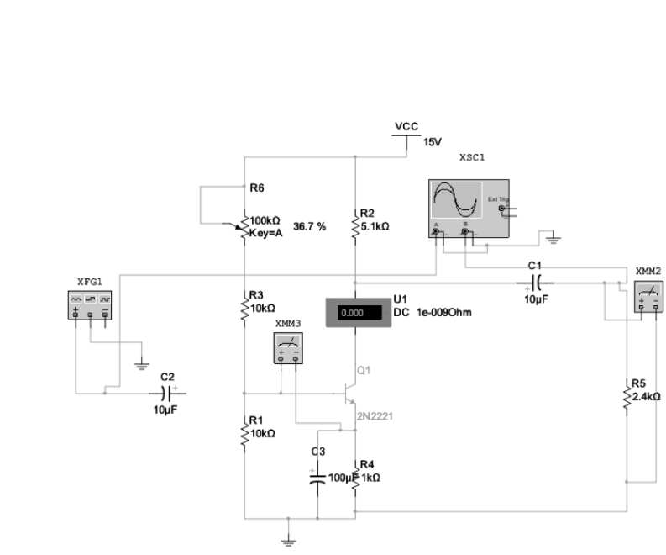

表6-1静态工作点调节

|  |  |  |  |  |  |
| --- | --- | --- | --- | --- | --- |
| 测试条件 | Rc=5.1K | RE=1K | Vi=0 | F=0 | VCC=12V |
| ICQ | VB | VE | VC | VBE | VCE |
| 1.3mA | 1.93V | 1.30V | 5.47V | 0.63V | 4.16V |

表6-2 RC对静态工作点的影响

|  |  |  |  |
| --- | --- | --- | --- |
| RC | 5.1K | 2K | 6.8K |
| ICQ | 1.3mA | 1.32mA | 1.25mA |
| VBEQ | 0.63V | 0.63V | 0.64V |
| VCEQ | 4.16V | 8.03V | 2.20V |

表6-3 VCC对静态工作点的影响

|  |  |  |  |
| --- | --- | --- | --- |
| VCC | 12V | 9V | 15V |
| ICQ | 1.3mA | 0.82mA | 1.74mA |
| VBEQ | 0.63V | 0.62V | 0.64V |
| VCEQ | 4.16V | 3.96V | 4.34V |

表6-4 不同负载的放大倍数

|  |  |  |  |  |
| --- | --- | --- | --- | --- |
| 测试条件 | RL | vi | vol | Av |
| VCC=12V  ICQ=1.3mA | 510 | 10mv | 222mV | 22.2 |
| 2.4K | 10mv | 704mV | 70.4 |
| 20K | 10mv | 1.46V | 146 |
| 无穷 | 10mv | 1.71V | 171 |

表6-5 不同ICQ的放大倍数

|  |  |  |  |  |
| --- | --- | --- | --- | --- |
| 测试条件 | 标称ICQ | vi | vol | Av |
| VCC=12V | 0.8mA | 10mv | 475mV | 47.5 |
| 1.3mA | 10mv | 704mV | 70.4 |
| 1.6mA | 10mv | 822mV | 82.2 |

表6-6 不同VCC的放大倍数

|  |  |  |  |  |  |
| --- | --- | --- | --- | --- | --- |
| 测试条件 | VCC | 标称ICQ | vi | vol | Av |
| ICQ=1.3mA | 9V | 1.3mA | 10mv | 664mV | 66.4 |
| 12V | 1.3mA | 10mv | 704mV | 70.4 |
| 15V | 1.3mA | 10mv | 734mV | 73.4 |

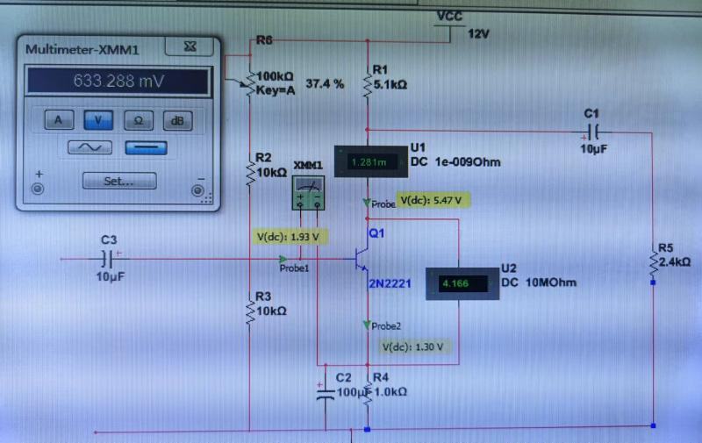

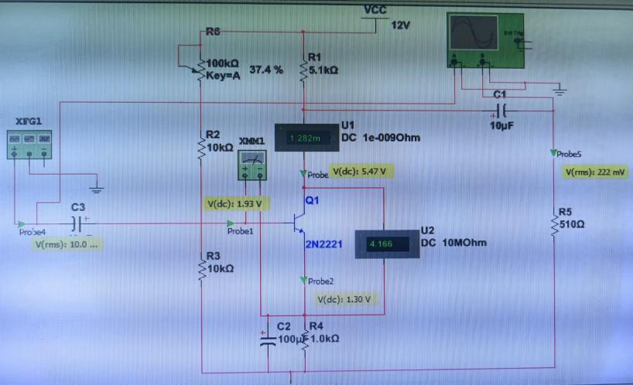

表4-1：戴维宁定理的验证数据记录

|  |  |  |
| --- | --- | --- |
| 开路电压(V) | 等效电阻(Ω) | R3电流I |
| 11.599V | 400 | 8.285 |

表5-1 稳压电路不同参数数据

|  |  |  |  |  |  |
| --- | --- | --- | --- | --- | --- |
| 数据 | U | R1 | R2 | XTM1 | XTM2 |
| 1 | 6V | 120Ω | 1KΩ | 10.283mA | 4.255V |
| 2 | 8V | 120Ω | 1KΩ | 26.72mA | 4.28V |
| 3 | 6V | 120Ω | 500Ω | 6.166mA | 4.242V |

表5-2 二极管通断状态测试

|  |  |  |  |
| --- | --- | --- | --- |
| S1开关状态 | 电流表读数 | 电压表读数 | 二极管通断状态 |
| S1置V1 | 4.267mA | 733.455mV | 导通 |
| S1置V2 | -888.178nA | -4.999V | 截止 |

