**RabbitMQ Exchanges**

**RabbitMQ Queues**

**GRPC Server**

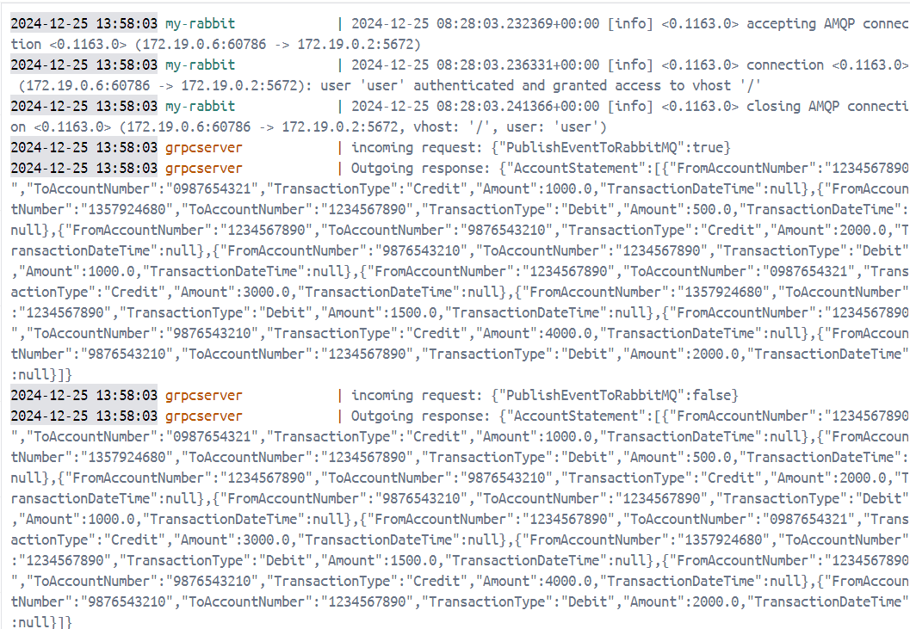

**Running APIs (Swagger)**

**Events Consumed by Notification Services 1 & 2**

