**Experiment 1**

**AIM:** Explain in detail various steps to install and run a .html file using LAMP/XAMP/WAMP server

**THEORY:**

**EXPERIMENT 1**

**AIM :**To explain in detail various steps to install and run a .html file using LAMP/XAMPP/WAMP server

**PROGRAM:** HERE ARE THE FILES I USED FOR HOSTING IN THIS EXPERIMENT

<http://vinaypanchal.com/scratch/>

**PROCEDURE:**

WE WILL GO WITH XAMPP SERVER

**STEP 1**

SEARCH FOR XAMPP ON WEB BROWSER AND CLICK ON FIRST RESULT

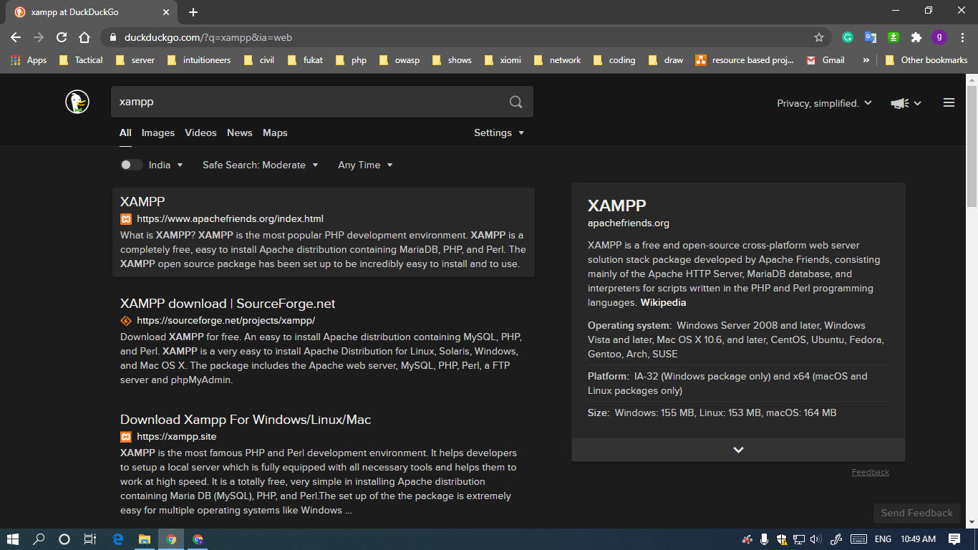

**STEP 2**

SELECT YOUR HOST OS… I WILL GO WITH WINDOWS

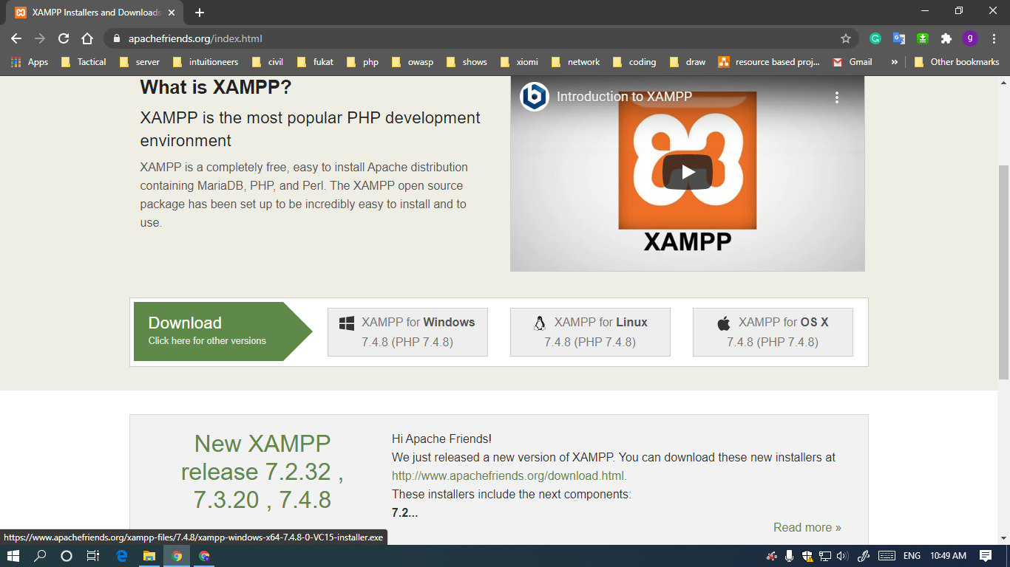

**STEP 3**

WAIT FOR IT TO DOWNLOAD

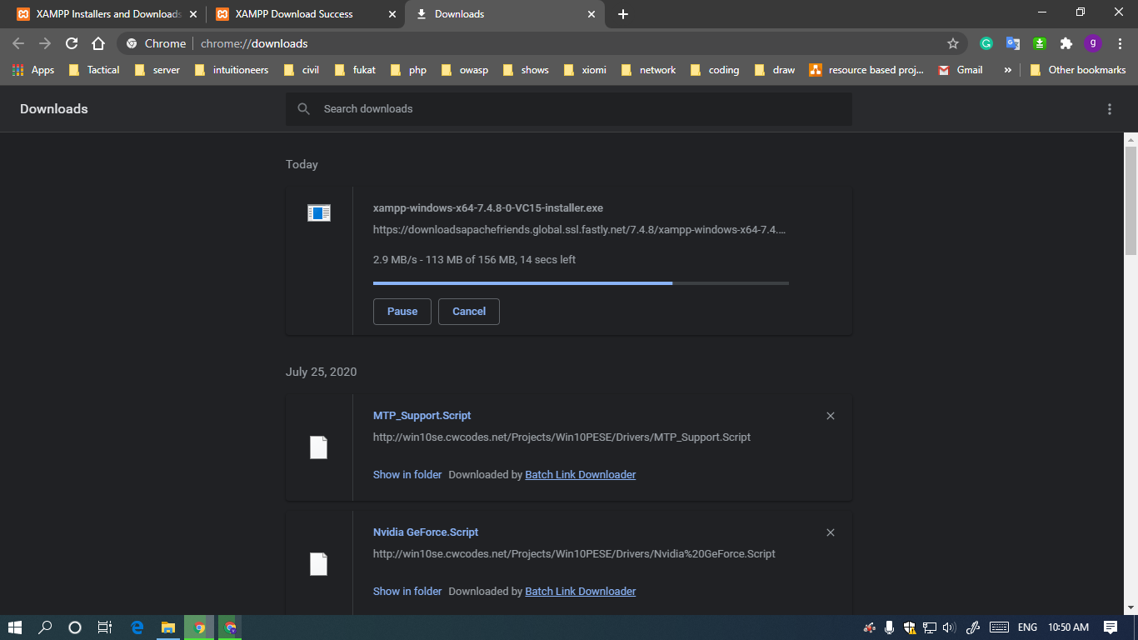

**STEP 4**

OPEN INSTALLATION FILE

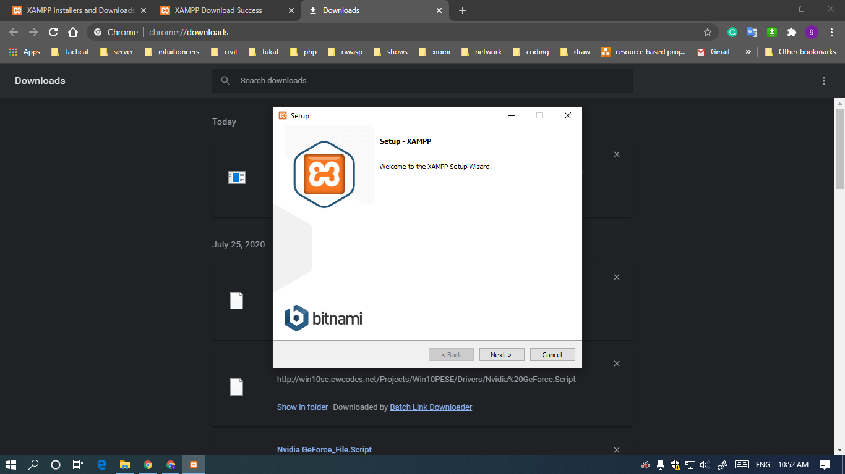

**STEP 5**

KEEP CLICKING ON NEXT BUTTON UNTILL YOU CAN'T

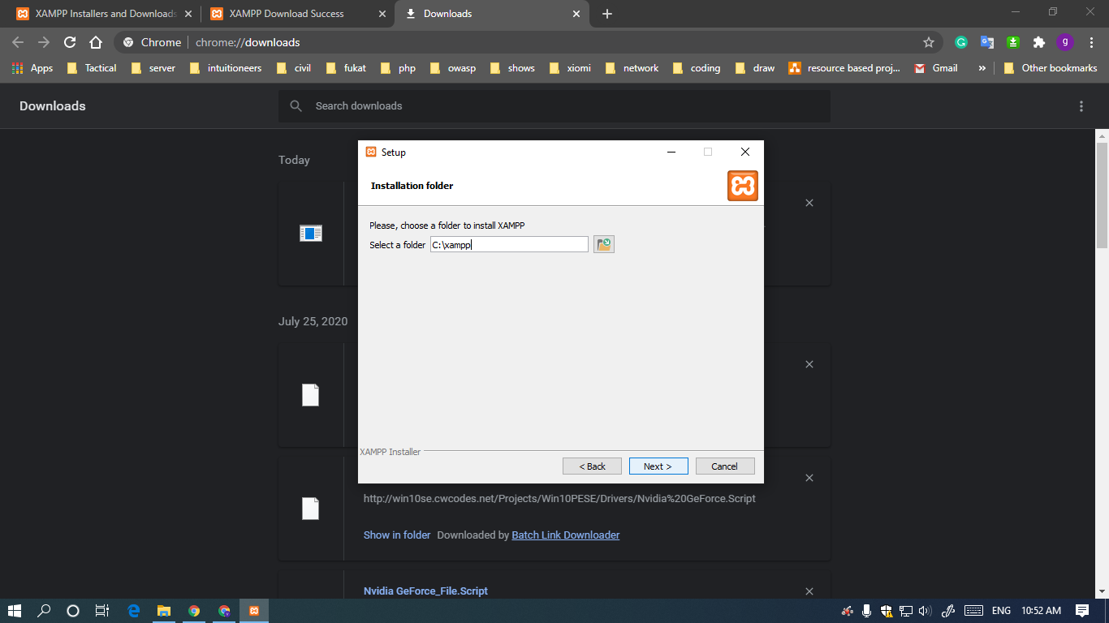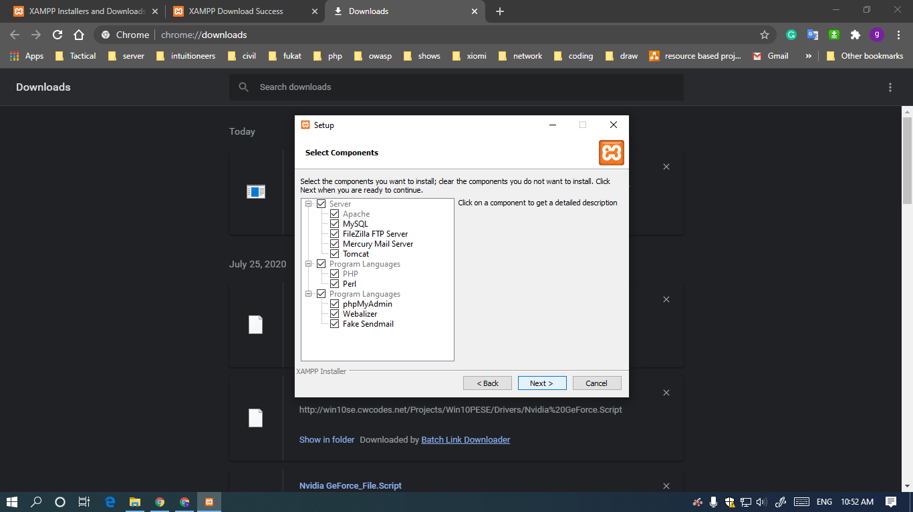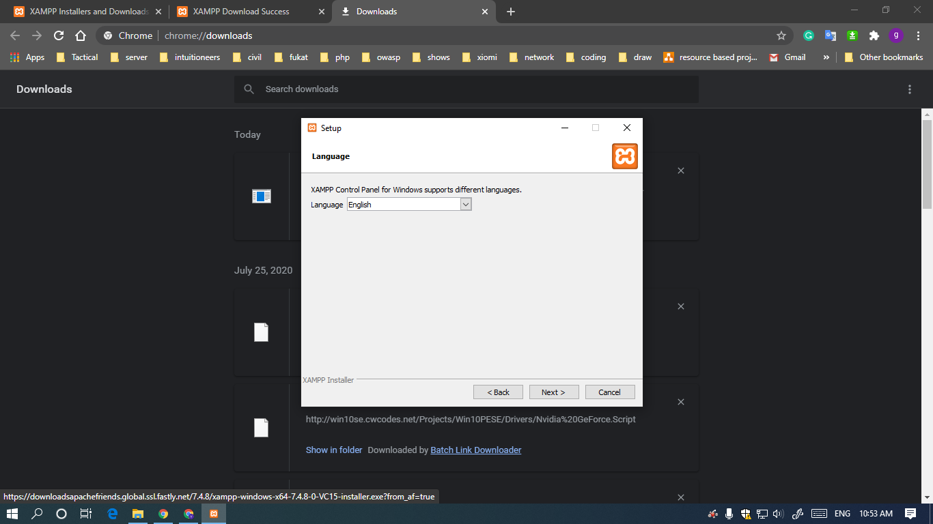

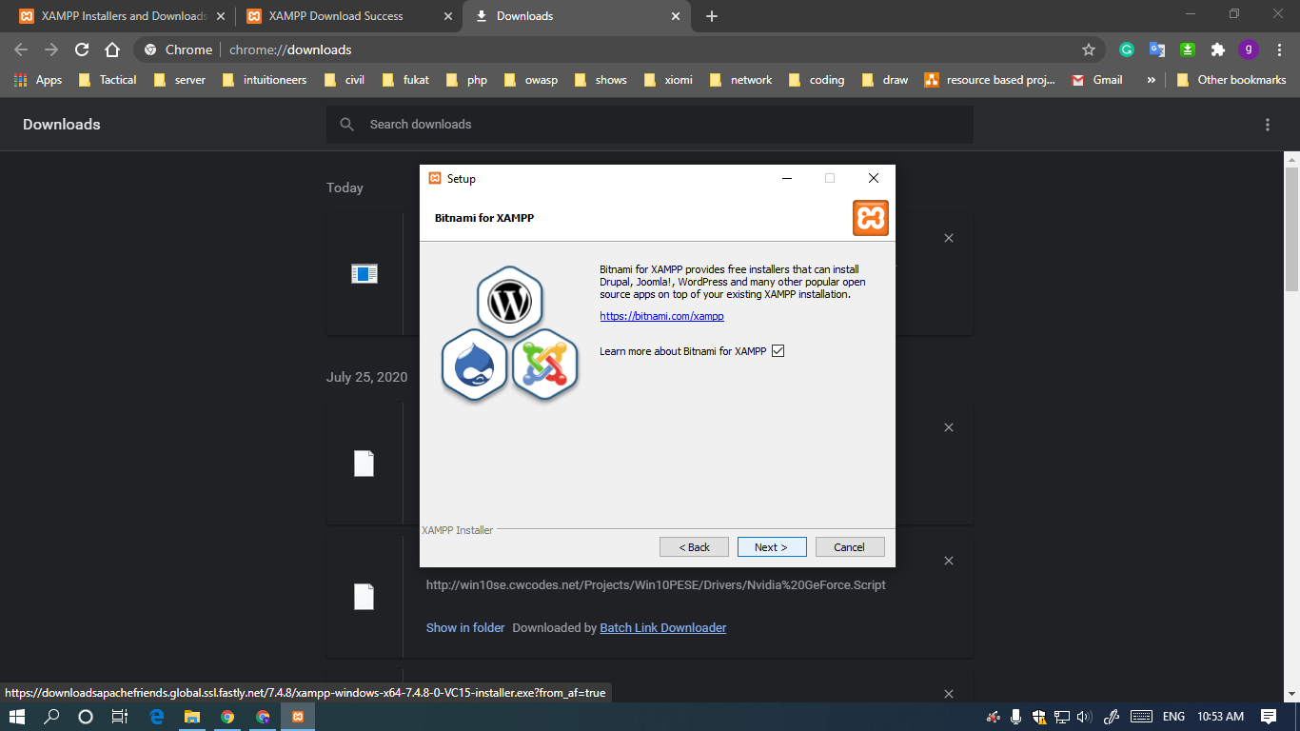

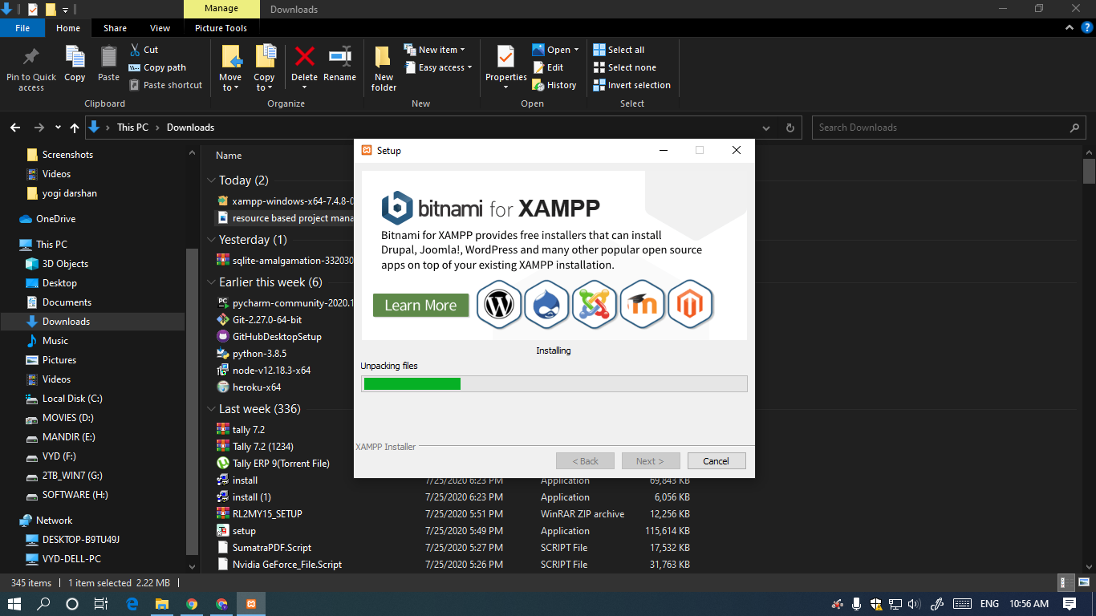

**STEP 6**

CLICK ON FINISH BUTTON

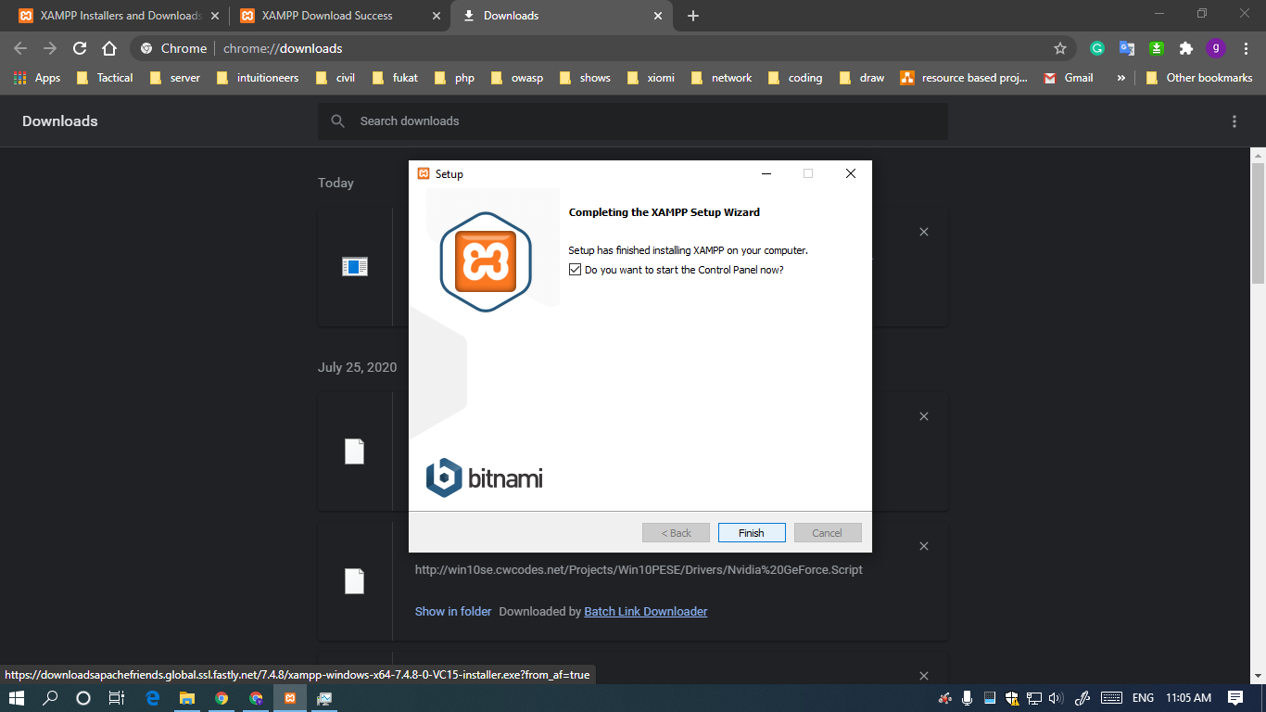

**STEP 7**

OPEN THE PROGRAM YOU JUST INSTALLED

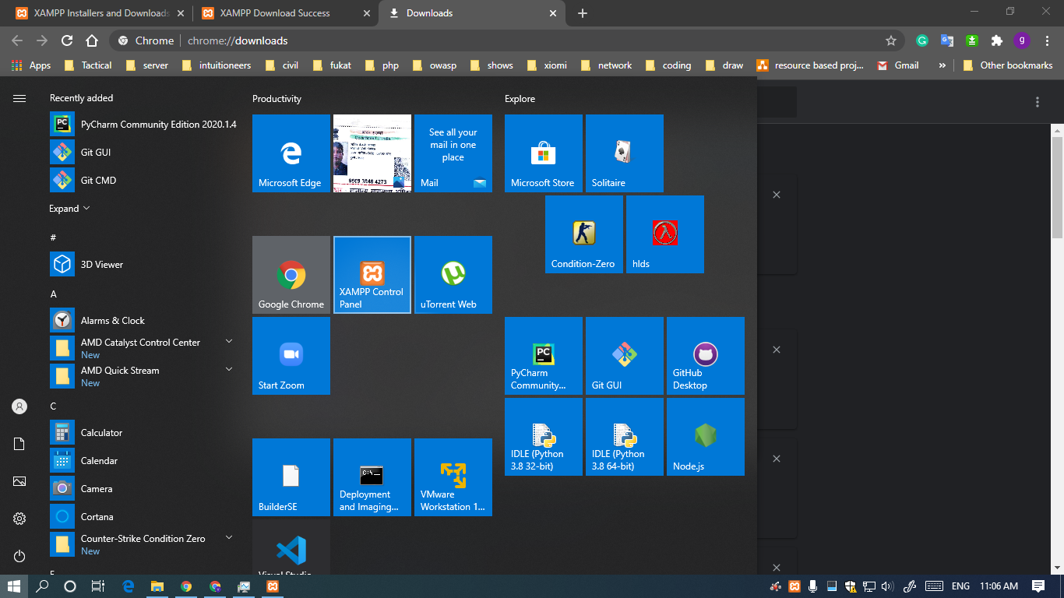

**STEP 8**

GET YOURSELF COMFORTABLE WITH THE UI

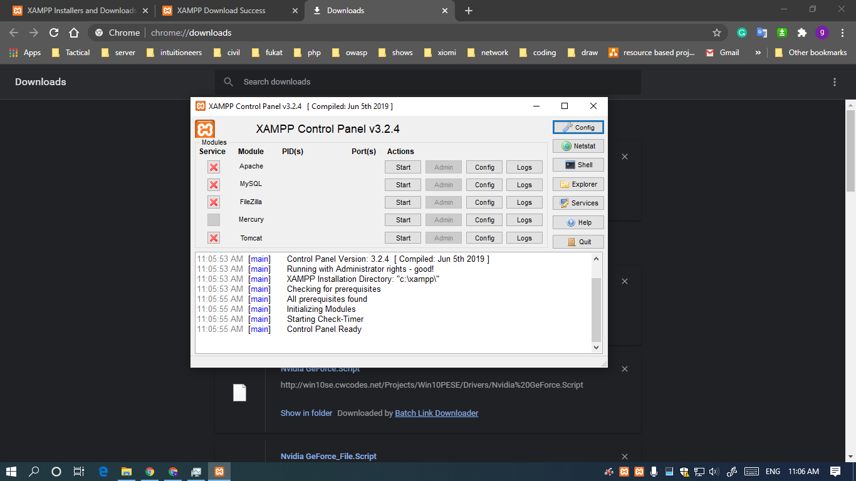

**STEP 9**

TOGGLE START BUTTON OF APACHE AND MYSQL MODULES

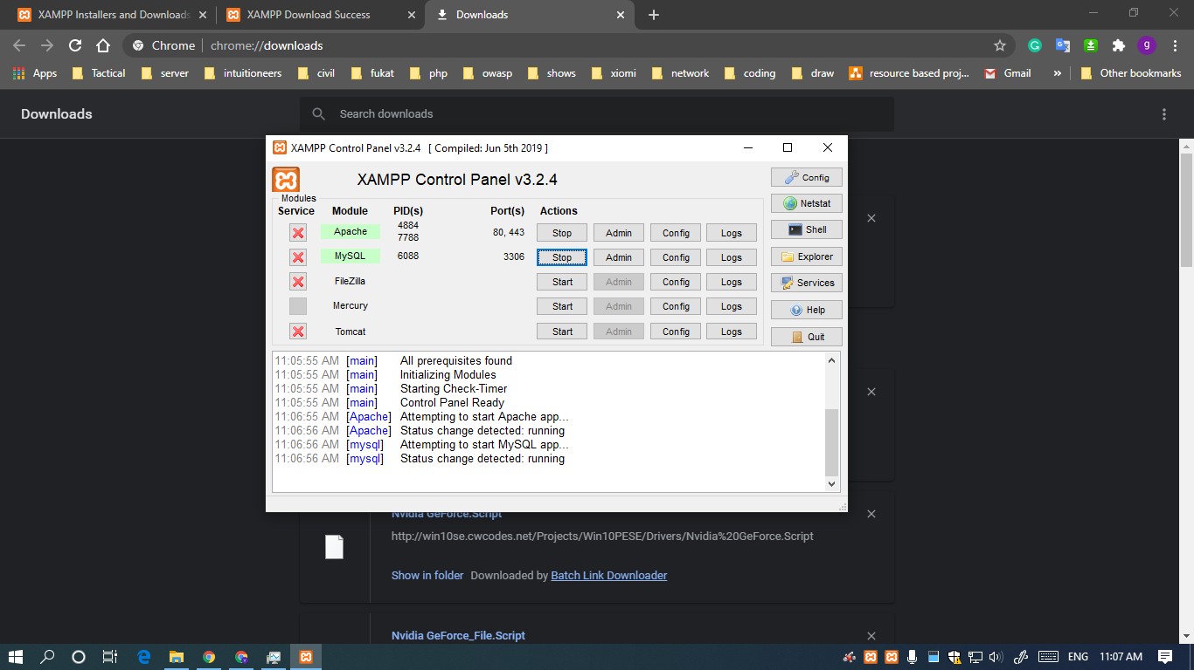

**STEP 10**

MARATHON THROUGH THE DIRECTORY C:\xampp\htdocs

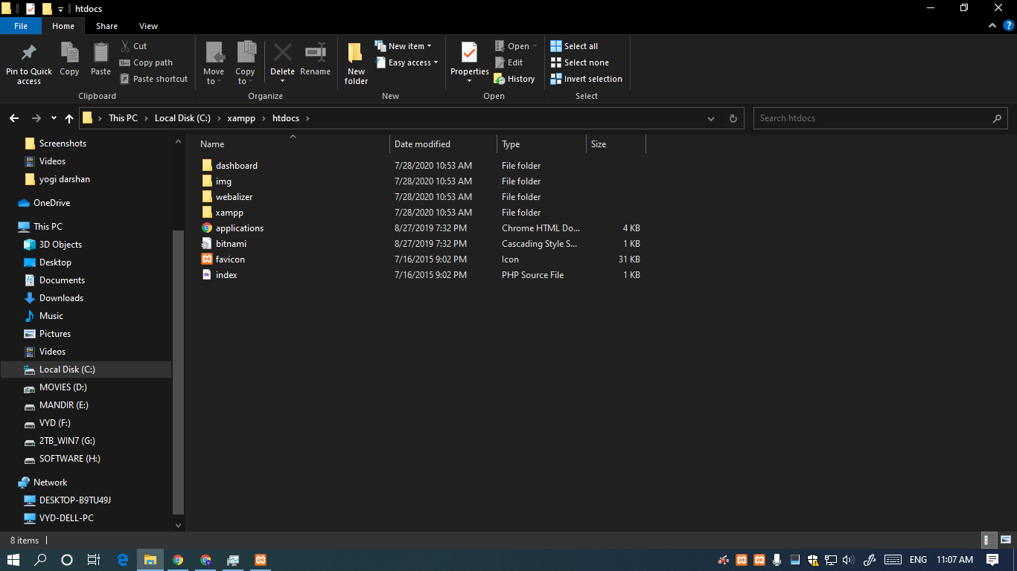

**STEP 11**

DELETE ALL FILES AND PASTE YOUR OWN PROJECT FILES IN THIS DIRECTORY AND USE THIS AS ROOT DIRECTORY

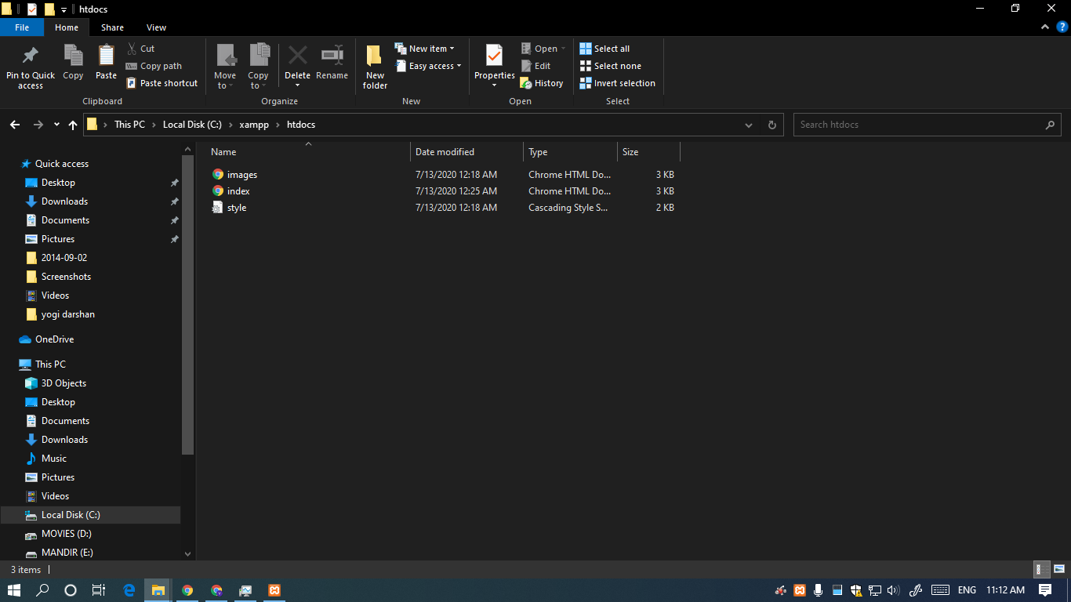

**STEP 12**

NOW OPEN YOUR BROWSER AND TYPE localhost IN URL TAB



**STEPS TO RUN A .HTML FILE USING LAMP/XAMP/WAMP SERVER**

1. Go to "Start" on the Windows taskbar and type "XAMPP" into the search box. Select "XAMPP Control Panel" and press the "Enter" key. Start Apache from the XAMPP Control Panel. Apache is ready for use once you see the word "Running" highlighted in green.

1. Go to "Start" and open "Computer." Navigate to your XAMPP folder, normally found as a top-level folder under your computer's main hard drive. Open the htdocs folder.

1. Open "Computer" again and navigate to the folder where you keep your HTML files. If you do not already have any HTML files created, create one and save it to the htdocs folder under the XAMPP folder. Copy and paste your HTML files, if you find any, in to the htdocs folder.
2. Start your Web browser and type "localhost/filename.html" into the address bar. Press "Enter" and watch your HTML file load as a Web page. Now your Apache server that came with XAMPP is serving your Web pages.

**CONCLUSION :** SO WE FINALLY ACHIEVED WHAT WE WANTED