**Experiment 2**

# **AIM:** Create a detailed resume, provide links for all your social media accounts . Use tables ,frames, hyper links in designing your detailed resume

**THEORY:**

**HTML**

HTML is the standard markup language for creating Web pages.

HTML stands for Hyper Text Markup Language

HTML is the standard markup language for creating Web pages

HTML describes the structure of a Web page

HTML consists of a series of elements

HTML elements tell the browser how to display the content

HTML elements label pieces of content such as "this is a heading", "this is a paragraph", "this is a link", etc.

All HTML documents must start with a document type declaration: <!DOCTYPE html>.

The HTML document itself begins with <html> and ends with </html>.

The visible part of the HTML document is between <body> and </body>

**The <!DOCTYPE> Declaration**

The <!DOCTYPE> declaration represents the document type, and helps browsers to display web pages correctly.

It must only appear once, at the top of the page (before any HTML tags).

The <!DOCTYPE> declaration is not case sensitive.

The <!DOCTYPE> declaration for HTML5 is:

<!DOCTYPE html>

**HTML Headings**

HTML headings are defined with the <h1> to <h6> tags.

<h1> defines the most important heading. <h6> defines the least important heading:

Example

<h1>This is heading 1</h1>

<h2>This is heading 2</h2>

<h3>This is heading 3</h3>

**HTML Paragraphs**

HTML paragraphs are defined with the <p> tag:

Example

<p>This is a paragraph.</p>

<p>This is another paragraph.</p>

**HTML Links**

HTML links are defined with the <a> tag:

Example

<a href="https://www.pinterest.com">This is a link</a>

The link's destination is specified in the href attribute.

Attributes are used to provide additional information about HTML elements.

**HTML Images**

HTML images are defined with the <img> tag.

The source file (src), alternative text (alt), width, and height are provided as attributes:

Example

<img src="car.jpg" alt="cars.com" width="104" height="142">

**PROGRAM:**

**Speciality of this code**

Entire site is made from scratch with zero binary files hosted….

All images are remotely loaded directly from Google drive as thumbnails.

Hence increasing performance on web hosting by dividing load with free Google drive hosting.

**INDEX FILE HTML PART**

<!DOCTYPE html>

<html lang="en">

<head>

    <title>VINAY PANCHAL</title>

    <link rel="stylesheet" href="style.css">

    <link rel="stylesheet" href="https://fonts.googleapis.com/css?family=Sofia">

    <meta name="viewport" content="width=device-width, initial-scale=1.0">

</head>

<body>

    <header>

        <main><img src="https://drive.google.com/thumbnail?id=1PMrBo42GXpToOfdkrbTVgIz9MyqRGOiA" alt="my face"

                style="width:100px;height:100px;">

            VINAY PANCHAL </main>

        </a>

    </header>

    <h4>

        MASTER OF ALL BUT GOOD FOR NOTHING

    </h4>

    <section>

        <div class="aaju">

            <h4>

                projects i am working on

            </h4>

            <a href="http://www.vinaypanchal.com/projects/projects.html">

                <h6>portable personal server</h6>

            </a>

            <a href="http://unilink.intuitioneers.com/">

                <h6>unilink (link shortner)</h6>

            </a>

            <a href="http://intuitioneers.com/">

                <h6>ignite (startup community)</h6>

            </a>

            <a href="http://www.vinaypanchal.com/projects/projects.html">

                <h6>price calculator for second hand electronics</h6>

            </a>

            <a href="http://www.vinaypanchal.com/projects/projects.html">

                <h6>electric bike</h6>

            </a>

        </div>

        <div class="baaju">

            <h3>

                so in this resume let's talk about just non academic achievements

            </h3>

            <h3>

                ask why?

            </h3>

            <h3>

                i don't know but let's keep it that way

            </h3>

            <h3>

                by the way this site is entirely sized less than 7kb

            </h3>

            <h3>

                so even if you use 2g internet will it load in 0.5 seconds?

            </h3>

            <h3>

                naah

            </h3>

            <h3>

                ask why ?

            </h3>

            <h3>

                because science!

            </h3>

            <h3>

                click on the last words of this site to get in touch with me and know

            </h3>

        </div>

    </section>

    <div>

        <a href="images.html">

            <h4><br>checkout my photography skills</h4>

        </a>

        <a href="https://youtu.be/sbXfAQ5utWs">

            <h4>artistic schientist(youtube channel)</h4>

        </a>

        <a href="https://youtu.be/fPR5xxxjnWM">

            <h4>keen psyche(youtube channel)</h4>

        </a>

        <a href="https://github.com/vinaynpp">

            <h4>my github repos</h4>

        </a>

        <a href="winmod.html">

            <h4>WINMOD PROJECT <br> MODIFIED VERSIONS OF WINDOWS MADE BY ME</h4>

        </a>

    </div>

    <section>

        <footer>

            <a href="https://yaadnahiabhi.typeform.com/to/qa39Iv">

                <h6>GOT SOMETHING TO SAY ?</h6>

            </a>

        </footer>

    </section>

</body>

</html>

**INDEX FILE CSS PART**

body {

    background-color: #333333;

    font: 16px 'Indie Flower';

    width: 90%;

    padding: 4.5%;

}

main {

    color: #ffffff;

    text-align: center;

    float: right;

    text-transform: uppercase;

    font-family: "Sofia";

    font-size: 450%;

    width: 100%;

}

h6 {

    color: #ffffff;

    text-align: center;

    text-transform: uppercase;

    font-family: 'Segoe UI', sans-serif;

    font-size: 100%;

}

H5 {

    color: #ffffff;

    text-align: center;

    text-transform: uppercase;

    font-family: 'Segoe UI', sans-serif;

    font-size: 300%;

}

h4 {

    color: #ffffff;

    text-align: center;

    text-transform: uppercase;

    font-family: 'Segoe UI', sans-serif;

    font-size: 150%;

}

h3 {

    color: #ffffff;

    text-align: left;

    text-transform: uppercase;

    font-family: 'Segoe UI', sans-serif;

    font-size: 100%;

}

p {

    color: #ffffff;

    text-transform: uppercase;

    font-family: 'Segoe UI', sans-serif;

    font-size: 100%;

}

.center {

    display: block;

    margin-left: auto;

    margin-right: auto;

    width: 75%;

}

.aaju {

    width: 35%;

    float: left;

}

.baaju {

    width: 55%;

    float: left;

    background-color: #616161;

    padding: 3%;

}

table {

    background-color: #ffffff;

    width: 100%;

    padding: 20px;

    border: 40px #333333;

    border-spacing: 10px;

    border-color: black;

}

td {

    text-align: center;

    padding: 20px;

    border: 40px #333333;

    border-spacing: 10px;

    border-color: black;

    font-family: 'Segoe UI', sans-serif;

}

caption {

    font-family: "Sofia";

    font-size: xx-large;

    color: #ffffff;

}

footer {

    float: bottom;

    text-align: center;

    padding: 10% 10%;

}

**OUTPUT:**

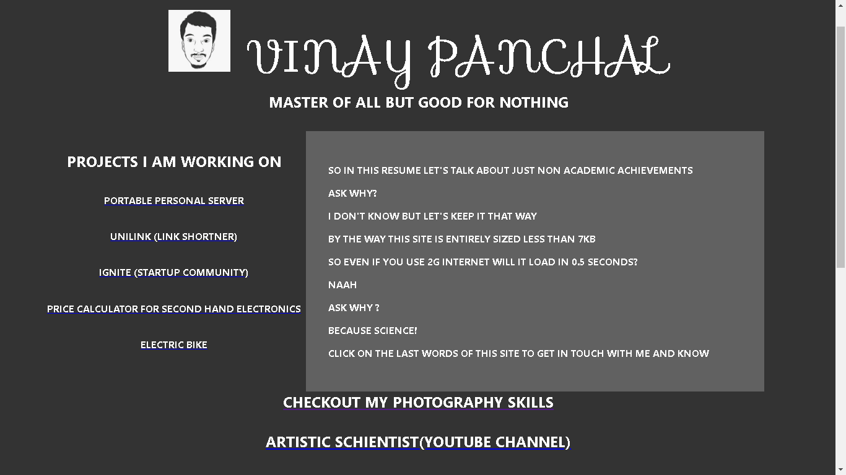

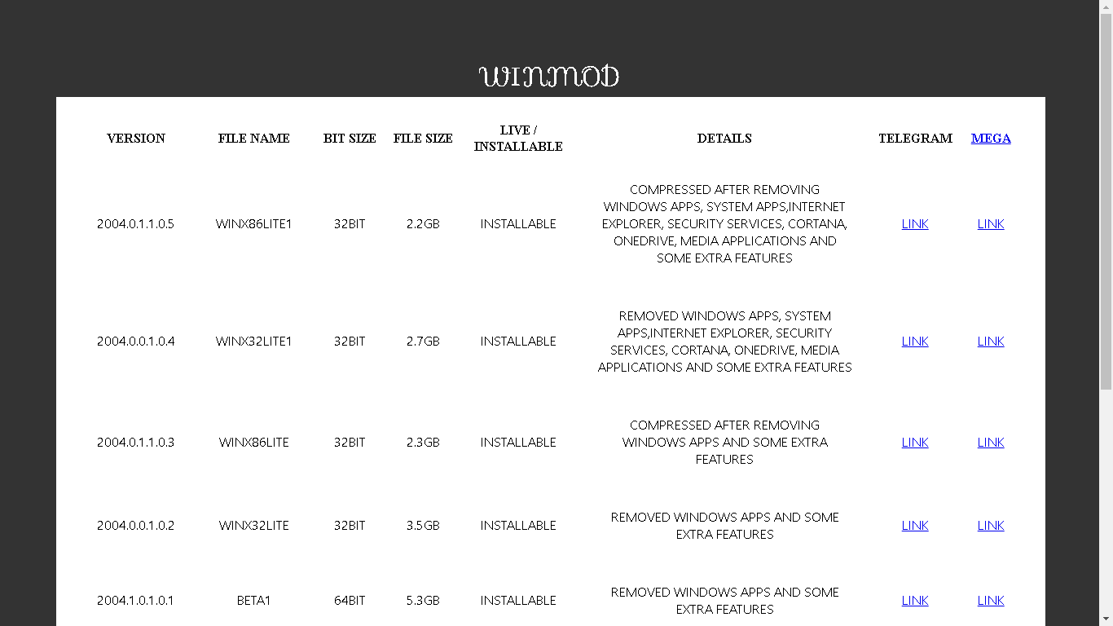

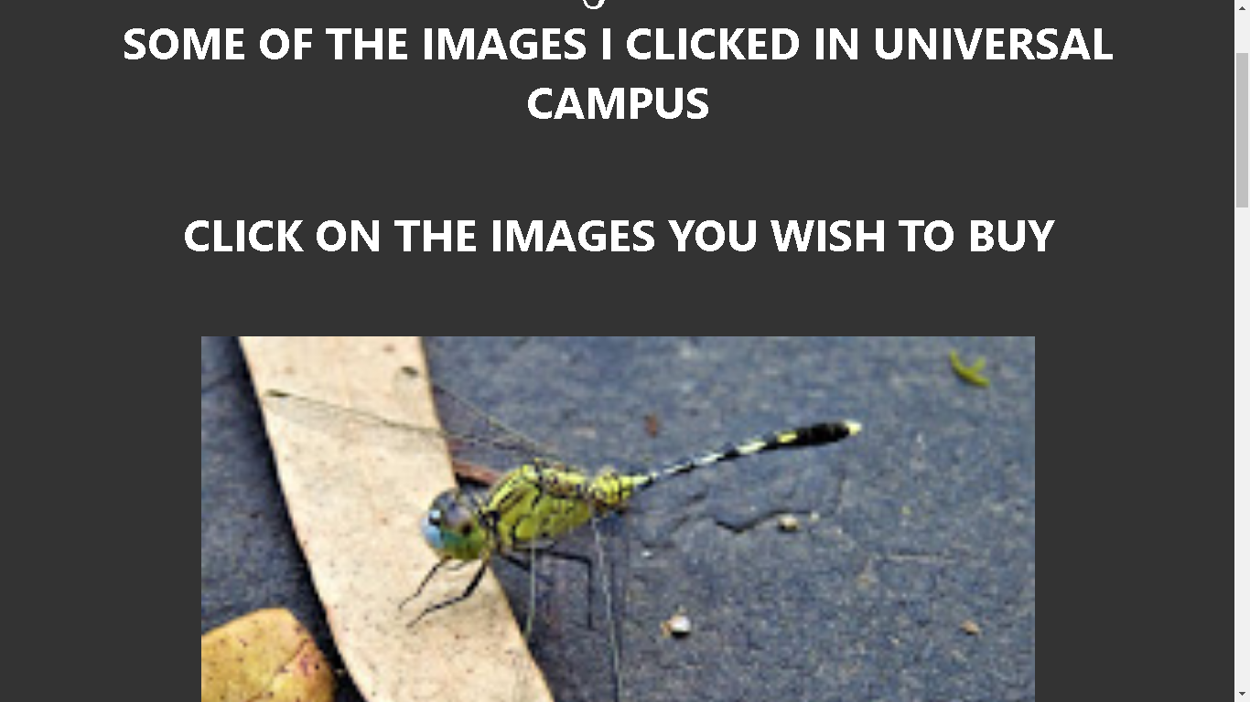

**CONCLUSION**

# Hence we have created a detailed resume, provide links for all our social media accounts . Using tables ,frames, hyper links in designing our detailed resume.