**Experiment 4**

# **AIM:** Using PhP and mysql perform the following operations 1. Create 2. Read 3.Update 4. Delete

**THEORY:**

CRUD is an acronym for **C**reate, **R**ead, **U**pdate, and **D**elete. CRUD operations are basic data manipulation for database

**PHP**

PHP is an acronym for "PHP: Hypertext Preprocessor"

PHP is a widely-used, open source scripting language

PHP scripts are executed on the server

PHP is free to download and use

PHP can generate dynamic page content

PHP can create, open, read, write, delete, and close files on the server

PHP can collect form data

PHP can send and receive cookies

PHP can add, delete, modify data in your database

PHP can be used to control user-access

PHP can encrypt data

PHP script can be placed anywhere in the document.

A PHP script starts with <?php and ends with ?>:

The default file extension for PHP files is ".php".

A PHP file normally contains HTML tags, and some PHP scripting code

**MYSQL**

MySQL provides a set of some basic but most essential operations that will help you to easily interact with the MySQL database

Some of The Most Important SQL Commands

SELECT - extracts data from a database

UPDATE - updates data in a database

DELETE - deletes data from a database

INSERT INTO - inserts new data into a database

CREATE DATABASE - creates a new database

ALTER DATABASE - modifies a database

CREATE TABLE - creates a new table

ALTER TABLE - modifies a table

DROP TABLE - deletes a table

CREATE INDEX - creates an index (search key)

DROP INDEX - deletes an index

**PROGRAM:**

**SQL CONNECTIVITY PART**

<?php

session_start();

$con = mysqli_connect("localhost", "root", "", "ecom");

define('SERVER_PATH', $_SERVER['DOCUMENT_ROOT'] . '/ecom1/');

define('SITE_PATH', 'http://localhost/ecom1/');

define('PRODUCT_IMAGE_SITE_PATH', SITE_PATH . 'photu/');

define('PRODUCT_IMAGE_SERVER_PATH', SERVER_PATH . 'photu/');

?>

**FUNCTIONS PART**

<?php

function pr($arr){

    echo '<pre>';

    print_r($arr);

}

function prx($arr){

    echo '<pre>';

    print_r($arr);

    die();

}

function get_safe_value($con, $str)

{

    if ($str != '') {

        $str = trim($str);

        return mysqli_real_escape_string($con, $str);

    }

}

function get_product($con,$limit='',$product_id='',$cat_id=''){

    $sql="select * from product ";

    if($product_id!=''){

        $sql.=" where product.id=$product_id ";

    }

    if($limit!=''){

        $sql.=" limit $limit";

    }

    $res=mysqli_query($con,$sql);

    $data=array();

    while($row=mysqli_fetch_assoc($res)){

        $data[]=$row;

    }

    return $data;

}

?>

**ADMIN DASHBOARD PART**

<?php

require('connection.inc.php');

require('functions.inc.php');

if (isset($_SESSION['ADMIN_LOGIN']) && $_SESSION['ADMIN_LOGIN'] != '') {

} else {

    header('location:bossandar.php');

    die();

}

if (isset($_GET['type']) && $_GET['type'] != '') {

    $type = get_safe_value($con, $_GET['type']);

    if ($type == 'status') {

        $operation = get_safe_value($con, $_GET['operation']);

        $id = get_safe_value($con, $_GET['id']);

        if ($operation == 'active') {

            $status = '1';

        } else {

            $status = '0';

        }

        $update_status_sql = "update product set status='$status' where id='$id'";

        mysqli_query($con, $update_status_sql);

    }

    if ($type == 'delete') {

        $id = get_safe_value($con, $_GET['id']);

        $delete_sql = "delete from product where id='$id'";

        mysqli_query($con, $delete_sql);

    }

}

$sql = "select product.* from product order by product.id desc";

$res = mysqli_query($con, $sql);

?>

<?php require('bossnav.php');?>

    <table style="width: 100%;">

        <tr>

            <th>IMAGES</th>

            <th>TITLE</th>

            <th>MRP</th>

            <th>STOCK</th>

            <th>DETAIL</th>

            <th>ACTIVATION</th>

            <th>EDIT</th>

            <th>DELETE</th>

        </tr><?php

                $i = 1;

                while ($row = mysqli_fetch_assoc($res)) {

                ?><tr>

                <td><img src="<?php echo PRODUCT_IMAGE_SITE_PATH . $row['image'] ?>" alt="product images" style="width: 60px;"></td>

                <td>

                    <h5><?php echo $row['name'] ?></h5>

                </td>

                <td>

                    <H4><?php echo "₹";

                        echo  $row['mrp'] ?></H4>

                </td>

                <td><?php echo $row['qty'] ?></td>

                <td style="width: 30%;"><?php echo "DETAIL : ";

                                        echo $row['description'] ?></td>

                <td><?php if ($row['status'] == 1) {

                        echo "<span ><a href='?type=status&operation=deactive&id=" . $row['id'] . "'>Active</a></span>&nbsp;";

                    } else {

                        echo "<span ><a href='?type=status&operation=active&id=" . $row['id'] . "'>Deactive</a></span>&nbsp;";

                    }           ?></td>

                <td><?php

                    echo "<span ><a href='product.php?id=" . $row['id'] . "'>Edit</a></span>&nbsp;";

                    ?></td>

                <td><?php

                    echo "<span ><a href='?type=delete&id=" . $row['id'] . "'>Delete</a></span>";

                    ?></td>

                <td></td>

            </tr><?php } ?>

    </table>

    <div class="footer">

        <p>Copyright© <a href="http://vinaypanchal.com/">VINAY PANCHAL</a>All right reserved.</p>

    </div>

    <script src="bs.js"></script>

</body>

</html>

**PRODUCT EDIT PART**

<?php

require('connection.inc.php');

require('functions.inc.php');

$name = '';

$mrp = '';

$qty = '';

$image = '';

$description    = '';

$msg = '';

$image_required = 'required';

if (isset($_GET['id']) && $_GET['id'] != '') {

    $image_required = '';

    $id = get_safe_value($con, $_GET['id']);

    $res = mysqli_query($con, "select * from product where id='$id'");

    $check = mysqli_num_rows($res);

    if ($check > 0) {

        $row = mysqli_fetch_assoc($res);

        $name = $row['name'];

        $mrp = $row['mrp'];

        $qty = $row['qty'];

        $description = $row['description'];

    } else {

        header('location:index.php');

        die();

    }

}

if (isset($_POST['submit'])) {

    $name = get_safe_value($con, $_POST['name']);

    $mrp = get_safe_value($con, $_POST['mrp']);

    $qty = get_safe_value($con, $_POST['qty']);

    $description = get_safe_value($con, $_POST['description']);

    $res = mysqli_query($con, "select * from product where name='$name'");

    $check = mysqli_num_rows($res);

    if ($check > 0) {

        if (isset($_GET['id']) && $_GET['id'] != '') {

            $getData = mysqli_fetch_assoc($res);

            if ($id == $getData['id']) {

            } else {

                $msg = "Product already exist";

            }

        } else {

            $msg = "Product already exist";

        }

    }

    if ($_GET['id'] == 0) {

        if ($_FILES['file']['type'] != 'image/png' && $_FILES['image']['type'] != 'image/jpg' && $_FILES['file']['type'] != 'image/jpeg') {

            $msg = "Please select only png,jpg and jpeg image formate";

        }

    } else {

        if ($_FILES['file']['type'] != '') {

            if ($_FILES['file']['type'] != 'image/png' && $_FILES['image']['type'] != 'image/jpg' && $_FILES['file']['type'] != 'image/jpeg') {

                $msg = "Please select only png,jpg and jpeg image formate";

            }

        }

    }

    if ($msg == '') {

        if (isset($_GET['id']) && $_GET['id'] != '') {

            if ($_FILES['image']['name'] != '') {

                $image=rand(111111111,999999999).'_'.$_FILES['image']['name'];

                move_uploaded_file($_FILES['image']['tmp_name'],PRODUCT_IMAGE_SERVER_PATH.$image);

                $update_sql = "update product set name='$name',mrp='$mrp',qty='$qty',description='$description',image='$image' where id='$id'";

            } else {

                $update_sql = "update product set name='$name',mrp='$mrp',qty='$qty',description='$description' where id='$id'";

            }

            mysqli_query($con, $update_sql);

        } else {

            $image=rand(111111111,999999999).'_'.$_FILES['image']['name'];

            move_uploaded_file($_FILES['image']['tmp_name'],PRODUCT_IMAGE_SERVER_PATH.$image);

            mysqli_query($con, "insert into product(name,mrp,qty,description,status,image) values('$name','$mrp','$qty','$description',1,'$image')");

        }

        header('location:index.php');

        die();

    }

}

?>

**OUTPUT:**



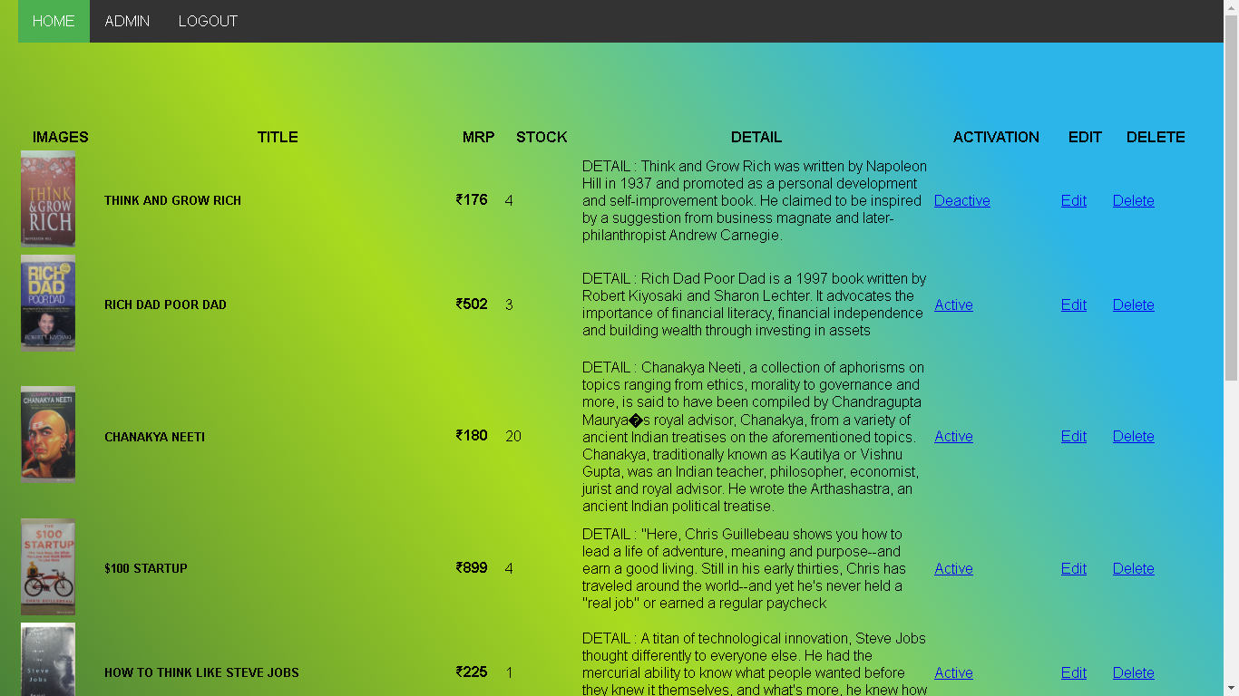

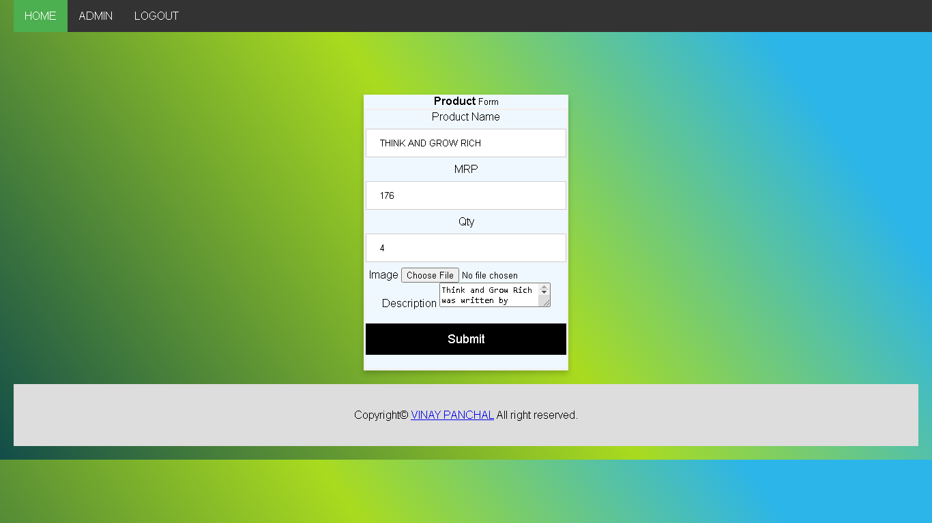

**CONCLUSION**

Thus, implemented CRUD operations using PhP and mysql.