**Experiment 7**

# **AIM:** Create a web application using laravel framework. The web application should contain laravels user registration process

**THEORY:**

Laravel is an open-source PHP framework, which is robust and easy to understand. It follows a model-view-controller design pattern. Laravel reuses the existing components of different frameworks which helps in creating a web application. The web application thus designed is more structured and pragmatic.

Laravel offers a rich set of functionalities which incorporates the basic features of PHP frameworks like CodeIgniter, Yii and other programming languages like Ruby on Rails. Laravel has a very rich set of features which will boost the speed of web development.

If you are familiar with Core PHP and Advanced PHP, Laravel will make your task easier. It saves a lot time if you are planning to develop a website from scratch. Moreover, a website built in Laravel is secure and prevents several web attacks.

Advantages of Laravel

Laravel offers you the following advantages, when you are designing a web application based on it −

* The web application becomes more scalable, owing to the Laravel framework.
* Considerable time is saved in designing the web application, since Laravel reuses the components from other framework in developing web application.
* It includes namespaces and interfaces, thus helps to organize and manage resources.

**PROGRAM:**

**APP HOME PART**

<!DOCTYPE html>

<html lang="{{ str_replace('_', '-', app()->getLocale()) }}">

<head>

    <meta charset="utf-8">

    <meta name="viewport" content="width=device-width, initial-scale=1">

    <!-- CSRF Token -->

    <meta name="csrf-token" content="{{ csrf_token() }}">

    <title>{{ config('app.name', 'Laravel') }}</title>

    <!-- Scripts -->

    <script src="{{ asset('js/app.js') }}" defer></script>

    <!-- Fonts -->

    <link rel="dns-prefetch" href="//fonts.gstatic.com">

    <link href="https://fonts.googleapis.com/css?family=Nunito" rel="stylesheet" type="text/css">

    <!-- Styles -->

    <link href="{{ asset('css/app.css') }}" rel="stylesheet">

</head>

<body>

    <div id="app">

        <nav class="navbar navbar-expand-md navbar-light navbar-laravel">

            <div class="container">

                <a class="navbar-brand d-flex align-items-center" href="{{ url('/') }}">

                    <div><img src="VYDMART.png" style="height: 20px; border-right: 1px solid #333;" class="pr-3"></div>

                    <div class="pl-3">VYD MART</div>

                </a>

                <button class="navbar-toggler" type="button" data-toggle="collapse" data-target="#navbarSupportedContent" aria-controls="navbarSupportedContent" aria-expanded="false" aria-label="{{ __('Toggle navigation') }}">

                    <span class="navbar-toggler-icon"></span>

                </button>

                <div class="collapse navbar-collapse" id="navbarSupportedContent">

                    <!-- Left Side Of Navbar -->

                    <ul class="navbar-nav mr-auto">

                    </ul>

                    <!-- Right Side Of Navbar -->

                    <ul class="navbar-nav ml-auto">

                        <!-- Authentication Links -->

                        @guest

                            <li class="nav-item">

                                <a class="nav-link" href="{{ route('login') }}">{{ __('Login') }}</a>

                            </li>

                            @if (Route::has('register'))

                                <li class="nav-item">

                                    <a class="nav-link" href="{{ route('register') }}">{{ __('Register') }}</a>

                                </li>

                            @endif

                        @else

                            <li class="nav-item dropdown">

                                <a id="navbarDropdown" class="nav-link dropdown-toggle" href="#" role="button" data-toggle="dropdown" aria-haspopup="true" aria-expanded="false" v-pre>

                                    {{ Auth::user()->username }} <span class="caret"></span>

                                </a>

                                <div class="dropdown-menu dropdown-menu-right" aria-labelledby="navbarDropdown">

                                    <a class="dropdown-item" href="{{ route('logout') }}"

                                       onclick="event.preventDefault();

                                                     document.getElementById('logout-form').submit();">

                                        {{ __('Logout') }}

                                    </a>

                                    <form id="logout-form" action="{{ route('logout') }}" method="POST" style="display: none;">

                                        @csrf

                                    </form>

                                </div>

                            </li>

                            <div class="header">

                                <h1 style="   padding: 14px 16px;  text-align: center;font-family: 'Segoe UI', Roboto, Oxygen, Ubuntu, Cantarell, 'Open Sans', 'Helvetica Neue', sans-serif"> <img src="VYDMART.png" alt="" height="60px"><a href="/ecom">ENTER VYD MART</a> </h1>

                              </div>

                        @endguest

                    </ul>

                </div>

            </div>

        </nav>

        <main class="py-4">

            @yield('content')

            <div class="footer">

                <div>

                  <p style="   padding: 14px 16px;  text-align: center;font-family: 'Segoe UI', Roboto, Oxygen, Ubuntu, Cantarell, 'Open Sans', 'Helvetica Neue', sans-serif"> <img src="VYDMART.png" alt="" height="60px">Copyright© <a href="http://vinaypanchal.com/">VINAY PANCHAL</a> All right reserved.</p>

                </div>

              </div>

        </main>

    </div>

</body>

</html>

**USER REGISTRATION PART**

@extends('layouts.app')

@section('content')

<div class="container">

    <div class="row justify-content-center">

        <div class="col-md-8">

            <div class="card">

                <div class="card-header">{{ __('Register') }}</div>

                <div class="card-body">

                    <form method="POST" action="{{ route('register') }}">

                        @csrf

                        <div class="form-group row">

                            <label for="name" class="col-md-4 col-form-label text-md-right">{{ __('Name') }}</label>

                            <div class="col-md-6">

                                <input id="name" type="text" class="form-control{{ $errors->has('name') ? ' is-invalid' : '' }}" name="name" value="{{ old('name') }}" autocomplete="name" autofocus>

                                @if ($errors->has('name'))

                                    <span class="invalid-feedback" role="alert">

                                        <strong>{{ $errors->first('name') }}</strong>

                                    </span>

                                @endif

                            </div>

                        </div>

                        <div class="form-group row">

                            <label for="email" class="col-md-4 col-form-label text-md-right">{{ __('E-Mail Address') }}</label>

                            <div class="col-md-6">

                                <input id="email" type="email" class="form-control{{ $errors->has('email') ? ' is-invalid' : '' }}" name="email" value="{{ old('email') }}" autocomplete="email">

                                @if ($errors->has('email'))

                                    <span class="invalid-feedback" role="alert">

                                        <strong>{{ $errors->first('email') }}</strong>

                                    </span>

                                @endif

                            </div>

                        </div>

                        <div class="form-group row">

                            <label for="username" class="col-md-4 col-form-label text-md-right">Username</label>

                            <div class="col-md-6">

                                <input id="username" type="username" class="form-control{{ $errors->has('username') ? ' is-invalid' : '' }}" name="username" value="{{ old('username') }}" autocomplete="username">

                                @if ($errors->has('username'))

                                    <span class="invalid-feedback" role="alert">

                                        <strong>{{ $errors->first('username') }}</strong>

                                    </span>

                                @endif

                            </div>

                        </div>

                        <div class="form-group row">

                            <label for="password" class="col-md-4 col-form-label text-md-right">{{ __('Password') }}</label>

                            <div class="col-md-6">

                                <input id="password" type="password" class="form-control{{ $errors->has('password') ? ' is-invalid' : '' }}" name="password" autocomplete="new-password">

                                @if ($errors->has('password'))

                                    <span class="invalid-feedback" role="alert">

                                        <strong>{{ $errors->first('password') }}</strong>

                                    </span>

                                @endif

                            </div>

                        </div>

                        <div class="form-group row">

                            <label for="password-confirm" class="col-md-4 col-form-label text-md-right">{{ __('Confirm Password') }}</label>

                            <div class="col-md-6">

                                <input id="password-confirm" type="password" class="form-control" name="password_confirmation" autocomplete="new-password">

                            </div>

                        </div>

                        <div class="form-group row mb-0">

                            <div class="col-md-6 offset-md-4">

                                <button type="submit" class="btn btn-primary">

                                    {{ __('Register') }}

                                </button>

                            </div>

                        </div>

                    </form>

                </div>

            </div>

        </div>

    </div>

</div>

@endsection

**OUTPUT:**

**APP HOME PART**

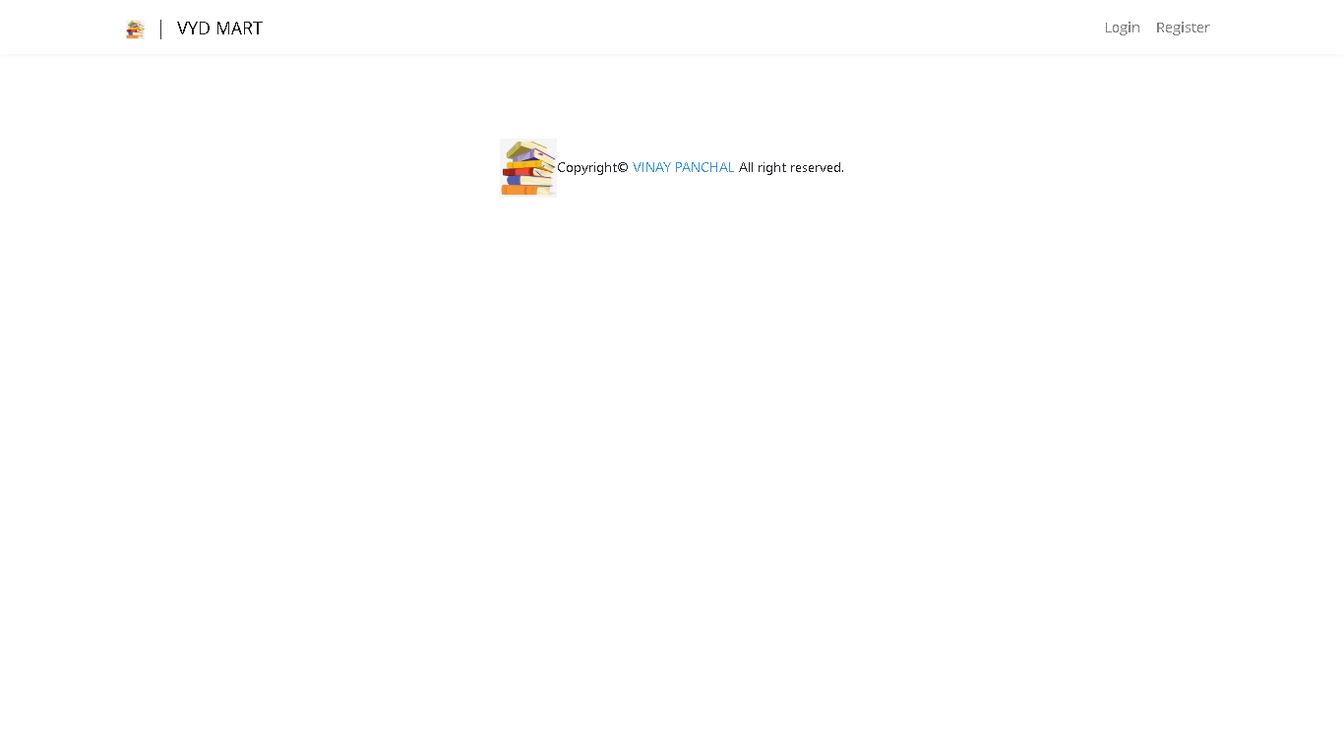

**USER REGISTRATION PART**

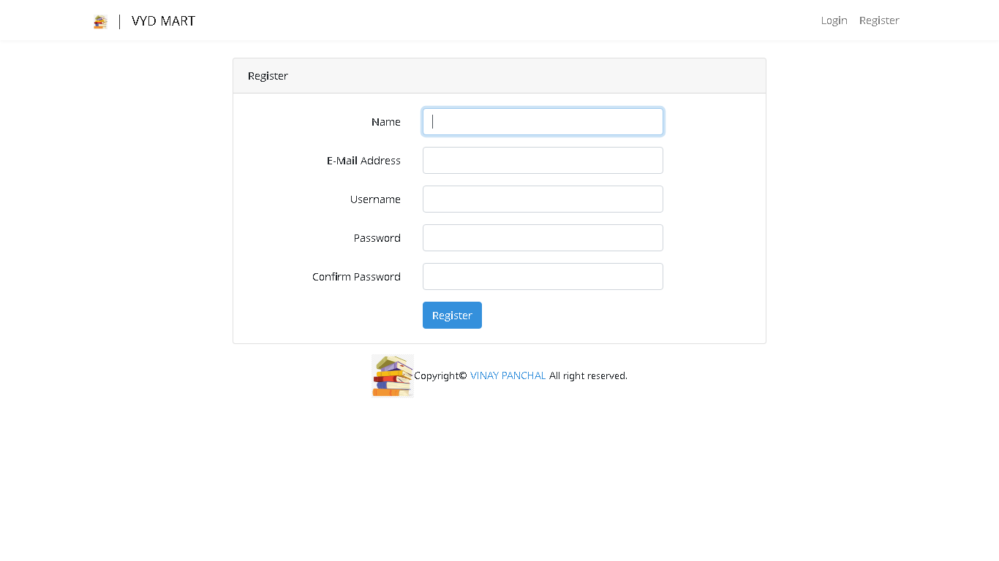

**CONCLUSION**

Thus,created a web application using laravel framework