**Experiment 9**

# **AIM:** Host the web application created in Exp 8 using Domain Registration Process

**THEORY:**

Web Hosting and Domain Registration are two elements of running a website. But it’s important to understand the difference and use cases.

Web Hosting is an account on a computer (aka server) that can store and serve website files via the Internet.

Domain Registration is leasing a human-readable word (e.g., amazon.com) that directs people to specific website files via a browser.

As an analogy, a domain is an “address” on the Internet. Hosting is the “land” or space where your website files live.

That’s the short version. But there’s more to web hosting vs. domain registration than their definition.

How Hosting & Domains Work

Web hosting and domain registration are frequently paired together. But it’s important to understand exactly what they do.

Domain Registration

Internet addresses are technically “IP Addresses.” IP addresses are a long series of numbers that make no sense to humans.

So instead of typing in 192.168.0.1.1 to access a website, the website owner can register a domain that will route to that specific IP address.

When you register a domain name, you are leasing it from the Internet Corporation for Names and Numbers (ICANN). ICANN provides domains via approved registrars.

A domain does not do anything on its own. Registration provides you the right to “point” your domain wherever you want.

You can tell it to redirect to another website – But usually, you’ll want it to direct browsers to your website…on your hosting account.

You can read more in Domain Names, Explained post.

Web Hosting

Web hosting is an account on a web server that “hosts” your website files.

If you do not have a domain “pointed” to your hosting account, you can access it with a string of numbers in an IP address.

While you can technically build your own server at home, most people buy hosting from a hosting company.

A hosting company is a company that owns a bunch of pre-configured servers that they lease out according to different hosting plans.

They will usually include instructions on how to “point” your domain to your hosting account. They’ll also provide instructions for software to build & manage your website.

You can read more in Website Hosting, Explained post.

But there are usually a few other terms that confuse issues.

**PROGRAM:**

**MAIN CONTROLLER PART**

<?php

namespace App\Http\Controllers;

use Illuminate\Http\Request;

use App\Http\Controllers\Auth\LoginController;

class PagesController extends Controller

{

    public function index(){

        return view('pages.index');

    }

}

**MAIN USER CONTROLLER PART**

<?php

namespace App\Models;

use Illuminate\Contracts\Auth\MustVerifyEmail;

use Illuminate\Database\Eloquent\Factories\HasFactory;

use Illuminate\Foundation\Auth\User as Authenticatable;

use Illuminate\Notifications\Notifiable;

class User extends Authenticatable

{

    use HasFactory, Notifiable;

    /**

     * The attributes that are mass assignable.

     *

     * @var array

     */

    protected $fillable = [

        'name',

        'email',

        'password',

    ];

    /**

     * The attributes that should be hidden for arrays.

     *

     * @var array

     */

    protected $hidden = [

        'password',

        'remember_token',

    ];

    /**

     * The attributes that should be cast to native types.

     *

     * @var array

     */

    protected $casts = [

        'email_verified_at' => 'datetime',

    ];

}

**OUTPUT:**

**DNS SETTINGS PART**

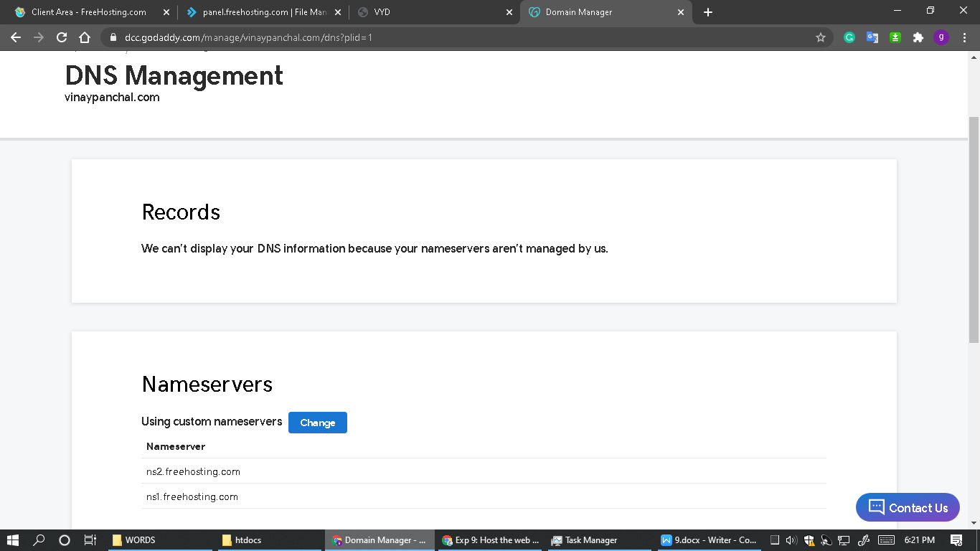

**HOSTING PANEL PART**

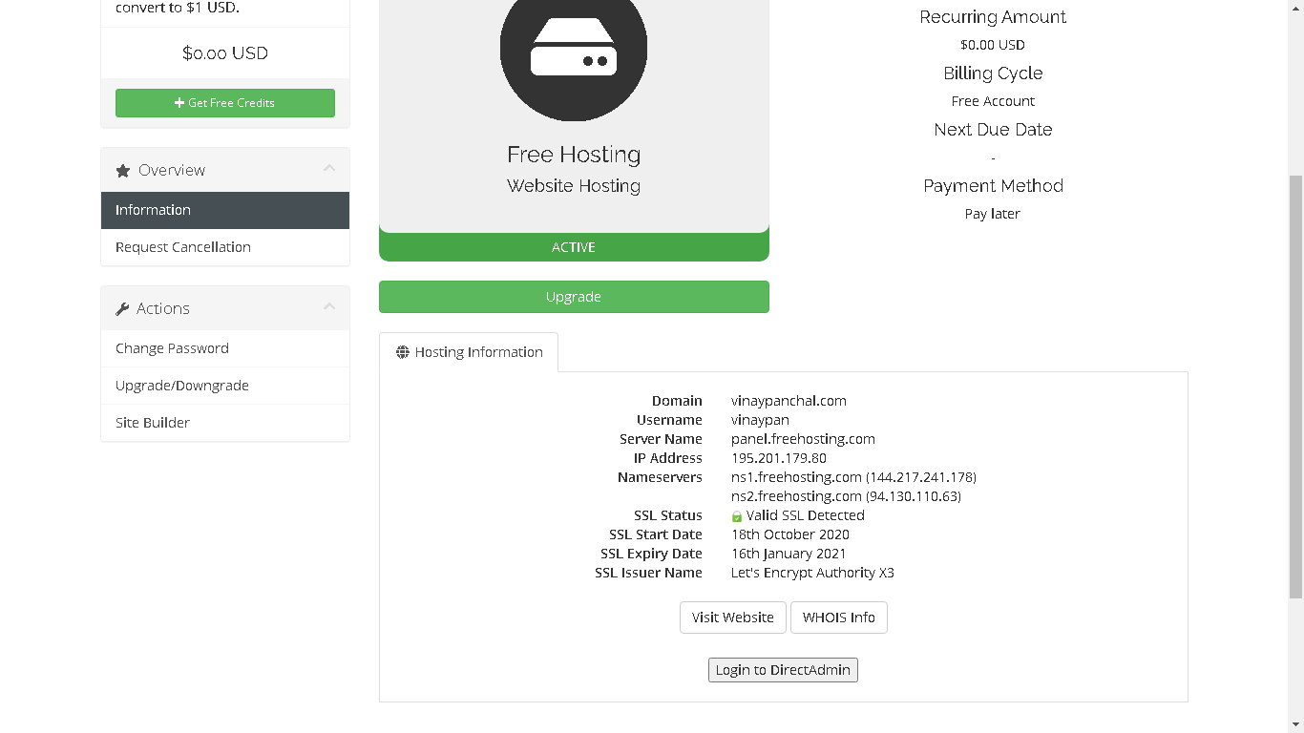

**HOSTED LARAVEL APP**

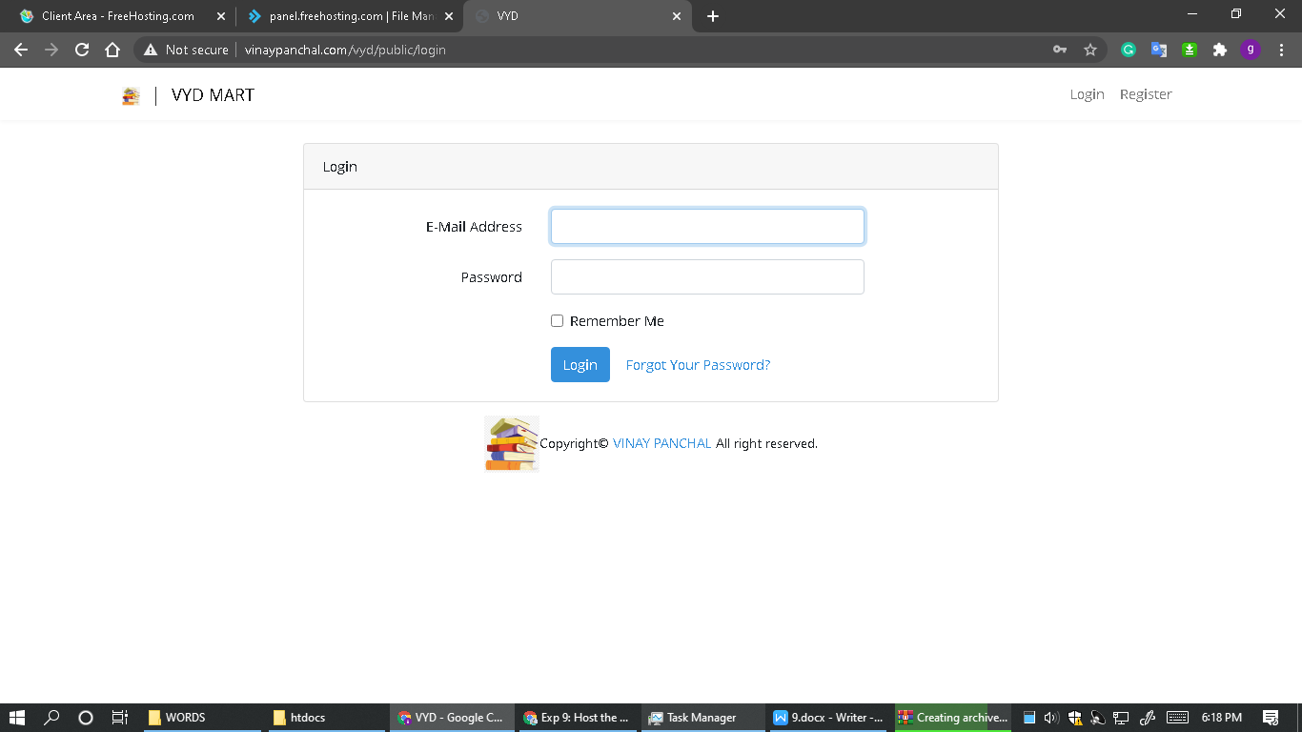

**CONCLUSION**

# Hence hosted the web application created in Exp 8 using Domain Registration Process