**RBPMS (MINI-PROJECT)**

**RESOURCE BASED PROJECT MANAGEMENT SYSTEM**

**THEORY**

The entire system of RESOURCE BASE PROJECT MANAGEMENT is designed to keep all your team’s tasks in one place ,collaborate and work in real time for real results, the most powerful and simple way to collaborate with your team.

**Problem statement:**

A combination of HRM(human resource manager) and PMS(project management system) is integrated .

Company has a manager who controls and assigns project to employees under him. Manager decides which project to be assigned , on the basis of employee's credentials like skills, experience and training. Project's nature can be acknowledged by its progress status, description and time limit.

**OVERVIEW OF PROJECT**

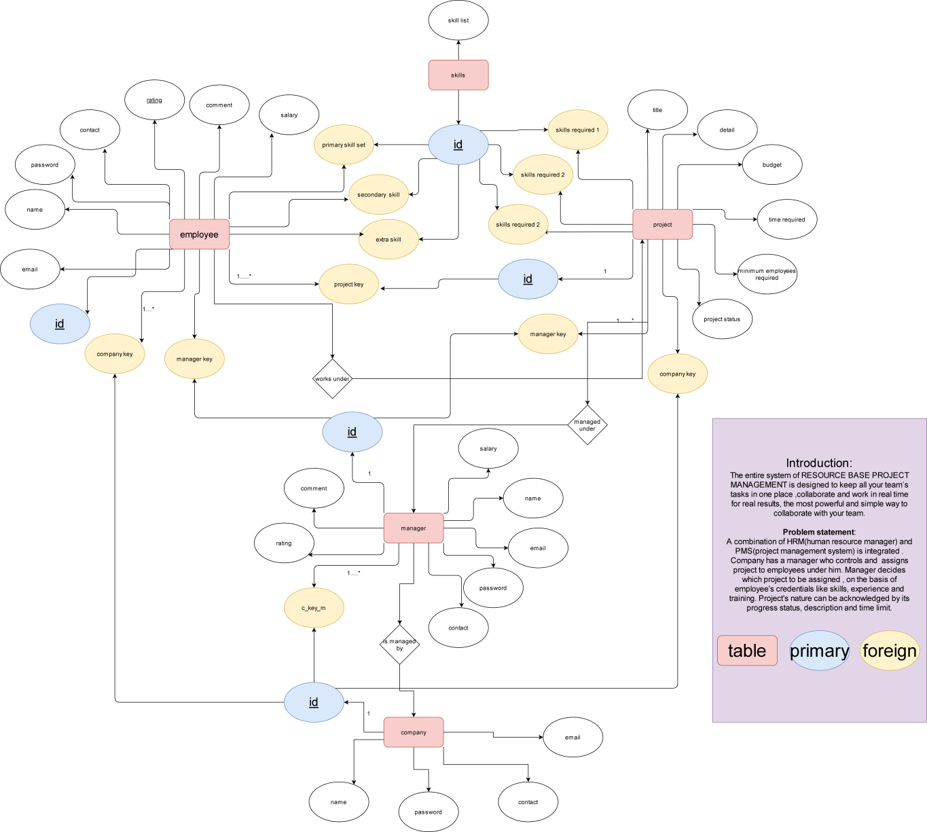

**LOGIN PAGE OF PROJECT**



**ADMIN PANEL OF PROJECT**

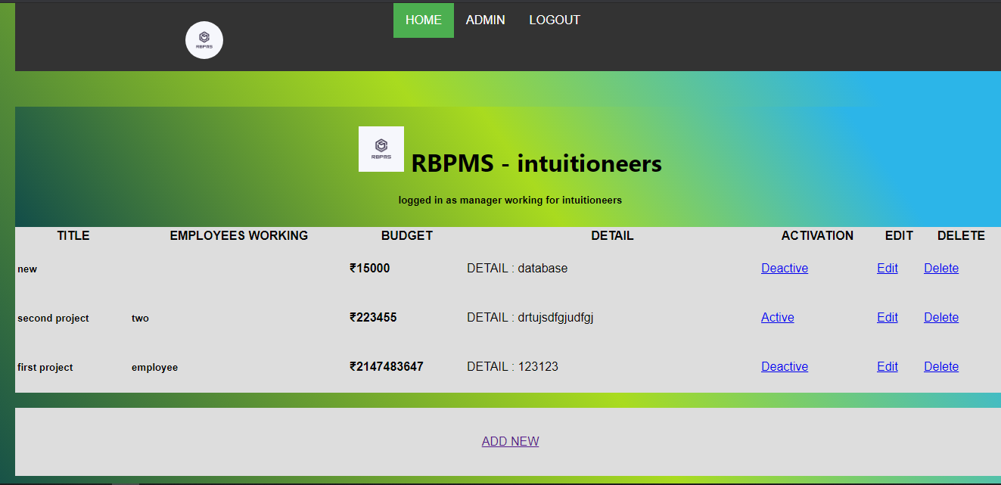

**DATABASE STRUCTURE OF PROJECT**

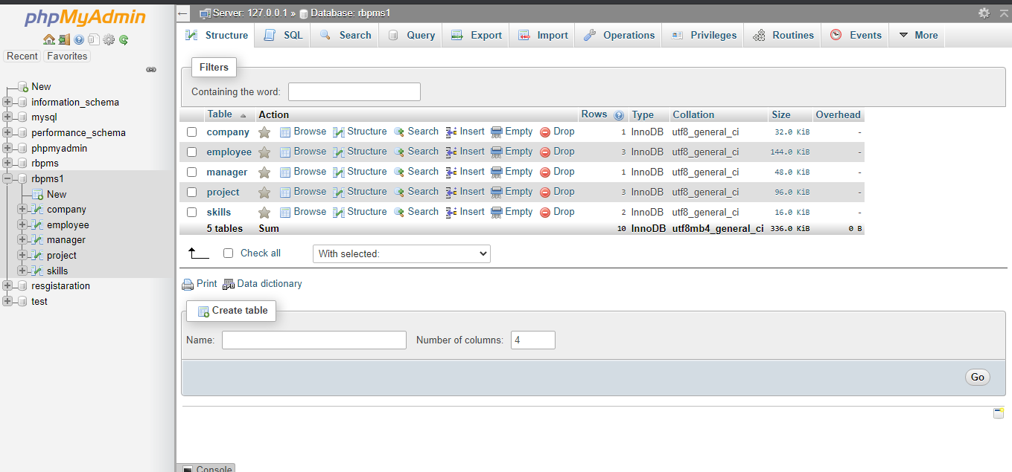

**PROJECT TABLE OF PROJECT**

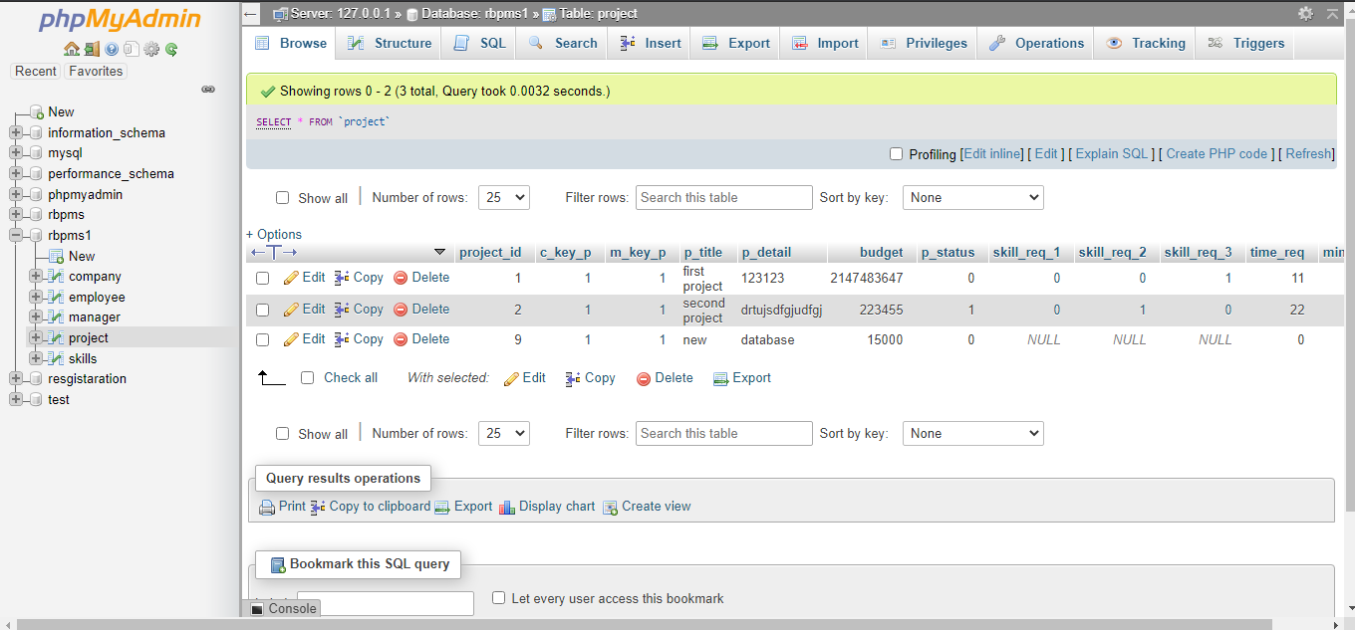

**HOSTED ENTIRE PROJECT ON**

<http://www.vinaypanchal.com/rbpms>

**SOURCE CODE OF ENTIRE PROJECT ON**

<https://github.com/vinaynpp/wdl>