Practice Test 2 Python
PRN : 060

Q.1. Write a code to accept a number & print its digits in words .

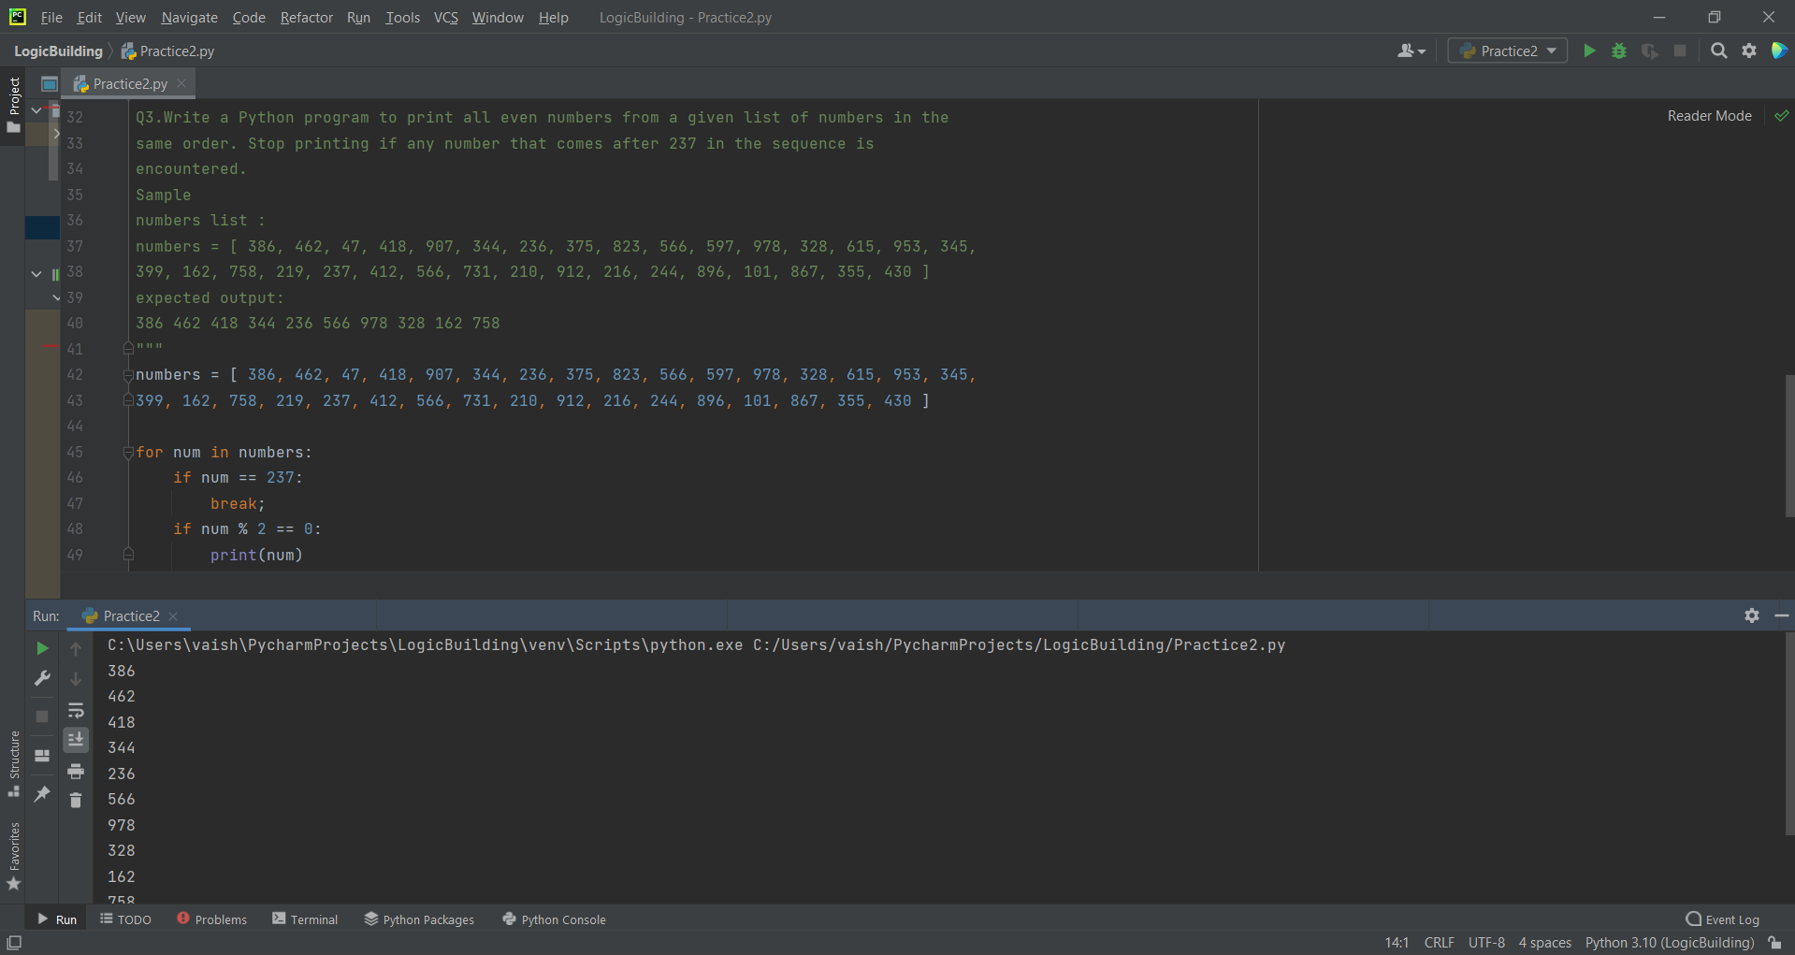

Q.2 Write a python program to get the path and name of the file that is currently executing
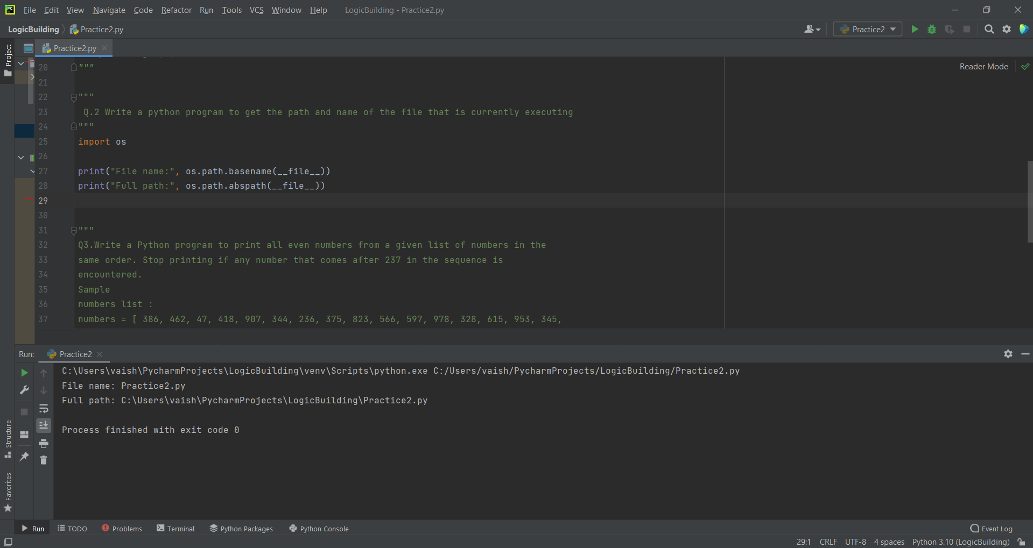

Q.3. Write a Python program to print all even numbers from a given list of numbers in the same order. Stop printing if any number that comes after 237 in the sequence is encountered.

Q.4 pattern
