Practice Test 5
PRN : 060
- Write a Python function to check whether a string is a pangram or not. Note : Pangrams are words or sentences containing every letter of the alphabet at least once. For example : "The quick brown fox jumps over the lazy dog"
Ans :
def is_pangram(s):
alphabet = set("abcdefghijklmnopqrstuvwxyz")
return alphabet.issubset(set(s.lower()))
text = "The quick brown fox jumps over the lazy dog"
print(is_pangram(text))

Output:
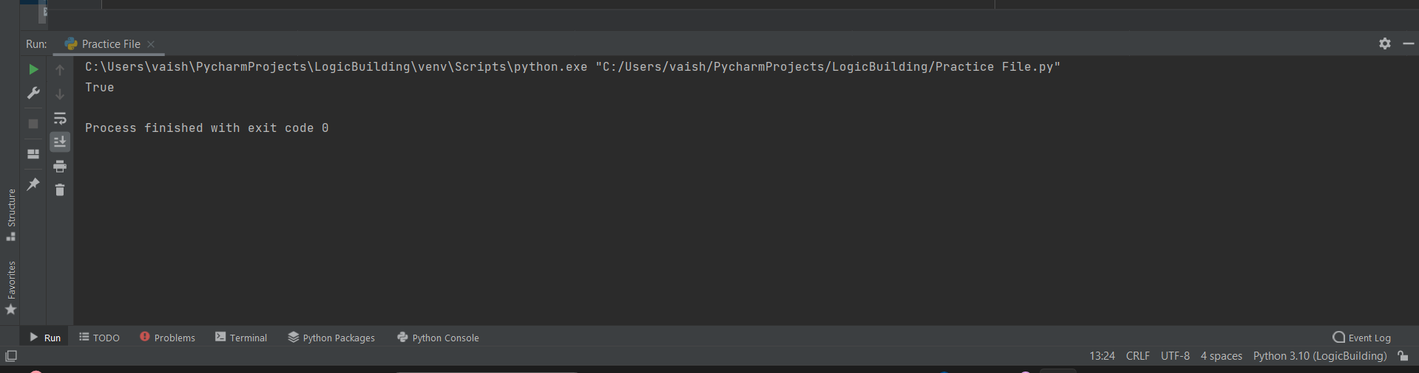

- Write a Python program to calculate the sum of the digits in an integer.

digits = (input("Enter the digits"))
print("Sum of digits =", sum(int(d) for d in digits))

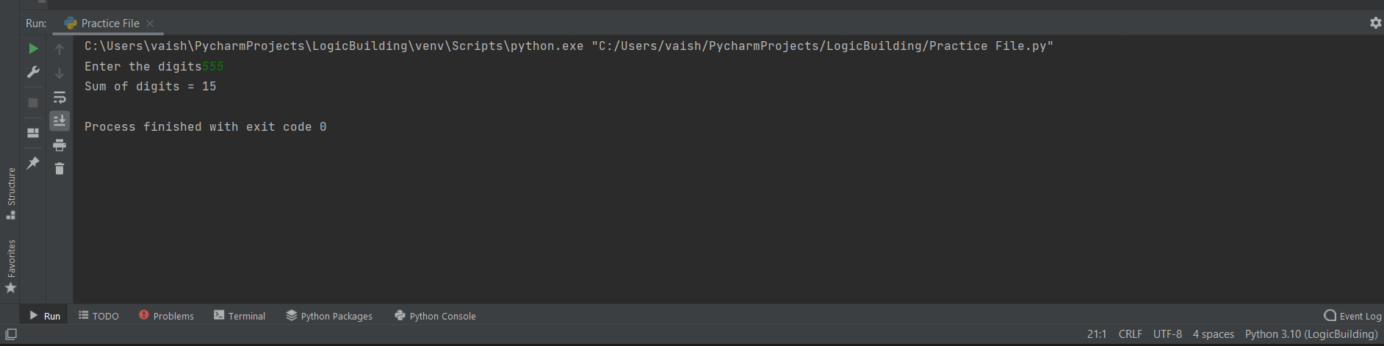

- Write a Python program to sort three integers without using conditional statements and loops. [ u can use built in functions for this ]

a,b,c = map(int,input("Enter the numbers:").split())
print(sorted([a, b, c]))

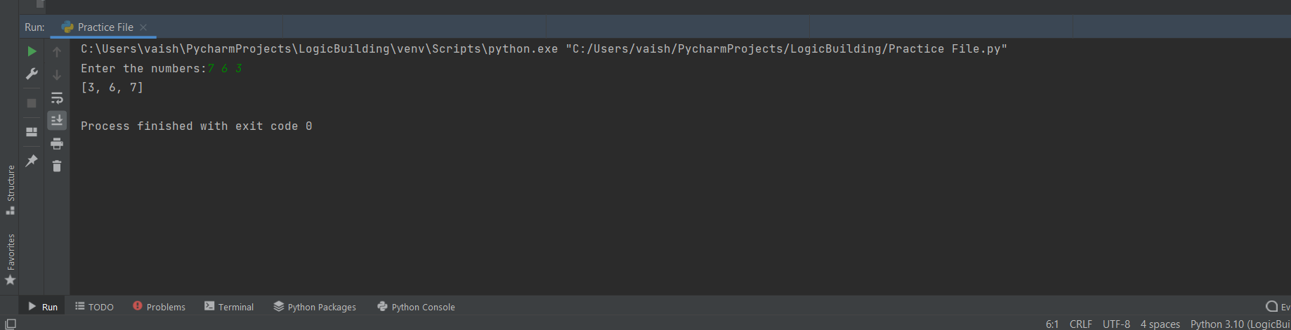

- Write a Python function to check whether a number is perfect or not.

def is_perfect(n):
return n == sum(i for i in range(1,n) if n % i == 0)
n = int(input("Enter number:"))
print(is_perfect(n))

