Practice Test 4
PRN : 060
Q.1) int arr[]={1,2,2,3,3,4,4,4,4,5,5,5,5,5} alter array in such way that the element which occur most times will print first. sample output-arr[]={5,5,5,5,5,4,4,4,4,2,2,3,3,1};.
Ans :
int arr[]={1,2,2,3,3,4,4,4,4,5,5,5,5,5}
freq = {}
for x in mylist:
freq[x] = freq.get(x, 0) + 1
alter_list = sorted(mylist, key=lambda x: (-freq[x], x))
print(alter_list)

Q.2) Write a Python program to find if a given string starts with a given character using Lambda.
string = "tython"
char = "P"
starts_with = lambda s, ch: s.startswith(ch)
print(starts_with(string, char))

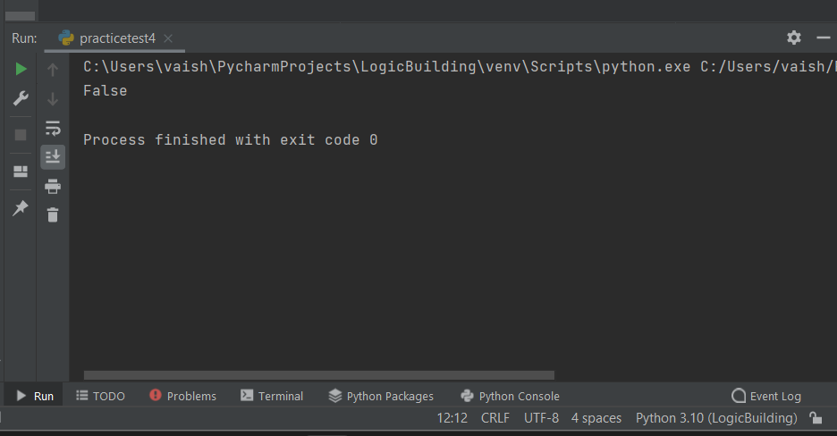

3) Write a Python program to filter a given list whether the values in the list are having length of 6 using Lambda.
words = ["python","java","sql","flask","reactjs"]
result = list(filter(lambda x: len(x) == 6, words))
print(result)

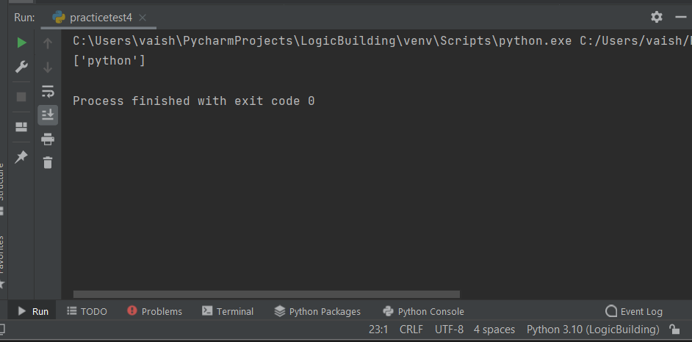

4)
n = int(input("Enter number: "))
fib = lambda n: [0, 1] \
if n == 2 \
else fib(n-1) + [fib(n-1)[-1] + fib(n-1)[-2]]
if n == 1:
print([0])
else:
print(fib(n))
