Practice Test 6 :
Name : Vaishnavi Shinde
PRN : 060
- Write a Python program to count the even, odd numbers in a given array of integers using
Lambda.
Ans:
arr = [1, 2, 3, 4, 5, 6, 7, 8, 9]
ecount = len(list(filter(lambda x: x%2==0,arr)))
ocount = len(list(filter(lambda x : x%2 !=0,arr)))
print("even count is :",ecount)
print("odd count is :",ocount)

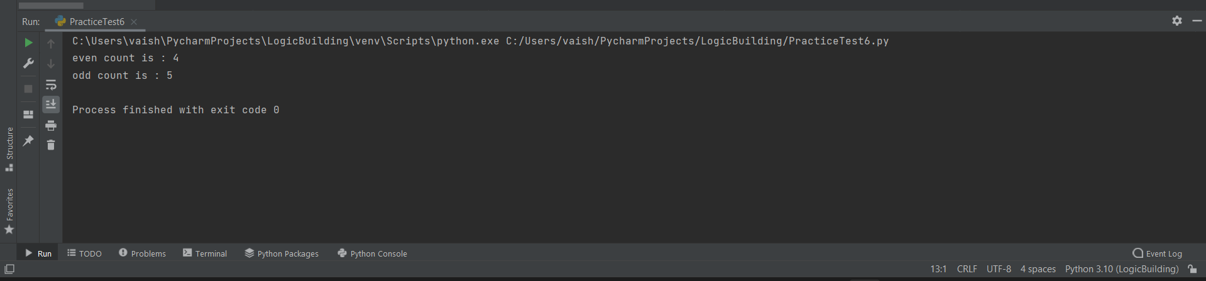

- Write a Python program to find palindromes in a given list of strings using Lambda.
Ans:
words = ["madam", "hello", "level", "world", "radar"]
palindromes = list(filter(lambda x: x == x[::-1], words))
print("Palindromes:", palindromes)

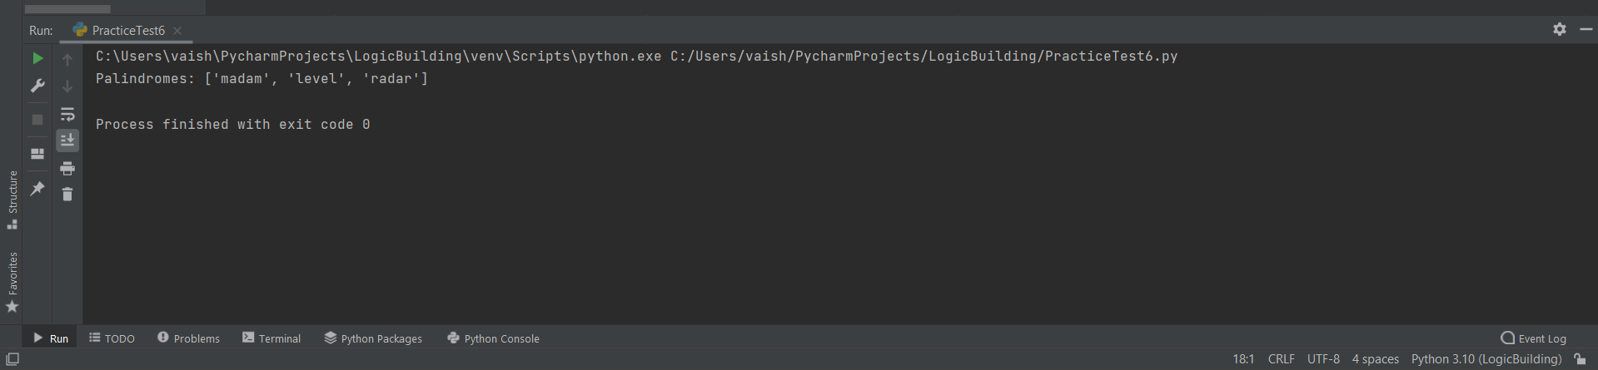

- Solve the following pattern using one loop only: accept no. of rows from user.
n = int(input("Enter the number:"))

for i in range(1, n + 1):
print("".join(str(j) for j in range(1, i + 1)) +
"".join(str(j) for j in range(i - 1, 0, -1)))
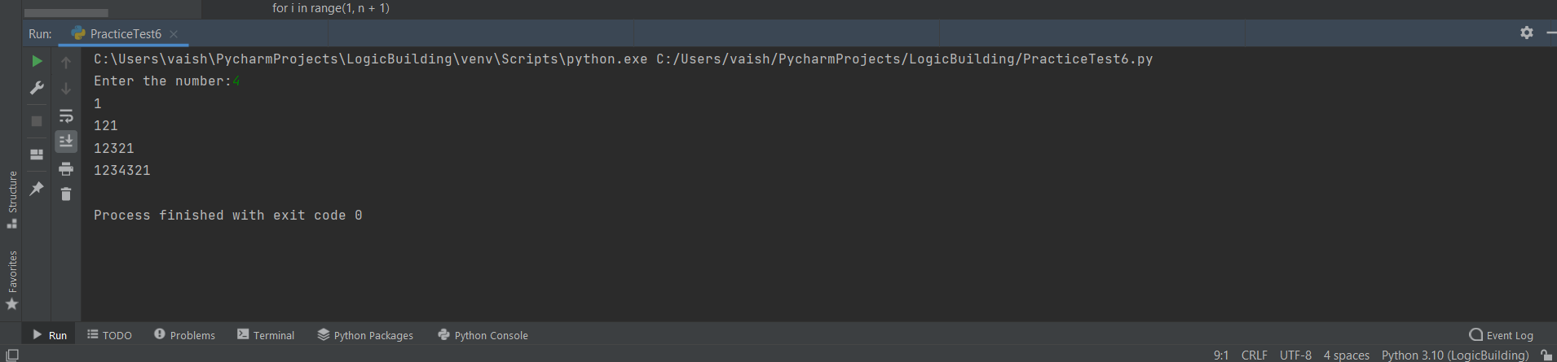

- Write a Python program to convert a byte string to a list of integers. Sample Input: “hello” Sample Output: [104, 101, 108, 108, 111]

s = "hello"
str_byte = list(map(ord, s))
print(str_byte)

