Practice Test 3
PRN : 060

- Write a code to Read a file and append lines to a list.

new_list = []
with open("KPI 2.txt","r") as file:
for line in file:
new_list.append(line.strip())
print(new_list)

OUTPUT:
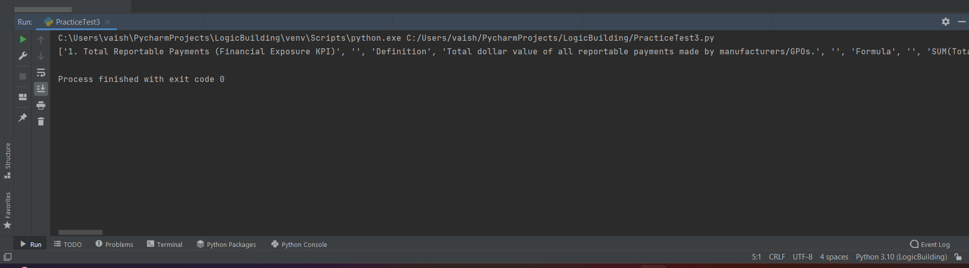

- Write a code to catch an Exception in python?

try:
a = int(input("Enter the a :"))
b = 10 / a
except ZeroDivisionError:
print("Cannot divide by zero")
else:
print("Result:", b)
finally:
print("Execution completed")

OUTPUT:
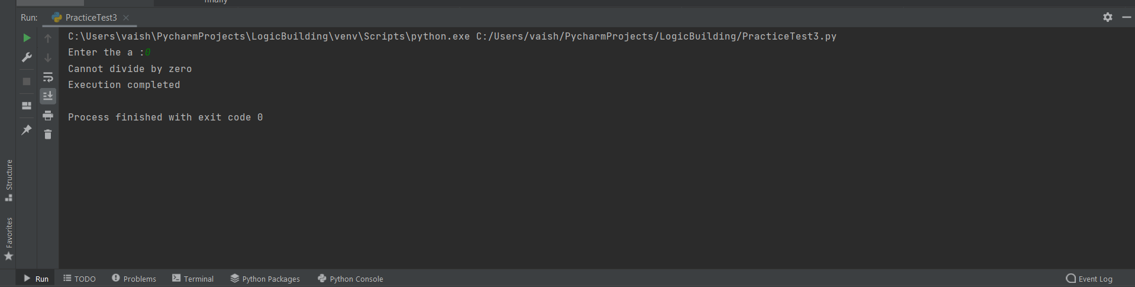

- Write a Python function that accepts a list containing strings and integers. Merge all string elements using # and add all integer elements.
e.g.
input list is
['100', 'welcome', 'hi', '200', '300', 'bye', 'welldone', '500']
Output should be:
welcome#hi#bye#welldone#
1100

def Merge(lst):
string = ""
int_sum = 0
for item in lst:
if item.isdigit():
int_sum += int(item)
else:
string += item + '#'
print(string_part)
print(int_sum)
Merge(lst)

- Write a script to sort a dictionary based on its values and find the sum of middle two values input_dict = {"x": 5, "y": 15, "z": 25}
Output: Sorted Dictionary: {'x': 5, 'y': 15, 'z': 25}
Sum of middle two values: 15 + 5 = 20 or input_dict = {"x": 5, "y": 15, "z": 25,"p":12} Output: Sorted Dictionary: {'x': 5, 'p': 12,'y': 15, 'z': 25} Sum of middle two values: 12 + 15 = 27

Ans :

def sortsum_dict(d):
if len(d) == 0:
print("Dictionary is empty. Cannot calculate sum.")
return
values = sorted(d.values())
print("Sorted values:", values)
n = len(values)
if n == 1:
print("Sum =", values[0] * 2)
elif n % 2 == 0:
print("Sum middle values =", values[n//2 - 1] + values[n//2])
else:
print("Sum =", values[n//2] * 2)
sortsum_dict({"x": 5, "y": 15, "z": 25} )
sortsum_dict({"x": 5, "y": 15, "z": 25,"p":12})

