Robin Shindelman CS
CS 432 – Applied Machine Learning | shindelr@oregonstate.edu
Machine Learning Based weather prediction

Table of Contents
Introduction 2
Why weather? 2
Gathering Data 3
Direct Data Download 3
Urban Air Quality Data 3
Curated Rain Occurrence Data 3
Data Cleaning 4
Urban AQI Data 4
Before Cleaning 4
After Cleaning 6
Rain Occurrence 7
Before Cleaning 7
After Cleaning 9
Clustering & PCA 10
K-Means without PCA 10
Clean & Prepared Data 10
K = 1 10
K = 2 11
K = 3 11
Discussion 12
K-Means with PCA 12
Clean & Prepared Data 12
3D PCA Reduction & Clustering 13
Discussion 13
Agglomerative Hierarchical Clustering 14
Discussion 14
Linear Regression Analysis 15
Preparation & Plan 15
Results 15
Section Conclusion 16
Logistic Regression Analysis 16
Preparation & Plan 16
Results 17
Section Conclusion 18
Decision Trees 19
Preparation & Plan 19
Results 19
Section Conclusion 21
Preparation & Plan 21
Results 22
Section Conclusion 23
Conclusions 23
Clustering 23
Linear & Logistic Regression 24
Decision Trees & Naïve Bayes 24
References 25

Introduction

Why weather?
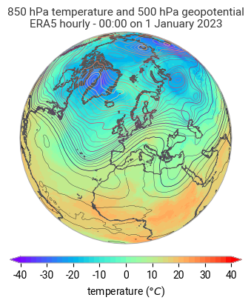
The weather, on any given day, is important for almost every industry and activity a person can think of. From simple recreational activities like skiing all the way to the hyper complex organization of global shipping lanes, weather plays an integral role. Weather can reach us even in places where it physically cannot travel. Wind speed and solar predictions affect prices on the stock market based on renewable energy prediction. Even infrastructure as wide and ubiquitous as a state’s electricity grid can be brought to a grinding halt by the power of heat domes or hurricanes.

Precisely because of the wide reaching impacts of weather, large quantities of accessible data from many sources exist for use in modeling and research. This huge amount of information makes the topic ideal for an aspiring data scientist. Many large models from around the globe are in production, with many more under development. These studies can be used as inspiration and guides for those of us beginning to dip our toes in the field.

The impetus for this project comes from multiple places. As a lifelong surfer, skier, and general outdoor enthusiast, the weather has always played an important role in my
1. Beautiful chart depicting temperature, geopotential, and isobars over the Arctic, Europe, and North Africa.
favorite activities. I’ve been poring over marine forecasts to predict swell at my favorite beaches since I was 12. Sometime later, when I found myself exploring alpinism and backcountry skiing, I added avalanche reports and mountain weather to the list of charts that needed understanding. Now, after nearly two decades of this self-forecasting, I’ve found myself a part of an OSU CEOAS lab where the understanding of how swell might propagate to our field site in the Caribbean is of great importance for data collection.

The true prediction of weather is beyond the scope of this course and probably an undergraduate degree in general. However, this seems to be a perfect opportunity to explore atmospheric data in a structured way. A primary goal for this project is to gain some understanding of how processes in the atmosphere are measured, as well as how non-weather specific events can be related to the weather in a way that is apparent through the data. The latter of these goals is most obviously illustrated my work with the urban air quality dataset at the end of this report.

Gathering Data

Direct Data Download
Urban Air Quality Data
https://www.kaggle.com/datasets/abdullah0a/urban-air-quality-and-health-impact-dataset

This dataset focused on urban air quality provides real measurements of 10 different cities’ AQI for the month of September in 2024. Columns span the gamut from meteorological data such as windspeed, precipitation, and temperature; to human dimensions such as the day of the week, health risk score, and whether it’s the weekend or not.

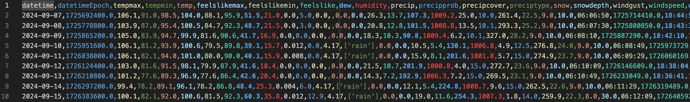

Curated Rain Occurrence Data
https://www.kaggle.com/datasets/zeeshier/weather-forecast-dataset

This dataset is focused on predicting whether or not rain occurred on a given day, based on a variety of factors such as cloud cover, pressure, or humidity. The majority of the data is quantitative with just a single qualitative column of “rain” or “no rain” which is to be used as labels for ML.
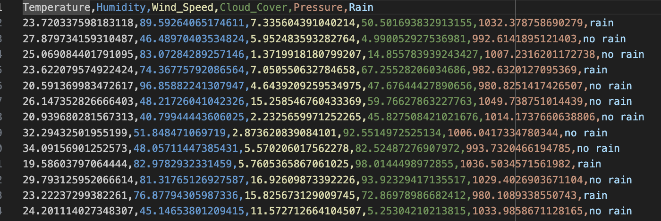

Data Cleaning

Urban AQI Data

Before Cleaning

Example Data
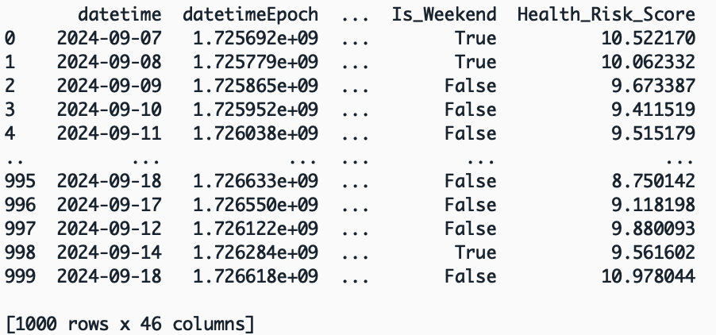

Visualizing Variables
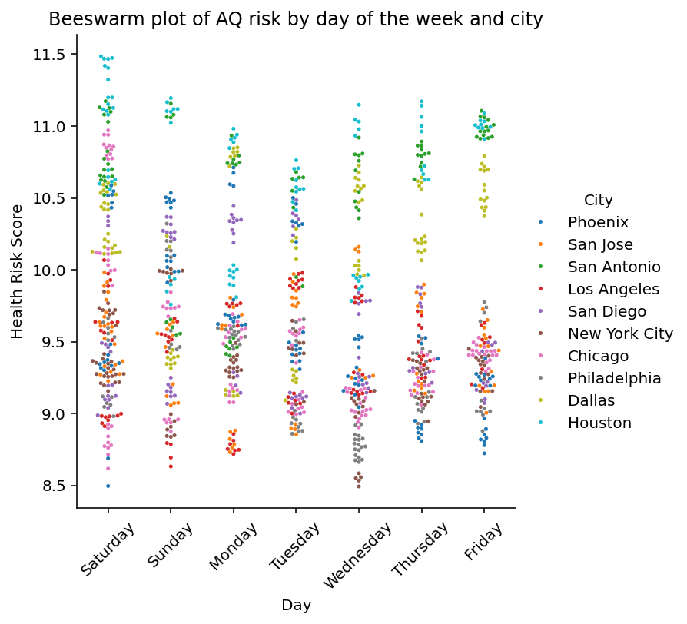
Initial EDA indicates an interesting trend between air pollution and the day of the week. Across the board, the health risk score seems to be lower for most cities on the weekdays. Air quality decreases most on Saturdays in general. This plot does not reveal any outliers or erroneous data points, but it’s quite informative for the structure of the data.

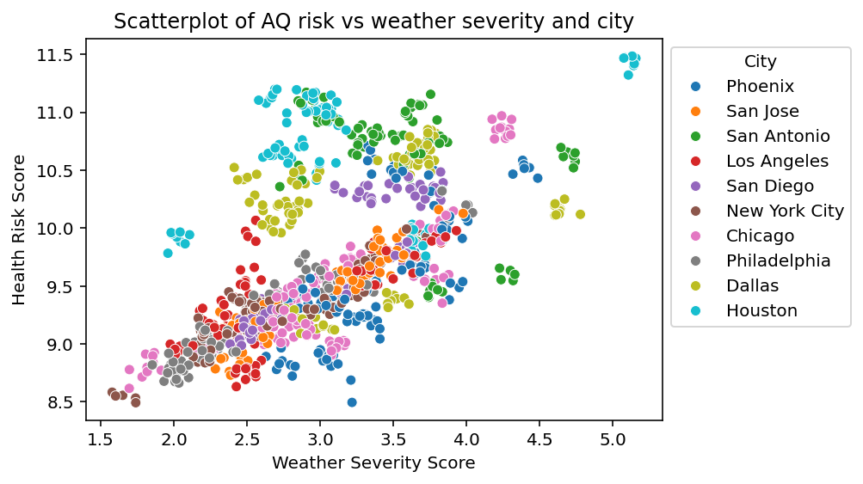

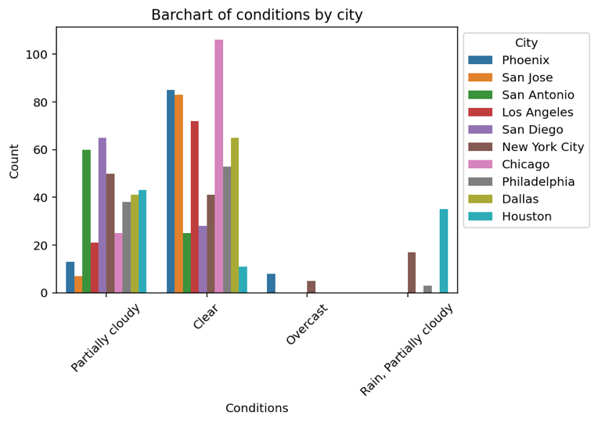
Further exploration of air quality, while taking the city in question into account, revealed an interesting linear trend in conjunction with the severity of the day’s weather. The scatter plot shows two fairly strong clumps of data. Nearly all the cities in the upper section are located Texas! Only Houston exhibits data approaching an outlier level of significance. More investigation is needed to be sure.
A bar chart of general sky conditions and the cities they occur in most often is shown to the left. Much this plot is fairly sparse, with most cities only reporting either Partially Cloudy or Clear. This could indicate that the data is not very representative of the cities in question. If all these locations always have this nice of weather in September, how can the analysis derive insight on the impact of poor weather on the AQI?

After Cleaning
The Urban AQI dataset was downloaded as a .csv. Initial EDA seemed to indicate that the dataset is quite clean already, as is often the case when data is gathered from Kaggle. After some simple cleaning operations, the final, ready-for-analysis data will be stored as a new .csv.

A majority of the data types for this dataset were read in correctly by Pandas. The “datetime” variable was changed to a datetime type. “City”, “conditions”, and “Day_of_Week” were all converted to categories. Lastly, “Month” was converted to an integer.
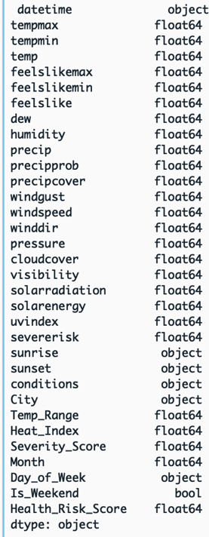
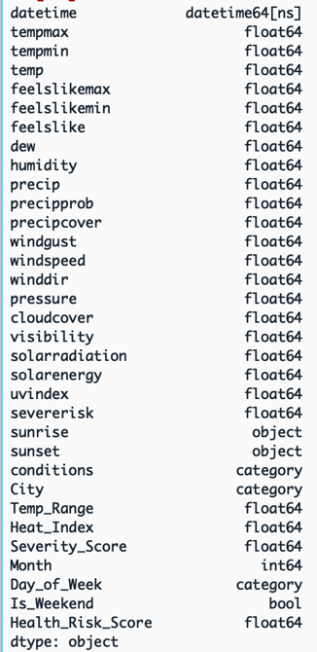

Once the columns, 'datetimeEpoch', 'sunriseEpoch', 'sunsetEpoch', 'moonphase', 'description', 'icon', 'stations', 'source', 'Condition_Code', 'preciptype', 'snow', 'snowdepth', 'Season' were dropped, not a single null value remained in the dataset. These columns were dropped because they either contained all 0’s, as in the case of the “snowdepth” variable, or because they seemed unnecessary for analysis.

Working with all 25 quantitative columns to discover outliers was a challenge. In the end, the 1st and 3rd quartiles, and the interquartile range for each column was calculated. From there, a Boolean mask using the quartile outlier formula was used to uncover columns with at least one record that contained a possible outlier.
$$low outliers= Q1-1.5*IQR \\ high outliers=Q3+1.5*IQR$$

Using a loop, each of the suspicious variables was inspected with a boxplot. From this exploration, only two variables had outliers of any significance: “dew” and “windspeed”. Both records were cleaned using a Boolean mask.

Rain Occurrence

Before Cleaning

Example Data
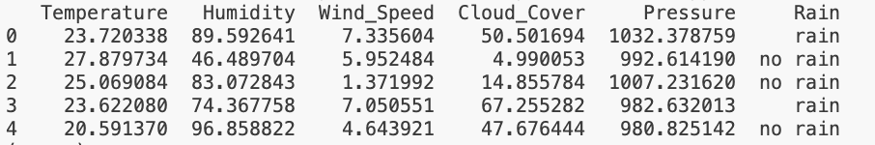

Visualizing Data
The Rain Occurrence dataset is quite curated, especially since it was sourced from Kaggle with the intention of being used as a toy dataset for machine learning applications. Because of this, the dataset is extremely clean right off the bat. For example, below are shown the distributions of the Temperature, Humidity, Wind_Speed, and Cloud_Cover variables. As the reader can no doubt tell, the distributions of each these variables are incredibly uniform and balanced.

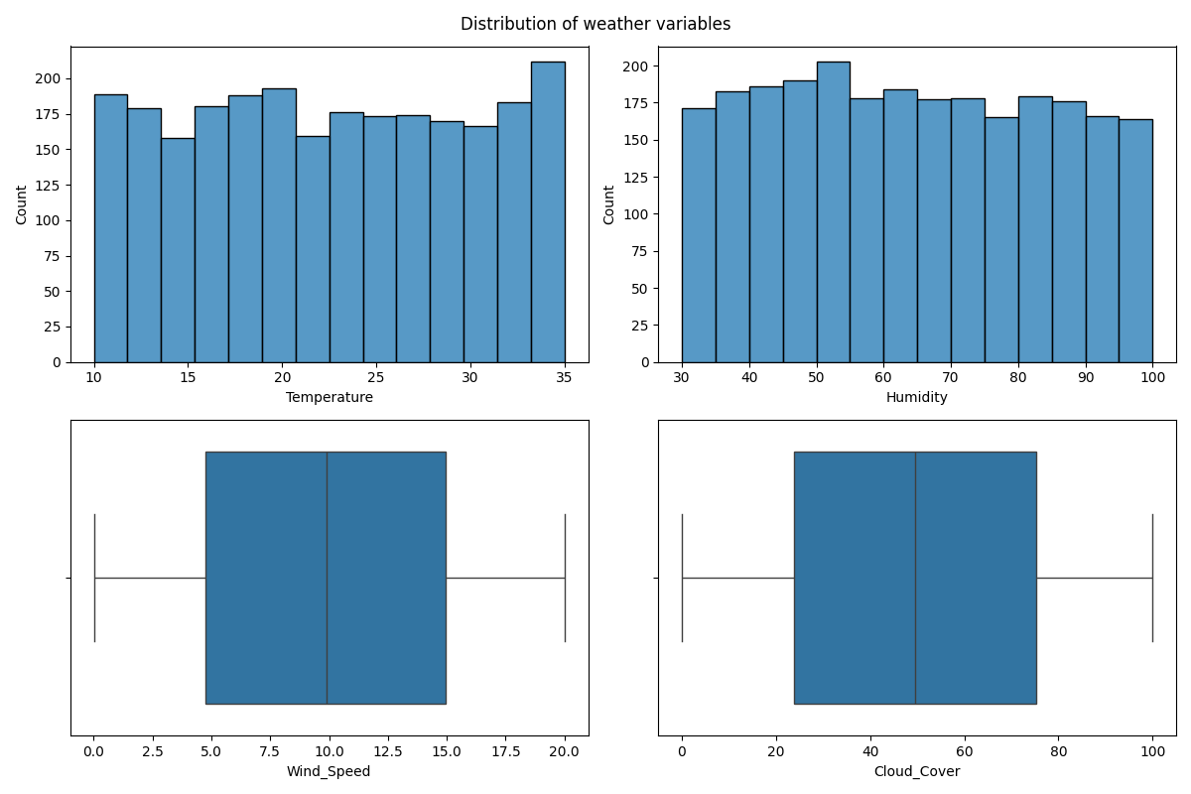

A mixture of histograms and boxplots was used to explore different visualizations in the hope that any obvious outliers would be discovered.

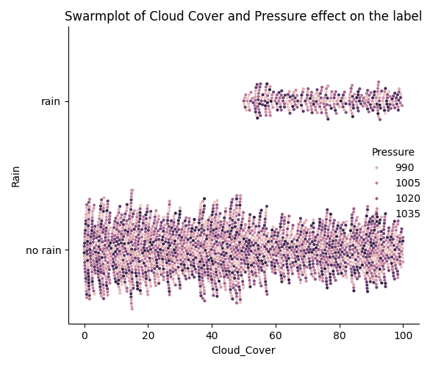
Further exploration uncovered very little in the way of outliers or completely erroneous data points. To the right, a beeswarm plot exploring the relationship between the Rain label and the variable Cloud_Cover can be seen. Examining this plot reveals an obvious correlation between the presence of dense cloud cover and rainfall. This constitutes a wonderful sanity check for the validity of this dataset. If instead the reverse correlation was seen, there may be cause to doubt the accuracy of the data collected.

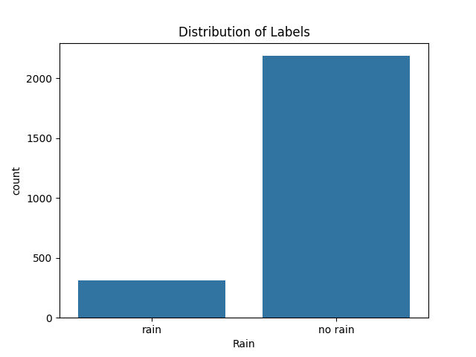
Interestingly, this plot uncovered a distinct imbalance in the dataset’s distribution of the label itself. A simple count plot to the right visualizes this imbalance nicely. Labels indicating a day when it rained comprise only 12.56% of the rows present in the dataset. Using SkLearn’s resample utility method, the minority rain label was upsampled, resulting in a 50-50 split. This technique should hopefully limit model bias in later cases.
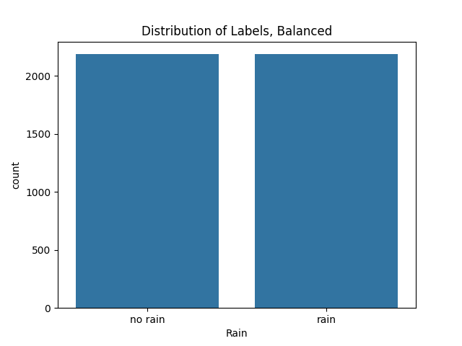

After Cleaning

Once the dataset was fully cleaned and balanced, there were approximately 4700 rows present. Each variable was either a Float64 representing quantitative data, or the variable was the label column. All data fell into a roughly uniform distribution without statistically significant outliers. The smallest values of data approached 1, while the largest were upwards of 1000. This spread may require some normalization to smooth the use of distance based models such as K-Means or KNN. The final, clean dataset was output to a fresh .csv file.

Clustering & PCA

K-Means without PCA

Clean & Prepared Data
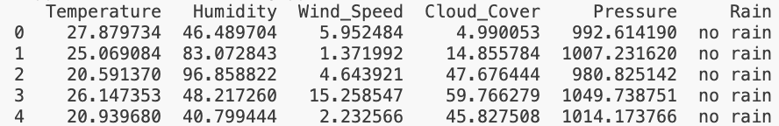

K = 1
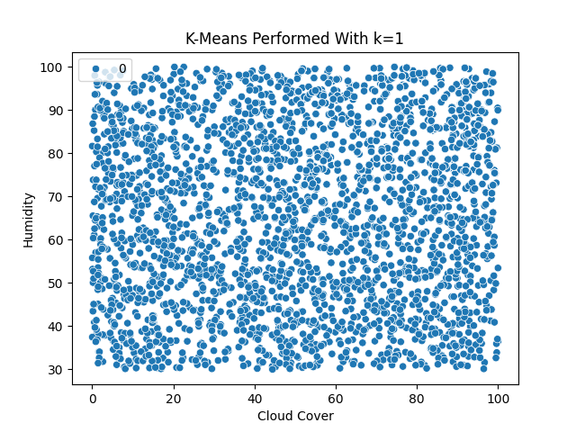

K = 2
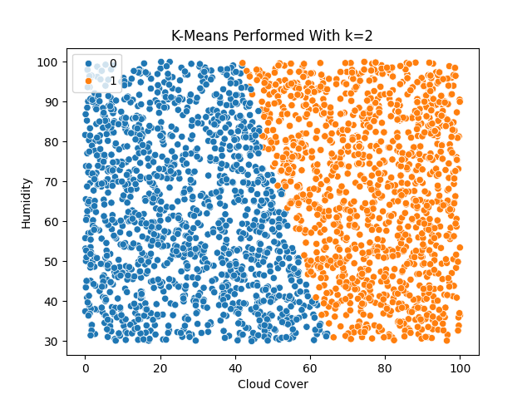

K = 3
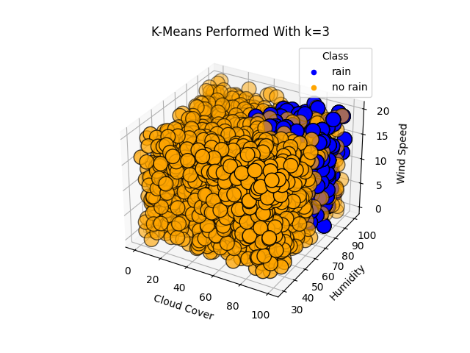

Discussion
In this section, unsupervised learning with k-means clustering was performed. As can easily be seen by the plots above, this dataset has an extremely uniform distribution of information. This problem certainly impacts the ability of the model to separate clusters out into distinct and fully disjoint groups. However, as the dimensionality of the visualization increases, the viewer may notice that two clusters begin to appear.

When $k=1$, the uniformity of the data presents with a single huge cluster spreading to each corner of the plot. As $k$ increases to 2 clusters, a perfect diagonal split appears across the plot of Humidity vs. Cloud Cover. It’s worth noting that this form the plot is taking on is not ideal for visualizing clusters, as it only covers 2 of the 5 dimensions in the plot. Finally, with $k=3$ and a 3D scatter plot of Humidity, Cloud Cover, and Wind Speed, a distinct cluster begins to appear in the top right corner closest to the viewer. It should be noted that in this case, k being equal to 3 has nothing to do with the quality of visualization as there are only two classes present in the original dataset.

K-Means with PCA

Clean & Prepared Data
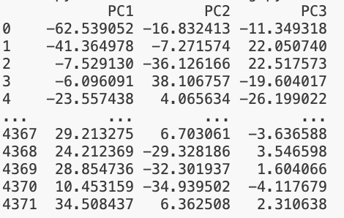

3D PCA Reduction & Clustering
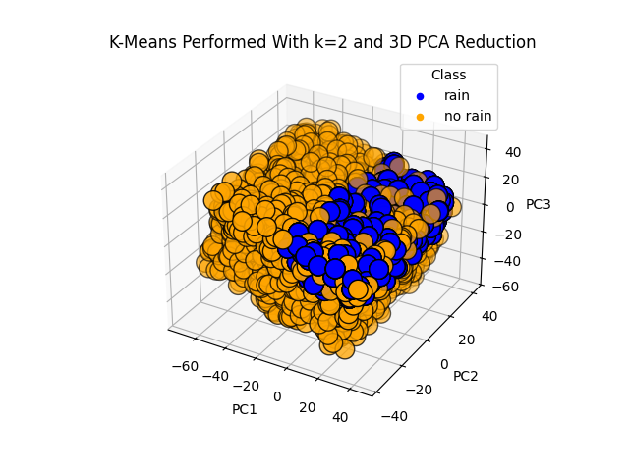

Discussion
Rather unexpectedly, Principle Component Analysis did not have the effect of breaking up the uniformity present in the data. Instead, PCA appeared to have preserved the structure and relationship of each data point to all the others, resulting in the same perfect cube as can be seen in the pure K-Means section above. Interestingly, the use of PCA tilted the cube along the axes corresponding to what must be the direction of each discovered component. All in all, this plot is quite useful. The viewer can easily discern the importance of a high PC1 and PC3 to find whether or not it rained.

Agglomerative Hierarchical Clustering
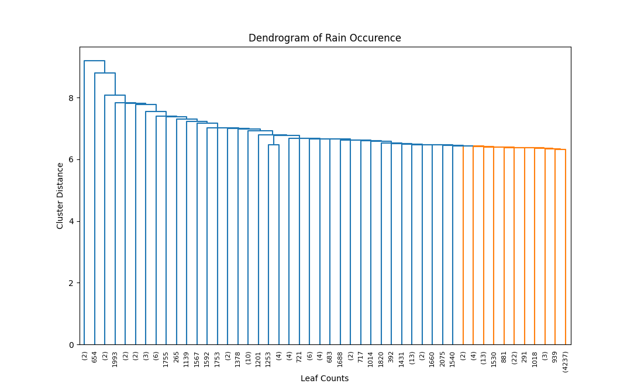

Discussion
The above plot depicts a dendrogram showing the results of a different clustering technique called Hierarchical Agglomerative Clustering (HAC). Without specifying how many groups should exist within the data, the HAC model discovered the same two groups as before. Unfortunately, the colors of each cluster are reversed in this diagram, so orange corresponds to ‘rain’ and blue corresponds to ‘no rain’. As the viewer can see, the ‘rain’ cluster still comprises a tight cluster that is highly mixed with the ‘no rain’ cluster. An interesting thing to note is the one cluster near the middle of the dendrogram with nearly 1300 leaves in it that joins the rest of the ‘no rain’ cluster late.

As for the differences between k-means and HAC, in this case, very little felt different. Both models discovered two distinct groups in the data, which makes sense since there were two labels in the original dataset, matching it perfectly. Something that was very interesting in both models was the tight grouping of the ‘rain’ cluster. Part of the process for cleaning and formatting this dataset included up-sampling the ‘rain’ label, as it had comprised less than 15% of the original data. In the clean dataset, both labels are represented nearly equally. However, clustering of the dataset shows a very distinct range wherein the ‘rain’ labels should reside, despite the uniform distribution of the data.

Linear Regression Analysis

Preparation & Plan
To work with purely Linear Regression, the Urban AQI Data was used. As mentioned in the gathering and cleaning sections above, this dataset contains a large number of columns labeled by a “Health Risk Score”. This score is a continuous value representing the risk of health damage from the air quality of the given city.

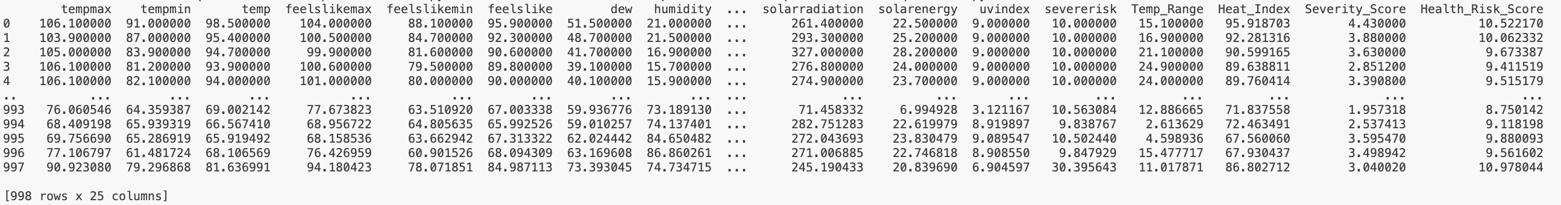

There were a variety of non-quantitative columns in the clean dataset kept in the cleaning Urban AQI Data section. In this case, to model the data with Linear Regression, only quantitative columns were kept. On the far right of the data show above, the reader may notice the two columns “Severity Score” and “Health Risk Score”. Though these two sound similar, “Severity Score” actually refers to the quality of weather. A higher “Severity Score” may coincide with a heat wave or strong storms such as hurricanes.

Using this dataset to predict the health risk posed to city residents by the air quality is of direct interest to this report. As was discussed in the Introduction, the weather affects the lives of people in many ways, some very obvious and some more obscure. In this case, the weather has a clear connection with air quality in urban areas.

Results
To model the data using Linear Regression, an 80/20 train-test-split was used.

Equation:
$$\hat{y}= 0.6257-0.0083x_{1}​+0.0001x_{2}​-0.0105x_{3}+0.0115x_{4}​-0.0036x_{5}​+0.0045x_{6}​+0.0084x_{7​}+0.0232x_{8}​+0.0785x_{9}​+0.0003x_{10}​+0.0014x_{11}​+0.0264x_{12}​+0.0016x_{13}​+0.0003x_{14}​-0.0014x_{15}​+0.0010x_{16}​+0.0082x_{17}​-0.0002x_{18}​-0.0022x_{19}​+0.0773x_{20}​+0.0016x_{21}​+0.0035x_{22}​+0.0880x_{23}​+0.3018x_{24}$$

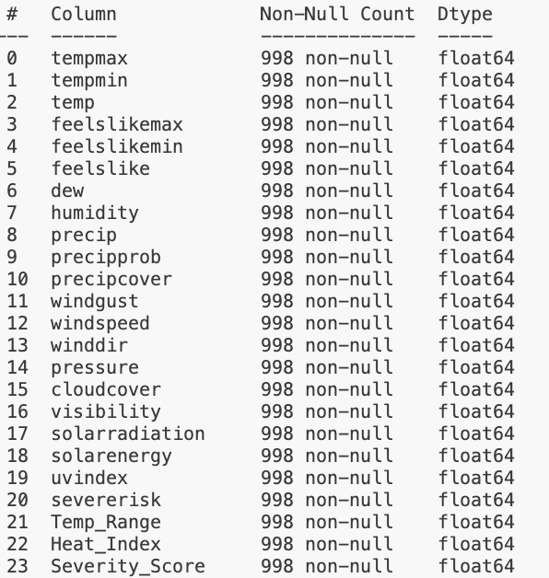
Where each of the 24 coefficients above map, in-order, to the variables shown on the left.

To predict on the first row of the test dataset:
$$<97.200, 75.600, 86.400, 97.800, 75.600, 86.600, 62.500, 48.000,$$
$$0.004, 12.900, 4.170, 12.500, 6.700, 107.300, 1011.600, 6.000,$$
$$15.000, 261.800, 22.700, 8.000, 10.000, 21.600, 87.908, 2.850>$$

$$\hat{y} =0.626 + \left(–0.008\right)\left(97.200\right)+ \left(0.000\right)\left(75.600\right)+ \left(–0.010\right)\left(86.400\right)+ \left(0.012\right)\left(97.800\right)+ \left(–0.004\right)\left(75.600\right)+ \left(0.005\right)\left(86.600\right)+ \left(0.008\right)\left(62.500\right)+ \left(0.023\right)\left(48.000\right)+ \left(0.078\right)\left(0.004\right)+ \left(0.000\right)\left(12.900\right)+ \left(0.001\right)\left(4.170\right)+ \left(0.026\right)\left(12.500\right)+ \left(0.002\right)\left(6.700\right)+ \left(0.000\right)\left(107.300\right)+ \left(–0.001\right)\left(1011.600\right)+ \left(0.001\right)\left(6.000\right)+ \left(0.008\right)\left(15.000\right)+ \left(–0.000\right)\left(261.800\right)+ \left(–0.002\right)\left(22.700\right)+ \left(0.077\right)\left(8.000\right)+ \left(0.002\right)\left(10.000\right)+ \left(0.003\right)\left(21.600\right)+ \left(0.088\right)\left(87.908\right) + \left(0.302\right)\left(2.850\right)$$

$$\hat{y}=10.602$$

The predicted “Health Risk Score” of 10.602 is remarkably close to the true label of 10.907! Overall, the model’s accuracy score was 96.80%. This means that out of 100 predictions, users of this model could expect predictions for AQI impact on public health to be accurate roughly 97 times.

Section Conclusion
While the quality of results attained in this section have been exciting, it’s worth noting a few caveats before running up to your project manager to deploy the model. Most importantly, this data was only collected for the month of September in 2024, and in 10 specific cities around the U.S.. Refer to Visualizing Variables on the Urban AQI dataset for a list of the cities involved in this analysis. There is much danger to be encountered in Linear Regression when extrapolating analysis results to predictions that are not within the problem space the model was trained on. However, if one is interested in providing fairly accurate Health Risk Score predictions for a fairly specific list of cities and only in the month of September, this model might do a pretty good job!

Logistic Regression Analysis

Preparation & Plan
The Rain Occurrence dataset was chosen as the subject of analysis for logistic regression. As mentioned in the Rain Occurrence data cleaning and preparation section, this dataset consists entirely of quantitative data. Each row is also labeled with a binary classification of either “rain” or “no rain”, making it ideal for the use of logistic regression. The cleaned, balanced, and normalized dataset is shown below, coming in at 4372 rows:

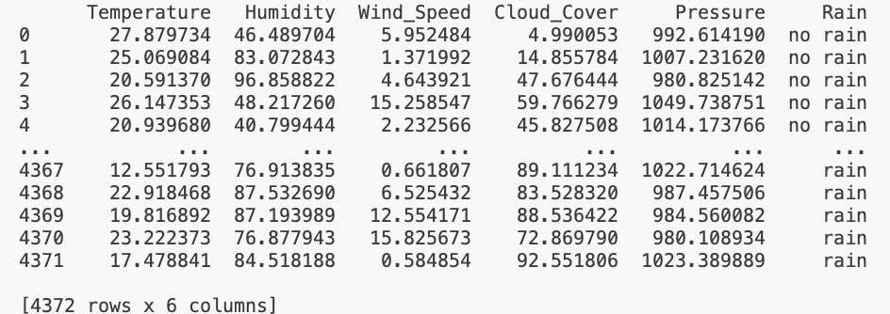

Using this dataset, the plan is to predict whether or not it was raining at the location and instantaneous time that this data was sampled. Using logistic regression to model this data is a strong choice since each row should be classified into a binary “rain” or “no rain”. Practicing building useful and accurate models with a smaller dataset such as this one will allow for the discovery of appropriate methods for modelling larger datasets like the ERA5.

Results
Implementing the Logistic Regression model on this dataset was not terribly difficult. With the labels removed and an 80/20 train-test-split, the data was fit to the model.

General Linear Equation:
$$\hat{y}= -10.730-0.274x_{1}+0.153x_{2}-0.007x_{3}+0.091x_{4}-0.001x_{5}$$

Where x₁ is Temperature, x₂ is Humidity, x₃ is Wind Speed, x₄ is Cloud Cover, and x₅ is Pressure.

To make a new prediction on this dataset, each value in a given data vector can be substituted into its appropriate spot on the linear equation. For instance, using row 3851 of the data rounded to 3 significant figures:

$$<15.388 87.687 8.25 95.396 1029.622>$$

$$\hat{y}= -10.730-0.274\left(15.388\right)+0.153\left(87.687\right)-0.007\left(8.25\right)+0.091\left(95.396\right)-0.001\left(1029.622\right)$$
$$\hat{y}= 6.063$$

This linear prediction is then passed through the Sigmoid function to find a value between 0 and 1 representing the probability of rain occurring at the conditions represented by our original vector. The closer a value is to 1, the higher probability that event has, vice versa.

$$σ\left(6.063\right)=\frac{1}{1+e^{-6.063}} \\ = 0.998$$
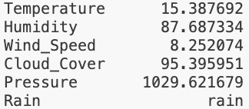
The result of 0.998 indicates that the model is very sure that, given the conditions in the first row of the dataset, it was likely raining. Indeed, after accessing the original dataset, that row’s label is “rain”.

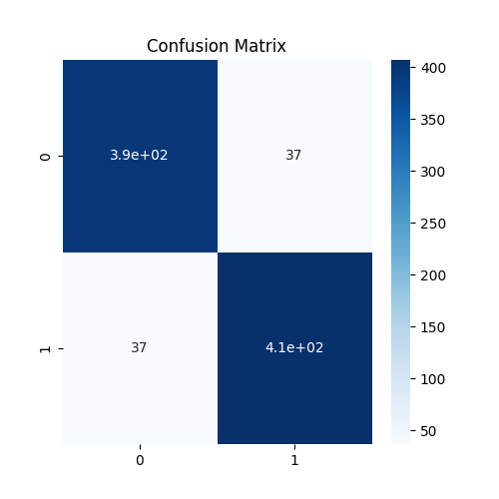
This is just a single datapoint and the reader may rightfully be skeptical of the model’s efficacy. However, on the 20% of data withheld from the training process, this Logistic Regression model predicted with an accuracy of 91.54%. Given the confusion matrix shown to the right, the model in combination with this particular dataset produced a majority of true positives and negatives. Interestingly, exactly the same quantity of false negatives and false positives were predicted! These are cases where the model predicted “rain” when the true label was “not rain” and vice versa.

Section Conclusion
The Logistic Regression model produced above has a fairly strong accuracy score right out of the box. While the Rain Occurrence dataset datatypes are perfectly suited to this kind of classifier, they may not be entirely appropriate. This is because Logistic Regression’s foundations are built upon Linear Regression, which has a variety of requirements. For instance, each variable should be linearly associated with the dependent variable, in this case, “rain” or “no rain”. Furthermore, each independent variable should have very little to no linear relationship with another variable. If there is some collinearity, one of those variables should either be removed, or a collinear coefficient should be added to the model to account for that relationship. In this case, the former issue of each variable having a linear relationship with the dependent may be in violation. Refer to Visualizing Data in the Rain Occurrence section to see some strong examples of a perfectly uniform distribution of data throughout the problem space. With this in mind, a different supervised model such as Decision Trees or Support Vector Machines could be a better choice for this dataset.

Decision Trees

Preparation & Plan
For a demonstration of a Decision Tree Classifier, the Urban AQI Data was chosen. This dataset contains a mixture of qualitative and quantitative data associated with a continuous “Health Risk Score”. This score describes the danger to individuals outside in one of the cities contained in the dataset. To prepare the AQI data for Decision Trees, some irrelevant or non-encodable qualitative data was removed, while other qualitative data such as “City” or “Day_of_Week” was ordinally encoded. Most importantly, the “Health Risk Score” was discretized into bins to allow for classification.

Air quality and the weather are inextricably linked. Finding new ways to predict risk to the public’s health due to air quality should be of the utmost importance. Machine learning strategies such as Decision Trees are a great choice for this task. This particular type of model has the unique quality of allowing users to trace the logic of the Decision Tree, understanding why the model came to the decision that it did. Using Decision Trees in this context could help uncover patterns and clues as to how the weather impacts air quality in urban areas.
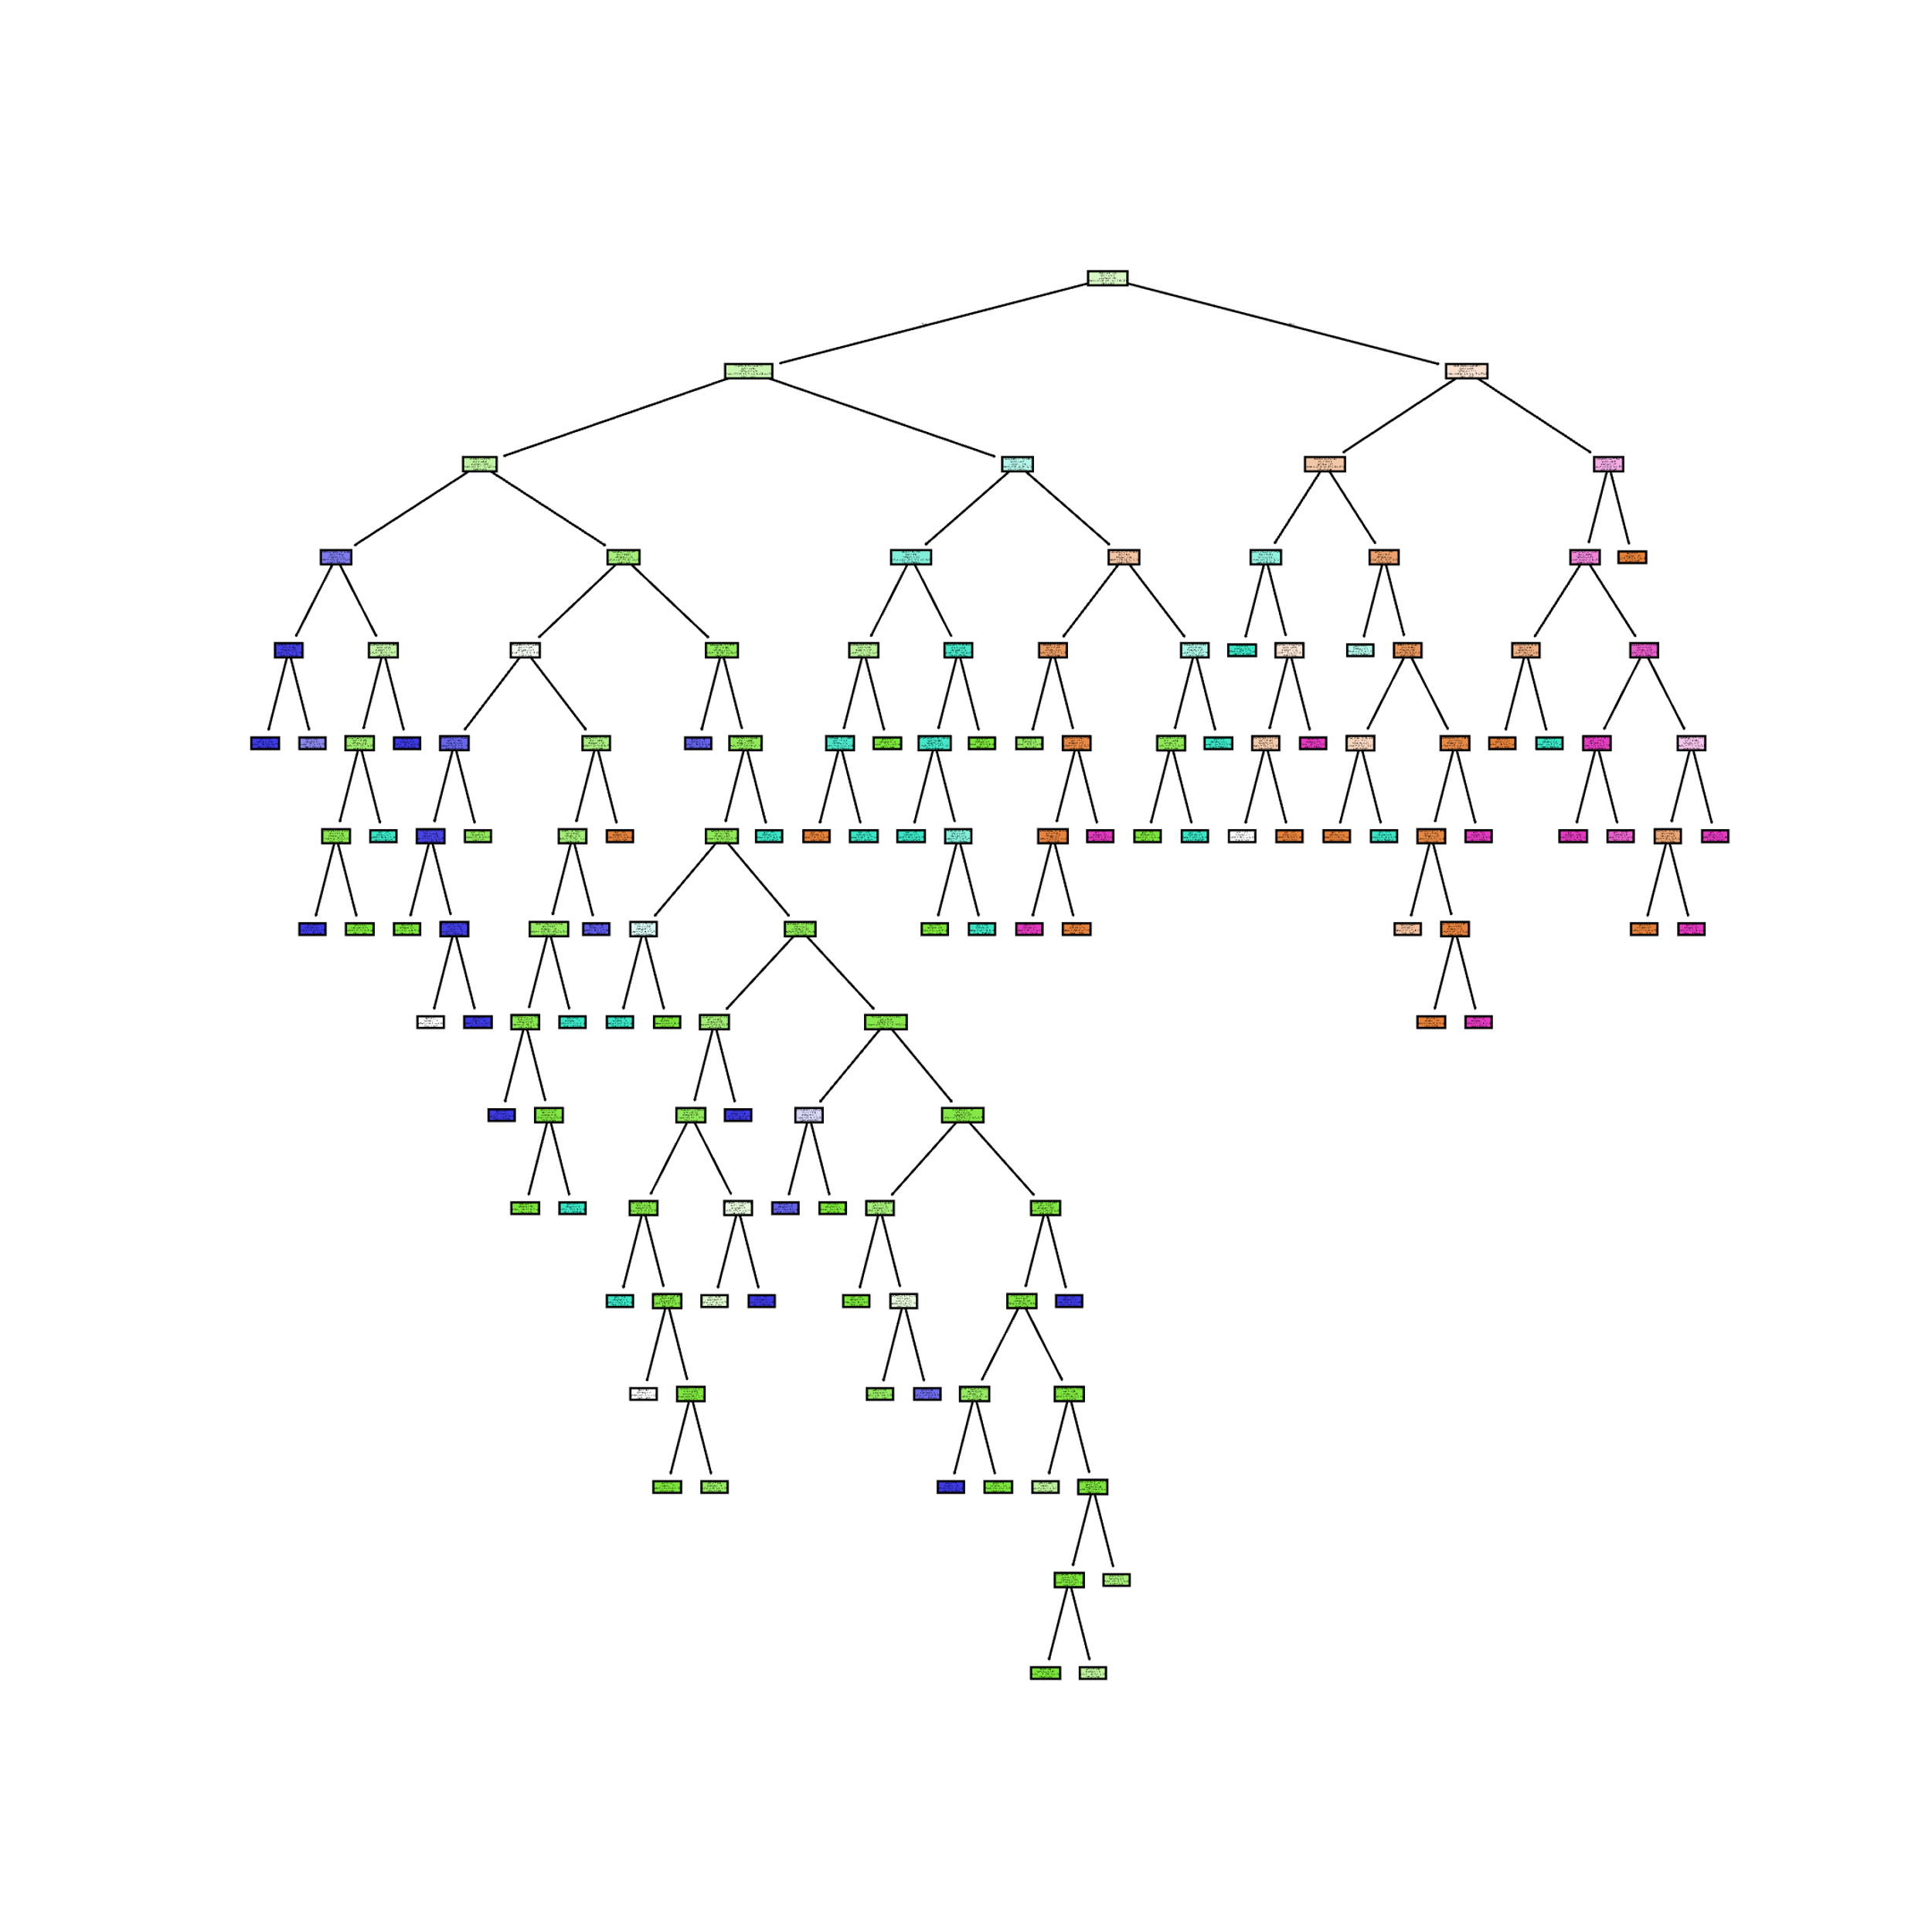

Results
The first of the two Decision Trees being created by this report can be seen to the right. As the reader can probably tell already, Decision Trees can quickly become quite unwieldly in their size. These models are known for their ability to create arbitrarily convoluted decision boundaries and thus benefit from limiting factors like lowering the maximum depth allowed.

In this case though, an interesting pattern can be seen rather quickly. All the “low” and “medium” risk scores appear to be clustered off the left side of the root, while nearly all the “high” and “severe” labels can be found on the right. This tells us that perhaps more understandable results – and maybe even more accurate modeling – could be achieved with a simpler tree.
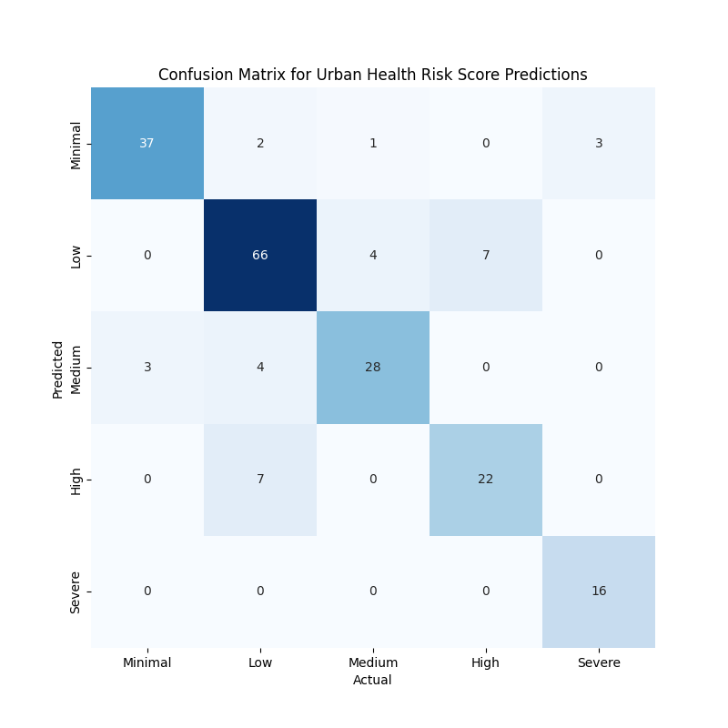
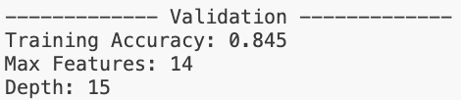

Shown here is validation information regarding the performance of the Decision Tree depicted above. With a maximum number of features limited to 14 and a depth of 15 leaves, this model achieved 84.5% accuracy on the test dataset.

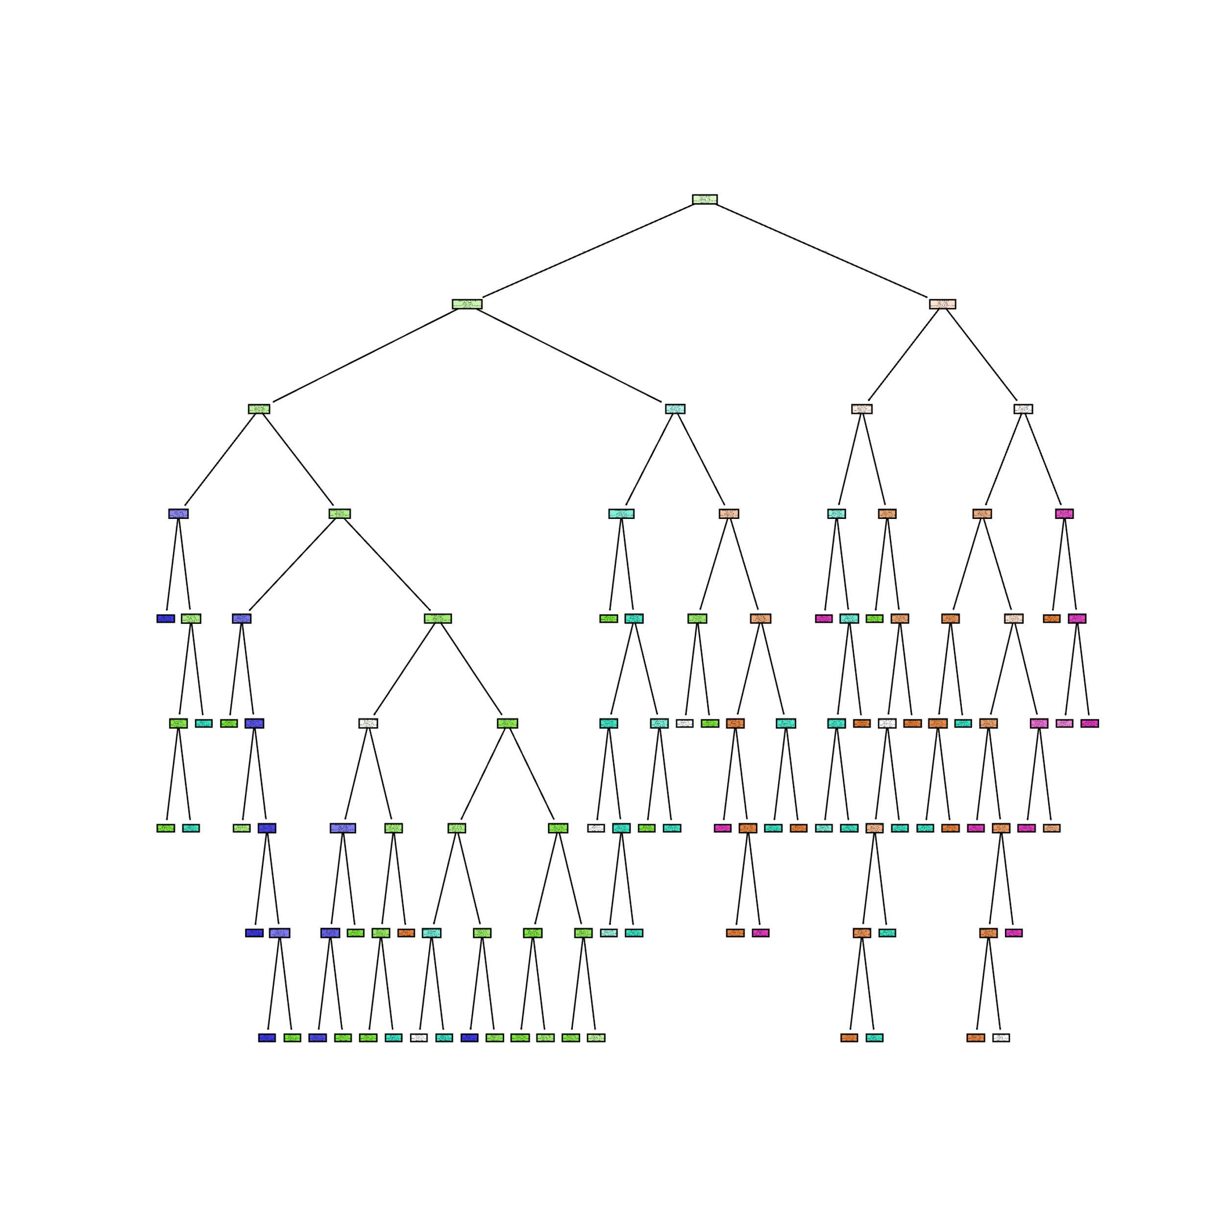

The second decision tree is shown on the right. This tree was limited to roughly half the depth and half the allowed features. As the reader can see, this model is far less complicated than the first. In the worst possible scenario, an analyst would only have to understand 8 decisions for a given prediction as opposed to 15 in the last attempt!

Once again, the same clustering of labels can be seen to the left and right of the root node. This really illustrates how useful decision trees can be. Though not an unsupervised machine learning method, they can still help us understand the structure of our data. Simultaneously, we can ask our decision trees to make predictions of new, unseen data.

Interestingly, limiting the number of features and depth of the new tree resulted in a performance gain of 2.5%! This is most likely due to tradeoffs in overfitting. Given the flexible nature of Decision Trees, it’s quite easy for them to become far too specialized in their training data. By limiting the features and depth, users can help the tree generalize to new data more effectively.
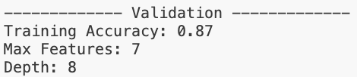
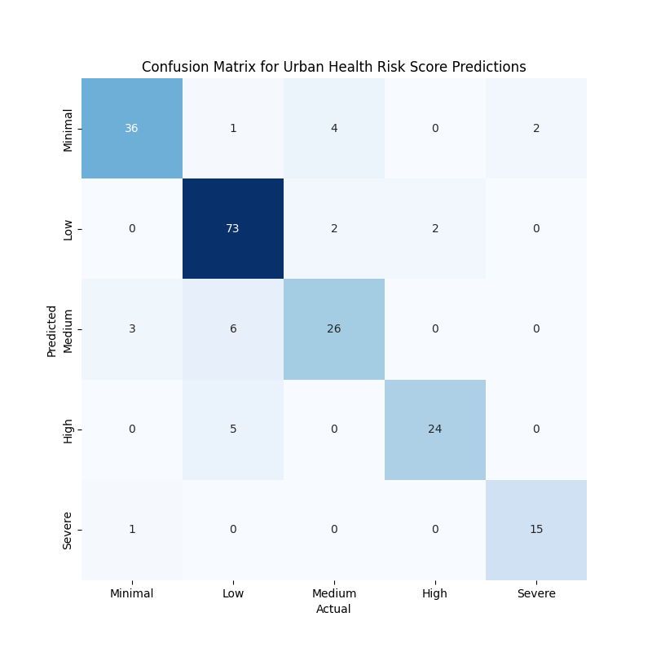
Section Conclusion
Predicting a city’s air quality health score from a large variety of meteorological factors is not an easy feat, yet a Decision Tree does quite well. Some brief insights can be gleaned from the second – and more useful – model above. For example, the majority of Low and Minimal scoring days depend on a dew point below 63.346, general severity score less than 3.376, and solar radiation levels under 186.792. On the other hand, a city is likely to have a Severe or High scoring day with a dew point above 63.346, and a temperatures above 80.569 degrees.
Naïve Bayes
TODO: Show prepped data two different types for two different naïve bayes models, Use for the model in terms of the project, Results including conf matrix for each model and talk about some of the probabilities, Section Conclusions

Preparation & Plan
This section will show an analysis of the Urban AQI Data for both Gaussian and Categorical Naïve Bayes. Each type of Naïve Bayes is suited for different circumstances and data types. Gaussian NB works to classify labels from quantitative data, so predictions on the health risk label will be made from ordinally encoded and otherwise continuous values. Categorical Naïve Bayes makes predictions based on categories, so only ordinally encoded variables will be included for this model.

Data curated for Gaussian Naïve Bayes:
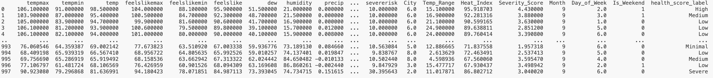

Data curated for Categorical Naïve Bayes prior to ordinal encoding:
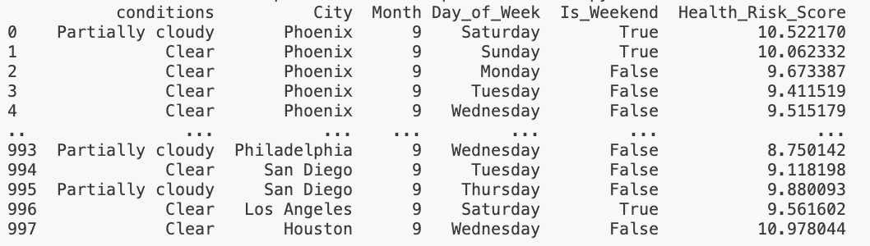

Results
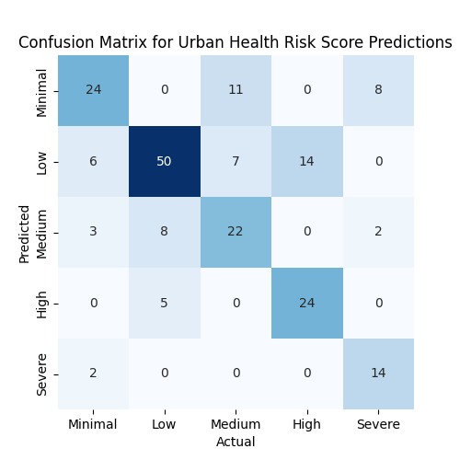
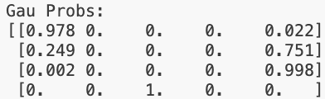

The Gaussian Naïve Bayes model’s accuracy score came in at a dismal 67%. This is a very low confidence model, and would most likely not be deployed in a professional setting. As can be seen in the confusion matrix on the right, over half of the predictions were correct, aligning along the diagonal. However, a very large quantity of predictions came in as Type 1 and 2 errors. These are False Positives and Negatives.

Above, a small sample of the probabilities for each prediction are shown. The list depicts the probability of each prediction falling into its given category. For the first row, we can see that the model gave this vector a 97.8% probability of having a “minimal” health risk score as well as a 0.22% of a “severe” risk score. Obviously, as human beings, we would expect there to be some middle ground between these predictions. Health risk is not typically a binary question of “minimal” or “severe”.
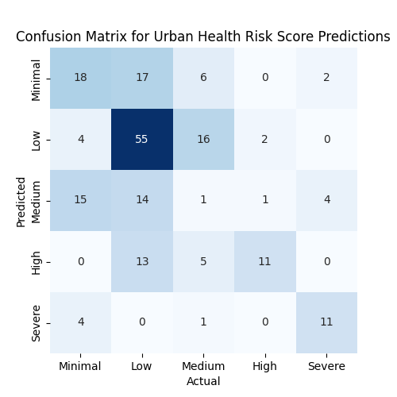
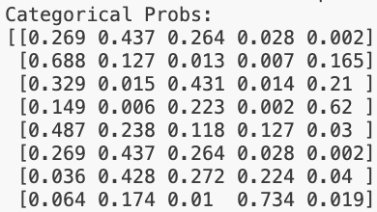

Incredibly, the Categorical Naïve Bayes model performed even more poorly with a validation accuracy score of 48%, worse odds than 50-50! As can be very clearly seen in the probabilities sample above, there’s almost a perfectly even distribution of probabilities across all categories for each row. In the confusion matrix, there appears to be a bias towards predictions of “minimal” or “low”, with very few of the predictions going to “high” or “severe”, and almost none for “medium”.

Section Conclusion
Overall, this demonstration of Naïve Bayes underperformed significantly. However, this is most certainly not due to any intrinsic failings of the model itself. Rather, the nature of this particularly dataset most certainly does not lend itself to successful modeling with Naïve Bayes. That’s not to say that the data is unpredictable, as we’ve seen accuracy ratings of up to 96.80% with Linear Regression Analysis on the same data. The truth is most likely that those variable which were encodable in the Urban AQI dataset were just not that significant for predicting label. Given a different dataset with more qualitative, categorical values that are relevant to the prediction space, this model would have performed much better.

Conclusions

Clustering
In this section, different methods were used to group simple meteorological weather data based on patterns present in the dataset. First, a technique called k-means clustering showed that the data was very evenly spread out, making it hard to form clear groups, although two general patterns did emerge when looking at more features together. Adding a third group didn’t actually match the real structure of the data, which originally had just two categories. Then, another method called Principal Component Analysis (PCA) was used to simplify the data, but it didn’t break up the even spread, rather, it reshaped the data slightly while keeping the overall structure intact. Lastly, a different grouping method, Hierarchical Agglomerative Clustering (HAC), naturally found the same two groups without needing to be told how many to look for. While the colors representing the groups were flipped in the diagram, the important takeaway was that both k-means and HAC revealed a clear pattern. Even though the data was evenly balanced, the “rain” category stayed tightly grouped together, reflecting a narrow window of weather conditions where rain might occur at the location where this data was gathered.

Linear & Logistic Regression

Linear and logistic regression models are impressive supervised machine learning models for predictive modeling. However, like any model, they do come with important limitations that must be considered or users risk misleading decision makers with their results. Linear regression, for instance, assumes that independent variables are linearly related to the dependent variable and that there is minimal multicollinearity between predictors. Logistic regression, which is fundamentally based on linear regression, inherits many of these assumptions and extends them to classification tasks. When these assumptions are not met, such as when predictors show uniform distributions or nonlinear relationships, model performance degrades.

Importantly, both regression approaches struggle when applied outside the bounds of the training data. Linear regression, in particular, should never be used for extrapolating beyond the specific domain it was trained on. Because of this, even when models produce seemingly strong results on a given dataset, their applicability in broader contexts should be approached with caution. To build robust models, it’s essential to pair statistical accuracy with an understanding of data context, model assumptions, and the potential for overgeneralization.

Decision Trees & Naïve Bayes
Decision Trees and Naïve Bayes differ fundamentally in their structure and assumptions, which explains their divergent performance on the air quality prediction task presented to them in this section. A Decision Tree partitions the feature space by learning simple threshold rules, making it great at capturing all kinds of interactions among continuous and discrete variables without requiring any statistical assumptions. Better still, its tree structure allows for interpretability – users can trace exactly which splits lead to a given prediction – a pretty rare quality for a machine learning model.

Naïve Bayes relies on the assumption that all predictors are conditionally independent given the class label, which greatly simplifies probability estimation and generally works well with categorical or discretized inputs. However, as the reader may have noticed in this section, the model can struggle significantly when real-world features exhibit complex dependencies. Naïve Bayes tends toward underfitting when its independence assumption is violated, meaning it can benefit greatly from datasets with a large number of independent categorical variables.
To Top

References
- Price, I., Sanchez-Gonzalez, A., Alet, F. et al. Probabilistic weather forecasting with machine learning. Nature 637, 84–90 (2025). https://doi.org/10.1038/s41586-024-08252-9

