WEEK 3: ADVANCED DATA ANALYSIS
AND VISUALIZATION IN LOGISTICS
Logistics Data Analyst Internship — YuvaIntern
120 simulated shipment records | Python, Pandas, NumPy, Matplotlib

1. Executive Summary
This report demonstrates exploratory data analysis on a hypothetical dataset of 120 shipment records. Mean delivery time is 2.92 days and median delivery time is 2.85 days. The simulated on-time rate is 80.0% and delay rate is 20.0% under illustrative status rules. Mean transportation cost is INR 2,205.51, and mean shipment distance is 469.7 km. These metrics describe only the simulated dataset, not DataCo or a real company.

2. Objectives
- Explore a hypothetical logistics dataset and summarize its variables.
- Calculate central tendency and dispersion statistics.
- Analyze relationships between distance, volume, delivery time, and cost.
- Create and justify multiple visualizations.
- Translate the results into cautious operational recommendations.

3. Dataset Design and Limitations
The dataset contains 120 simulated records with Shipment_ID, Shipment_Distance_km, Shipment_Volume_units, Transportation_Mode, Delivery_Time_Days, Transportation_Cost_INR, and Delivery_Status. A fixed random seed makes the exercise reproducible. Patterns were intentionally simulated for teaching EDA; this is not the DataCo Smart Supply Chain dataset and cannot support claims about real operations.
Quality check: 0 missing cells and 0 exact duplicate rows in this generated dataset. This clean starting point is for EDA practice and does not imply real-world data is always complete.

4. Methodology
- Generate reproducible synthetic data with NumPy.
- Inspect shape, columns, missing values, and duplicates with Pandas.
- Use describe() for mean, standard deviation, minimum, quartiles, median, and maximum.
- Calculate Pearson correlations for linear associations; correlation does not prove causation.
- Create five charts with Matplotlib and compare transportation modes.

5. Descriptive Statistics
Variable | Mean | Median | Std. dev. | Minimum | Maximum
Shipment_Distance_km | 469.68 | 452.00 | 278.16 | 43.00 | 993.00
Shipment_Volume_units | 43.65 | 44.00 | 22.74 | 5.00 | 80.00
Delivery_Time_Days | 2.92 | 2.85 | 1.37 | 1.00 | 7.50
Transportation_Cost_INR | 2205.51 | 1954.33 | 1503.14 | 330.54 | 8063.74
Mean delivery time is 2.92 days and median delivery time is 2.85 days. Mean transportation cost is INR 2,205.51. The difference between mean and median should be interpreted alongside the distribution rather than by itself.

6. Visualizations and Interpretation

Figure 1. Delivery-time histogram
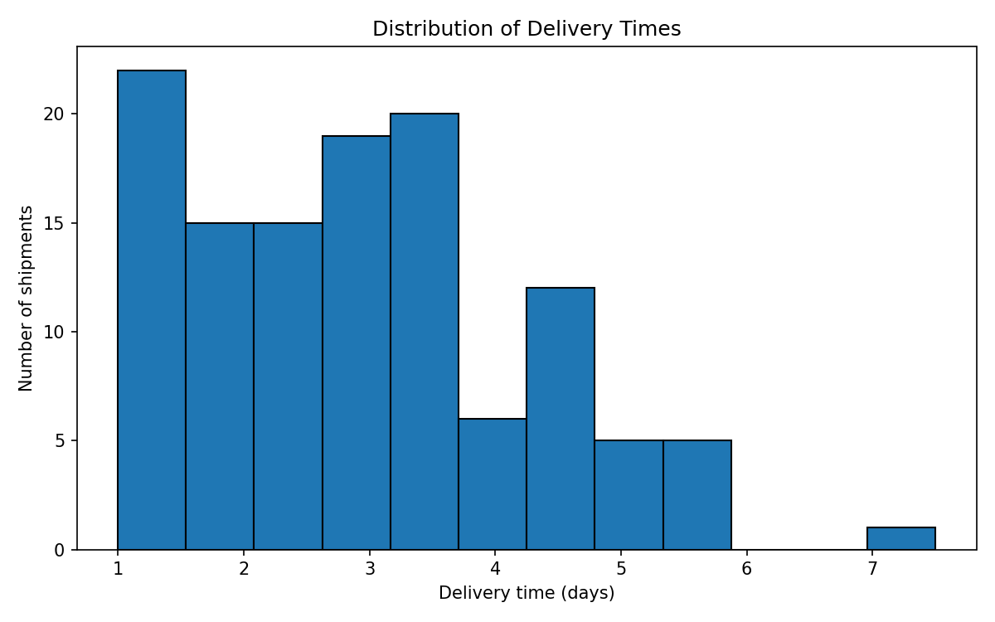
A histogram shows how frequently delivery times fall within intervals. It helps identify the typical range, spread, and possible long-delay tail. In real operations, investigate long delivery times by route, carrier, and priority.

Figure 2. Average cost by mode
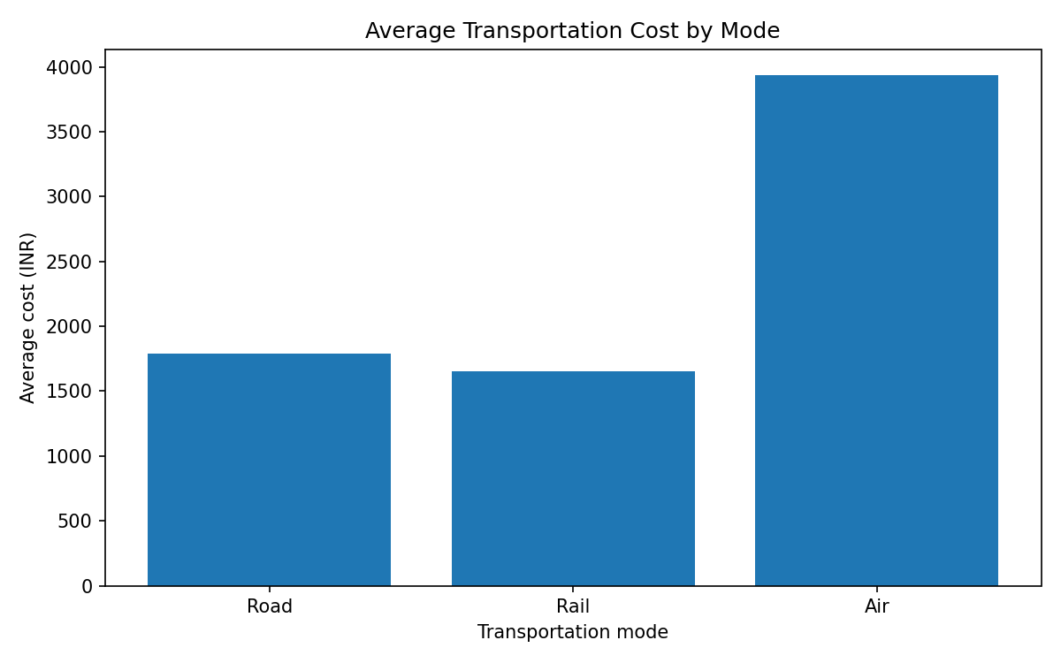
A bar chart compares a numeric measure across categories. Costs differ by mode partly because mode-specific rates were intentionally used to generate the synthetic data. For real comparisons, control for distance, volume, urgency, and service level.

Figure 3. Distance versus cost scatter plot
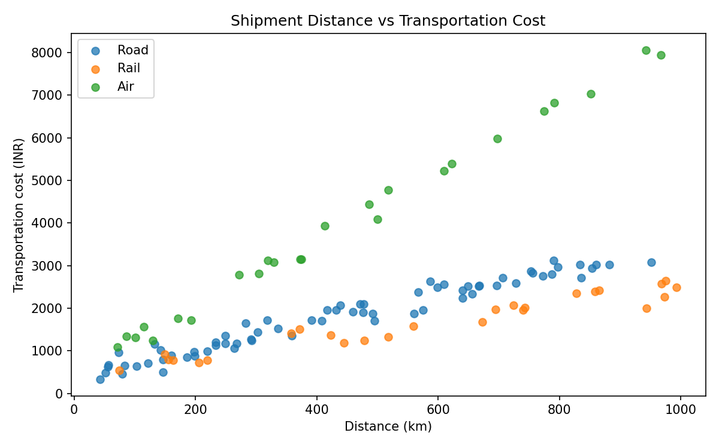
A scatter plot displays the relationship between two numeric variables, with transport mode shown separately. An upward pattern is expected because simulated cost includes distance. This is an association in generated data, not evidence of real-world causality.

Figure 4. Correlation heatmap
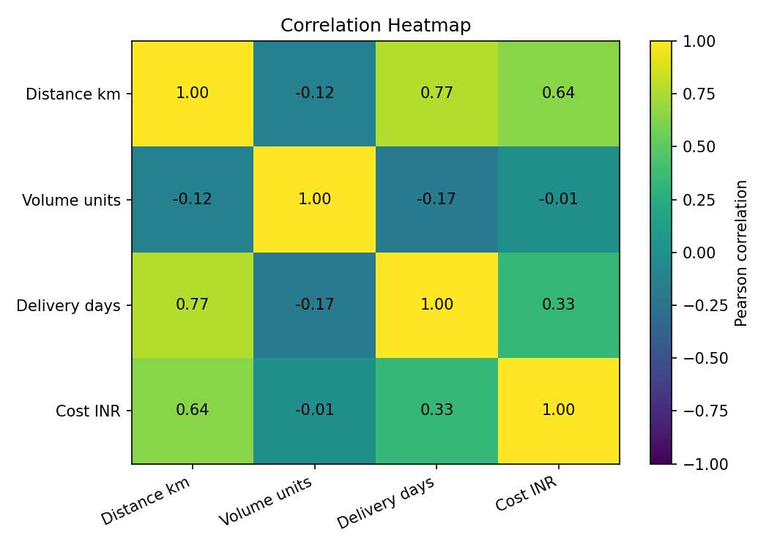
The heatmap summarizes Pearson correlation coefficients from -1 to +1. Values near +1 indicate positive linear association; near -1 indicate negative association; near zero indicate weak linear association. The exact values are shown in the chart and summary. Correlation does not prove causation.

Figure 5. Delivery time by mode box plot
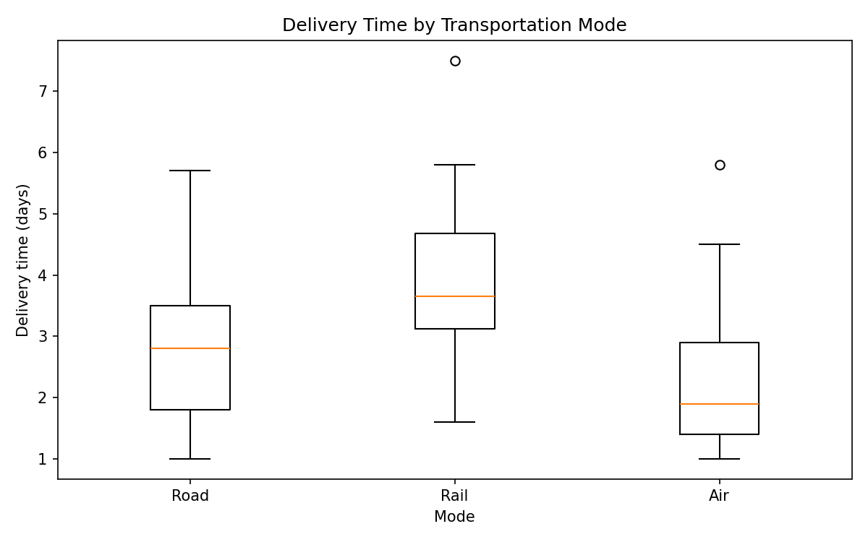
A box plot compares medians, interquartile ranges, and potential extreme observations across modes. It helps compare typical delivery time and variability, but a fair real-world comparison should also consider route length and shipment priority.

7. Transportation Mode Summary
Mode | Shipments | Avg days | Avg cost (INR) | On-time rate
Air | 25 | 2.29 | 3,937.19 | 84.0%
Rail | 26 | 3.88 | 1,652.48 | 69.2%
Road | 69 | 2.78 | 1,786.48 | 82.6%
Mode comparisons are descriptive. Since mode-specific delivery and cost patterns are part of the data-generation rules, these differences reflect the simulation design. Real analysis should compare similar shipments and consider cost per kilometre or cost per unit.

8. Key Findings
- Overall simulated on-time rate is 80.0% and delay rate is 20.0% under illustrative status thresholds.
- Average delivery time is 2.92 days; median is 2.85 days.
- Average simulated transportation cost is INR 2,205.51. The distance-cost plot helps examine their association.
- Mode averages may hide differences in shipment distance, volume, urgency, and route complexity.
- All findings are for demonstration and should not be represented as real company performance.

9. Recommendations
- For real data, define on-time delivery against a verified promised-delivery date and status field.
- Track cost per kilometre and cost per unit, not only total cost.
- Investigate long delivery times by route, carrier, mode, and priority before assuming they are errors.
- If dates are available, examine weekday and seasonal patterns in a later task.
- For predictive modelling, split training and test data before fitting data-dependent transformations to avoid leakage.

10. Python Tools and Reproducibility
Pandas handles tabular data, grouping, descriptive statistics, and correlations. NumPy creates reproducible hypothetical records. Matplotlib creates the figures. The script saves a CSV, summary, and five PNG charts.
Install: pip install pandas numpy matplotlib
Run: python logistics_eda.py

11. Conclusion
This task demonstrates an EDA workflow using descriptive statistics, correlations, visualizations, interpretation, and recommendations. The charts provide complementary views of delivery-time distribution, mode-level costs, distance-cost association, numeric correlations, and delivery-time variability. Since the data is hypothetical, the next step is to repeat the analysis on a verified real dataset before making operational claims.

Appendix: Selected Python Code
print(df[numeric].describe().round(2))
print(df[numeric].corr().round(3))
plt.hist(df["Delivery_Time_Days"], bins=12, edgecolor="black")
plt.xlabel("Delivery time (days)")
plt.ylabel("Number of shipments")
plt.tight_layout()

