Supply Chain Delivery Risk
& Profitability Analysis
Project Report
Dataset: DataCo Supply Chain Dataset
Tools: Python · Pandas · Scikit-learn · SMOTE · Matplotlib / Seaborn
Date: July 2026

1. Executive Summary
This report presents an end-to-end analysis of the DataCo Supply Chain dataset, covering 172,765 completed orders across multiple regions, shipping modes, and product categories. The project analyzes delivery performance, uncovers profitability drivers, and builds a machine learning model to predict Late Delivery Risk.
Key findings show that more than half of all orders (54.7%) are delivered late, generating a significant total loss of approximately $2.1M from delayed shipments, even though the overall business remains profitable (80.7% of orders are profitable). A Random Forest Classifier, trained on frequency-encoded shipping and order features and balanced using SMOTE, achieved 74% accuracy and 79% precision in predicting late delivery risk, providing a practical foundation for proactive delay management.
KPI | Value
Total Orders Analyzed | 172,765
Late Deliveries | 94,523 (54.71%)
On-time Deliveries | 45.29%
Total Profit (positive orders) | ≈ $7.5M
Total Loss due to Delays | ≈ $2.1M
Model Accuracy (Random Forest) | 0.74
Model Precision | 0.79

2. Business Problem
A global e-commerce company operating across multiple regions manages end-to-end order fulfillment, including shipping and delivery, for products such as sporting goods. The company is facing inconsistent delivery performance, where actual shipping times often deviate from scheduled timelines, leading to late deliveries and unpredictable order profitability.
The desired outcome is to analyze delivery operations, identify bottlenecks, and build a predictive system to reduce delay, optimize shipping decisions, and improve overall profitability and efficiency.

3. Objectives
- Analyze delivery operations across regions, shipping modes, and time periods.
- Identify bottlenecks contributing to late deliveries.
- Study the relationship between delivery delay and order profitability.
- Build a machine learning model to predict Late Delivery Risk for incoming orders.

4. Dataset Overview
The analysis uses the DataCo Supply Chain Dataset, a real-world e-commerce dataset containing order, shipping, customer, product, and profitability information. After cleaning, the working dataset contains 172,765 rows and 21 columns.
Attribute Group | Example Columns
Order Details | Type, Order Status, Order Region, Days for shipment (scheduled/real)
Delivery Info | Delivery Status, Late_delivery_risk, Shipping Mode
Customer Info | Customer Segment, Customer Country
Product Info | Category Name, Department Name, Product Name, Product Price
Financials | Sales, Order Profit Per Order, Order Item Discount, Order Item Profit Ratio
Dates | order date (DateOrders), shipping date (DateOrders)
Distribution highlights from the raw data:
- Delivery Status: Late delivery (98,977), Advance shipping (41,592), Shipping on time (32,196).
- Shipping Mode: Standard Class (103,153), Second Class (33,806), First Class (26,513), Same Day (9,293).
- Customer Segment: Consumer (89,420), Corporate (52,528), Home Office (30,817).
- Customer Country: EE. UU. / USA (106,425), Puerto Rico (66,340).

5. Data Cleaning & Preprocessing
Before analysis, the raw dataset was cleaned and prepared as follows:
- Removed irrelevant, redundant, or zero-variance columns (e.g., Customer Email, Customer Password, Product Image, Latitude/Longitude, IDs, and columns with only one unique value).
- Filtered out cancelled orders (Delivery Status = 'Shipping canceled') since they do not reflect real delivery time or profitability patterns.
- Converted 'order date' and 'shipping date' columns to proper datetime format for time-based calculations.
- Verified data quality post-cleaning — the resulting dataset had zero missing values across the top fields checked, with a final shape of 172,765 rows × 21 columns.
- Engineered delay-related features (detailed in Section 7) to support both EDA and modeling.

6. Exploratory Data Analysis
Exploratory analysis focused on understanding delivery performance, profitability distribution, and how delay length affects business outcomes.

6.1 Profitability Distribution
Orders were classified into Profit, Loss, or Break-even categories based on 'Order Profit Per Order'. The overwhelming majority of orders (80.7%) are profitable, while a notable 18.7% result in a loss — highlighting that profitability issues are concentrated in a meaningful subset of orders rather than being widespread.
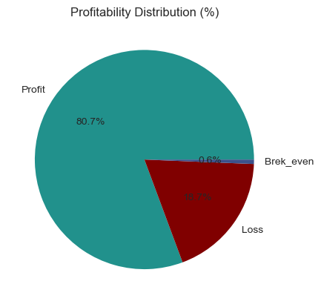
Figure 1: Profitability Distribution of Orders (Profit vs. Loss vs. Break-even)
Profitability Flag | Order Count
Profit | 139,354
Loss | 32,295
Break-even | 1,116

6.2 Delay Distribution and Profit Impact
Delay is measured as the difference between actual order-processing time and the scheduled shipment time. A positive value means the order was delivered later than promised. The delay distribution shows that 30.97% of all orders are delivered exactly 1 day late — the single largest delay bucket — while only about 7.8% of orders are delayed by 3 or more days.
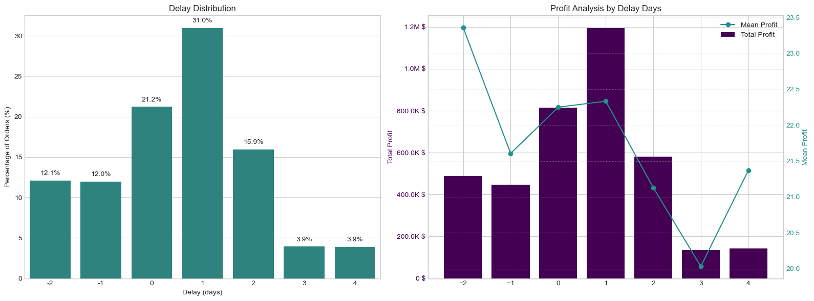
Figure 2: Delay Distribution (left) and Total/Mean Profit by Delay Days (right)
Delay (days) | Mean Profit ($) | Total Profit ($) | Order Count | % of Orders
-2 | 23.4 | 487,596 | 20,873 | 12.08%
-1 | 21.6 | 447,629 | 20,719 | 11.99%
0 | 22.2 | 815,430 | 36,650 | 21.21%
1 | 22.3 | 1,194,895 | 53,503 | 30.97%
2 | 21.1 | 582,111 | 27,551 | 15.95%
3 | 20.0 | 135,653 | 6,772 | 3.92%
4 | 21.4 | 143,107 | 6,697 | 3.88%
Interestingly, mean profit per order stays relatively stable (roughly $20–$23) across all delay levels, meaning delay alone does not sharply erode per-order margin. However, because 1-day-late orders make up the largest share of volume (31%), they also generate the largest total profit pool — showing that delay-related losses are driven more by shipping cost and customer-experience risk than by shrinking per-order margins directly captured in this metric.

7. Feature Engineering
The following features were engineered to support both exploratory analysis and predictive modeling:
Feature | Description
Order Processing Time | Difference (in days) between shipping date and order date
Delay | Order Processing Time minus scheduled shipment days; positive = late
Is_Delayed | Boolean flag: True if Delay > 0
Profitability Flag | Categorizes each order as Profit / Loss / Break-even
order_month / order_day / order_hour | Extracted from order date for seasonal/time-of-day patterns
Frequency-encoded categorical features | Type, Category Name, Customer Segment, Department Name, Order Region, Shipping Mode converted to frequency scores for modeling

8. Machine Learning Model
The target variable is 'Late_delivery_risk' (binary: 1 = high risk of late delivery, 0 = low risk). The target distribution is moderately imbalanced: 98,977 orders labeled high-risk (1) versus 73,788 labeled low-risk (0).

8.1 Feature Set
The model uses: Type, Days for shipment (scheduled), Category Name, Customer Segment, Department Name, Order Region, Shipping Mode, order_month, and order_hour. Categorical columns were frequency-encoded rather than one-hot encoded, keeping dimensionality low while remaining robust to high-cardinality fields.

8.2 Train/Test Split & Class Balancing
Data was split 80/20 with stratification on the target variable (X_train shape reflects 172,765 total rows, encoded to 9 features). Because the training set was imbalanced (79,182 vs. 59,030 before balancing), SMOTE (Synthetic Minority Over-sampling Technique) was applied to the training set only, producing a balanced 79,182 / 79,182 split for model training.

8.3 Model Selection
A Random Forest Classifier (random_state = 42) was trained on the SMOTE-balanced training data and evaluated on the untouched, original-distribution test set to ensure realistic performance estimates.

9. Model Evaluation
KPI | Value
Accuracy | 0.74
Precision | 0.79
Recall | 0.75
Detailed classification report on the test set (34,553 orders):
Class | Precision | Recall | F1-score | Support
0 (On-time / Low risk) | 0.68 | 0.73 | 0.70 | 14,758
1 (Late / High risk) | 0.79 | 0.75 | 0.77 | 19,795
Accuracy |  |  | 0.74 | 34,553
Macro avg | 0.73 | 0.74 | 0.73 | 34,553
Weighted avg | 0.74 | 0.74 | 0.74 | 34,553
Business interpretation: The model correctly identifies 75% of orders that are genuinely at high risk of late delivery (recall for class 1), and when it flags an order as high-risk, it is correct 79% of the time (precision for class 1). This balance makes the model suitable for proactive interventions — such as prioritizing high-risk orders for expedited handling or customer communication — while keeping false alarms on low-risk orders at a manageable level (68% precision for class 0).

10. Business Insights & Recommendations
- Reduce delay-prone routes: With 54.7% of orders arriving late and 31% delayed by exactly one day, small scheduling or carrier-handoff improvements on the most common routes could meaningfully cut the late-delivery rate.
- Optimize shipping mode allocation: Standard Class accounts for the majority of shipments (103,153 orders); reviewing whether faster shipping modes should be used for high-value or delay-sensitive orders can reduce risk without a full-scale mode shift.
- Improve inventory and processing-time planning: Since Order Processing Time is a direct driver of Delay, tightening warehouse and fulfillment processing time is likely to have a direct effect on on-time delivery percentage.
- Monitor profitability alongside delivery performance: Although mean profit per order remains stable across delay levels, the ~$2.1M in profit tied to delayed orders represents at-risk revenue from potential returns, customer churn, and service costs not captured directly in the profit figure.
- Operationalize the predictive model: Integrate the Random Forest late-delivery-risk model into order-management workflows to flag high-risk orders at the time of order placement, enabling proactive customer communication or carrier upgrades.

11. Conclusion
This project delivered a complete pipeline — from data cleaning and exploratory analysis to feature engineering and predictive modeling — for understanding and addressing late delivery risk in a multi-region e-commerce supply chain. The analysis confirmed that late deliveries are widespread (54.7% of orders) and that delay levels, while not drastically reducing per-order profit margins, are associated with a large pool of at-risk profit (~$2.1M).
The Random Forest Classifier, trained on SMOTE-balanced data with frequency-encoded categorical features, achieved solid predictive performance (74% accuracy, 79% precision, 75% recall on the high-risk class), demonstrating that operationally available features — shipping mode, scheduled shipment days, region, segment, and order timing — carry meaningful signal for anticipating late deliveries.
Future enhancements could include testing gradient-boosted models (e.g., XGBoost or LightGBM) for potential accuracy gains, incorporating external factors such as carrier performance or weather data, performing hyperparameter tuning and cross-validation, and extending the profitability analysis to quantify indirect costs of delay such as customer churn and return rates.

