* **The code in the  folder is for the current class, which you have to explain to the student. Explanations for this code are mentioned in the class document of C114.**
* **The code in 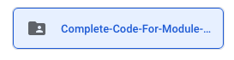 folder is the complete code for the module from C114 to C116. This is just given for the reference.**

**DO NOT EXPLAIN THIS CODE in the current class which is C114**