**TOOLMATE**

A PROJECT REPORT

*Submitted in the fulfillment of the requirement for the award of diploma*

In

**INFORMATION TECHNOLOGY**

By

**Omkar V. Telange (2131972)**

**Dhiraj P. Andhere (2131913)**

**Shubham S. Shinde (2131964)**

Under the guidance of

**Mr. Pravin Hanpude**



**DEPRTMENT OF INFRMATION TECHENLOGY ENGINEERING**

**INSTITUTE OF PETROCHEMICAL ENGINEERING**

**LONERE – RAIGAD.**

**Approval Sheet**

The project report entitled TOOLMATE A Networking Site submitted by Dhiraj P. Andhere(2131913), Omkar V. Telange(2131972), Shubham S. Shinde(2131964) is approved for the fulfillment of requirement of the award of the diploma in Information Technology.

(Prof. Sandip M. Gaikwad)

Head

Department of Information Technology

(Mr. Pravin Hanpude)

Guide

Department of Information Technology

Place: Institute of Petrochemical Engineering, Lonere.

Date:

**Certificate**

This i to certify that the project entitled U PortalA Social Networking Site is a bonafide work carried out by Dhiraj P. Andhere(2131913), Omkar V. Telange(2131972), Shubham S. Shinde(2131964) under the guidance of Mr. Pravin Hanpude in the fulfillment of the requirement for the award of the diploma in Information Technology of Institute of Petrochemical Engineering, Lonere in the academic year 2015-16.

(Prof. Sandip M. Gaikwad)

Head

Department of Information Technology

(Mr. Pravin Hanpude)

Guide

Department of Information Technology

External Examiners:

1. ________________ (Name: _____________________ )

2. ________________ (Name: _____________________ )

Place: Institute of Petrochemical Engineering, Lonere.

Date:

**Acknowledgment**

This is work is just not an individual contribution till its completion. I take this opportunity to express a deep gratitude towards my guide Mr. Pravin Hanpude, for providing excellent guidance encouragement and inspirational throughout the project work. Without his invaluable guidance, this work would never have been a successful one.

I wish to express my sincere thanks to the all department faculties and staff members for their support. I would also like to thank my all classmates for their valuable guidance and helpful discussion.

**Dhiraj P. Andhere (2131913)**

**Omkar V. Telange (2131972)**

**Shubham S. Shinde (2131964)**

**Abstract**

Now a days websites are being undivided part of everyone’s life. That’s why we have tried to build an optimized website for personal as well as academic use of student. In this report we tried to state terminologies and structure of our project which is described through UML notations and relationship diagrams. Also we have described technology and system details for all aspects of our project.

In this report we have described main details of our project such as Design, Programming structure, System architecture, Database structures with different roles of users and their domain and rights.

Content

List of figures

List of tables

**Chapter 1: Introduction of System**

# 1.1 Introduction

TOOLMATE, as the name says, it is a website which enables a person to sell-out his academic as well as other stuff, which is currently not needed to him but can be useful to someone else. Otherwise that stuff is taking unnecessary space and one don’t have any idea what to do about it.

This website will provide a mean to do something about it, which will be helpful and beneficial to both parties (seller and buyer). Some stuff is only required for one year. When a new batch comes the required materials must be bought again. Instead of buying a new product, if they have an option to get it from someone who doesn’t need it anymore within affordable or even half of actual price then why not get it!

# 1.2 Problem Statement

There are number of websites which provide these facilities, but students in our college are not aware of how to use it. There is particular problems of other websites for small reach. This website is being developed only for a limited premises, so sellers or buyers don’t need to travel to other places to get something.

In this project we are taking efforts in order to connect college authority i.e. students and staff digitally in the more interesting way.

# 1.3 Objectives

In this project we are taking efforts in order to connect college authority i.e. office people, teachers etc., and students digitally in the more interesting way.

Below we are taking glance at objectives which will help different actors across the academic circle.

For students, this site will help to communicate with other people like they usually do with other popular sites in addition with our features which will bring convenience of handling academic information and documents, features regarding their interests and hobbies, and discussions on topics they like with other friends. Our site will combine our important features and popular features like other social sites then students will show interest and use our site for their convenience.

For college authority, our site will give easy platform to share important documents, schedules and notifications. Teachers will also share their study material and publish tutorials using our site thus site will serve students as learning platform.

Hopefully we are taking further steps to build this site in reality then all targeted people will take advantages from our project.

**Chapter 2: System Description**

# 2.1 Architecture of System

Architecture of system for project is explained with block diagram as below.

# 2.2 System Requirements

Requirements for system are explained in two parts:

## 2.2.1 Software Requirements:

* Windows Operating System or any open source Operating Systems
* Visual Studio 10 (for development in ASP.net and VB.net)
* M.S. Access (for Database)
* Web browsers like Chrome, Firefox, Opera etc. (to run and test website)
* Adobe Photoshop 8 (to create banners and logo)
* Flash Player plugin (for animations)

## 2.2.2 Hardware Requirements:

* Processor Core i3 and above.
* RAM 1GB and above.
* External drive -4GB (to keep backup of website)

**Chapter 3: UML Diagrams**

# 3.1 Use Case Diagram

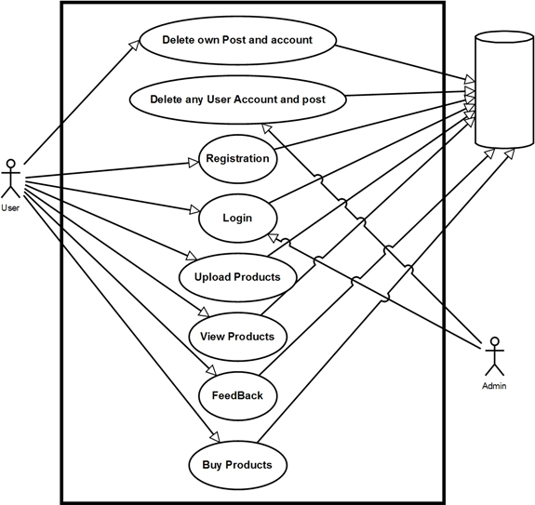

# 3.2 E-R Diagram

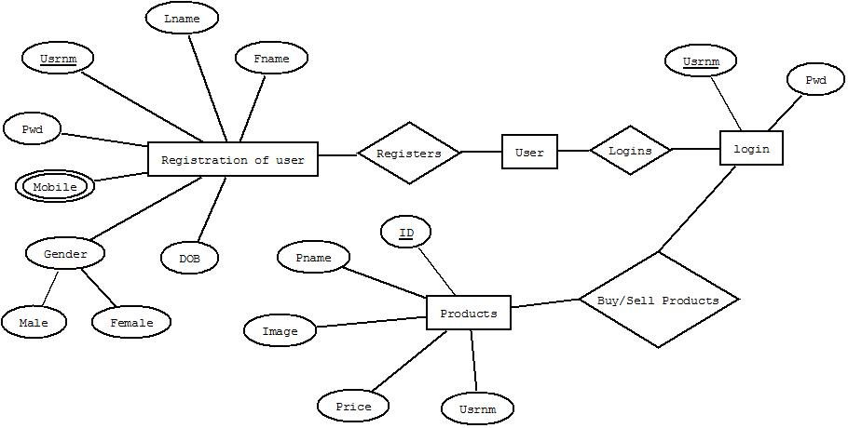

**CHAPTER 4**

**Snapshot**

4.1. Home page snapshot

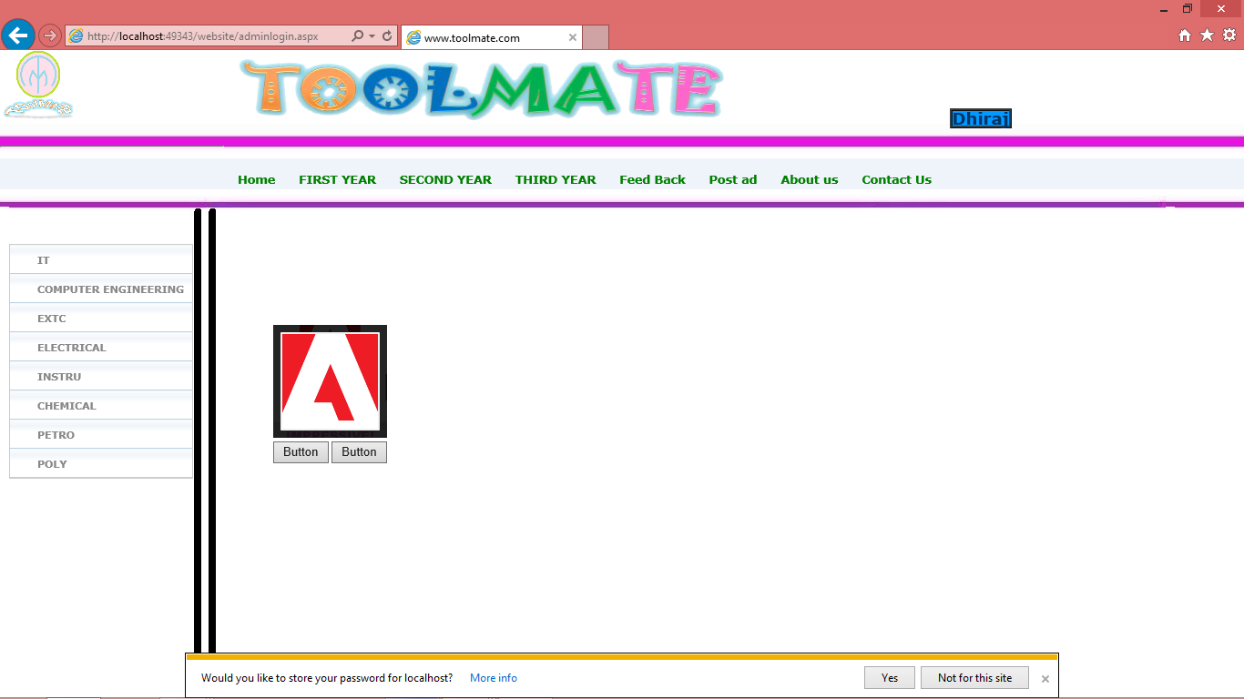

4.2. Login page snapshot

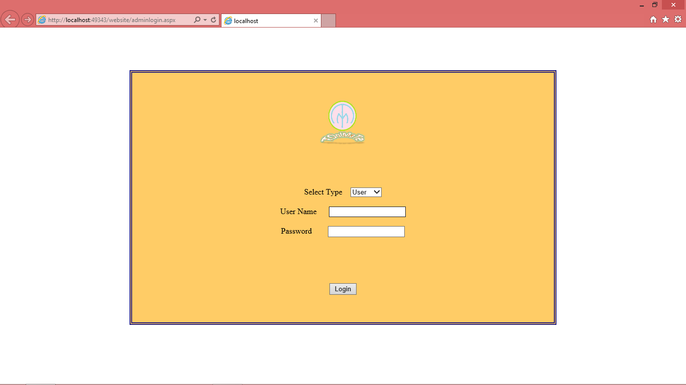

4.3. Register page snapshot

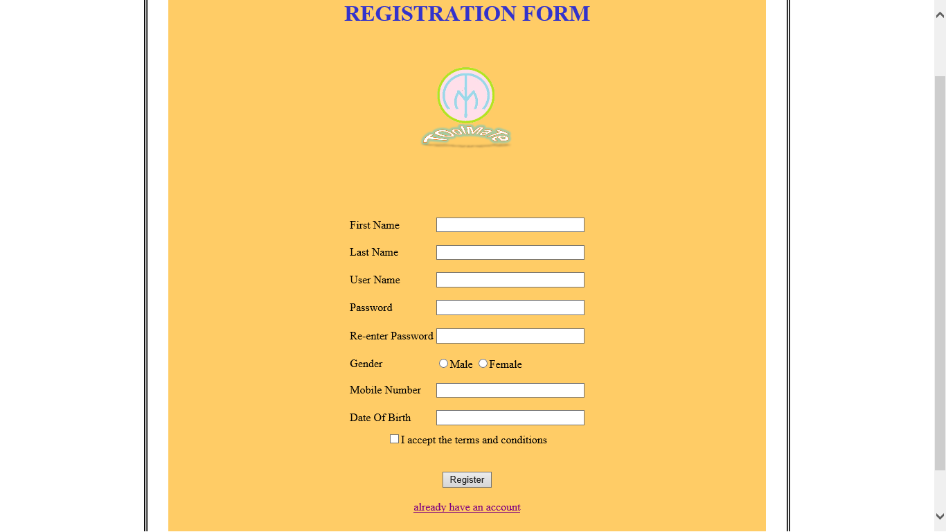

4.4. Post Product

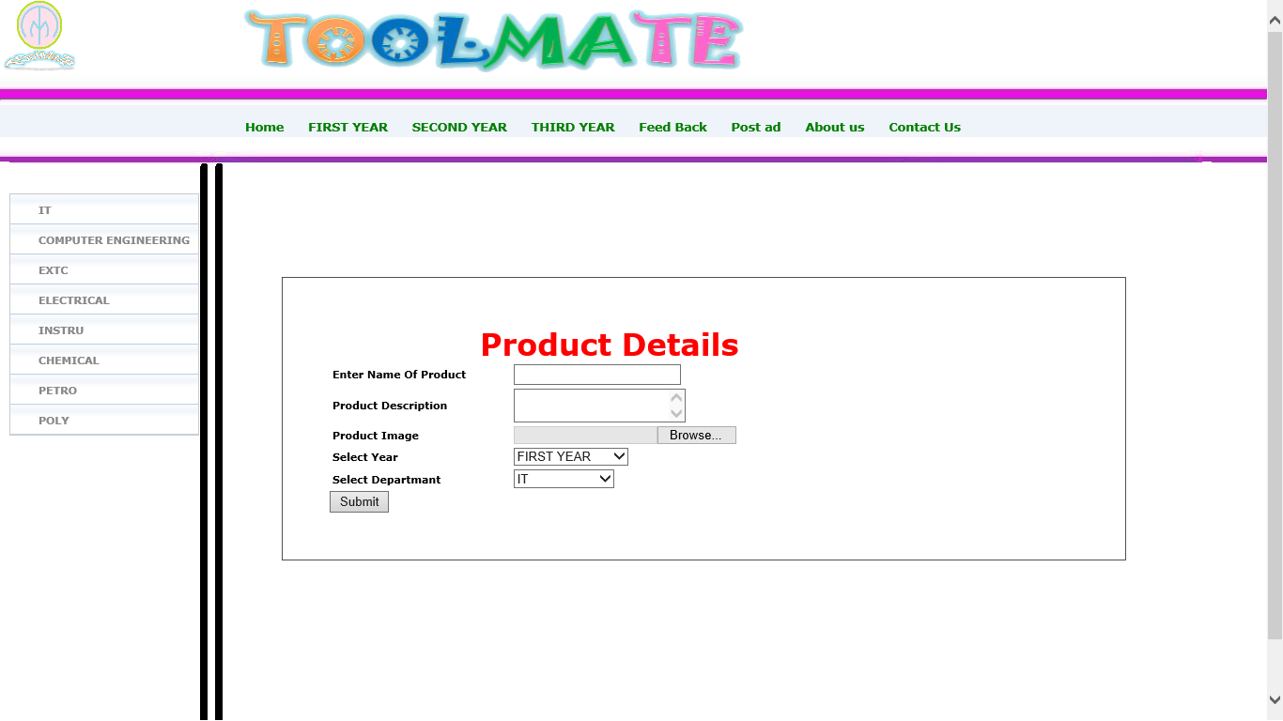

4.5. contact us

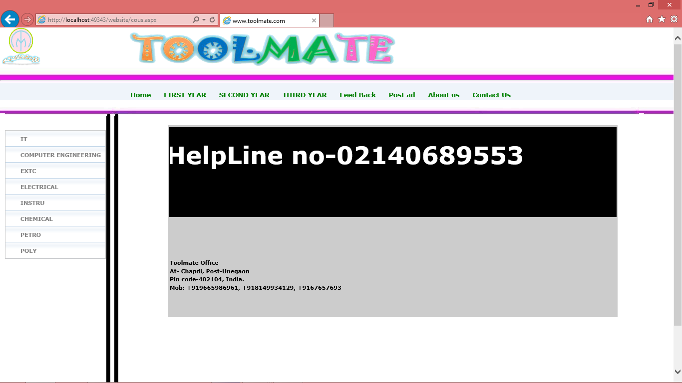

**BIBLIOGRAPHY**

* Mastering ASP.NET with VB.NET

Writer-Russell Jones.

* Web Designing and Programming

Writer-Rajesh Patwardhan.