 

An RGB-D tracker exploiting multi-feature local-global spatio-temporal consistency

Jingjing Xiao, Rustam Stolkin, Yuqing Gao, Heng Yang, Ales Leonardis

Abstract

This paper presents a novel method for single target tracking in RGB-D images, and also contributes a new benchmark dataset for evaluating RGB-D trackers. Despite its potential for occlusion reasoning, target depth information must be properly integrated with depth context and appearance features to avoid triggering false occlusion detections when targets move rapidly in the depth direction. To use depth information more robustly, we propose an adaptive multi-feature local-global target model with both temporal and spatial constraints. In the global layer, temporal consistency is used to adaptively fuse information from both RGB and depth images to find a candidate target region. In frames where one or more features are temporally inconsistent, this global candidate region is further split into local candidate regions for matching to local-layer target parts. Spatially, both target region and contextual feature statistics are used to robustly constrain matching of local-layer parts. We also derive a physical constraint from the depth context, which robustly accommodates large target depth variation, while still enabling accurate reasoning about occlusions. For evaluation, we introduce a new RGB-D benchmark dataset with per-frame annotated attributes and extensive bias analysis. Our tracker is evaluated using two different SOA methodologies, VOT [1] and VTB[2], and in both cases it outperforms the SOA RGB-D trackers.

Download: [PDF],[Dataset],[Results],[code: annotator],[code:tracker],[code:evaluation]

Share your results, please email to: shine636363@sina.com

Dataset (如果一排放不下九个，可以用滚动的方式播放，当然也可以根据你觉得漂亮的方式排版，但是RGB和深度要对其)

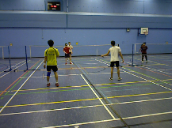 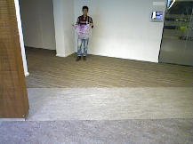  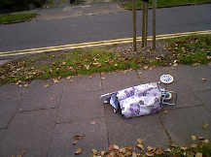 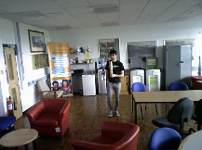 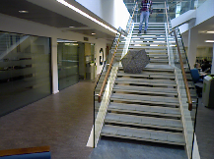

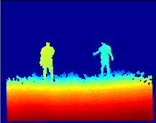 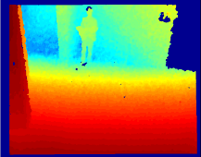 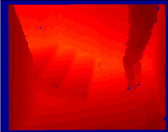 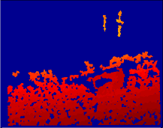 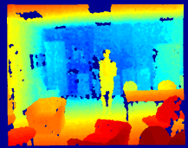 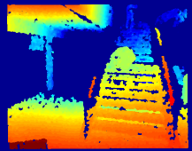

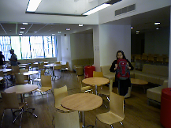 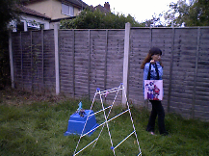 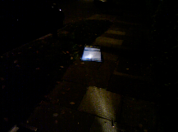 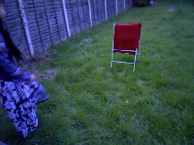  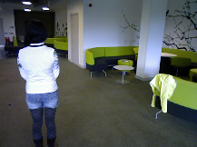

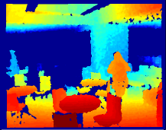 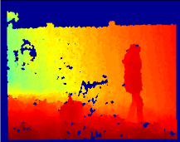 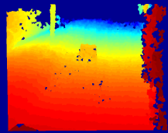 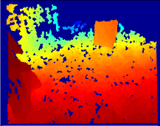 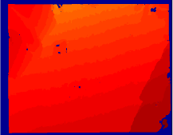 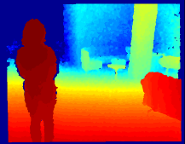

 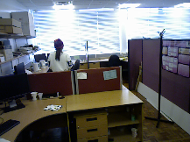 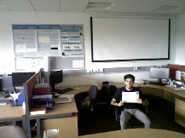 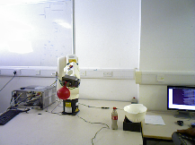  

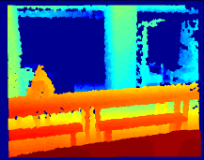 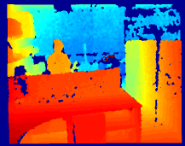 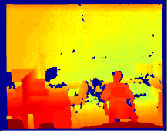 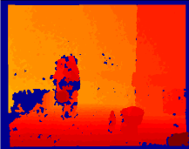 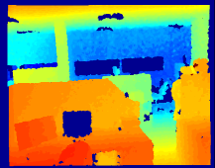 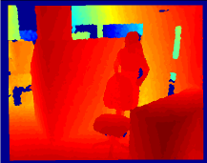

Results

Table 1 Area Under Overlap Curve

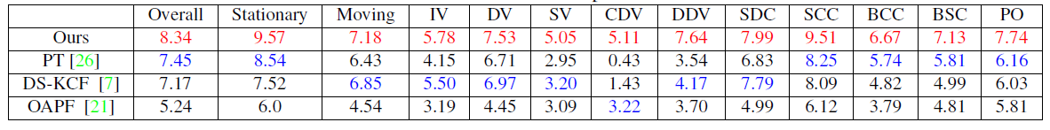

(请将文献变好改为[3][4][5],这个最好以table的形式，因为到时候我们可以随时更新排名)

Table 2 VOT protocol results

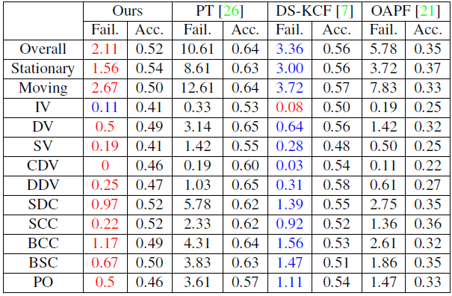

Acknowledgement

This work was supported in part by EU H2020 RoMaNS, 645582, and EPSRC EP/M026477/1.

Reference

[1] M. Kristan et al. The visual object tracking VOT2013 challenge results. In ICCV visual object tracking workshop, pages 98–111, Dec 2013.

[2] Y. Wu, J. Lim, and M.-H. Yang. Online object tracking: A benchmark. In CVPR, pages 2411–2418. IEEE, 2013.

[3] S. Song and J. Xiao. Tracking revisited using RGBD camera: Unified benchmark and baselines. In ICCV, pages 233–240, 2013.

[4] M. Camplani, S. Hannuna, M. Mirmehdi, D. Damen, A. Paiement, L. Tao, and T. Burghardt. Real-time RGB-D tracking with depth scaling kernelised correlation filters and occlusion handling. In BMVC. Springer, 2015.

[5] K. Meshgia, S.-i. Maedaa, S. Obaa, H. Skibbea, Y.-z. Lia, and S. Ishiia. Occlusion aware particle filter tracker to handle complex and persistent occlusions. CVIU, 2015.