### 

This is to certify that

**Mr:** Luong Hoang Huong

Has successfully Designed &

Developed:

Qui Huynh Dinh

Tinh Van Vo

Minh Cong Truong

Truong Van Nguyen

Submitted by:

Qui Huynh Dinh

Date of issue:

09-Mar-2018

Authorized Signature:

**Problem Definition**

**What is bridge?**

A bridge is a structure built to span physical obstacles without closing the way underneath such as a body of water, valley, or road, for the purpose of providing passage over the obstacle. There are many different designs that each serve a particular purpose and apply to different situations. Designs of bridges vary depending on the function of the bridge, the nature of the terrain where the bridge is constructed and anchored, the material used to make it, and the funds available to build it.

**Why we make it?**

Picture the scene. Africa, a young Neanderthal, lithe, hairy, fantastically fit, emerges from a clearing, makes his way down to a river, pauses, then runs nimbly across the dead tree that reaches from one side of the river to the other. And there it is, the first bridge crossing, and no one even made a note of it. Ever since that unrecorded moment, we’ve pushed at the limits of engineering and design, and improved on the dead tree over the river pretty much every time. To the point where we can put a bridge almost anywhere. We’ve got bridges that span rivers, that traverse mountain ranges, bridges over oceans, that connect countries, soar above jungles, and in the case of the Bosphorous bridge, that stick one continent to another. Sometimes, they seem almost timeless, transcendent. One of them is older than Christ. Let’s face it, we couldn’t live without bridges. So we’ve gathered together the most amazing bridges in the world that we could find. Just for you.

We want to create a website help you easy to know about it. This website will present the information about the various famous bridges throughout the world. The information behind this creation must be added. The information of amazing bridges can be categorized based on zone wise (Longest, Tallest, Highest, Oldest etc.).

All infomation we find it in the internet.

**Thank to:**

**Google**

**Wikipedia**

**Other website**

**Customer** **Requirement Specification(CRS)**

**Client:** Amazing Bridges

**Business/ project objective:**

Give customers one website to introduce to the world widely about the most famous bridge.

**Input provided by the client:**

* Home page must have the logo in the upper left corner.
* The site must contain links to navigate involving Amazing Bridges.
* The site must have the gallery, about us, contact us.
* The site must be located by Geolocation API on the maps.
* History and information about the bridges can be added along with the image.
* Gallery section can be added to see different images.
* The viewer has the right to respond.
* The advertising part of the bus, flights can be included to achieve places.

**Hardware Requirements:**

* A minimum computer system that will help you access all the tools in the courses is a Pentium 166 or better
* 64 Megabytes of RAM or better

**Software Requirements:**

* Notepad/HTML editor
* Dreamweaver
* IE 5.0/ Netscape 6.0

**Scope of the Work**

* The Home Page should be created making use of Sections with a suitable logo, the header section can be added which will show images of famous bridges.
* The site must contain the links to navigate through any category for the information.
* Links of monuments can be categorized by zone wise like (Longest, Tallest, Highest, Oldest etc.) apart from country wise link can be added.
* Clicking on any monument should open the page about the monument with it’s location displayed using GeoLocation API on the maps.
* History and information of the bridges can be added along with the images.
* Gallery section can be added for viewing different images.
* Feedback must be allowed to enter by the viewer
* Site map, Gallery, about us, Queries link, Contact us link must be added.
* The complete historic reason and its description must be allowed to get download as pdf or doc file.
* The advertise section of bus, flights can be included for reaching the places.

**Architecture and Design of the system**

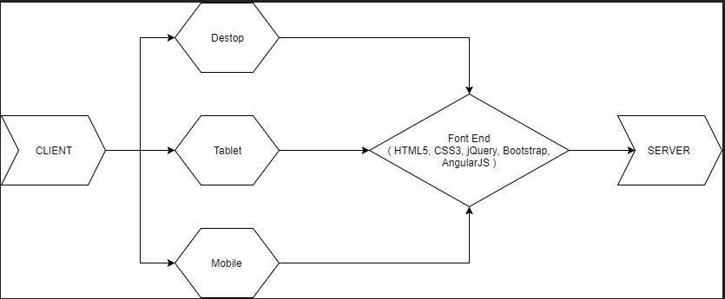

**Site Map**

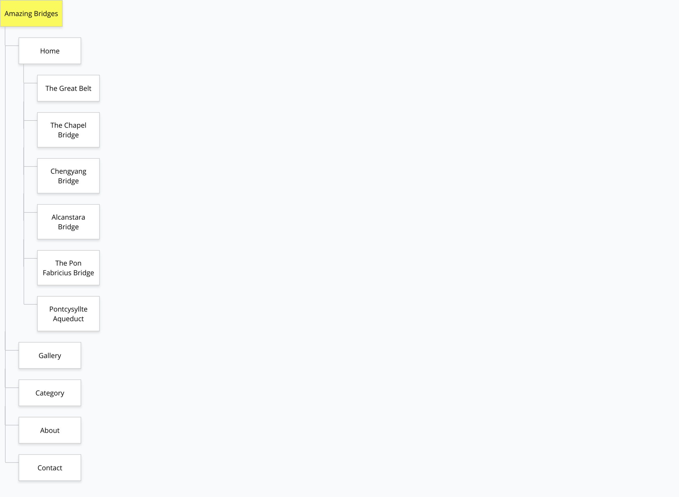

**Task Sheet**

|  |  |  |  |  |  |  |  |
| --- | --- | --- | --- | --- | --- | --- | --- |
| **Project Ref.No.:**  **eP/Advertisement**  **Portal Management**  **System/01** | | **Project Title:** | **Activity Plan Prepared**  **By:** | **Date of Preparation of Activity Plan:** | | | |
| **Sr.No.** | **Task** | **Actual Start**  **Date** | **Actual Days** | **Team**  **Mate**  **Names** | **Status** |
| 1 | Home Page design and coding |  | Huynh Dinh Qui |  | 3 | Truong.  Minh.  Tinh. | Completed |
| 2 | Gallery Page design, Single Page Application design and coding |  | Trinh Cong Minh |  | 2 | Qui.  Truong.  Tinh. | Completed |
| 3 | About Page design, Open Street Map and coding |  | Vo Van Tinh |  | 2 | Qui.  Minh.  Truong | Completed |
| 4 | Contact Page design and coding, Design Logo |  | Nguyen Van Truong |  | 3 | Qui. Minh.  Tinh. | Completed |
| 5 | Word Download |  | Huynh Dinh Qui  Trinh Cong Minh  Vo Van Tinh  Nguyen Van Truong |  | 2 |  | Completed |
| 6 | Word Document |  | Huynh Dinh Qui  Trinh Cong Minh  Vo Van Tinh  Nguyen Van Truong |  | 2 |  | Completed |

**Checklists of Validations**

|  |  |
| --- | --- |
| **Option** | **Validate** |
| Do all text links to the appropriate Web site? | Yes |
| Do all the image lead to the appropriate Web site? | Yes |
| Are all the image and links clearly visible on the page? | Yes |
| Is the Web page opening properly in all the tested Web  browers? | Yes |
| Is the Web page taking too long to load? | Yes |
| Is the navigation sequence correct through all the Web pages on the site? | Yes |
| Is the JavaScript code working as expected in all click event | Yes |

**Submission Checklist**

|  |  |  |  |  |  |
| --- | --- | --- | --- | --- | --- |
| **Sr.NO.** | **Particulars** | **Yes** | **No** | **NA** | **Comments** |
| 1. | Are all the users able to view the images  and links? | Yes |  |  |  |
| 2. | Have all the views, modules, and  coltrolles been properly integrated and  is the site functional as a Single Page  Application? | Yes |  |  |  |
| 3. | Are the GUI contents devoid of spelling  mistakes? | Yes |  |  |  |
| 4. | Is the application user-friendly? | Yes |  |  |  |
| 5. | Is the Web site launching correctly in the  browser? | Yes |  |  |  |

**4. User Guide**

**A. System Requiremients:**

|  |  |  |
| --- | --- | --- |
| **No.** | **Items** | **Description** |
| 1 | Operating System | Windows 8, 10, or higher |
| 2 | Software | Bootstrap 3.3 libraries from getbootstrap.com, jQuery plugins, and CoffeeCup, Notepad++, or other HTML editor. |