<https://www.youtube.com/watch?v=TEMhWt9WwTA>

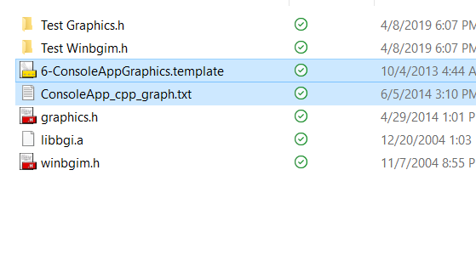

Copy in template folder

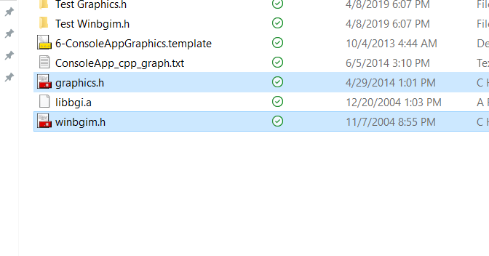

Include folder



Last one libbgi.a in lib folder

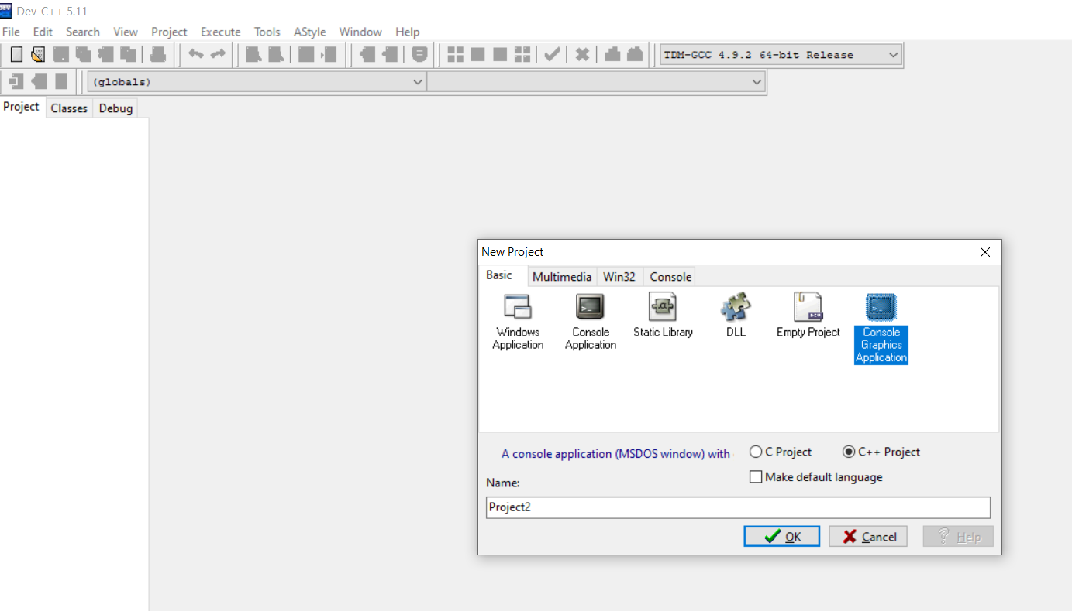

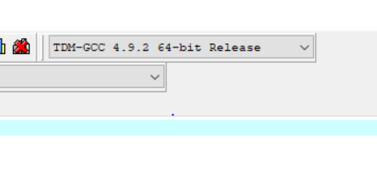

32 bit