Bootstrap Framework HTML5 - Desktop
IE10
- When we click on Start course button 1st time, course does not get load. It only shows loading icon on screen. And when we refresh the course it gets successfully launch.
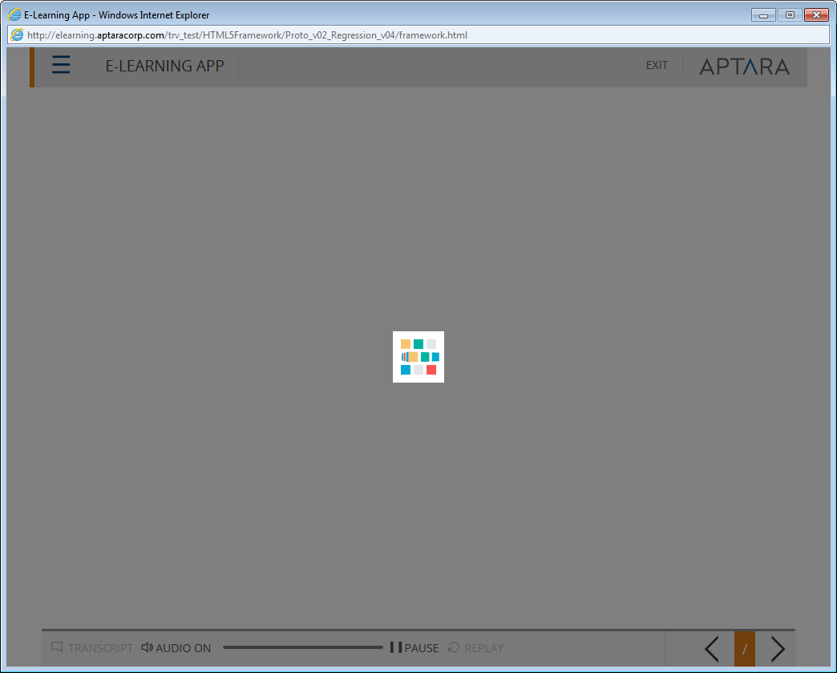
- Global for all - Recourse, Glossary, Help – Roll over effect is display on these buttons in disabled state when we click and move the arrow pointer outside from button. See the below snap for recourse button
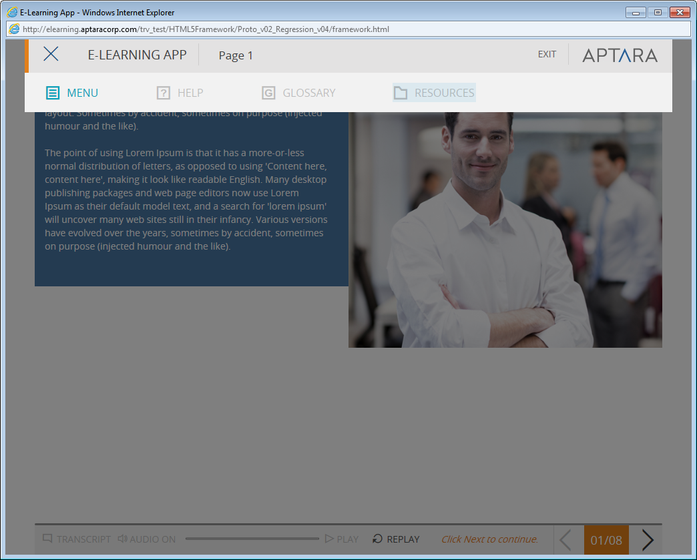
- Global - Menu popup – Current screen from Menu popup should not clickable. As of now hand cursor is enabled on currently selected menu item & it is clickable.
- Global - Menu popup & Page progress – Open Menu popup in middle of the page progress, now click on same page from menu item; here control moves to the same page button page gets resume from the point when we open Menu popup.
- Global - Menu item & Page title is mismatch.
- Menu button should not be enabled when we open Exit popup.
- Start Course button – When we click on Start course button course shell gets load but Start course button should not get disappeared immediately. It takes fraction of second, to disappeared
- Global - Play/pause button – Play/pause button should remain in same state after we open and closed the Menu popup. E.g. when play/pause button is in pause state (||) open and closed Menu popup. After closing menu popup, play/pause button state should be in Play mode, it remains as in Pause state. Check same scenario with Exit button popup. It working correctly.
- Global - Play/pause button, audio, Exit popup – In the middle of the page, make play/pause button in pause mode, now open and closed Exit popup; at this time audio starts playing but play /pause button state is not gets changed. Audio should get start when we change the play/pause button state.
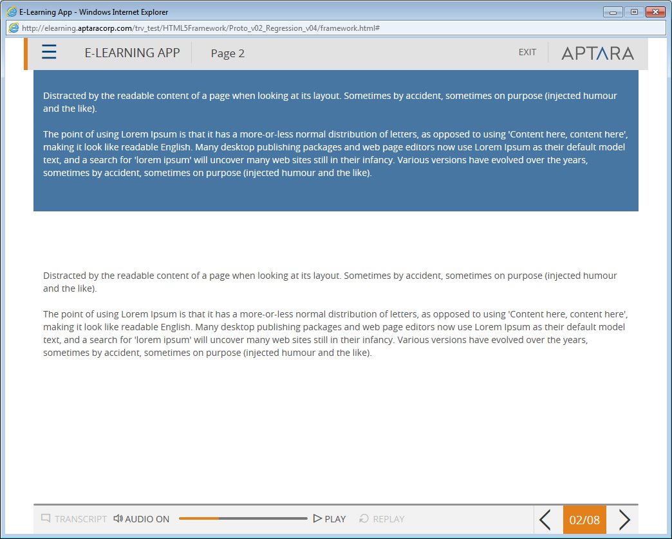

- Global - Page 6, Scroll bar is activate on theses screens – 6, 8,
- Progress bar progress bar shows the progress on Play/pause & Replay button. See the snap below. This is replicated after many permutation combination of the play/pause, Exit & Menu popup actions.

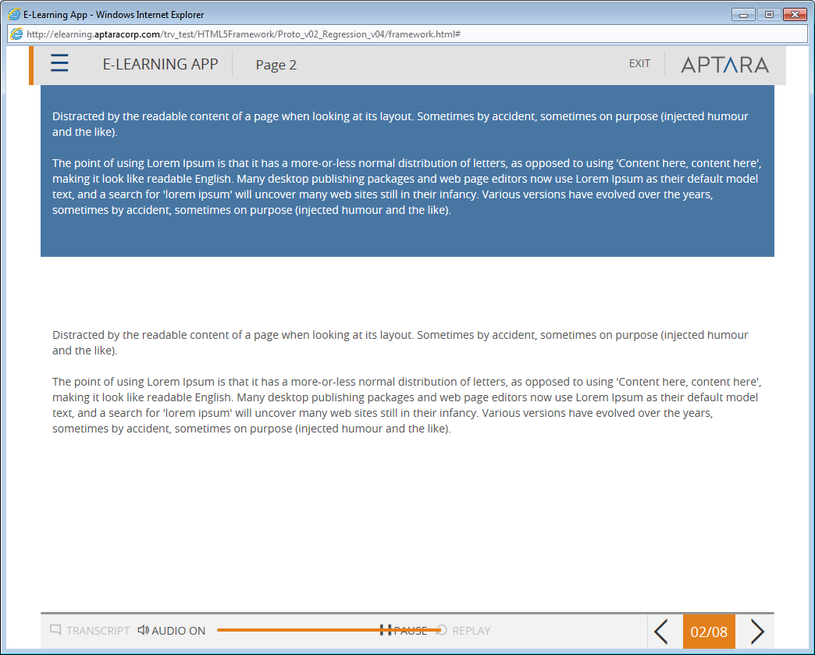

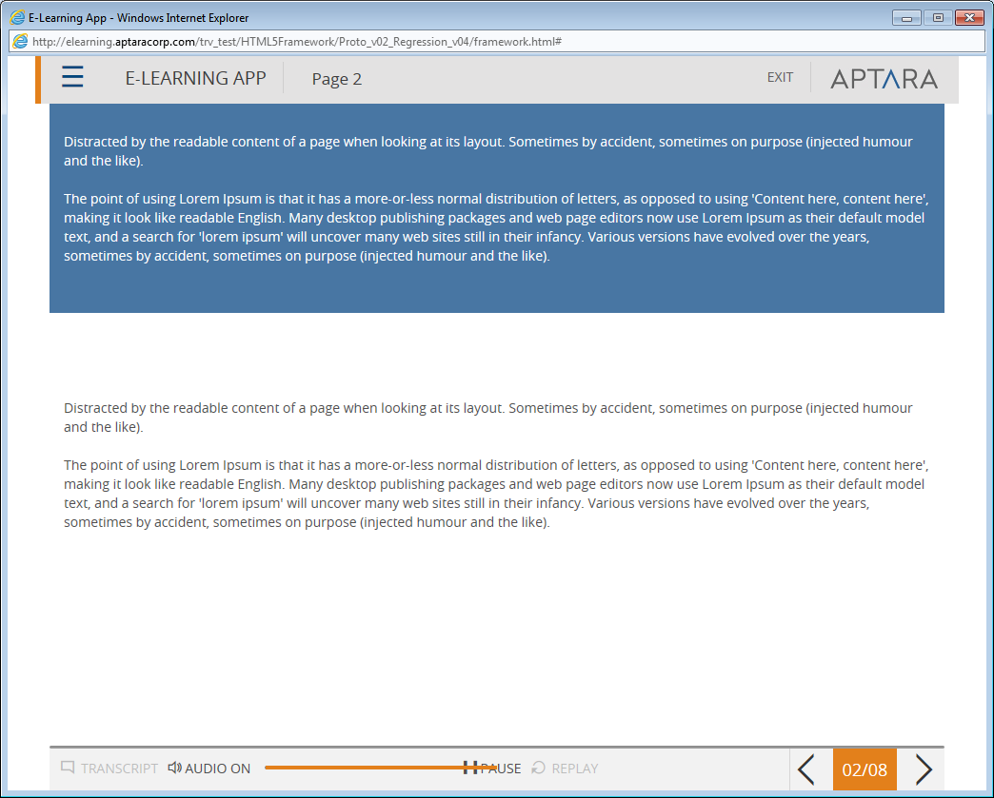
- Page 8, 7 – current selected state is not display in Menu popup for this screen for 1st attempt
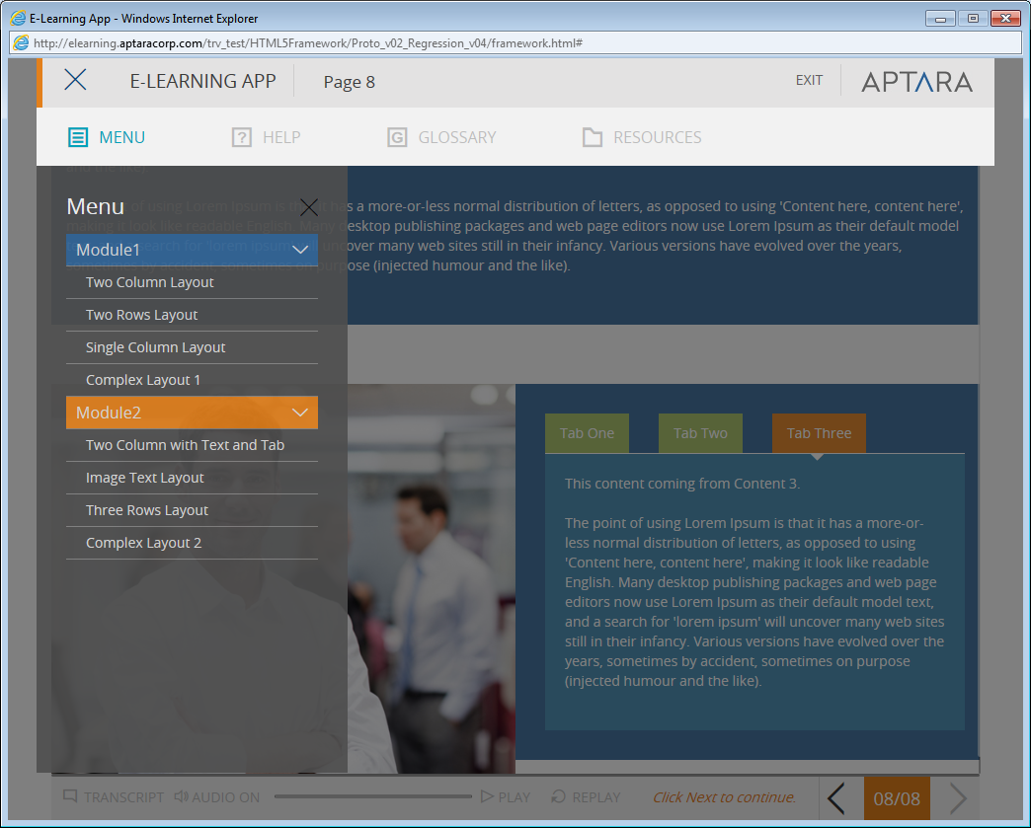

- Global - Exit popup – “No” button should be center aligned on blue patch.
- Global – Next button instruction should not get display on last screen

IE 9
1) Global - Play/pause button – Make play/pause button in pause mode & open & closed exit popup. At this time audio start playing but play/pause button state does not get changed.
2) Global for all - Menu popup – currently selected screen is clickable.

Mobile Devices
IPhone 4
- Start Course is not aligned correctly in portrait mode. DONE
- Landscape mode – iPhone menu bar gets disappeared in landscape mode on start course screen. It only display “Start Course” button in landscape mode. DONE
- Global for all – Menu popup – Open Menu popup in landscape mode now change the orientation to portrait mode, Menu popup gets disappeared. This is reproduce in vice versa portrait to landscape DONE
- Suggestion – Menu popup design is too much congested in both orientations.
- Global for all screens & mobile devices –
Scroll bar should get reset when we move to the next screen having scroll. E. g. page 2 & 3.
- Global – Text – Page 4, 5, – Tab 2 – dot is missing after 2 in 1st sentence. DONE
- Global – When we open menu popup grey patch is not display fully at the bottom.

IPad
- Start Course is not aligned correctly in portrait mode. DONE
- Top portion gets hide behind the browser tabs. And if we adjust the top side of the shell then bottom buttons gets cut.
- Audio is not playing on iPad for 1st attempt. It gets started in on 2nd screen & after navigating on 1st screen again gets paused.
- Progress bar – Progress bar is display on iPad but it is not working.
- As audio does not get complete, Replay button also not get enabled.
- Grey patch is not display till bottom shell buttons while navigating through the course.
- Exit button should not display on iPad.( In All Touch Device DONE )

- Course name & page title should not display correctly on both orientation.
- Menu, Help, Glossary, Recourse button labels are missing in portrait mode.
- Menu popup gets disappeared if we open it & change the orientation. DONE
- Next button instruction should not display on last screen.

Samsung S3
- Global for all pages. Ex.Page-1, Landscape mode image should be centrally aligned.
- Global, Progress bar is not appearing in both orientations.
- Landscape “Start course” button alignment is not proper. DONE
- Scroll bar should be reset when navigate to other page.
NOTE 8
- “Start Course” button alignment is not proper in landscape orientation. DONE
- In landscape mode gap is showing more on both sides.
- Global remove the unwanted scroll from page in both orientations.
- Progress bar is not appearing in both orientations.
- Global for mobile devices Pinch zoom functionality is showing enabled check whether it is required or not.
- Page-4, 5, 7 & 8 If change the orientation interactivity template design gets change.
Ex. If we select Tab3 in portrait & then change orientation to landscape, the opened tab is showing different check for vice versa.
- Global, on last page i.e. Page-8, Next button instruction is appearing.
- After opening Menu if we change the orientation it gets disappear. DONE
- Page-7 & 8, current selection is disappearing from Menu popup. DONE
- In both orientations shell buttons labels are missing.(IGNORED)

