New HTML5 Bootstrap framework and templates

- Start Course Button alignment is not proper.

- Menu bar button icon should not get change to “X” when we click on it.

- Exit button functionality – When we click on Exit button, its popup is display on screen but Yes / No button is not working. Also every thing gets freezed. See the below snap. User need to refresh the course. DONE

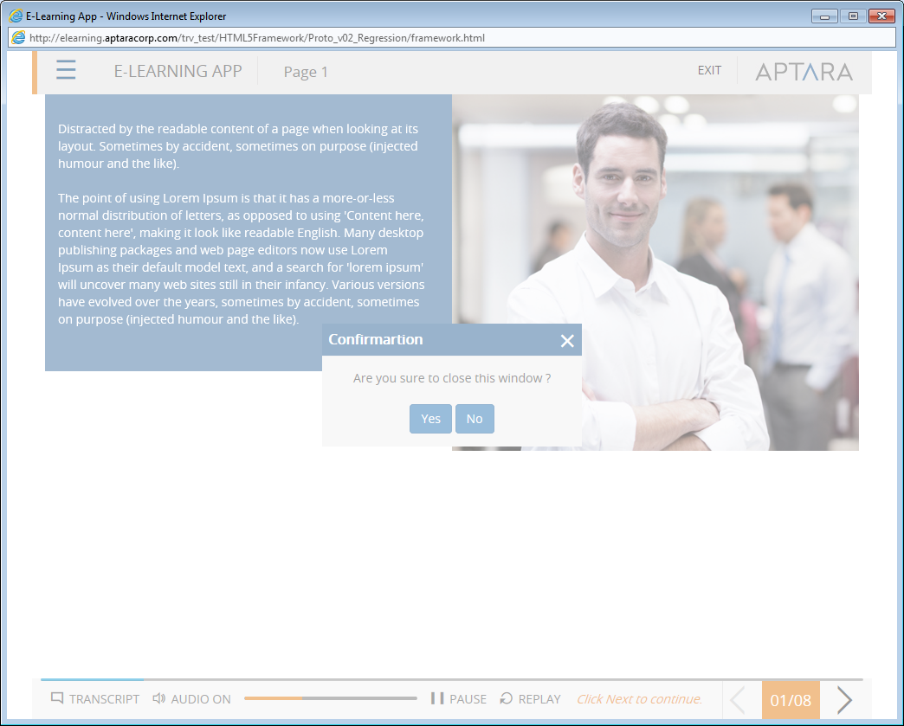

- Audio & Play/Pause button – When we click on Audio & Play/pause button other button alignment gets changed.

- On Screen Next Button instruction is display from starting. It should be display after page audio completion.

- Up on Replay Next button instruction need to reset.

- Help/Glossary/Resources – Hand cursor should not display on these button in disable state. As of now hand cursor is display on button icons and when we click on these buttons it gets enabled. DONE

- Menu popup –
  - Close button tool is missing.
  - Menu Module heading – hand cursor should display on both Module name whether it is in Expanded Or Collapsed state. DONE
  - Module Name – Leave some space/margin from left side while display in menu DONE

- Page loading – Some It takes more time to load the screen. And screen display blank
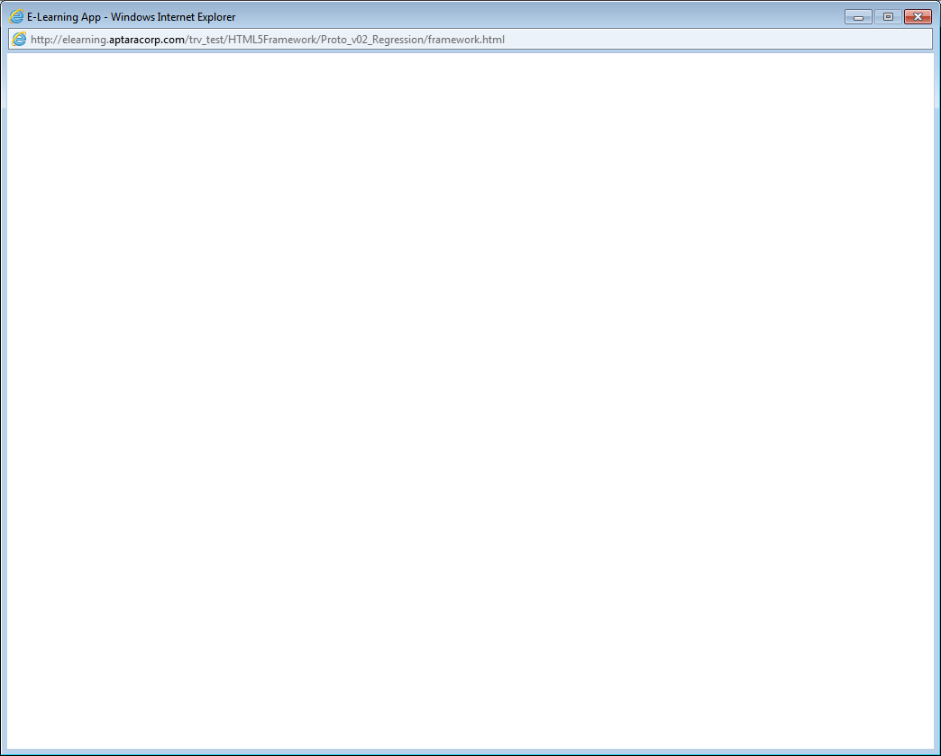

- Menu – Current selected Menu item state is display when we open the Menu popup. Now collapse the Module & expand it again, it does not show the current selected page. See the below 2 snap shots.

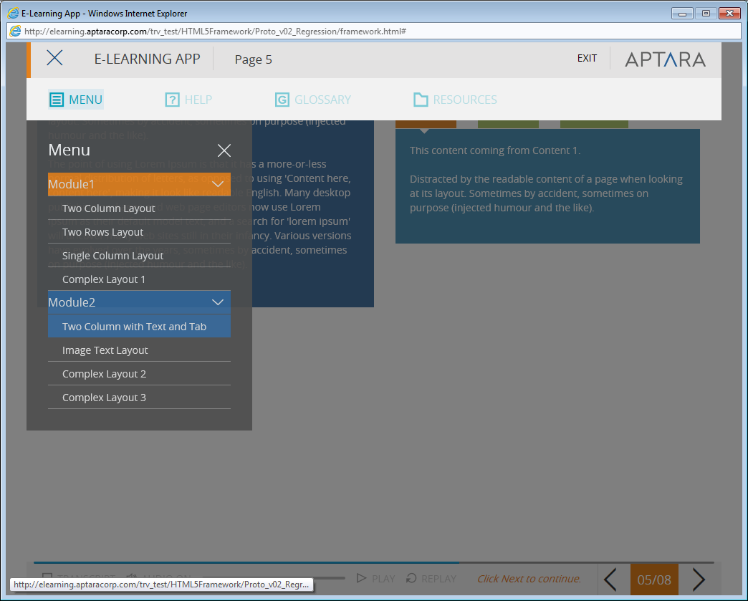

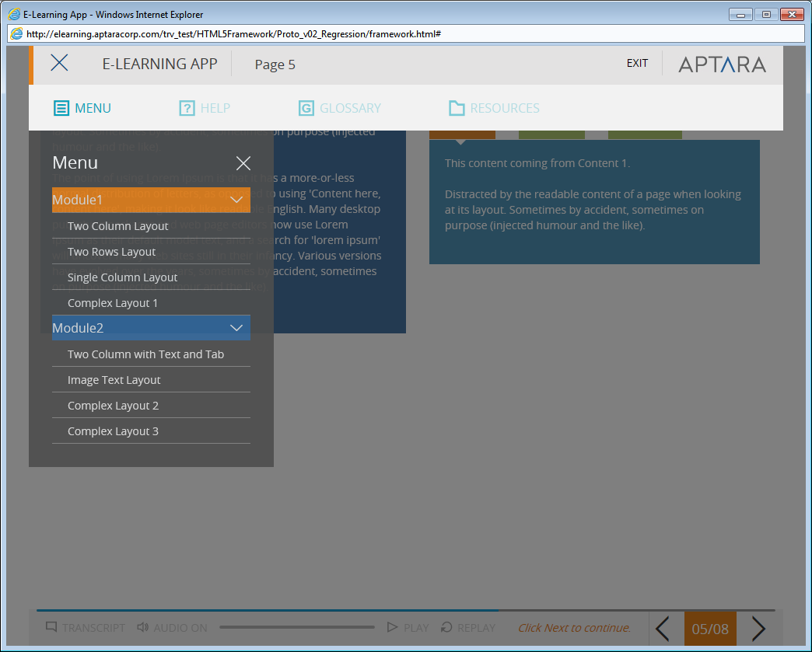

11) Next /Back Button should not display too much highlighted when we open Menu bar. State of Next Back button should be same as that of other buttons on screen.

- Next button – Next button should get highlight after page completion.

- Menu popup – Collapse all modules & close the Menu popup. Now again open Menu popup. Here the current selected Module should be display in Expand state.

The Menu should not display as below –

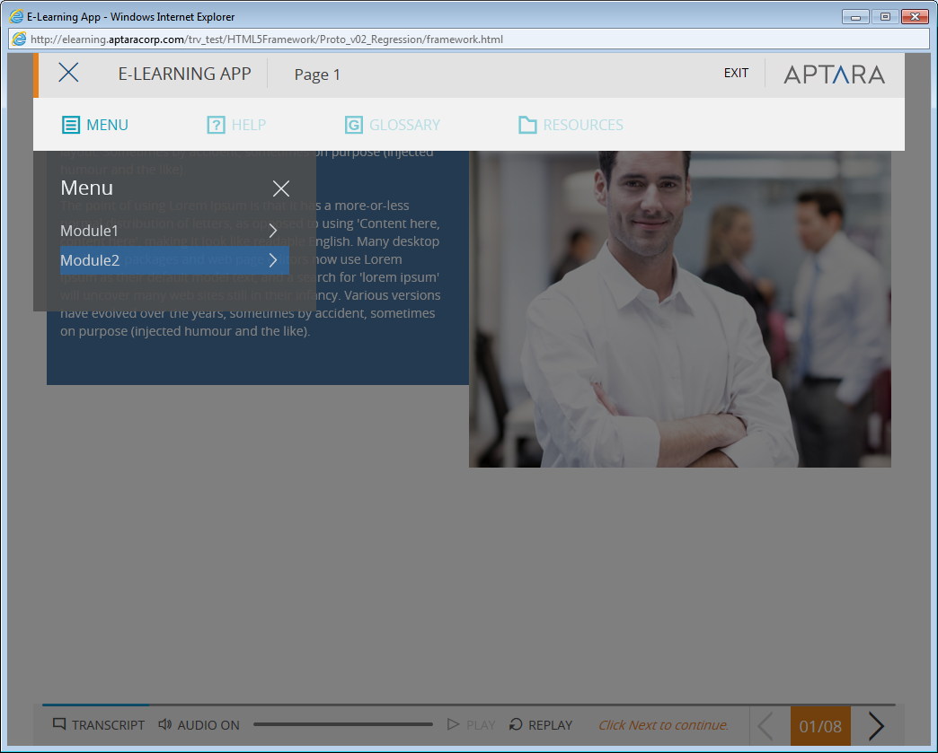

- Global for all pages -Transcript button – Page no. 1 Transcript button should be disable on this page.
- Global – Browser tool tip for all buttons is missing.
- Global – Roll over effect is missing for all buttons.
- Global – On screen images and text should be center aligned.
- Global for all pages – When we Pause the audio and if we open and close the Menu popup then the audio starts playing but Play/Pause button is in Pause state.
- Page 4, 5, 6, 8 – Replay button should be enable on this page.
- Page 4, 5, 7, 8 – Hand cursor should not appeared on selected tab. DONE
- Page 4, 5, 7, 8 – Dialog box tool tip should be appeared after selected any ant only. Currently is appeared on roll over the tab. Refer below screen shot. DONE
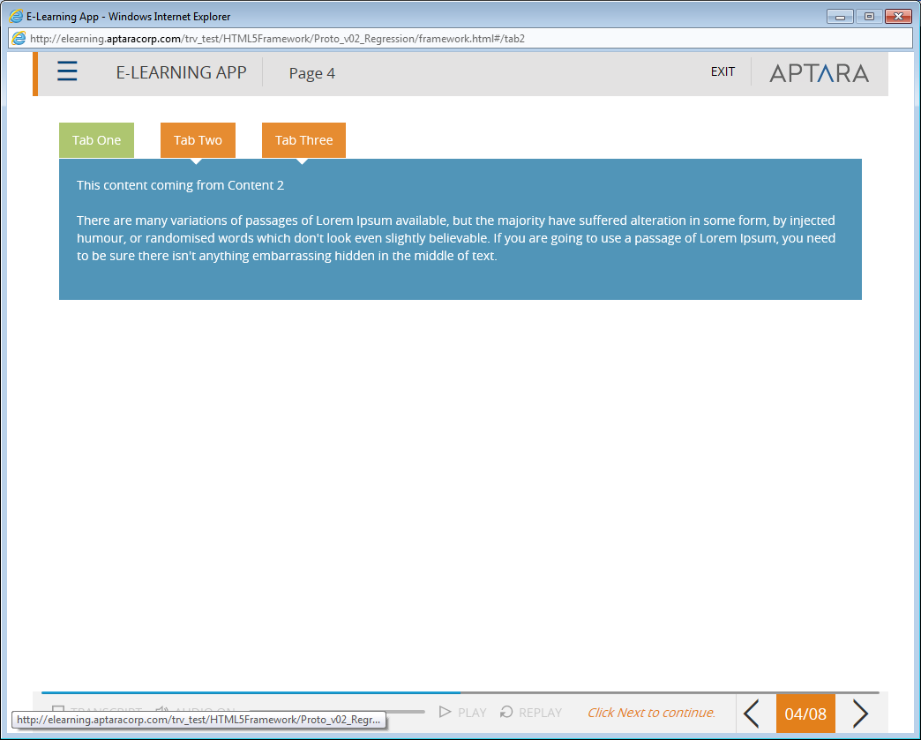

- Page 6, 8 – Hand cursor is appearing on below highlighted area. Scroll get activate. DONE
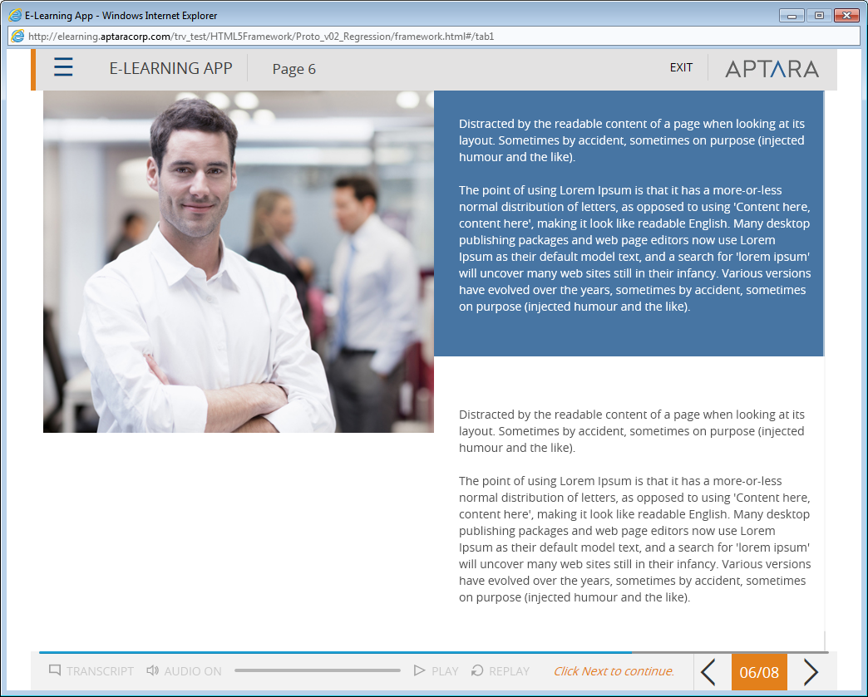
- Page 7 – Tab should get enable after audio completion.

