1 Địa chỉ website: https://caphetb.com/
URL các trang:
https://caphetb.com/index.html
https://caphetb.com/sildeshow.html
https://caphetb.com/du-lich-ha-long.html
https://caphetb.com/du-lich-hoi-an.html
https://caphetb.com/du-lich-sapa.html
https://caphetb.com/du-lich-phu-quoc.html
https://caphetb.com/updating.html
2. Phương pháp SEO: Sử dụng SEO keywords, description, alt: DU LỊCH
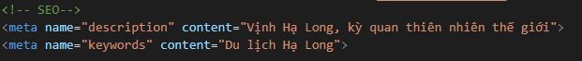
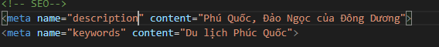
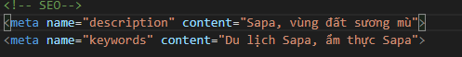
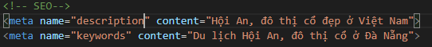
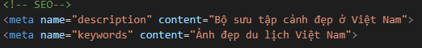
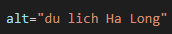
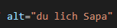
3. Dashboard Google Analytics:
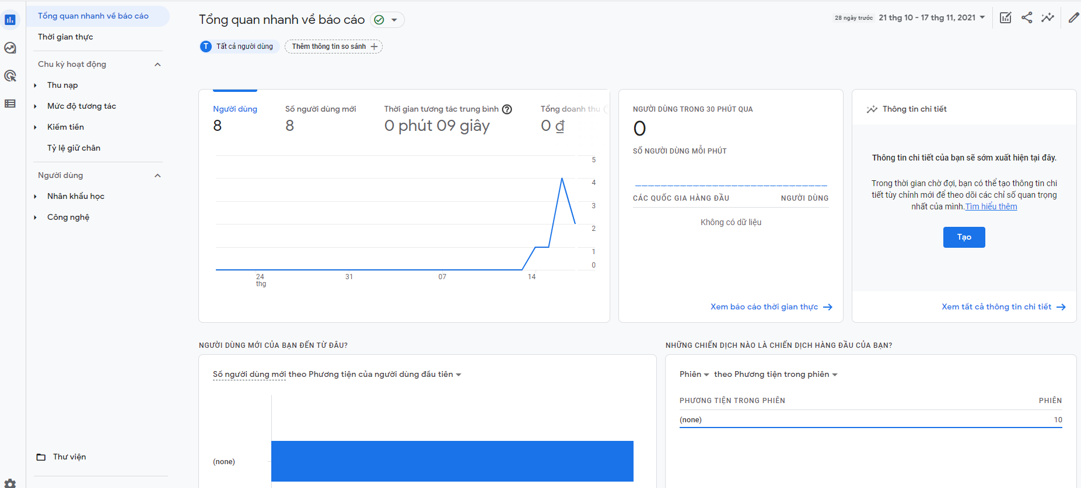

4. Dashboard Google Search Console:
