**Noah’s Pet Clinic**

**By Cutting Hedge Software**



**Viran Gohil 15500582**

Table of Contents

**Part I** 2

1.1 Executive Summary 2

1.2 3

**1.2a Main goals of the system, user & system requirements.** 3

**1.2b Users, Personas and Scenario’s.** 4

**1.2c Functional and non-functional requiremets for the user and the system** 9

1.3 High Level and Lower Level Use Case Diagrams for Noah’s Pet Clinic 14

**Low Level Use Case Diagram for Pet Registration** 16

**Low Level Use Case Diagram for Payments** 18

1.4 Data Flow Diagrams 25

**Part II** 28

2.1 Basic Entity Relationship Diagram 28

2.2 Extended Entity (EER) Relationship Diagram 30

2.5 Select Statements 31

2.6 Critical Analysis 33

**Part III** 34

3.1 SQL Query 34

3.2 SQL Query 35

3.3 SQL Query 36

3.4 SQL Query 37

3.5 SQL Query 38

3.6 SQL Query 39

# **Part I**

## 1.1 Executive Summary

Noah’s Pet Clinic is a highly regarded veterinary office and specialised dog clinic located in rural Manchester, staffed by seven veterinary doctors and five nurses alongside equally hardworking maintenance and cleaning staff. In recent years the clinic has turned annual profits of £50,546 (2012), £36, 004 (2013) and £12,976 (2014). In addition, there is a newly opened rival clinic in the area that is beginning to take business away from the clinic, affecting profits, forcing redundancies within the clinic and providing problems for the future.

In a world that is increasingly digital and where customers want more autonomy and more personalised care, the days of pen and paper medical records are over and it’s time to fully embrace electronic medical software as the necessary step to guarantee long term profits and real job satisfaction. When the ratio of filing cabinets to people starts to become unmanageable, we at Cutting Hedge specialise in condensing these bulky paper goliaths into a bitesize and user friendly database that allows for more sophisticated queries outside of their former alphabetised limits. Currently; customer data is cumbersome and difficult to access; issues as a result of staff shortages are being exacerbated by excessive administration; customers cannot interact with the clinic unless reception is available. Our proposal is to digitise the medical records and administrative duties of Noah’s Pet Clinic through an online database which will guarantee a more professional service that grants greater autonomy to customers whilst simultaneously freeing up services within the clinic.

We know that nobody wants to become a veterinary doctor or nurse so that they can deal with paperwork. For many in the industry we recognise that being a nurse or a doctor is a vocation where staff want to spend their time productively offering the best possible care for their customers. We understand that Noah’s Pet Clinic is competing in an environment where customers expect low prices as well as excellent service. In addition, we understand the very difficult task of convincing customers of the quality of your services in a market swelling with sleek private clinics. Our promise is to provide a competitive advantage that will afford staff the time necessary to deliver this quality of care. Billing and record keeping that would have taken hours will now take only minutes. Doctors and nurses will have the freedom to expeditiously search customer records from their desks as well as the ability to enter client details into the data-base in real-time. Everything about a client will be in one contained environment which can be accessed by any computer with internet access at the doctor’s convenience. In addition, customers will have access to a personalised profile that will facilitate the booking and amendment of appointments, the registration for themselves and their pets, and the ability to upload pet information prior to their appointment.

Specifically, this will be implemented through the use of Oracle’s SQL software to create the database and to facilitate useful queries over medical and staff records. Additionally, the clinic will be equipped with computers across the site and personal laptops to key members of staff. Cutting Hedge offers a six month guarantee where any errors or problems that might occur with the database will be managed by ourselves. This will allow staff the necessary time to become familiar with the system and allow for a smoother transition to the new digitised clinic. All staff and customer information is then filtered through different access rights and viewed through a single webpage. For staff the database will allow for immediate access on all information within the clinic whereas customers will have access to only their details.

Customers will feel their expense justified from the instance they register with the clinic through a site that personalises the customer experience. Everything will run and be managed more effectively through a system that instantly connects bookings, cancellations, deferrals, referrals, diagnoses and prescriptions to customer and pet profiles. Ultimately, this webpage will maximise the potential of the clinic and create a working environment with less stress and better organisational understanding for all staff.

## 1.2

### **1.2a Main goals of the system, user & system requirements.**

**Main Goals**

* Create a web based electronic diary accessible to staff and clients, with email appointment confirmation and SMS reminders
* Offer support and guidance during a six month guarantee period where errors will be fixed by those at Cutting Hedge
* Enable web based self-registration for new clients
* Create a pet registration and consultation history database enabling access to update and amend this data.
* Set up doctor's individual email contact centre to follow up regards ref feral, deferral and/or prescriptions.
* Set up a payment system with electronic billing and online payments for cancelled and attended appointments.

**User Requirements**

* User will be able to view the diary, view availability for appointments, make, amend and cancel appointments.
* Users will be able to self-register their pet online.
* Users will electronically check-in on arrival for appointment.
* Some Users will be able to view pets consultation history.
* Some users will be able to amend, create, email out and/or print consultation data.
* Some users will be able to send emails.
* Users will be able to pay online.
* Some users will be able to access and update staff data.

**System Requirements**

* System will give diary access to pet owners to enable them to book in and cancel directly.
* System will offer online self-fill registration for new owners that does not accept new pets over 12 years and records the owners name, pets name, pet type, owners address, pet gender, pets age, pets colour, pets weight and owners email address.
* System will send email confirmation of appointment and SMS reminder
* System will show real-time updated diary scheduled for staff.
* System will request owner check in upon arrival.
* System will advise doctor/nurse of patients arrival.
* System will store and enable retrieval of patient data from database.
* System will enable amendment and update of owner, pet data and consultation history.
* System will have an individual email and online access panel for vet doctors and a shared email address for vet nurses.
* System will take generate invoices and receipts as it will accept online payments for appointments.
* System will give diary access to cleaning and maintenance staff to schedule works.
* System will store, update and enable retrieval of staff data including doctor and nurse's names, contact numbers and whether they are part of full time.

### **1.2b Users, Personas and Scenario’s.**

|  |  |  |
| --- | --- | --- |
| Primary Users | Secondary Users | Tertiary Users |
| * Customer * Receptionist * Vet Nurse * Vet Doctor | * Managing Director | * Cleaner * Maintenance |

|  |  |  |  |
| --- | --- | --- | --- |
| User Type, Persona Type and Name | Profile | Skills |  |
| PRIMARY USER  Customer  Betty Crockett | 59 Years Old  Part Time Teacher  Married, children left home  Lives in 4 bed semi-rural house, Glossop   * Semi-retired English teacher * Plays piano in her spare time * Enjoys long walks with her 2 dogs in the country-side * Went to university and studied poetry * Husband works away on oil rigs * 3 Children, 2 married with kids, other at university studying business * Enjoys reading * Financially comfortable, but teachers part time in the local secondary school to keep herself busy.   Needs:   * Time outdoors with the dogs * Expects honesty * Doesn’t like people beating around the bush | Skills:   * Doesnt use the internet much, * Would need some training and guidance * The customer would access appointment details, fill in registration details and make payments | **Customer**  Betty would start her day by registering her pets on the system so that she can get a vet to look at her two dogs Page and Rock. She would fill in all the details about her two dogs onto the system, using the step by step instructions. Once all the information has been submitted, she would then get a notification by her email that she is registered. She will then be able to login into the system and make an appointment to see a vet for the first time. |
| PRIMARY USER  Receptionist  Kathy Smith | 40 Years Old  Receptionist  Married, children at home   * Lives in a 3 Bed Semi-detached house, Sale. * Married to her husband for 15 years * Has two sons aged 13 & 15 * Been a receptionist with the clinic for 5 years * Temp work before that * She has a cat named Roger * Enjoys knitting * Has a mortgage, low income, but not in any reasonable debt   Needs:   * Kathy needs stable income and stress free working environment * During quiet times getting on with her knitting * She expects good organisation | Skills:   * She is able to organise paper files and appointments diaries and phone calls * She is familiar with some computer programs like office from previous employment * Will need training for a ‘cloud’ based system * She will be using the system to make appointments, fill in registration details and process payments | **Receptionist**  Kathy would start her day by sitting at her desk and turning on her computer. She would access the appointments database, ready for relaying information with pet owners. If an owner called to make an appointment/change or cancel, then she can do that live at the same time. If a new owner comes into the clinic then she would give the owner a form to fill in, once they have filled it in, she will input the data into the database in order to make a new record for this owner/pet. Kathy will also let the doctors and nurses know when pet and owners have arrived, and also let them know when they can go through to see the doctor. She will also make new appointments to any owners who was told to make a new appointment from listening to the doctor. She will also process any payments which owners wish to do in the clinic. |
|  |  |  |  |
| PRIMARY USER  Vet Doctor  Sally Case | 29 Years Old  Recently Qualified Vet  Engaged, no children   * Lives in a two bed flat in Salford with her fiancée * Has a cat called Domino * Saving for her wedding, has student debt to pay off * Enjoys a good night in with a bottle of wine * Once married she wants to buy a house in the country   Needs:   * Friendly atmosphere * Coffee * Wants respect | Skills:   * Familiar with computers during her studying * Will need training for the new system * Doctor would be using the system to access the appointments and enter consultation information | **Vet Doctor**  Sally will start her day in his office looking at the appointments she has for the day. She will look at the notes of the system for each patient and note down anything that might be important for the consultation. During the consultation she will assess and examine the patient and any notes will be written on the system. After the consultation she will add any further notes to the system, and will write details if necessary for prescriptions. If she needs to refer the patient to a specialist, then she would create a letter to send to the specialist requesting that the owner comes and sees them. |
| PRIMARY USER  Vet Nurse  Megan Williams | Qualified vet nurse  31 Years Old  Single   * Shares a house with other nurses in Altrincham * Has a rabbit called Nibbles * Almost paid off student debt, has a credit card in arrears * In part-time training to become a vet   Needs:   * Time to ‘let her hair down’ * Respectable company | Skills:   * Some computer skills from her current studies * Will need some training with the new system * The nurse will use the system to fill in the weight of new pets, access appointment information and consultation notes | **Vet Nurse**  Megan will start her day from within the nurse office, she will look at what appointments there are in the day, and what might be necessary for each appointment. She will then see her first patient with the doctor who will then write down notes in the system as the doctor is seeing the patient. She will then get the information up for the next appointment and so on. If the she sees any new patients, she will weigh them and update the weight information within the registration details |
| SECONDARY USER  Managing Director  Adam Brown | 55 Years Old  Managing Director of the clinic  Married with 3 children   * Lives in Wilmslow with his wife and 2 teenage sons * Daughter has left to go to university * No pets * Enjoys expensive holidays * No debt, except Mortgage, large amount of savings   Needs:   * An orderly way to manage the clinic * Respectable and reliable staff | Skills:   * Only familiar with MS Office, however uses access currently * Some minor training needed * The managing director will access the system to manage employees and monitor payments | **Managing Director** Adam will look at the system occasionally throughout the day, making sure that there are no gaps in the appointments and making sure that all employees are in attendance. He will also monitor the payments system checking that there are no financial shortfalls from payments not being made. |
| SECONDARY USER  Cleaner  Mary Brooks | 68 Years Old Cleaner Widow   * Lives in 1-bedroom council flat in Wythenshawe * Has a dog called Princess * Enjoys her weekly bingo night * Has some money problems * Supported partly by husband’s life insurance   Needs:   * A safe atmosphere to work * Lots of cups of tea | Skills:   * Very poor computer skills * Not need access to the system | **Cleaner**  Mary will start off her day cleaning the offices and empty consulting rooms. She will look at the rota which has been given to her as where she needs to clean and what areas need to be cleaned in a certain way. She may stop and have a conversation will staff, but will not access the computer system. |
| SECONDARY USER  Maintenance  Bradley Higgins | 39 Years Old Maintenance Worker Married with one son   * Lives in Stockport in a 2-bedroom semi-detached house * Wife stays at home and son goes to high school * They have a dog named bouncer * Has a mortgage and loan debt * Enjoys rugby, supports Sale Sharks   Needs:   * No mess in the workplace * Friendly banter | Skills:   * Basic computer skills * Does not need access to the new system | **Maintenance** Bradley will start off the day looking at the list of jobs he needs to do that will have been left for him by management. Throughout the day he may be asked from working members of staff of issues that may need to be fixed within the offices and consultation rooms. He will not have access to the computer system at all. |

### **1.2c Functional and non-functional requirements for the user and the system**

Functional Requirements

|  |
| --- |
| **USER - Customer**   * User shall enter website * System will request login in order to book an appointment   + If not already ready registered.     - User shall input name and mail     - System will send verification link to user customer email     - Customer will click verification     - System will confirm email * User shall click log in * User shall enter username * User shall enter password * System will verify log in details with the database * System will display options to 'register pet', 'amend details', 'view/ book appointment'   + *If user selects 'register dog':*     - User shall enter 'pet owner name'     - User shall enter 'pet name'     - User shall enter 'age'     - User shall enter 'sex' ('m' or 'f')     - User shall enter 'address'     - User shall enter 'type & breed'     - User shall enter weight (if known)     - User shall click save information     - System will save to the database     - System will generate a the next available 'dog_id' between 1000 - 3000   + *If user selects 'amend details':*     - User will select which detail to amend     - System will update the database   + *If user selects 'view/ book appointment':*     - *If user selects 'view':*       * User shall amend appointment       * User shall cancel appointment       * System will charge £5 cancellation fee for on the day cancellations       * User will pay       * System will email a receipt     - *If user selects 'book appointment'*       * System shall display available dates       * System shall display vet & nurse       * User shall enter pet owners name & age       * User shall ender pet name, type & pet_no       * User shall select an available date       * System will email customer       * System will update diary database       * System will display price       * User will select 'pay now' or 'pay at appointment'       * *If user selects 'pay now'*         + User will enter payment details         + System will email a receipt       * *If User selects ' pay at appointment'*         + System will update appointment as 'not paid' |
| **USER - Vet**   * User shall enter database * User shall enter log in * User shall enter password * System will verify details with the database * System will give options to 'view appointment diary'   + If user selects 'view appointment diary':     - System shall display appointments     - User will select appointment     - System will show basic fee due     - User will enter additional fee due     - System will display consultation card     - User will enter diagnosis     - User will enter medication required     - System will display cost of medication     - User will enter a referral or deferral     - System will print prescription for customer     - System will save to database |
| **USER - Nurse**   * User shall enter database * User shall enter log in * User shall enter password * System will verify details with the database * System will give options to 'view appointment diary' & 'view/amend pet information'   + *If user selects 'view appointment diary':*     - System shall display appointments     - User will select appointment     - System will show basic fee due     - User will enter additional fee due     - System will display consultation card     - User will enter pets_weight     - System will save to database   + *If user selects 'view/ amend pet information':*     - System displays list of registered pets     - User will select which detail to amend     - System will update the database   **USER - Receptionist**   * User shall enter database * User shall click log in * User shall enter username * User shall enter password * System will verify log in details with the database * System will display options to 'register dog', 'amend details', 'view diary' or 'book appointment'   + *If user selects 'register dog':*     - User shall enter 'pet owner name'     - User shall enter 'pet name'     - User shall enter 'age'     - User shall enter 'sex' ('m' or 'f')     - User shall enter 'address'     - User shall enter 'type & breed'     - User shall enter weight (if known)     - User shall click save information     - System will save to the database     - System will generate a the next available 'dog_id' between 1000 - 3000   + *If user selects 'amend details':*     - User will select which detail to amend     - System will update the database   + *If 'view':*     - System shall display appointments     - User will select appointment     - User will mark if patient attended/ not attended       * If 'not', System will charge £5 cancellation fee     - System will show fee due     - System will save to database   + *If user selects 'book appointment':*     - System shall display available dates (mon or fri only)     - System shall display vet & nurse     - User shall enter pet owners name & age     - User shall enter pet name, type & pet_no     - User shall select an available date     - System will email customer & staff     - System will update diary database     - System will display price     - User will select 'pay now' or 'pay at appointment' |
| **USER - Managing Director**   * User shall enter database * User shall click log in * User shall enter username * User shall enter password * System will verify log in details with the database * System will display options to 'view customers', 'view diary' & 'view/ amend staff'   + *If 'view customers':*     - System will display a list of customers     - System will display fees & fees due   + *If 'view diary':*     - System will show a list of appointments   + *If 'view/ amend staff':*      - *System shall show list if staff*     - *System will show salaries*     - *User will add staff*     - *User will update staff*     - *User will update salaries*     - *System will display updates.* |

**N**on-Functional Requirements

|  |
| --- |
| **Non-Functional – Users**  **Access Rights**   * Receptionist access rights: pet registration, appointment diary & consultation card * Vets access rights: appointment diary, consultation card * Nurse's access rights: appointment diary, consultation card, pet registration * Customers access rights: Their own appointments cards, pet registration * Managing directors access rights: Staff database, appointment diary. * Users must have access between 7am - 8pm.   **Non-Functional - System**  **Technical constraints**  Hardware   * Windows 7 PC's: Intel I5 processors, 4GB RAM, 250 GB SSD - In consultation rooms & ón reception. * Printers - in consultation rooms & ón reception. * Bank card reader for payments   Software   * Windows 7 - Reliable * Oracle database   **Performance**   * Updating data fields will take no longer than 3 seconds * System shall process at least 5 amendments per second * System will store a maximum number of 2000 clients & their pets   **Reliability constraints**   * pet_no will be between 1000 - 3000 * System will allocation the next sequentially available pet_no * All pet registration fields are compulsory except pet_weight * All appointment fields are compulsory except 'attendance' * Error message displayed if information not saved to the database   **Security constraints**   * System must have an anti-virus from Trojan attacks and hackers. * System requires passwords must have at least 6 characters and at least one number. * System requires all users except customers to change their password every 2 months. * System requires   **Financial constraints**   * System must be built for £15,000   **Time Constraints**   * System must be built within 4 months. |

## 1.3 High Level and Lower Level Use Case Diagrams for Noah’s Pet Clinic

**High Level Use Case Diagram for Noah’s Pet Clinic**



The high level use case diagram shows how users interact with the new pet clinic system. There are a total of 5 actors who interact with the system. These are the Customer, Receptionist, Vet Nurse, Vet Doctor and the Managing Director. The use cases which make up the new system include Pet Registration, Appointments, Consultation, Payments and Staff.

The first use case, which is Pet Registration, three actors interact with this. The customer interacts with the Pet Registration use case so that they can register their pet with the clinic via the online system from home. The receptionist interacts with the Pet Registration use case as she can register new pets if the customer decides to come in and fill in a paper form, the Receptionist will then input all this information into the system. The Vet Nurse interacts with this use case in order to add the pet’s weight to the new registration file.

The second use case which is Appointments has four actors interacting with it. These are the Customer, Receptionist, Vet Nurse and Vet Doctor. The customer will interact with the Appointments use case so that they can book and cancel appointments to see a vet online from home. This will give them a greater flexibility without having to call during clinic opening hours. The receptionist will interact with the Appointments use case so that she can make new appointments on request by customers. This will come from customers calling to make appointment, those who wish to make an appointment in person. Also, after a consultation, a vet may request the customer make a follow-up appointment, this will be done at Reception. The Vet Nurse and Doctors will interact with the Appointments use case in order to organise their day. They will need to know when they have appointments each day and who it will be with.

The third use case which is Consultation has two actors that interact with it. These are both the Vet Nurses and the Vet Doctors. This is so they can input the information for each pet when they have a consultation. They then may need to use the system to contact specialists or prescription information.

The fourth use case which is Payments, there are three actors who interact with this. They are the Customer, Receptionist and the Managing Director. The Customer interacts with this so that they can make payments for appointments and other fees they might have to pay, they can do this online at home. The Receptionist will interact with this use case as she can process payments at Reception on behalf of Customers. The Managing Director can interact with the use case so that he can monitor payments made. This is so he can manage the financial matters regarding the clinic and any problems or complaints the clinic may receive.

The last use case is that of the Staff part of the system, this has only one actor. The actor for the Staff use case is the Managing Director. This is so he can have access to all the staff information and he can then add or delete staff from the system as they come and go.

# **Low Level Use Case Diagram for Pet Registration**



This low level use case diagram shows how users interact with the new pet registration part of the new system. There are a total of 3 actors who interact with this part of the system. These are the Customer, Receptionist, and Vet Nurse. The use cases which make up this part of the include Enter Customer Name, Enter Customer Address, Contact Details, Add Pet, Gender, Age and Weight.

The first use case, which is Enter Customer Name, has two actors interact with this. The Customer interacts with the Enter Customer Name use case so that they can enter their Name onto the registration system via the online system from home. The Receptionist interacts with the Enter Customer Name use case as she can fill in the Customer Name into the system. If the customer decides to come in and fill in a paper form, the Receptionist will then input all this information into the system.

The second use case, which is Enter Customer Address, has two actors that interact with. Like the use case above the Customer interacts with the Enter Customer Address. So that they can enter the information online. The Receptionist can also input the information herself if the customer decides to come in and fill in a paper form, the Receptionist will then input all this information into the system.

The third use case, which is Contact Details, has two actors that interact with. Like the use case above the Customer interacts with the Contact Details. So that they can enter the information online. The Receptionist can also input the information herself if the customer decides to come in and fill in a paper form, the Receptionist will then input all this information into the system.

The fourth use case, which is Add Pet, has two actors that interact with it. Like the use case above the Customer interacts with the Add Pet. So that they can enter the information online. The Receptionist can also input the information herself if the customer decides to come in and fill in a paper form, the Receptionist will then input all this information into the system.

The fifth use case, which is Pet Type, has two actors that interact with it. Like the use case above the Customer interacts with the Pet Type use case so that they can enter the information online. The Receptionist can also input the information herself if the customer decides to come in and fill in a paper form, the Receptionist will then input all this information into the system.

The sixth use case, which is Gender, has two actors that interact with it. Like the use above the Customer interacts with the Gender use case so that they can enter the information online. The Receptionist can also input the information herself if the customer decides to come in and fill in a paper form, the Receptionist will then input all this information into the system.

The seventh use case, which is Age, has two actors that interact with it. Like the use above the Customer interacts with the Age use case so that they can enter the information online. The Receptionist can also input the information herself if the customer decides to come in and fill in a paper form, the Receptionist will then input all this information into the system.

The eighth use case, which is Weight, has three actors that interact with it. These are the Customer, Receptionist and Vet Nurse. The customer interacts with this use case, so they can enter the weight of their pet if they know upon registering online. The receptionist interacts with this use case because she also can enter this information which she will copy from the form that an owner has filled in. The nurse interacts with the use case because she can weigh the pet herself when the owner arrives for the first time. She can then enter the weight onto the system.

# **Low Level Use Case Diagram for Payments**



This low level use case diagram shows how users interact with the payments aspect of the new system. There are a total of 3 actors who interact with this part of the system. These are the Customer, Receptionist, and Managing Director. The use cases which make up this part of the include Logon, Find Customer Details, Choose type of payment, Enter Card Details, Verify Card Details, Confirm Payment, Produce Receipt and View Payment Transactions.

The first use case, which is Logon, has three actors interact with this. The Customer interacts with the Logon use case so that they can enter log into the payment system from home. The Receptionist interacts with the Logon use case so she can logon to the system ready to input customer payments. The Managing Director interacts with this use case so that he can logon to the system in order to access the payment data he needs.

The second use case, which is Find Customer Details, has only one actor that interact with. The receptionist interacts with this use case so she can find the customer details for the customer wishing to pay. This will bring up the details of what the customer needs to pay and how much.

The third use case, which is Choose type of Payment, has two actors that interact with. The customer interacts with this use case as when they are on the payment system they need to choose their method of payment. The Receptionist also interacts with this use case as she can pick the method of payment which the customer in reception wants to use.

The fourth use case, which is Enter Card Details has two actors that interact with it. The customer interacts with the use case as they enter the details of their debit/credit card into the system. The receptionist interacts with this use case by inserting the customer’s card into the card machine. Once the card is in the machine the card details will be read and entered into the system.

The fifth use case, which is Verify Card Details has two actors that interact with it. The customer interacts with the use case, as the system verifies the card information. The receptionist interacts with this use case as the system verifies the data which is given from the card machine.

The sixth use case, which is Confirm Payment has two actors that interact with it. The customer and receptionist interacts with the use case. The system will confirm to the user that the payment transaction has been processed successfully.

The seventh use case, which is Produce Receipt has two actors that interact with it. The customer interacts with this use case, and will receive a receipt by email will the payment details. The receptionist who also interacts with this case, will have a receipt produced by the card machine which can be given to the customer.

The last use case which is View Payment Transactions has only one actor. The Managing Director interacts with this case. He can view the payment transactions to make sure everything is accountable for.

**Low level use diagram for appointments**

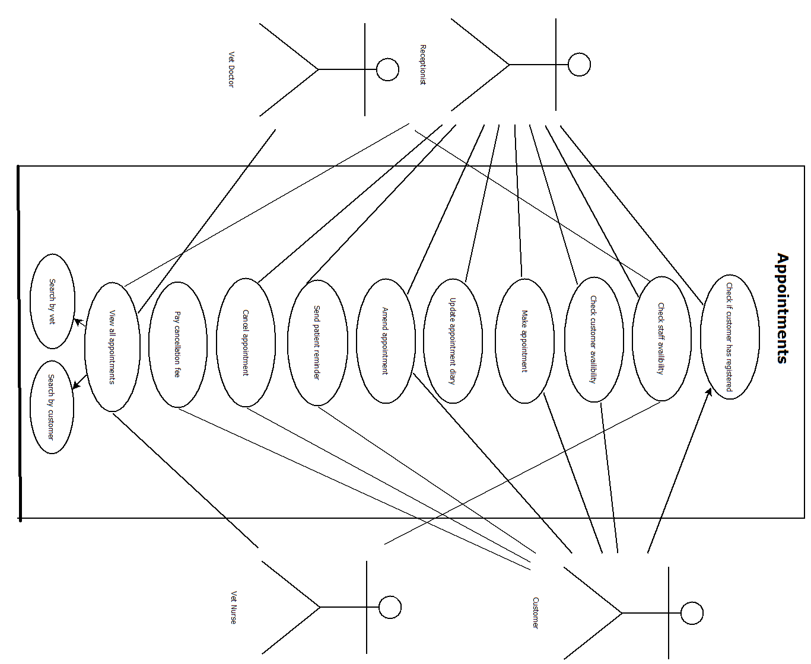

This lower UML diagram displays four users that have regular interaction with the appointments system and incudes; receptionists, customers, veterinary doctors and veterinary nurses. The diagram aims to display their relationship with the various processes that exist within this system.

The first function on the diagram involves both the receptionist and the customer where in order for an individual to book and attend an appointment, registration is a required. Searching for the Pet ID will allow either user to check if a profile already exists which is necessary due to the information that is captured during the registration process.

The next three operations involve all four users. In order for a time to be agreed the database needs to be able to display which offices and what staff are available. The availability then needs to be checked against the customer’s schedule in order for an appointment to be made. Currently our system does not store the exact working hours for the employees but this could be added at a later date. Instead, availability would be shown through the existing appointments schedule.

An appointment can be booked either by calling reception, who can manually enter in the details, or by the customer themselves using the webpage. Ideally the customer would be shown a calendar with the available times and they can simply click and confirm the best time for them whereas the receptionist will see a more complete appointments table.

In any working environment flexibility is key and staff changes sometimes need to be made on short notice. The update appointment diary function is specifically referring to the receptionist’s responsibility in making sure that any of these changes can be updated quickly. Similarly, the amend appointment function is referring to the customer and receptionist’s ability to amend the time of the appointment when all other details remain the same.

Patient reminders will be sent automatically 48 hours before the agreed time to give the opportunity for the customer to cancel without incurring any cancellation fees. The receptionist can send these reminders but the system can do it automatically. The customer will be prompted to get in touch if any changes need to be made. If the appointment does need to be cancelled this can again be done either through the webpage or through the receptionist. If a cancellation is made on the same day, the customer can pay their cancellation fee through the webpage within 28 days of cancelling or it will be added to be next appointment cost.

Finally, in order for the clinic to run efficiently all staff need to be able to view appointments. This can be done by any staff member through the webpage and their staff login.

**Low level use diagram for Consultation**

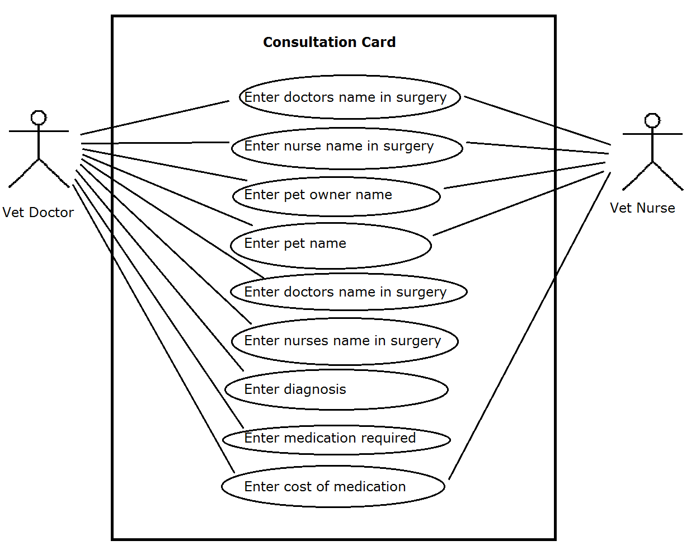

This lower level use case diagram shows how users interact with the consultation area of the system. There are two actors who will interact with this part of the system; Vet doctors and Vet Nurses. The use cases consist of entering the pet owners name, pet name, doctors name in surgery, nurses name in surgery, the diagnosis, any medication required along with its cost, a referral if necessary and deferral if applicable.

When the patient comes to the appointment, both actors, the vet doctor and vet nurse both have access to enter the pet owners name & pet name, this is so the system is flexible enough to deal with times where the vet doctor might be busy doing something else and vice versa.

Similarly, we have extended this flexibility to allow both the vet doctor and vet nurse to enter the doctors name in surgery and the nurses name in surgery.

Once the examination of the pet is over, the vet doctor will enter the diagnosis. Access is restricted to the vet doctor only because only the vet doctor is qualified to give this information. If there are any required medicines associated with the diagnosis the vet doctor will enter the medication required and the cost of this medication.

Only the vet doctor can refer a patient to another specialist and if this is applicable the vet doctor will enter this information. The vet doctor can then send a copy of the consultation card to the specialist who will then contact the pet owner directly to make an appointment.

Both actors; the vet doctor and the vet nurse can enter whether a deferral is advised. If so, the pet’s owner will either take the consultation card to reception to book another appointment or do it themselves at a later time via the website.

**Low level use diagram for Staff**

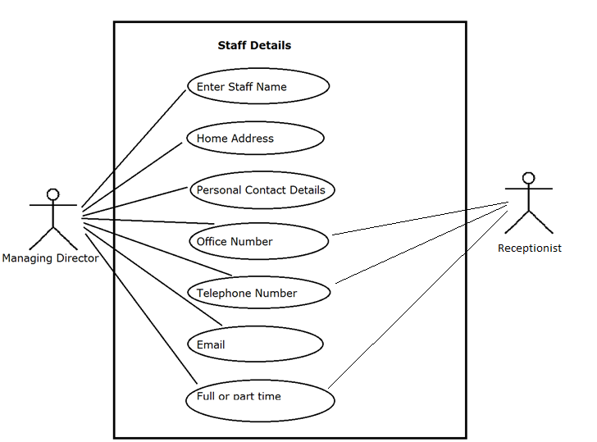

This lower level use diagram shows how users interact with the staff details with the system. The two actors who will interact with this part of the system are the managing director and the receptionist. The managing director will have full access to access, amend and create new staff name entries, homes addresses, personal contact details, office numbers, telephone numbers, emails, addresses and whether they are full or part-time. The receptionist will interact to allocate, view, and amend office numbers, telephone numbers and whether they are full or part –time.

## 1.4 Data Flow Diagrams

LEVEL 0 (Context Level)

High level data flow showing that generically users will login before interacting with the system. The output of their interaction will be diagnosis and treatment for their pet’s ailments and /or information in terms of appointment times or patient history.

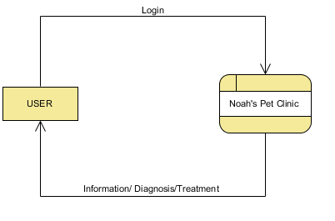

**LEVEL 1 DFD**

The first level diagram shows that users will login. In the case of new clients, they will have to self-register before making an appointment. All registered users will login to the diary and contact centre where clients can view appointment availability and staff can access and send emails. Once an appointment has started, vet doctors and nurses will access the patient history in the patient database.

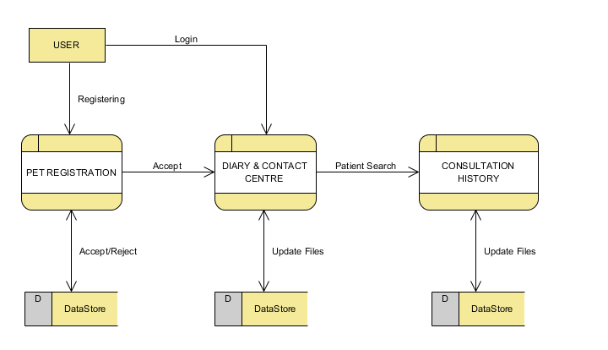

**LEVEL 2 – PET REGISTRATION DFD**

The level 2 diagram shows the user interaction in terms of registering a new patient. For self-registering pet owners, they will enter basic personal details and an email address which will send a verification email. Clicking on the link within the verification email will verify their email address enabling access to the pet registration requirements. Upon entering these details, they will proceed to view the diary. If a staff member completes details on behalf of a pet owner, the option will be available to override email verification.

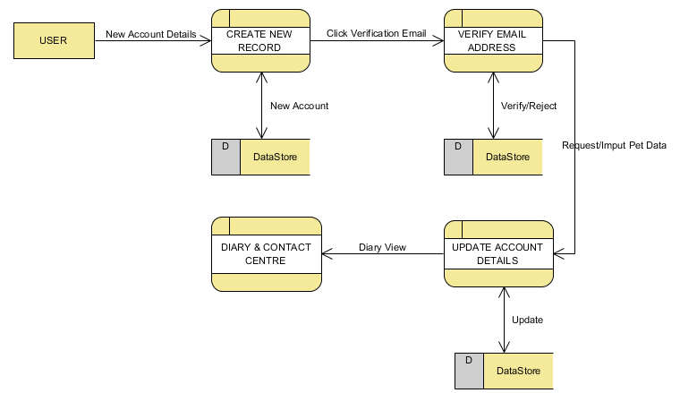

**LEVEL 2 - DIARY AND CONTACT CENTRE DFD**

The diary and contact centre interaction for all users enables access to view, select and cancel appointments in a real time diary. It also shows how customers will be able to pay online for same day cancellations. Furthermore, it shows how the system will automatically send appointment confirmation emails and sms reminders to pet owners. Relevant staff users will send and receive emails and set up their own diary alerts.

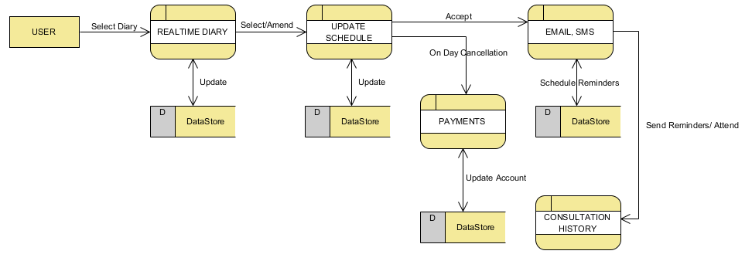

**LEVEL 2 – CONSULTATION HISTORY DFD**

The consultation history diagram shows how authorised users will access, select, create and update owner and pet details and payment history outputting relevant information back to the diary and contact centre form where it is electronically communicated with customers or third-party vets in the case of referral’s.

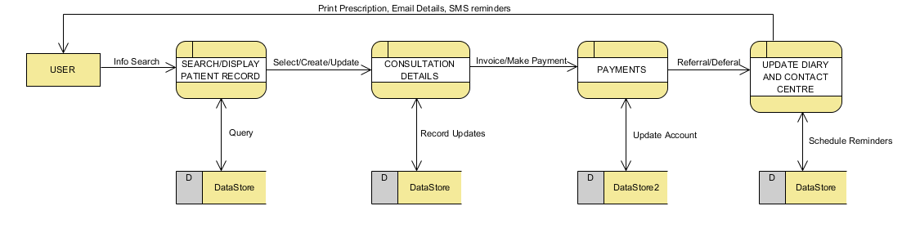

# **Part II**

## 2.1 Basic Entity Relationship Diagram

We approached the entity relationship diagram with 4 tables in mind; Employee, Appointment, Consultation and Pet.

The *employee* table is designed to hold all employee records. All employees are assigned employee numbers and *vet doctors* and *vet* *nurses* are also assigned different *vet doctor ID’s* and *vet nurse ID’s* respectively. Initially it was felt an *employee ID* would be sufficient however upon designing the database we decided that vet doctors and vet nurses were better identified in other tables with a separate *vet doctor ID* and *vet nurse ID.*

Employees attend appointments and so in the *appointment* table *employee ID, vet doctor ID & vet nurse ID* are identified as foreign keys. *Pet ID* is also a foreign key as pets attend the appointments.

An employee gives a consultation and so in the *consultation* table the *employee ID, vet doctor ID and vet nurse ID’s* are foreign eyes while the *pet ID* from the pet table is also a foreign key as the pet gets a consultation.

Initially the Employee table’s relationship with the Appointment & Consultation tables, along with the Pet to Appointment table were many to many relationships and so to normalise the relationships weak entities called *EmployeeAppointment, PetAppointment,* and *EmployeeConsultation* were created.

As a result, one employee can now attend many appointments while one appointment may contain many employees, such as vet doctors and vet nurses. Similarly, one pet may attend many appointments, while an appointment may contain more than one pet in cases where customers such as Kylie have more than one pet.

One pet may also receive many consultations however only one consultation is never given too many pets. Like the employee-appointment relationship, one employee may give many consultations and one consultation may be given by many employees (such as vet doctor and vet nurse).

**2.1 Basic Entity (ER) Relationship Diagram**

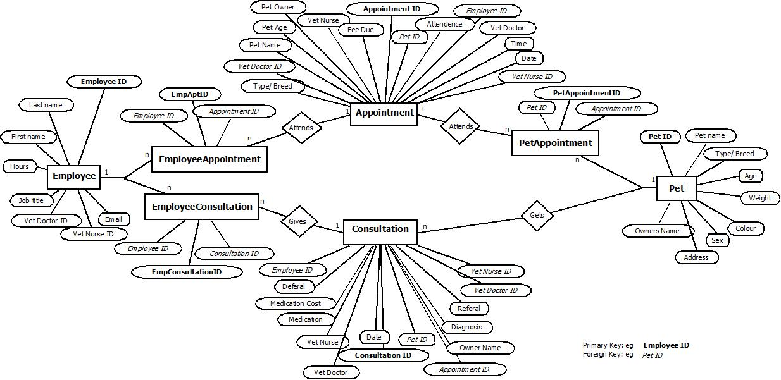

## 2.2 Extended Entity (EER) Relationship Diagram

The diagram is very similar to the basic version and simply displays the modality and cardinality between each entity. Whilst in our actual database the employees table contains both the doctor ID and the nurse ID this diagram suggests an improvement where they be considered separate entities that have unique attributes. In addition, foreign keys have not been added into this diagram to display more clearly the attributes that are unique to each entity.

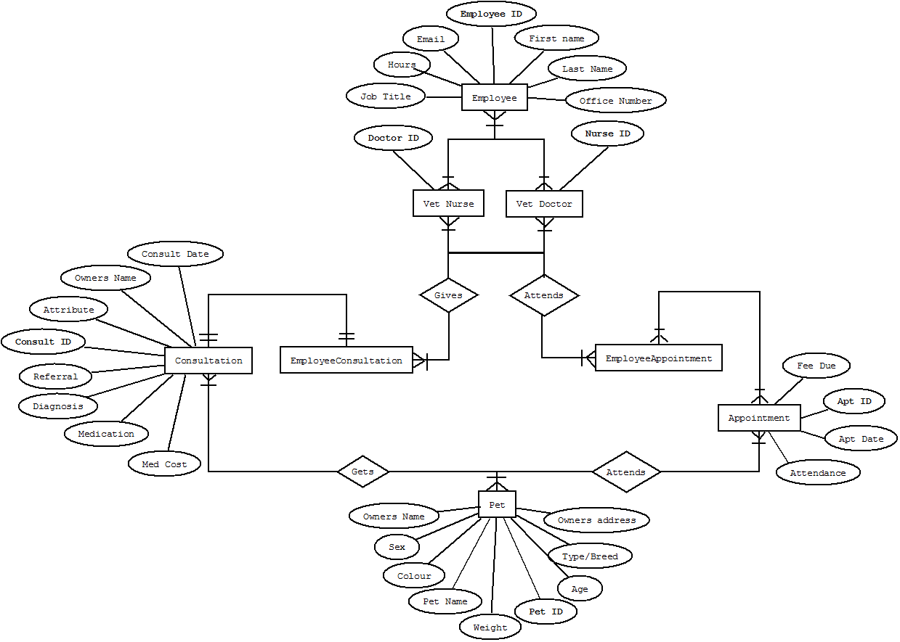

## 2.5 Select Statements

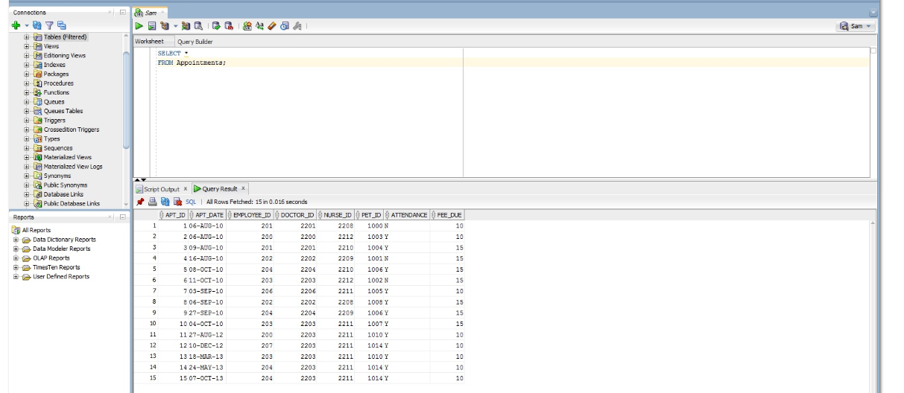

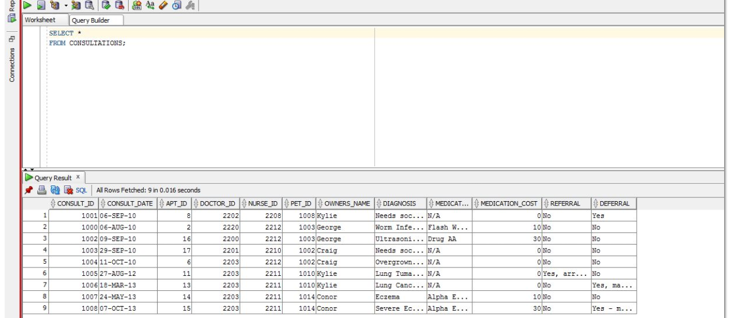

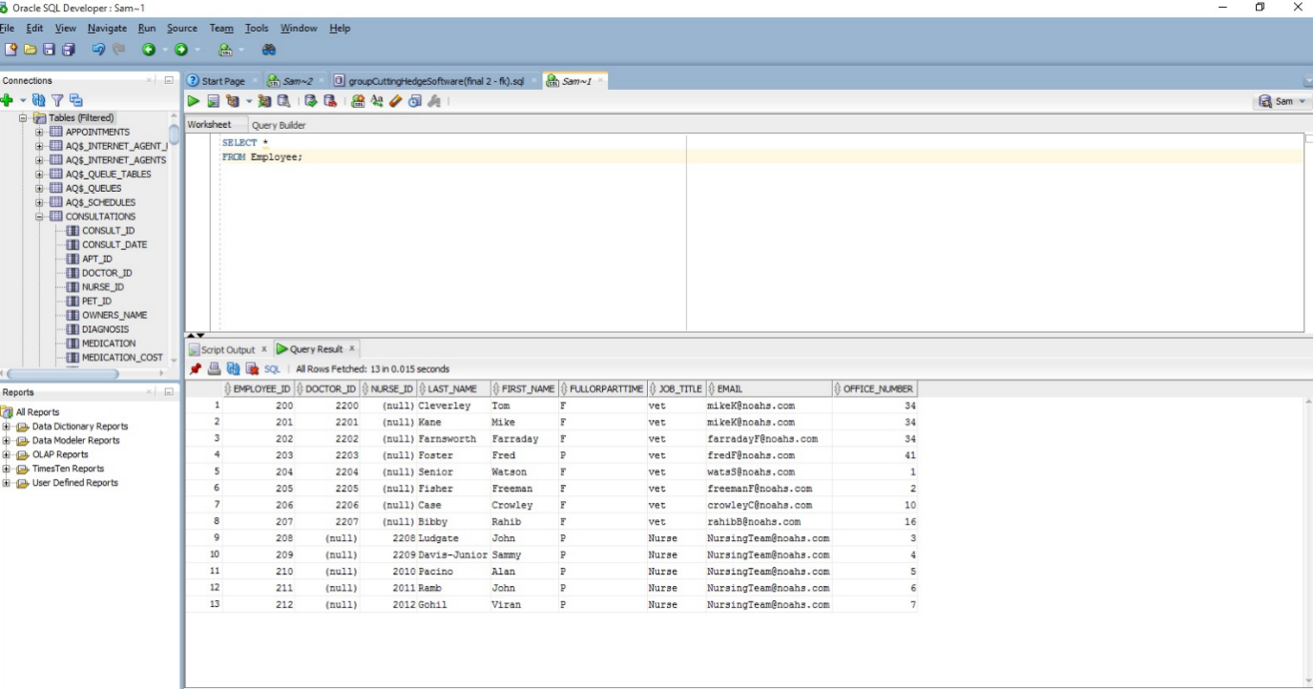

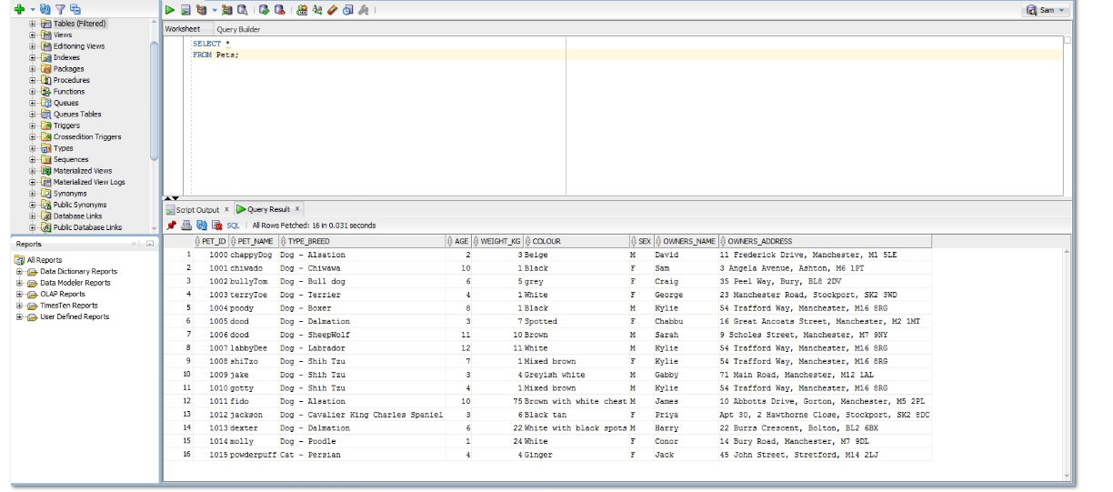

## 2.6 Critical Analysis

In creating an Employee, we created a table for all employees including vets, nurses & receptionists. In reality the receptionists book appointment rather than attend them as per the Entity Relationship diagram. As such in addition to an *employee_id*we created a separate *doctor_id*& *nurse_id* so that the type of employee could be identified uniquely within the consultation and appointment tables and so that their names could be auto populated in the *vet nurse*& *vet doctor* tuples rather than inputted every time.

The system could be expanded so that there is a separate table for each type of employee so that in a Vet Doctor table the primary key would be *vet_doctor_id*, and in the nurse table the primary key would be *vet_nurse_id*and so on for receptionists & the managing director.

While debugging the SQL code it became apparent that we could not use non-primary keys as foreign codes in other tables and so these were removed. If separate vet doctor and nurse tables were to be added in the future as we recommend in a future update, then the *doctor_id*& *nurse_id*could become active foreign keys again.

Currently in order for nurses and doctors to be allocated to an appointment the receptionist needs to consult a staff ROTA that is external to our database. Whilst this information is not currently available it should be acknowledged that this could easily be added in the future through a timetable that can be seen and amended online. This would further automate the receptionist’s role and allow for staff allocation to be more intuitive and flexible.

During our testing it became obvious that we needed a specific key to highlight when a pet had received a diagnosis or not. We have worked around this issue by beginning each diagnosis with the words "Given" or "Not Given". Alternatively, the key could be whether the pet was deferred/referred or not but currently the assumption is that a diagnosis could still be given despite the consultation being deferred/referred.

The consultation table could be expanded to include further fields which would split the data in the diagnosis field. This would include a Boolean as to whether a diagnosis has been made and then a description of the diagnosis in a separate field. A field could also be produced for any treatment which the vet will be giving.

More tables could be added to the database which would connect with the consultations table. These could include details of the types of drugs vet doctors can prescribe to the pets and details of where they can be found. Also, there could be a table containing details of specialists that pets can be referred to for further treatment or diagnosis.

# **Part III**

## 3.1 SQL Query

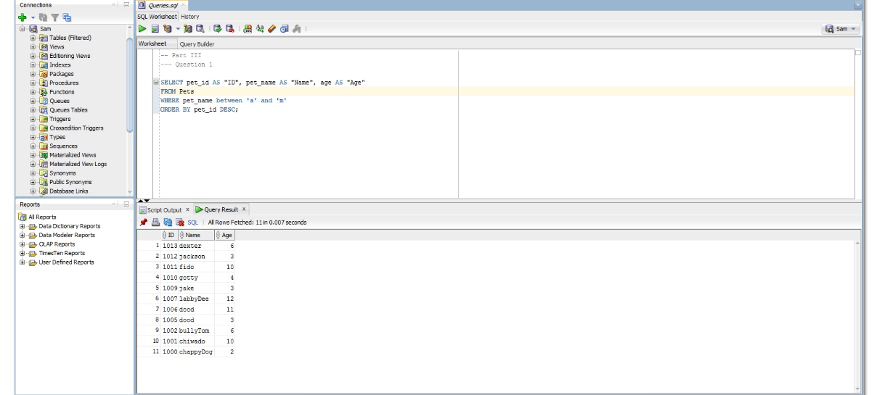

## 3.2 SQL Query

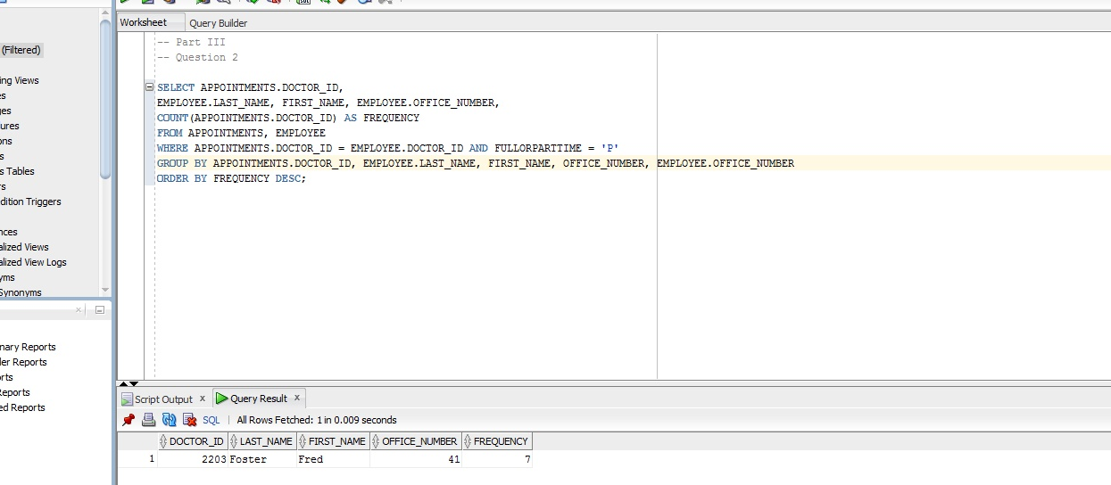

## 3.3 SQL Query

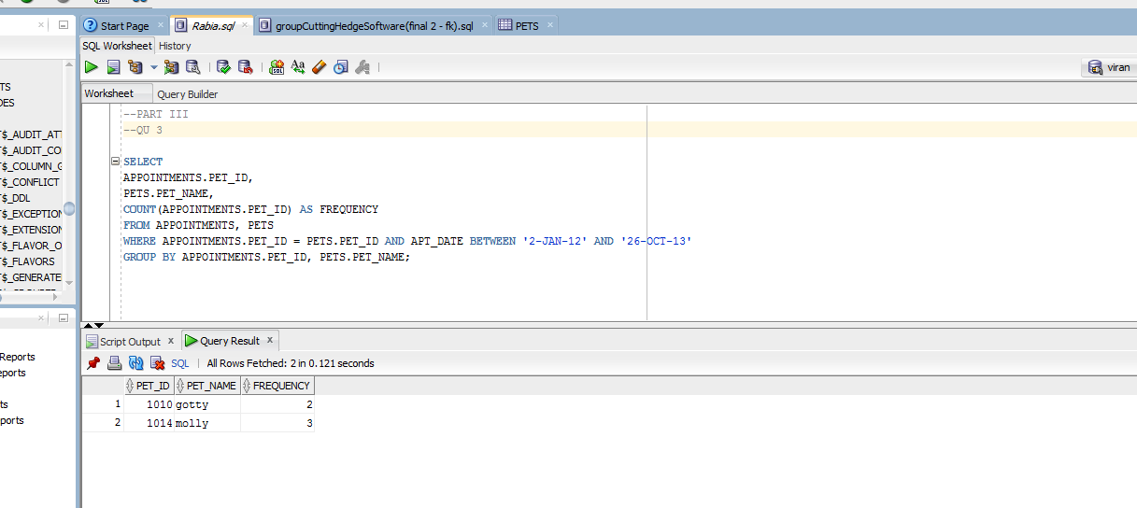

## 3.4 SQL Query

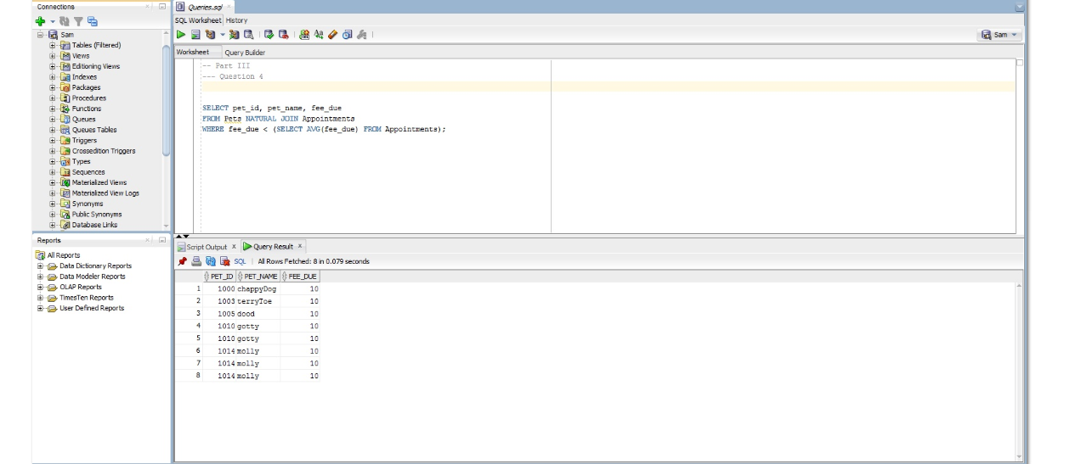

3.5 SQL Query

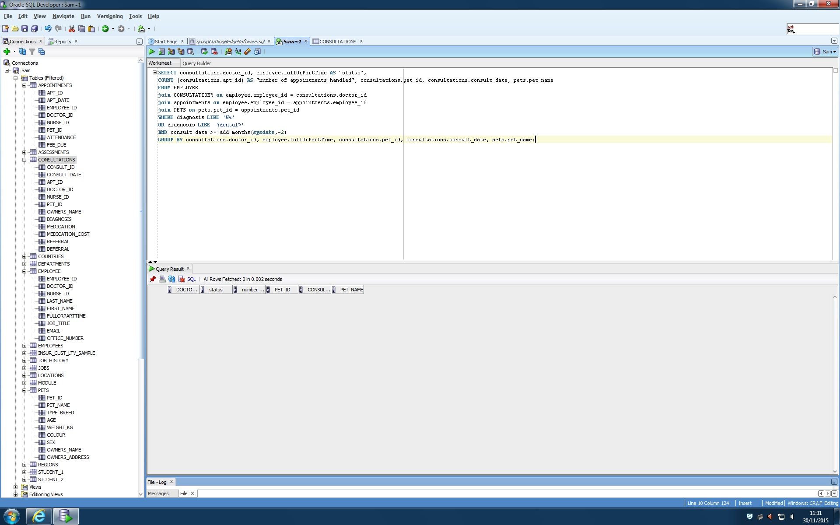

3.6 SQL Query