Football Player Profiling and Scouting Using Explainable Machine Learning: A Role-based Similarity and Recommendation Framework for Emerging Talent Identification

A DISSERTATION SUBMITTED TO MANCHESTER METROPOLITAN UNIVERSITY
FOR THE DEGREE OF MASTER OF SCIENCE
IN THE FACULTY OF SCIENCE AND ENGINEERING

2026
By
Shine Wai Lu
Department of Computing and Mathematics

Contents
Contents | ii
List of Tables | iv
List of Figures | v
Abstract | vi
Declaration | vii
Acknowledgements | viii
Abbreviations | ix
Chapter 1 - Introduction | 1
1.1 Motivation | 1
1.2 Problem Statement | 2
1.3 Aim and Objectives | 3
1.4 Research Questions | 4
1.5 Scope and Contributions | 4
1.6 Report Structure | 4
Chapter 2 - Literature Review | 5
2.1 Football Analytics: From Events to Player Valuation | 5
2.2 Unsupervised Clustering for Player Profiling | 6
2.3 Similarity-Based Scouting Systems | 7
2.4 Supervised Market-Value Prediction | 8
2.5 Explainable AI in Sports Analytics | 10
2.6 Data Availability and Reproducibility Constraints | 11
2.7 Social, Ethical, Legal and Professional Context | 11
2.8 Research Gap and Positioning | 12
Chapter 3 – Methodology Design | 14
3.1 Requirements | 14
3.2 Overall System Architecture | 15
3.3 Data and Integration Design | 15
3.4 Feature and Role Design | 17
3.5 Clustering Design | 21
3.6 Similarity-Recommender Design | 21
3.7 Supervised Modelling and Explainability Design | 22
3.8 Dashboard and Interaction Design | 23
3.9 Evaluation and Testing Design | 23
Chapter 4 - Implementation | 24
4.1 Data Collection | 23
4.2 Record Linkage, Cleaning and Dataset Construction | 24
4.3 Feature-Engineering Implementation | 27
4.4 Clustering and Recommender Implementation | 27
4.5 Supervised Models and SHAP Implementation | 27
4.6 Dashboard Implementation | 27
4.7 Testing Strategy and Implementation Checks | 31
Chapter 5 – Evaluation | 32
5.1 Evaluation Framework | 32
5.2 Data Quality and Coverage | 32
5.3 Clustering Evaluation | 32
5.4 Similarity-Recommender Evaluation | 35
5.5 Supervised Market-Value Evaluation | 37
5.6 Explainability and Local Error Evaluation | 40
5.7 Dashboard and System Evaluation | 42
5.8 Critical Discussion of Findings | 42
5.9 Achievement Against Objectives | 43
5.10 Limitations | 43
Chapter 6 – Conclusion | 45
6.1 Summary and Answers to the Research Questions | 45
6.2 Practical Implications | 45
6.3 Limitations and Future Work | 45
6.4 Reflection | 46
References | 47
Glossary | 50
Appendices | 51
Appendix A – Terms of Reference | 51
Appendix B – EthOS Email | 59
Appendix C – Source-Code Repository Link | 61
Appendix D – Explainable ML Pipeline | 61
Appendix E – Full Model Comparison | 61
Appendix F – Test Runs | 62
Appendix G – Additional Tables and Evaluations (csv and png files) | 62

List of Tables
Table 1. Project functional and non-functional requirements | 14
Table 2. Data sources and their roles | 24
Table 3. Final dataset composition by position family | 26
Table 4. Retrospective transfer-evaluation summary | 37
Table 5. Global five-fold cross-validation comparison | 37
Table 6. Best supervised model within each position family | 39
Table 7. Achievement of the original project objectives | 43

List of Figures
Figure 1. Overall design of the explainable football scouting system | 15
Figure 2. Data integration and preparation design | 17
Figure 3. Feature correlation heatmap | 19
Figure 4. Market-value distribution before and after log transformation | 20
Figure 5. FBref website – empty data cells | 25
Figure 6. Position-family counts in the final dataset | 26
Figure 7. Player profile dashboard | 28
Figure 8. Similar players recommender dashboard | 29
Figure 9. Market value prediction dashboard | 29
Figure 10. Hit or miss dashboard | 30
Figure 11. Methodology and findings dashboard | 31
Figure 12. Cluster model-selection metric sweep | 33
Figure 13. UMAP projection of the selected player clusters | 34
Figure 14. Standardised cluster profile heatmap | 35
Figure 15. Similarity distributions for Saka, Rodri and Haaland | 36
Figure 16. Global comparison of the four supervised models | 38
Figure 17. Predicted versus actual market value | 38
Figure 18. Per-position R² comparison | 39
Figure 19. Global SHAP feature importance | 40
Figure 20. Per-position SHAP importance heatmap | 41

Abstract
Data-driven recruitments can help professional football clubs compare players across leagues and identify alternatives, but many analytics systems either ignore tactical role or present recommendations and valuations without explaining the reasons behind them. This dissertation develops an integrated, role-aware and explainable machine-learning pipeline for player profiling and scouting across the “Big-Five” leagues called Premier League, La Liga, Bundesliga, Serie A and Ligue 1 using the 2023/24 and 2024/25 seasons. The final analytical dataset contains 2,935 outfield player-seasons assembled from FBref performance statistics and Transfermarkt market values and position labels, with StatsBomb Open Data used as an event-data reference. Unsupervised role discovery was compared using K-Means, Gaussian Mixture Models and HDBSCAN; the selected K-Means solution used four clusters and achieved a silhouette score of 0.191. A cosine-similarity recommender combined these latent clusters with expert-labelled positions, while four supervised regression methods were evaluated globally and by position family using five-fold cross-validation and a log-transformed market-value target. The best global model was Random Forest (R² = 0.404, MAE = €10.11m, median absolute error = €5.05m), while Forward and Winger models achieved R² values of 0.570 and 0.547 respectively. SHAP explanations showed age as the strongest global value driver and exposed a recurring attacking bias caused by the available dataset, which offered richer attacking than defensive information. The main contribution is therefore not a single high-performing model, but an auditable end-to-end scouting prototype combining potential roles, expert positions, similarity search, market-value prediction, local and global explanations, and an interactive Streamlit dashboard.

Declaration
No part of this project has been submitted in support of an application for any other degree or qualification at this or any other institute of learning. Apart from those parts of the project containing citations to the work of others, this project is my own unaided work. This work has been carried out in accordance with the Manchester Metropolitan University research ethics procedures and has received ethical approval number Your EthOS Number.

Signed: Shine Wai Lu

Date: 11-09-2026

Acknowledgements
I would like to thank Pavitra Kumar for guidance and support throughout this project, and the staff of Manchester Metropolitan University for providing the academic environment in which the work was developed. I am also grateful to the researchers and maintainers who make football data, open-source software and reproducible analytics resources available to students.

Abbreviations
Abbreviation | Long Form
AI | Artificial Intelligence
API | Application Programming Interface
CSV | Comma-Separated Values
FBref | Football Reference
GMM | Gaussian Mixture Model
HDBSCAN | Hierarchical Density-Based Spatial Clustering of Applications with Noise
MAE | Mean Absolute Error
ML | Machine Learning
PCA | Principal Component Analysis
R² | Coefficient of Determination
RQ | Research Question
SHAP | SHapley Additive exPlanations
UMAP | Uniform Manifold Approximation and Projection
XAI | Explainable Artificial Intelligence
xA | Expected Assists
xG | Expected Goals

Chapter 1 – Introduction

1.1 Motivation
Professional football recruitment is both a sporting and a financial decision. Clubs attempt to improve team performance and strength while operating in a transfer market where individual transfer can reach nine-figure sums and annual international spending has reached record levels. FIFA reported USD 13.08 billion in international transfer fees in men’s professional football during 2025, illustrating the scale of the market and the value of reducing uncertainty in recruitment decisions (FIFA, 2026). Data analysis cannot remove that uncertainty, but it can make the comparison of potential targets more systematic, reproducible and transparent.
The data available to analysts have also changed substantially. Previously, early performance analysis relied heavily on match summaries and manually coded events. Modern public and commercial datasets provide player-level aggregates, detailed event streams and, in some environments, tracking data. Pappalardo et al. (2019) demonstrated the research value of large public spatio-temporal football datasets, while Decroos et al. (2019) showed how event data can support action valuation that goes beyond goals and assists. Rein and Memmert (2016) similarly argued that tactical analysis benefits from integrating richer contextual information. These developments have created the conditions for machine-learning systems that profile players, estimate value and assist scouting.
However, being able to predict player performance does not automatically produce better decisions. For example, a recommendation that a player is “similar” to another player is not very practically useful if the system cannot explain what dimensions of performance created the similarity. Likewise, a market-value estimate is difficult to trust when the model's important variables are hidden. Therefore, explainable artificial intelligence (XAI) is particularly relevant to scouting, because recruitment decisions are high-cost, multi-stakeholder decisions in which analysts, scouts and sporting directors need to interrogate the evidence rather than accept a model’s score (Lundberg and Lee, 2017; Li et al., 2025).
A second issue is tactical role. Football positions are not interchangeable, and even conventional labels such as midfielder or forward can conceal large stylistic differences. Sattari et al. (2021) showed that players assigned to the same conventional position can have highly different passing and receiving patterns. This motivates a role-aware architecture in which player style can be represented both by data-driven latent structure and by expert position labels. This study therefore combines clustering, similarity search, supervised market-value modelling and SHAP explanations within a single scouting workflow rather than treating them as separate analytical exercises.
These two requirements, role awareness and interpretability, are closely connected. An explanation is only useful if the player comparison makes sense from a football perspective. For example, a model might show that two players are mathematically similar based on their statistics, but a scout still needs to know whether the candidate occupies a comparable role and whether the statistics describe the same tactical responsibilities. The aim of the project is therefore not simply to maximise predictive accuracy or similarity. It is also important that the results are realistic, understandable and useful to football professionals. This motivates to use two ways of representing player roles, latent clusters are used to expose recurring statistical styles, while expert position labels such as midfielder or forward are retained to impose tactical constraints when required.
The project consequently uses machine learning as a decision support tool rather than as an automated replacement for scouting judgement. Rein and Memmert (2016) argue that the value of data analysis in football depends on combining quantitative evidence with tactical interpretation, while XAI research emphasises that a model's output should be accompanied by information that helps a user understand why the prediction was made (Lundberg and Lee, 2017). In player recruitment, this distinction is important because statistics cannot capture everything that matters when signing a player. For instance, data may not show a player’s contract situation, personality, injury records or medical risks, ability to adapt to a new league, or suitability for a particular coach’s tactical system. Therefore, the purpose of the analytical system is to help scouts reduce the number of players need to consider and understand why certain players are recommended, while allowing football experts to make the final decision.

1.2 Problem Statement
Existing football analytics research offers strong examples of individual components of the scouting problem. For example, clustering can group players with similar playing styles, similarity methods can find players who play in similar ways, regression models can estimate market value, and post-hoc explanation methods can expose model behaviour. Yet these components are frequently developed in isolation. This can create problems. For example, a group of players may look statistically similar but may not actually play the same tactical role. Similarly, a similar model may identify players who have similar statistics but play in completely different positions. A market-value predictor may be difficult to justify to a football practitioner.
The major problem addressed by this dissertation is therefore the design of an integrated system that remains useful when these components interact. The system must discover latent roles without discarding expert football knowledge, recommend players who are not only statistically similar but also relevant for the required tactical role, estimate player market value without assuming all positions sharing the same factors influencing their value, and provide explanations at both model and player level. The project also recognises that the quality of the available data affects the results. Public football data comes from different sources and is often incomplete, meaning that some useful player data may be missing. Therefore, the performance of the models needs to be judged based on the data and features that could be collected, rather than assuming that the system had access to every factor that professional clubs might use.

1.3 Aim and Objectives
The aim of this project is to build an explainable machine-learning system that combines role-based player profiling, similarity recommendation, and position-aware market value prediction in a single interpretable scouting pipeline.
- Aggregate heterogeneous public data from FBref, Transfermarkt and StatsBomb Open Data into a reproducible player-season dataset.
- Compare unsupervised clustering algorithms for discovering statistical player roles.
- Build a role-aware cosine-similarity recommender and evaluate it using qualitative examples and retrospective transfer cases.
- Compare Linear Regression, Random Forest, XGBoost and LightFGBM globally and within position families.
- Use SHAP to explain feature importance globally and to produce player-level explanations.
- Deliver an interactive Streamlit dashboard that exposes the analytical pipeline to non-technical users.

1.4 Research Questions
RQ1: Do latent statistical clusters correspond to meaningful tactical roles and expert-labelled positions?
RQ2: Do per-position supervised market-value models outperform a single global model?
RQ3: Can SHAP make market-value predictions interpretable in a scouting workflow?
RQ4: Can the recommender identify real transfer targets using only pre-transfer player information?

1.5 Scope and Contributions
The first contribution is architectural: clustering, role-aware similarity, supervised valuation, SHAP and an interactive dashboard are implemented as one pipeline. The second is the use of two complementary ways of understanding player roles. K-Means provides data-driven clusters, while Transfermarkt provides fine-grained expert position labels; the recommender can use either or both depending on the desired level of tactical strictness. Third is a small retrospective evaluation of the recommendation system. Finally, the analysis finds a consistent feature-set attacking bias. Attack-oriented positions are more sharply separated in clustering, obtain higher treating this only as a weakness, this study documents it as a methodological result that links model behaviour directly data availability.

1.6 Report Structure
This report follows the example of MSc Project structure in the handbook. Chapter 2 reviews the relevant research on football data analytics, clustering, similarity-based scouting, market-value modelling, machine learning and XAI literature and considers the wider social, ethical, legal and professional context. Chapter 3 states the project requirements and explains the methodology design of the data pipeline, feature representation, clustering, recommender, supervised models, explainability layer and dashboard. Chapter 4 describes how those designs were implemented, including data collection, record linkage, model code, dashboard construction and testing strategy. Chapter 5 evaluates the completed system and its empirical results against the original objectives, with critical discussion of clustering quality, recommendation behaviour, market-value prediction, SHAP explanations and limitations. Chapter 6 concludes the work, answers the research questions and identifies future work.

Chapter 2 – Literature Review

2.1 Football analytics: From Events to Player Valuation
Football analytics has developed from descriptive match statistics, such as goals, shots, tackles and passes, toward models that represent actions, context and player contribution. Traditional statistics are still useful because they are easy to understand and widely available, but they do not fully explain what happens during a match. For instance, the number of passes does not show the importance or difficulty of those passes. Rein and Memmert (2016) suggested that tactical behaviour requires contextual information from multiple sources and considers the situation in which actions happen. Herold et al. (2019) reviewed how machine learning can extend attacking-performance analysis beyond traditional key performance data. Public datasets have also made advanced football analysis more accessible. Pappalardo et al. (2019) released a large event dataset covering major competitions and demonstrated the research potential of open football data.
Event-based approaches offer a richer presentation of player performance than season aggregates. Decroos et al. (2019) introduced the VAEP framework, which evaluates player actions based on their effect on the probabilities of scoring and conceding. Such approaches demonstrate why a simple goal or assist count does not fully explain a player’s contribution. For example, a progressive pass, interception or ball recovery can have an important effect on an attack or possession, even if it does not directly lead to a goal or an assist. More broadly, these methods position player evaluation as a modelling problem rather than a fixed set of summary statistics.
Player valuation is a related but distinct task. Market value is not identical to transfer fee because market value is an estimate of a player’s expected worth in the market, while a transfer fee is the actual transaction affected by contract length, bargaining power, strategic need and timing. Müller, Simons and Weinmann (2017) showed that data-driving models can reproduce crowdsourced market valuations using player characteristics and performance data. Franceschi et al. (2024), in a systematic review of football valuation research, found that factors such as age, playing time, performance and other contextual variables are commonly linked to player value. Transfermarkt valuations are frequently used because they cover players who have not recently transferred, reducing the selection problem that arises when only realised fees are analysed.
Recent work has increasingly combined prediction with explanation. Huang and Zhang (2023) applied SHAP to an ensemble valuation model, Li et al. (2025) used SHAP to decompose real transfer fee estimations, and Fotache, Cojocariue and Bertea (2026) predicted and interpreted market value across the five major European leagues using FBref and Transfermarkt-derived data. These studies indicate that having an accurate prediction is no longer the only goal. It is also important for users to understand why a model makes a particular prediction. Therefore, explainability and transparency are becoming important parts of modern football analytics.

2.2 Unsupervised Clustering for Player Profiling
Clustering offers a way to identify groups of players without deciding their conventional positions in advance. This is useful in football because modern roles overlap. A fullback may contribute like a winger, a centre forward may operate as a creative player, and a midfielder can have different statistical patterns depending on a particular team’s roles and functions. The purpose of clustering in this setting is not to claim that football contains objectively discrete player types. Instead, it is used to find common patterns in player statistics and summaries whether these patterns can create useful groups or player profiles.
K-Means is a common clustering baseline because it is simple, scalable and interpretable. It groups players by placing those with similar statistical characteristics into the same cluster based on their distance around centroids. However, it works best when the groups have a relatively simple and similar shape. Gaussian Mixture Models use a more flexible approach by allowing players to have a probability of belonging to different clusters instead of putting each player into only one group. HDBSCAN takes a different approach by looking for stable high-density regions and can label low-density observations as noise (Mclnnes, Healy and Astels, 2017). Comparing these methods is useful because they encode different assumptions about the geometry of player-style data.
Football-specific research also supports the use of comparative clustering methods. Akhanli and Hennig (2023) analysed player performance data from eight European Leagues and argued that the quality of a cluster should be judged based on which the grouping will be used. This is especially relevant because clustering can have different purposes, such as finding broad groups of similar players or identifying players with similar playing styles. Sattari et al. (2021) reached a related conclusion from passing networks. They showed that a player’s traditional position does not always determine playing patterns, and interpretable latent role representations can capture differences within the same position label.
Internal clustering metrics are useful, but they should not be treated as footballing truth. The silhouette score measures how closely players within the same cluster are grouped and how different they are from other clusters (Rousseeuw, 1987). Davies and Bouldin (1979) proposed an index in which lower values indicate better separation, while the Calinski-Harabasz criterion compares between-cluster and within-cluster dispersion. These metrics measure geometry rather than tactical usefulness. A solution with a slightly weaker internal score may still be preferable if its clusters are more stable and interpretable, whereas a numerically strong solution may fragment the data into groups that do not support practical scouting decision. Therefore, this project compares the clustering results using both statistical measures and football-based interpretation.
A further issue in player clustering is temporal stability. A one-season can be visually convincing while merely reflecting temporary form, limited playing time or a specific tactical environment. Repeated observations of the same player across seasons therefore provide another way to check whether the clusters are meaningful. If a player’s statistical style is stable, their data from adjacent seasons should be often appear in the same or a similar cluster. However, this does not prove that the cluster is a true tactical role because a player can change responsibilities between seasons. Even so, this provides more football-related evidence than an internal clustering score alone. This study uses this idea when interpreting repeated observations such as Haaland and Thuram, rather than treating the silhouette coefficient as the sole measure for validity.

2.3 Similarity-Based Scouting Systems
Similarity systems represent each player as a vector and rank other players by a distance or similarity measure. Euclidean distance measures absolute proximity and is sensitive to feature scale and magnitude. Cosine similarity compares the angle between vectors, making it useful rather than their overall size. This makes it useful when the aim is to find a relative player statistical profile. For instance, two players can show the same distribution of strengths while operating at different overall volumes. Once vectors are normalised, cosine similarity is computationally efficient because it becomes a simple dot product.
The key methodological question is not only which distance measure to use, but which players are allowed to be compared. A global nearest-neighbour search can return statistically similar but tactically implausible results when the feature space is incomplete. Position filtering is one solution, yet overly strict position labels can also conceal versatility. Barbosa, Ribeiro and Dutra (2021) demonstrated that passing-sequence representations can recover meaningful similarities between players, while Sattati et al. (2021) showed that latent passing and receiving roles can identify similarities that traditional positions may miss. These findings support a hybrid design in which latent and expert roles operate together rather than relying on only one method.
Evaluation is difficult because there is no universal ground-truth list of a player’s correct alternatives. Qualitative case studies can help check whether the recommendations valid, especially when using well-known players whose roles and playing styles are already familiar. Retrospective transfer validation provides a more demanding test. In this approach, only pre-transfer data is used to check whether the system would have recommended the player who was eventually signed by the club. However, these results should be treated carefully because transfers depend on wages, contracts, injuries, tactical responsibilities, availability and negotiations. A recommendation system should therefore be judged as a decision-support tool that helps scouts for identifying realistic and statistically similar players, rather than a model that is expected to predict the transfer market perfectly.
Recommendation evaluation also depends on the purpose of the system. A tool designed to find a direct replacement for an injured player should penalize cross-position suggestions heavily, whereas an exploratory recruitment tool may deliberately surface players whose registered positions differ but whose statistical profiles are similar. Ranking metrics such as hit@k or precision@k are therefore informative only after the candidate pool and relevance definition have been specified. This motivates evaluating multiple filter modes in this study. The same similarity function is applied in each case, while the group of players that can be recommended is changed, allowing the effect of tactical constraints to be examined separately from the similarity calculation itself.

2.4 Supervised Market-Value Prediction
Market-value prediction has been studied using both traditional statistical methods and machine-learning approaches. Müller et al. (2017) used multilevel regression on more than four thousand players from the five major European leagues and found that player performance and personal characteristics can produce data-driven valuations comparable with crowd estimates. Al-Asadi and Tasdemir (2022) compared machine-learning methods on FIFA-derived attributes and found Random Forest to be effective for nonlinear valuation. Tamim et al. (2025) similarly reported strong performance for Random Forest on a large European-player dataset. More recent studies have explicitly addressed explainability and richer feature integration (Li et al., 2025; Fotache et al., 2026).
One common problem is football market-value prediction is that player values are not evenly distributed. Most players have relatively modest value ranges, while a small number of elite players are valued above €100 million. Models trained with squared-error objectives can become disproportionately influenced by this tail, and tree models cannot predict values outside the range experienced during training. Using a logarithmic transformation can help by reducing the extreme values and making proportional differences easier to model. The trade-off is that the predicted values can move closer to the average when they are converted back to the original scale. This problem is particularly noticeable for expensive superstar players like Haaland.
Player position is also matters. Franceschi et al. (2024) showed that playing position is often included in football valuation research, while role-specific models are intuitively valid because clubs value different outputs from different types of players. A goal has direct impact for forwards but is unusual for centre-backs. On the other hand, defensive actions like winning duels and defensive positioning may matter more for defenders and deeper midfielders. Training separate models can therefore reduce the averaging of heterogeneous relationships, but it also reduces sample size. Whether position-specific models outperform a global model is an empirical question rather than an assumption, and it forms RQ2 in this dissertation.
A second distinction in valuation research is between explanation and prediction. A variable can be useful for forecasting market value without representing a direct reason for that value. Age, for instance, can be useful because it can indicate a player’s career stage, future potential celling and possible resale value. Similarly, performance statistics may be related to the quality of the player’s team or league. Franceschi et al. (2024) show that valuation studies repeatedly identify demographic data, contract information and performance-related determinants, but the available data differ substantially between studies substantially. Consequently, comparisons of R² values across studies need to consider the dataset, target construction and evaluation protocol rather than interpreting the highest reported score as evidence of a universally superior algorithm.

2.5 Explainable AI in Sports Analytics
Explainability is important whenever model outputs influence consequential decisions. Ribeiro, Singh and Guestrin (2016) introduced LIME, a method that explains a complex model locally with an interpretable surrogate. Lundberg and Lee (2017) proposed SHAP, a unified additive feature-attribution framework based on Shapley values from cooperative game theory (Shapley, 1953). SHAP assigns each feature a contribution to the difference between a prediction and a baseline expectation. Tree-specific algorithms make these explanations efficient for tree ensembles, and later work demonstrated how local attributions can be aggregated into global understanding (Lundberg et al., 2020).
SHAP offers several advantages for a football scouting workflow. Global mean absolute SHAP values identify the variables that have the strongest influence on the model’s predictions across all players. SHAP can also show whether higher or lower values of a feature tend to increase or decrease predictions. Local explanations show how a particular player’s age, scoring output, crossing or defensive statistics move the model above or below its baseline. This is more actionable than a single feature-importance ranking because a scout can inspect the reason for an individual recommendation or market-value estimate.
Nevertheless, SHAP explanations must be interpreted as explanations of what the model has learned, rather than explanations of the real transfer market. When two features are closely related, their importance be shared between them. Also, a model can only explain patterns using the data and features that are available to it. For example, if there is limited defensive performance is unimportant in the transfer market. It may simply mean that the dataset does not contain enough information to measure its importance properly. This is particularly important in this dissertation because the data shows a repeated difference between attacking and defensive information across clustering, player similarity and supervised modelling.
The distinction between global and local explanation is especially relevant to scouting. Global explanations show which variables the model relies on most across the population and can reveal systematic biases in the training representation. Local explanations focus on one specific player and explain why their estimated value differs from the model’s average prediction. A scouting interface benefits from both types of explanations. The global view supports model governance and diagnosis, while the local view supports an analyst examining a candidate. SHAP is useful because these views are derived from the same additive attribution framework, although correlated football statistics can divide or redistribute attribution across related features.

2.6 Data Availability and Reproducibility Constraints
Football analytics has a difference between the data available to professional clubs and the data available to academic researchers. Professional clubs can purchase event and tracking data from companies such as Opta, Wyscout and StatsBomb, whereas student research often relies on public websites, open repositories and scraping tools. Pappalardo et al. (2019) made an important contribution by releasing a large event dataset, but open datasets still cover a limited subset of competitions and seasons compared with the detailed data available through commercial providers.
Public sources also change. Website structure, anti-bot systems and API behaviour can make a previously reproducible collection pipeline unreliable. This creates a methodological issue. Failure to obtain a feature is not equivalent to evidence that the feature is not important. Therefore, researchers need to document what data were available at the time of collection, which parts of the pipeline were successful, and which analyses are constrained by missing categories. Reproducibility also depends on software versions, standardised preprocessing, saved intermediate data and clear audit logs.
The present project addresses these constraints by retaining raw and interim CSVs, logging unmatched names, separating collection from analysis code, and documenting a failed attempt to obtain additional FBref passing, defensive and possession tables. This transparency is vital because the ultimate limitations of the models are partly limitations of the public data environment.
Reproducibility in this setting requires more than publishing a notebook. It requires recording the source, season convention, collection date, matching rules, filters and intermediate outputs used to create the modelling table. A future rerun against a live website may return different rows even when the code is unchanged. Retaining intermediate CSV files and audit logs creates a stable evidence trail from raw collection to analysis. This is especially important for being built on public web sources, because the limitations of collection are inseparable from the limitations of the resulting model.

2.7 Social, Ethical, Legal and Professional Context
A scouting system affects decisions about people, so technical performance is only one part of responsible use. The dashboard is designed as decision support rather than an automated recruitment authority. Statistical similarity cannot represent medical history, personality, contractual constraints, cultural adaptation or the tactical intentions of a coaching staff. Presenting model outputs alongside underlying statistics and SHAP explanations helps a professional user challenge the evidence instead of treating a numerical score as a final judgement.
The use of public football data also creates legal and professional responsibilities. Collection code must respect the conditions and technical restrictions of source websites, use conservative request rates and retain a clear record of how data were collected. The project therefore separates the original and intermediate data from modelling outputs and documents failed collection attempts rather bypassing them hiding. This is important for reproducibility because public websites can change their structure or introduce new restrictions over time. The project’s ethics documentation should be included in Appendix of the report.
Ethically, the most important model risk identified this project is bias in the data. The available public data contains much richer attacking than defensive information. A system built from that information can make attacking players appear easier to classify, compare and value than players in defensively deeper positions. Therefore, the dissertation treats this imbalance as a finding that must be disclosed to users. Professionally, this system should be used as a support tool, not as a replacement for human judgement. It can help scouts narrow a candidate pool and explains its reasoning while final recruitment decision remains with qualified football staff.

2.8 Research Gap and Positioning
The reviewed literature demonstrates mature work on each individual component of the problem. Football players have been clustered into latent roles; similarity models have identified statistical peers; valuation models have used regression and ensemble learning; and SHAP has been applied to football market-value prediction. However, what is less common is a single scouting pipeline in which these components are explicitly designed to constrain, validate and explain one another.
This dissertation brings these different areas of football analytics together in one system. It tests latent clusters against expert position labels, uses both as filters in a recommender, compares global and position-specific value models, and applies SHAP explanations through the same interactive dashboard. It also evaluates the recommender retrospectively under multiple filter modes, understanding the balance between finding players with similar styles and keeping the recommendation tactically suitable. Overall, the contribution is integrative and methodological. This project does not only ask whether each model performs well but also considers the limitations and assumptions of one stage can affect the results of the next.

Chapter 3 – Methodology Design

3.1 Requirements
The requirements were derived from the project aim and research questions. They were separated into functional requirements, which define what the product must do, and non-functional requirements, which define qualities needed for an analytical prototype.
ID | Type | Requirement | Design response
FR1 | Functional | Integrate public performance, position and market-value data. | Separate source collectors and a reproducible player-season integration pipeline.
FR2 | Functional | Discover data-driven player roles. | Compare K-Means, GMM and HDBSCAN using multiple validity metrics.
FR3 | Functional | Return tactically plausible similar players. | Cosine similarity with cluster-only, family and strict-position filters.
FR4 | Functional | Estimate player market value globally and by position. | Four supervised regressors with global and seven position-family scopes.
FR5 | Functional | Explain model behaviour and individual predictions. | Global and local SHAP views alongside model outputs.
FR6 | Functional | Expose the workflow to a non-technical user. | Interactive Streamlit pages for profiles, similarity, value prediction and validation.
FR7 | Functional | Support retrospective validation. | User-selectable query/target pairs and fixed transfer case studies.
NFR1 | Non-functional | Outputs should be interpretable and auditable. | Readable football features, documented filters, saved intermediate data and explanations.
NFR2 | Non-functional | Experiments should be reproducible. | Deterministic preprocessing, persisted CSV/model artefacts and cross-validation.
NFR3 | Non-functional | The prototype should be responsive in normal use. | Cached model artefacts and vectorised similarity calculations.
NFR4 | Non-functional | Components should be reusable rather than duplicated. | Recommender and modelling logic separated from dashboard presentation code.
Table 1. Project functional and non-functional requirements

3.2 Overall System Architecture
The product was designed as a staged analytical pipeline rather than as one single model. First, data from different sources are collected and matched to create a common player-season table. Next, feature engineering produces an interpretable representation that is reused by the clustering, recommendation and supervised-modelling components. SHAP operates on the fitted value models, while the Streamlit dashboard presents player profiles, recommendations, predictions and validation results in one interface. This separation allows each stage to be tested independently and prevents changes to the dashboard not affecting the actual analytical results.
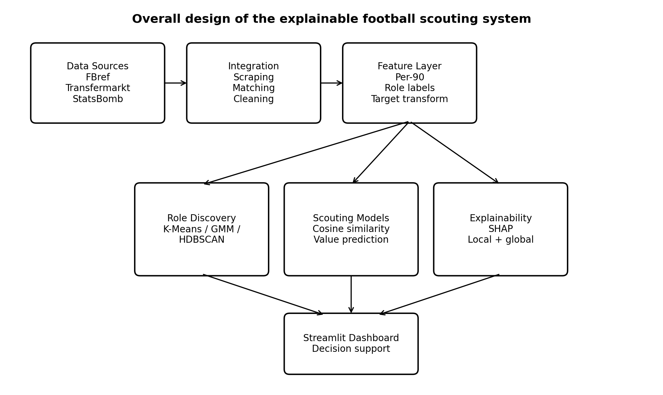
Figure 1. Overall design of the explainable football scouting system

3.3 Data and Integration Design
The analytical data was assembled from three public football data sources, with each source providing different types of information. FBref was used for player performance statistics for each season. Transfermarkt supplied player market values and detailed position labels. StatsBomb Open Data provided event-level data that was used as a methodological reference rather than merged into the final Big-Five player-season table. Combining these sources was necessary because no single public source contained the complete dataset of performance, positional and valuation information required by the system. This reflects the broader problem of football data being spread across different sources as described by Pappalardo et al. (2019).
The scope of this project focused on the English Premier League, Spanish La Liga, German Bundesliga, Italy Serie A and France Ligue 1 during the 2023/24 and 2024/25 seasons. These leagues were chosen because they provide comparatively rich public coverage and are commonly used in football analytics and valuation research. Using two seasons provided recent data while also making it possible to observe the repeated players across different seasons. This was later used as a basic temporal-stability check for clustering and similarity.
FBref data were collected through the soccerdata Python package. At the time of collection, the accessible player-level categories for the target leagues were standard, shooting, playing time, goalkeeper and miscellaneous statistics. Passing, possession and detailed defensive tables could not be obtained reliably through the same route. This created an important limitation in the dataset. As a result, the available variables contained more numerous attacking indicators than defensive performance. This imbalance influenced the later clustering, player similarity and market-value prediction results.
Transfermarkt was used for two types of information that were not available in enough detail from FBref such as player market-value in euros and detailed tactical positions. The use of Transfermarkt as a market-value target is consistent with substantial previous football research. Franceschi et al. (2024) found that Transfermarkt values are frequently used because they provide broad and continuously available estimates. Müller et al. (2017) also used crowd-based market values as a useful comparison for data-driven valuation models. Therefore, in this dissertation, the target is interpreted as perceived market-value rather than an actual transfer fee.
StatsBomb Open Data was also examined to understand and validate the event-level football data. Event data can provide richer context than simple per-90 statistics because individual actions can be represented with location and match-state information (Decroos et al., 2019). However, the open StatsBomb dataset did not provide the required Big-Five leagues coverage for the selected seasons. It was therefore retained as a reference source rather than combined with the final modelling dataset. After matching all data sources, filtering the records and cleaning the data, the final dataset contained 2,935 outfield player-season observations.
The data from the different sources were matched using league and season because the source websites do not use a shared universal player identifier. A conservative fuzzy-matching approach was preferred to maximizing apparent coverage: an omitted row is less damaging than assigning the wrong market-value or tactical position to a player. The data design also separates target information from role discovery so that market value cannot influence the clusters or similarity outcomes.
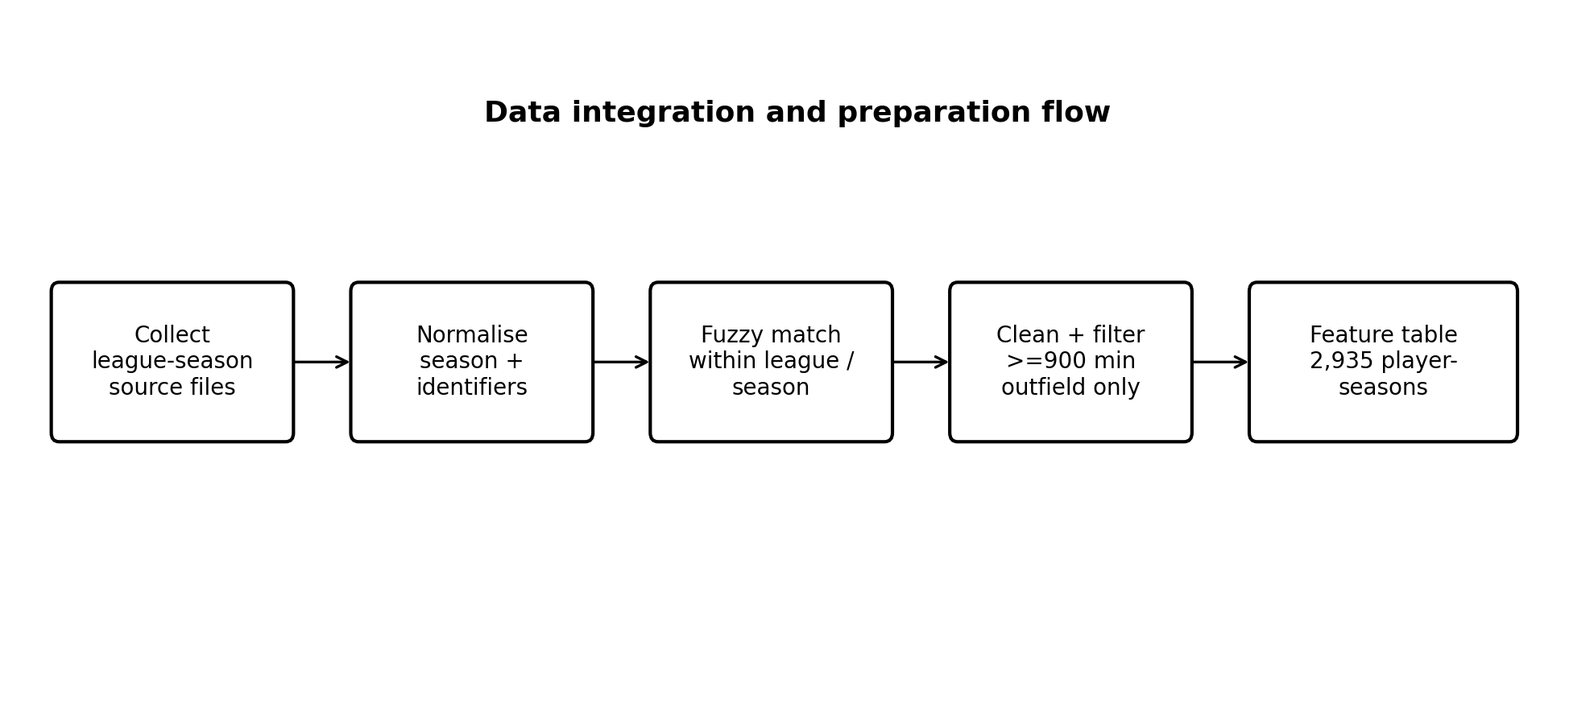
Figure 2. Data integration and preparation design

3.4 Feature and Role Design
Raw football statistics are strongly influenced by playing time, so volume statistics were converted to per-90 rates where appropriate. For a statistic x recorded over m minutes, the transformation was x_p90 = (x × 90) / m. This makes players with different workloads more comparable by expressing output per full-match equivalent rather than per season.
The conversion was applied to statistics such as goals, assists, non-penalty goals, shots, shots on target, interceptions, tackles won, fouls committed, fouls drawn, crosses and offsides, together with related variables from the accessible FBref categories. The minimum playing-time filter described in Section 3.3 reduces the instability that per-90 statistics can create for very small samples. Per-90 normalisation does not completely remove contextual differences such as team possession or tactical system, but it is a necessary first step for making player comparisons more consistent.
The final dataset contained 21 features: sixteen rate or efficiency statistics, four composite indicators and the player’s age. The feature set was intentionally compact. The dataset was too small to justify hundreds of weakly constrained predictors, and interpretability was the main goal of the design requirement.
Four composite indicators were created from the raw rates. The attacking index used goals and assists per 90 minutes, together with half of the shots per 90. The creativity index was assists per 90 with 0.3 times crosses per 90. The defensive index combined interceptions per 90 and tackles won per 90. The discipline index subtracted fouls committed per 90 from fouls drawn per 90. These weights are chosen using simple rules rather than learned parameters. Their purpose is to provide readable summary dimensions for the dashboard and later analysis.
The four composites were excluded from clustering because they are linear combinations of variables already present in the feature set. Including them in a distance-based model would double count the same football actions and could cause attacking or defensive output to dominate the cluster geometry. They were retained for supervised modelling and interpretation, where precise composite indicators can help describe why a player’s predicted value differs from the model’s baseline prediction.
Two types of positional information were retained in the dataset. FBref provided a broad position categories, including combinations such as DF, MF, FW, DF/MF, and MF/FW. Transfermarkt provided more specific labels such as Centre-Back, Defensive Midfielder, Right Winger and Centre-Forward. The fine-grained position labels were retained for the strict recommender filter because they encode expert football knowledge that unsupervised clusters may not recover.
For supervised modelling, the thirteen labels were grouped into seven position families: Centre-Back, Full-Back, Defensive Midfield, Central Midfield, Attacking Midfield, Winger and Forward. Small categories such as Second Striker, Left Midfield and Right Midfield were merged into the most tactically appropriate family to avoid training very small standalone models. This uses two types of role information: latent clusters for statistical style and expert position label for tactical position. As a result, this allows the system to consider both playing style and traditional football roles.
Several selected features are correlated by construction. Goals per 90 and non-penalty goals per 90 correlates strongly because penalties account for only a subset of goals. Goals-plus-assists variables also overlap with their components. These relationships could be a problem if the main objective was to measure the separate causal effects of each feature. However, that is not the aim of this project. The models are predictive and explanatory at the model level, not causal.
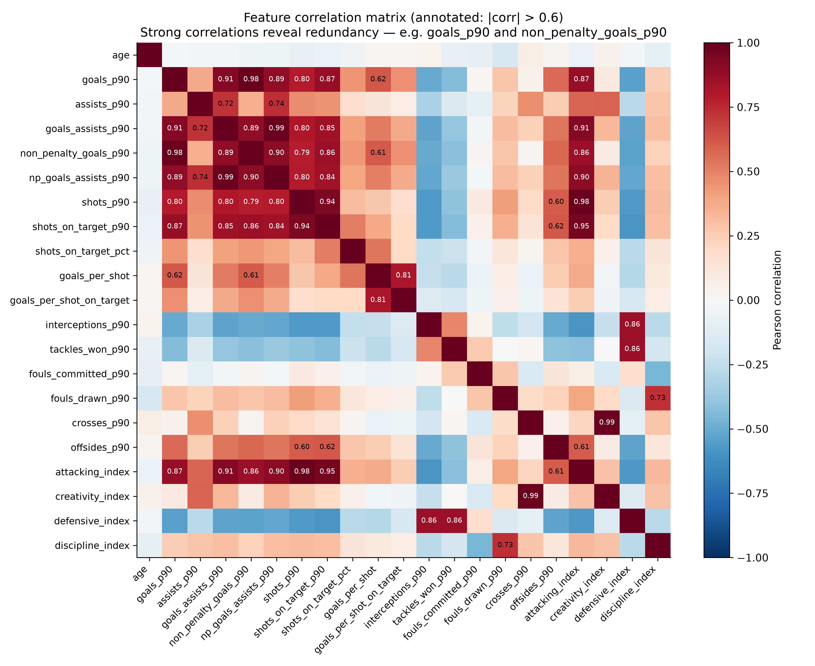
Figure 3. Feature correlation heatmap
Retaining familiar statistics offers an interpretability advantage because a scout can understand an attribution to goals, crosses or interceptions. This is more readily than using complex features difficult to interpret. The correlation heatmap is therefore used to show which variables contain similar information, rather than removing every related feature. The composites were excluded only from clustering stage, where duplicate dimensions directly affect the distances between players.
Correlation also provides and early indication of the feature-set imbalance. Attacking statistics form a richer block of related information, whereas the defensive variables is represented by relatively few direct metrics. This structural observation anticipates the later finding that attacking roles are easier to cluster, compare and value. The correlation structure of the selected feature is shown in Figure 3, highlighting both the redundancy among related attacking metrics and the comparatively limited representation of defensive statistics.

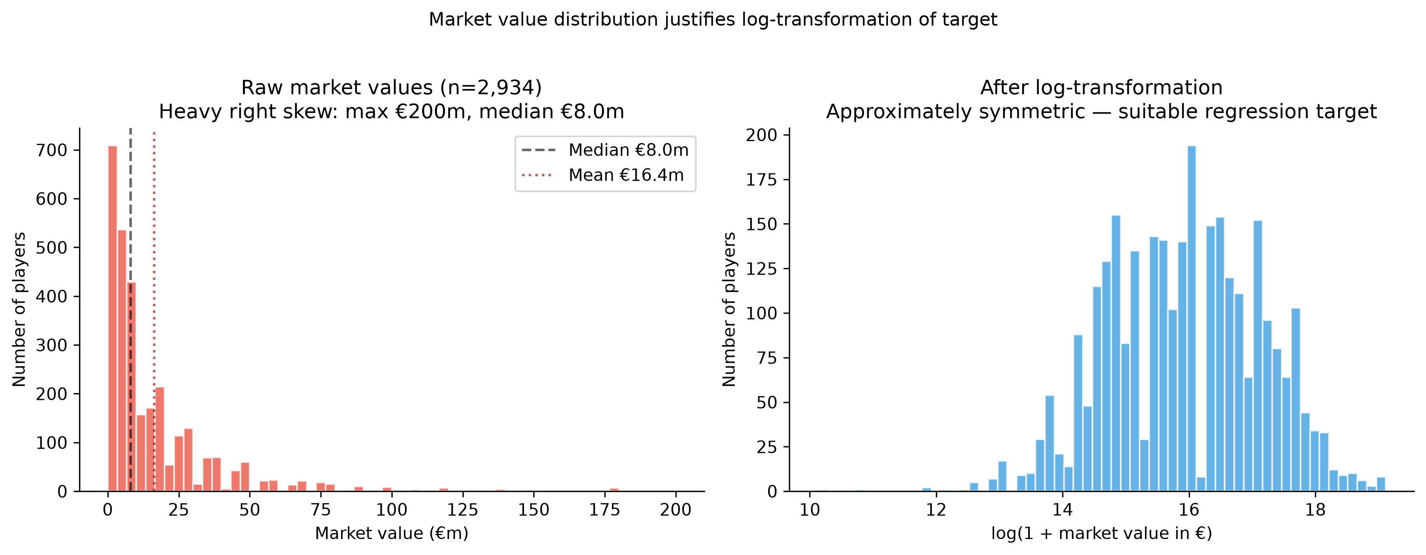
Figure 4. Market-value distribution before and after log transformation
As in Figure 3, Transfermarkt market value is highly right-skewed, meaning that most players had relatively low or medium values, while a small number of elite players had very high values. The median player was valued at approximately €8 million, while the maximum reached €200 million. If the raw market values were modelled directly, these elite players could have too much influence on the model because of the squared-error optimisation. A log(1 + market value) transformation was therefore applied before supervised training. This log-transformed distribution makes substantially more compact and is better suited to regression modelling as shown in Figure 3.
The log1p transformation, defined as ln(1+ x), was chosen rather than the natural logarithm because it remains defined when value is zero. Predictions were converted back to euros with the inverse expm1 transformation before MAE and median absolute error were reported. The log transformation reduces the heavy tail and produces a more stable regression problem, but it also contributes to regression toward the mean after back-transformation. This is considered explicitly in Chapter 5, where the model’s tendency to underestimate the value of elite players is analysed.
The log transformation also affects how error metrics should be interpreted. Models were fitted against the transformed target because this reduces the dominance of the most expensive observations, but final predictions were converted back to euros before MAE and median absolute error were reported. This makes the results easier for scouts and examiners to understand because the errors are shown in real market-value terms. R² was evaluated on the out-of-fold predictions under the project’s implementation and is therefore discussed together with euro-based errors rather than in isolation.
Feature engineering was kept simple and transparent. More advanced models, such as dimensionality reduction or automatically learned features, might improve the model’s performance, but they would make the individual features harder to communicate in the dashboard and in SHAP explanations. The selected approach accepts some redundancy in exchange for recognizable football concepts. This design choice supports the aim of this dissertation. The system should be inspectable by a football practitioners, rather than being designed only to achieve the highest possible prediction accuracy.

3.5 Clustering Design
K-Means, Gaussian Mixture Models (GNN) and HDBSCAN were compared because they represent different assumptions about player-style structure. K-Means provides compact groups around central points. GMM is more flexible and gives each player a probability of belonging to different cluster shapes. HDBSCAN identifies persistent dense areas and can label those unusual players as noise (Mclnnes, Healy and Astels, 2017).
The quality of the clustering models was assessed with silhouette score, Davies-Bouldin index and Calinski-Harabasz score. These metrics measure complementary aspects of how well the player groups are formed, such as how similar players are within the same group and how different the groups are form each other. The final clustering method was therefore not chosen based on one score alone. The numerical results were considered together with football interpretability (Rousseeuw, 1987; Davies and Bouldin, 1979).
Before clustering, the player statistics were standardised using StandardScaler so that variables with different scales could be compared fairly. The four composite indicators were also excluded from the clustering process to avoid double counting their underlying statistics.
PCA then reduced the standardised data into nine components, while retaining approximately 95% of the original information or variance. This gives a more compact representation for distance-based clustering. K-Means and GMM were tested for k value from 4 to 10, while HDBSCAN used minimum-cluster size values of 30, 50, 80 and 100. The three clustering quality measures were recorded for each configuration and football interpretability was used as a selection criterion.

3.6 Similarity-Recommender Design
The recommender represents each player-season as a feature vector and ranks candidates using cosine similarity. Instead of focusing on the total amount of output, cosine similarity looks at the overall direction or pattern of a player’s statistics. This compares the direction of two player profiles. For example, two players may have different numbers of goals, assists, or shots, but if they share a similar balance of strengths, the system can still identify them as similar players.
Eligible vectors were normalised before ranking. Candidates were first restricted by the K-Means cluster, then one of three role filters could be applied: cluster-only, the same broad position family, or the same detailed Transfermarkt position. This approach allows the user to choose between greater flexibility in finding similar players and stricter tactical matching.
Retrospective validation was carried out three verified player transfers from the 2024/25 season under all three filter modes to test whether the system could identify realistic alternative players using only information that was available before the transfer took place.

3.7 Supervised Modelling and Explainability Design
Four regression models were compared using the same features and target pipeline. Linear Regression was used as an interpretable baseline. Random Forest was trained using 300 trees, while XGBoost used 500 boosted trees (Chen and Guestrin, 2016). LightGBM was also included as another efficient gradient-boosting method (Ke et al., 2017).
The comparison tested whether additional non-linear complexity improved generalization on a relatively small, heavy-tailed dataset. Hyperparameters were kept moderate so that the study compared robust model families rather than optimizing aggressively to one split.
Models were trained in two ways. Firstly, they were trained using all 2,935 player-season records to create global models. Secondly, separate models were trained for each of the seven position families. This allowed to test whether different positions have different factors that affect market value. However, this study does not assume that position-specific models would automatically outperform the global model, especially because of the smaller position samples (Franceschi et al., 2024).
An initial 80/20 split produced an unstable R² near 0.70 because a few very high-value players strongly affected the test set. Thus, the final design used five-fold cross-validation, producing one out-of-fold prediction for every observation. The models were evaluated using R², MAE and median absolute error so that explained variance, average euro error and typical error were all visible.
SHAP was used to explain the selected tree-based models at both global and player level. The mean absolute SHAP values summarized overall feature influence. For individual players, the positive or negative SHAP values showed which features increased or decreased that player’s predicted market value. Where Linear Regression won, its coefficients remained the primary model-faithful explanation and tree-based SHAP views were treated only as supplementary proxies.

3.8 Dashboard and Interaction Design
The dashboard was designed as an interactive research prototype for scouts, analysts and examiners. It allows users to explore the analysis without needing to run Python notebooks or commend-line code scripts.
The dashboard keeps predictions and explanations together. For example, similar-player results show the statistics that make players comparable, while market-value predictions include SHAP explanations so users can inspect the evidence behind each result. Streamlit provided the browser interface and Plotly the interactive charts. The pages were organized around four main tasks: player profile, similar-player search, market-value prediction and transfer validation. The main analytical functions were kept separate from the interface, making the system easier to maintain and reducing the risks of the dashboard changing the actual analysis.

3.9 Evaluation and Testing Design
Evaluation was designed across the full pipeline. Data integration used match-rate and audit logs. Clustering was evaluated using statistical quality measures and football interpretation. The recommender was tested using consistency across seasons, players, case studies and retrospective transfers. Supervised models used five-fold cross-validation with R², MAE and median absolute error. SHAP explanations were also checked for coherent global and local explanations.
Software testing covered testing data transformations, position mapping, candidate filtering, similarity ranking, saved artefact loading and dashboard integration, The final “pytest -v” outputs is reserved for appendix F so the submitted evidence reflects the final code version.

Chapter 4 - Implementation

4.1 Data Collection
Data collection was separated by source. FBref data for five leagues and two seasons were collected through soccerdata Python package. When direct access was blocked by Cloudfare, SeleniumBase was used instead. Intermediate CSV files were saved so that the data collection process could be reproduced later.
Transfermarkt data were scraped with requests and BeautifulSoup4 using an approximately four-second delay. This process produced 7,585 raw player records across ten league-season files and retrying transient features such as the missing records during an initial run.
StatsBomb Open Data was accessed through statsbombpy to examine event-level football data. The 2022 World Cup dataset included 64 matches and around 19,166 events that were inspected. However, this data was not merged into the main Big-Five league dataset. Instead, it was used only as a reference for the event-data part.
The three sources consequently served complementary purposes:
Source | Main information used | Role in this study
FBref | Player performance statistics | Primary performance source
Transfermarkt | Market values and detailed positions | Primary valuation and positional source
StatsBomb Open Data | Event-level football data | Reference/methodological source
Table 2. Data Sources and their roles
Attempts to obtain additional FBref passing, defensive and possession tables return empty statistical cells even after brower access. This was treated as a data-availability constraint and later considered when interpreting weaker defensive-role results.
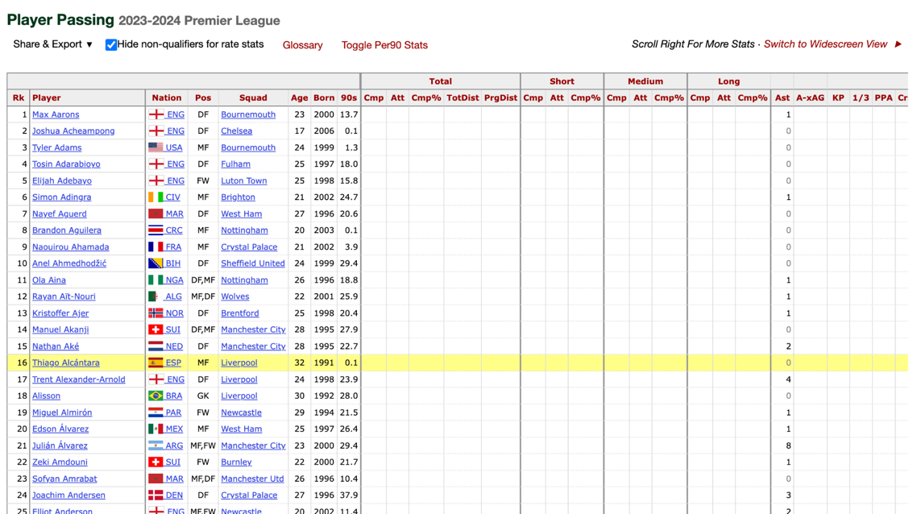
Figure 5. FBref website - empty data cells

4.2 Record Linkage, Cleaning and Dataset Construction
FBref and Transfermarkt lacked a shared player identifier, so names were matched within each league and season after normalising season formats. Blocking reduced the risk of comparing players from unrelated competitions or seasons.
The RapidFuzz WRatio method was used with a matchin threshold of 85 out of 100. This successfully matched 2,935 out of 2,955 FBref records, giving a 99.3% match rate. Unmatched records were exported separately for audit, prioritising correct linkage over maximum coverage. Players with fewer than 900 minutes were removed before calculating per-90 statistics to reduce unstable rates from small samples.
Mid-season club records were aggregated to player-season level, six goalkeeper records were removed, and the analysis was restricted to outfield players. Missing values were handled based on what each feature meant. A total of 161 missing values were changed to zero only when zero was the correct value. For example, if a player had no shots, a statistic such as goals per shot could be treated as zero rather than missing.
After cleaning, the final dataset contained 2,935 outfield player-seasons. The seven supervised position families were Centre-Back, Full-Back, Defensive Midfield, Central Midfield, Attacking Midfield, Winger, and Forward. The distribution is uneven, but no family is so small that model fitting becomes impossible. Centre-backs form the largest group, while attacking midfielders form the smallest.
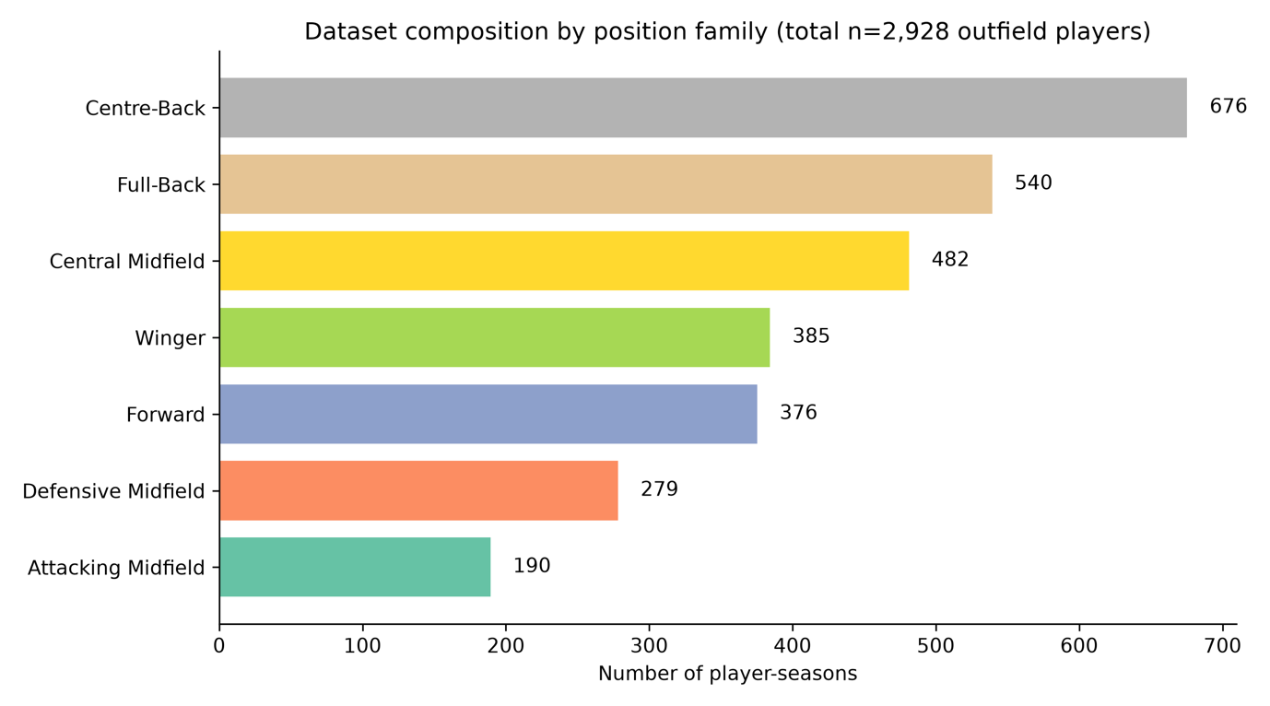Figure 6. Position-family counts in the final dataset
League and season coverage was comparatively balanced, with roughly around 600 player observations per league and approximately 1,450 observations per season. This is useful because a single competition does not dominate the results. However, the dataset should not be interpreted as a random sample of football players worldwide. It only includes outfield players from the five major European leagues who exceeded the minimum-minute playing time and could be matched successfully across the public data sources.
The Big-Five and two-season scope was chosen to balance recent, comparable coverage with reproducibility. However, the dataset should not be considered representative of football world. To avoid data leakage, market value was excluded from clustering and similarity features, while Transfermarkt positions were used as filtering labels rather than numeric clustering inputs.
Position family | Player-seasons | Share of dataset
Centre-Back | 676 | 23.0%
Full-Back | 540 | 18.4%
Defensive Midfield | 279 | 9.5%
Central Midfield | 482 | 16.4%
Attacking Midfield | 191 | 6.5%
Winger | 385 | 13.1%
Forward | 376 | 12.8%
Table 3. Final dataset composition by position family

4.3 Feature-Engineering Implementation
Feature transformations were implemented as fixed and consistent functions shared by the main analysis and the dashboard. Per-90 rates were calculated after the 900-minute filter and composite indicators were derived from named raw rates.
Statₚ₉₀ = (Statₜₒₜₐₗ × 90) / Minutes Played
Attacking Index = Goals+Assistsₚ₉₀ + 0.5 × Shotsₚ₉₀
Creativity Index = Assistsₚ₉₀ + 0.3 × Crossesₚ₉₀
Defensive Index = Interceptionsₚ₉₀ + Tackles Wonₚ₉₀
Discipline Index = Fouls Drawnₚ₉₀ − Fouls Committedₚ₉₀
yₗₒg = ln(1 + y)
ŷ = exp(ŷₗₒg) − 1
Market value used log1p during training and expm1 for euro-scale reporting. Composite indicators were excluded from the clustering matrix to prevent double counting.

4.4 Clustering and Recommender Implementation
The clustering implementation applied StandardScaler, PCA and the selected clustering estimator in sequence, with metric sweeps and summaries saved as processed artefacts.
X_scaled = scaler.fit_transform(X)
X_pca = pca.fit_transform(X_scaled)
Labels = kmeans.fit_predict(X_pca)
The recommender normalised eligible vectors, filtered the candidate pool before ranking, and used dot products for cosine similarity. The same module served evaluation scripts and the dashboard.

4.5 Supervised Models and SHAP Implementation
All four regressors used a common five-fold evaluation routine for global and seven position-family scopes, generating out-of-fold predictions for every eligible observation.
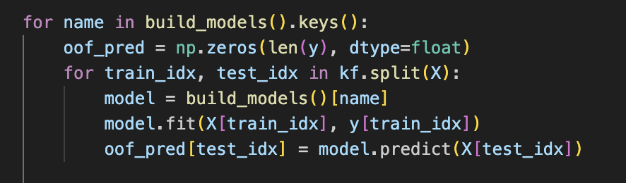
TreeSHAP artefacts were generated for tree models, with mean absolute values for global importance and signed contributions for player-level explanations. Prediction and explanation artefacts were saved for dashboard loading.

4.6 Dashboard Implementation
The Player Profile page allows a user to search for a player-season and inspect identity information, position, cluster and selected per-90 statistics relative to the relevant position-family average. This page acts as the entry point for understanding the feature representation before invoking a model.
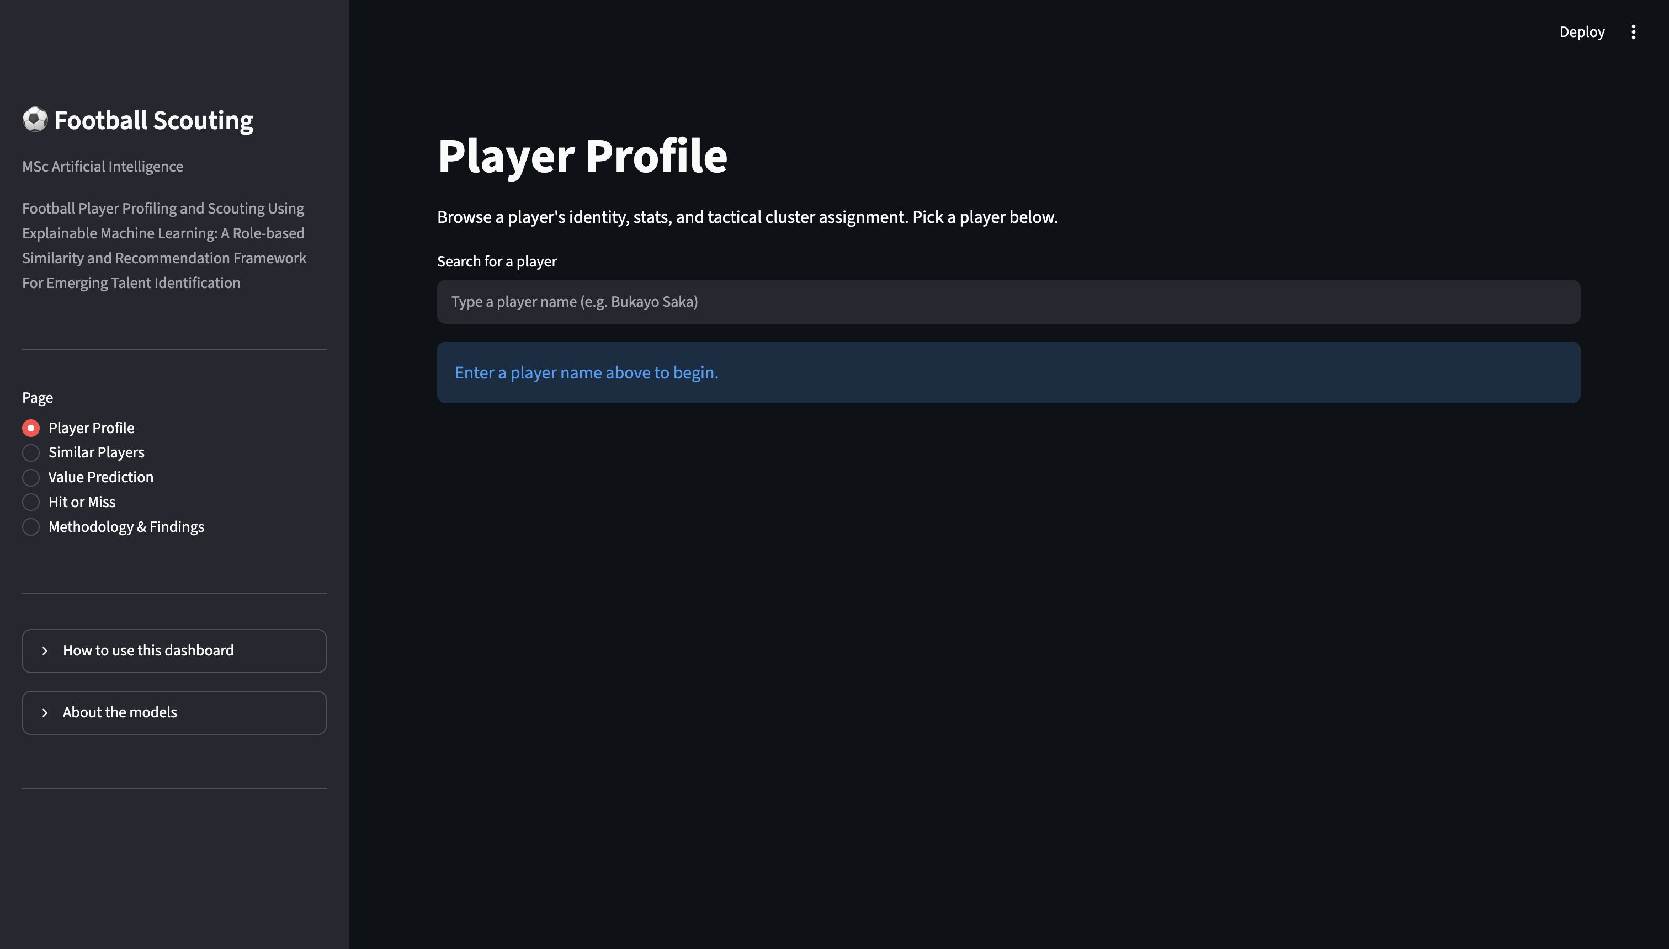
Figure 7. Player profile dashboard
The Similar Players page provides the recommender interface. Users can choose the position-filter mode and apply practical constraints such as age range, market-value range, excluding the same team or excluding the same league. Exposing these filters makes clear that player recruitment is a constrained search problem rather than a single similarity score.

Figure 8. Similar players recommender Dashboard

The Value Prediction page displays the global and per-position market-value estimates side-by-side where both are available. It also presents a SHAP explanation so that the user can see which features raise or lower the prediction relative to the model baseline. Showing both scopes helps communicate model disagreement and prevents the system from hiding the fact that a role-specific model may perform differently from the global one.
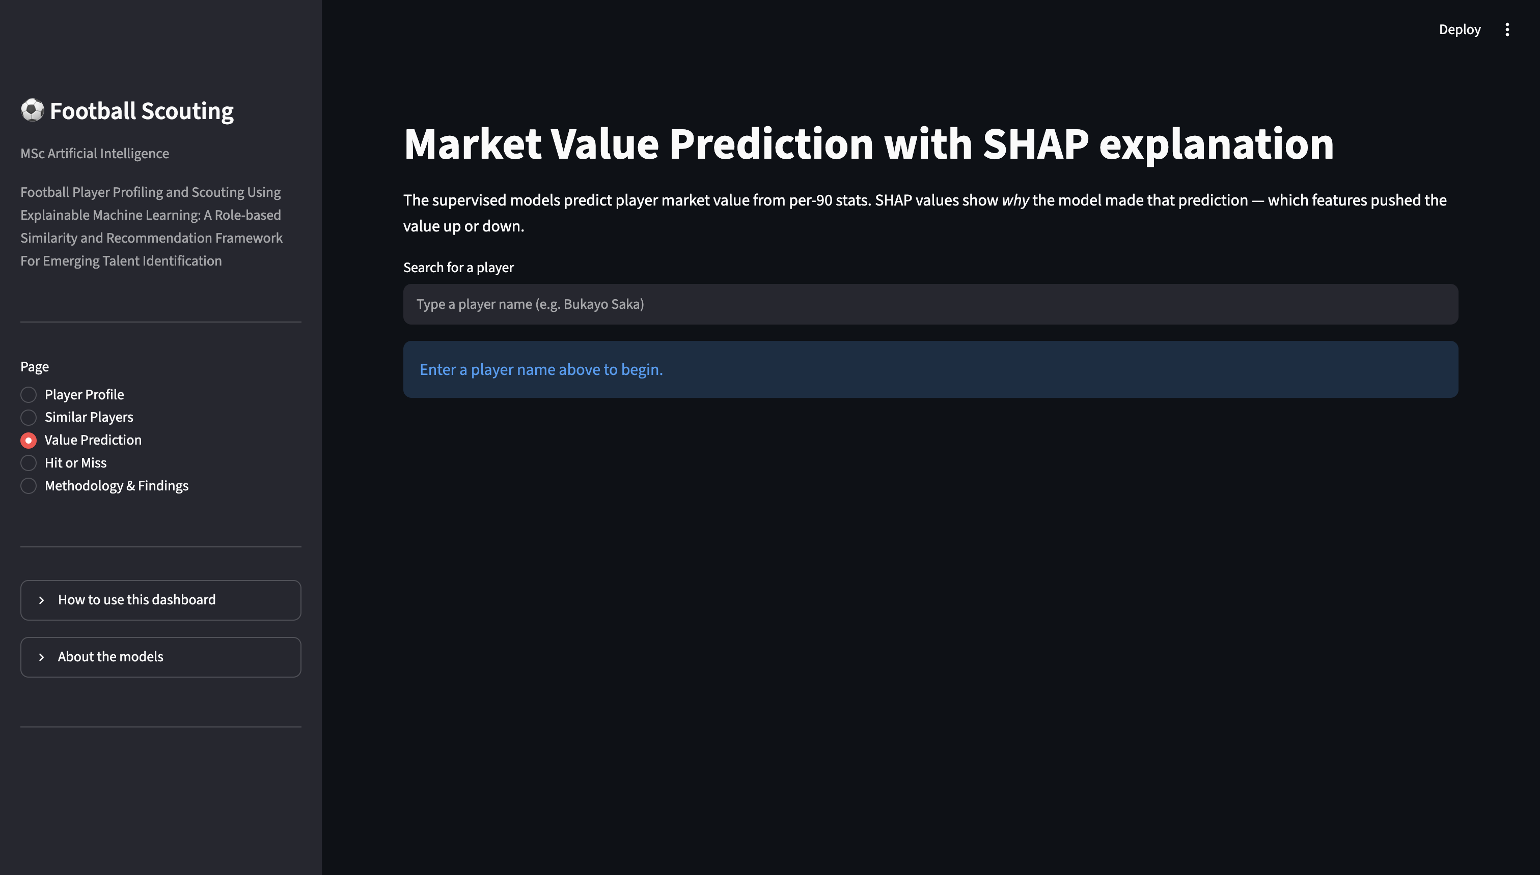 Figure 9. Market value prediction dashboard
The Hit or Miss page converts the retrospective evaluation framework into an interactive tool. The user selects a query player and a candidate target. The system reports whether the target is found, its rank and similarity, then displays comparative statistics. This makes it possible to explore transfer hypotheses beyond the three fixed cases evaluated in Section 5.4.
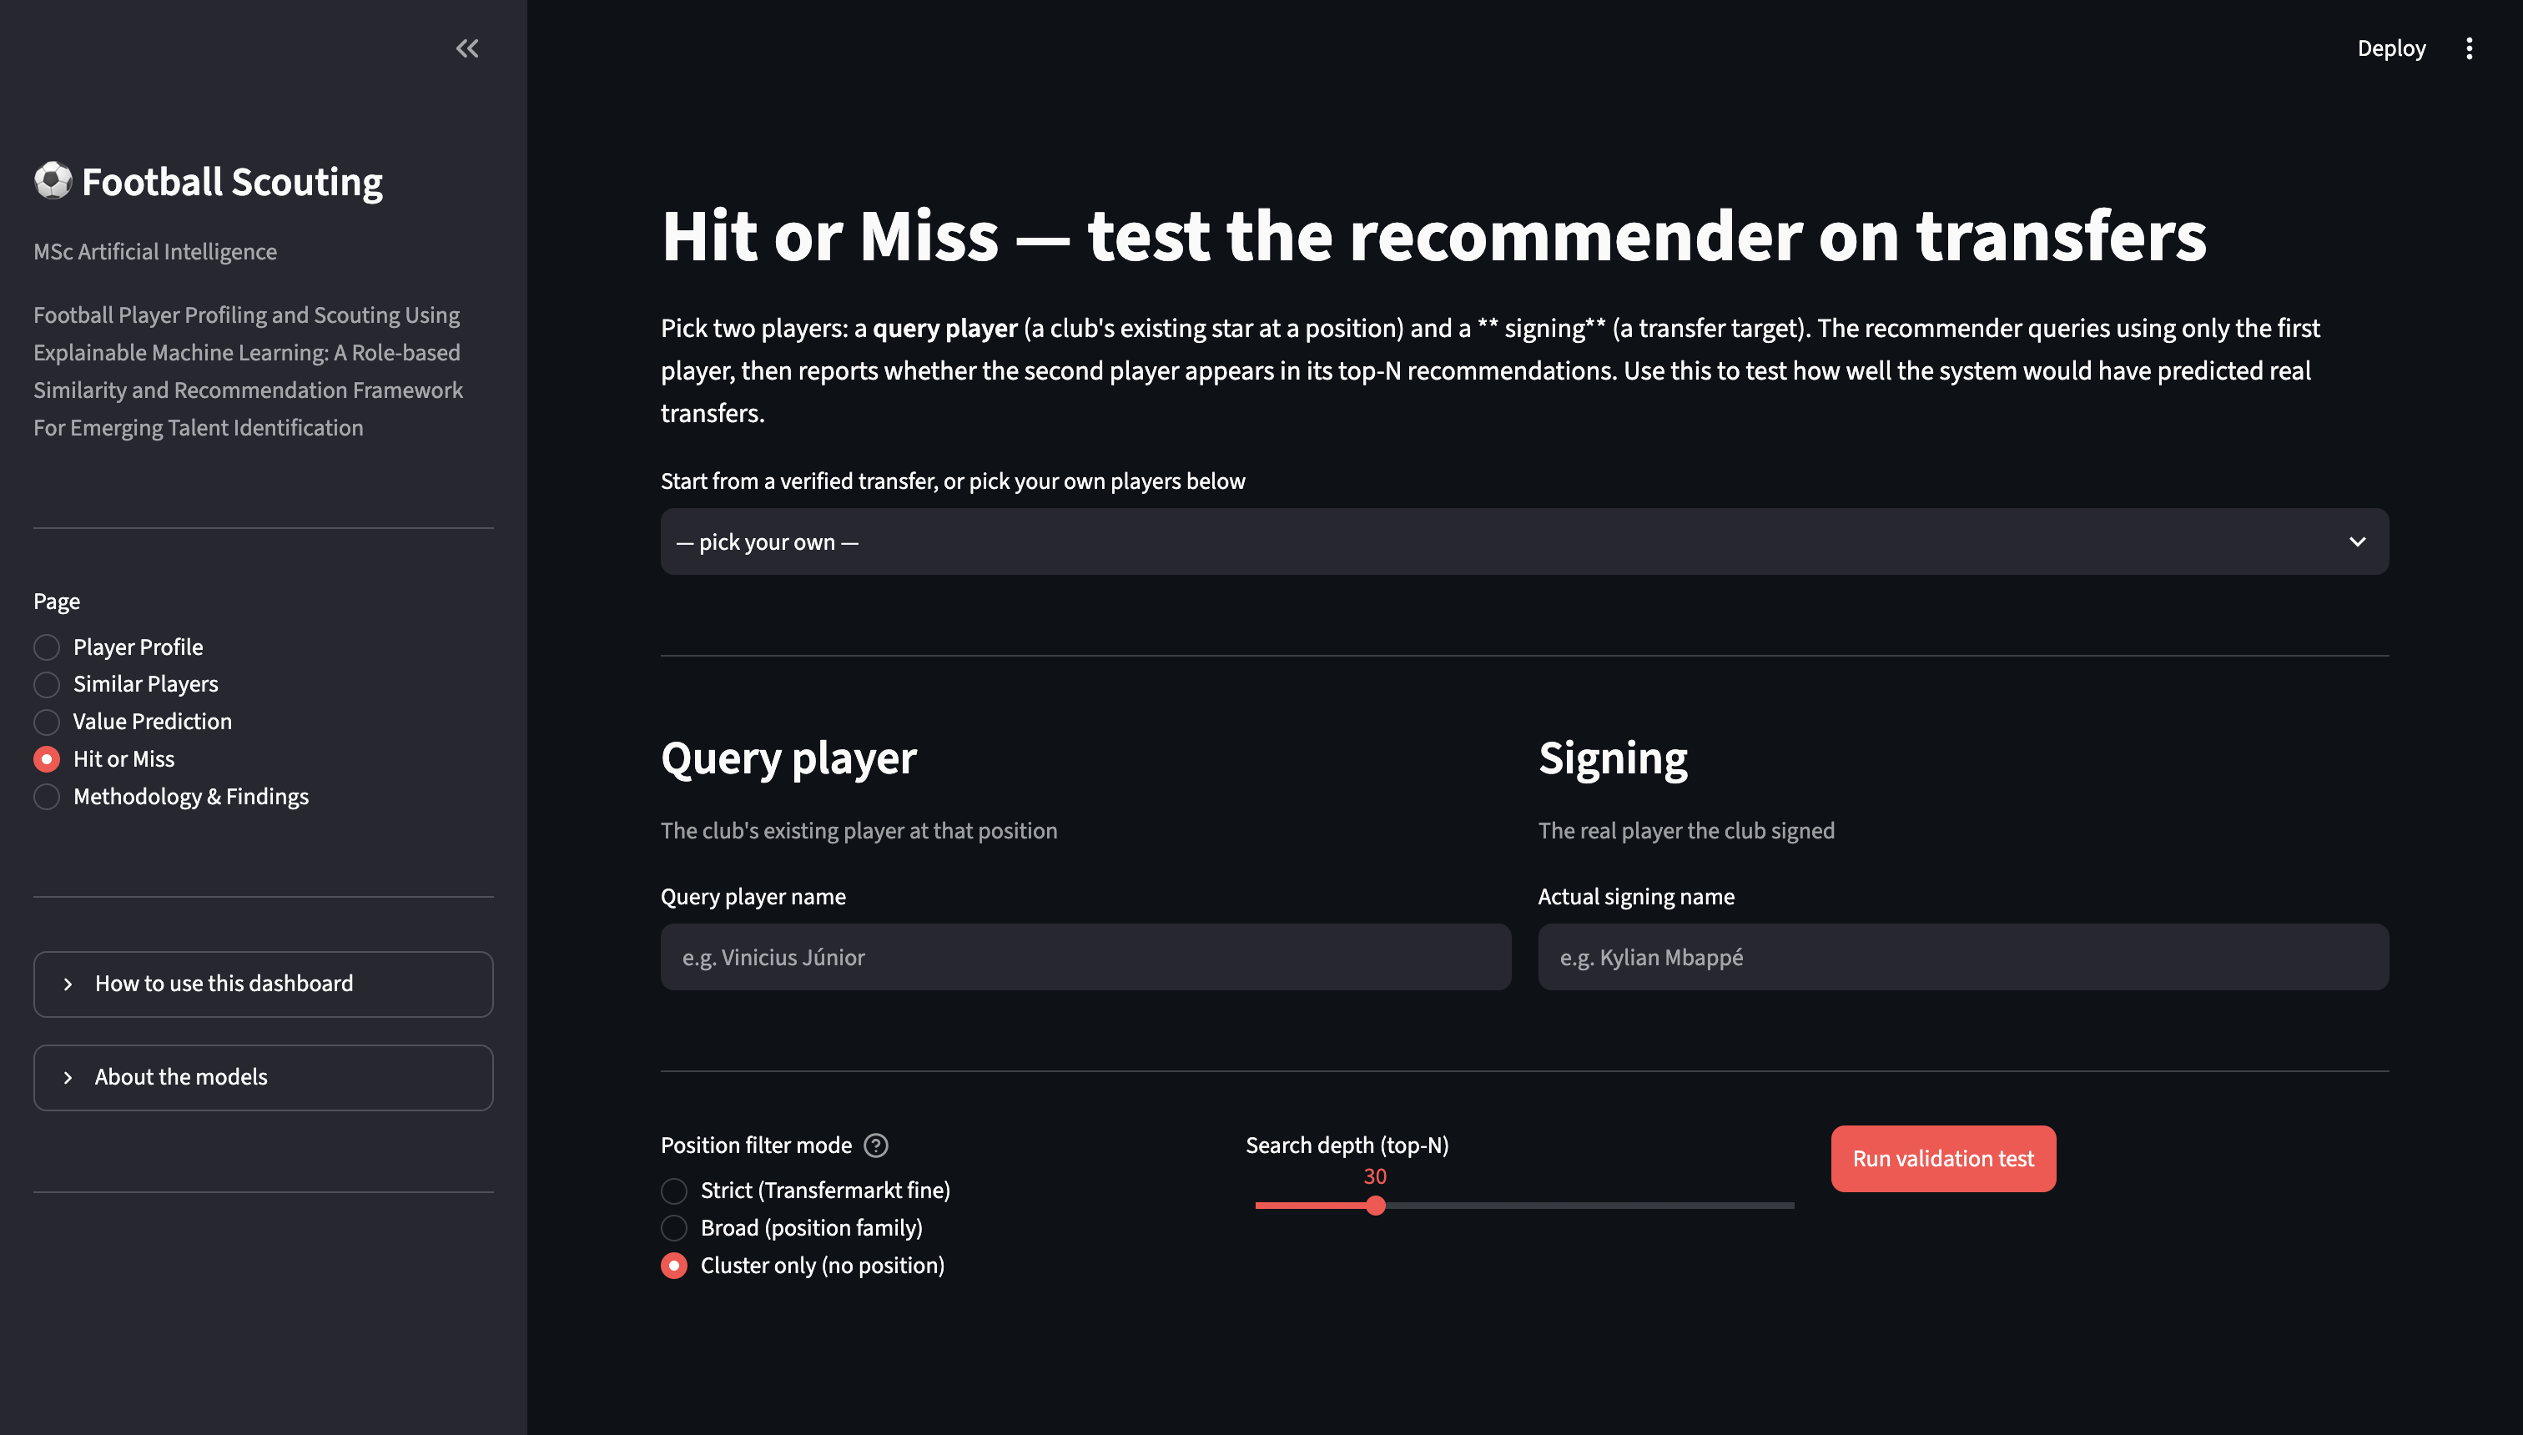 Figure 10. Hit or miss dashboard
Finally, the Methodology and Findings page summarises model choices, key metrics and known limitations. Sidebar expanders explain how to use the dashboard and what each model is doing. These explanatory elements were included deliberately for viva use: a non-technical examiner can move from a result to the corresponding methodological rationale without leaving the application.

Figure 11. Methodology and findings dashboard
Usability and reproducibility were supported by placing statistics, filters and explanations beside each result, caching data/model artefacts, and reusing the same recommender functions in both the dashboard and offline evaluation. Production features such as authentication, persistent databases and monitoring were outside the prototype's scope.

4.7 Testing Strategy and Implementation Checks
Testing covered data integrity, deterministic feature transformations, valid cluster labels, candidate filtering, cross-validation output shape, inverse target transformation and dashboard loading of the same saved artefacts used by evaluation scripts. The actual `pytest -v` output is included in appendix F.

Chapter 5 - Evaluation

5.1 Evaluation Framework
Evaluation was aligned with the project objectives: data quality used coverage checks; clustering used validity metrics and profile interpretation; recommendation used qualitative and retrospective cases; valuation used five-fold out-of-fold metrics; SHAP assessed interpretability; and the dashboard was assessed as the integration layer for these outputs.

5.2 Data Quality and Coverage
The final linkage matched 2,935 of 2,955 candidate FBref rows, corresponding to coverage rate of 99.3%. Twenty-one unmatched rows were logged separately for auditing purposes. The resulting dataset covers the five major European leagues and two seasons, with roughly balanced numbers of players from each league and season. This dataset is sufficient for the project's comparative experiments, but it is not representative of lower divisions or non-European football.
The more important data-quality limitation is the coverage of features. The accessible FBref data provided a strong set of attacking and general indicators but relatively less information on passing, possession, and defensive performance. This limitation appears again in all three modelling approaches and therefore becomes an important factor to the critical evaluation of the results.

5.3 Clustering Evaluation
K-Means and GMM were tested using values of k from 4 to 10, while HDBSCAN was tested for minimum cluster sizes of 30, 50, 80 and 100. All sweep results were saved for reproducibility.
K-Means achieved its best silhouette score at k = 4, with a value of 0.191. GMM also peaked at four components but produced a lower silhouette of 0.169 and was consistently weaker across the tested range. Increasing k fragmented the data without producing a corresponding improvement in separation or football interpretation. K-Means with four clusters was therefore selected as the primary role-discovery model.
HDBSCAN produced a more interesting result. All observations were labelled as noise for every tested minimum-cluster-size setting. This result was not treated as a failed experiment to be discarded. HDBSCAN is specifically designed to identify persistent dense areas, so its inability to find any at the tested scales suggests that the feature space does not contain strongly separated density groups. In football terms, this indicates that player’s statistical styles may overlap gradually rather than forming clearly isolated groups.
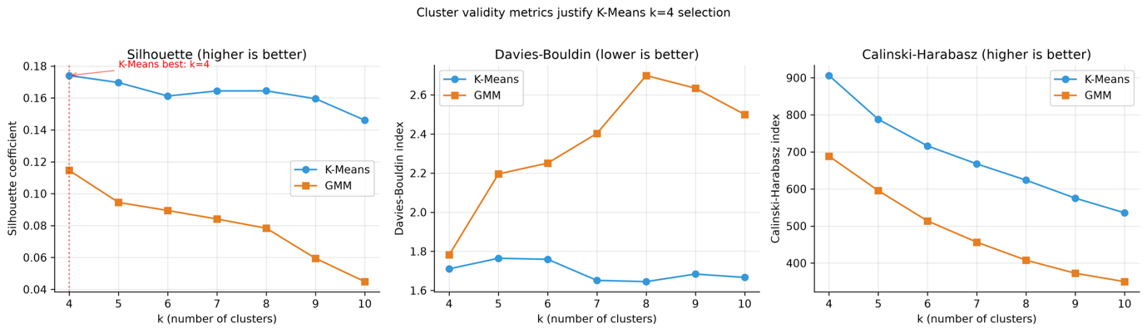
Figure 12. Cluster model-selection metric sweep
Cluster interpretation was based on the mean values of the standardised features, representative players and the distribution of expert-labelled positions. Cluster 0 contained 767 observations and showed higher values for crossing, assisting and creativity. It was therefore interpreted as representing creative wide players and attacking full backs. Examples of representative players included Theo Hernández and Matt O’Riley. These examples show that the cluster represents an attacking playstyle that can occur in more than one traditional position.
Cluster 1 contained 423 observations and was the clearest attacking group. It had high values of shot volume and non-penalty goals, so it was interpreted as representing goal-scoring number nines and other direct finishers. Marcus Thuram appeared in this cluster in both seasons, while Erling Haaland also remained in the same cluster across the two seasons. These repeated assignments provide a simple temporal-stability check over time. Although each player-season is treated as a separate observation, the model consistently identifies players with highly distinctive playing styles.
Cluster 2 was the largest group with 1,162 observations. Its profile was mainly characterised by higher levels of interceptions and tackles, together with lower attacking output. It was therefore interpreted as representing volume defenders and holding midfielders. Mario Hermoso and Nélson Semedo appeared among the representatives. The larger size and internal variety of this cluster are important because they indicate weaker resolution among defensive and deeper roles. Instead of clearly distinguishing defensive midfielders, centre backs and more defensive full backs, the available features place many of them in a broad group with relatively low attacking output.
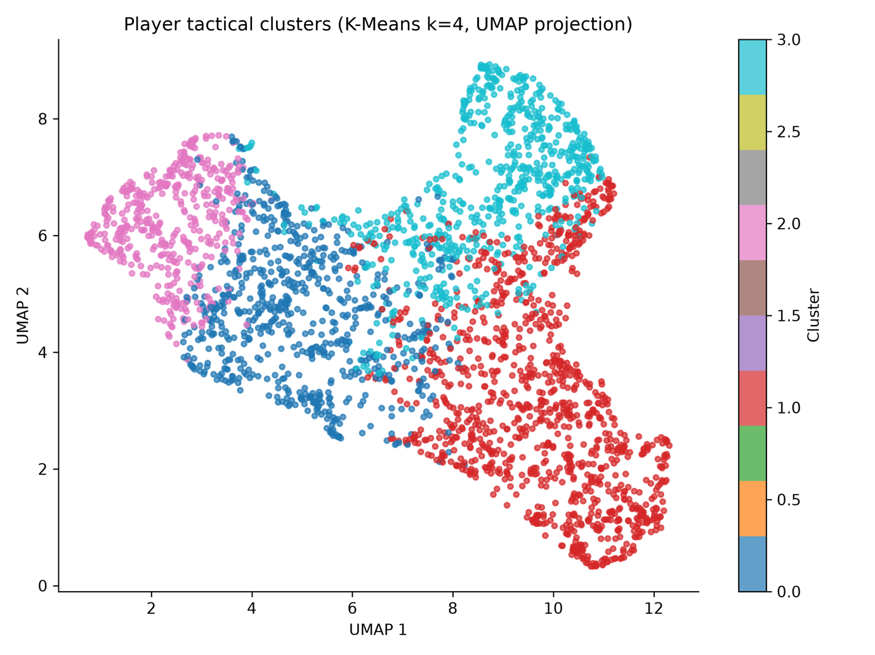
Figure 13. UMAP projection of the selected player clusters
Cluster 3 contained 603 observations and showed a distinctive efficiency profile. It had relatively low attacking volume but higher goals-per-shot values, particularly among some centre-backs, which may be linked to finishing from set-piece situations. Kristoffer Ajer and Abdul Mumin were representative examples. This cluster highlights the risk of labelling purely from one single metric. It should not be viewed as a group of ‘elite finishers’ in the same way as attacking players like forwards, because the high efficiency is mainly related to a small number of specific shooting opportunities.
Figure 14 compares the standardised feature profiles of the four clusters and highlights the variables that distinguish their playing styles, including crossing and creativity in Cluster 0, shooting and non-penalty scoring in Cluster 1, defensive activity in Cluster 2, and finishing efficiency in Cluster 3.
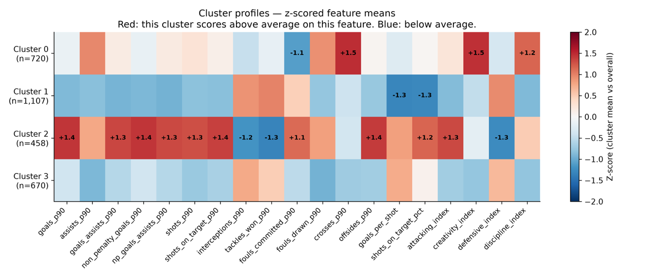
Figure 14. Standardised cluster profile heatmap
Therefore, the cluster profiles give only a partial answer to RQ1. The identified clusters represent recognisable football playing styles, but they do not map one-to-one onto expert tactical positions. This is precisely why the recommender system retained both cluster and Transfermarkt position information. The UMAP visualisation is used for interpretation rather than model fitting. It should be understood as a two-dimensional representation of a higher dimensional feature space, rather than proof of perfectly separated groups.

5.4 Similarity-Recommender Evaluation
Qualitive testing showed that expert position constraints were necessary. A cluster-only search could return tactically unsuitable players, such as Bradley Barcola as a peer for Rodri. Adding strict Transfermarkt position and broader position-family filters improved tactical relevance while retaining a more flexible cluster-only option.
The similarity scores also varied considerably between positions. Saka’s winger peers were commonly above 0.90, with a range of approximately 0.90-0.97. Haaland’s forward comparisons were similarly strong, with values between around 0.85 to 0.98, and De Bruyne’s attacking midfield comparisons were around 0.88 to 0.96. In contrast, Rodri’s defensive midfield peers had a much wider range, from around 0.29 to 0.71. This does not mean that defensive midfielders are naturally more diverse. Instead, it suggests that the available features represent attacking playing styles more effectively than deeper roles.
A useful temporal check came from Haaland. The 2024/25 Haaland observation ranked second when the 2023/24 Haaland season was used as the query, with similarity 0.974. A recommender that fails to recognise the same player’s style across consecutive seasons would have weak face validity. The high level of consistency supports the stability of the representation for players with distinctive attacking playstyles. At the same time, the lower similarity scores among defensive players show where the representation is less effective.
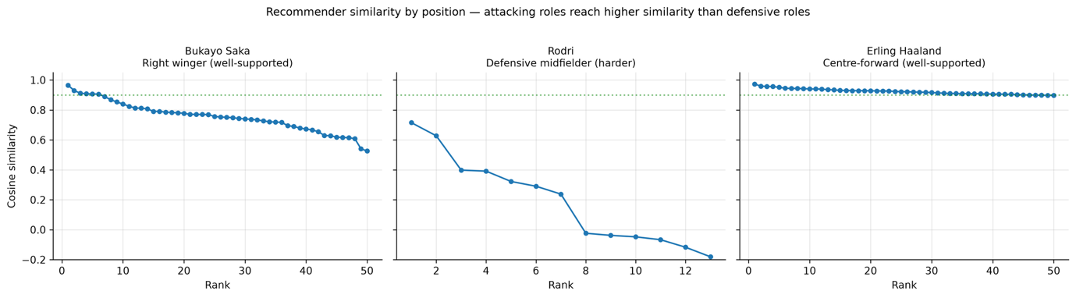
Figure 15. Similarity distributions for Saka, Rodri and Haaland
A small retrospective study tested whether the system could identify players who were subsequently recruited in the real 2024/25 transfer window. Three source-target relationships were evaluated under three filter modes, producing nine tests in total. These included Kylian Mbappé for Real Madrid's 2024 recruitment compared with his recent teammate Vinicius Júnior, Julián Álvarez to Omar Marmoush for Manchester City's 2025 recruitment context, and comparison between first lineup player Erling Haaland and his substitute Omar Marmoush for the same window.
Only two of the nine tests produced a hit in the chosen top-k range, 30. Under the cluster-only filter, Mbappé at rank 10 for Vinicius with cosine similarity 0.958, while Marmoush appeared at rank 29, with similarity 0.781, for Julián Álvarez under strict-position filter. Only the Mbappé case qualified as a hit at the stricter top 10 threshold.
This outcome exposes an important design trade-off. Strict same-position filtering improves tactical relevance and reduces unsuitable recommendations, such as the Rodri-Barcola result, but it can also exclude versatile players who perform in more than one role. Broad position-family filtering provides a middle ground. The evaluation therefore supports an interface in which the analyst chooses the constraint rather than an architecture in which the system fixes it.
The low hit rate should also be interpreted honestly. Real transfers are driven by factors absent from the dataset, including contract duration, wage demands, availability, club strategy, agent relationships, home-grown rules and injury risks. Therefore, the stylistic recommender is not expected to reproduce every transfer. In fact, a model that perfectly predicted historical signings from performance statistics alone would likely be learning market-specific shortcuts rather than measuring only sporting similarity. For this reason, the retrospective study is best considered a test of the system’s plausibility and its filter design.
Cosine similarity should be read as a measure of stylistic similarity within the selected group of candidates, rather than as an equality of raw production or market value. The retrospective transfer study is therefore a test of plausibility rather than a transfer market predictor, because contracts, wages, availability and club strategy are not modelled. A larger evaluation should predefine more transfer cases and report fixed ranking metrics across windows.
Query / context | Transferred player | Best documented result | Interpretation
Vinicius Júnior | Kylian Mbappé | Rank 10; similarity 0.958; cluster-only | Strong stylistic peer; strict position excluded him
Julián Álvarez | Omar Marmoush | Rank 29; similarity 0.781; strict position | Retrieved only near the bottom of the top 30.
Erling Haaland | Omar Marmoush | No hit in tested top-k | Transfer motive is broader than direct replacement
Table 4. Retrospective transfer-evaluation summary
The dashboard extends this validation by allowing any two player-seasons to be tested under the chosen filter mode, returning hit or miss, rank, similarity and side-by-side statistics.

5.5 Supervised Market-Value Evaluation
Random Forest was the best global model, with R² = 0.404, MAE = €10.11 million and median absolute error = €5.05 million. XGBoost achieved R² = 0.384, Linear Regression 0.374 and LightGBM 0.368. The differences are relatively small. In particular, the linear baseline is close to the tree ensembles, indicating that the selected features contain a substantial near-linear relationship with transfer value after the log transformation.
Model | Global R² | Interpretation
Random Forest | 0.404 | Best overall; primary global model
XGBoost | 0.384 | No improvement over Random Forest
Linear Regression | 0.374 | Competitive baseline; substantial additive signal
LightGBM | 0.368 | Lowest of the four global models
Table 5. Global five-fold cross-validation comparison
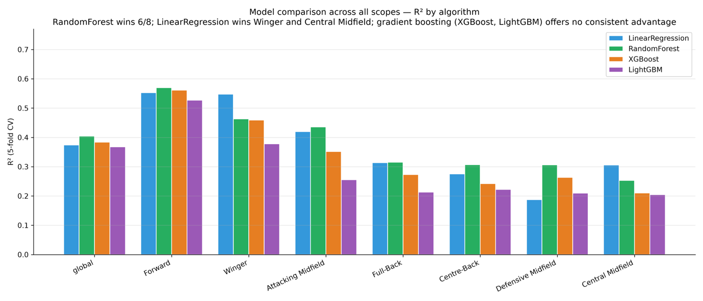
Figure 16. Global comparison of the four supervised models
A median error of €5.05 million means that half of the out-of-fold predictions are within roughly €5.05 million of the corresponding Transmarkt value. This can be useful as a screening estimate for many ordinary players. However, the MAE is almost twice as high because a relatively small number of expensive players produce much larger absolute misses. The model should therefore be viewed as a tool for supporting relative decisions rather than as an automated system for setting player prices.
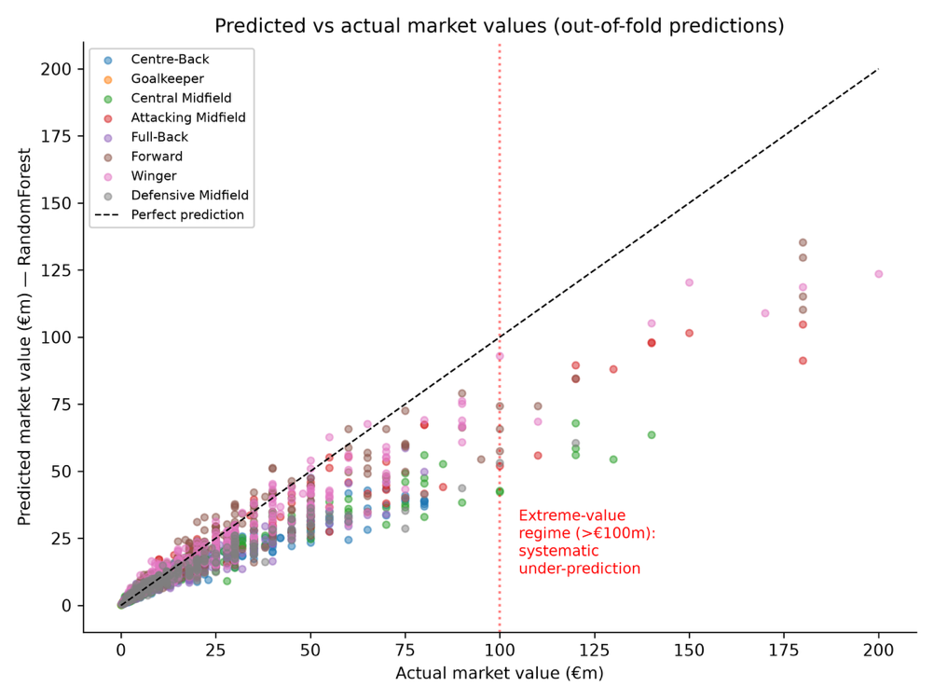
Figure 17. Predicted versus actual market value
Per-position models improved performance for the three most attack-oriented families but not for the defensively deeper roles. The Forward cluster was the strongest scope, with Random Forest achieving R² of 0.570. Winger was the second strongest group, with Linear Regression reaching R² of 0.547. Attacking Midfield also performed better than the global model, with Random Forest achieving R² of 0.436. These results support the hypothesis that the role-specific models can be useful when the available features strongly describe a particular playing role.
The remaining families did not outperform the global R² of 0.404. Full Back achieved 0.315, Centre Back 0.307, Central Midfield 0.306 and Defensive Midfield 0,306. Although the best algorithm differed between some groups, the defensive and central roles remained close to the same performance ceiling. This pattern is more informative than declaring one algorithm the winner. It suggests that the main limitation comes from the available feature representation rather than from the choice of regression method.
Exactly three of seven per-position scopes therefore performed better than the global model: Forward, Winger, and Attacking Midfield. This means that RQ2 can only be answered conditionally rather than generally. Position specific training can help where role-relevant outputs are well presented, but it cannot solve the issue of missing data. Dividing a limited defensive feature set into smaller samples can even lead to lower performance.
Position family | Winning model | R²
Forward | Random Forest | 0.570
Winger | Linear Regression | 0.547
Attacking Midfield | Random Forest | 0.436
Full-Back | Random Forest | 0.315
Centre-Back | Random Forest | 0.307
Central Midfield | Linear Regression | 0.306
Defensive Midfield | Random Forest | 0.306
Table 6. Best supervised model within each position family
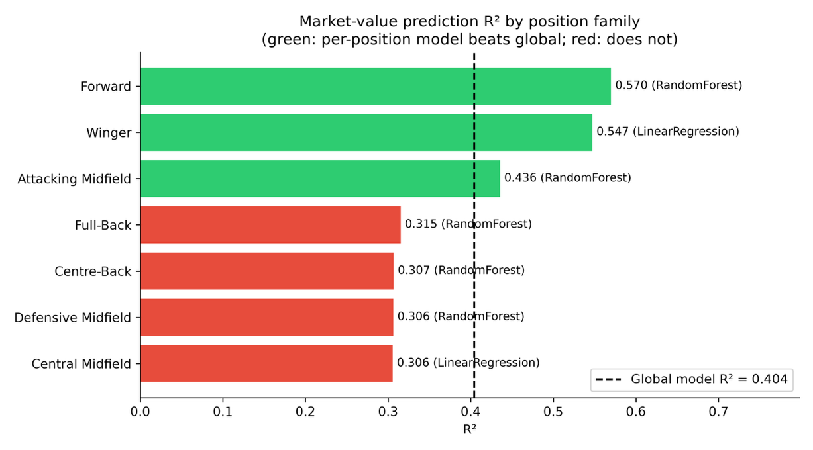
Figure 18. Per-position R² comparison
The position-specific experiment also shows a bias-variance trade off. Role-specific models can reduce dissimilarities between different player types, but the smaller sample sizes can offset this benefit. The strongest gains occur in attack-oriented roles, while defensive roles remain close to R² of 0.31. This is consistent with the limited amount of defensive information available in the dataset.

5.6 Explainability and Local Error Evaluation
SHAP helped connect the model outputs to recognisable football features, with global feature importance summarising overall reliance of the model and local SHAP attributions explaining the contribution of individual features to specific predictions (Shapley, 1953; Lundberg and Lee, 2017).
For the selected global Random Forest model, the mean absolute SHAP values showed that age was the most important feature, with a value of approximately 0.39 in model-output units. Non-penalty goals plus assists per 90 followed at 0.16, goals plus assists per 90 at 0.11, crosses per 90 at 0.09 and fouls committed per 90 at 0.08. These values should not be interpreted as direct effects in euros because the model was trained using the log-transformed target. Instead, they are useful for comparison and show that age contributes considerably more to variation in the predictions than any single performance statistic. Age’s dominance is consistent with valuation research, where it frequently captures career stage and resale potential (Franceschi et al., 2024).
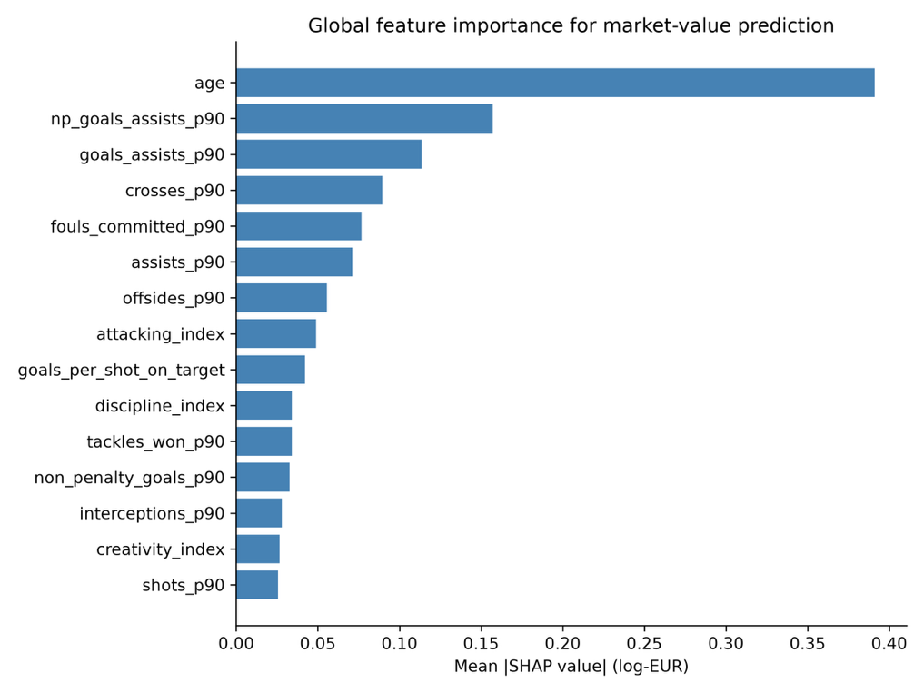
Figure 19. Global SHAP feature importance
The SHAP profiles for each position demonstrate that the relationships between features and player value can change depending on the role. Crosses become more influential for full backs, goals-per-shot matters more for forwards, and discipline or interceptions become relatively more relevant for centre backs. This provides one of the strongest reasons for retaining position-aware analysis even when per-position R² is not always higher. The explanations can reveal different patterns of value for each role, which would otherwise be combined and hidden by a single global ranking.
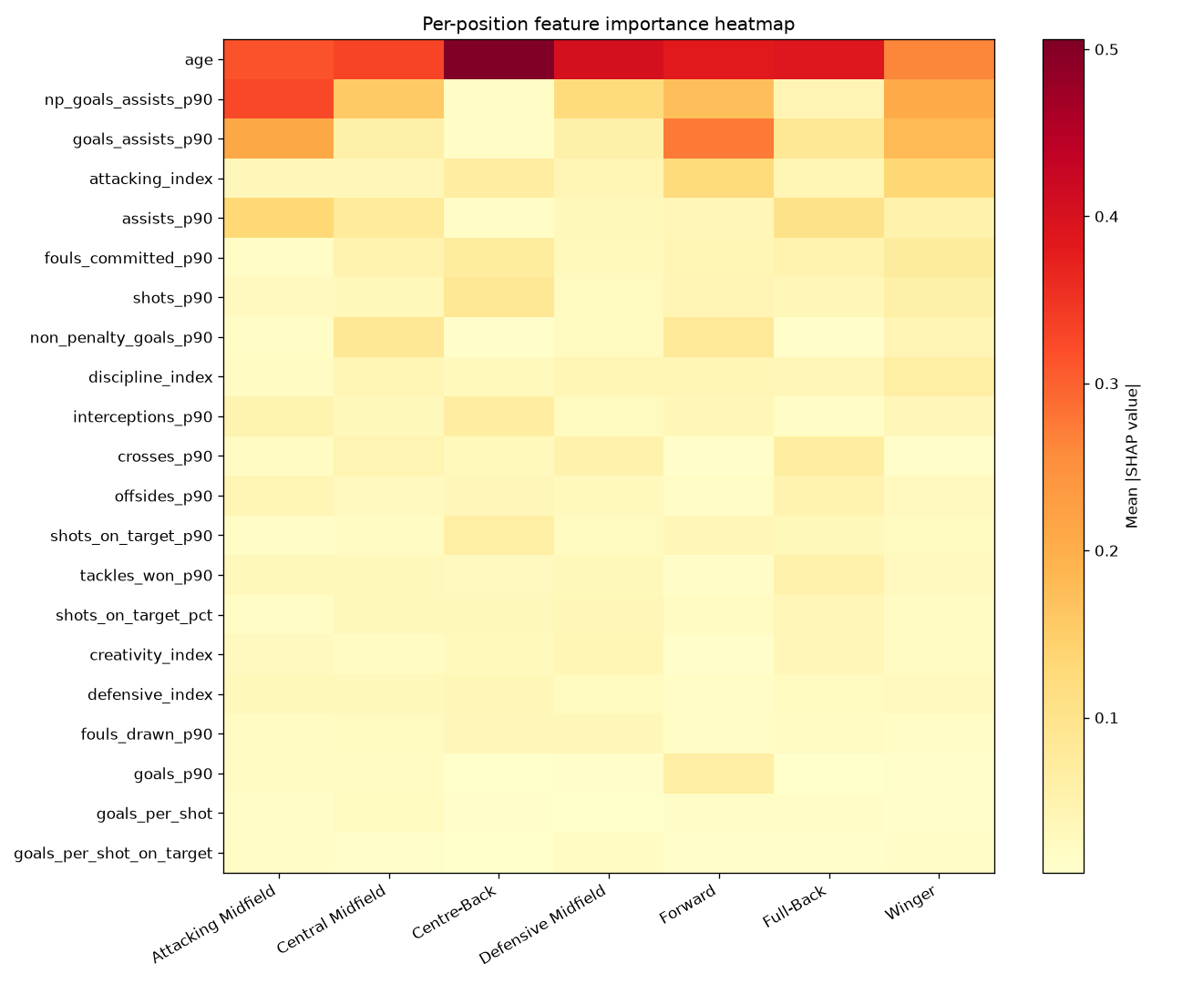
Figure 20. Per-position SHAP importance heatmap
Defensive variables remain in the lower half of the global feature importance ranking. However, this should not be interpreted as a proof that defensive contribution has little market value. SHAP explains what the trained model uses, but it cannot measure the importance of information that was unobserved, such as progressive passes, aerial ability, tactical positioning or team tactical responsibilities.
For scopes won by Linear Regression, tree-based SHAP explanations are only supplementary information. In these cases, the regression coefficients provide the most appropriate interpretation of the model.
TreeSHAP was used for the tree-based models because it provides an efficient way to calculate Shapley-style feature attributions (Lundberg et al., 2020). Because several football features are correlated with each other, SHAP values are interpreted as model attributions rather than independent causal effects.
The largest errors were concentrated among elite players. All the top twenty by actual value were under-predicted by the model. For example, Yamal was predicted at €124 million predicted compared with an actual value of €200 million, while Rodri was predicted at €61 million compared with €120 million. Van Dijk also had a large difference, with a predicted value of €7 million compared with an actual value of €30 million. This reflects heavy-tail regression toward the mean and the limited ability of tree ensembles to predict values at the extreme upper end. Consequently, the system is more suitable for relative ranking and screening than precise pricing of elite superstars.

5.7 Dashboard and System Evaluation
The dashboard shows that the whole pipeline can operate as a single product. The player profile, similar-players recommender, value prediction and transfer validation pages reuse the same saved artefacts and modelling functions. Its task-focused layout and clear explanations support good usability, although no formal evaluation with professional scouts was conducted, so claims about usability remain limited to the functionality demonstrated by the prototype.

5.8 Critical Discussion of Findings
Three findings dominate the evaluation. First, position-specific modelling helps selectively. Forward, Winger and Attacking Midfield outperform the global model, while deeper roles do not. Second, an attacking-feature bias appears independently in clustering, similarity and supervised modelling. This suggests that the main limitation is the quality and coverage of the feature representation rather than simply the choice of algorithm.
The same limitation is visible across methods. Attackers separate more clearly and often have similarity scores above 0.90, whereas Rodri's plausible peers can be much lower. Similarly, supervised R² falls from 0.570 for Forwards to 0.306 for Defensive Midfield. Therefore, richer passing, possession and defensive features are the highest priority methodological improvement.
Third, role filters create an important trade-off. Strict positions prevent implausible comparisons, yet they excluded Mbappé from Vinicius despite a 0.958 cluster-only similarity. This supports flexible filtering and a broader view of explainability. Users should be able to understand why a candidate was eligible, which features were unavailable and how sensitive a result is to tactical constraints (Sattari et al., 2021).
The global R² of 0.404 should also be interpreted relative to the compact public feature set. Studies using richer FIFA, SoFIFA or combined datasets have reported stronger prediction, while valuation has identified many contextual factors absent in the current dataset (Al-Asadi and Tasdemir, 2022; Franceschi et al., 2024; Li et al., 2025; Tamim et al., 2025). Likewise, the 0.191 clustering silhouette supports the view of Akhanli and Hennig's (2023) that football roles are often overlapping and depending the purpose of the analysis rather than sharply separated classes.

5.9 Achievement Against Objectives
Objective | Evidence of achievement | Assessment
O1: Aggregate heterogeneous public data | FBref and Transfermarkt merged to 2,935 outfield player-seasons; StatsBomb used as event-data reference. | Achieved within public-data constraints
O2: Compare clustering algorithms | K-Means, GMM and HDBSCAN compared with multiple validity metrics. | Achieved
O3: Build and evaluate role-aware recommender | Three filter modes, qualitative cases and retrospective transfer evaluations. | Achieved; external validation sample is small
O4: Compare supervised models globally and by position | Four algorithms evaluated globally and across seven position families with 5-fold CV. | Achieved
O5: Provide global and local explainability | SHAP importance and player-level explanations implemented; linear scopes require careful proxy interpretation. | Achieved with stated limitation
O6: Deliver interactive dashboard | Streamlit prototype integrates profile, similarity, valuation, explanation and validation pages. | Achieved as prototype
Table 7. Achievement of the original project objectives

5.10 Limitations
The principal limitation is the availability of the features. The lack of detailed passing, possession and defensive variables reduces tactical resolution, particularly for centre-backs and defensive midfielders. The Big-Five, two-season sample also limits generalisation beyond the studied competitions.
A second limitation is the heavy-tailed nature of the target variable. Players above €100 million are systematically under-predicted, so absolute estimates are least reliable at the top of the market. The retrospective transfer evaluation is also small, which only three transfer cases across nine filter-mode tests. Plus, it cannot support a statistically reliable accurate estimate.
Finally, role labels are player-level rather than match-specific. Future work should prioritise richer event features, broader and longer temporal coverage, leakage-aware forecasting methods and larger predefined transfer evaluations. Success should be judged by whether the system produces reasonable, explainable candidates and describes uncertainty, rather than whether it reproduces every historical transfer.

Chapter 6 – Conclusion

6.1 Summary and Answers to the Research Questions
This project developed an end-to-end, explainable scouting prototype combining public-data integration, role discovery, similarity search, market-value prediction, SHAP and an interactive dashboard.
RQ1 is answered partially. The four K-Means clusters represent recognisable styles, but they do not map one-to-one onto expert positions. Therefore, latent clusters and position labels are complementary.
RQ2 is conditional. Forward, Winger and Attacking Midfield models exceeded the global R² of 0.404, whereas the other four position families did not. Role-specific modelling helps only where the available features provide sufficient information to capture the characteristics of a particular playing role.
RQ3 is answered positively with limitations. SHAP provides useful global and player-level explanations, but these describe model behaviour rather than causality and remain limited by the input representation.
RQ4 receives limited positive evidence. Mbappé appeared at rank 10 for Vinicius with similarity 0.958 in cluster-only mode, but strict position filtering excluded him. The result supports the recommender's plausibility and explains the importance of filter design rather than demonstrating transfer-prediction accuracy.

6.2 Practical Implications
Practically, the two-axis role design allows a scout to move from broad stylistic discovery to stricter positional replacement. The dashboard supports this workflow by presenting comparative statistics, predictions and explanations together, making the system most appropriate as a screening and audit tool rather than an automated system for making recruitment decisions.

6.3 Limitations and Future Work
Future work should firstly add richer passing, possession and defensive features and test whether this improves deeper roles. A second priority is temporal forecasting using historical value trends and leakage-aware data splits, followed by a larger predefined transfer study across multiple transfer windows and leagues.
Further improvements could use probabilistic role memberships instead of strict binary filters, combine global and position-specific predictions with shrinkage or meta-learning, add prediction intervals to show uncertainty, compare SHAP with other explanation methods, and deploy the Streamlit prototype with stronger testing, versioning and data-refresh infrastructure.

6.4 Reflection
The project demonstrated that representation and evaluation design can matter as much as algorithm choice. If the project were repeated, collecting richer defensive data and developing a larger predefined transfer evaluation would be prioritised earlier. This would help improve the reliability and depth of the analysis. The final reflection is also adapted to accurately describe my own experience and learning throughout the project.

References
Akhanli, S.E. and Hennig, C. (2023) 'Clustering of football players based on performance data and aggregated clustering validity indexes', Journal of Quantitative Analysis in Sports, 19(2), pp. 103–123. doi:10.1515/jqas-2022-0037.
Al-Asadi, M.A. and Tasdemir, S. (2022) 'Predict the value of football players using FIFA video game data and machine learning techniques', IEEE Access, 10, pp. 22631–22645. doi:10.1109/ACCESS.2022.3154767.
Barbosa, A., Ribeiro, P. and Dutra, I. (2021) 'Similarity of football players using passing sequences', in Machine Learning and Data Mining for Sports Analytics, Communications in Computer and Information Science. doi:10.1007/978-3-031-02044-5_5.
Calinski, T. and Harabasz, J. (1974) 'A dendrite method for cluster analysis', Communications in Statistics, 3(1), pp. 1–27.
Chen, T. and Guestrin, C. (2016) 'XGBoost: A scalable tree boosting system', Proceedings of the 22nd ACM SIGKDD International Conference on Knowledge Discovery and Data Mining, pp. 785–794. doi:10.1145/2939672.2939785.
Davies, D.L. and Bouldin, D.W. (1979) 'A cluster separation measure', IEEE Transactions on Pattern Analysis and Machine Intelligence, PAMI-1(2), pp. 224–227. doi:10.1109/TPAMI.1979.4766909.
Decroos, T., Bransen, L., Van Haaren, J. and Davis, J. (2019) 'Actions speak louder than goals: Valuing player actions in soccer', Proceedings of the 25th ACM SIGKDD International Conference on Knowledge Discovery and Data Mining, pp. 1851–1861. doi:10.1145/3292500.3330758.
FIFA (2026) Global Transfer Report 2025. Zurich: Fédération Internationale de Football Association.
Fotache, M., Cojocariu, I. and Bertea, A. (2026) 'Machine learning for the prediction of football players’ market value in five European leagues', Applied Sciences, 16(10), 5035. doi:10.3390/app16105035.
Franceschi, M., Brocard, J.-F., Follert, F. and Gouguet, J.-J. (2024) 'Determinants of football players’ valuation: A systematic review', Journal of Economic Surveys, 38(3), pp. 577–600. doi:10.1111/joes.12552.
Herold, M., Goes, F., Nopp, S., Bauer, P., Thompson, C. and Meyer, T. (2019) 'Machine learning in men’s professional football: Current applications and future directions for improving attacking play', International Journal of Sports Science & Coaching, 14(6), pp. 798–817. doi:10.1177/1747954119879350.
Huang, C. and Zhang, S. (2023) 'Explainable artificial intelligence model for identifying market value in professional soccer players', arXiv:2311.04599.
Ke, G., Meng, Q., Finley, T., Wang, T., Chen, W., Ma, W., Ye, Q. and Liu, T.-Y. (2017) 'LightGBM: A highly efficient gradient boosting decision tree', Advances in Neural Information Processing Systems, 30.
Li, Y., Ayanso, A., Yuan, S., Kusy, M. and Kerwin, S. (2025) 'When interpretable machine learning meets the beautiful game: A predictive analytics approach to soccer player valuation in the transfer market', Sport, Business and Management: An International Journal, 16(2), pp. 240–261. doi:10.1108/SBM-05-2025-0108.
Lundberg, S.M. and Lee, S.-I. (2017) 'A unified approach to interpreting model predictions', Advances in Neural Information Processing Systems, 30, pp. 4765–4774.
Lundberg, S.M. et al. (2020) 'From local explanations to global understanding with explainable AI for trees', Nature Machine Intelligence, 2, pp. 56–67. doi:10.1038/s42256-019-0138-9.
McInnes, L., Healy, J. and Astels, S. (2017) 'hdbscan: Hierarchical density based clustering', Journal of Open Source Software, 2(11), 205. doi:10.21105/joss.00205.
McInnes, L., Healy, J., Saul, N. and Großberger, L. (2018) 'UMAP: Uniform Manifold Approximation and Projection', Journal of Open Source Software, 3(29), 861. doi:10.21105/joss.00861.
Müller, O., Simons, A. and Weinmann, M. (2017) 'Beyond crowd judgments: Data-driven estimation of market value in association football', European Journal of Operational Research, 263(2), pp. 611–624. doi:10.1016/j.ejor.2017.05.005.
Pappalardo, L., Cintia, P., Rossi, A., Massucco, E., Ferragina, P., Pedreschi, D. and Giannotti, F. (2019) 'A public data set of spatio-temporal match events in soccer competitions', Scientific Data, 6, 236. doi:10.1038/s41597-019-0247-7.
Pedregosa, F. et al. (2011) 'Scikit-learn: Machine learning in Python', Journal of Machine Learning Research, 12, pp. 2825–2830.
Rein, R. and Memmert, D. (2016) 'Big data and tactical analysis in elite soccer: Future challenges and opportunities for sports science', SpringerPlus, 5, 1410. doi:10.1186/s40064-016-3108-2.
Ribeiro, M.T., Singh, S. and Guestrin, C. (2016) 'Why should I trust you?: Explaining the predictions of any classifier', Proceedings of the 22nd ACM SIGKDD International Conference on Knowledge Discovery and Data Mining, pp. 1135–1144. doi:10.1145/2939672.2939778.
Rousseeuw, P.J. (1987) 'Silhouettes: A graphical aid to the interpretation and validation of cluster analysis', Journal of Computational and Applied Mathematics, 20, pp. 53–65.
Sattari, A., Johansson, U., Wilderoth, E., Jakupovic, J. and Larsson-Green, P. (2021) 'The interpretable representation of football player roles based on passing/receiving patterns', in Machine Learning and Data Mining for Sports Analytics, pp. 62–76. doi:10.1007/978-3-031-02044-5_6.
Shapley, L.S. (1953) 'A value for n-person games', in Kuhn, H.W. and Tucker, A.W. (eds.) Contributions to the Theory of Games II. Princeton: Princeton University Press, pp. 307–317.
Tamim, A., Jahan, M.W., Chowdhury, M.R.S., Hossain, A., Rahman, M.M. and Imon, A.H.M.R. (2025) 'Machine learning-driven market value prediction for European football players', Journal of Computational Mathematics and Data Science, 15, 100118. doi:10.1016/j.jcmds.2025.100118.

Glossary
Term | Meaning
Cosine similarity | A measure of the angle between two feature vectors; used here to compare the shape of player profiles.
Latent role | A data-driven player grouping discovered from statistical behaviour rather than imposed from a position label.
Market value | A Transfermarkt estimate of a player's perceived market worth; not identical to an observed transfer fee.
Per-90 statistic | A football count scaled to a 90-minute match equivalent to improve comparability across playing time.
Position family | One of seven broad tactical categories derived from the finer Transfermarkt position labels.
SHAP value | A model attribution describing how a feature shifts a prediction relative to a baseline expectation.

Appendices

Appendix A – Terms of Reference

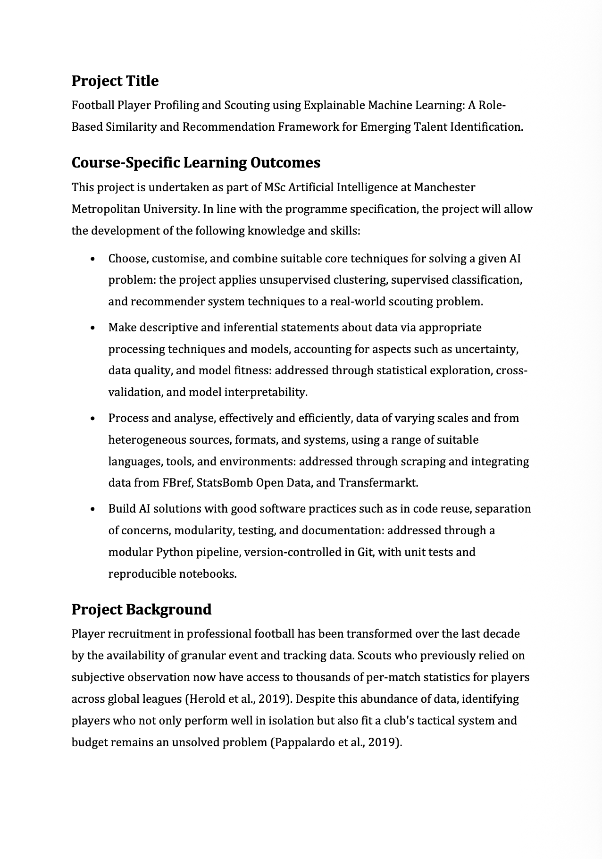

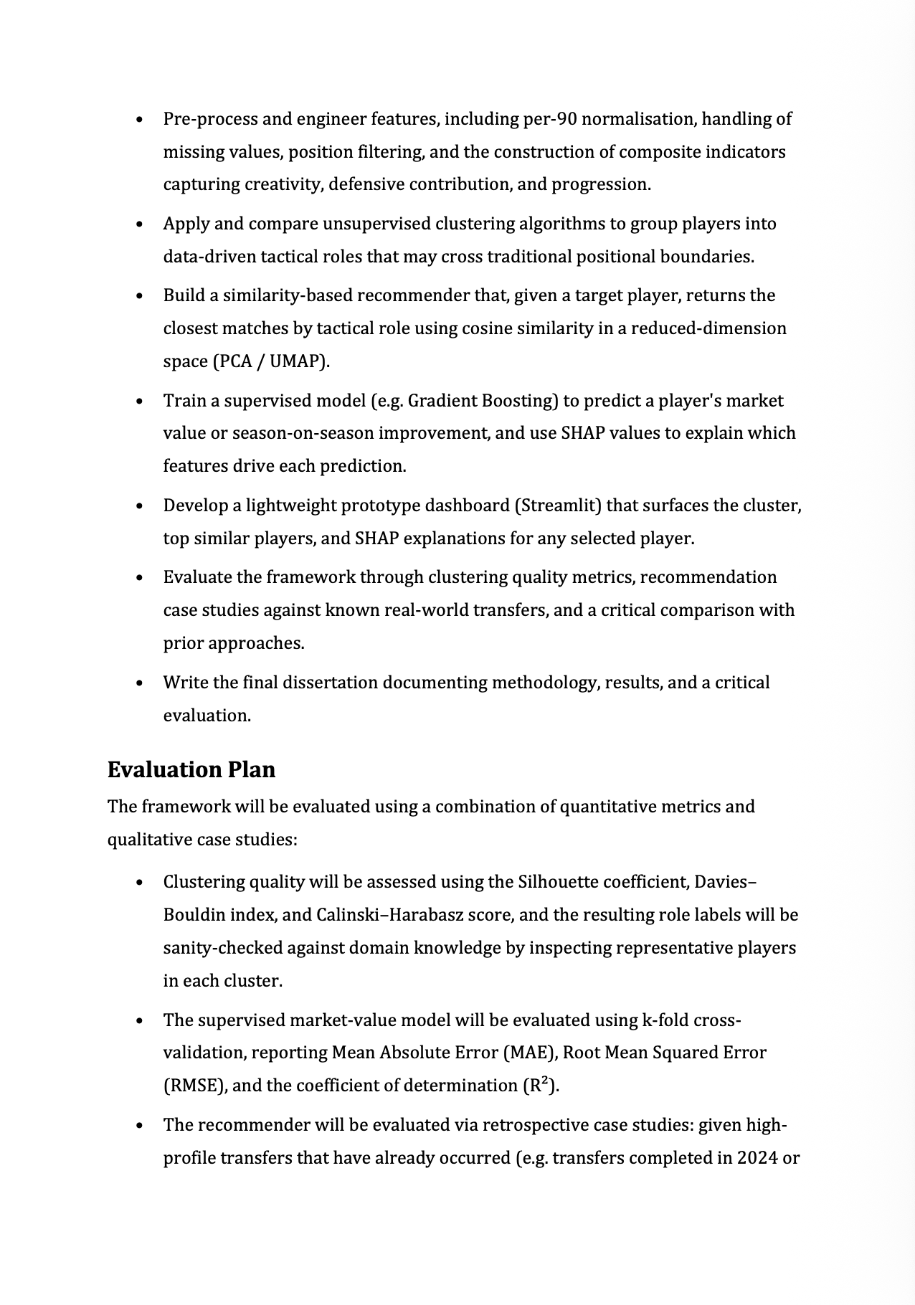
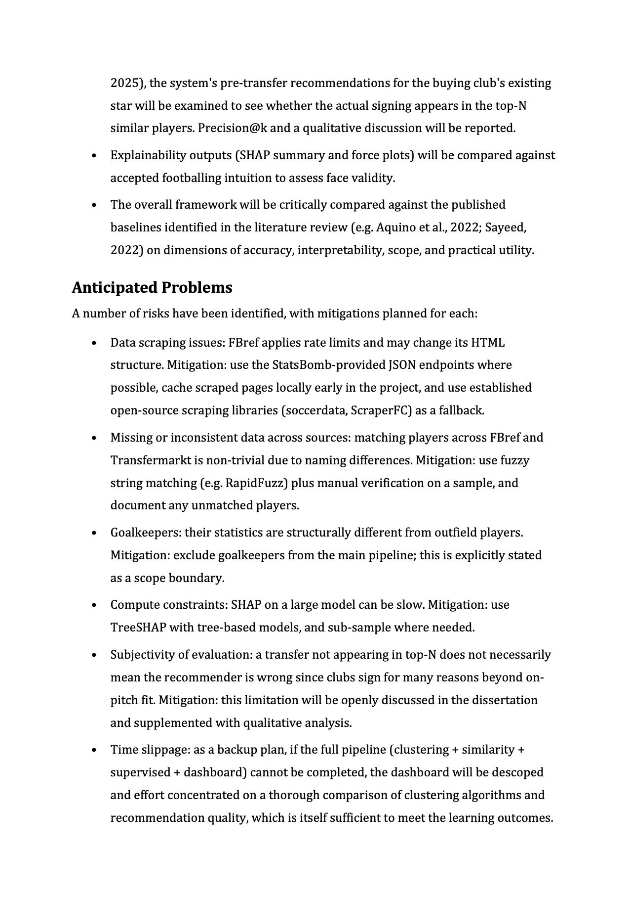
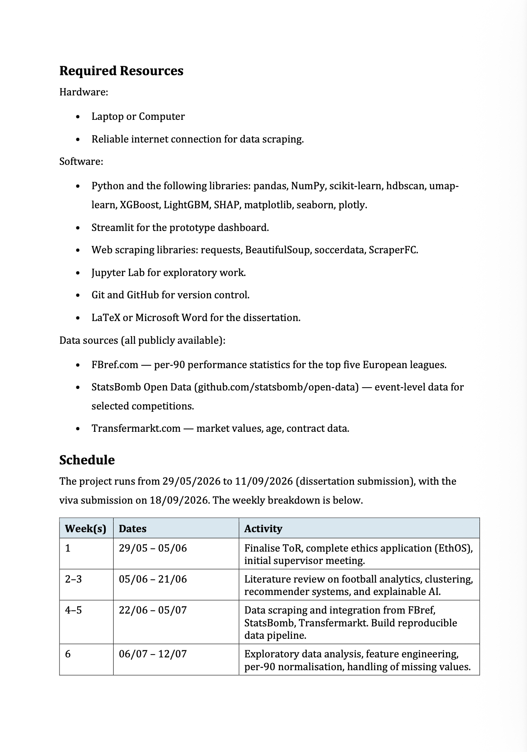
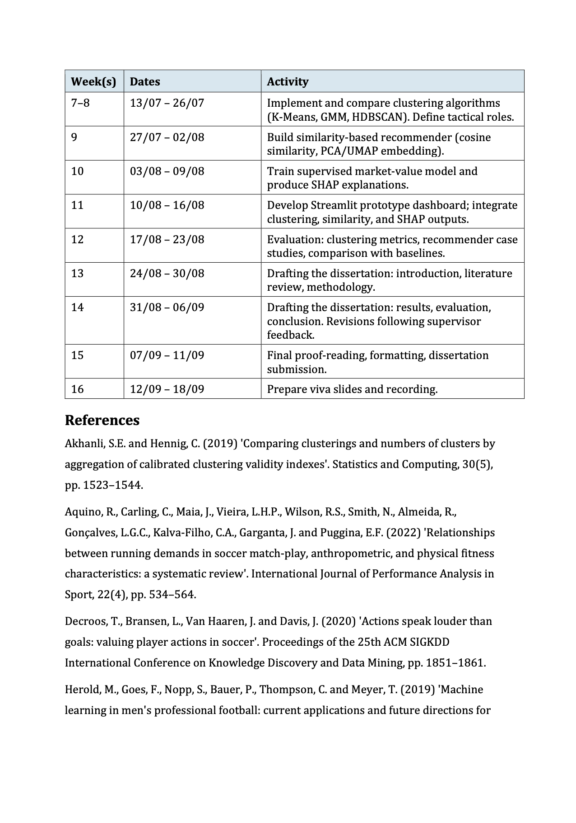


Appendix B – EthOS Email




Appendix C - Source-Code Repository Link
https://github.com/shinewailu10/Football-Player-Profiling-and-Scouting-Using-Explainable-Machine-Learning.git

Appendix D – Explainable ML Pipeline
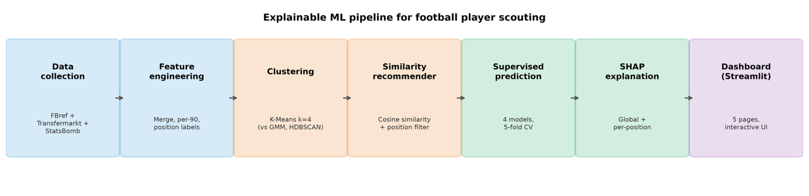

Appendix E - Full Model Comparison
model_comparison_all.csv
scope | algorithm | n_samples | r2 | mae_eur_m | median_error_m | rank_in_scope | is_best_for_scope
Attacking Midfield | RandomForest | 190 | 0.436 | 14.69 | 6.14 | 1 | TRUE
Attacking Midfield | LinearRegression | 190 | 0.42 | 15.32 | 6.38 | 2 | FALSE
Attacking Midfield | XGBoost | 190 | 0.352 | 15.84 | 7.32 | 3 | FALSE
Attacking Midfield | LightGBM | 190 | 0.256 | 16.32 | 8.28 | 4 | FALSE
Central Midfield | LinearRegression | 482 | 0.306 | 10.07 | 4.8 | 1 | TRUE
Central Midfield | RandomForest | 482 | 0.253 | 10.21 | 4.82 | 2 | FALSE
Central Midfield | XGBoost | 482 | 0.21 | 10.32 | 5.09 | 3 | FALSE
Central Midfield | LightGBM | 482 | 0.205 | 10.34 | 4.97 | 4 | FALSE
Centre-Back | RandomForest | 676 | 0.307 | 9.3 | 5.2 | 1 | TRUE
Centre-Back | LinearRegression | 676 | 0.275 | 9.99 | 4.93 | 2 | FALSE
Centre-Back | XGBoost | 676 | 0.242 | 9.66 | 5.84 | 3 | FALSE
Centre-Back | LightGBM | 676 | 0.223 | 9.91 | 5.7 | 4 | FALSE
Defensive Midfield | RandomForest | 279 | 0.306 | 10.36 | 6.06 | 1 | TRUE
Defensive Midfield | XGBoost | 279 | 0.263 | 10.71 | 5.99 | 2 | FALSE
Defensive Midfield | LightGBM | 279 | 0.21 | 10.8 | 5.97 | 3 | FALSE
Defensive Midfield | LinearRegression | 279 | 0.188 | 11.71 | 5.71 | 4 | FALSE
Forward | RandomForest | 376 | 0.57 | 10.86 | 4.36 | 1 | TRUE
Forward | XGBoost | 376 | 0.561 | 10.82 | 4.79 | 2 | FALSE
Forward | LinearRegression | 376 | 0.552 | 11.72 | 4.93 | 3 | FALSE
Forward | LightGBM | 376 | 0.527 | 11.41 | 5.06 | 4 | FALSE
Full-Back | RandomForest | 540 | 0.315 | 7.26 | 3.53 | 1 | TRUE
Full-Back | LinearRegression | 540 | 0.313 | 7.35 | 3.58 | 2 | FALSE
Full-Back | XGBoost | 540 | 0.273 | 7.39 | 3.77 | 3 | FALSE
Full-Back | LightGBM | 540 | 0.213 | 7.64 | 4.08 | 4 | FALSE
Winger | LinearRegression | 385 | 0.547 | 12.33 | 7.06 | 1 | TRUE
Winger | RandomForest | 385 | 0.463 | 12.51 | 6.76 | 2 | FALSE
Winger | XGBoost | 385 | 0.459 | 12.49 | 7.35 | 3 | FALSE
Winger | LightGBM | 385 | 0.378 | 13.48 | 7.6 | 4 | FALSE
global | RandomForest | 2934 | 0.404 | 10.11 | 5.05 | 1 | TRUE
global | XGBoost | 2934 | 0.384 | 10.16 | 5.09 | 2 | FALSE
global | LinearRegression | 2934 | 0.374 | 10.42 | 4.99 | 3 | FALSE
global | LightGBM | 2934 | 0.368 | 10.38 | 5.31 | 4 | FALSE

Appendix F - Test Runs
The final pytest -v output or an exported test summary.
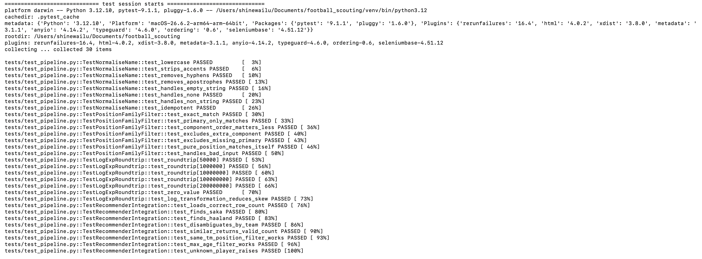

Appendix G – Additional Tables and Evaluations (csv and png files)
per_position_errors.csv
position_family | n | median_actual_m | median_pred_m | median_abs_error_m | mean_abs_error_m
Attacking Midfield | 190 | 12.0 | 12.32 | 1.97 | 7.0
Central Midfield | 482 | 8.0 | 8.13 | 1.48 | 4.79
Centre-Back | 676 | 8.0 | 7.91 | 1.5 | 4.3
Defensive Midfield | 279 | 9.0 | 8.73 | 1.59 | 4.87
Forward | 376 | 10.0 | 9.64 | 1.51 | 4.48
Full-Back | 540 | 5.0 | 5.83 | 1.08 | 3.2
Goalkeeper | 6 | 0.45 | 1.18 | 0.78 | 1.08
Winger | 385 | 14.0 | 13.42 | 2.04 | 4.99

prediction_errors_top20.csv
player | team | season | position | age | actual_m | predicted_m | error_m | abs_error_pct | top_3_drivers
Lamine Yamal | Barcelona | 2425 | Right Winger | 17 | 200.0 | 123.7 | -76.3 | 38.2 | np_goals_assists_p90(+0.86), age(+0.56), goals_assists_p90(+0.44)
Jude Bellingham | Real Madrid | 2324 | Attacking Midfield | 20 | 180.0 | 91.3 | -88.7 | 49.3 | np_goals_assists_p90(+0.78), age(+0.50), goals_assists_p90(+0.41)
Vinicius Júnior | Real Madrid | 2324 | Left Winger | 23 | 180.0 | 118.7 | -61.3 | 34.1 | np_goals_assists_p90(+0.96), goals_assists_p90(+0.55), age(+0.39)
Kylian Mbappé | Real Madrid | 2425 | Centre-Forward | 25 | 180.0 | 129.7 | -50.3 | 27.9 | np_goals_assists_p90(+1.04), goals_assists_p90(+0.61), attacking_index(+0.37)
Jude Bellingham | Real Madrid | 2425 | Attacking Midfield | 21 | 180.0 | 104.7 | -75.3 | 41.8 | np_goals_assists_p90(+0.78), age(+0.55), goals_assists_p90(+0.35)
Kylian Mbappé | PSG | 2324 | Centre-Forward | 24 | 180.0 | 135.3 | -44.7 | 24.8 | np_goals_assists_p90(+1.04), goals_assists_p90(+0.59), attacking_index(+0.37)
Erling Haaland | Manchester City | 2324 | Centre-Forward | 23 | 180.0 | 115.2 | -64.8 | 36.0 | np_goals_assists_p90(+0.91), goals_assists_p90(+0.56), attacking_index(+0.34)
Erling Haaland | Manchester City | 2425 | Centre-Forward | 24 | 180.0 | 110.2 | -69.8 | 38.8 | np_goals_assists_p90(+0.90), goals_assists_p90(+0.52), age(+0.38)
Vinicius Júnior | Real Madrid | 2425 | Left Winger | 24 | 170.0 | 108.9 | -61.1 | 35.9 | np_goals_assists_p90(+0.96), goals_assists_p90(+0.53), age(+0.40)
Phil Foden | Manchester City | 2324 | Attacking Midfield | 23 | 150.0 | 101.6 | -48.4 | 32.2 | np_goals_assists_p90(+0.86), goals_assists_p90(+0.47), age(+0.40)
Bukayo Saka | Arsenal | 2425 | Right Winger | 22 | 150.0 | 120.4 | -29.6 | 19.7 | np_goals_assists_p90(+0.89), goals_assists_p90(+0.52), age(+0.45)
Pedri | Barcelona | 2425 | Central Midfield | 21 | 140.0 | 63.6 | -76.4 | 54.6 | age(+0.49), fouls_committed_p90(+0.34), assists_p90(+0.22)
Bukayo Saka | Arsenal | 2324 | Right Winger | 21 | 140.0 | 105.2 | -34.8 | 24.9 | np_goals_assists_p90(+0.89), age(+0.50), goals_assists_p90(+0.49)
Florian Wirtz | Leverkusen | 2425 | Attacking Midfield | 21 | 140.0 | 97.7 | -42.3 | 30.2 | np_goals_assists_p90(+0.84), goals_assists_p90(+0.49), age(+0.46)
Jamal Musiala | Bayern Munich | 2425 | Attacking Midfield | 21 | 140.0 | 98.0 | -42.0 | 30.0 | np_goals_assists_p90(+0.83), age(+0.50), goals_assists_p90(+0.40)
Federico Valverde | Real Madrid | 2425 | Central Midfield | 26 | 130.0 | 54.5 | -75.5 | 58.1 | fouls_committed_p90(+0.35), age(+0.31), assists_p90(+0.17)
Florian Wirtz | Leverkusen | 2324 | Attacking Midfield | 20 | 130.0 | 88.1 | -41.9 | 32.2 | np_goals_assists_p90(+0.78), age(+0.48), goals_assists_p90(+0.45)
Federico Valverde | Real Madrid | 2324 | Central Midfield | 25 | 120.0 | 56.1 | -63.9 | 53.3 | age(+0.42), assists_p90(+0.28), fouls_committed_p90(+0.26)
Declan Rice | Arsenal | 2324 | Central Midfield | 24 | 120.0 | 67.9 | -52.1 | 43.4 | age(+0.44), goals_assists_p90(+0.28), assists_p90(+0.24)
Rodri | Manchester City | 2324 | Defensive Midfield | 27 | 120.0 | 60.6 | -59.4 | 49.5 | np_goals_assists_p90(+0.60), goals_assists_p90(+0.31), age(+0.28)

recommender_precision_all_modes.csv
query_player | query_season | actual_signing | filter_mode | hit_rank | hit_similarity | at_5 | at_10 | at_25 | n_candidates_returned | note
Vinicius Júnior | 2023/24 | Kylian Mbappé | strict (tm_position) | -1 |  | FALSE | FALSE | FALSE | 30 | Real Madrid signed Mbappé on free transfer June 2024
Vinicius Júnior | 2023/24 | Kylian Mbappé | broad (position_family) | -1 |  | FALSE | FALSE | FALSE | 30 | Real Madrid signed Mbappé on free transfer June 2024
Vinicius Júnior | 2023/24 | Kylian Mbappé | cluster-only (no position) | 10 | 0.958 | FALSE | TRUE | TRUE | 30 | Real Madrid signed Mbappé on free transfer June 2024
Julián Álvarez | 2023/24 | Omar Marmoush | strict (tm_position) | 29 | 0.781 | FALSE | FALSE | FALSE | 30 | Man City signed Marmoush Jan 2025 as Álvarez's replacement (per NBC Sports)
Julián Álvarez | 2023/24 | Omar Marmoush | broad (position_family) | -1 |  | FALSE | FALSE | FALSE | 30 | Man City signed Marmoush Jan 2025 as Álvarez's replacement (per NBC Sports)
Julián Álvarez | 2023/24 | Omar Marmoush | cluster-only (no position) | -1 |  | FALSE | FALSE | FALSE | 30 | Man City signed Marmoush Jan 2025 as Álvarez's replacement (per NBC Sports)
Erling Haaland | 2023/24 | Omar Marmoush | strict (tm_position) | -1 |  | FALSE | FALSE | FALSE | 30 | Man City signed Marmoush Jan 2025 to strengthen Haaland's forward line
Erling Haaland | 2023/24 | Omar Marmoush | broad (position_family) | -1 |  | FALSE | FALSE | FALSE | 30 | Man City signed Marmoush Jan 2025 to strengthen Haaland's forward line
Erling Haaland | 2023/24 | Omar Marmoush | cluster-only (no position) | -1 |  | FALSE | FALSE | FALSE | 30 | Man City signed Marmoush Jan 2025 to strengthen Haaland's forward line

recommender_precision.csv
query_player | query_season | actual_signing | hit_rank | hit_at_5 | hit_at_10 | hit_at_25
Vinicius Júnior | 2023 | Kylian Mbappé | not in top 25 | FALSE | FALSE | FALSE
Julián Álvarez | 2023 | Omar Marmoush | not in top 25 | FALSE | FALSE | FALSE

cluster_profiles.csv
kmeans_label | goals_p90 | assists_p90 | goals_assists_p90 | non_penalty_goals_p90 | np_goals_assists_p90 | shots_p90 | shots_on_target_p90 | interceptions_p90 | tackles_won_p90 | fouls_committed_p90 | fouls_drawn_p90 | crosses_p90 | offsides_p90 | goals_per_shot | shots_on_target_pct | attacking_index | creativity_index | defensive_index | discipline_index | cluster_size
0 | 0.1579160683546130 | 0.17442533994824000 | 0.33234140830285300 | 0.14341820841094000 | 0.31784354835918000 | 1.7634350814447400 | 0.602807611678946 | 0.5537502239352640 | 0.8809619203064430 | 1.0876333711916400 | 1.4800860357663700 | 3.7077072237611000 | 0.23268774008729900 | 0.09170065253090500 | 33.98545851295330 | 1.2140589490252200 | 1.2867375070765700 | 1.4347121442417100 | 0.3924526645747310 | 720
1 | 0.01678171471342370 | 0.05514089969188910 | 0.07192261440531280 | 0.016368344224587900 | 0.07150924391647700 | 0.6756807103313470 | 0.17041766941175700 | 1.0551105081041200 | 1.2302543229445300 | 1.2245405936141400 | 0.9238419324801370 | 1.2722853253854400 | 0.05822531276878270 | 0.01830103251077530 | 24.216983160166000 | 0.40976296957098600 | 0.4368264973075210 | 2.2853648310486500 | -0.3006986611339990 | 1107
2 | 0.4527208515342240 | 0.16192146801023900 | 0.6146423195444630 | 0.4085353696720320 | 0.5704568376822710 | 2.7658523270772000 | 1.1635269860226400 | 0.2866334735456890 | 0.5263690329674740 | 1.282214071120310 | 1.4488217709913300 | 1.337491978674860 | 0.5271859840533640 | 0.1673528155760360 | 42.30202351246630 | 1.9975684830830700 | 0.5631690616126970 | 0.8130025065131630 | 0.1666076998710220 | 458
3 | 0.10869987956804300 | 0.051195408327626600 | 0.1598952878956690 | 0.10338105861365500 | 0.15457646694128100 | 0.7503776773899560 | 0.25026723743198100 | 1.0040362187266700 | 1.0793112853503100 | 1.1377846288099200 | 0.8661143301017140 | 0.8845324086567650 | 0.07030024230839860 | 0.16265681789380800 | 34.40060643429570 | 0.5350841265906470 | 0.31655513092465600 | 2.083347504076980 | -0.271670298708211 | 670

cluster_representatives.csv
cluster | rank | player | team | season | pos | age | market_value_eur | distance_to_centroid
0 | 1 | Achraf Hakimi | PSG | 2324 | DF,MF | 24.0 | 60000000.0 | 1.2788070026484400
0 | 2 | Romano Schmid | Werder Bremen | 2425 | MF | 24.0 | 17000000.0 | 1.304024999751980
0 | 3 | Florian Sotoca | Lens | 2324 | MF,FW | 32.0 | 3000000.0 | 1.4077229052226900
0 | 4 | Piotr Zieliński | Inter | 2425 | MF | 30.0 | 10000000.0 | 1.537762496851550
0 | 5 | Theo Hernández | Milan | 2324 | DF | 25.0 | 60000000.0 | 1.5518377248438400
1 | 1 | Mathías Olivera | Napoli | 2425 | DF | 26.0 | 20000000.0 | 0.9901887631996860
1 | 2 | Janik Haberer | Union Berlin | 2425 | MF | 30.0 | 2500000.0 | 1.0158999947890000
1 | 3 | Mario Hermoso | Atlético Madrid | 2324 | DF | 28.0 | 25000000.0 | 1.0413119648756400
1 | 4 | Javier Muñoz | Las Palmas | 2425 | MF,DF | 29.0 | 2000000.0 | 1.0856761890414700
1 | 5 | Nélson Semedo | Wolves | 2324 | MF,DF | 29.0 | 12000000.0 | 1.1052537693562600
2 | 1 | Neal Maupay | Brentford | 2324 | FW | 26.0 | 12000000.0 | 1.338677144882600
2 | 2 | Marcus Thuram | Inter | 2324 | FW | 25.0 | 65000000.0 | 1.3955767846736500
2 | 3 | Yoane Wissa | Brentford | 2324 | FW | 26.0 | 28000000.0 | 1.4219535264661400
2 | 4 | Abdallah Sima | Brest | 2425 | FW,MF | 23.0 | 9000000.0 | 1.5231663936402700
2 | 5 | Raheem Sterling | Chelsea | 2324 | MF | 28.0 | 35000000.0 | 1.542701261582660
3 | 1 | Jorge Cuenca | Villarreal | 2324 | DF | 23.0 | 6000000.0 | 0.9117846434897120
3 | 2 | Kristoffer Ajer | Brentford | 2324 | DF | 25.0 | 15000000.0 | 0.9460681299508690
3 | 3 | Clément Lenglet | Atlético Madrid | 2425 | DF | 29.0 | 7500000.0 | 1.0389356218336300
3 | 4 | Abdul Mumin | Rayo Vallecano | 2425 | DF | 26.0 | 5000000.0 | 1.0853639073636800
3 | 5 | Adam Masina | Torino | 2425 | DF | 30.0 | 1500000.0 | 1.1295914199126700

clustering_metrics.csv
algorithm | param | silhouette | davies_bouldin | calinski_harabasz | n_clusters | n_noise
KMeans | 4 | 0.17406002665830200 | 1.7104516224160400 | 906.0010972710010 | 4 | 0
KMeans | 5 | 0.16966788737185900 | 1.7644780056307600 | 787.895078997039 | 5 | 0
KMeans | 6 | 0.16120607694149400 | 1.7592588537338000 | 716.1137319688420 | 6 | 0
KMeans | 7 | 0.16442245622328000 | 1.6514236464984900 | 667.6516276835300 | 7 | 0
KMeans | 8 | 0.16446571133422500 | 1.6451067006948600 | 623.7101876224050 | 8 | 0
KMeans | 9 | 0.15951402496475600 | 1.6838986490720600 | 575.0668798271400 | 9 | 0
KMeans | 10 | 0.146068255935752 | 1.6665901490753000 | 535.6341027855440 | 10 | 0
GMM | 4 | 0.11456021432257900 | 1.7818099635785300 | 688.5314253649900 | 4 | 0
GMM | 5 | 0.094509953106197 | 2.1955635419864400 | 595.4964601950240 | 5 | 0
GMM | 6 | 0.08943890851431010 | 2.2510465149155700 | 513.6630904555780 | 6 | 0
GMM | 7 | 0.08411716138826160 | 2.4026738539421000 | 456.4682550818830 | 7 | 0
GMM | 8 | 0.07832171443800040 | 2.698584792484570 | 407.82271822896800 | 8 | 0
GMM | 9 | 0.059447704490035700 | 2.6338609087741700 | 372.5648846289740 | 9 | 0
GMM | 10 | 0.04485485193265450 | 2.4997917506819100 | 349.951206073978 | 10 | 0
HDBSCAN | 30 |  |  |  | 0 | 2955
HDBSCAN | 50 |  |  |  | 0 | 2955
HDBSCAN | 80 |  |  |  | 0 | 2955
HDBSCAN | 100 |  |  |  | 0 | 2955

per_position_importance.csv
position_family | algorithm | algorithm_note | feature | mean_abs_shap
Attacking Midfield | RandomForest | best overall | age | 0.3140941768405040
Attacking Midfield | RandomForest | best overall | goals_p90 | 0.0202850869944487
Attacking Midfield | RandomForest | best overall | assists_p90 | 0.13086012630042800
Attacking Midfield | RandomForest | best overall | goals_assists_p90 | 0.21097135503372800
Attacking Midfield | RandomForest | best overall | non_penalty_goals_p90 | 0.015830855859430900
Attacking Midfield | RandomForest | best overall | np_goals_assists_p90 | 0.326001980492703
Attacking Midfield | RandomForest | best overall | shots_p90 | 0.02620377956518800
Attacking Midfield | RandomForest | best overall | shots_on_target_p90 | 0.01837581563169830
Attacking Midfield | RandomForest | best overall | shots_on_target_pct | 0.01675785839970500
Attacking Midfield | RandomForest | best overall | goals_per_shot | 0.01400209154456810
Attacking Midfield | RandomForest | best overall | goals_per_shot_on_target | 0.016808423721055000
Attacking Midfield | RandomForest | best overall | interceptions_p90 | 0.04812435836195740
Attacking Midfield | RandomForest | best overall | tackles_won_p90 | 0.03129293401875620
Attacking Midfield | RandomForest | best overall | fouls_committed_p90 | 0.01862078781619840
Attacking Midfield | RandomForest | best overall | fouls_drawn_p90 | 0.0196107005620857
Attacking Midfield | RandomForest | best overall | crosses_p90 | 0.019429284778132700
Attacking Midfield | RandomForest | best overall | offsides_p90 | 0.039685756667229000
Attacking Midfield | RandomForest | best overall | attacking_index | 0.03269682061387510
Attacking Midfield | RandomForest | best overall | creativity_index | 0.025984095784852700
Attacking Midfield | RandomForest | best overall | defensive_index | 0.031085959595407800
Attacking Midfield | RandomForest | best overall | discipline_index | 0.019233133404550900
Central Midfield | RandomForest | tree proxy (overall best was LinearRegression) | age | 0.33023269415726900
Central Midfield | RandomForest | tree proxy (overall best was LinearRegression) | goals_p90 | 0.01901240383376270
Central Midfield | RandomForest | tree proxy (overall best was LinearRegression) | assists_p90 | 0.07725700825558310
Central Midfield | RandomForest | tree proxy (overall best was LinearRegression) | goals_assists_p90 | 0.05726905210338060
Central Midfield | RandomForest | tree proxy (overall best was LinearRegression) | non_penalty_goals_p90 | 0.0867142771051263
Central Midfield | RandomForest | tree proxy (overall best was LinearRegression) | np_goals_assists_p90 | 0.15562576709790800
Central Midfield | RandomForest | tree proxy (overall best was LinearRegression) | shots_p90 | 0.032234253147151800
Central Midfield | RandomForest | tree proxy (overall best was LinearRegression) | shots_on_target_p90 | 0.020866279727180800
Central Midfield | RandomForest | tree proxy (overall best was LinearRegression) | shots_on_target_pct | 0.029472014327529900
Central Midfield | RandomForest | tree proxy (overall best was LinearRegression) | goals_per_shot | 0.024645966094582700
Central Midfield | RandomForest | tree proxy (overall best was LinearRegression) | goals_per_shot_on_target | 0.011648725700607200
Central Midfield | RandomForest | tree proxy (overall best was LinearRegression) | interceptions_p90 | 0.029507241242310500
Central Midfield | RandomForest | tree proxy (overall best was LinearRegression) | tackles_won_p90 | 0.02941805215856650
Central Midfield | RandomForest | tree proxy (overall best was LinearRegression) | fouls_committed_p90 | 0.04896788006764380
Central Midfield | RandomForest | tree proxy (overall best was LinearRegression) | fouls_drawn_p90 | 0.023285822196790000
Central Midfield | RandomForest | tree proxy (overall best was LinearRegression) | crosses_p90 | 0.04476184605973620
Central Midfield | RandomForest | tree proxy (overall best was LinearRegression) | offsides_p90 | 0.025338467590944000
Central Midfield | RandomForest | tree proxy (overall best was LinearRegression) | attacking_index | 0.03337945313616450
Central Midfield | RandomForest | tree proxy (overall best was LinearRegression) | creativity_index | 0.02079495431355770
Central Midfield | RandomForest | tree proxy (overall best was LinearRegression) | defensive_index | 0.02913437995013440
Central Midfield | RandomForest | tree proxy (overall best was LinearRegression) | discipline_index | 0.039700786526365900
Centre-Back | RandomForest | best overall | age | 0.5058859845805620
Centre-Back | RandomForest | best overall | goals_p90 | 0.007303460392922100
Centre-Back | RandomForest | best overall | assists_p90 | 0.015361053077643800
Centre-Back | RandomForest | best overall | goals_assists_p90 | 0.018045955011012300
Centre-Back | RandomForest | best overall | non_penalty_goals_p90 | 0.009600205620583430
Centre-Back | RandomForest | best overall | np_goals_assists_p90 | 0.018954788238604700
Centre-Back | RandomForest | best overall | shots_p90 | 0.08573227176954280
Centre-Back | RandomForest | best overall | shots_on_target_p90 | 0.06309195895501810
Centre-Back | RandomForest | best overall | shots_on_target_pct | 0.02944924013591290
Centre-Back | RandomForest | best overall | goals_per_shot | 0.011254421525940200
Centre-Back | RandomForest | best overall | goals_per_shot_on_target | 0.007466567837676540
Centre-Back | RandomForest | best overall | interceptions_p90 | 0.06717161937112320
Centre-Back | RandomForest | best overall | tackles_won_p90 | 0.026175421921112200
Centre-Back | RandomForest | best overall | fouls_committed_p90 | 0.07148016224962140
Centre-Back | RandomForest | best overall | fouls_drawn_p90 | 0.03442931606351200
Centre-Back | RandomForest | best overall | crosses_p90 | 0.028571184075873400
Centre-Back | RandomForest | best overall | offsides_p90 | 0.03416314955745740
Centre-Back | RandomForest | best overall | attacking_index | 0.06859949946457160
Centre-Back | RandomForest | best overall | creativity_index | 0.028323664272217100
Centre-Back | RandomForest | best overall | defensive_index | 0.035597183171491000
Centre-Back | RandomForest | best overall | discipline_index | 0.027169076380186400
Defensive Midfield | RandomForest | best overall | age | 0.40308291679339600
Defensive Midfield | RandomForest | best overall | goals_p90 | 0.012886720375307700
Defensive Midfield | RandomForest | best overall | assists_p90 | 0.03151271784471750
Defensive Midfield | RandomForest | best overall | goals_assists_p90 | 0.05599791168774630
Defensive Midfield | RandomForest | best overall | non_penalty_goals_p90 | 0.023207826700103500
Defensive Midfield | RandomForest | best overall | np_goals_assists_p90 | 0.12169434059975200
Defensive Midfield | RandomForest | best overall | shots_p90 | 0.024279364595795900
Defensive Midfield | RandomForest | best overall | shots_on_target_p90 | 0.024204478742554400
Defensive Midfield | RandomForest | best overall | shots_on_target_pct | 0.0357254070735092
Defensive Midfield | RandomForest | best overall | goals_per_shot | 0.007893968278701960
Defensive Midfield | RandomForest | best overall | goals_per_shot_on_target | 0.021270958472937400
Defensive Midfield | RandomForest | best overall | interceptions_p90 | 0.024651760052472700
Defensive Midfield | RandomForest | best overall | tackles_won_p90 | 0.031477646176409900
Defensive Midfield | RandomForest | best overall | fouls_committed_p90 | 0.028591357590640500
Defensive Midfield | RandomForest | best overall | fouls_drawn_p90 | 0.034195169369497600
Defensive Midfield | RandomForest | best overall | crosses_p90 | 0.050859611047670200
Defensive Midfield | RandomForest | best overall | offsides_p90 | 0.028647691117124600
Defensive Midfield | RandomForest | best overall | attacking_index | 0.041733533070972400
Defensive Midfield | RandomForest | best overall | creativity_index | 0.038483828311872300
Defensive Midfield | RandomForest | best overall | defensive_index | 0.02365870758005980
Defensive Midfield | RandomForest | best overall | discipline_index | 0.03919975453991450
Forward | RandomForest | best overall | age | 0.38221039606130400
Forward | RandomForest | best overall | goals_p90 | 0.06510506478175840
Forward | RandomForest | best overall | assists_p90 | 0.037504806651885900
Forward | RandomForest | best overall | goals_assists_p90 | 0.2749527826583680
Forward | RandomForest | best overall | non_penalty_goals_p90 | 0.08050524476120670
Forward | RandomForest | best overall | np_goals_assists_p90 | 0.17371333427842200
Forward | RandomForest | best overall | shots_p90 | 0.043695660011599800
Forward | RandomForest | best overall | shots_on_target_p90 | 0.03704884637519670
Forward | RandomForest | best overall | shots_on_target_pct | 0.020489831265889300
Forward | RandomForest | best overall | goals_per_shot | 0.013380450127569100
Forward | RandomForest | best overall | goals_per_shot_on_target | 0.01050360943396100
Forward | RandomForest | best overall | interceptions_p90 | 0.03517754033314280
Forward | RandomForest | best overall | tackles_won_p90 | 0.014872783640545800
Forward | RandomForest | best overall | fouls_committed_p90 | 0.040707177545997600
Forward | RandomForest | best overall | fouls_drawn_p90 | 0.015864539444109900
Forward | RandomForest | best overall | crosses_p90 | 0.009705304389299810
Forward | RandomForest | best overall | offsides_p90 | 0.01861401699563400
Forward | RandomForest | best overall | attacking_index | 0.123646489451746
Forward | RandomForest | best overall | creativity_index | 0.009857636522849050
Forward | RandomForest | best overall | defensive_index | 0.015574502569172500
Forward | RandomForest | best overall | discipline_index | 0.04084783816996970
Full-Back | RandomForest | best overall | age | 0.38900764058679000
Full-Back | RandomForest | best overall | goals_p90 | 0.008709511893553220
Full-Back | RandomForest | best overall | assists_p90 | 0.10404241238730400
Full-Back | RandomForest | best overall | goals_assists_p90 | 0.08536064731008550
Full-Back | RandomForest | best overall | non_penalty_goals_p90 | 0.012423537881952700
Full-Back | RandomForest | best overall | np_goals_assists_p90 | 0.042461440577971100
Full-Back | RandomForest | best overall | shots_p90 | 0.03621327997273700
Full-Back | RandomForest | best overall | shots_on_target_p90 | 0.03069259206456560
Full-Back | RandomForest | best overall | shots_on_target_pct | 0.03836563833731420
Full-Back | RandomForest | best overall | goals_per_shot | 0.018260498804625500
Full-Back | RandomForest | best overall | goals_per_shot_on_target | 0.01297918383035860
Full-Back | RandomForest | best overall | interceptions_p90 | 0.018958168951517700
Full-Back | RandomForest | best overall | tackles_won_p90 | 0.05071413603253500
Full-Back | RandomForest | best overall | fouls_committed_p90 | 0.0497455799324563
Full-Back | RandomForest | best overall | fouls_drawn_p90 | 0.020799172439904300
Full-Back | RandomForest | best overall | crosses_p90 | 0.06579274164772080
Full-Back | RandomForest | best overall | offsides_p90 | 0.04831631202668150
Full-Back | RandomForest | best overall | attacking_index | 0.038524317684586200
Full-Back | RandomForest | best overall | creativity_index | 0.037932168784801500
Full-Back | RandomForest | best overall | defensive_index | 0.023711509928984500
Full-Back | RandomForest | best overall | discipline_index | 0.03627085776652480
Winger | RandomForest | tree proxy (overall best was LinearRegression) | age | 0.2626080753566070
Winger | RandomForest | tree proxy (overall best was LinearRegression) | goals_p90 | 0.011494354638116700
Winger | RandomForest | tree proxy (overall best was LinearRegression) | assists_p90 | 0.051581355325601500
Winger | RandomForest | tree proxy (overall best was LinearRegression) | goals_assists_p90 | 0.18092254522208300
Winger | RandomForest | tree proxy (overall best was LinearRegression) | non_penalty_goals_p90 | 0.04251525134753400
Winger | RandomForest | tree proxy (overall best was LinearRegression) | np_goals_assists_p90 | 0.20427302961221500
Winger | RandomForest | tree proxy (overall best was LinearRegression) | shots_p90 | 0.05864265114053210
Winger | RandomForest | tree proxy (overall best was LinearRegression) | shots_on_target_p90 | 0.022989673310566500
Winger | RandomForest | tree proxy (overall best was LinearRegression) | shots_on_target_pct | 0.020822261785743400
Winger | RandomForest | tree proxy (overall best was LinearRegression) | goals_per_shot | 0.01242399822639630
Winger | RandomForest | tree proxy (overall best was LinearRegression) | goals_per_shot_on_target | 0.014716713276960700
Winger | RandomForest | tree proxy (overall best was LinearRegression) | interceptions_p90 | 0.034332697768480900
Winger | RandomForest | tree proxy (overall best was LinearRegression) | tackles_won_p90 | 0.026283069972908000
Winger | RandomForest | tree proxy (overall best was LinearRegression) | fouls_committed_p90 | 0.07197973725869610
Winger | RandomForest | tree proxy (overall best was LinearRegression) | fouls_drawn_p90 | 0.017643992090535200
Winger | RandomForest | tree proxy (overall best was LinearRegression) | crosses_p90 | 0.012044343987941000
Winger | RandomForest | tree proxy (overall best was LinearRegression) | offsides_p90 | 0.026622936660164700
Winger | RandomForest | tree proxy (overall best was LinearRegression) | attacking_index | 0.13220502841544700
Winger | RandomForest | tree proxy (overall best was LinearRegression) | creativity_index | 0.022546281487925800
Winger | RandomForest | tree proxy (overall best was LinearRegression) | defensive_index | 0.02499790307576260
Winger | RandomForest | tree proxy (overall best was LinearRegression) | discipline_index | 0.062355637363519600

local_Bukayo_Saka_2023.png
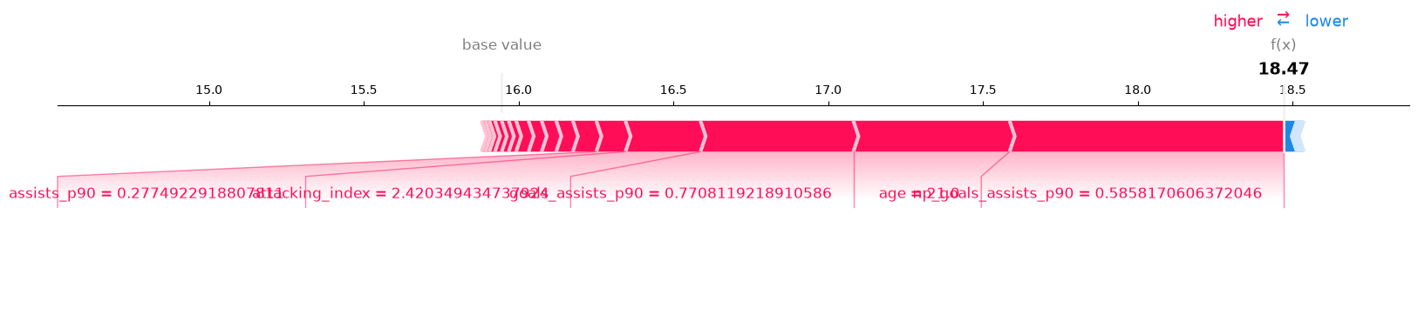
local_Erling_Haaland_2023.png
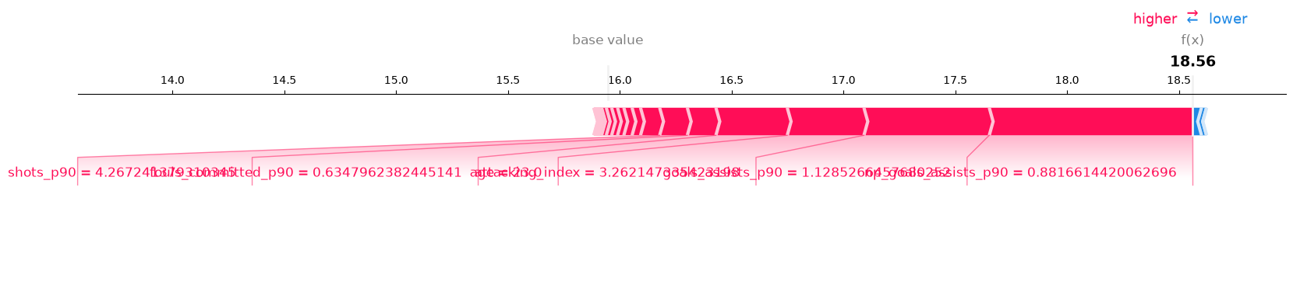
local_Kevin_De_Bruyne_2023.png
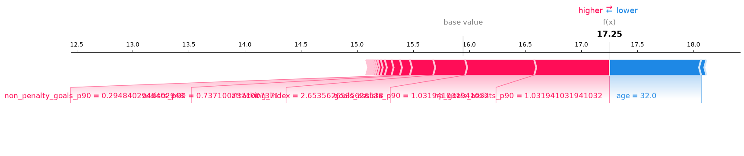
local_Lamine_Yamal_2024.png
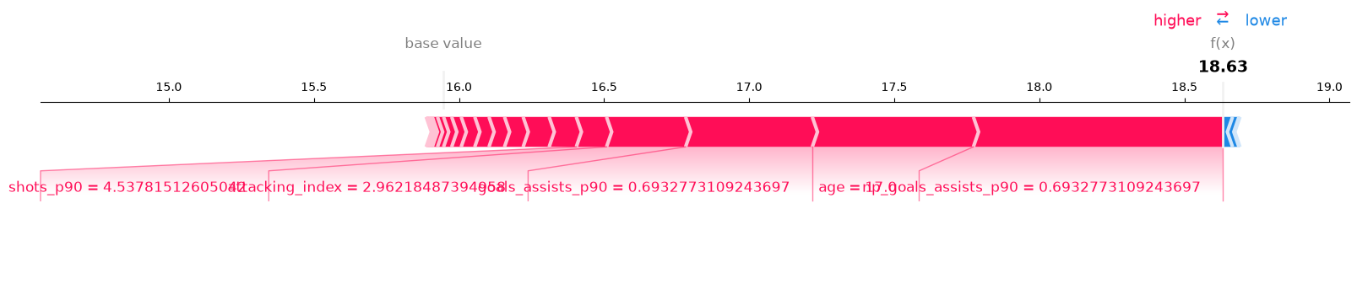
local_Rodri_2023.png
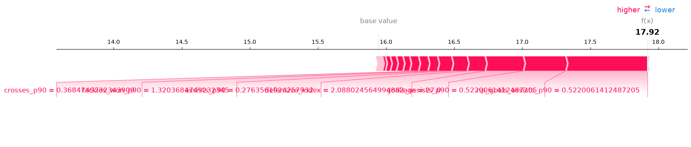
local_Virgil_van_Dijk_2023.png
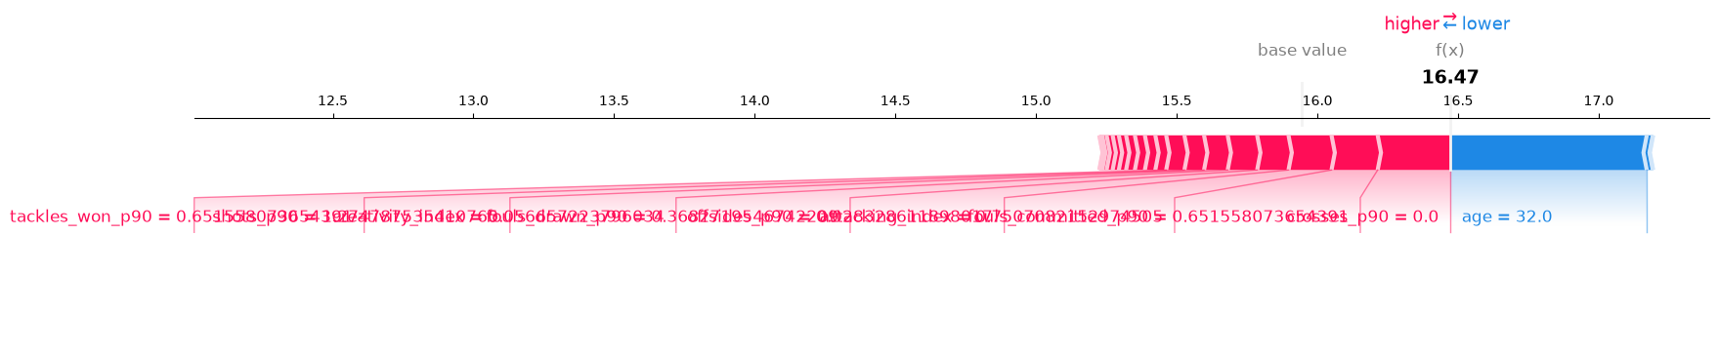
Dashboard Screenshots
