Report

Classes design:

Test-run of program:

Login box when we start the game:

After logging in, the game starts:

When player wins:

When dealer wins:

When player quits:

Error Handling:

1. **Login credentials invalid:**

Correct username is gg and password is gg.

But here one of the credentials Is incorrect, then the error message will be popped out:

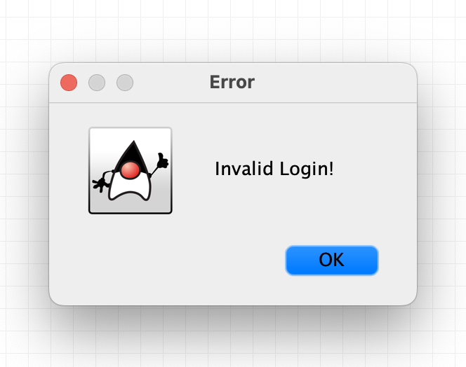

1. **Player can’t quit for the first round:**

The program won’t ask whether player quit or call for the first round.

If the player quits, this error message popped out:

1. **Invalid input while filling bet amount:**

This error will be popped out:

1. **invalid amount of bet:**

Then, this banner will be popped out:

