

Digital Invoicing

**User Manual Version: 1.5**

**Disclaimer:**

The information provided in this document is intended solely for the Digital Invoicing (DI) from PRAL. The contents of this document may not be reproduced or divulged outside the intended organizations without the express written permission of PRAL.

**PAKISTAN REVENUE AUTOMATION (PVT.) LTD**

PRAL – Head office, Software Technology Park-III, Plot No. 156, Service Road (North), Industrial Area, I-9/3, Islamabad. Pakistan

# Document Information

**Document Name** Digital Invoicing - User Manual

**Project Name** Digital Invoicing

**Version** 1.5

**Status** Issued

**Author**

Muhammad Umair Siddique

**Reviewer(s)**

Arslan Nazir

**First Review Date**

05-Apr-25

**Approver**

SA&D

**Issue Date** 05-Apr-25

**Updated by** Anam Majid Ali

**Last Update Date** 29-Jul-25

**Update Reviewed by**

Mehboob Ur Rehman

**Distribution** SD Wing

**Category**

External

**Privacy Level** Public



*Document Version :1.5 PRAL © 2025 – All rights reserved Page* ***1*** *of* ***20***



*Document Version :1.5*

*PRAL © 2025 – All rights reserved*

*Page* ***2*** *of* ***20***

# Document Changelog

|  |  |  |  |
| --- | --- | --- | --- |
| **Sr. #** | **Review/Update Date** | **Reviewer(s) Name** | **Remarks** |
| 1. | 05-Apr-25 | Mehboob Ur Rehman | Initial Document |
| 2. | 03-June-25 | Arslan Nazir | Screens Update, Enhancements & CRM |
| 3. | 05-Jun-25 | Mehboob Ur Rehman | Focused solely on the taxpayer |
| 4. | 23-Jun-25 |  | CRM Link Update |
| 5. | 29-Jul-25 | Mehboob Ur Rehman | Reattempting Invoice Submission After Connection Loss |



*Document Version :1.5*

*PRAL © 2025 – All rights reserved*

*Page* ***3*** *of* ***20***

**Table of Content**

|  |  |  |
| --- | --- | --- |
| **Sr. No.** | **Title** | **Page No.** |
| 1 | Introduction | 4 |
| 2 | Objective | 4 |
| 3 | Scope of the Document | 4 |
| 4 | Digital Invoicing User Manual | 5 |
| 4.1 | Taxpayer’s Registration Process | 5 |
| 4.1.1 | IF “Proceed with PRAL as Licensed Integrator” | 7 |
| 4.1.2 | IF “Proceed with Other Licensed Integrator” | 11 |
| 5 | Invoice Dashboard | 12 |
| 5.1 | Reattempting Invoice Submission After Connection Loss | 13 |
| 6 | DI CRM Manual | 14 |
| 7 | Frequently Asked Question (FAQs) | 17 |

## Introduction



This document serves as a comprehensive guide for understanding and utilizing the Digital Invoicing System developed by Pakistan Revenue Automation Limited (PRAL) for the Federal Board of Revenue (FBR), Pakistan. The Digital Invoicing System is a pivotal step towards modernizing the taxation process by streamlining invoice management and fostering compliance. It provides an integrated platform for taxpayers, license integrators, and tax officers to collaborate effectively in managing and validating digital invoices in accordance with FBR regulations.

## Objective

To provide clear guidance on effectively using the Digital Invoicing System developed by PRAL for FBR to streamline invoice management and ensure compliance with tax regulations.

## Scope of the Document

This document provides detailed guidance on the following aspects of the Digital Invoicing System:

##### Taxpayer Responsibilities:

* + API integration Process.
  + Transmission and management of digital invoices.
  + Use of DI CRM for PRAL Support

##### System Functionalities:

* + Real-time invoice management and viewing (daily, monthly, Quarterly and Yearly).
  + Seamless integration with FBR’s broader taxation infrastructure.

*Document Version :1.5 PRAL © 2025 – All rights reserved Page* ***4*** *of* ***20***

## Digital Invoicing User Manual

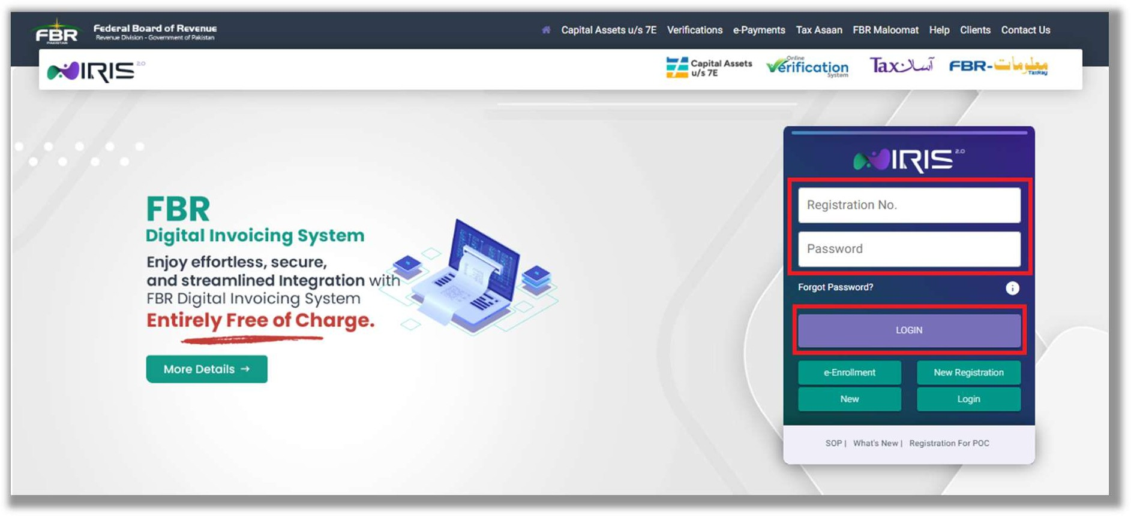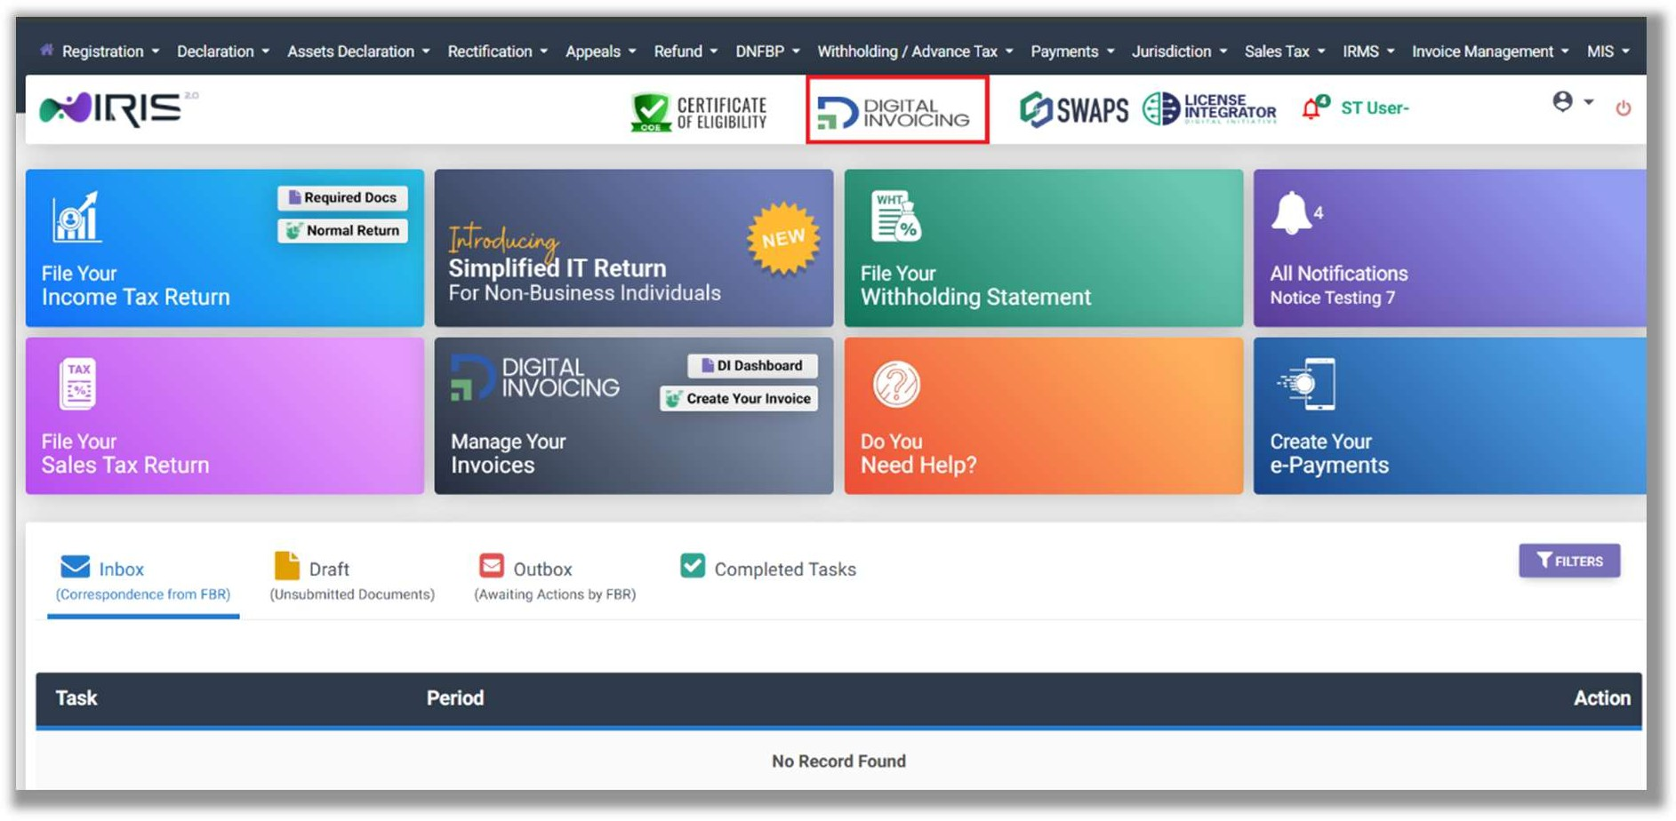

### Taxpayer’s Registration Process

#### Log In

* + - Access the IRIS portal using the designated link by entering your registration number and password. Upon logging in, you will be directed to the dashboard.
    - Navigate to **Digital Invoice** by selecting the **Digital Invoicing**.

*Document Version :1.5 PRAL © 2025 – All rights reserved Page* ***5*** *of* ***20***

#### Integration Mode

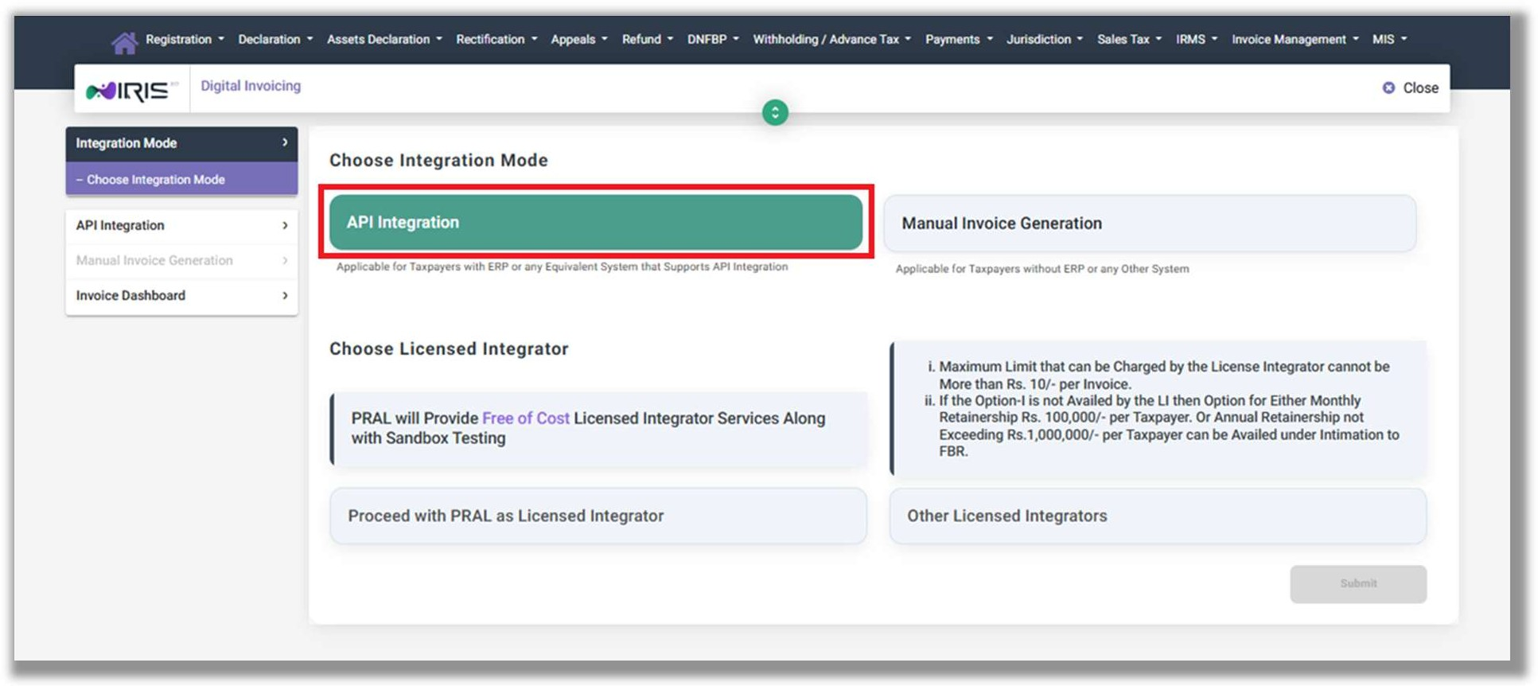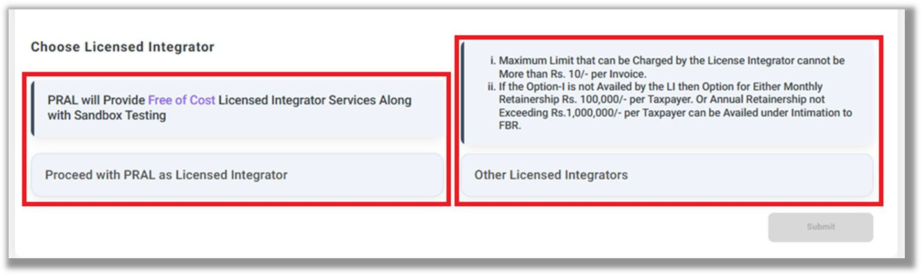

* + - You will land on the Integration Mode screen where two Modes can be seen: **API Integration** and **Manual Invoice Generation**.

#### API Integration

Proceed to the **API Integration** tab and Choose Licensed Integrator. PRAL will Provide Free of Cost Licensed Integrator Services along with Sandbox Testing, whereas Other Licensed Integrators may charge certain fee.

*Document Version :1.5 PRAL © 2025 – All rights reserved Page* ***6*** *of* ***20***

###### IF “Proceed with PRAL as Licensed Integrator”

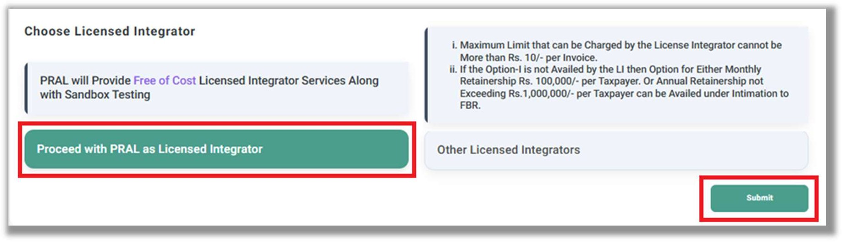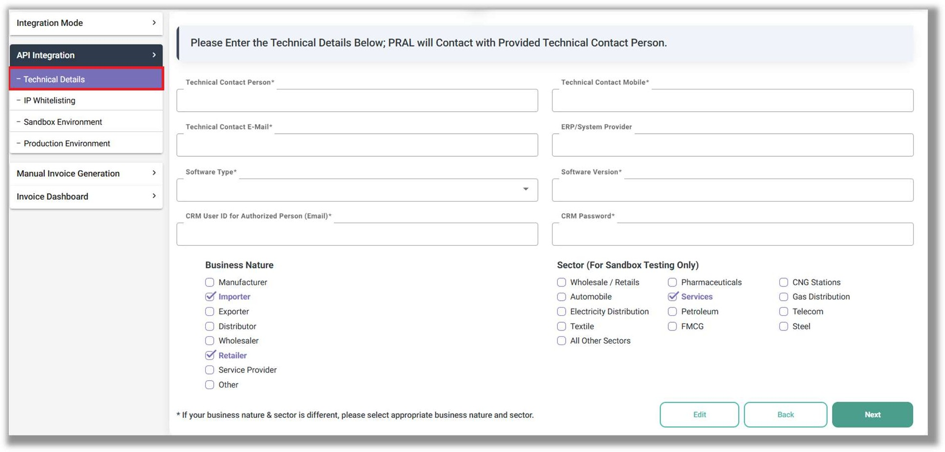

* + - * Select “**Proceed with PRAL as Licensed Integrator**” and click the “Submit” button.

###### Technical Details:

* + - * Provide Technical Details and click on Next button.
        + Technical Contact Person
        + Technical Contact Mobile
        + Technical Contact Email
        + ERP/System Provider
        + Software Type (Cloud/On Premises)
        + Software Version
        + CRM User ID for Authorized Person (Email that will be used to register complaint or seek support at our “Customer Relationship Management”.
        + CRM Password
      * Specify Business Types (for Sandbox Testing Only)
        + Business Nature (Multiple Can be Selected)
        + Sector (Select One Only)
      * Click on “Next” button.

*Document Version :1.5 PRAL © 2025 – All rights reserved Page* ***7*** *of* ***20***

###### IP Whitelisting:

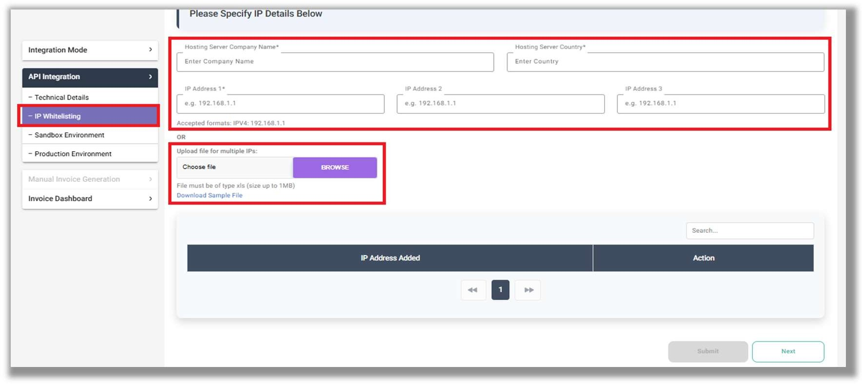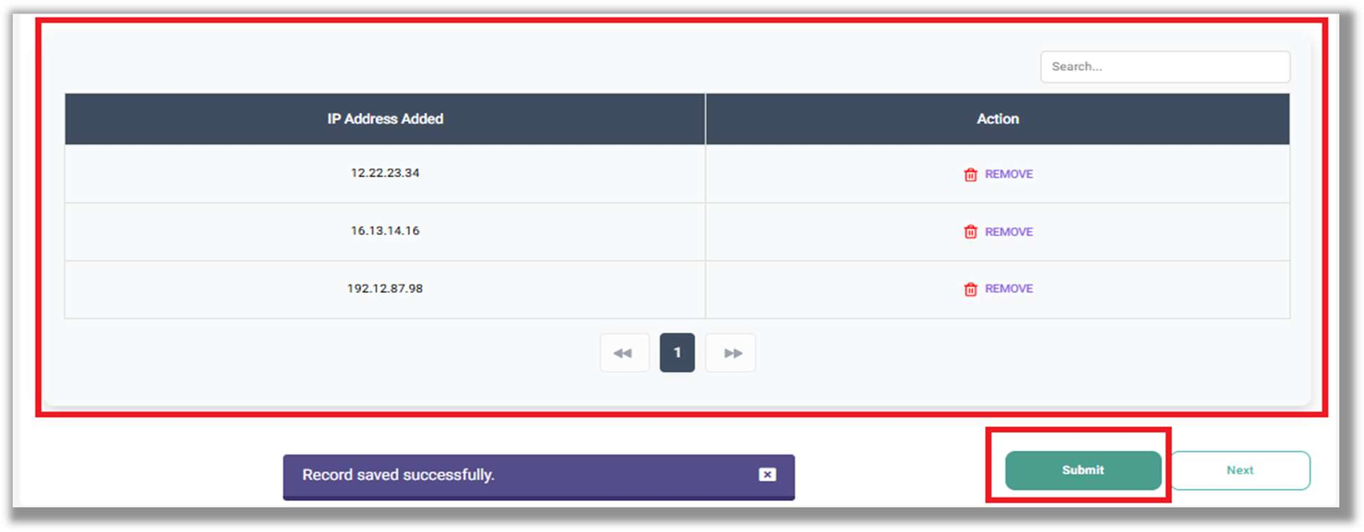

* + - * Enter **IP Whitelisting** details.
        + Hosting Server Company Name
        + Hosting Server Country
        + IP Address (minimum 1 and maximum 3)

OR

* + - * Upload file for multiple IPs
        + Click the **Download Sample File** Link**.**
        + Fill details and upload.
        + File type must be xls with up to 1 MB size.
      * The IPs detail will be displayed in below table:
      * By clicking the “Submit” button, the application will be successfully submitted to PRAL. The PRAL Data Centre will accept or reject the IPs submitted by the taxpayer within 2 working hours. This will automatically initiate Sandbox testing.

*Document Version :1.5 PRAL © 2025 – All rights reserved Page* ***8*** *of* ***20***

###### Sandbox Environment:

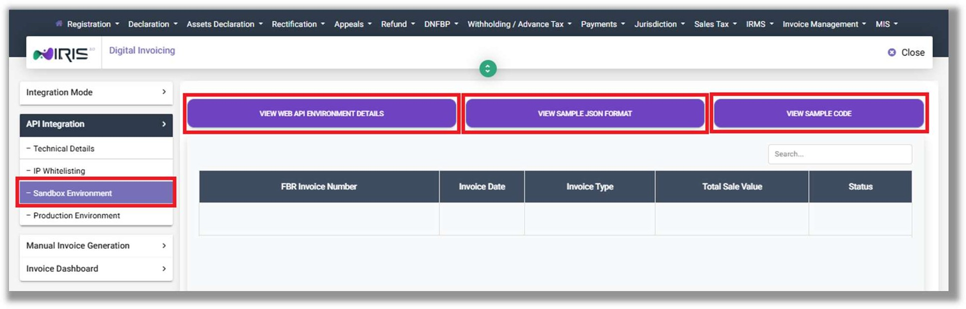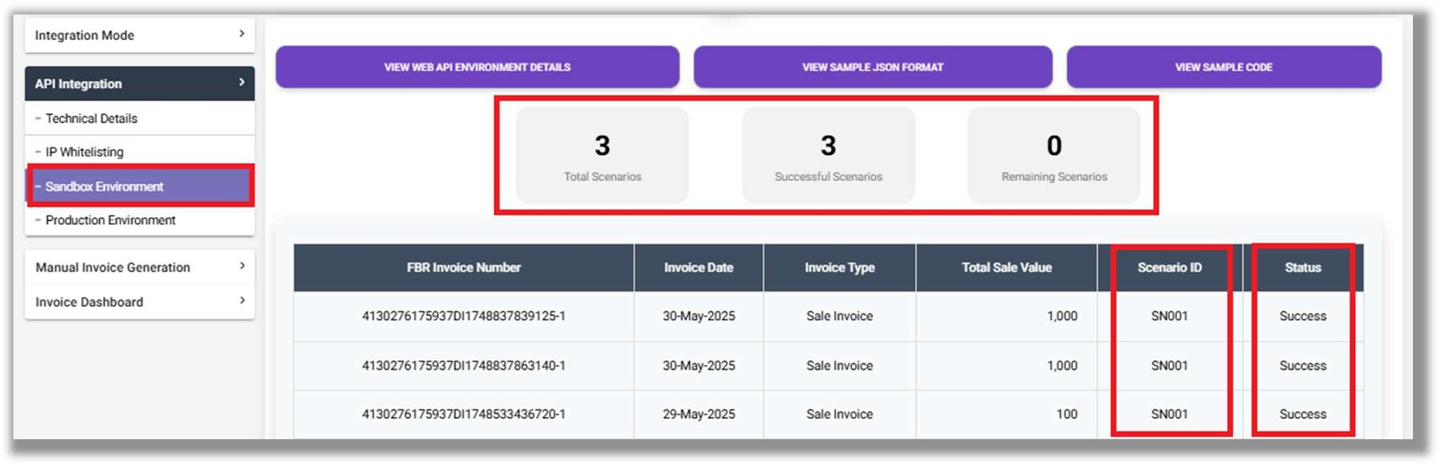

* + - * Click on Sandbox Environment to view below information to complete integration for testing:
        + View Web API Details
        + View Sample JSON Format
        + View Sample Code
      * Upon completing the integration in the Sandbox Environment, the taxpayer must submit scenario-based invoices that align with the selected combination of **“Business Nature”** and **“Sector”** as specified in the **Technical Details** section.
      * To begin, use the Sandbox Environment token to get access to the available JSON invoice data. After you’re authorized, post each invoice JSON according to the specific scenario explained in the Technical Document. Each time you submit an invoice, the system will give you a unique Invoice Number.
      * When a test invoice is successfully submitted, the system will automatically generate a **Production Token**.

*Document Version :1.5 PRAL © 2025 – All rights reserved Page* ***9*** *of* ***20***

###### Production Environment:

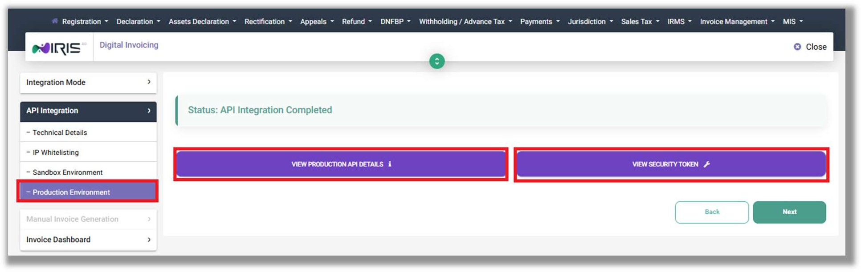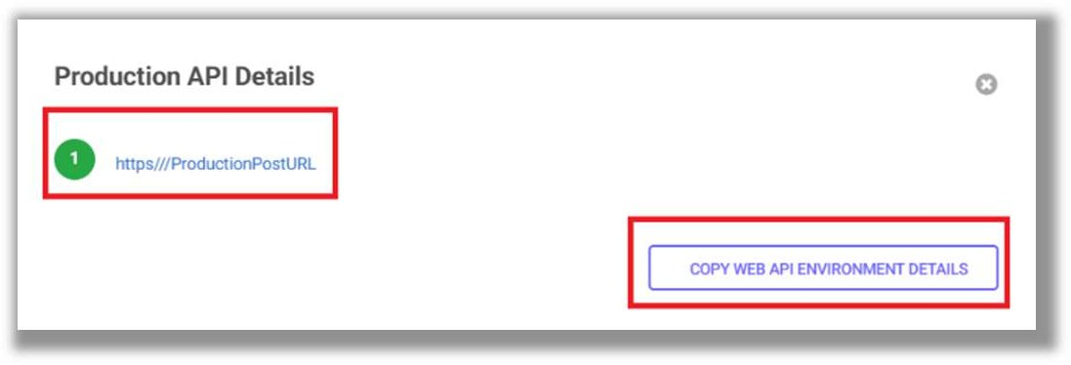

* + - * Click on Production Environment to view below details:
        + View Production API Details
        + View Security Token
      * Use the aforementioned information to complete integration on Production and start transmitting invoices in real time.

**Note:** Once you’ve successfully submitted all the required test invoices for every relevant sector and business type, the system will generate the final Production Token for you.

*Document Version :1.5 PRAL © 2025 – All rights reserved Page* ***10*** *of* ***20***

###### IF “Proceed with Other Licensed Integrator”

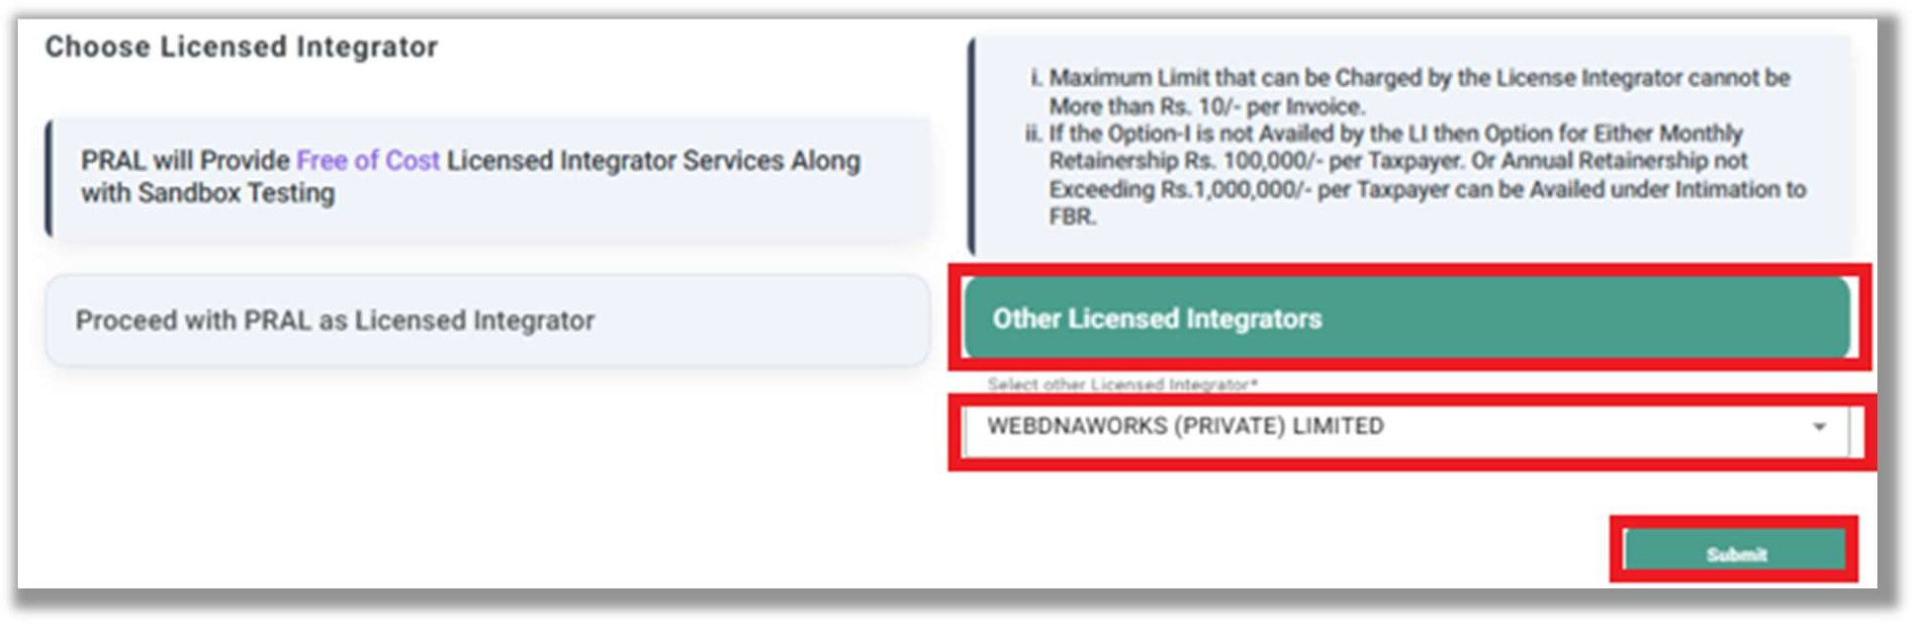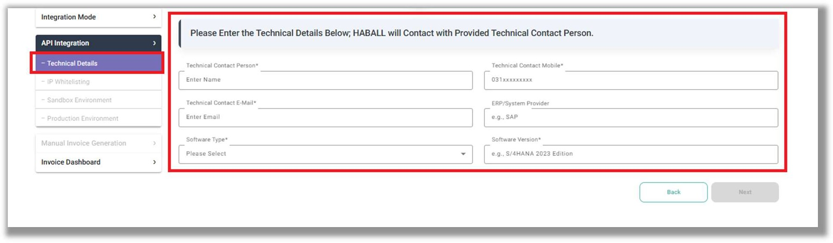

* + - * Select “**Proceed with Other as Licensed Integrator**”, choose the desired license integrator from drop down list and click on “Submit” button.
      * Click on Submit button to navigate on “API Integration” Screen.

###### Technical Details:

* + - * Provide Technical Details.
      * After the acceptance of application by the chosen Licensed Integrator, remaining menu links (under API Integration Tab) will be available.

**Note**: The rest of the process remains the same as explained in “Proceed with PRAL as Licensed Integrator”. However, in case of an LI other than PRAL, PRAL does not perform IP whitelisting for taxpayers.

*Document Version :1.5 PRAL © 2025 – All rights reserved Page* ***11*** *of* ***20***

1. **Invoice Dashboard**

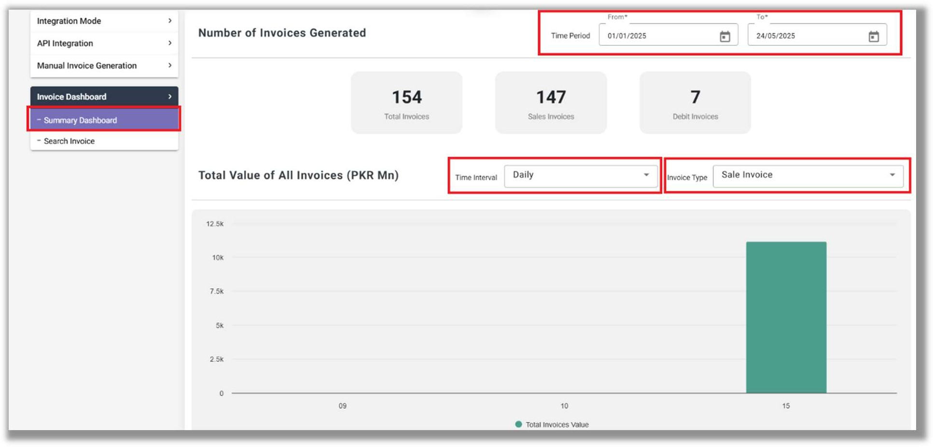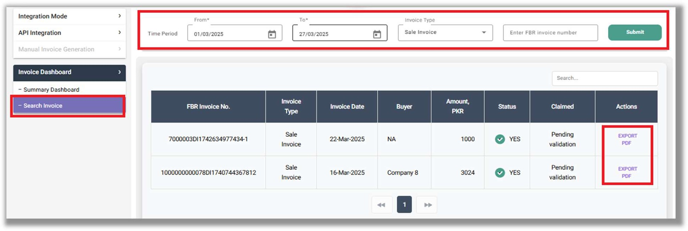

Navigate to the Invoice Dashboard. In the Summary Dashboard, invoices from a selected month and year can be viewed.

* View real time invoice value graph data in four formats:
  + Daily
  + Monthly
  + Quarterly
  + Yearly
* The invoice value graph is available in three formats:
  + Sale Invoice
  + Debit Note
* In the invoice search, you can find invoices by selecting the time period and invoice type and export in pdf.

*Document Version :1.5 PRAL © 2025 – All rights reserved Page* ***12*** *of* ***20***

### Reattempting Invoice Submission After Connection Loss



In situations where invoice submission is interrupted due to internet connectivity issues or other unforeseen technical problems, it is essential to resubmit the affected invoice through the Digital Invoicing System. The system does not support automatic retries for failed uploads; therefore, the invoice must be submitted again to ensure successful transmission.

Resubmitting the invoice helps maintain the accuracy and completeness of invoicing data, which is critical for compliance with tax regulations. The taxpayer can reconcile the invoices in their records (Invoice Dashboard) and proceed to transmit it again via invoicing system.

*Document Version :1.5 PRAL © 2025 – All rights reserved Page* ***13*** *of* ***20***

## DI CRM Manual:

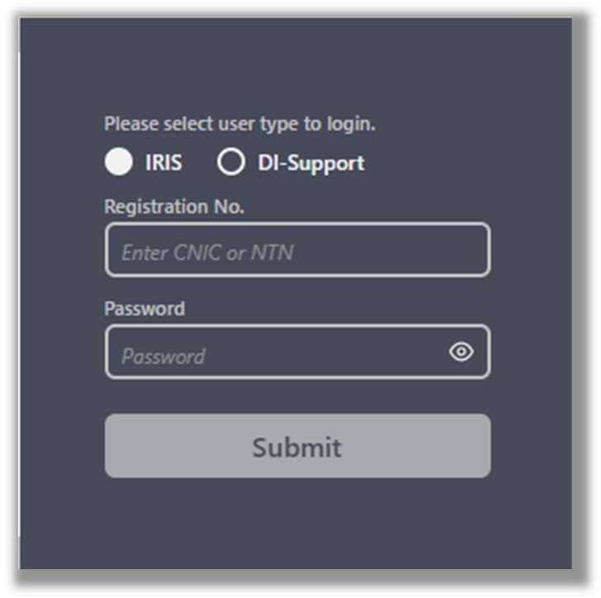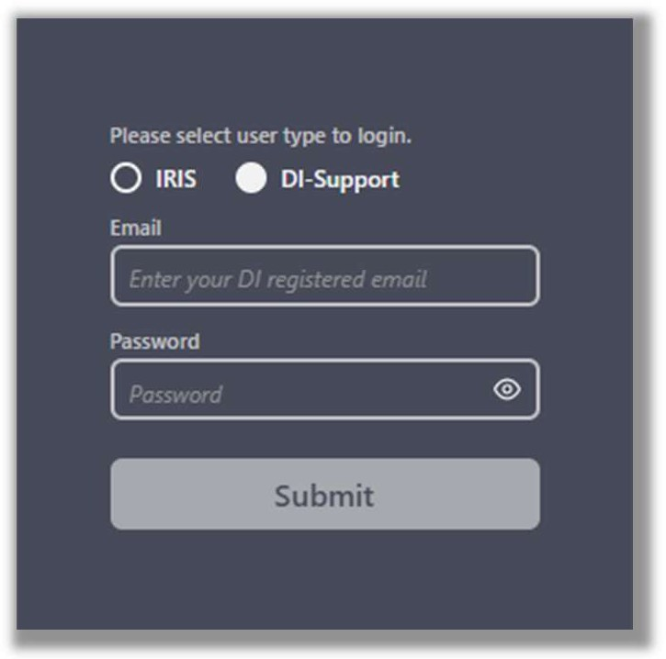

In Order to seek help and support for issues during integration and post integration, the Taxpayer and License Integrators will use the “Customer Relationship Management” (CRM) for Digital Invoicing.

##### Log In

* + Navigate to the ECRM portal. (**https://dicrm.pral.com.pk**)
  + Select the relevant radio button.
    - License Integrators will select **IRIS**

(Login by Entering registration number and Password)

* + - Taxpayer / Technical Content Person will select **DI-Support**

(Login by entering DI registered email ID and Password provided in technical details)

* + Log in by entering your **credentials** and click on “Submit” button.

**(Note: After 5 unsuccessful attempts, ID will be Blocked)**

**Note:** A taxpayer can log in using either IRIS or the DI Support option. If he wants to log in himself, he can use the IRIS option. If he wants to authorize a person (as mentioned in the technical details screen), the login should be done through the DI Support option.

* + Upon successful login, you will be directed to the main dashboard, which displays the

**Case List** and provides the option to create **New Case.**

* + Cases can be searched by their **case number** or **title**.
  + To view details of an existing case, simply click the **“View”** icon next to the case entry.

*Document Version :1.5 PRAL © 2025 – All rights reserved Page* ***14*** *of* ***20***

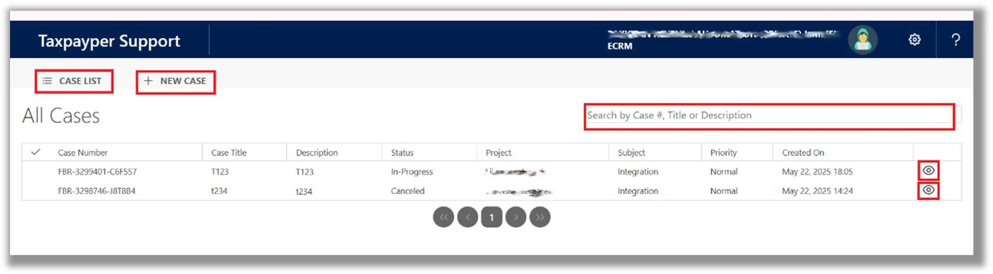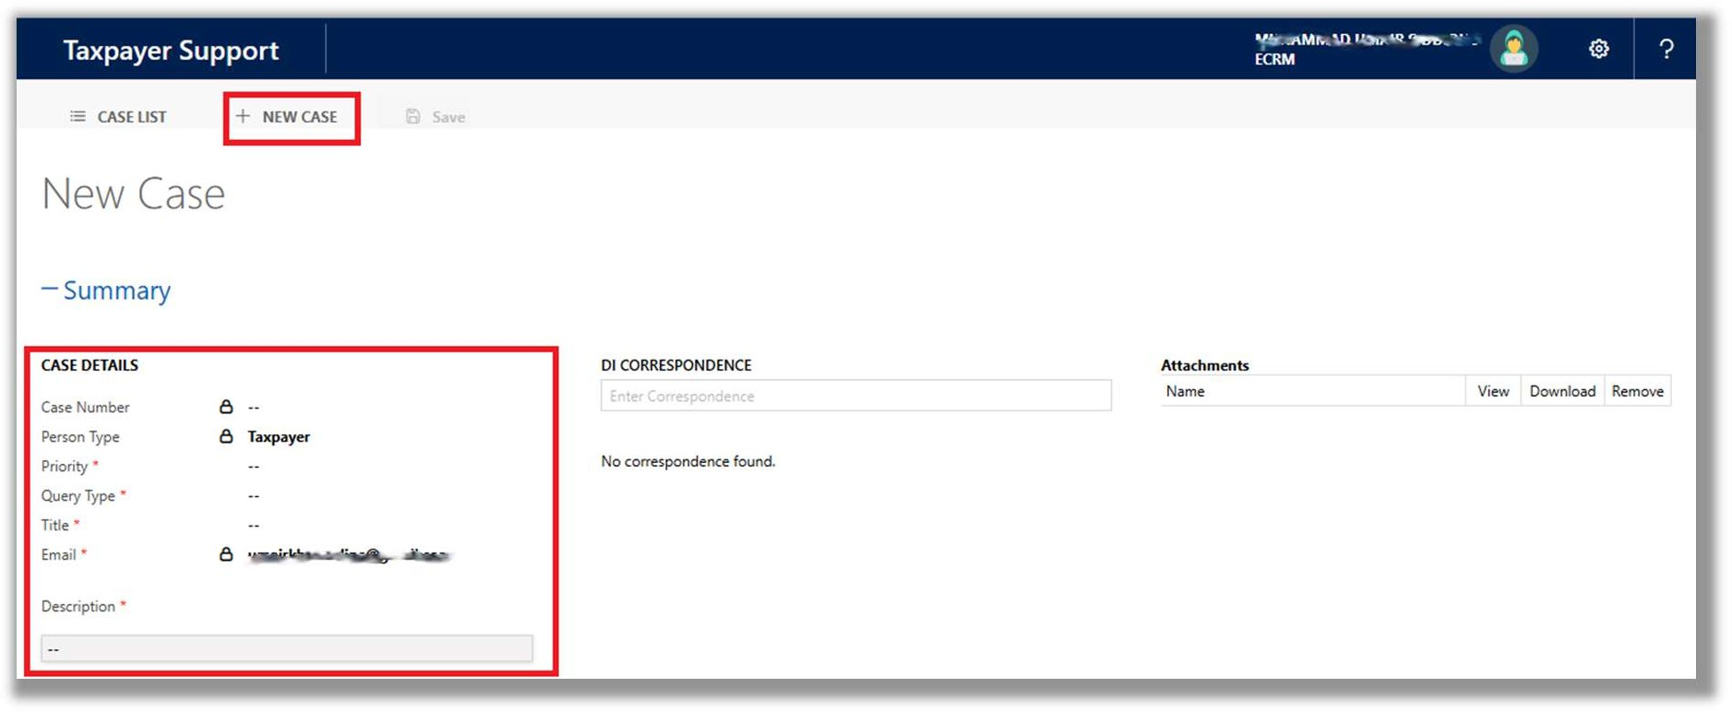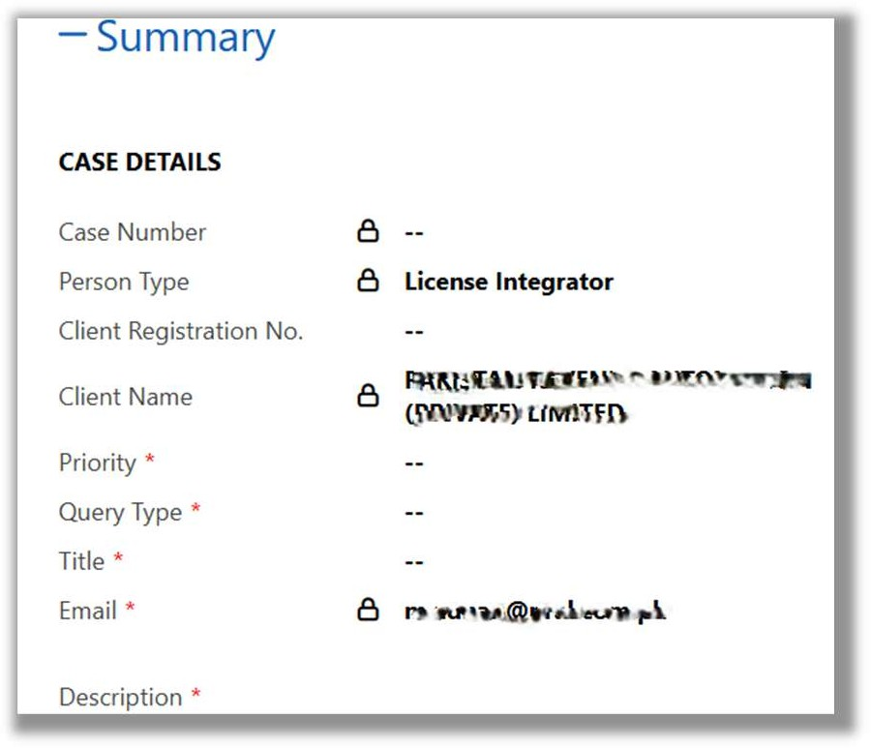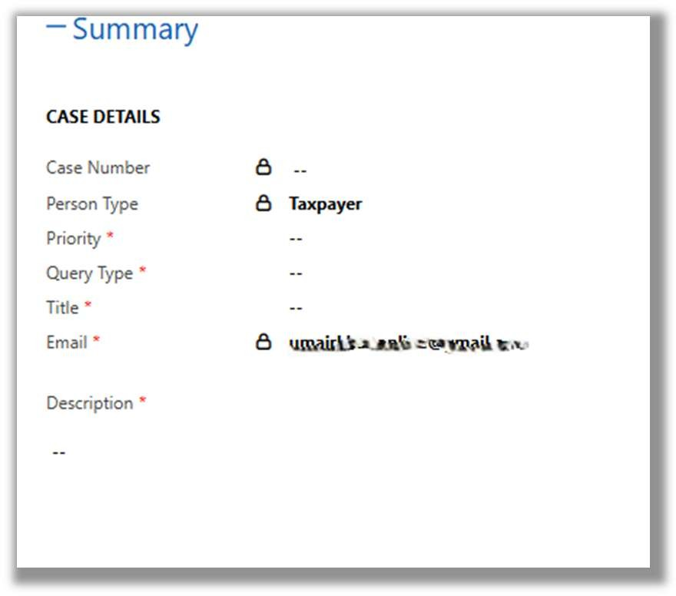

##### New Case

* + To enter a new case, click on '+ New Case' on the main dashboard.

##### FOR LICENSE INTEGRATOR FOR TAXPAYER

The fields marked with * are mandatory

* + In case of LI, enter **Client Register No. /Name** and all the locked details will be auto selected.
  + **“Case Number”** will be assigned by the system.

*Document Version :1.5 PRAL © 2025 – All rights reserved Page* ***15*** *of* ***20***

* + Person type “**License Integrator**” or “**Taxpayer**” will be auto fetched at the time of login as per user type selection ***(IRIS/DI-Support)***

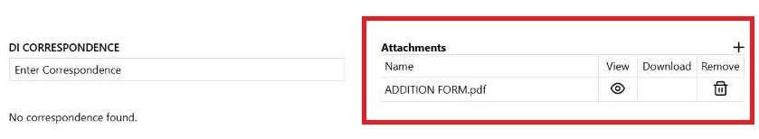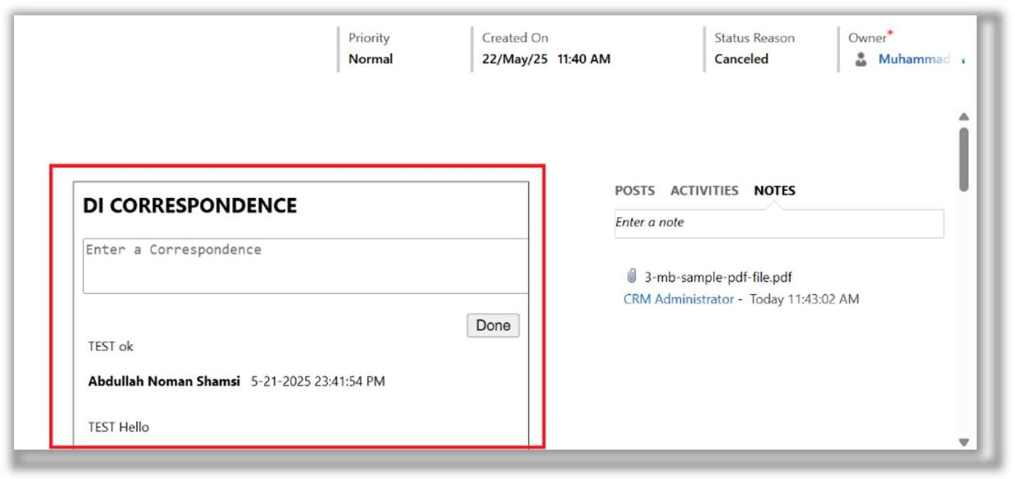

* + Client Name (In case of LI) auto populated and cannot be changed.
  + Select the **Priority Type** from the drop-down list. (Mandatory)
    - High
    - Normal
    - Low
  + Select the **Query Type** from the drop-down list. (Mandatory)
    - Integration
    - Post Integration
  + Select the **Title.** (Mandatory)
  + **Email** auto populated and cannot be changed. (Mandatory)
  + Describe the issue in Description (Mandatory)
  + Click the **“Save”** button.

##### Attachments

* + Once the case is saved, attachments can be added, removed, viewed, and downloaded.
  + Attachments should be in PDF format and must not exceed a file size of 5MB

##### Correspondence

* + Any additional information or correspondence can be added under the correspondence section.

*Document Version :1.5 PRAL © 2025 – All rights reserved Page* ***16*** *of* ***20***

## Frequently Asked Questions (FAQs)



##### What is the Digital Invoicing System?

The Digital Invoicing System is an initiative by FBR to modernize invoice reporting. It allows taxpayers to report invoices in real-time using PRAL's integration platform.

##### What are the benefits of using the Digital Invoicing System?

* + Real-time invoice submission and validation.
  + Automated tax calculations.
  + Seamless integration with ERP or any invoicing systems.
  + Reduced manual errors and improved compliance.
  + Auto population of invoices in Annexure C and Sales Tax Return.

##### How do I access the Digital Invoicing System?

You can access the system via the IRIS portal using your registration number and password. Navigate to **Digital Invoicing** from the dashboard. Detailed documentation available on FBR website.

##### What are the two integration modes available?

**API Integration:** For automated real-time invoice submission.

**Manual Invoice Generation:** For manual entry of invoices (limited functionality).

##### Is integration with PRAL mandatory?

No. Taxpayers can choose PRAL or any other FBR-licensed integrator. However, PRAL offers free services, while others may charge a fee.

##### How do I register for Digital Invoicing through PRAL?

PRAL provides free integration services, including Sandbox testing. You will need to:

* + Submit technical details (contact person, ERP details, etc.).
  + Provide IP whitelisting details (mandatory step).
  + Complete assigned scenarios on the basis of selected business nature and activity in sandbox environment before moving to Production.

*Document Version :1.5 PRAL © 2025 – All rights reserved Page* ***17*** *of* ***20***



##### What if I choose another Licensed Integrator?

You must select the LI from the dropdown list and submit your application. The LI will review and approve your request. The remaining process (IP whitelisting, Sandbox, etc.) will be handled by the LI.

##### What technical details are required for registration?

Technical contact person details (name, mobile, email).

* + ERP or any other invoicing system provider information.
  + Software type (Cloud/On-Premises) and version.
  + CRM User ID and password for support.
  + Business Nature & Sector

##### What is IP Whitelisting, and why is it required?

IP whitelisting ensures secure communication between taxpayer’s system and PRAL's servers. You must provide:

* + Hosting server details (company name, country).
  + Up to 3 IP addresses or upload a file for multiple IPs.

##### How do I upload multiple IPs?

Use the downloadable Excel template, enter IP details, and upload. File should be less than or equal to 1 MB in .xls format.

##### How long does IP whitelisting approval take?

PRAL typically approves or rejects IP whitelisting requests within **2 working hours**.

##### What is the Sandbox Environment?

The Sandbox is a testing environment where you can simulate invoice submissions before going live. It helps ensure your integration works correctly.

##### How do I access the Sandbox Environment?

After IP whitelisting approval, navigate to the **Sandbox Environment** tab to:

* + View Web API details.
  + Access sample JSON formats and code snippets.
  + Submit scenarios-based test invoices.

*Document Version :1.5 PRAL © 2025 – All rights reserved Page* ***18*** *of* ***20***



##### What happens after Sandbox access is granted?

* + Get Sandbox token
  + Use test credentials and endpoints
  + Submit invoices using **scenario-based testing** according to your sector/business type

##### What test invoices should I submit?

Submit invoices that match the **Business Nature** and **Sector** selected during registration. Each submission will generate a unique Invoice Number.

##### What are scenarios in Sandbox testing?

Scenarios are predefined test cases (e.g., standard rate sales, exempt goods) based on your business activity. Refer to the Point # 9 **Scenarios for Sandbox Testing** section of Technical Document.

##### How do I know which testing scenarios to use?

The eligible scenarios will be viewable in sandbox environment. Further you may check the point # 10 **“Applicable Scenarios based on Business Activity”** in the technical document. E.g., textile manufacturers must test SN001, SN002, SN005, SN006, etc.

##### How do I know if my Sandbox test is successful?

The system will validate your test invoices.

Upon successful completion of all assigned scenarios, a **Production Token** will be auto generated.

##### How much invoices of each scenario I need to complete?

Minimum 1 invoice of each scenario must be successful to mark it complete. Note: The successful, pending and unsuccessful scenarios will be viewable in sandbox environment.

##### What if a test invoice fails?

Use the error code returned to fix issues. Refer to detailed error code list provided in the technical document (Sales/Purchase Errors).

*Document Version :1.5 PRAL © 2025 – All rights reserved Page* ***19*** *of* ***20***

##### How do I move from Sandbox to Production?



Once all test invoices are successfully submitted, the system will generate a **Production Token**. Use this token to complete integration in the Production Environment.

##### What details are available in the Production Environment?

* + Production API details.
  + Security Token for real-time invoice submissions.

##### How do I go live?

* + Use Production Token
  + Switch endpoints
  + Start real-time invoice posting

##### Where can I find more help?

* + Refer to the **User Manual** and **Technical Documentation**.
  + Contact PRAL support via CRM https://dicrm.pral.com.pk/

##### How do I raise a new case in CRM?

* + Log in to the CRM. (https://dicrm.pral.com.pk)
  + Click **+ New Case**.
  + Fill in mandatory fields (priority, query type, title, description).
  + Attach supporting documents (PDF, max 20MB).

##### How can I track my support case?

* + Use the **Case List** to view existing cases.
  + Search by case number or title.
  + Click **View** to check updates or add correspondence.

*Document Version :1.5 PRAL © 2025 – All rights reserved Page* ***20*** *of* ***20***