学生信息表作业
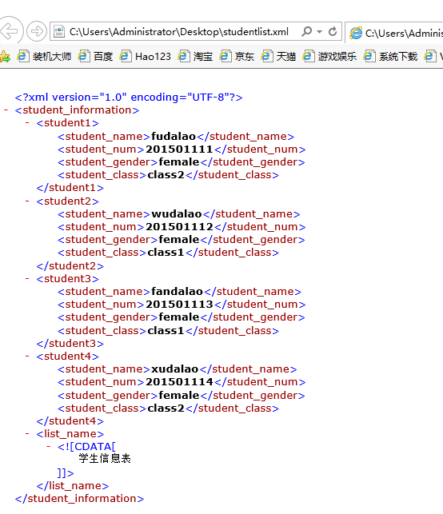
C++验证父类子类的构造和析构函数的调用顺序
1.验证程序
#include "stdafx.h"
#include<iostream>
using namespace std;
class Person
{
char name;
int age;
public:
Person()
{
cout << "父类的构造.\n" << endl;
}
~Person()
{
cout << "父类的析构.\n" << endl;
}
};

class Student :public Person
{
int grade;
public:
Student()
{
cout << "子类的构造.\n" << endl;
}
~Student()
{
cout << "子类的析构.\n" << endl;
}
};

int main()
{
Person a;
Student b;
return 0;
}
2.验证结果
