CET325: ADVANCED MOBILE DEVELOPMENT

STUDENT NAME: SHINGIDZANO LESETEDI

REGISTRATION NUMBER: BH44GG

COURSE: COMPUTER SYSTEMS ENGINEERING

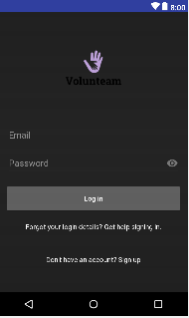

Contents

Analysis 2

Evaluation of Development Approaches and Methodologies 3

Plan—Driven Approach 3

Change—Driven Approach 3

Waterfall methodology 3

Agile methodology 3

Screen Hierarchy 4

Wireframe Designs 4

Design Principles 5

Application Functionality Achieved 6

Dependencies/ APIs Used 6

Evaluation of Functionality 6

Application Testing 8

Monkey Test 8

Lint Test 9

Evaluation of Project 9

# Analysis

Native mobile applications are established through vendor-specific development tools and languages. Usually, native applications have the complete usage to the hardware functionalities of the device. Several most important mobile platforms with particular native development methods contains Android, IOS, and Windows. All these platforms offer mobile application designers with their own consistent SDKs, development tool, and interface components. For example, IOS provides the XCode as the general SDK however Android developers make use of ASD tool and Windows developers are mounted with UWP which is Universal Windows Platform. Each of these requirement aims to allow developers to form native applications with relative easiness. When the development of mobile application take place, applications sets are arranged to their particular app stores from where the user can connect with them.

Native local database storage in android is carried out using Sqlite database. It contains a table called Sqlite master which holds all the information for tables used and created. In this database structure the front-end being the activity is where the user interacts with the app. The DBAdapter interacts with the sqlite database and activities in the app. It also creates tables and columns that are to be used in the database. Within it we have the OpenHelper,DatabaseHelper,SQLiteDatabase and Cursor which are responsible for carrying out crude functions to the database as per user interaction with the app activities.

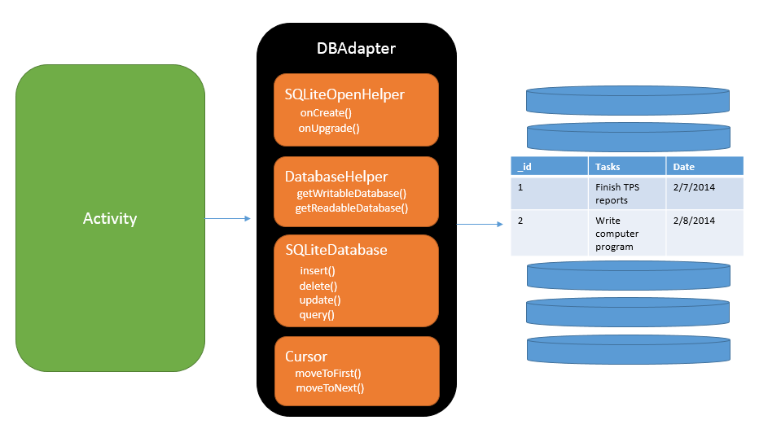

*Figure 1.0 Diagram showing the flow of data from the activity to the sqlite database*

# Evaluation of Development Approaches and Methodologies

There are two main approaches which can be used to develop mobile applications. Namely Plan Driven Approach and Change Driven Approach. These are explained below.

## Plan—Driven Approach

This type of development approach emphasises planning and formal documentation for desired results and outcomes of the project. The project is typically broken down into stages which allows for early feedback and discovery of possible threats. It is most suitable for projects that have high risk and cannot have deviation.

## Change—Driven Approach

This approach focuses on delivering solutions quickly and incrementally. This usually involves direct involvement of the stakeholders through feedback. It poses a higher risk than Plan Driven Approach due to the lack of fixed planning and implementation practices. There is a higher uncertainty in the final solution. It is more fast paced and the environment of development changes quickly. This approach is mainly used in software development. For example, IOS or Android operating system updates.

The plan driven approach will be used in this project as the requirements are outlined in detail hence there is a clear picture of the expected final solution.

The two development methodologies that will be evaluated are the Waterfall methodology and the Agile methodology.

## Waterfall methodology

This is a sequential development strategy that involves development in stages or in a particular order. It is clear and concise but requires extensive planning before development can take place. There is no room for change or error in this approach because the plan developed is followed carefully from start to finish of the project. This in turn results in a much lengthier project. Another pitfall of this methodology is that it is difficult to make additional or adaptive changes.

## Agile methodology

The agile methodology is in a sense a solution to the shortcomings of the waterfall methodology. This methodology follows an incremental approach. The developer starts out with a simplistic design and starts working on small modules of the project one after the other. This strategy facilitates a more interactive approach with the client and ensures that the application is of most satisfaction. This methodology however has an unclear scope and requires continuous testing of deliverables.

The approach taken with this project is a combination of both the Agile methodology and the Waterfall methodology. This is a strategy to help combat both pitfalls of these methodologies and make use of a hybrid methodology that will ensure the project is carried out to the best standard possible.

# Screen Hierarchy

Below is a sitemap of the main screen activities that take place in the Volunteam. This shows the flow primary activities possible in the application.

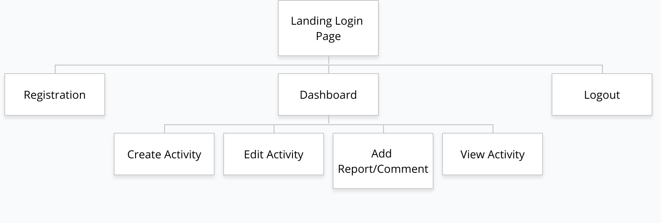

# Wireframe Designs

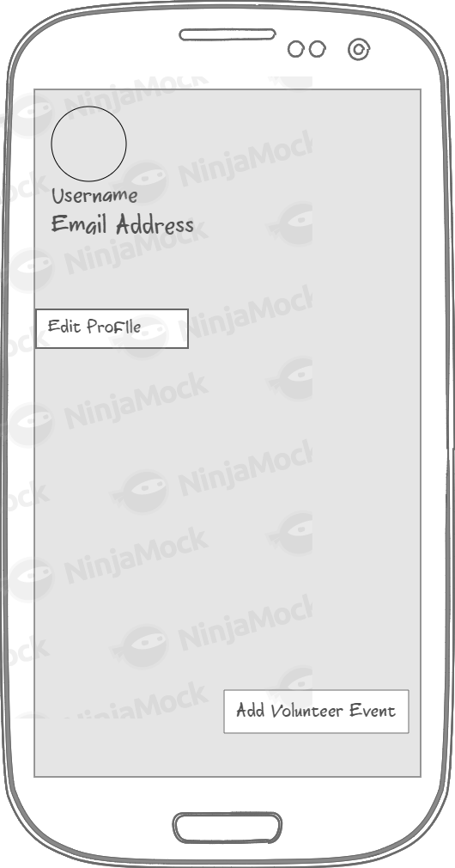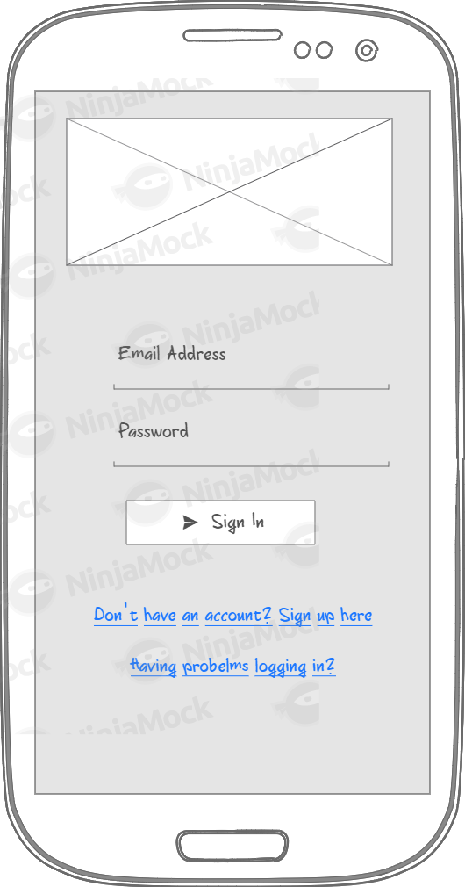 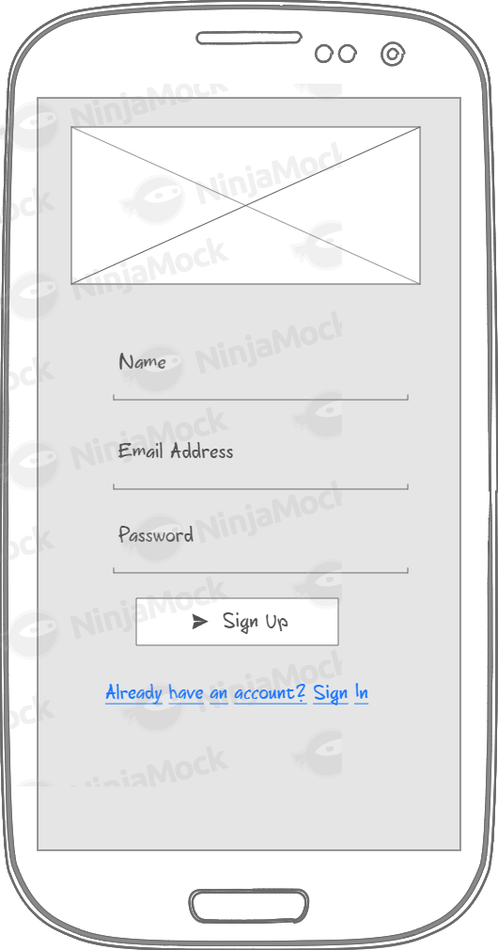

*Login Activity (landing) Registration Activity Dashboard*

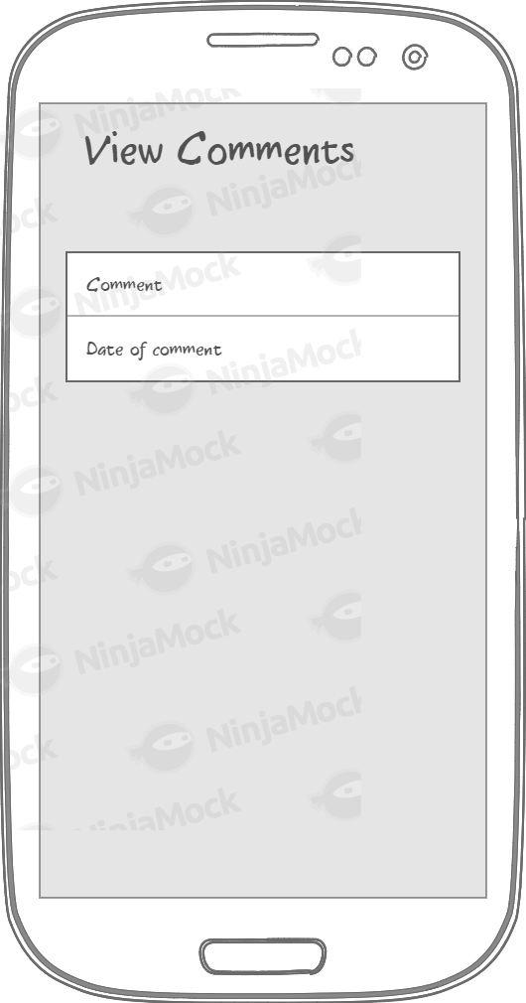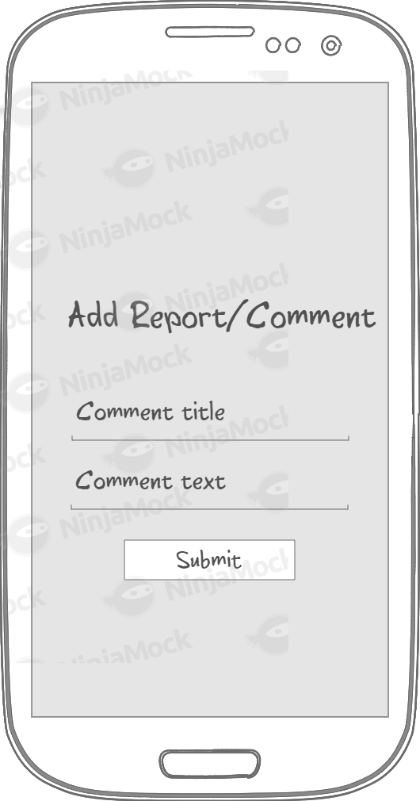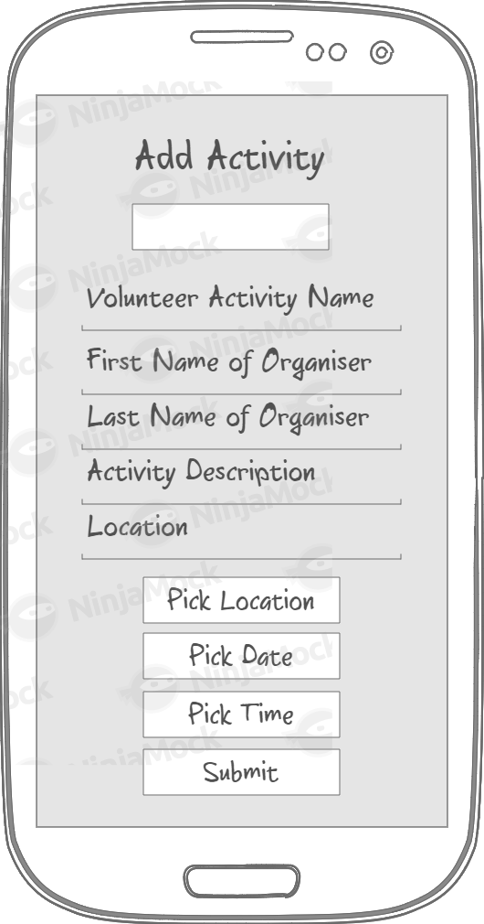

*Add Activity Add Comment View Comment*

# Design Principles

These are design principles that were developed by and for the android user experience team in keep the best interest of the users in mind when designing and developing applications.

The design of the Volunteam app follows a number of the design principles, the first being “Real objects are more fun than buttons and menus”. This was applied in the create activity menu where the upload image button is represented by an image instead of a plain text button. It was however avoided to use too many picture buttons to keep the application clean and formal.

The “pictures are faster than words” principle is applied in the volunteer event list which has pictures that entice volunteers to be keener to join the cause. The google maps location feature also allows a more interactive way to select activity locations in comparison to typing the location (which is still present).

“Only show what I need when I need it” is a principle that aims to avoid overcrowding of the app when certain menus are open. The volunteam app is properly segmented such that it has a minimalistic dashboard and only shows the drawer when the user opens it.

# Application Functionality Achieved

* Home screen/ Splash screen
* User Registration and Login
* Edit Events
* Delete Events
* Add Description of Event
* Add Date of Event
* Add Time of Event
* Add Picture of Event
* Add Location of Event
* Add Event Description
* Search Event by Keyword
* Users can see events on a map within a certain distance of their location
* Add Comment/Report to event

# Dependencies/ APIs Used

* com.android.support:recyclerview-v7:25.0.0
* com.android.support:cardview-v7:25.0.0
* com.google.android.gms:play-services:7.3.0
* com.android.support.test:runner:0.5

# Evaluation of Functionality

|  |  |  |  |  |
| --- | --- | --- | --- | --- |
| **Core Requirements** | **Fully** | **Partially** | **Not Used** | **Comments** |
| Home screen - the point of entry for your app | F |  |  | The entry point of the app |
| User registration and login | F |  |  |  |
| Manage my events | F |  |  |  |
| Create an event | F |  |  |  |
| Search for an event |  | P |  | Search only uses keywords |
| Respond to an event |  | P |  | Users are able to send a report and share the event |
| **Desirable Requirements** | **Fully** | **Partially** | **Not Used** | **Comments** |
| Users can see events on a map within a certain distance of their location. | F |  |  | Does not work on emulator but fully functional on android device |
| Users can be notified about events within a certain distance of a specified location or their own location |  | P |  |  |
| Users can select to receive notifications about events relating to a specific keyword |  |  | N |  |
| The ability to search for a user and write a review of them |  |  | N |  |

# Application Testing

## Monkey Test

Monkey is as tool that perform regression stress testing on application using some very random events. This test was carried out on the Volunteam app with no errors under 500 cycles.

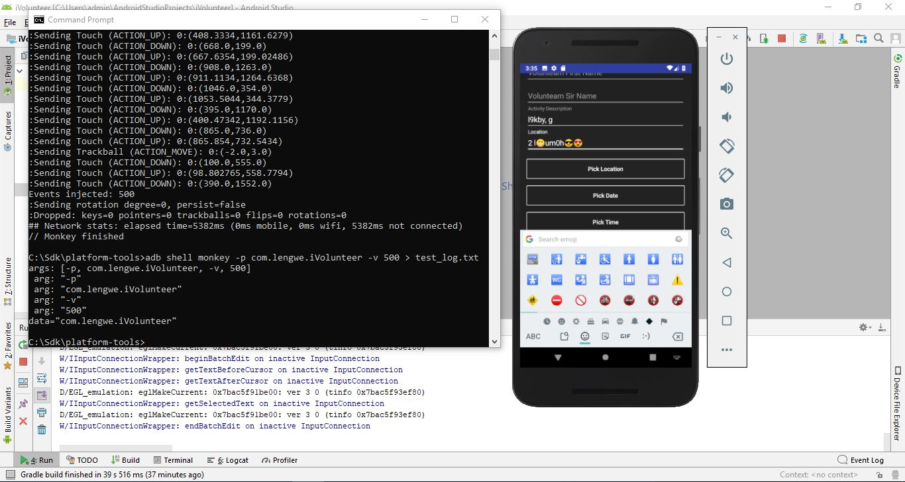The log file to the test is attached to this project archive.

## Lint Test

This test is used to detect all errors and warnings in the application code. Most of the warnings in the volunteam project were that of not having description for elements in the layout files.

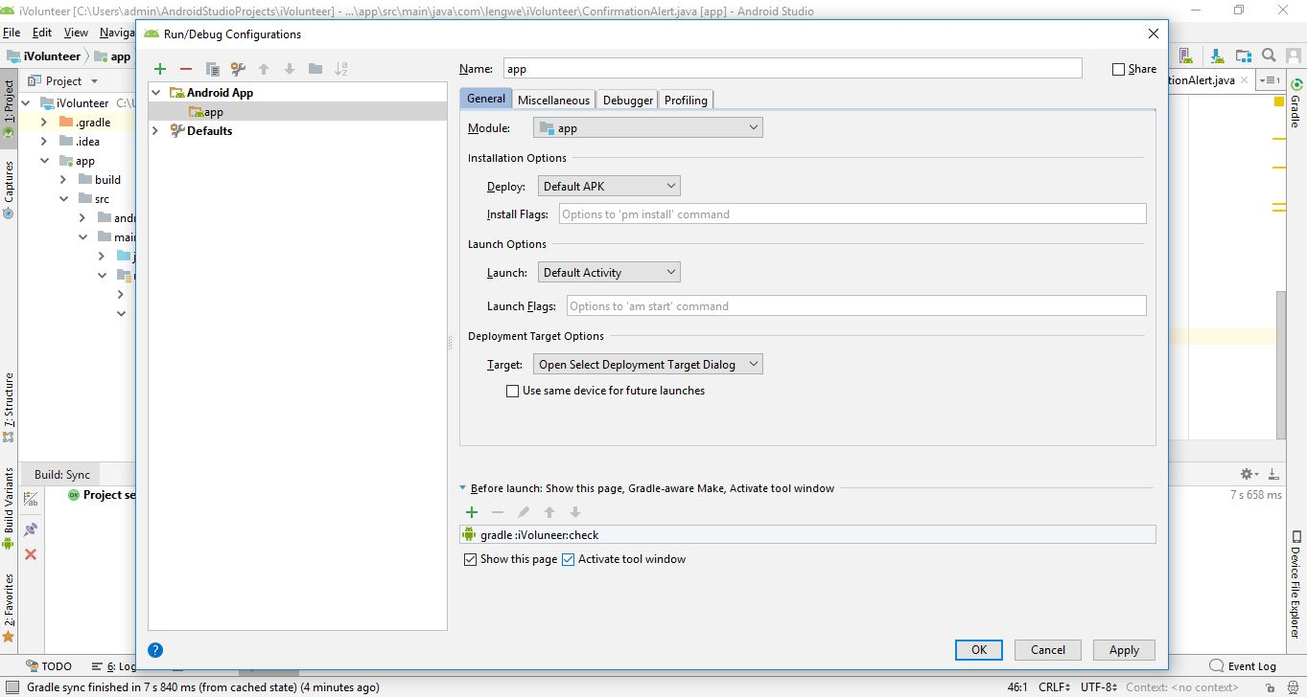

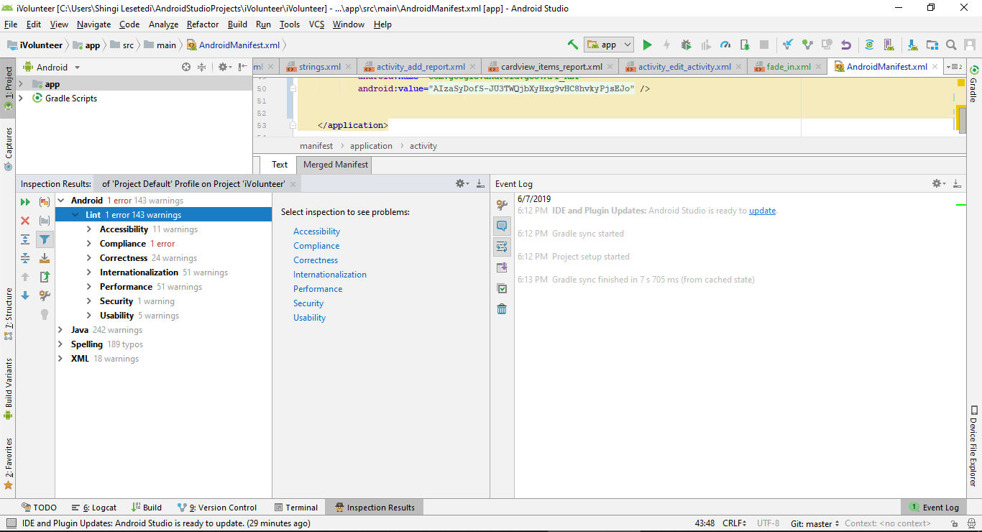

# Evaluation of Project

The volunteam app developed was mostly successful in terms of implementation of basic requirements that provide the basic functionality of the application. The additional functionality of location picking using google maps was fully implemented with the code developed and the API key generated. The feature works perfectly on a mobile device but for some reason does not behave the same way on the emulator. This is shown in the screencast demo attached to the submission. Further improvements to this application would be implementation of the missing and partially done functionality. In addition, the Lint test showed the prevalence of a number of warnings in element descriptions which could have been further refined to minimise them. This would make the application more application store worthy. Overall the project was not completely perfect but quite competent.

# Bibliography

AGARWAL, R. (2016, June 16). *Performance Testing using MONKEY tool for Android* . Retrieved from To The New: http://www.tothenew.com/blog/performance-testing-using-monkey-tool-for-android/

Developers, A. (2013, August 22). *Android Design Principles | Design Principles FTW*. Retrieved from Design Principles FTW: https://www.designprinciplesftw.com/collections/android-design-principles

Hub, E. (2017, May 18). *Why Agile Methodology for Mobile App Development? – eDesk HUB – Medium*. Retrieved from Medium: https://medium.com/@edeskhub/why-agile-methodology-for-mobile-app-development-e685b41ea462

Software, H. T. (2019, June 3). *Full-stack Solution For Developing a Social Media App - Case Study*. Retrieved from Hyper Tense Software: https://hypersense-software.com/2018/02/08/developing-a-social-media-app/