<https://www.techtarget.com/searchnetworking/answer/What-are-the-3-most-common-network-issues-to-troubleshoot>

TCP/IP addressing and subnetting basics

<https://learn.microsoft.com/en-us/troubleshoot/windows-client/networking/tcpip-addressing-and-subnetting>

1. Slow network

-if someone decides to download high-definition videos

1. Weak wi-fi signal

A large metal object, like a file cabinet, can block the WiFi signal.

Other devices: microwave oven, cordless phones and Bluetooth can all interfere with WiFi signals, too.

1. Physical connectivity issues

Damaged network cables.

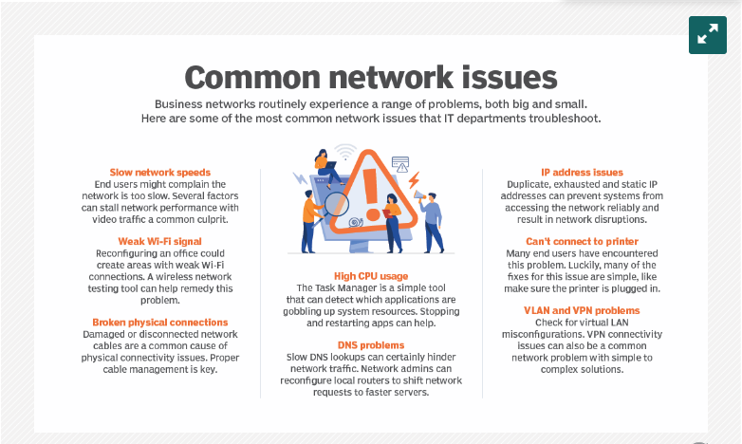

1. Duplicate and static IP addresses

-On a network, no two systems can share the same internet address. If there are duplicate internet addresses, neither system can access the network reliably.

IP concept

IP address vs. Subnet Mask vs. Gateway

Gateway: connects local devices to other networks.

-When a local device wants to send info to a device at an IP address on another network, it first send its packets to the gateway, which then forwards the data on to its destination outside of the local network.

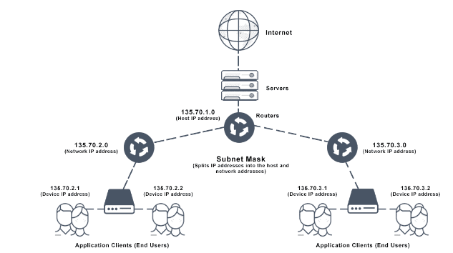

Source:

<https://avinetworks.com/glossary/subnet-mask/#:~:text=The%20subnet%20mask%20splits%20the,local%20devices%20to%20other%20networks>.

DHCP server (Dynamic Host Configuration Protocol)

-network server that automatically provides and assigns IP addresses, default gateways and other network parameters to client devices.

Ethernet vs. Wifi

Ethernet port, when to use which

<https://nordvpn.com/blog/ethernet-vs-wifi/#:~:text=Ethernet%20connections%20are%20faster%20because,and%20gives%20you%20faster%20speeds>.

lifewire.com/what-is-an-ethernet-port-817546

UPS(uninterruptible power supply), Switch, Router, Hub

Network Switch

-connects devices in a network to each other, enabling them to talk by exchanging data packets.

-Network switches operates on the data-link layer, or L2, of OSI model.

ethernet

physical and data link layer of a network (OSI layer 1 and layer 2)

Ethernet uses MAC addresses. (assigned to hardware by device manufacturers)

MAC: like street addresses or post office boxes

router

-used to pass packets between networks

-use IP addresses (like zip codes)

-connects LANs to other area networks or to the internet

-uses IP addresses to route data packets

cisco: https://www.cisco.com/c/en/us/products/switches/what-is-network-switching.html#~q-a

ethernet frames:

-data broken into packets

switch

-uses MAC addresses to identify where to send data packets

-HARDWARE!

-performs the switching process.

-connects network devices, such as computers and servers, to one another.

-switch acts as a traffic cop at a busy intersection.

-data packets can come from

1) directly attached to switch: computers or VoIP phones

2) indirectly connected devices: hub or router (network element)

What is connected to your network Switch?

switch vs. hub

-hub sends copies of the packet to every other device connected to it.

-can cause problems with traffic congestion and data security

-Switches solve this problem by keeping tables of the MAC addresses of all devices sending packets to them and forwarding packets only to their destinations, instead of flooding all connected devices with the packets.

switch vs. router

-A switch connects devices within a LAN (local-area network) by using MAC addresses to identify where to send data packets. A router connects LANs to other area networks or to the internet. A router uses IP addresses to route data packets.

Modern switches act as both switches and routers