Proj

Mānuka background(cultural,uses,industry)

Experimental Cross Design

Two east cape parents, F1 cross siblings

#### F1 Layout

Map indicates the layout of the F1 generation resulting from a cross between EC201 and EC103 parents. Column 1 is approximately lengthways facing north.

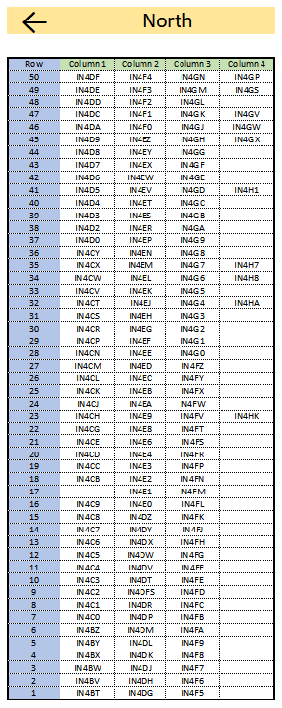

“Map of F1 Trees”

#### Height Diagram

Diagram indicates the areas of leaf collection regarding height. Each Tree generally had 10 leaves collected (some trees have been sampled more than once), leaves were selected from low, mid and high points of the tree. The first leaf sampled from each tree was measured twice for replication comparison.

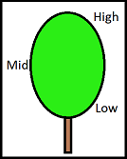

“Diagram of leaf collection levels”

#### Import and Arrange Data

Dualex was used to measure transmittance through all samples included in this dataset, more information on how this works can be found in Clara Rey Caramés, 2015.

"Full.xlsx

* Surface content of chlorophyll in $g/cm^{2}$ (Chl)
* Epidermal Flavoid content in absorbance units(Au); Flavonol(Flav) and Anthocyanin(Anth)
* Nitrogen Balance Index status is calculated using Chlorophyll and Flavonol values automatically (NBI)

It also contains information about the block position, the leaf height information, and presense or absence of flowering

Sheet “Dup” contains only the replicated samples

#### Checking Data Quality from Replicate Leaf Measures.

Replicates exist in two groups; first leaf measurement (Y1), and the second leaf measurement (Y2). The second measurement was taken after removing the leaf following the first reading, to help establish the presence of any leaf positional bias.

#### Replicate Plots and Data Overview

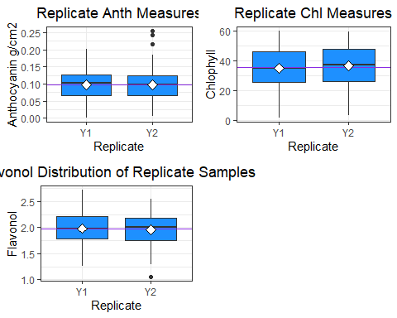

Plots of replicate measure disitributions, medians (lines), means (empty diamonds)

## Rep. AnthMean AnthSD ChlMean ChlSD FlavMean FlavSD  
## 1 Y1 0.09830189 0.04539806 34.93672 14.55641 1.979969 0.2863768  
## 2 Y2 0.09768153 0.04439018 36.59920 14.51963 1.954280 0.2796720

#### Replicate ANOVAs

## Analysis of Variance Table  
##   
## Response: Dup$Anth  
## Df Sum Sq Mean Sq F value Pr(>F)  
## Dup$Rep. 1 0.00003 0.0000304 0.0151 0.9023  
## Residuals 314 0.63303 0.0020160

## Analysis of Variance Table  
##   
## Response: Dup$Chl  
## Df Sum Sq Mean Sq F value Pr(>F)  
## Dup$Rep. 1 218 218.33 1.033 0.3102  
## Residuals 314 66366 211.36

## Analysis of Variance Table  
##   
## Response: Dup$Flav  
## Df Sum Sq Mean Sq F value Pr(>F)  
## Dup$Rep. 1 0.0521 0.052129 0.6506 0.4205  
## Residuals 314 25.1596 0.080126

Replicate measures and plots appear to correspond well - indicative that the measurements from the dualex are reliable. Might pay to remove the outliers.

#### Plots of leaf chemicals across groups

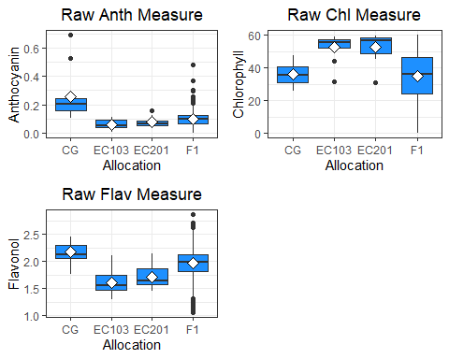

#### Data Summary

## Allocation AnthMean AnthSD ChlMean ChlSD FlavMean FlavSD  
## 1 CG 0.25763636 0.18306079 36.02836 7.090510 2.169455 0.2021457  
## 2 EC103 0.05883333 0.03576650 52.59242 7.889391 1.599833 0.2334250  
## 3 EC201 0.07790000 0.03665288 52.60670 9.291990 1.710800 0.2217590  
## 4 F1 0.09711830 0.04437066 34.99601 15.144271 1.967003 0.2479930

Anthocyanin Crimson Glory(CG) outgroup apparent, F1 population more similar to parental trees.

Chlorophyll F1 very diverse, overlaps with both parent trees and outgroup, more similar median and distrubtion to outgroup.

Flavonol F1 overlaps with parents and outgroup, slightly more similar to parental trees.

#### Plots of unadjusted F1 chemical

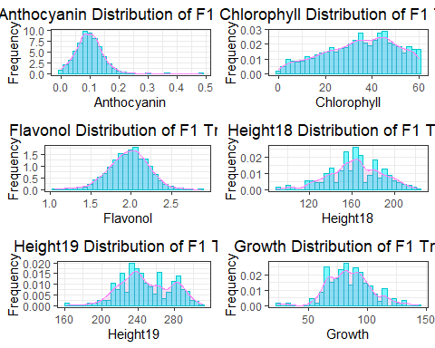

Anothcyanin left bias, long tail

Chlorophyll right bias, truncated

Flavonol typical bell curve with slightly long tails both directions

Height 2018 lumpy normal disitribution

Height 2019 appears to be two overlapping distribitiuons, maybe 3

Growth maybe 3 overlapping populations

#### Row Comparisons

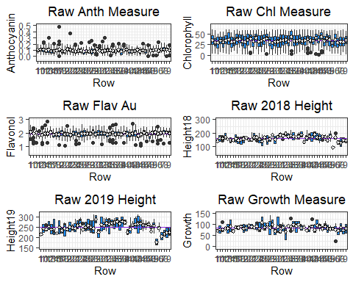

#### Column Comparisons

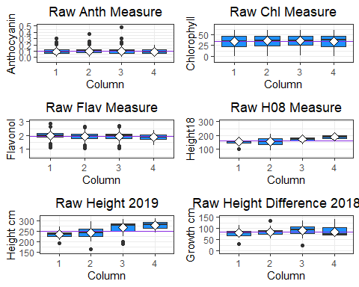

#### Row v Column Heatmaps

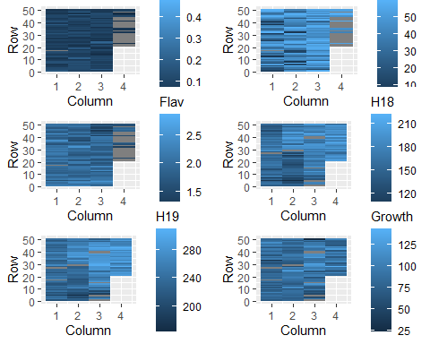

#### Height Plots

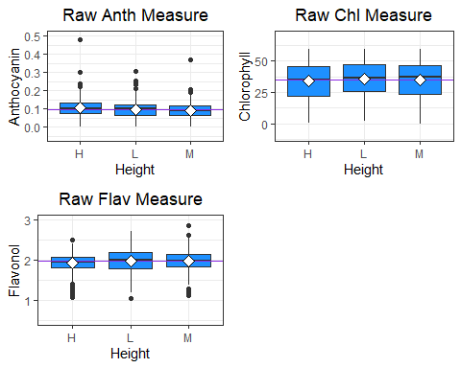

#### ANOVAs comparing Height, Row and Columns for each chemical

## Analysis of Variance Table  
##   
## Response: F1$Anth  
## Df Sum Sq Mean Sq F value Pr(>F)   
## F1$Row 1 0.0668 0.066767 35.0627 3.820e-09 ***  
## F1$Column 1 0.0042 0.004242 2.2279 0.1357   
## F1$Height 2 0.0522 0.026106 13.7094 1.234e-06 ***  
## Residuals 1787 3.4028 0.001904   
## ---  
## Signif. codes: 0 '***' 0.001 '**' 0.01 '*' 0.05 '.' 0.1 ' ' 1

## Analysis of Variance Table  
##   
## Response: F1$Anth  
## Df Sum Sq Mean Sq F value Pr(>F)   
## F1$Row 1 0.0668 0.066767 35.038 3.867e-09 ***  
## F1$Height 2 0.0521 0.026072 13.682 1.267e-06 ***  
## Residuals 1788 3.4071 0.001906   
## ---  
## Signif. codes: 0 '***' 0.001 '**' 0.01 '*' 0.05 '.' 0.1 ' ' 1

## Analysis of Variance Table  
##   
## Response: F1$Chl  
## Df Sum Sq Mean Sq F value Pr(>F)   
## F1$Row 1 5558 5557.6 24.5835 7.79e-07 ***  
## F1$Column 1 394 393.6 1.7409 0.1872   
## F1$Height 2 828 414.2 1.8321 0.1604   
## Residuals 1787 403984 226.1   
## ---  
## Signif. codes: 0 '***' 0.001 '**' 0.01 '*' 0.05 '.' 0.1 ' ' 1

## Analysis of Variance Table  
##   
## Response: F1$Chl  
## Df Sum Sq Mean Sq F value Pr(>F)   
## F1$Row 1 5558 5557.6 24.55 7.921e-07 ***  
## Residuals 1790 405206 226.4   
## ---  
## Signif. codes: 0 '***' 0.001 '**' 0.01 '*' 0.05 '.' 0.1 ' ' 1

## Analysis of Variance Table  
##   
## Response: F1$Flav  
## Df Sum Sq Mean Sq F value Pr(>F)   
## F1$Row 1 1.377 1.37745 23.0843 1.680e-06 ***  
## F1$Column 1 1.209 1.20913 20.2635 7.183e-06 ***  
## F1$Height 2 0.930 0.46482 7.7898 0.0004281 ***  
## Residuals 1787 106.631 0.05967   
## ---  
## Signif. codes: 0 '***' 0.001 '**' 0.01 '*' 0.05 '.' 0.1 ' ' 1

## Analysis of Variance Table  
##   
## Response: F1$H18  
## Df Sum Sq Mean Sq F value Pr(>F)   
## F1$Row 1 190041 190041 465.42 < 2.2e-16 ***  
## F1$Column 1 155091 155091 379.82 < 2.2e-16 ***  
## Residuals 1721 702727 408   
## ---  
## Signif. codes: 0 '***' 0.001 '**' 0.01 '*' 0.05 '.' 0.1 ' ' 1

## Analysis of Variance Table  
##   
## Response: as.numeric(F1$H19)  
## Df Sum Sq Mean Sq F value Pr(>F)   
## F1$Row 1 264274 264274 608.03 < 2.2e-16 ***  
## F1$Column 1 304495 304495 700.56 < 2.2e-16 ***  
## Residuals 1720 747587 435   
## ---  
## Signif. codes: 0 '***' 0.001 '**' 0.01 '*' 0.05 '.' 0.1 ' ' 1

## Analysis of Variance Table  
##   
## Response: as.numeric(F1$Growth)  
## Df Sum Sq Mean Sq F value Pr(>F)   
## F1$Row 1 6073 6073.3 19.996 8.268e-06 ***  
## F1$Column 1 24791 24790.5 81.621 < 2.2e-16 ***  
## Residuals 1720 522411 303.7   
## ---  
## Signif. codes: 0 '***' 0.001 '**' 0.01 '*' 0.05 '.' 0.1 ' ' 1

Anthocyanin Significant Row and Height effects

Chlorophyll Significant Row effect

Flavonol Significant row,column and height effects

Height 2018 Very Significant effect of row and column

Height 2019 Very Significant effect of row and column

Growth difference (Height 2019- Height 2018) Very Significant effect of row and column - need to double check might be from later in analysis

#### Adjusting Row, Column and Height measures

## Height Column Row Tree.ID Allocation Rep. measure Flower Flower.Level  
## 115 H 3 17 IN4FM F1 N 11 N 0  
## 1293 M 2 20 IN4E4 F1 N 7 N 0  
## Chl Flav Anth NBI Height08 Height09 H19 H18 Growth AnthRowMeans  
## 115 59.122 1.640 0.483 36.05 166 245 245 166 79 0.1163182  
## 1293 18.511 1.401 0.370 13.21 138 234 234 138 96 0.1105227  
## ChlRowMeans FlavRowMeans H18RowMeans H19RowMeans AnthColMeans ChlColMeans  
## 115 32.12650 1.886773 146.6957 232.0 0.09897588 36.04402  
## 1293 31.51561 1.933068 151.0000 246.5 0.09924281 35.39257  
## FlavColMeans H18ColMeans H19ColMeans AnthHeightMeans ChlHeightMeans  
## 115 1.960649 175.1734 267.4482 0.10500200 33.90735  
## 1293 1.944405 157.0018 241.0717 0.09133645 35.25540  
## FlavHeightMeans  
## 115 1.930788  
## 1293 1.983505

## Analysis of Variance Table  
##   
## Response: F1$AdjAnth  
## Df Sum Sq Mean Sq F value Pr(>F)  
## F1$Row 1 0.00026 0.00025836 0.1518 0.6969  
## F1$Colum 1 0.00118 0.00118033 0.6934 0.4051  
## F1$Height 2 0.00018 0.00008970 0.0527 0.9487  
## Residuals 1785 3.03861 0.00170230

## Analysis of Variance Table  
##   
## Response: F1$AdjChl  
## Df Sum Sq Mean Sq F value Pr(>F)  
## F1$Row 1 1 0.89 0.0041 0.9489  
## F1$Column 1 72 72.41 0.3349 0.5628  
## F1$Height 2 789 394.51 1.8249 0.1615  
## Residuals 1785 385885 216.18

## Analysis of Variance Table  
##   
## Response: F1$AdjFlav  
## Df Sum Sq Mean Sq F value Pr(>F)  
## F1$Row 1 0.019 0.018555 0.3357 0.5624  
## F1$Column 1 0.007 0.007400 0.1339 0.7145  
## F1$Height 2 0.001 0.000454 0.0082 0.9918  
## Residuals 1785 98.652 0.055267

## Analysis of Variance Table  
##   
## Response: F1$AdjH18  
## Df Sum Sq Mean Sq F value Pr(>F)   
## F1$Row 1 2625 2625.3 11.005 0.0009277 ***  
## F1$Column 1 6285 6285.4 26.347 3.176e-07 ***  
## Residuals 1719 410084 238.6   
## ---  
## Signif. codes: 0 '***' 0.001 '**' 0.01 '*' 0.05 '.' 0.1 ' ' 1

## Analysis of Variance Table  
##   
## Response: F1$AdjH19  
## Df Sum Sq Mean Sq F value Pr(>F)   
## F1$Row 1 3064 3063.9 12.788 0.0003586 ***  
## F1$Column 1 14757 14756.5 61.589 7.385e-15 ***  
## Residuals 1718 411630 239.6   
## ---  
## Signif. codes: 0 '***' 0.001 '**' 0.01 '*' 0.05 '.' 0.1 ' ' 1

## Analysis of Variance Table  
##   
## Response: as.numeric(F1$Growth)  
## Df Sum Sq Mean Sq F value Pr(>F)   
## F1$Row 1 26 26.07 0.1178 0.731482   
## F1$Column 1 1852 1851.64 8.3672 0.003869 **  
## Residuals 1718 380187 221.30   
## ---  
## Signif. codes: 0 '***' 0.001 '**' 0.01 '*' 0.05 '.' 0.1 ' ' 1

2018 and 2019 heights continue to require adjustment for row and column

Adjust height row and column effects

## Analysis of Variance Table  
##   
## Response: F1$AdjH182  
## Df Sum Sq Mean Sq F value Pr(>F)   
## F1$Row 1 297 296.75 1.3096 0.252631   
## F1$Column 1 1995 1995.24 8.8052 0.003045 **  
## Residuals 1719 389521 226.60   
## ---  
## Signif. codes: 0 '***' 0.001 '**' 0.01 '*' 0.05 '.' 0.1 ' ' 1

## Analysis of Variance Table  
##   
## Response: F1$AdjH192  
## Df Sum Sq Mean Sq F value Pr(>F)   
## F1$Row 1 423 423.06 1.8915 0.1692147   
## F1$Column 1 3107 3107.07 13.8915 0.0001999 ***  
## Residuals 1718 384260 223.67   
## ---  
## Signif. codes: 0 '***' 0.001 '**' 0.01 '*' 0.05 '.' 0.1 ' ' 1

## Analysis of Variance Table  
##   
## Response: as.numeric(F1$Growth)  
## Df Sum Sq Mean Sq F value Pr(>F)  
## F1$Row 1 5 5.167 0.0234 0.8784  
## F1$Column 1 102 102.133 0.4632 0.4962  
## Residuals 1718 378846 220.516

still column effects for height 2018 and 2019

## Analysis of Variance Table  
##   
## Response: F1$AdjH183  
## Df Sum Sq Mean Sq F value Pr(>F)  
## F1$Row 1 97 96.904 0.4285 0.5128  
## F1$Column 1 1 0.851 0.0038 0.9511  
## Residuals 1719 388737 226.141

## Analysis of Variance Table  
##   
## Response: F1$AdjH193  
## Df Sum Sq Mean Sq F value Pr(>F)  
## F1$Row 1 159 159.120 0.7125 0.3987  
## F1$Column 1 1 1.377 0.0062 0.9374  
## Residuals 1718 383676 223.327

## Analysis of Variance Table  
##   
## Response: F1$Growth2  
## Df Sum Sq Mean Sq F value Pr(>F)   
## F1$Row 1 32 32.27 0.1461 0.702385   
## F1$Column 1 2191 2191.01 9.9148 0.001668 **  
## Residuals 1718 379650 220.98   
## ---  
## Signif. codes: 0 '***' 0.001 '**' 0.01 '*' 0.05 '.' 0.1 ' ' 1

Adjust Column effects for Growth

## Analysis of Variance Table  
##   
## Response: F1$Growth3  
## Df Sum Sq Mean Sq F value Pr(>F)  
## F1$Row 1 3 2.997 0.0136 0.9072  
## F1$Column 1 0 0.026 0.0001 0.9913  
## Residuals 1718 378826 220.504

Measure distributions, comparison of before and after data adjustments

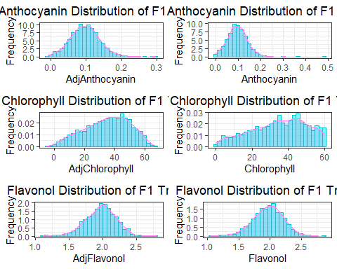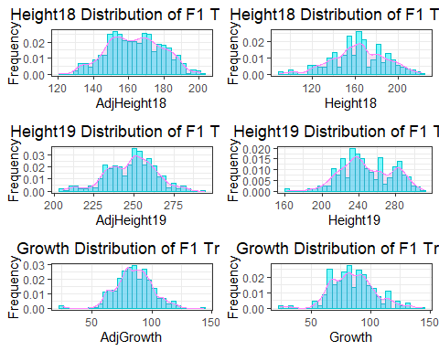

Measure comparisons for Rows before and after data adjustment

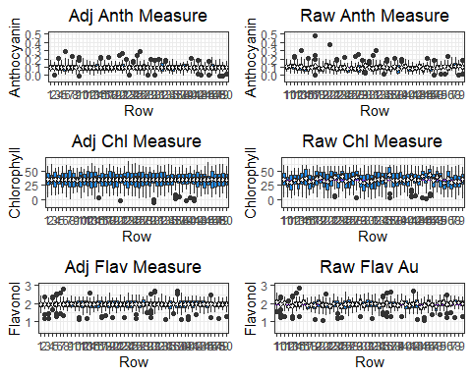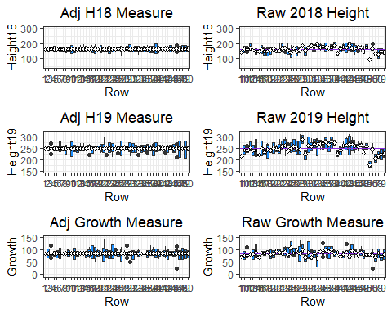

Measure comparisons for Columns before and after adjustment

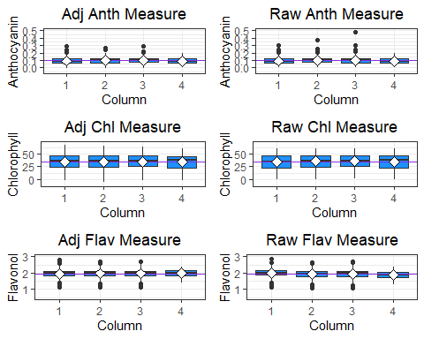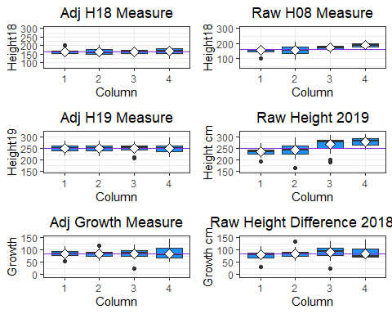 Comparison of measurement heatmaps before and after adjustment

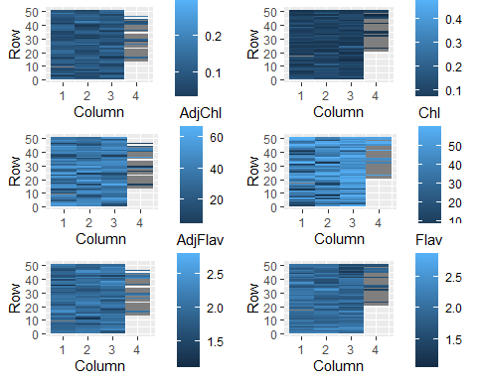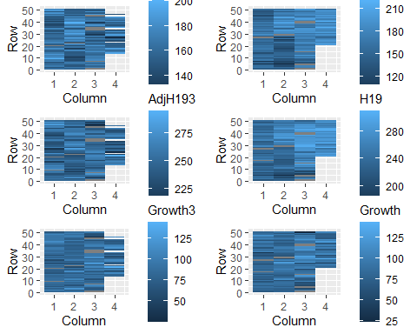

Comparisons for height differences before and after data adjustment

