Task: Wireshark HTTP Tracing

Network Requests & Responses: (http://www.httpforever.com)
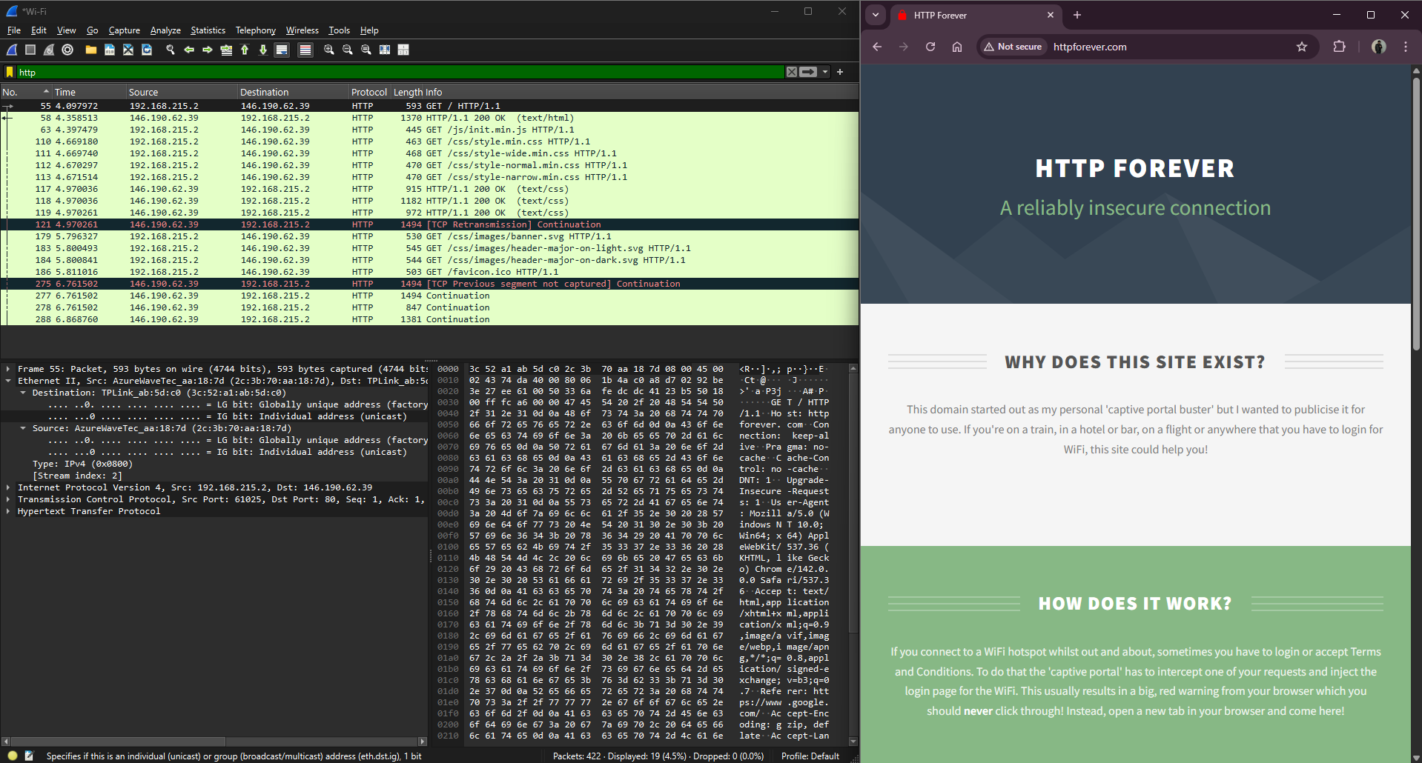
A HTTP-only protocol supported website was accessed in browser and the network packets were captured using WIFI interface in Wireshark by applying ‘http’ filter. A pair of Request & Response packets were then analyzed.

All Request Headers:
- HTTP Request Header (Application Layer):
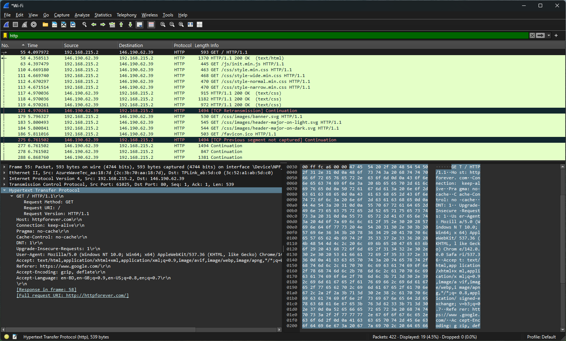
Here, we see a Request Type HTTP packet with GET method call for host: httpforever.com was sent.
- TCP Request Header (Transport Layer):
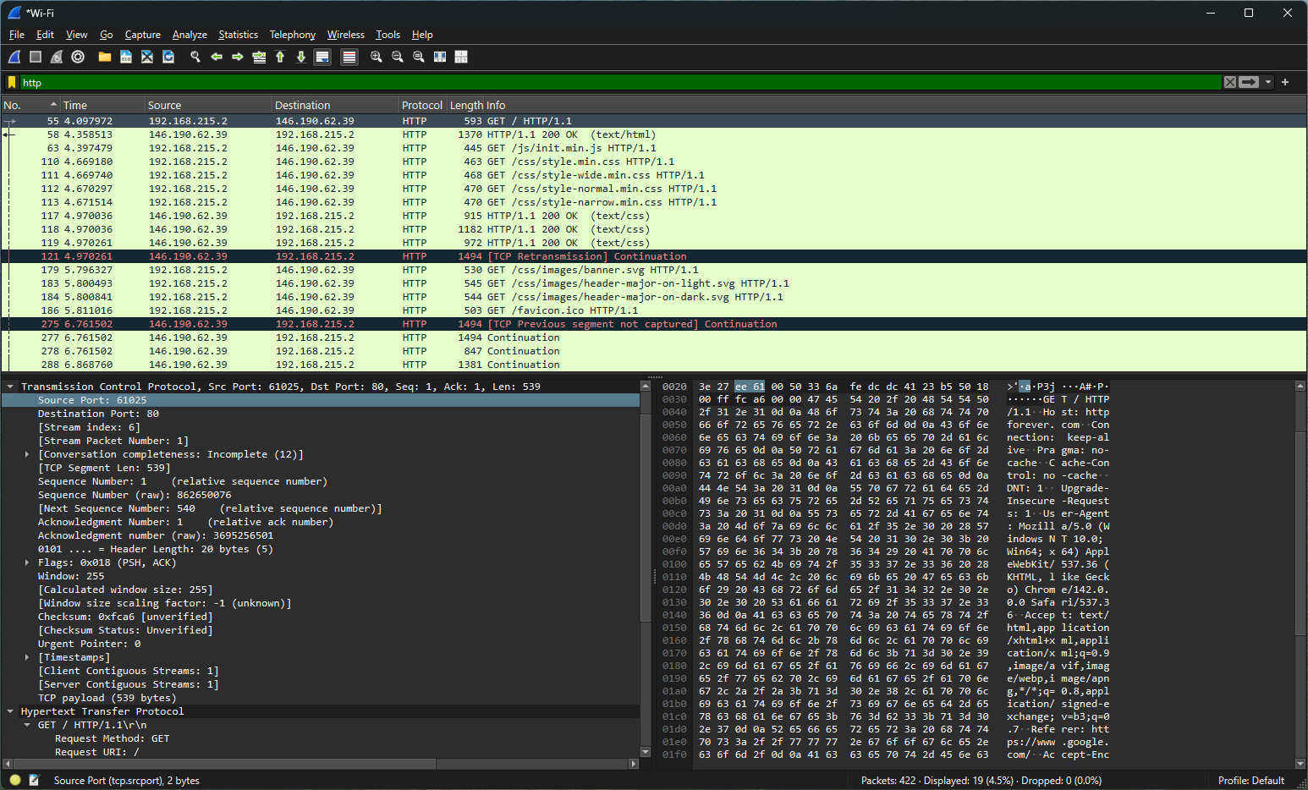
In this header, we see port addressing being done. Source Port: 61025, Destination Port: 80 (HTTP). There is also segment sequence & acknowledgment number, Segment length etc.
- IPv4 Header (Network Layer):
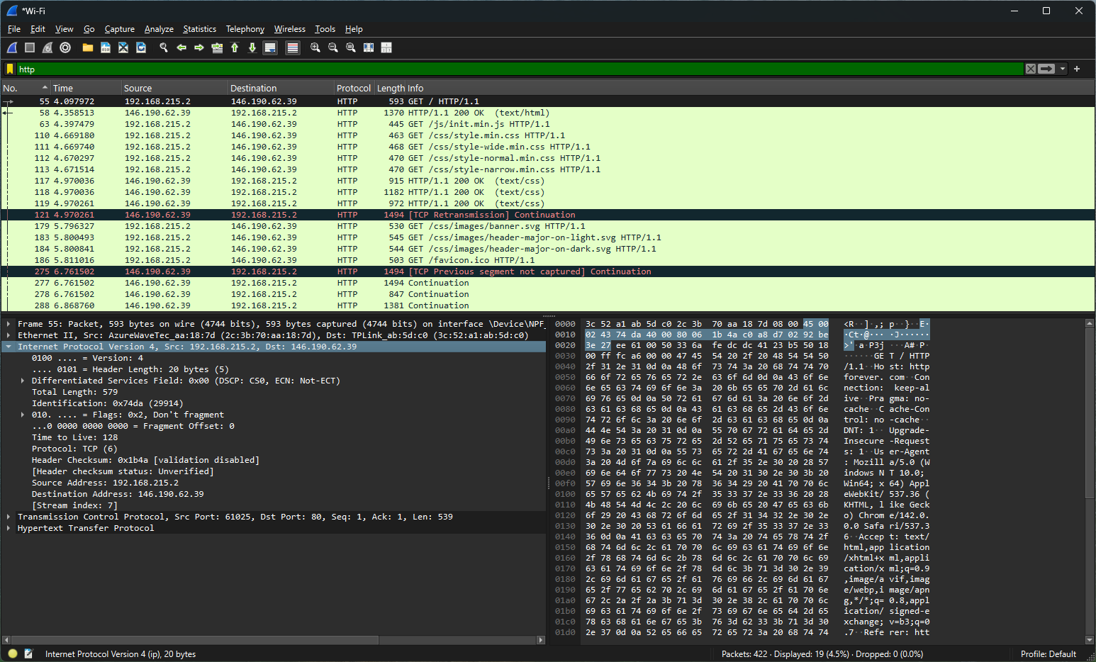
This layer handles the network IP addressing. We see the destination IP is (146.190.62.39).
- Ethernet II (Data Link Layer):
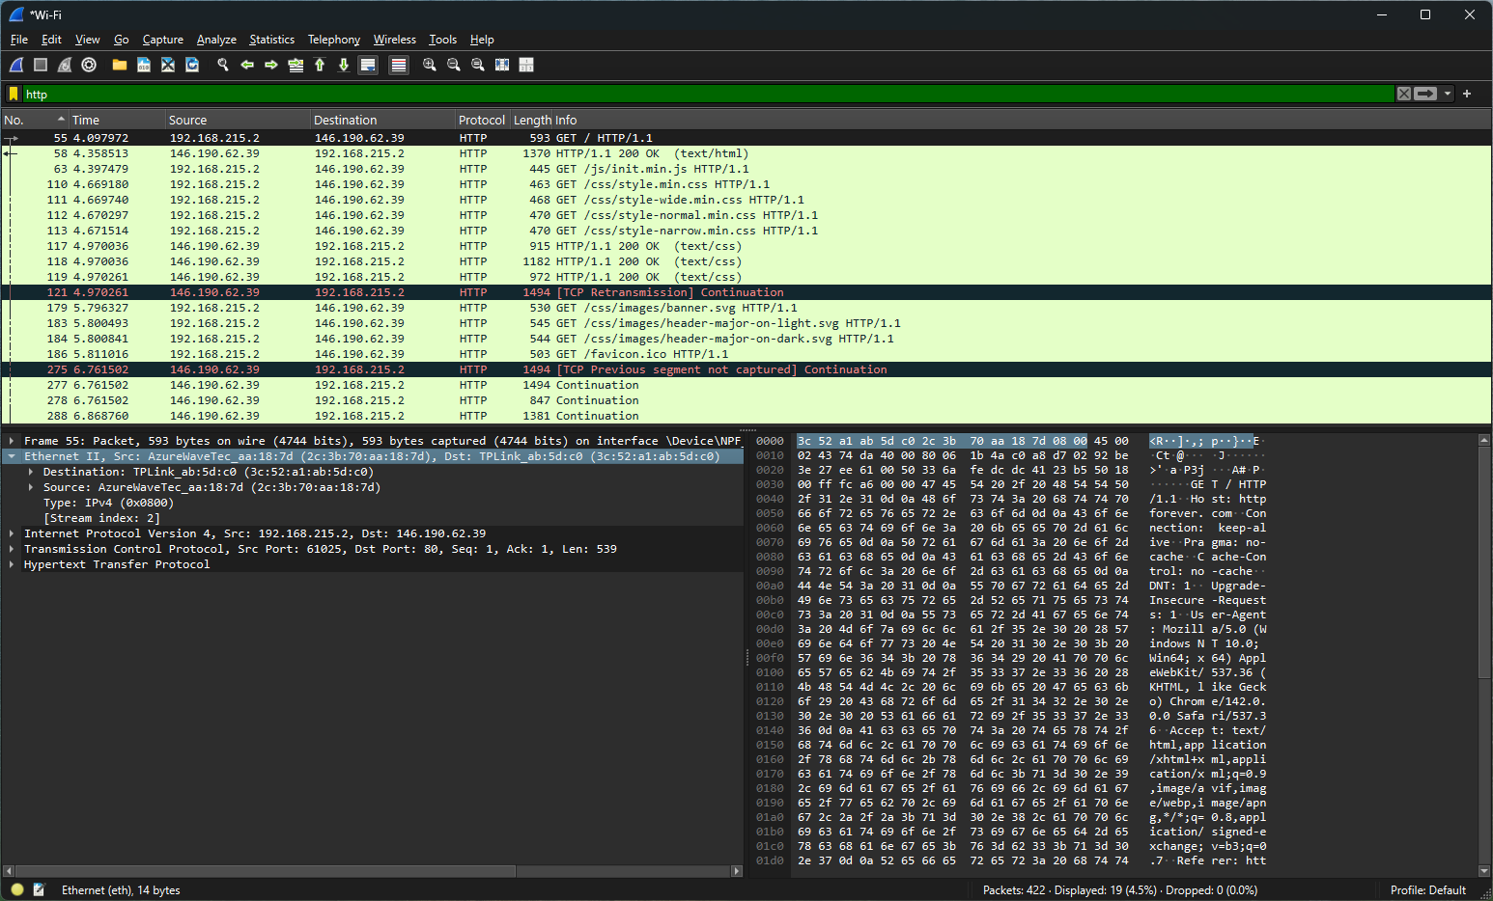
The header shows source & destination MAC and the destination being the Next-Hop MAC address for the packet.

- Frame Header (Pseudo protocol - Wireshark):
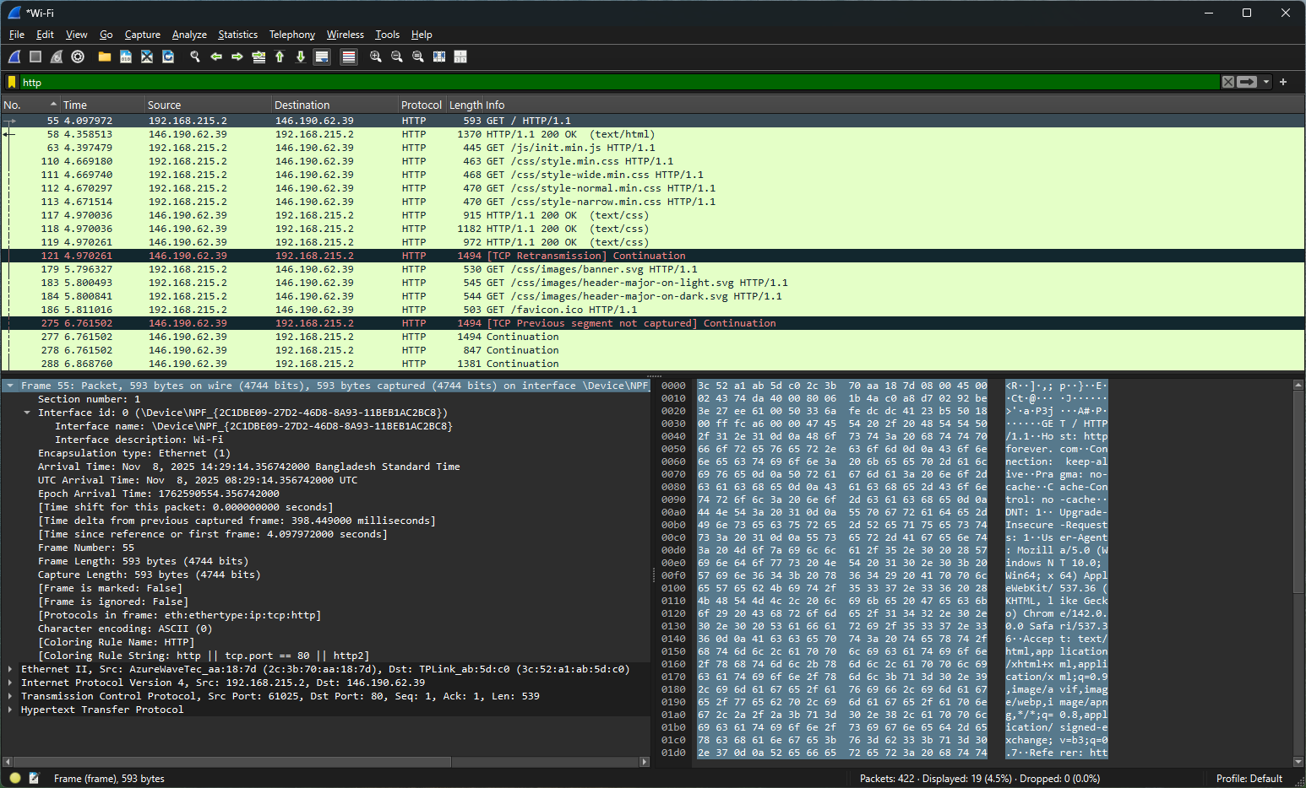
Shows metadata information of data packet captured by Wireshark itself. Not necessarily related to default network layers.

All Response Headers:
- HTTP Response Header (Application Layer):
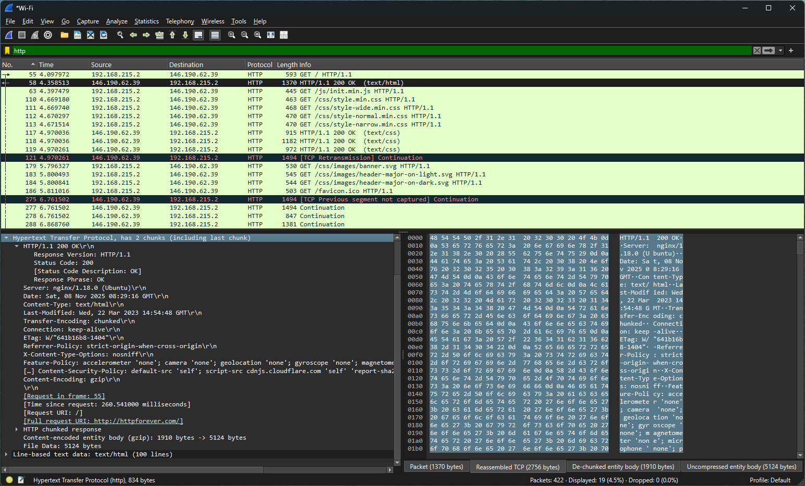
We see that a Response Type HTTP packet was received from the host containing almost 5000 bytes of text/HTML data in chunk.
- TCP Response Header (Transport Layer):
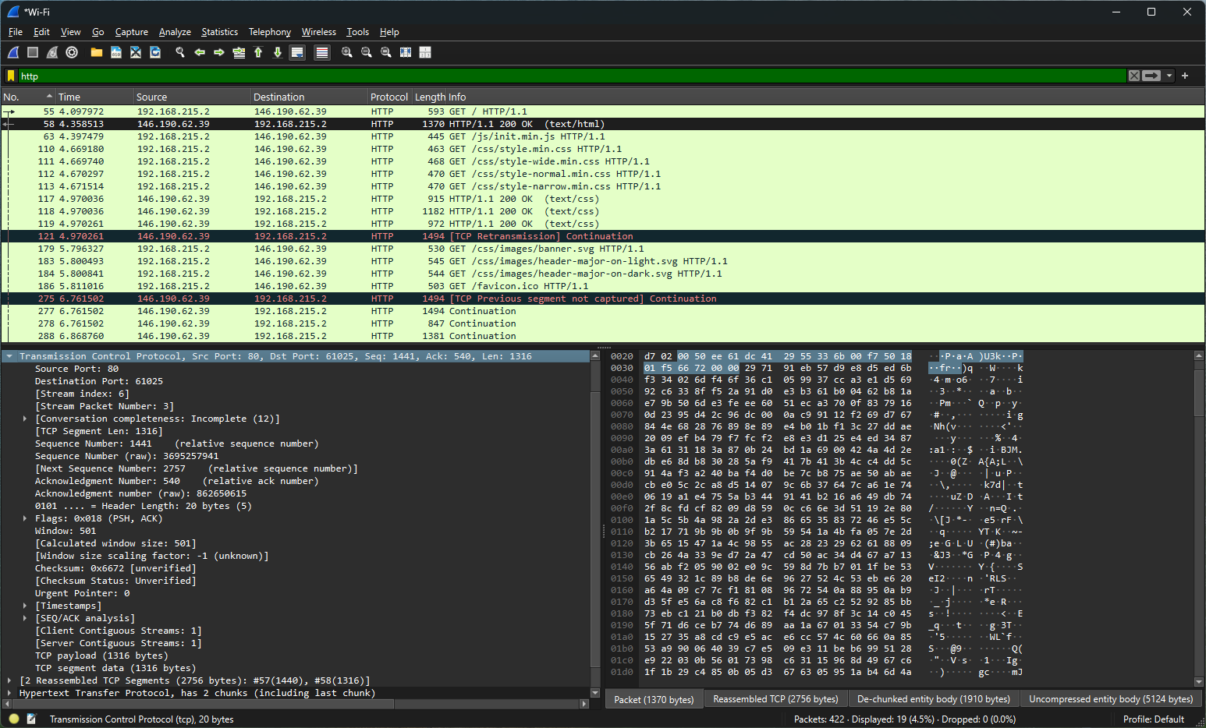
In this header, we see port addresses now reversed. Source Port: 80, Destination Port: 61025. There are segment sequence & acknowledgment number, Segment length etc. here as well, related to TCP.
- IPv4 Header (Network Layer):
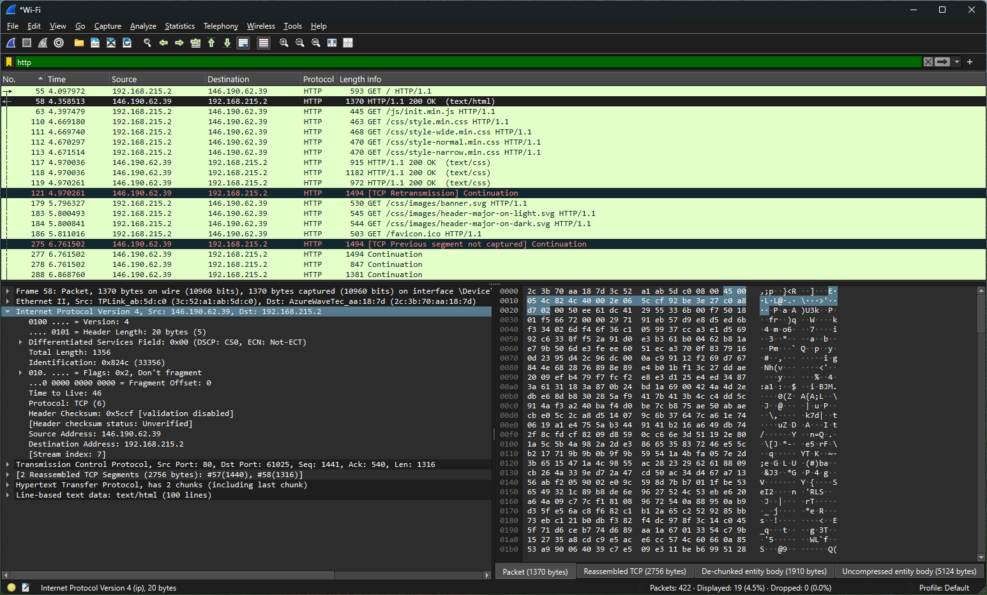
In this layer, we now see the source IP is (146.190.62.39). The destination being our PC address.
- Ethernet II (Data Link Layer):
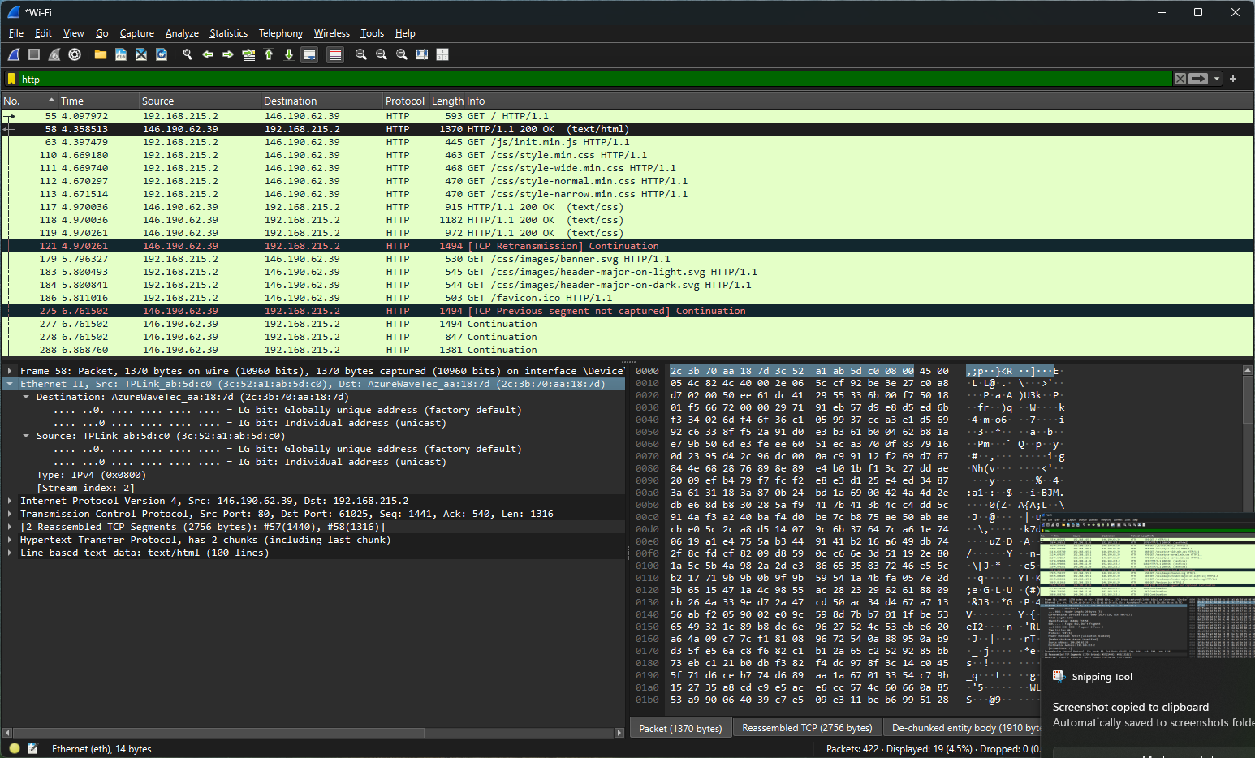
Here, we again see the destination and source MAC addresses being flipped.

- Frame Header (Pseudo protocol - Wireshark):
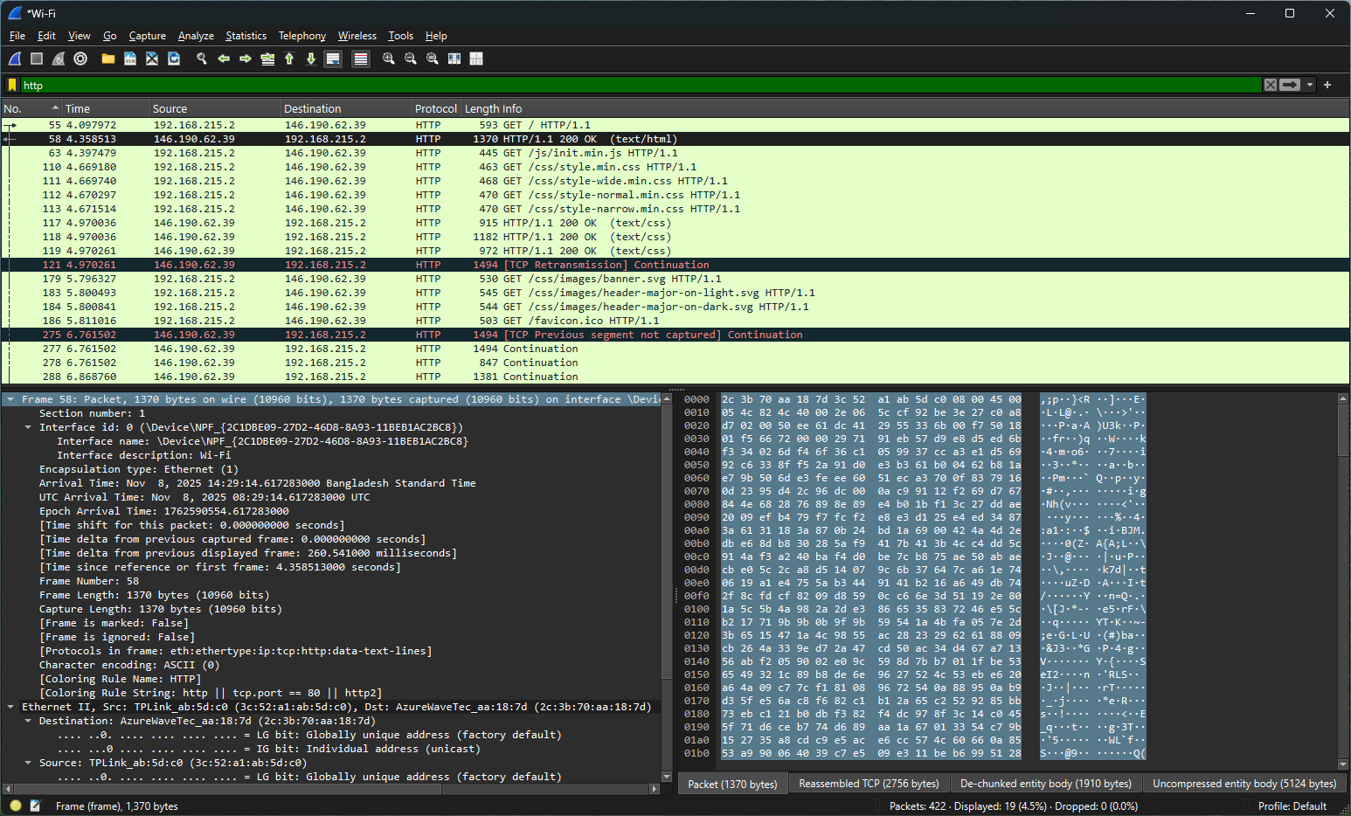
Again, shows metadata information of received data packet captured by Wireshark itself. Not necessarily related to default network layers.

