NS3 Simulator Outputs:
Packet Size: 128
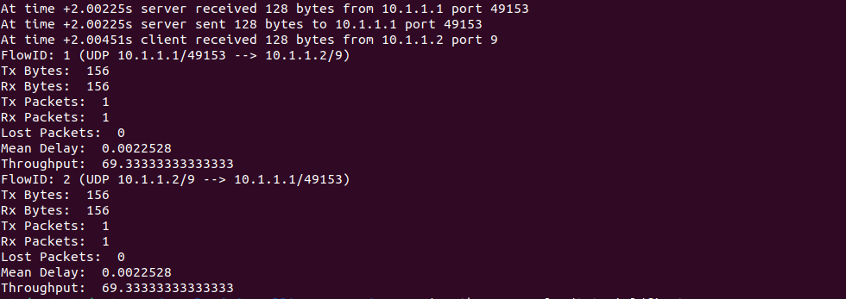
Packet Size: 256
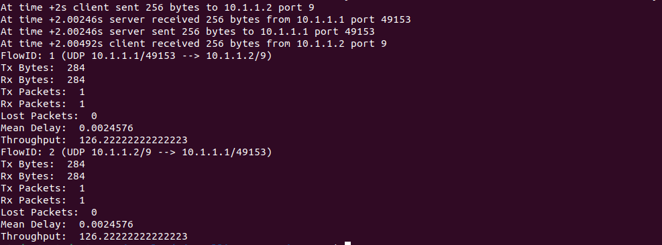
Packet Size: 512
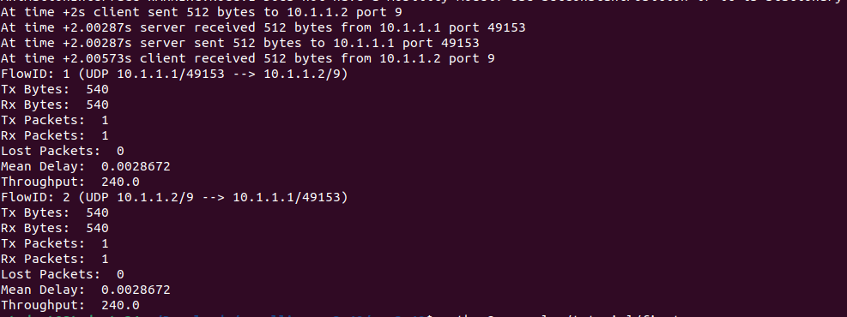

Packet Size: 1024
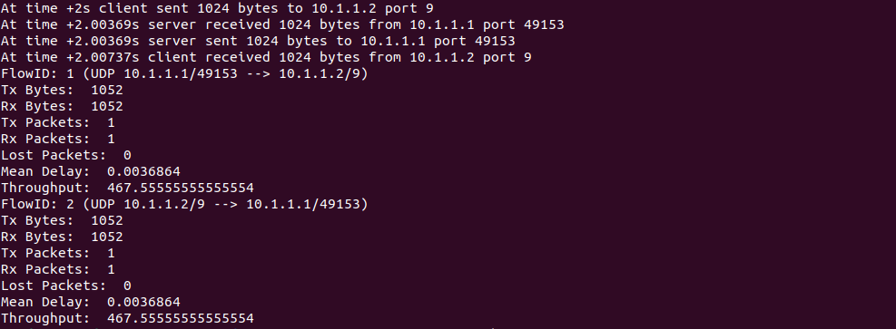
Packet Size: 2048
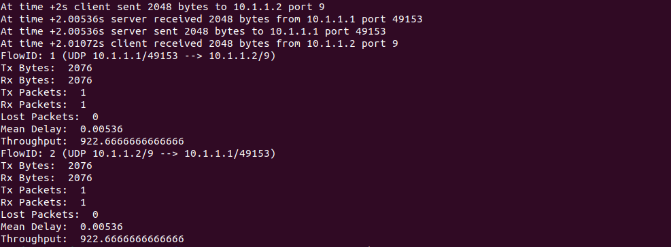

Graph Plot (Packet Size Vs Throughput):
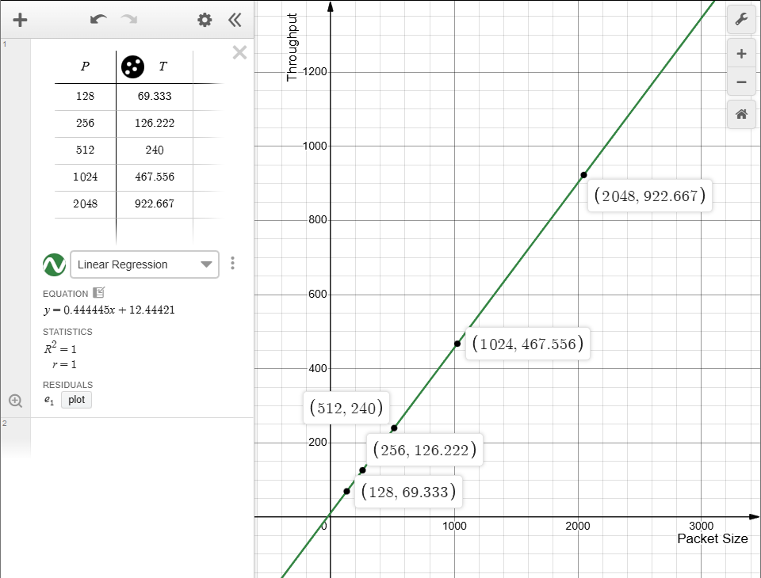
Description:
- Positive linear relationship between packet size and throughput.
- From 128 to 2048 bytes, throughput increases from approximately 69.333 to 922.666.
- Suggested pattern: Larger packet sizes result in higher throughput, likely due to more efficient data transmission with less overhead per byte.

