TOGAF-9 Notes

Architectural Framework
A common vocabulary
A set of tools / building blocks.
Method for designing the target state of the enterprise.
Set of recommended standards.
An enterprise is a company, or department or departments in a company, or company and its partners, or multiple tightly-knit companies.
Document - https://pubs.opengroup.org/architecture/togaf9-doc/arch/

Architectural domains(4 of them- BDAT)
An architectural domain is the architectural area that is under consideration.

Business Architecture
Business strategy, governance, organization, Key processes etc.
A view only from the Business point.

Data Architecture
It is about the records that you are keeping.
Structure of logical and physical data assets, data management.
How data is passed between applications.

Application Architecture
This is where the users and customers interface with technology.
Application blueprints, the way of iteration between them, relationship of applications to the business processes.

Technology(IT) Architecture
This includes hardware, software, networks, operating systems.

ADM – Architectural Development Method
This is heart of TOGAF.
Method by which an arch is designed, this is very generic, but can be extended/trimmed.
Step by step, phase by phase process.
It has 9 phases + Requirement management as in image below.
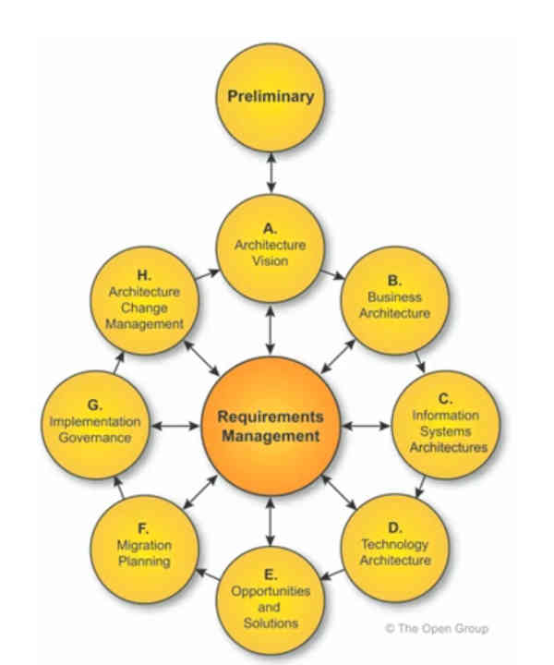

Baseline and target architecture

Baseline architecture
Architecture as of today. Current state of system.

Target architecture
Desired architecture.

Transitional architecture
When the goals are too far, we define intermediate arch state. This is not a target, but a midway state.

ADM Phases

Deliverable , building blocks and artifacts

Deliverable
These are contractually specified, reviewed, agreed and signed off by stakeholders.
Basically output of projects.

Artifacts
These are the items which are generated during the architectural process, which may not be part of the deliverable by itself but need to go into a deliverable.
Diagrams, matrices, lists etc.

Building block
This represent a unit in the architecture.

Architectural building block
this is a requirement we have. This will be put as a high level block.

Solution building block
This is the solution of an arch building block.

Enterprise Continuum
These are the lines in the enterprise architecture.
Says how the generic solutions can be used for your organization. There are 4 main classes of architecture that can be allied to an organization as given below. Listed from left to right of the continuum.

Foundation architecture(left most in continuum)
Very basic arch that can be applied to any company. May not be very useful.

Common systems architecture
Slightly more specific.

Industry architecture
Specific to an industry , eg – banking

Organization- specific architecture(right most in continuum)
Specific to the organization

Architectural repository
This is the repository where the deliverable and artifacts go.
Contains architectural outputs at various levels of abstraction. There will be separate drawer for each set of docs.
Some of them are
1. architecture meta model- templates using which you do architecture.
2. architecture capability – result of the assessment of your architectural group.
3. Architectural landscape – Details on baseline and target architecture.
4. Standards information base – External standards your are complying with. TOGAF, SAFE agile.
5. reference library – External reference models (of a specific industry etc)
6. Governance logs – Decisions made on architecture goes here.

Architectural Capability
This is about the bandwidth of the architectural group.
Is it one person, you have a group ? Is there a arch governance board?
How to ensure everyone follow the rules.
Roles and responsibilities.
Skills of the people in arch group and resources available.

