# Business Development Integrations Engineer – Pre-interview task

Please answer the following questions and send back prior to the interview so that we review during the meeting.

## Question 1

TeamViewer is working on an integration with a Tier1 EMM platform to implement attended and unattended access for all major platforms (OSX, Win, iOS, Android). This is a BYOL deal and TeamViewer will be working with the partner to execute the integration, although all development work will be carried out by the partner.

1. What are the steps and milestones you believe are important to guide the execution of the project from product/engineering perspective?

**1. As a first step, we have to define the scope and finalize the core requirements.**

**2. I would always look for a previous implementation (similar or nearly similar as available) as it can help us baseline the entire program/rollout.**

**3. The partner will be using the TV APIs. It would be a good idea to explain the core APIs and its usage briefly, at least the most commonly needed as per the current integration requirement.**

**We may even bring a blueprint from the past experience.**

**4. We can even collate a sequence of API invocations for the required/specific use cases. This can optimize the integration and avoid redundant API calls.**

**5. Knowing the region of usage and making sure the TV APIs are available in the region with acceptable latency.**

**6. Knowing the usage volume and make sure that the TV APIs can be scaled up as needed, with a buffer.**

**7. Review the solution from the security standpoint. Make sure all the tokens are revoked when no longer needed.**

**7. Breaking down the whole implementation into use cases / scenarios and track them separately.**

**8. Plan and support the testing of the implementation.**

**9. Prepare a timeline for the implementation and review the progress regularly.**

**Solution Finalization- Infra level decisions – Design finalization - test plan creation – Development and testing – End to End testing – CUT over and Production movement plan - Dry run in Production – Intesnive aftercare – Regular aftercare.**

1. What internal TeamViewer teams would you involve during the development and Go-To-Market process and in what way? Can you put together a Launch Readiness Checklist with all the tasks you believe should be performed pre- and post-launch?

**1. API development/maintenance team - For any assistance with the additional requirements, bug fixes.**

**2. Test team- To test the Functionality, including a load/perfornamce test of the integration.**

**3. Any data management team - To take care of any initial load of any data.**

**4. Architecture group – Whenever there is a substantial change/improvement required for any APIs.**

**4. Project management/ agile masters - For any support with the project management.**

1. What KPIs and other indicators would you consider for assessing the performance of the partnership e.g. 6 or 12 months after launch?

**1. Number of Devices added during launch and after 6 months.**

**2. Number of active devices per month.**

**3. Percentage addition of the devices after 6 months.**

**4. Review any feedback mechanism TeamViewer has, when working with a partner.**

**5. Look at the category of the devices which are most used(OSX, Win, Android, IOS).**

## Question 2

Can you create a Message Sequence Diagram showing the detailed message exchange to implement OAuth2 on a Cloud platform through the TeamViewer API on a SaaS platform e.g. an ITSM Helpdesk case (<https://integrate.teamviewer.com/en/develop/api/documentation/>) ? Please include detailed messages include HTTP headers and bodies of the requests/responses. See below as an example:

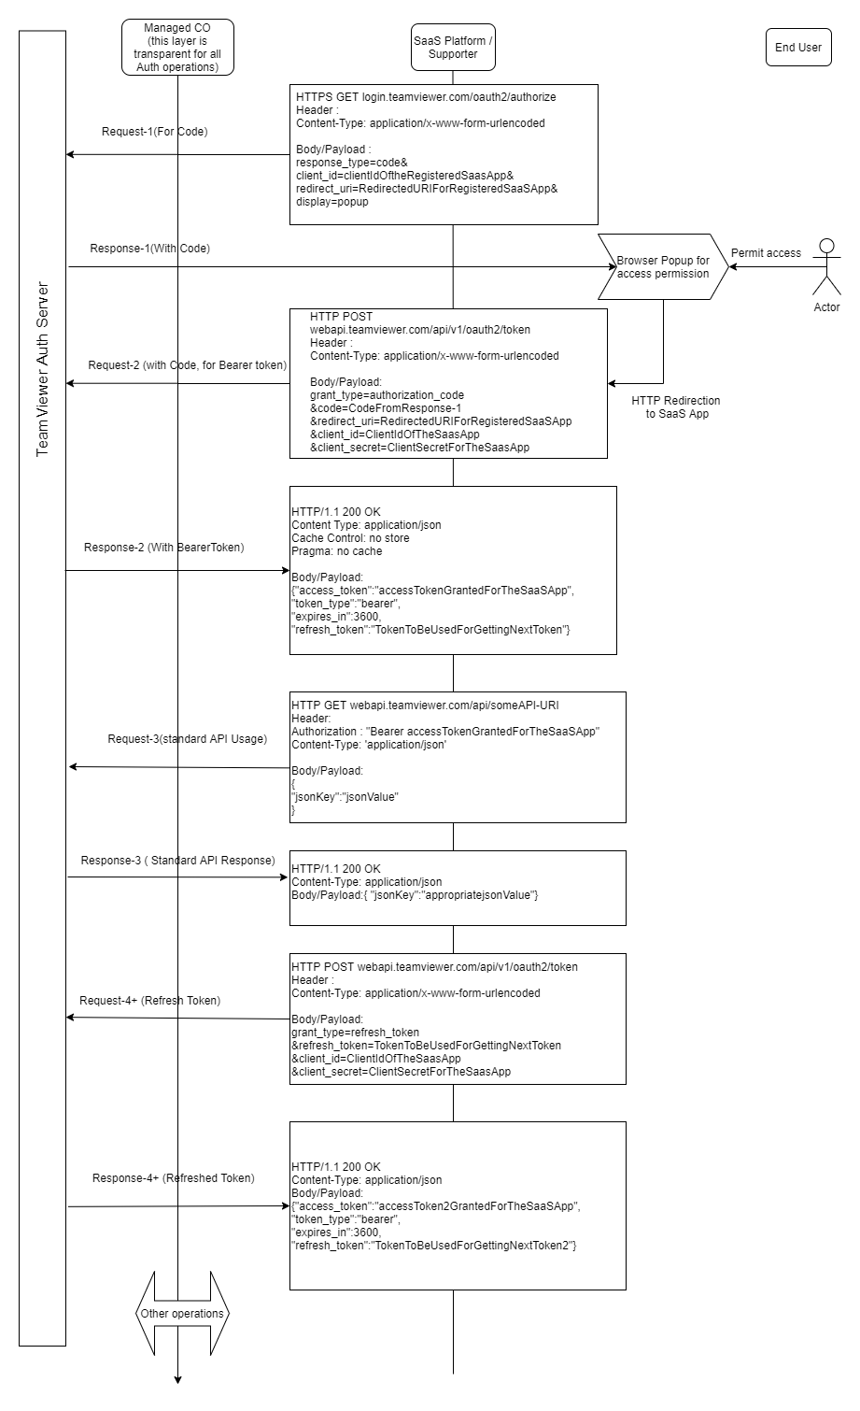

## Question 3

TeamViewer is planning to do an integration of Attended access with an ITSM platform for Attended Access using the TeamViewer API. The ITSM partner has a public SDK that allows ISVs to integrate to their platform autonomously.

The integration will be done through an external development company selected and paid by TeamViewer.

Please provide your comments on the following points:

1. What are the most important criteria for selecting a vendor? What do you suggest as must-have terms in the agreement with them?

**a. The partners with a history of such implementations. If there is a partner who has already worked with TeamViewer for similar implementation (successfully, that we have confidence in them), I would be more comfortable with them.**

**b. The cost of implementation - Of course this is a deciding factor and this may not be something TeamViewer also will be looking at.**

**c. A partner organization that is fairly big enough and capable of supporting in different situatons if needed (Like Operating from multiple locations/ time zones).**

**d. An Organization that will be able to arrange additinal developers in case there is some urgency creeping in for some reason.(Sort of Plan- B approach).**

**Must have agreement :**

**a. Commitment to implement within the schedule. Answer to “What if not able to complete” question.**

**b. Agreement on the comprehensive testing (In line with how TeamViewer normally handle such developments).**

**c. An Organization that work on several similar assignments , who can bring experience and expertise from other engineering aspects as well.**

1. Please describe how you believe you could best manage the partner. What practices would you use?

**a. Communicate efficiently and clearly stating the requirements, expectations and the timelines at every stage.**

**b. Capture the details of the Project in some locations accessible by TeamViewer and the partner organization. Keep everything well documented.**

**c. Review the progress regularly in short intervals and provide feedback to the partner organization and internal management as needed.**

**d. Possibly run in some agile mode (I am personally comfortable with Scrum and Kanban).**

**e. Use the internal tools as much as possible for tracking of development & defects and documentation.**

**f. if there is any delay or there is deterioration in pace or quality, get the attention by escalating to the matrix as agreed.**

1. What steps can you take in advance to ensure that the final delivery of the partner is of high quality and according to our specs?

**a. Document the requirements, design (HLD and LLD ) clearly.**

**b. Review the design internally& with the partner organization for any possible leakages.**

**c. Break down the whole solution into multiple functional chunks so that we can complete part by part.**

**d. Classify the requirement based on the priority and criticality. Give attention to most critical and high priority functionalities.**

**e. Test the solution properly making sure the test cases are written as per the requirements.**

**f. Review the progress in short intervals, provide feedback.**

**g. Raise flag when there is something out of the plan.**

**h. Have any alternate plans if there is any issue foreseen.**

**i. Always keep the spirit and hopes high.**