Jenkins Notes
Running Jenkins on K8s
https://www.jenkins.io/doc/book/installing/kubernetes/

Looking for a helm jenkins image

Helm lookup/ search
helm search repo jenkins
Above command is not returning anything.
Add the jenkins helm repo using below commands.
helm repo add jenkinsci https://charts.jenkins.io
helm repo update
Now the helm repo search will give the results when searched with jenkinsci (current official helm image).

Install and run jenkins in default k8s namespace
helm install jenkins jenkinsci/jenkins
It takes a while to get the jenkins running in the container=3-5 minutes. Run kubectl get pod and verify the READY status of the jenkins pods.
Get the jenkins admin password.
kubectl exec --namespace default -it svc/jenkins -c jenkins -- /bin/cat /run/secrets/chart-admin-password && echo
Read the jenkins container logs (jenkins-0 is the pod name)
kubectl logs jenkins-0 -c jenkins

port forward for external access.
kubectl --namespace default port-forward svc/jenkins 8080:8080
username will be admin, password as found in previous step.
Head to jenkins admin UI at - http://localhost:8080

Jenkins Project types
Freestyle- Basic proj
Pipeine -multiple steps like test,build , deploy
Multibranch Pipeline-
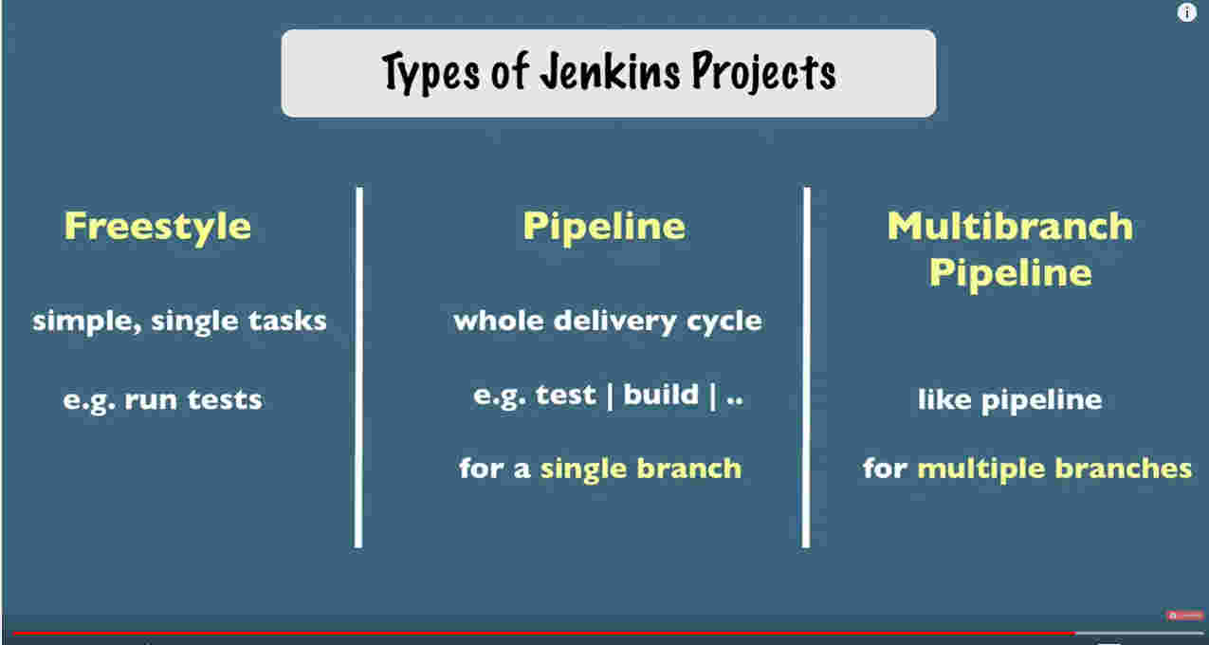

Create Multi branch pipeline
New item - > create new Jobs - > [name it] → choose type of item.
Add the credentials in the Folder under credentials in the job configuration.

Jenkinsfile
Can be written as scripted or declarative file.
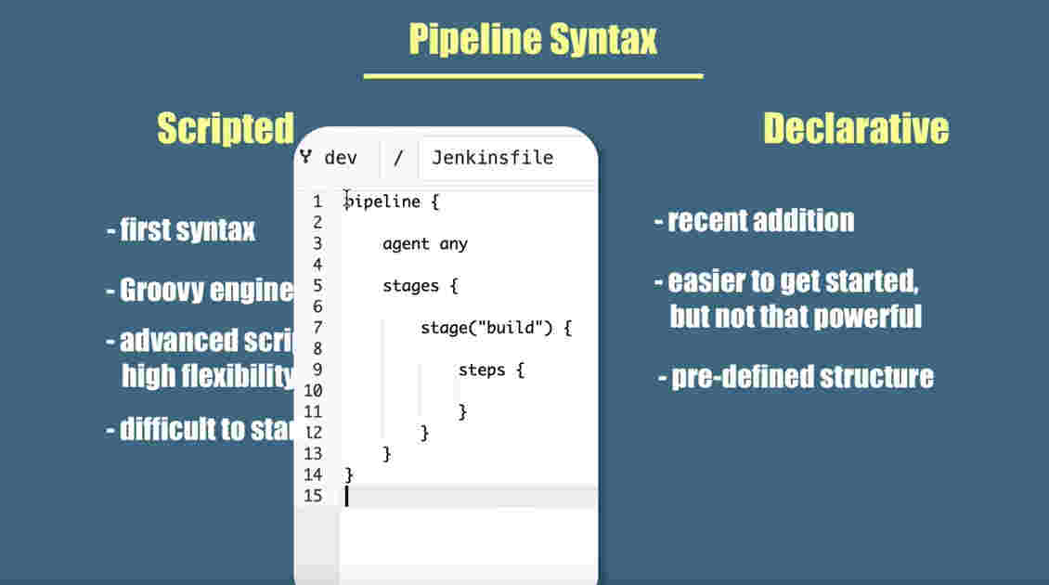
The build steps are usually the shell scrips for any required activities like copy code , build, move archives to any location etc.
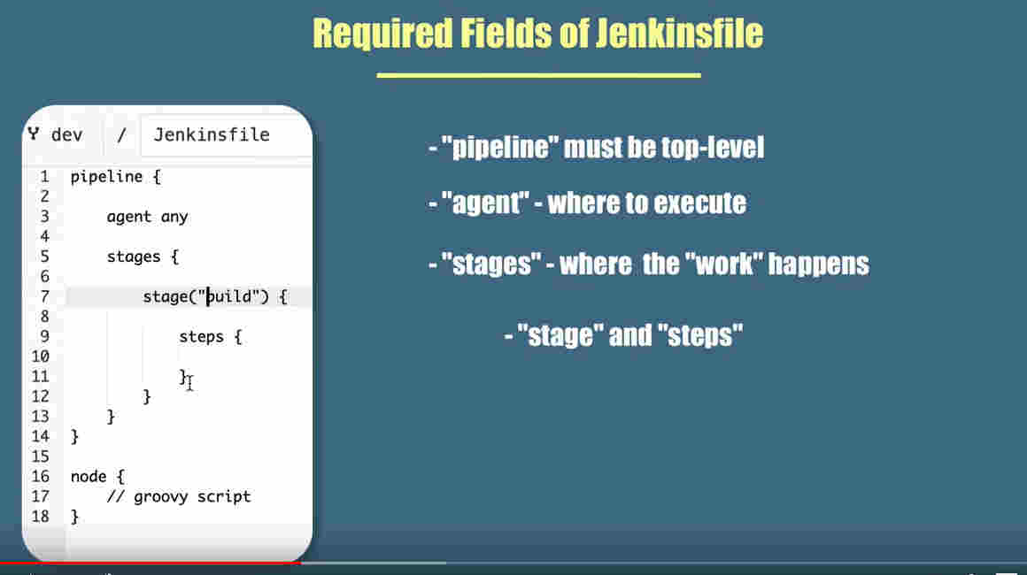
Agent is the jenkins agent server (the worker/slave) on which the job to be run. If we do not have any custom build tools available on all the servers (for instance tibco is on only one machine), the job has to be run on some specific servers.

Triggering the jenkins jobs
1. Push message from the repo. The Jenkins details to be configured in the repo.
2. Poll by jenkins. - will poll the repo for any changes periodically.

Jenkins Buildtools
For building the code, the jenkins server should have the necessary build tools corresponding to the tech stack used in the code.
For the backen Java apps, Maven and Gradle are used. For Javascript, npm and yarn used commonlly.
For apps like TIBCO, the tra should be installed so that the jenkins can cd to the tra folder for building ears.
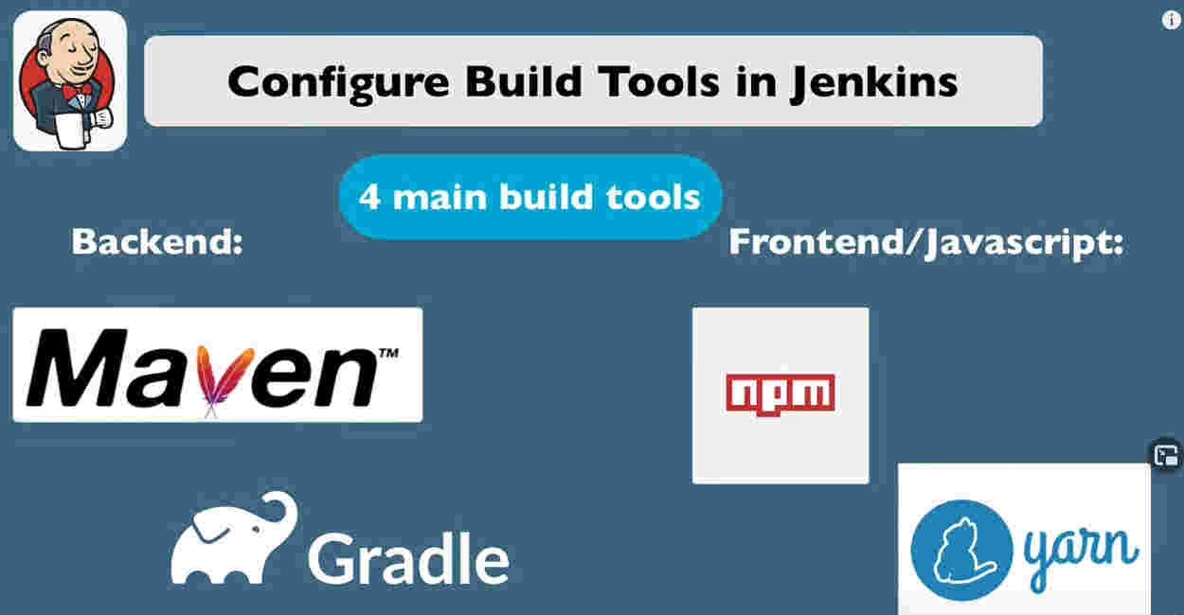
Build tools can be either specified in the stages/stage/steps as
steps{
nodejs(‘Node-10.17’)
echo ‘building nodejs code’
sh ‘yarn install’}
or build tools can be defined in the tools section just below agent any tag.
agent any
tools {gradle ‘Gradle-6.2’}
. . .
steps{
echo ‘building using gradle code’
sh ‘./gradlew -v’
}

Note – Build command will differ based on build tools

Groovy Scripts
Jenkinsfile depend on groovy scripts if we follow scrited mode of jenkinsfile.
Best approach is to write all the functions in an external groovt scrit file and us it in the jenkinsfile as needed.

