Kafka notes

Basics
Created a shift from data centric to event centric approach.
Distributes streaming platform.
Publish and subscribe to stream of events.
Process the stream of events as they occur.
Topics – store the stream of data sequentially marked with an offset.
Multiple brkers form the cluster.
Leader and follower mode to form the reliable Cluster.
Three main use cases -
- To publish (write) and subscribe to (read) streams of events, including continuous import/export of your data from other systems.
- To store streams of events durably and reliably for as long as you want.
- To process streams of events as they occur or retrospectively.

Topic
Basic storage mechanism for event streaming.
It has partitions and replicas for making it reliable.

Partitions
Single topic is split into partitions to speed up writing to the topics.
When a new event is published to a topic, it is actually appended to one of the topic's partitions. Events with the same event key (e.g., a customer or vehicle ID) are written to the same partition, and Kafka guarantees that any consumer of a given topic-partition will always read that partition's events in exactly the same order as they were written. Sequencing is guaranteed only per partition. Messages in different partitions does not guarantee sequencing. That is why we have to specify the key in case sequencing is needed(kafka will write messages with same key to the only one partition).
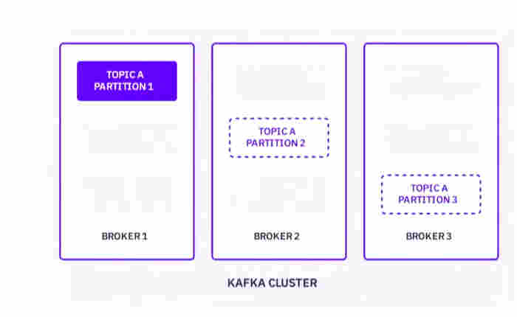

Replications
Each partition of the topic is replicated onto multiple brokers for high availability.
Each partition will have a replica leader and the followers. If leader fails, one of the followers is elected to be the leader.
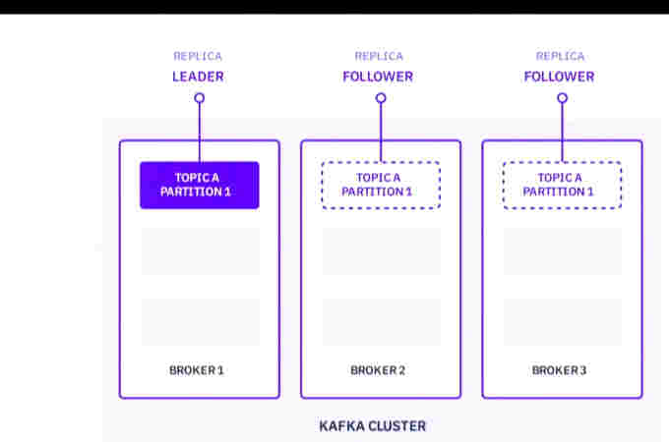

Kafka APIs
In addition to command line tooling for management and administration tasks, Kafka has five core APIs for Java and Scala:
- The Admin API to manage and inspect topics, brokers, and other Kafka objects.
- The Producer API to publish (write) a stream of events to one or more Kafka topics.
- The Consumer API to subscribe to (read) one or more topics and to process the stream of events produced to them.
- The Kafka Streams API to implement stream processing applications and microservices. It provides higher-level functions to process event streams, including transformations, stateful operations like aggregations and joins, windowing, processing based on event-time, and more. Input is read from one or more topics in order to generate output to one or more topics, effectively transforming the input streams to output streams.
- The Kafka Connect API to build and run reusable data import/export connectors that consume (read) or produce (write) streams of events from and to external systems and applications so they can integrate with Kafka. For example, a connector to a relational database like PostgreSQL might capture every change to a set of tables. However, in practice, you typically don't need to implement your own connectors because the Kafka community already provides hundreds of ready-to-use connectors.

Producers and consumers
Producers produce , consumers consume the messages.
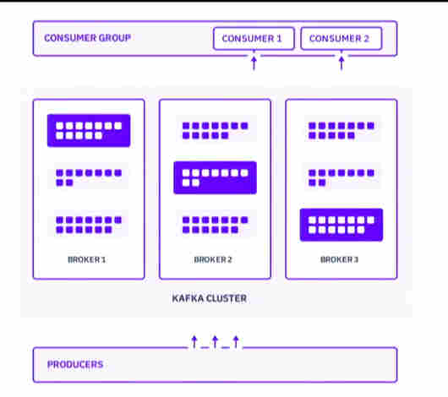

Consumer group
Consumers can be grouped and added to a consumer group so that the messages on all partitions of a topic are shared between the consumers in the group without duplicates being sent to 2 consumers. One message will goto only one consumer of the group.

Run Kafka on K8s(bitmani from helm)

Installation
Can be installed using helm charts. Bitnami chart is working.
helm repo add bitnami https://charts.bitnami.com/bitnami
helm install my-kafka bitnami/kafka

Uninstallation
For uninstalling use - helm delete my-kafka

Configuration
On installation , it will show the cluster dns name and the port on which it is accessible.
For making it accessible, do the following workaround.
Find the service for the kafka (normally will be the name of the installation, my-kafka in my case).
Find all its details - kubectl describe svc my-kafka
Edit the Service yaml to change the ClusterIP to Loadbalancer so that we can enable port-forwarding.
kubectl edit service my-kafka
[delete and backspace works only in command mode and typing works in insert mode. once changed, press esc, then :wq ]

Accessing the kafka server
Reference documentation - https://kafka.apache.org/quickstart
For a quick check, we can create a topic and send some messages from command line.
Find the details of the kafka pod.
Kubectl get pods
kubectl describe pod my-kafka-0
Look for specific containers. Normally only one container will be there for kafka.
Open the Kafka container terminal.
kubectl exec -it my-kafka-0 – bin/bash
Find the kafka installation folder /bin folder and cd to it. Bitnami gets installed in below folder.
cd /opt/bitnami/kafka/bin
Create a topic
./kafka-topics.sh --create --topic quickstart-events --bootstrap-server localhost:9092
View the topic details with describe option
./kafka-topics.sh --describe --topic quickstart-events --bootstrap-server localhost:9092
Produce some messages for the above topic
./kafka-console-producer.sh --topic quickstart-events --bootstrap-server localhost:9092

Consume the messages
./kafka-console-consumer.sh --topic quickstart-events --from-beginning --bootstrap-server localhost:9092

Run Confluent kafka platform on k8s
The platform will include multiple kafka servers, kafka API server, Schema registry, Kafka Connect componnet etc.
Documentation - https://docs.confluent.io/operator/current/co-deployment.html

Installation
Add the confluent platform repo to heml repo list
helm repo add confluentinc https://confluentinc.github.io/cp-helm-charts/
Update the helm repos
helm repo update
Install the confluent kafka (Confluent documentation for below command is not working with helm 3 and above)
helm install my-confluent-oss confluentinc/cp-helm-charts
The same above command can be extended if the Kafka Rest api, kafka connect and schema registry to be specifically disabled. All enabled in the below.
helm install --set cp-schema-registry.enabled=true,cp-kafka-rest.enabled=true,cp-kafka-connect.enabled=true confluentinc/cp-helm-charts

It takes some time 30minutes or more for creating all containers for all services and to run it. Make sure there is enough cpu cores and memory allocated to the minikube when starting it [minikube --memory 8192 --cpus 4 start]

Accessing the kafka server- produce and consume
Create a console producer for the 'test' topic.
kubectl exec -c cp-kafka-broker -it my-confluent-oss-cp-kafka-0 -- /bin/bash /usr/bin/kafka-console-producer --broker-list localhost:9092 --topic test
Read the messages from the test topic using the console consumer.
kubectl exec -c cp-kafka-broker -it my-confluent-oss-cp-kafka-0 -- /bin/bash /usr/bin/kafka-console-consumer --bootstrap-server localhost:9092 --topic test –from-beginning

Operations management of prod Kafka servers
Check the operations section for reference - https://docs.confluent.io/5.0.0/installation/installing_cp/cp-helm-charts/docs/index.html
Scaling operations to be done after disconnecting the producers and consumers.
Number of nodes should be always odd.
Any partition reassignment should be done before scaling

Scaling up
The new number of the instances to be updated in the kafka-values yaml.
This yaml file will have the general values that need to be updated. This file can be taken from confluent github [https://github.com/confluentinc/cp-helm-charts/blob/master/values.yaml].
Other chart values does not have to be touched normally.
helm upgrade –values=values.yaml <release name> cp-helm-charts

Cluster Apps and Kafka
A sample python app can connect to kafka from Cluster easily.
The connection parameters can be found by describing the kafka ClusterIP service.
Kubectl describe svc [kafka-service-name]
Look for the IP detail which will tell the Cluster IP using which the service can be consumed in the cluster(it wont be starting with the 128. . . ).

Python code snippet
from confluent_kafka import Producer
p = Producer({'bootstrap.servers': '10.106.20.185:9092'})
p.produce('test', key='hello', value='world')
p.flush(30)

