Prometheus Monitoring

What is Prometheus
Monitoring tool, primarily targeted at the container applications.
It monitors Errors, Response latency, overload, Resources, Monitor network loads.
Prometheus monitors itself by exposing its one /metrics http endpoint.

Prometheus Architecture
Main component is Prometheus server which does the actual monitoring.
Prometheus is very reliable.
Each Prometheus server is self-containng(no additional node services needed). Due to this reason its difficult to scale up prometheus.
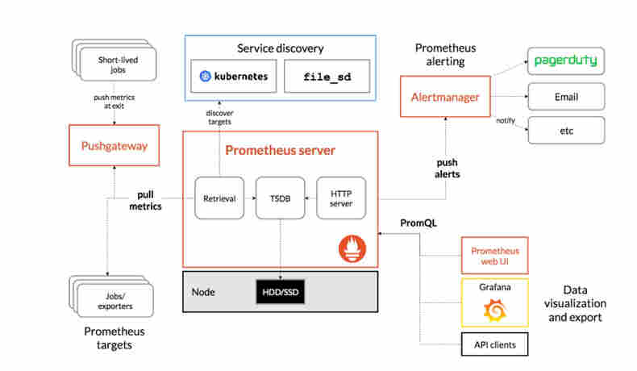

Prometheus Server
It has 3 main parts
- Time series database to store Current cpu usage, no of exceptions in an app etc
- Data Retriever Worker to – collect the metrics from the apps, services, servers and store in the database.
- HTTP server accepting queries to the stored data (PromQL queries). The output of this may be used for the visualization in Prometheus web ui or something like Grafana.
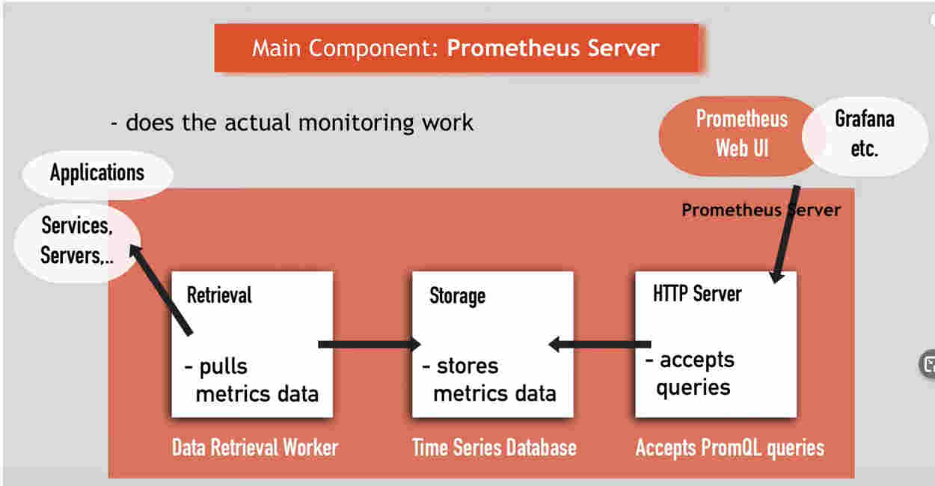

Monitoring Fundamentals
Monitors the following -

Target
What is being monitored – Server(win,unix), Apacher server, application, db services etc.

Units
Each target has units that can be monitored in them.
Eg: cup usage, disk usage, RAM usage etc for servers. Exception count, request count , request duration etc for applications and so on.

Metric
The Value of the Units that are saved into the Prometheus db.
Prometheus gives a Human readable format for the metrics.
Metric entries has TYPE and HELP attributes for readability.


Collecting metrics
Retried from http endpoint(hostname/metric service) exposed by target in the format understood by prometheus.
Some targets are out of the box able to serve the prometheus service for its scaping.
Other targets would need component called Exporter.
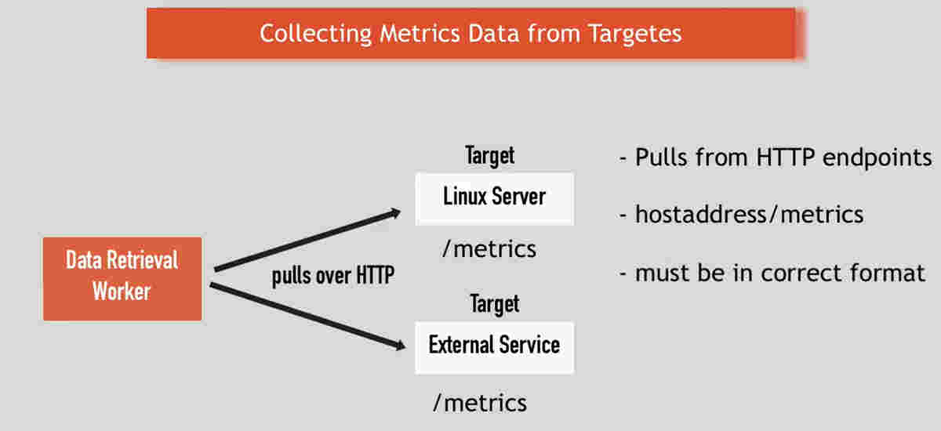

Exporter
For targets that do no have any out of the box support for Prometheus, This component is needed.
Exporter will collect the Metrics, conver to Prometheus format and expose it as an http service(/metrics).
Out of the box prometheus exporters-
https://prometheus.io/docs/instrumenting/exporters/
Client libraries for custom exporter -
https://prometheus.io/docs/instrumenting/clientlibs/
some documentation -
https://itnext.io/prometheus-for-beginners-5f20c2e89b6c

Pull based monitoring
Prometheus uses a pull based monitoring.
Applications doesnt have a trouble of pushing data.
No overloading if the monitoring system.
Multiple prometheus instance can pull data from separate targets.

Pushgateway Component
Some services which are not continuously running may not work in Pull mode. Say bacth job or jos run once in a day.
These applications can push their update the Prometheus Pushgateway, which in turn will act as an Exporter.
The prometheus Data retrieval worker will pull the data from the Pushgateway.

Alert Manager Component
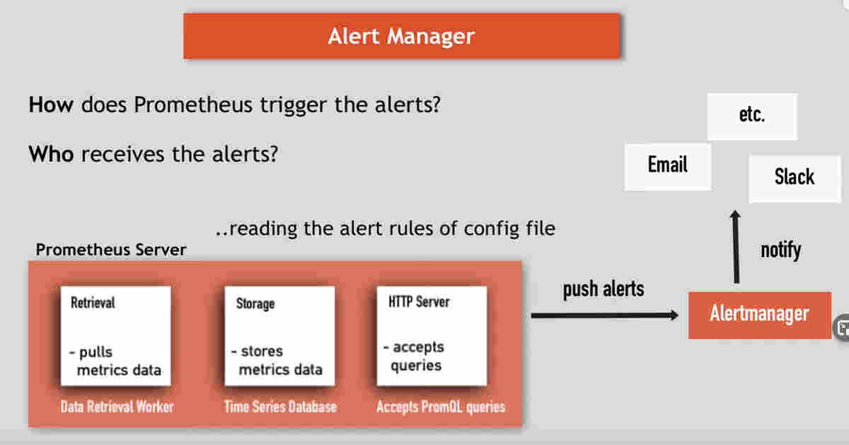

Prometheus configuration
Uses a config file which tell what target to be monitored in what intervals.

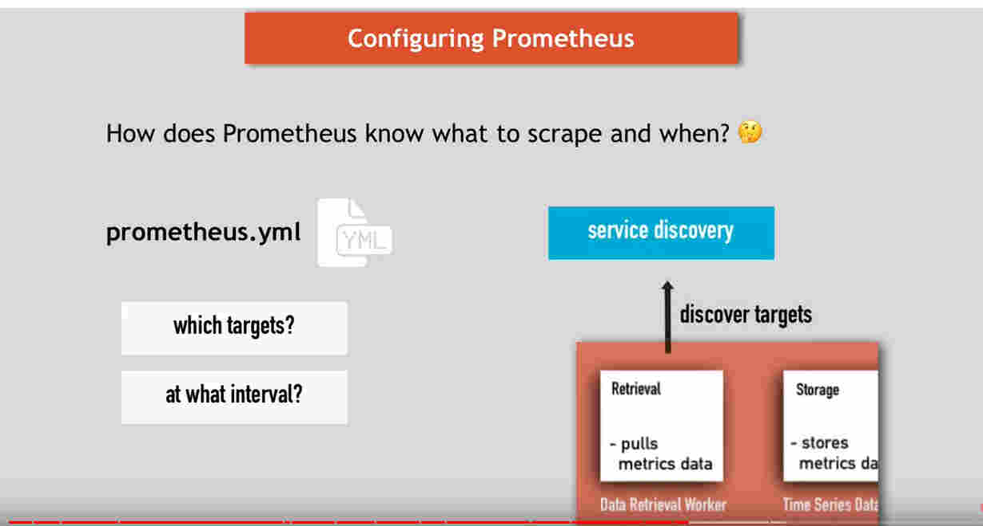
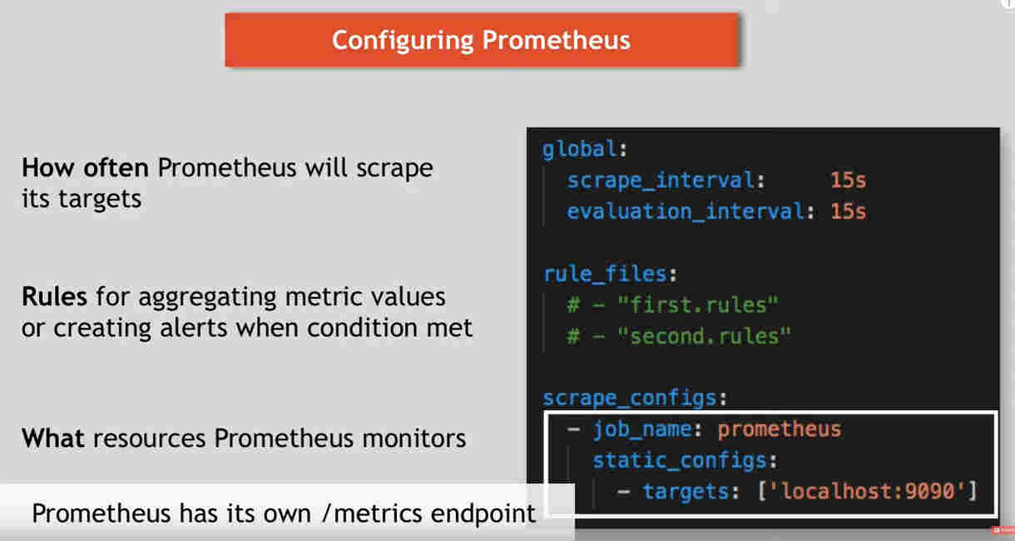
We can override the global configurations in individual target config.
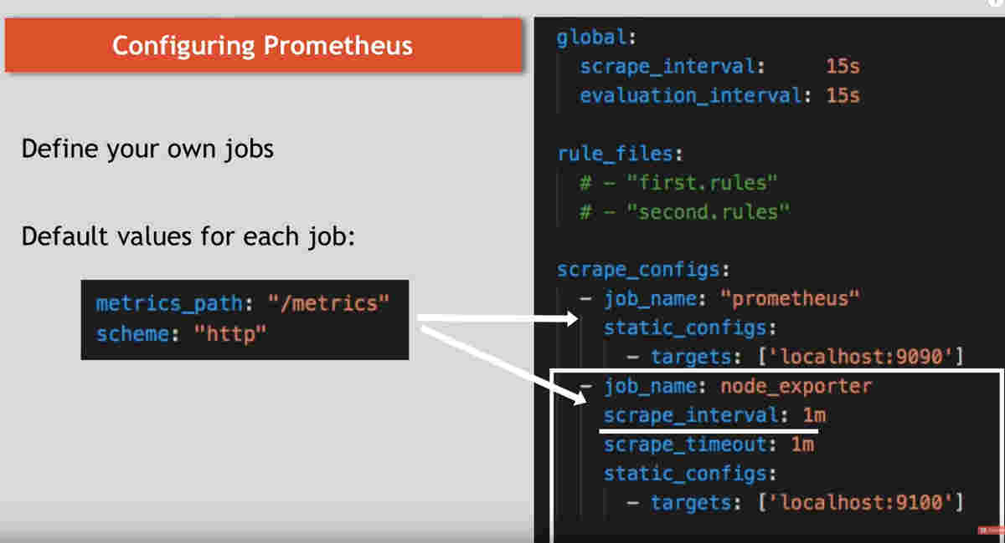

Setting up Prometheus
3 ways of doing it .
- configure using yamls – TOO difficult
- using operator
- using Helm.

Installing helm
Helm has to be downloaded and installed on Ubuntu.
Complete documentation below.
https://helm.sh/docs/intro/install/
curl -fsSL -o get_helm.sh https://raw.githubusercontent.com/helm/helm/master/scripts/get-helm-3
chmod 700 get_helm.sh
./get_helm.sh

Installing Prometheus
Add the prometheus repos to linux
helm repo add prometheus-community https://prometheus-community.github.io/helm-charts
helm repo add stable https://kubernetes-charts.storage.googleapis.com/
helm repo update
Install helm chart
helm install prometheus prometheus-community/kube-prometheus-stack
Install the updated helm chart
helm install prometheus prometheus-community/kube-prometheus-stack --version "9.4.1"
Official Helm Chart Documentation below-
[https://github.com/prometheus-community/helm-charts/tree/main/charts/kube-prometheus-stack]

Viewing Grafana
Find the port details on which grafana is running.
- Find the actual grafana pod name
kubectl get pod
- Now we know the pod name. This Grafana pod will have multiple containers inside. To view the logs of one specific container, we need to specify it like below.
kubectl logs prometheus-grafana-8db9dd95-xc7bq -c grafana
- the logs has following content
lvl=info msg="Created default admin" logger=sqlstore user=admin
lvl=info msg="HTTP Server Listen" logger=http.server address=[::]:3000 protocol=http subUrl= socket=
This says default admin user is admin and is using container port 3000.

- port forwarding / opening the port 3000 outside.
Kubectl port-forward deployment/prometheus-grafana 3000
-The command will be running without terminating. Open the browser on localhost:3000.
The passwerd for admin can be found in the link below – https://github.com/helm/charts/tree/master/stable/prometheus-operator.
On checking the pods, you can see the Exporter pod for the node.

Accessing Prometheus UI.
Prometheus web UI is run by a pod. Run kubectl get pod
- prometheus-prometheus-kube-prometheus-prometheus-0
Find the port on which this container is running and do the port forwarding to access it similar to how it was done for Grafana.

Configuring Prometheus Monitoring for Custom Apps
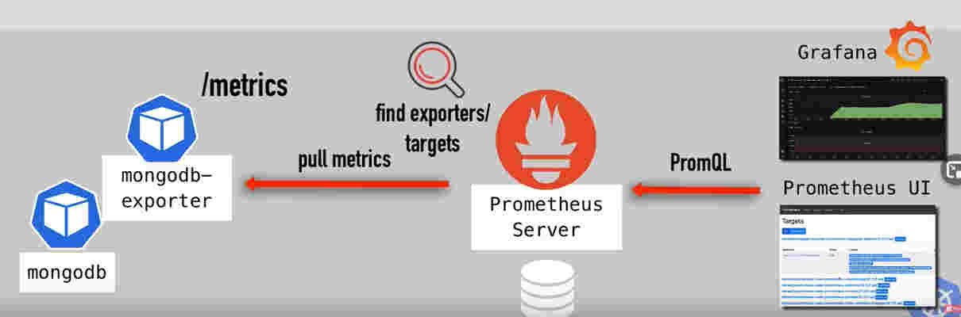

Find the prometheus service and open the UI.
kubectl get svc
Port forwarding
kubectl port-forward service/prometheus-kube-prometheus-prometheus 9090
Forwarding from 127.0.0.1:9090 -> 9090 < - this is the address to use
Forwarding from [::1]:9090 -> 9090

Components to configure for monitoring

Service Monitors
It is a custom k8s component.
kubectl get servicemonitor
There is a release tag that connects a service monitor to be monitored by Prometheus. Prometheus discover the monitors using this tag.
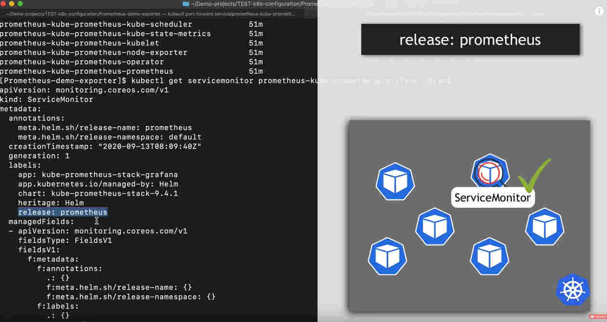

Just create the mongodb deployment and service.[refer the yaml]

Exporter
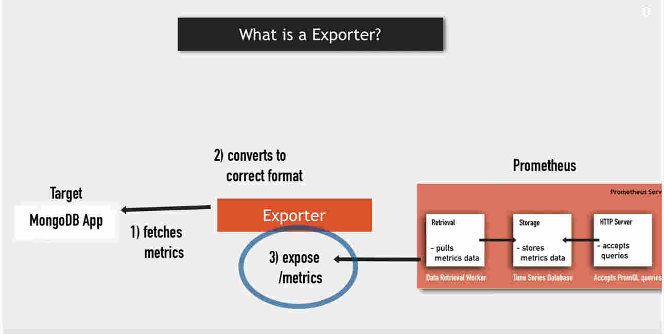

Find the available exporters from the Prometheus documentation or docker hub.
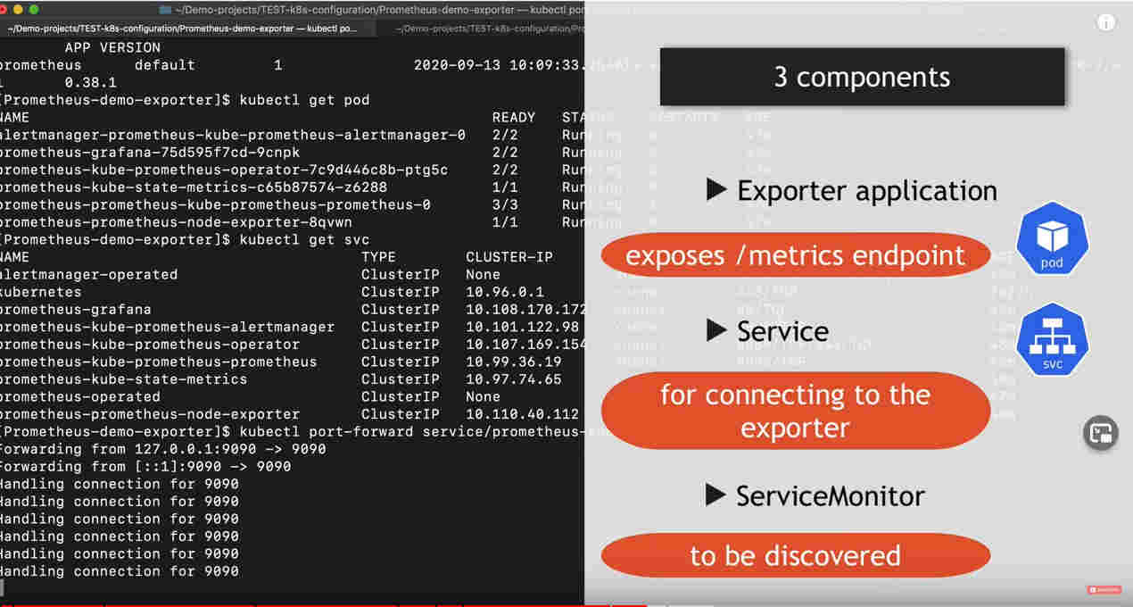

mongodb-exporter installation
helm install mongodb-exporter prometheus-community/prometheus-mongodb-exporter -f values.yaml
Note : installation might throw issues if you miss the values yaml as the uri will be empty by default.

The values.yaml will override the mongodb url and the release indicator for prometheus export indicator. This will enable the prometheus monitoring.
The output of above command will show the port on which the metrics /servie is running.
We can do port-forwarding and validate it.
kubectl port-forward service/mongodb-exporter-prometheus-mongodb-exporter 9216
Hit the url shown in the portforwarding output. You will see the metrics.

View this in Grafana and prometheus UI.
We are already port-forwarding the prometheus UI service - > http://127.0.0.1:9090/targets
Enable port forwarding for the prometheus-grafana deployment. - > http://127.0.0.1:3000/login
Use the default grafana cred- admin / prom-operator . Check the Manage section-mongodb-deployment.

