Machine Learning.

Stemming and Lemmatization.

Stemming
Process of reducing the infected words to their word stem. The output of stemming maynot be a meaningful word as you can see in the examples below.
Fast processing.
Eg:
History, historical - > histori
finally, final, finalized - > fina

Lemmatization
This is also stemming , but resulting in a meaningful word.
Slow processing to arrive a meaningful result.
Eg:
History, historical - > history
finally, final, finalized - > final

nltk library
Used for NLP.
Nltk.sent_tokenixe() - tokenize the paragraph to sentences.
Nltk.word_tokenixe() - tokenixe the paragraph to words.

Stopwords
Words like of, the, them, then, our which doesnt play good rule in word processing.
Stopwords.words(‘english’) this will give list of stop words in english.

Nltk stemming
stemmer = PorterStemmer()
stemmedword = stemmer.stem(wordtobestemmed)

nltk lemmatizer
lemmatizer = WordNetLemmatizer()
words = lemmatizer.lemmatize(word)

Bag of words
It is a collection of words as a matrix.
Binary BOW and Regular BOW.

Remove the stopwords, then we get our BOW. find the frequency of the remaining words in our collection of sentences. Create a table with the bow as the features in the Dataset of the sentences.
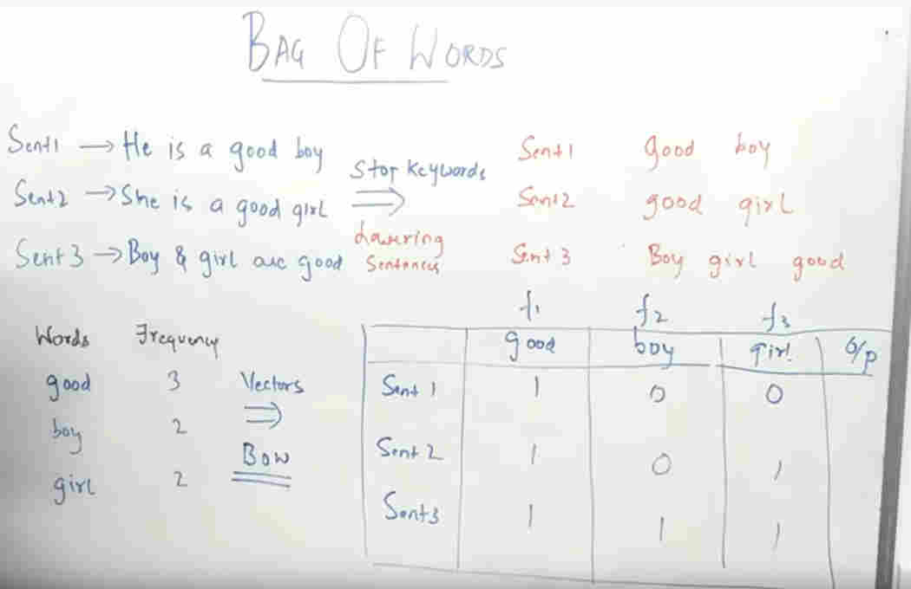
Disavantages of BOW – We do not weigh the importance of the words. All are treated with same priority.

For the code sampls, please refer the github repo for DS and the NLP folder inside.

TF-IDF(Term Freq and Inverse Document Freq)
TF means the number of occurrences of a specific word divided by total words in that sentence.
Formula in the screenshot.
IDF = formula below.
We form 2 datasets one with TF and one with IDF. Then we multiply the TF and Corresponding IDF values to form a new dataset(bottom most table in image).
