Chapter 1
Under the Wave off Kanagawa
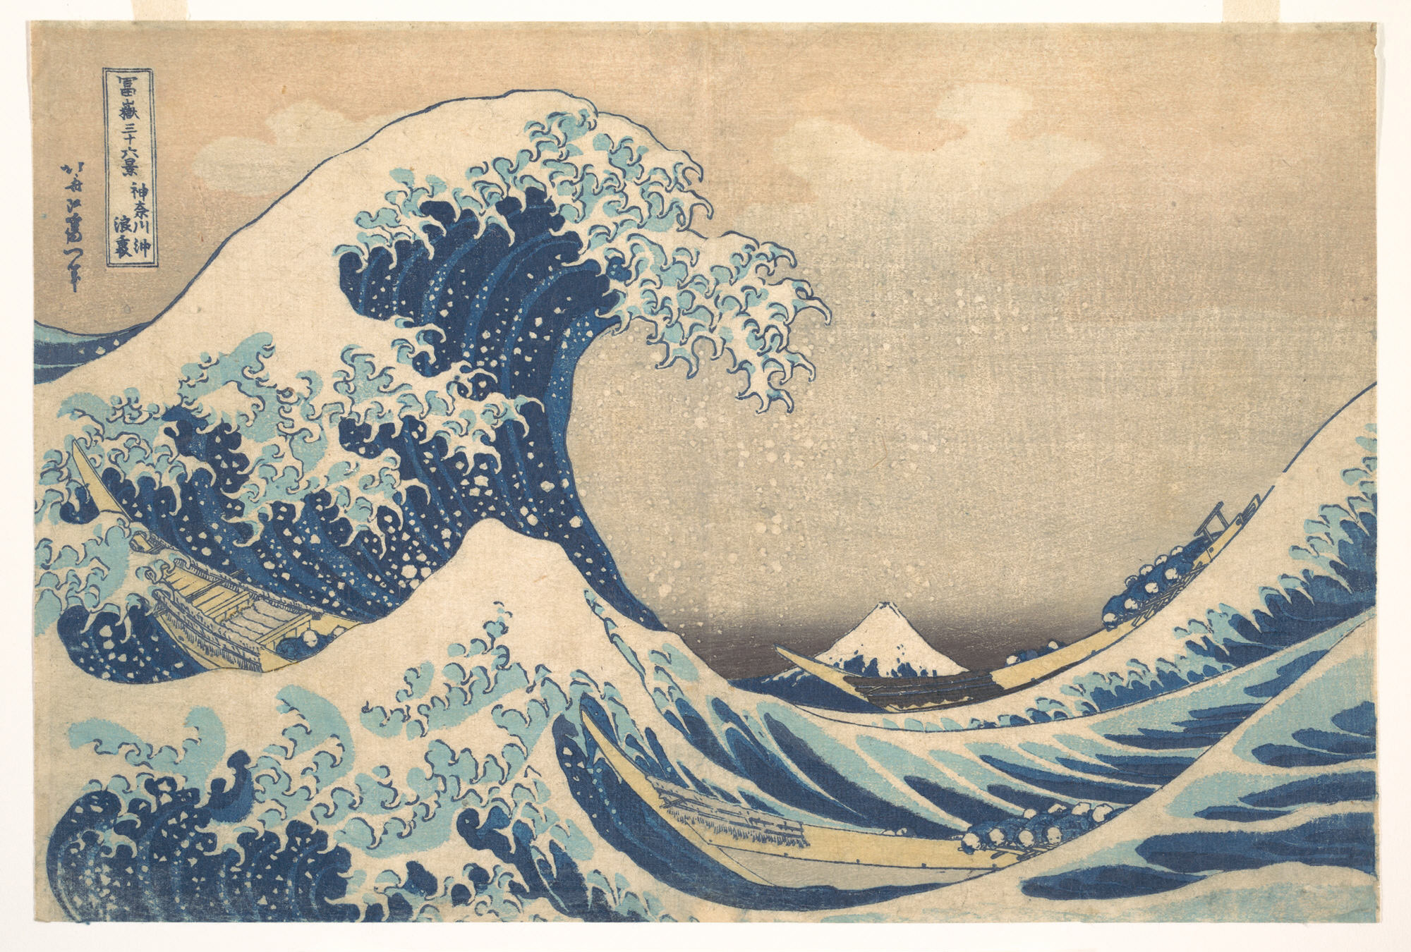
Also known as The Great Wave

