

PROJECT: CHIC LIGHTING
GROUP NO: 04 .BATCH:T1.2204.M0

A. SYSTEM REQUIREMENTS:
Sr. | Item | Description
1. | Operating system | Windows 7, 8, or higher
2. | Hardware | Pentium 166 or better with 64 Megabytes of RAM or better
3. | Web Browser | Version in later of: Edge 44, Firefox 40, Chrome 55, etc…
4. | Fonts | Standard font Unicode: Arial, Tahoma, Lucida Console, Times New Roman, etc…
5. | Other requirement | A working internet connection.
Notes: Do not install IDEs (Integrated Development Environment) on the system such as MS Visual Studio, Jbuilder, Dreamweaver, etc.

B. Program Instrallation
Step 1. Download eProjectSem01_ChicLighting_Group04.rar from email to your website directory (for example Drive D:\)
Step 2. Extract eProjectSem01_ChicLighting_Group04.rar file into the webroot.
Step 3. Open folder eProjectSem01_ChicLighting_Group04 > open ChicLighting folder.
Step 4. Run index.html in ChicLighting folder. (please use Chrome or Firefox browser for website for best experience.)
...........

C. Successful test
- The file is loaded successfully
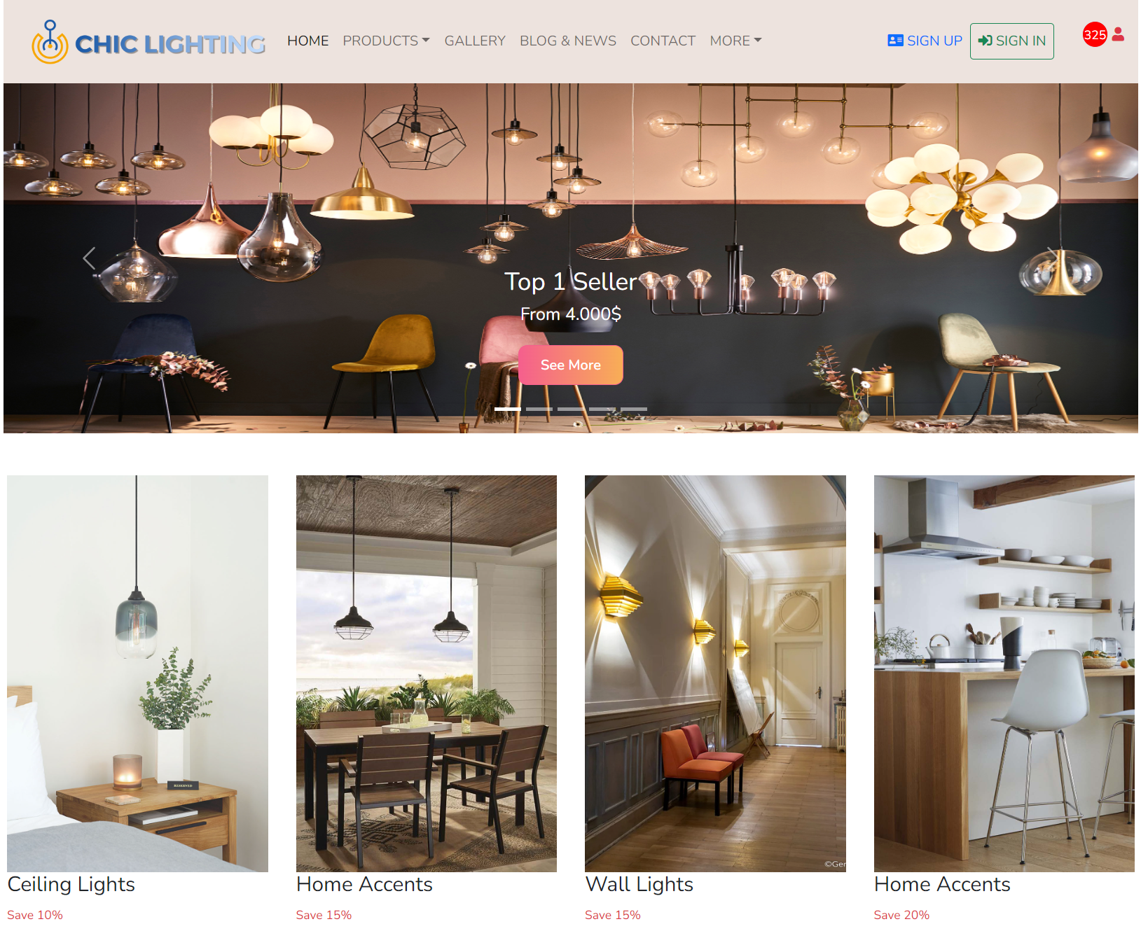
- Homepage should be displayed as described in the documentation.

