Question 1

* For question 1, there are 2 executables. One for WebAPI service, Nielsen.TechTest.Q1.RobotHosting and WebAPI client application built-in WPF, Nielsen.TechTest.Q1.RemoteRobotController
* To run 2 projects, still 2 instances of visual studio could be used. However
* **To run Nielsen.TechTest.Q1.RobotHosting project outside visual studio**, I created simple command file under “src” folder, **Run.Nielsen.TechTest.Q1.RobotHosting.cmd. So just double click in windows explorer (does not have to bring command prompt)**
* Nielsen.TechTest.Q1.RobotHosting and Nielsen.TechTest.Q1.RemoteRobotController projects are configured to use port 5050. Please check launchSettings.json for Nielsen.TechTest.Q1.RobotHosting and appsettings.json for Nielsen.TechTest.Q1.RemoteRobotController
* Also Nielsen.TechTest.Q1.RobotHosting and Nielsen.TechTest.Q1.RemoteRobotController projects are configured to log using NLog under “log” folder

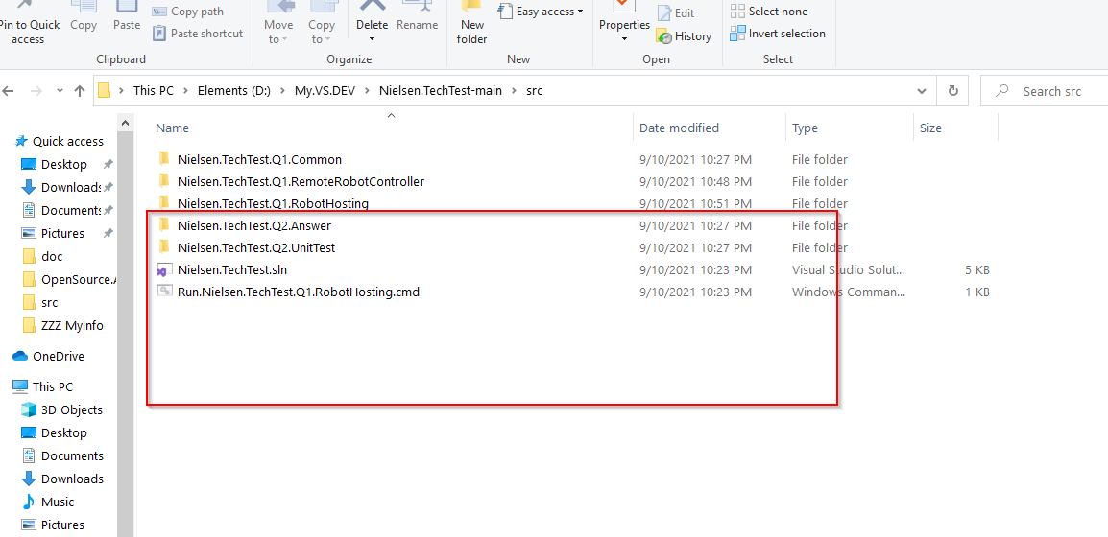

**Question 2**

* For question 2, there is no executable however instead, the solution has MS Test project
* Open and bring “Test Explorer”. Visual studio will shows Nielsen.TechTest.Q2.UnitTest with 4 test classes. Please start all.

Note: **My answer is Nielsen.TechTest.Q2.Answer.ArrayGeneratorUsingBitArray primarily** however **Nielsen.TechTest.Q2.Answer.ArrayGeneratorUsingReturnArray would be still good approach** when the range by low and high numbers is not big

The below is the screenshot in visual studio

