In Hierarchy, under canvas, under title screen, click text under easy button. Set alignment to center

Do it again to texts of medium and hard buttons

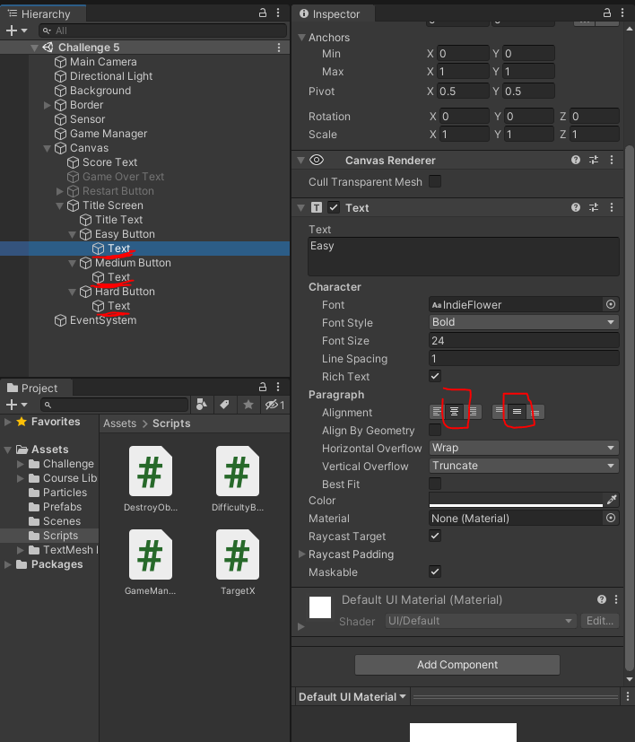

in Target script, change "OnMouseEnter" method to "OnMouseDown" method

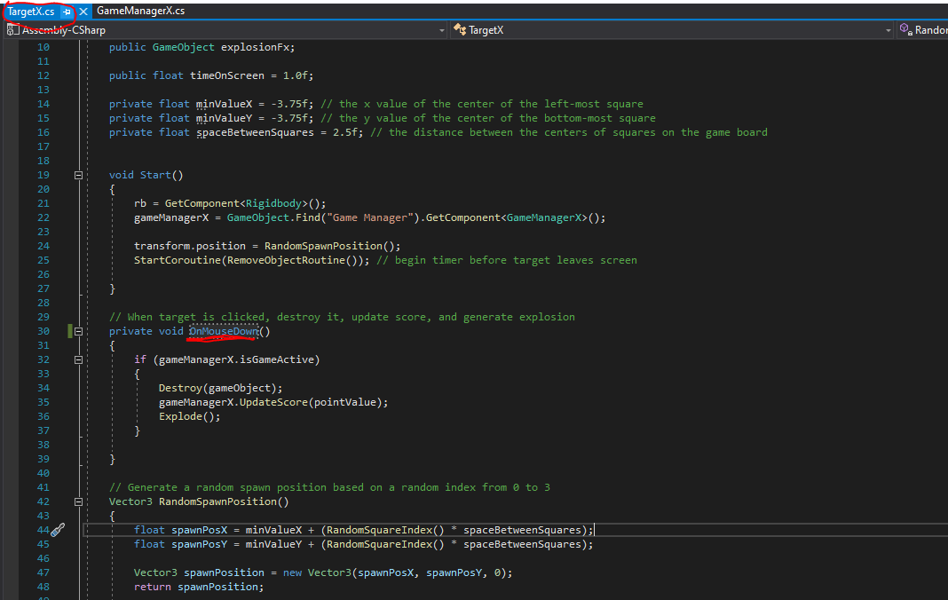

In Game Manager Script, under Update Score method, change "score" to $"Score: {score}"

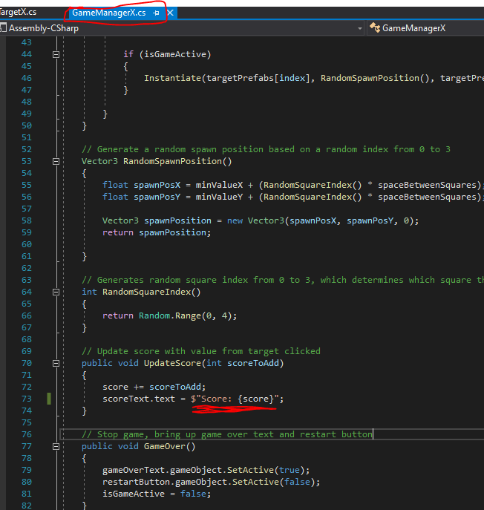

In Game Manager Script, under Game Over method, restart button set active to true (prev false)

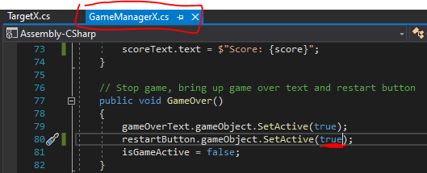

In Difficulty Button Script, under Set Difficulty method, pass difficulty as an argument

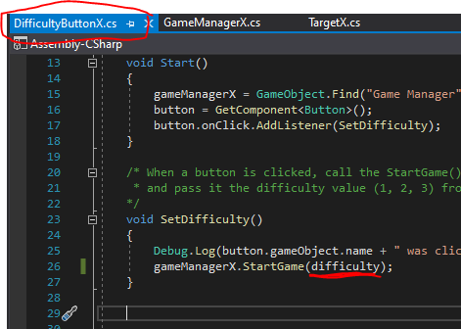

In Game Manager Script, at Start Method, accept an int difficulty parameter

Under it, change 5 to difficulty (pic of ss nxt pg)

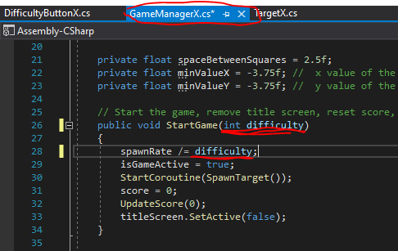

In Game Manager Script, create a public variable for timeText

Under start game method, start the start countdown timer routine

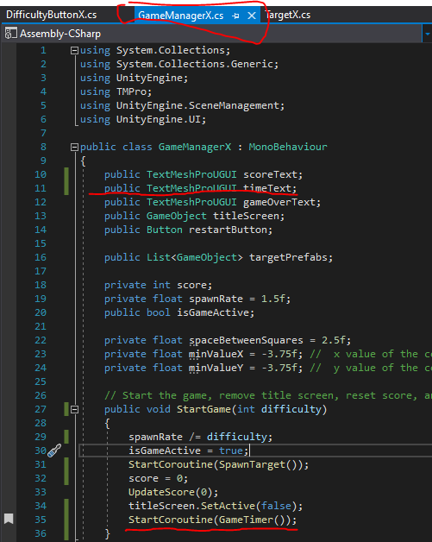

In Game Manager Script, create the game timer routine

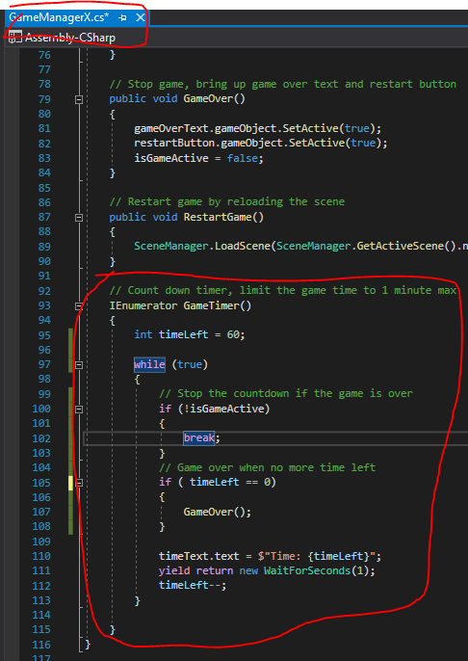

In Hierarchy, under canvas, duplicate the score text, change its object name to Time text, change its Pos Y to from -50 to -100, change the text input from “Score: ” to “Time: ”

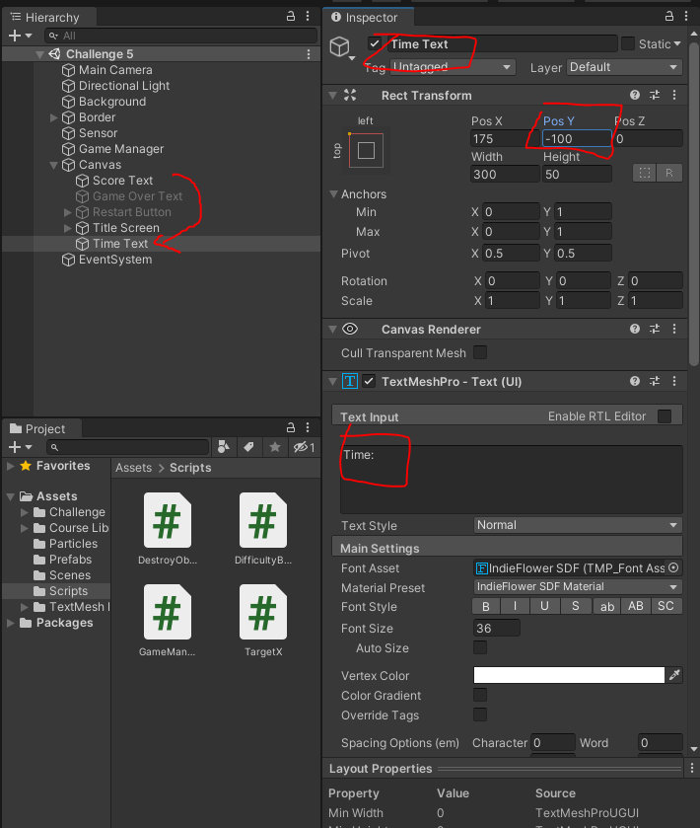

In Hierarchy, Click Game Manager, assign time text to time text variable

