APPENDICES
Appendix A

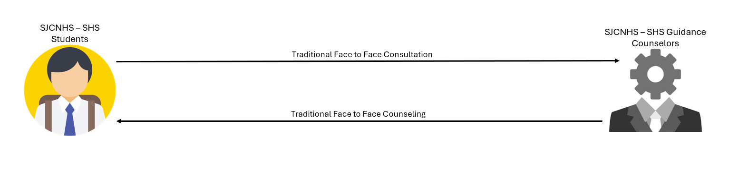
Existing System

Figure 1. Existing System (Conceptual Diagram for Application Process)

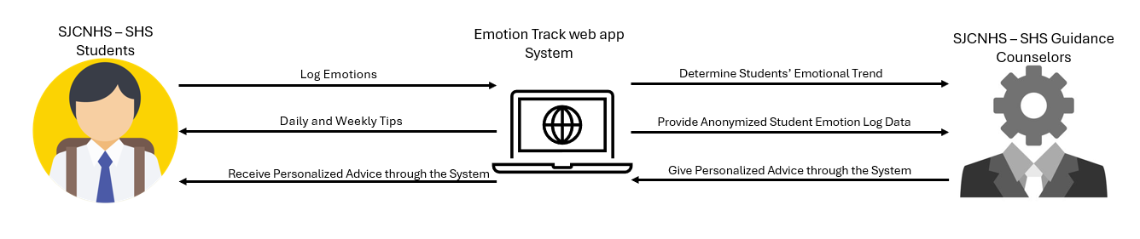
Proposed System

Figure 2. Proposed System (Conceptual Diagram for Application Process)

Appendix B
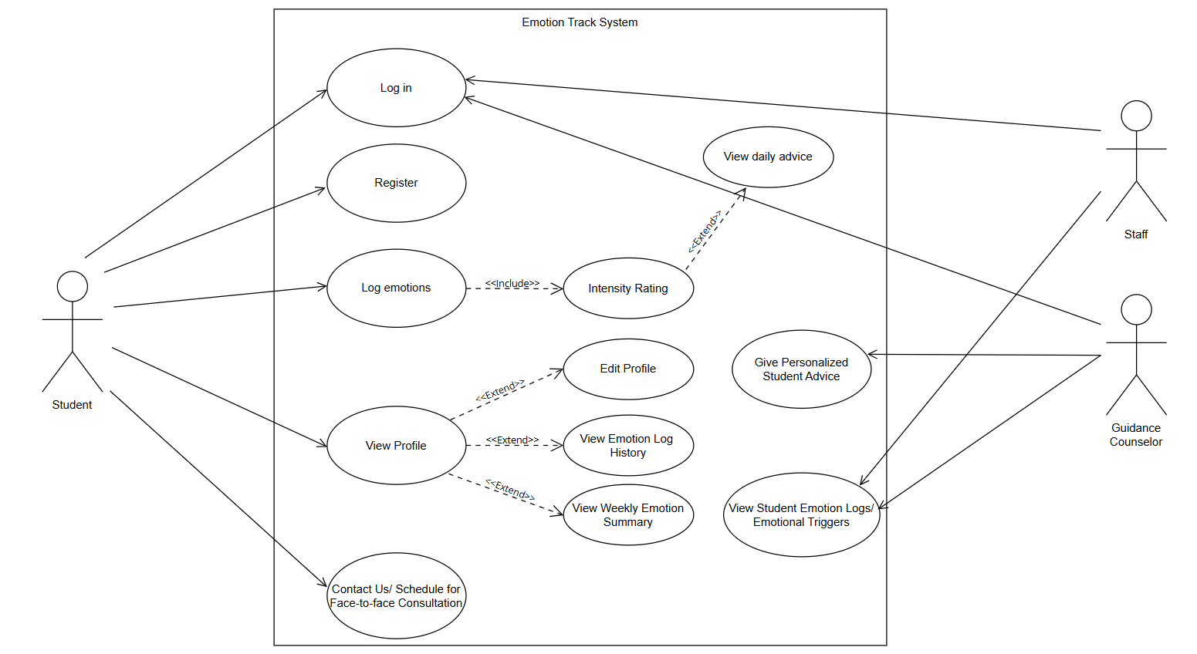
Use Case Diagram

Figure 6. Use Case Diagram

Appendix C
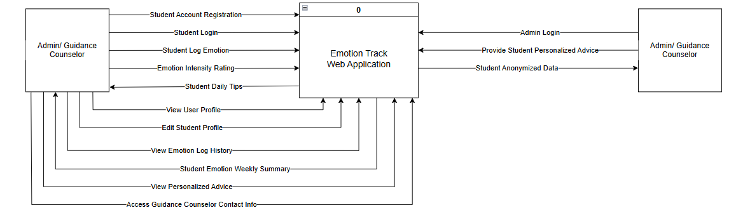
Context Diagram
Figure 7. Context Diagram

Appendix D
Data Flow Diagram
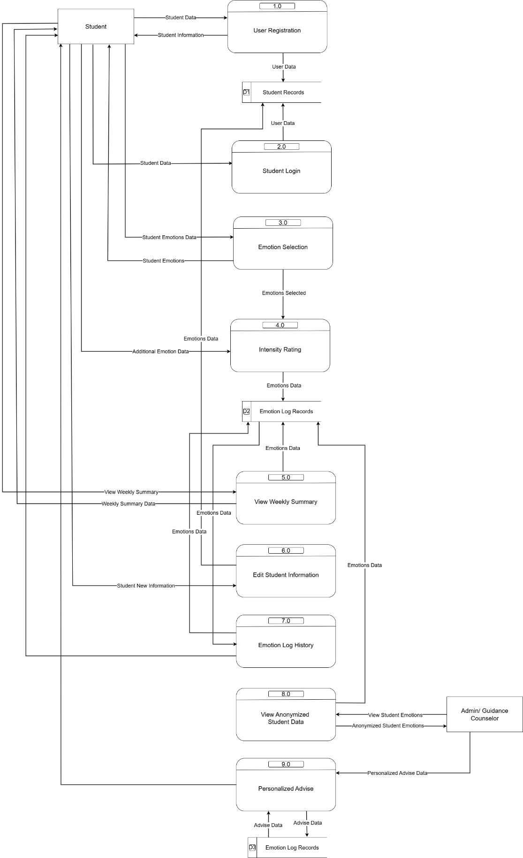
Figure 8: Data Flow Diagram
Appendix E
Level 1 DFD Process 1
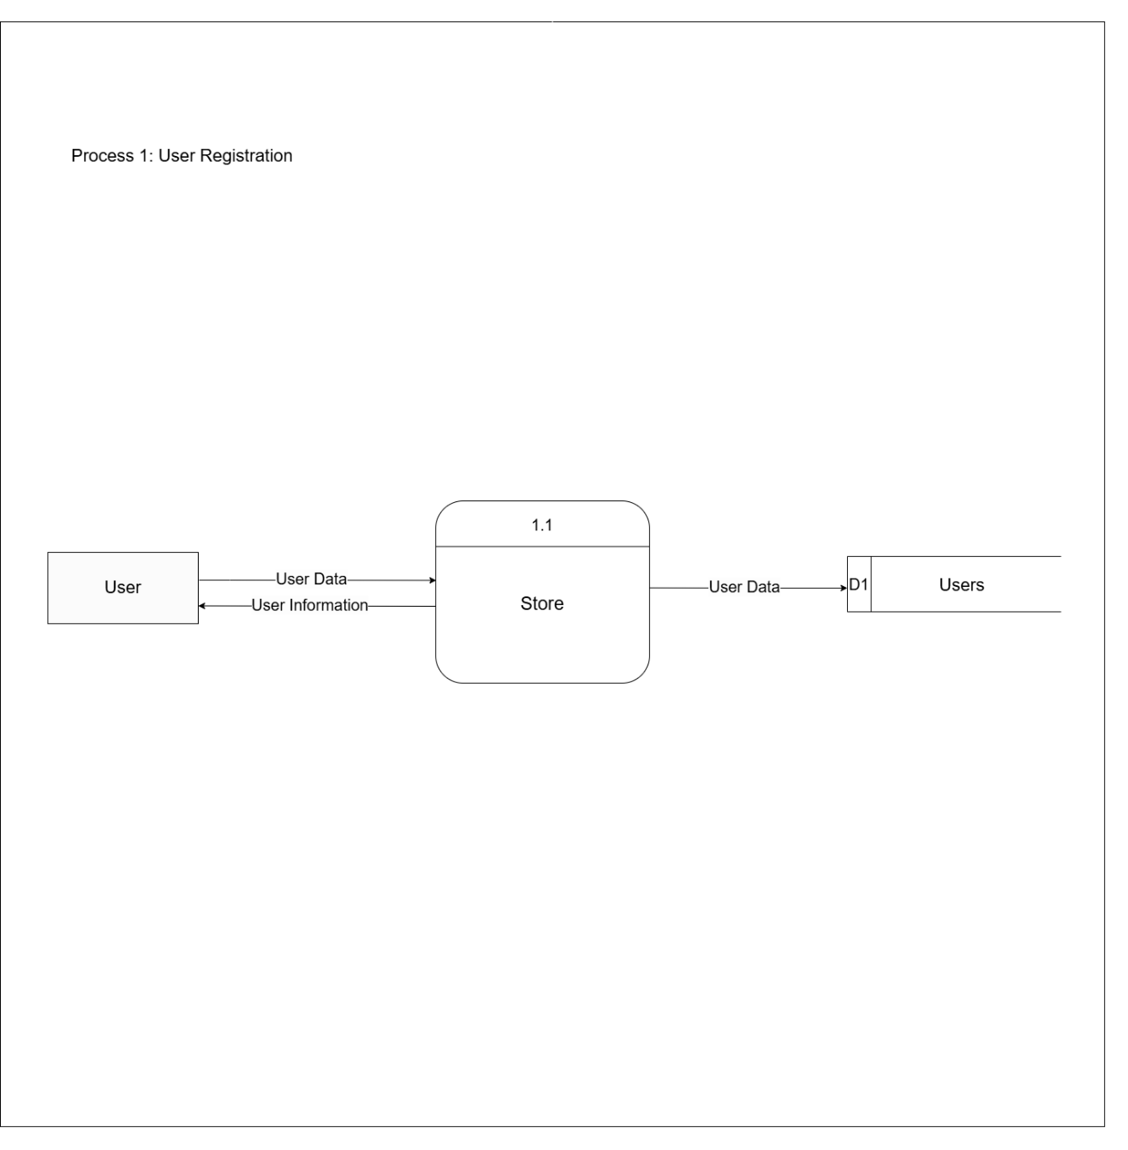
Figure 9: Exploded Data Flow Diagram 1.0

Appendix F
Level 1 DFD Process 2
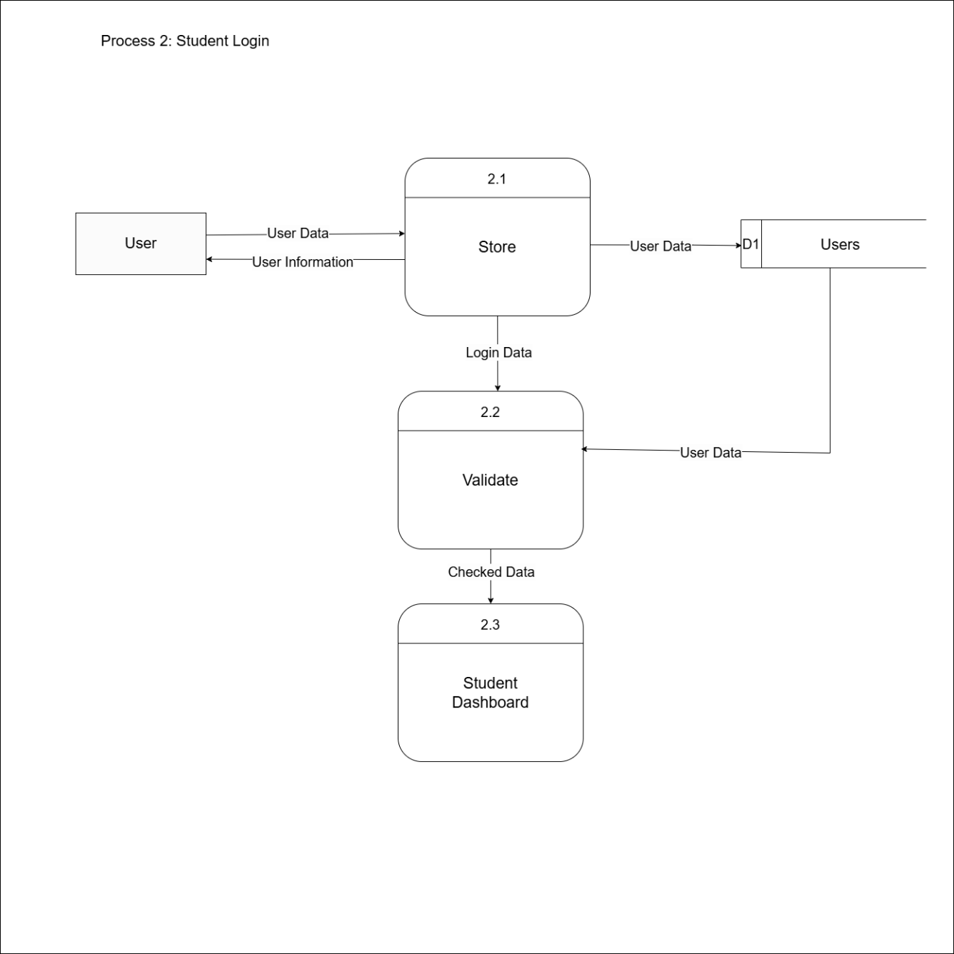
Figure 10: Exploded Data Flow Diagram 2.0

Appendix G
Level 1 DFD Process 3
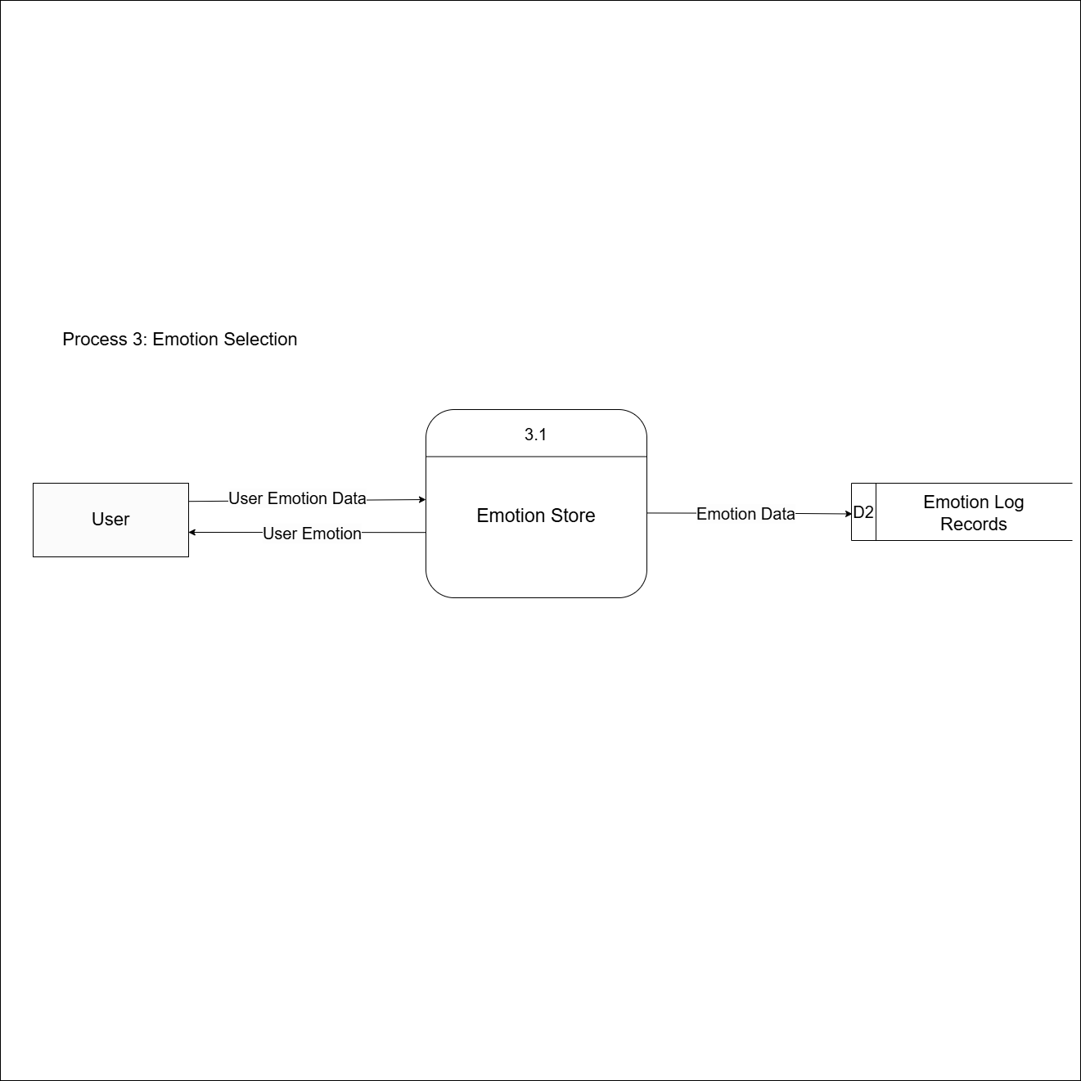
Figure 11: Exploded Data Flow Diagram 3.0

Appendix H
Level 1 DFD Process 4
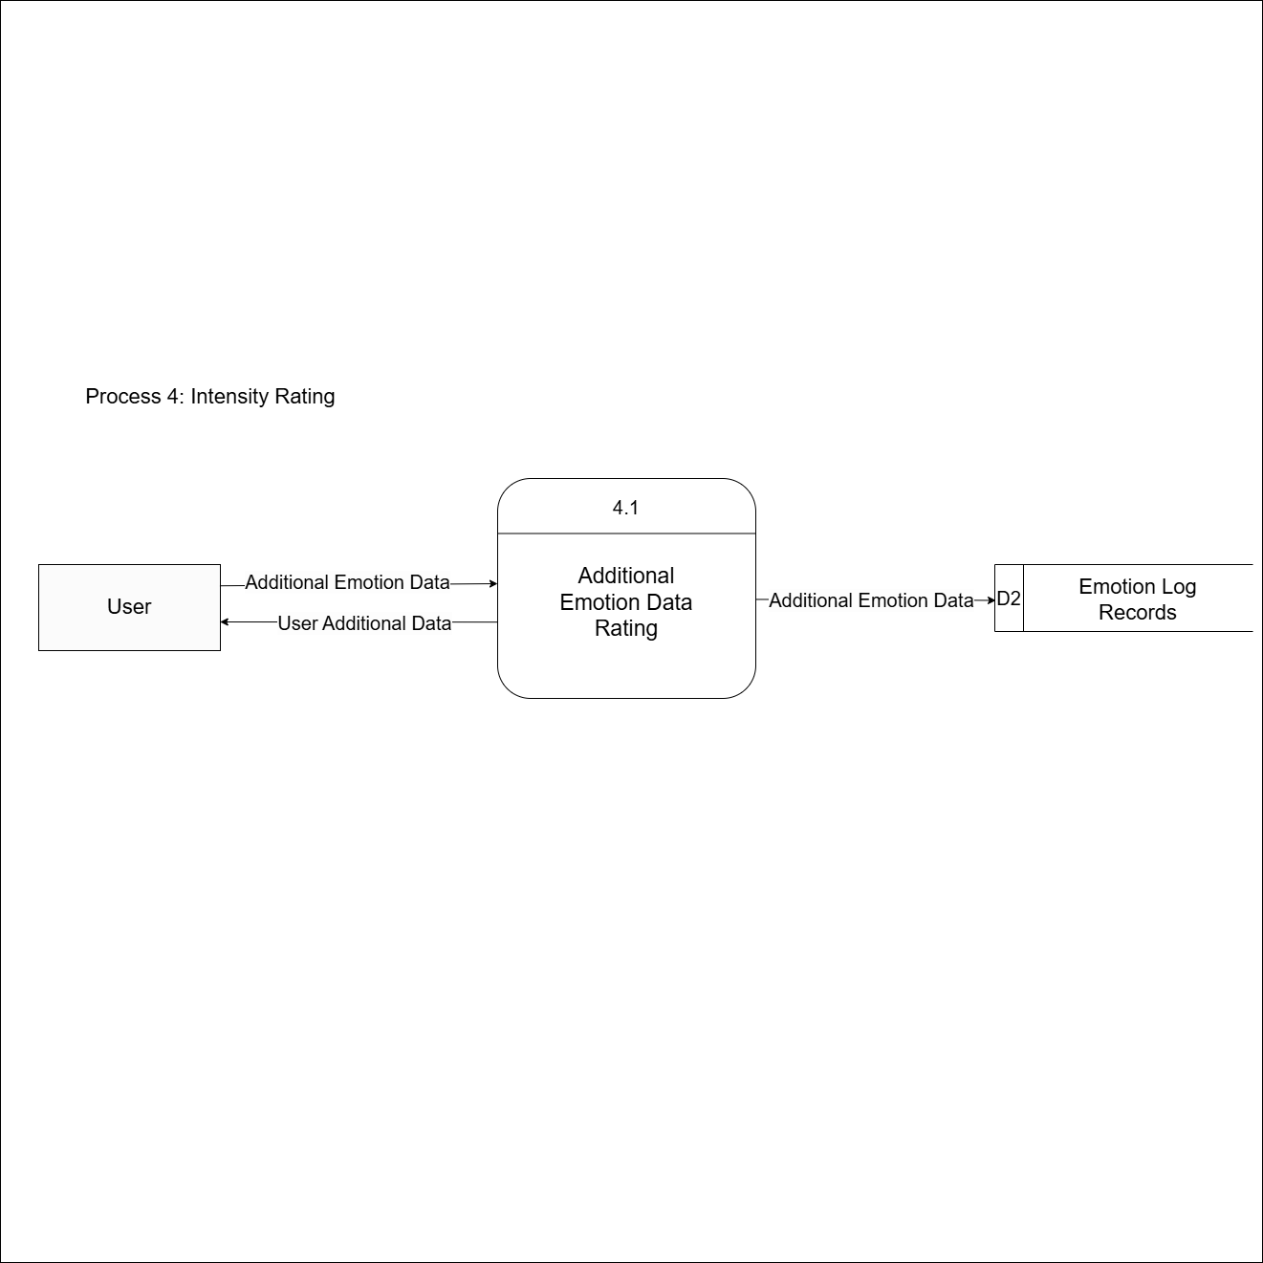
Figure 12: Exploded Data Flow Diagram 4.0

Appendix I
Level 1 DFD Process 5
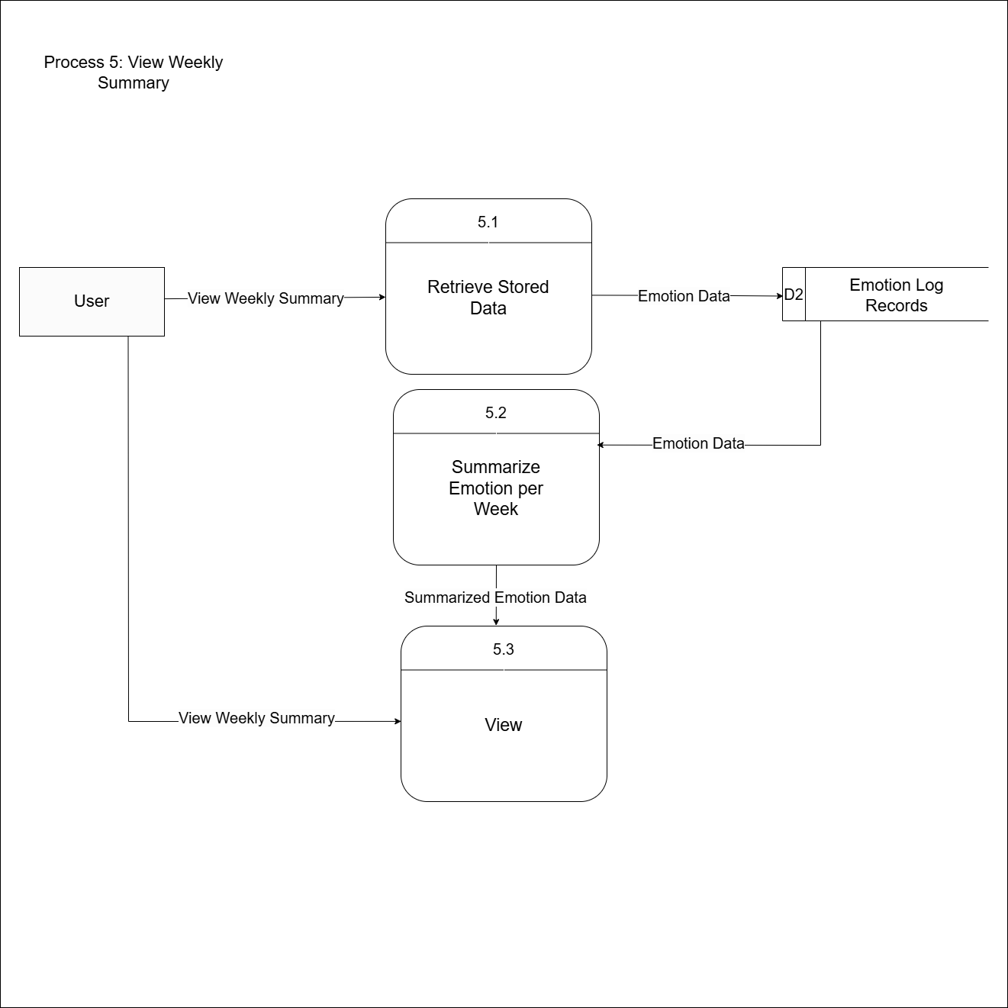
Figure 13: Exploded Data Flow Diagram 5.0

Appendix J
Level 1 DFD Process 6
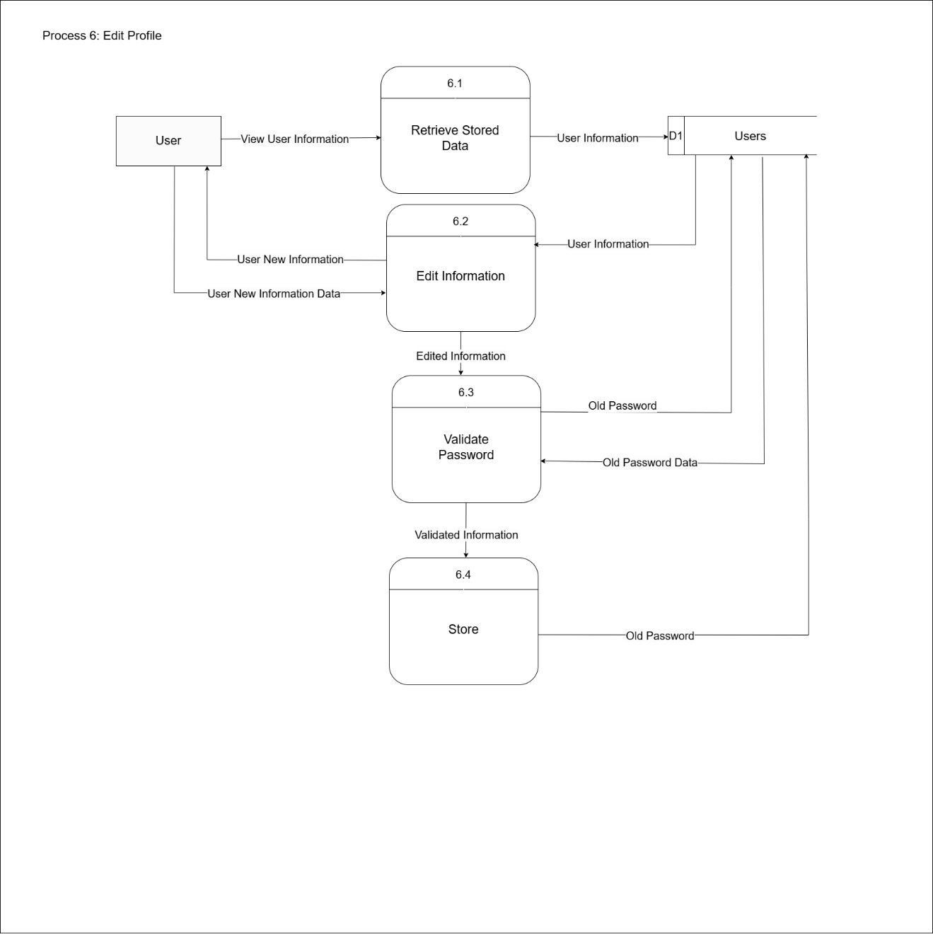
Figure 14: Exploded Data Flow Diagram 6.0

Appendix K
Level 1 DFD Process 7
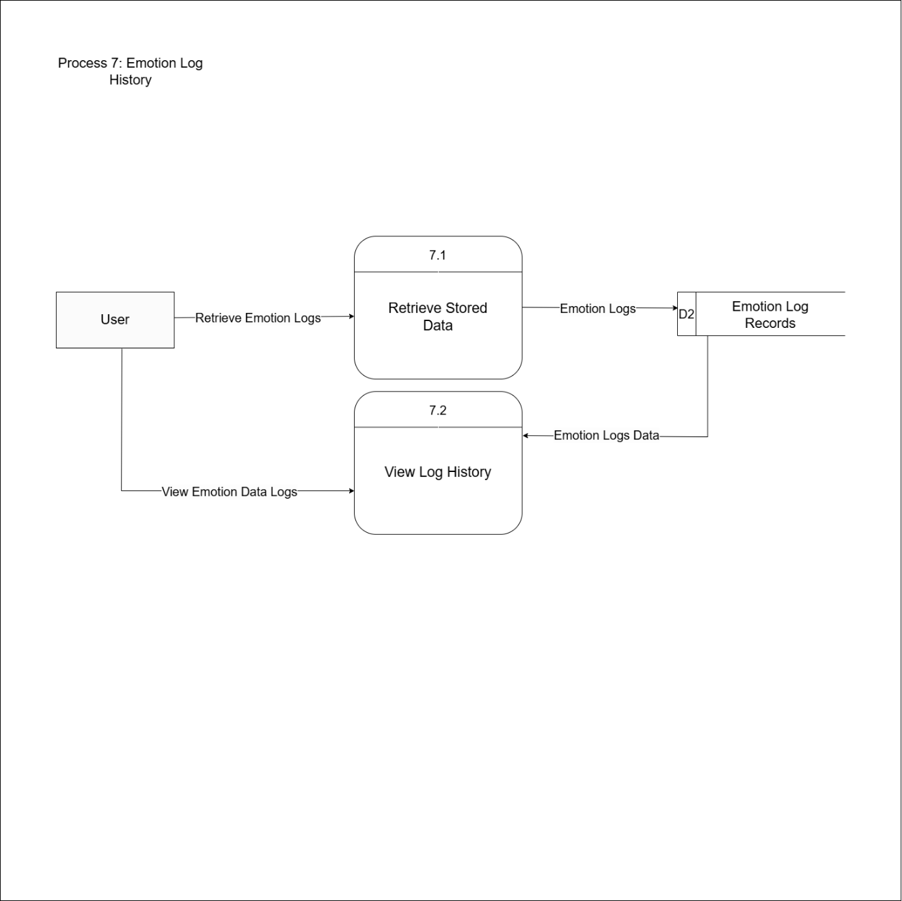
Figure 15: Exploded Data Flow Diagram 7.0

Appendix L
Level 1 DFD Process 8
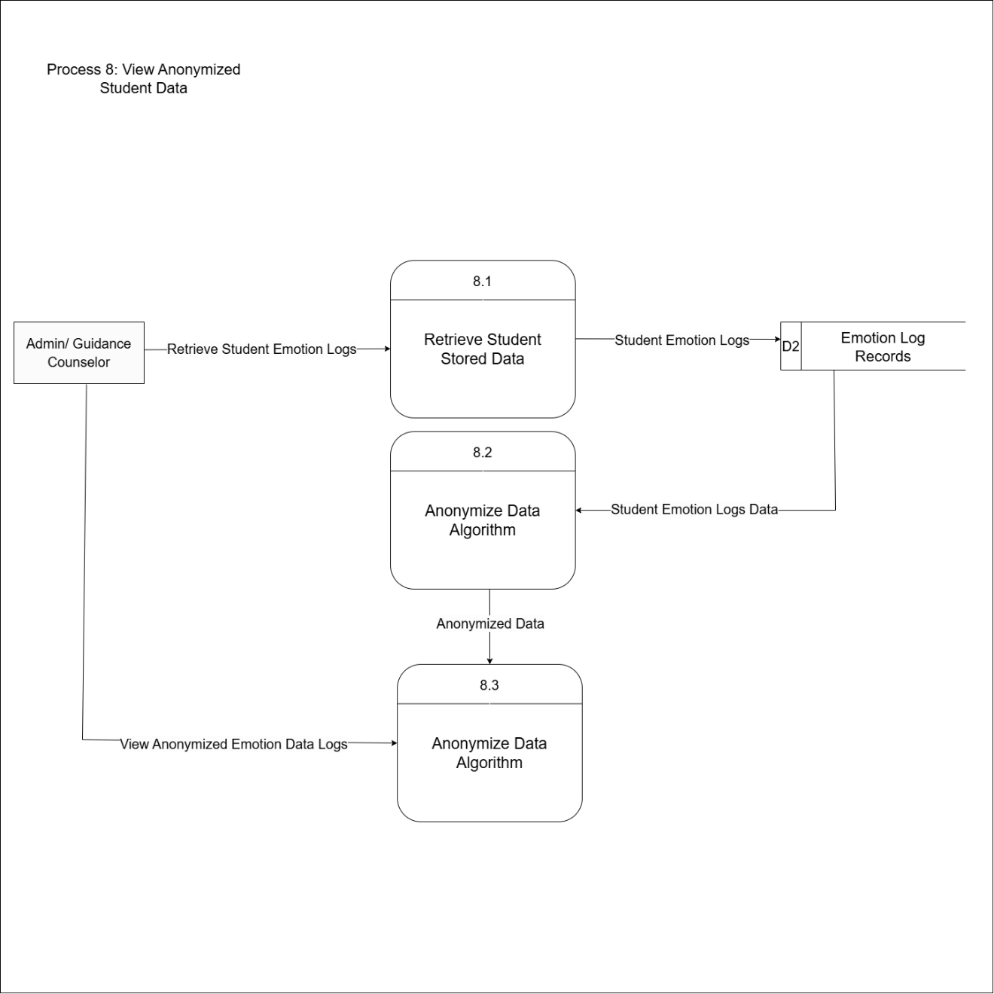
Figure 16: Exploded Data Flow Diagram 8.0

Appendix M
Level 1 DFD Process 9
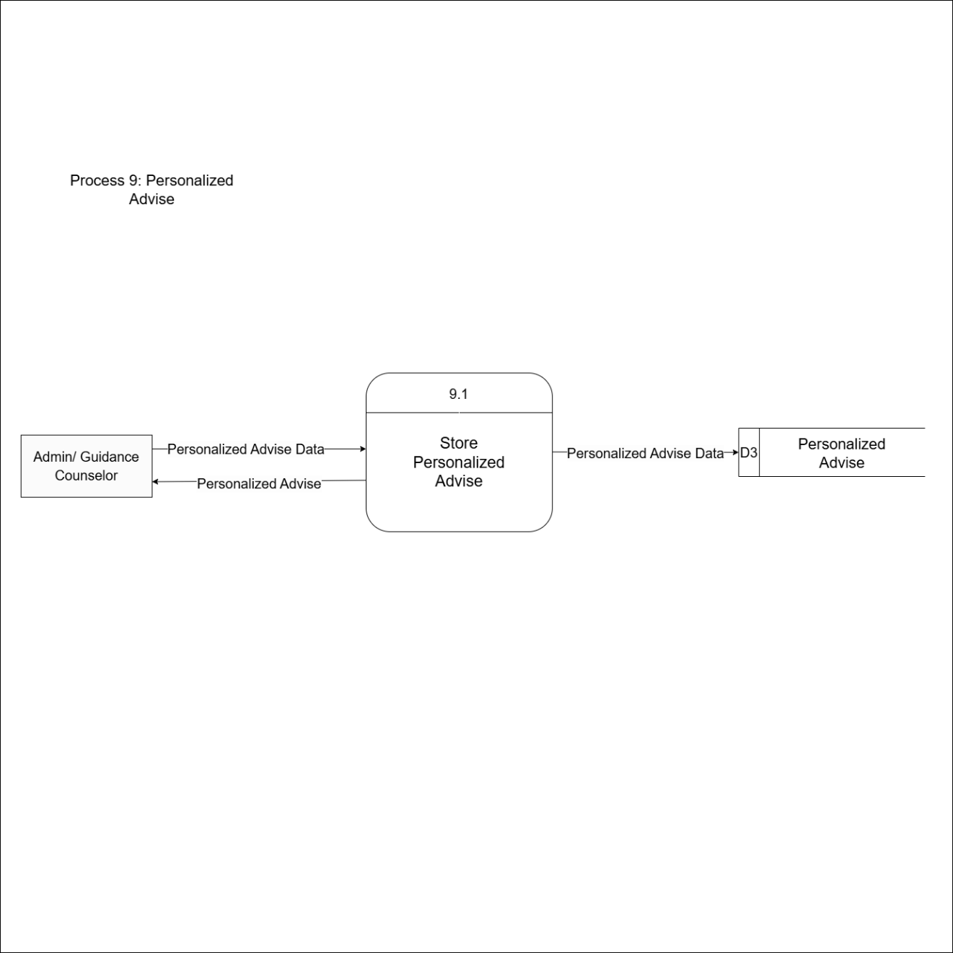
Figure 17: Exploded Data Flow Diagram 9.0

Appendix N
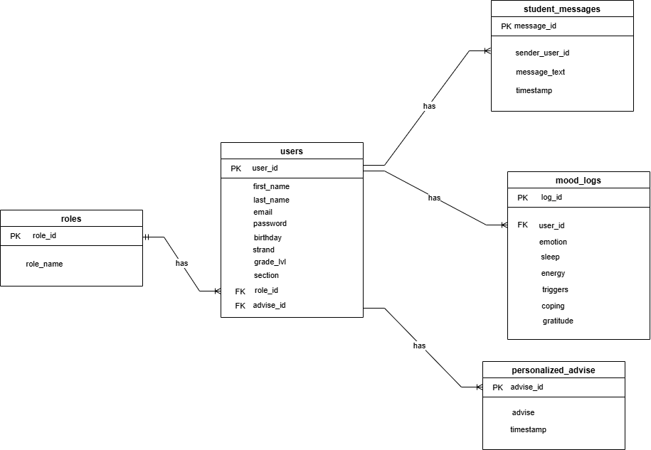
Entity Relationship Diagram
Figure 18: Entity Relationship Diagram

Appendix O
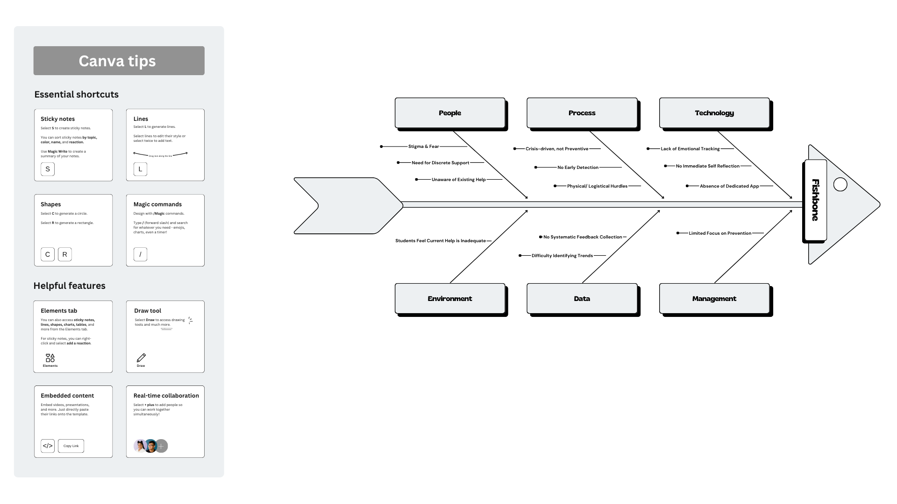
Fishbone Diagram
Figure 19: Fishbone Diagram

