

TITLE P
Department of Information Technology
COLLEGE OF ENGINEERING
CENTRAL LUZON STATE UNIVERSITY
Science City of Muñoz, Nueva Ecija

EMOTION TRACK: A WEB APPLICATION FOR MONITORING AND ANALYZING SENIOR HIGH SCHOOL STUDENTS’ EMOTIONS USING LOGGED INPUTS

A Capstone Project
Presented to the
Department of Information Technology

In Partial Fulfillment
Of the Requirements for the Degree

BACHELOR OF SCIENCE IN INFORMATION TECHNOLOGY

By:

Baquiran, Teddy S. Jr.
Luna, Raymond S.
Petralba, Sigmond Ace D.

May 2025

DISCLAIMER
This Capstone Project is submitted to the Department of Information Technology, College of Engineering, in partial fulfillment of the requirements for the degree Bachelor of Science in Information Technology at the Central Luzon State University, Science City of Muñoz, Nueva Ecija. It is a product of our own work except were indicated in the text. The project report or any portion thereof including the source code, or any section may be freely copied and distributed provided that the source is acknowledged.

APPROVAL SHEET

This capstone project proposal entitled “EMOTION TRACK: A WEB APP FOR MONITORING AND ANALYZING SENIOR HIGH SCHOOL STUDENTS’ EMOTIONS USING LOGGED INPUTS” prepared and submitted by SIGMOND ACE D. PETRALBA, RAYMOND S. LUNA, TEDDY S. BAQUIRAN JR. in partial fulfillment of the requirements for the degree BACHELOR OF SCIENCE IN INFORMATION TECHNOLOGY, has been examined and is hereby endorsed.

CHRISTIAN REY C. SECO

Adviser

CAPSTONE 1 PROJECT ORAL PRESENTATION COMMITTEE

DR. ANJELA C. TOLENTINO |  | MR. RONNIE CAMILLO F. ROBLES
Chair |  | Member
Date Signed |  | Date Signed

Accepted and approved in partial fulfillment of the requirements for the degree BACHELOR OF SCIENCE IN INFORMATION TECHNOLOGY, school year 2024-2025.

DR. ANJELA C. TOLENTINO

Head, Department of Information Technology

_______________

Date Signed

DR. ROY SEARCA JOSE P. DELA CRUZ

Acting Dean, College of Engineering

_______________

Date Signed

CERTIFICATION OF MANUSCRIPT PROOFREADING

This is to certify that the undersigned has reviewed and edited the manuscript of SIGMOND ACE D. PETRALBA, RAYMOND S. LUNA, TEDDY S. BAQUIRAN JR. entitled “EMOTION TRACK: A WEB APP FOR MONITORING AND ANALYZING SENIOR HIGH SCHOOL STUDENTS’ EMOTIONS USING LOGGED INPUTS”. This further certifies that the scope of editing is for proper English language, grammar, punctuation, spelling, and overall writing style.

Issued this 31st day of Month, year, at address.

FULL NAME OF CRITIC
Position/Designation
Name of institution/school

ABSTRACT
Mental health concerns among senior high school students are increasing, leading to anxiety, stress, emotional distress, and breakdowns that negatively impact academic performance and overall well-being.
In response to these challenges, the researchers developed Emotion Track, a web-based application designed to help San Jose City National High School – Senior High School (SJCNHS - SHS) students’ input, track, monitor, and analyze their emotions in real time. This system allows users to log their emotional states, estimate their intensity, and receive individualized daily and weekly motivational and coping recommendations. The program incorporates data analytics to detect emotional trends and offers useful insights. It was built using PHP, JavaScript, HTML/CSS, and a MySQL database, following the Agile methodology. The application was validated through stratified evaluation and usability testing.
Emotion Track provides a student-centered, confidential, and stigma-free approach to mental well-being for SJCNHS-SHS students. This web application helps senior high school students understand their emotional well-being and assists the SJCNHS-SHS guidance office in creating data-driven wellness initiatives.
This initiative exemplifies how digital tools can foster emotional resilience within academic communities and improve early intervention for mental health concerns.

TABLE OF CONTENTS

DISCLAIMER i
APPROVAL SHEET ii
CERTIFICATION OF MANUSCRIPT PROOFREADING iii
ABSTRACT iv
TABLE OF CONTENTS v
CHAPTER I 1
INTRODUCTION 1
PROBLEM STATEMENT 3
General Problem 3
Specific Problems 3
OBJECTIVES 4
General Objective 4
Specific Objectives 4
SCOPE AND LIMITATIONS 5
Scope 6
Limitations 6
SIGNIFICANCE OF THE STUDY 7
DEFINITION OF TERMS 8
CHAPTER II 13
REVIEW OF RELATED LITERATURES AND EXISTING ALTERNATIVES 13
Introduction 13
Existing Alternatives 16
Gaps in Existing Research 18
Conclusion 20
CHAPTER III 21
METHODOLOGY 21
Research Design 21
System Architecture 21
Development Tools and Technologies 22
Implementation Process 23
Software Development Methodologies 23
Data Collection and Processing 24
Ethical Consideration 33
REFERENCES 34
APPENDICES 37

LIST OF FIGURES
Figure No. Title Page
1. System Architecture. 21
2. Agile Methodology 23
3. Scrum Framework 29
4. Existing System 37
5. Proposed System 37
6. Use Case Diagram 38
7. Context Diagram 39
8. Data Flow Diagram 40
9. Exploded Data Flow Diagram 1.0 41
10. Exploded Data Flow Diagram 2.0 42
11. Exploded Data Flow Diagram 3.0 43
12. Exploded Data Flow Diagram 4.0 44
13. Exploded Data Flow Diagram 5.0 45
14. Exploded Data Flow Diagram 6.0 46
15. Exploded Data Flow Diagram 7.0 47
16. Exploded Data Flow Diagram 8.0 48
17. Exploded Data Flow Diagram 9.0 49
18. Entity Relationship Diagram 50
19. Fishbone Diagram 51
20. Student Landing Page UI 52
21. Student Login Page UI 52
22. Student Login Page UI 52
23. Student Registration Page UI 53
24. Student Dashboard Page UI/ Negative Emotion Selection UI 53
25. Student Dashboard Page UI/ Positive Emotion Selection UI 53
26. Emotion Intensity Rating UI 54
27. Latest Log Summary UI 54
28. Daily Tips UI 54
29. Sidebar UI 55
30. Profile Page UI 55
31. Emotion Log History UI 55
32. Log History Details 56
33. Weekly Emotion Insights UI 56
34. Weekly Emotion Insights UI 56
35. Weekly Emotion Insights UI 57
36. Guidance Office Consultation UI 57
37. Website Description/ Contacts UI 57
38. Logout Page UI 58
39. Admin Login Page UI………………………………………………………......58
40. Admin Dashboard UI……….………………………………………………......58
41. Student Mood Logs Monitoring UI ………………...…………………………......59
42. Admin Consultation UI…………………………………………………………59

LIST OF TABLES
Table No. Title Page
Table 1: Comparative Analysis of Prior Research and… 18
Table 2: Test Cases 31

CHAPTER I

INTRODUCTION
Over the past 45 years, research on students' mental health and well-being has significantly expanded, reflecting an increasing academic interest in this area, especially in the last decade. Bibliometric analysis of mental health studies reveals that the field continues to evolve, covering topics such as positive mental health, mental disorders, stress management, counseling, and mental health measurement. The interdisciplinary nature of this research, involving behavioral and biomedical sciences, highlights the importance of a multifaceted approach in addressing mental health concerns among students. These findings suggest that mental health interventions must be comprehensive, integrating education, counseling, and self-monitoring tools to effectively support students' well-being. (Shalaby & Agyapong, 2022)
Recent studies reveal that digital mental health clinics in schools could provide easily accessible, low cost, evidence-based support for students. In China, it was tested that the Digital Mental Health Clinic DMHC had various dynamics to provide online counseling service and mental health service, especially in nonworking time. In particular, the platform had contributed to interventions for students at high risk of suicide or self-harm. This demonstrates the excellent extension of web-based mental health apps in terms of school support systems and proactive interventions for student mental health (Xu et al., 2023).
The development of mental health applications has also been recognized as a promising intervention for public mental health awareness and management. A study conducted in South Korea highlighted the effectiveness of multidisciplinary collaboration in creating evidence-based mental health apps. The study pointed out that the app's mental health counseling was valid and practical due to the valid applied research of counseling psychologists, the mental health specialists, the instructional designers, and the app developers. Also, this example reveals the significance of the collaboration of various professionals and technology in crafting policies geared towards digital solutions for mental health issues. (Cho et al., 2022)
Strain, anxiety, and tension among students have become increasingly worrying issues that affect effective academic performance, as well as personal wellness. At San Jose City National High School-Senior High School (SJCNHS-SHS), the Guidance Office has dedicated its support programs aimed at promoting the welfare of the students. Despite the initiative, many students still face barriers to managing their mental health due to stigma, limited information, and a lack of mechanisms to monitor their psychological state.

To tackle this, a web application called Emotion Track is designed to assist students in managing their emotions through monitoring, pattern recognition, and offering tailored coping strategies. Capable of logging in daily moods, Emotion Track provides users with a snapshot of emotional intensity while also offering mental wellness insights, such as relaxation techniques, motivational quotes, and recommended activities.

In combining analytics and user-defined algorithms, Emotion Track hopes to offer SJCNHS-SHS students a proactive, stigma-free solution for mental health tracking. This initiative is in partnership with the Data Science & AI Research Lab (DSAIRe Lab) which focuses on the use of machine learning to analyze emotions in order to enhance early intervention strategies.

Through this initiative, SJCNHS-SHS can enhance its infrastructure for student mental health support, cultivating a more resilient academic community. This type of mental health support aligns directly with the Guidance Office initiatives through providing a digital interface that improves mental health awareness and informs evidence-based wellness programming.
PROBLEM STATEMENT
General Problem
Mental health concerns among senior high school students continue to rise, impacting their academic performance and overall well-being. Despite the efforts of the Guidance Office at San Jose City National High School-Senior High School (SJCNHS-SHS) to provide support programs, many students still struggle to manage stress, anxiety, and emotional distress.
Specific Problem
- No Real Time Emotional Monitoring: SJCNHS-SHS mental health initiatives have no way they can track their emotions and reflect on their emotions in real time.
- Stigma: Some students avoid seeking help due to fear of judgment, embarrassment, or being labeled negatively, which discourages them from reaching out or asking for mental health support.
- Lack of Access: Current mental health support strategies may not be easily accessible, especially outside school hours, limiting students’ ability to manage stress independently.
- Insufficient Feedback Systems: There is no structured approach to collect and analyze students’ feedback on their mental health journey, making it harder to keep improving support services

OBJECTIVES
General Objective
The objective of this study is to design and develop "Emotion Track," a web-based system for SJCNHS-SHS students to track their emotions, drawing insights from psychological assessment principles like semi-structured interviews, and detect emotional patterns for recommendations on personalized coping strategies. This aims to provide a data-driven, interactive, and private method for mental health monitoring, specifically assisting the CLSU Guidance Office in upgrading their student well-being programs by incorporating a digital tool that complements their one-on-one sessions, group activities, and current hybrid consultation methods.
Specific Objectives
- Develop a web-based system, "Emotion Track," that enables students to track, monitor, and reflect on their emotions in real-time, leveraging principles from established psychological assessment methods such as semi-structured interviews and, where applicable, elements from standardized psychological tests (e.g., personality, aptitude, intelligence, and emotional quotient inventories) as a basis for emotional input interpretation.
- Make "Emotion Track" accessible and private to further ensure students use it without fear of judgment or embarrassment, ensuring adherence to the CLSU Guidance Services Unit's principles of confidentiality in their existing one-on-one sessions and communication-based tools.
- Provide psychologically informed messages like positive reminders and coping tips based on the student’s emotional input, informed by the support and psychoemotional guidance offered in CLSU's current one-on-one sessions, group activities and the holistic approach to student well-being.
- Facilitate meaningful interaction between students and the CLSU Guidance Office through "Emotion Track," allowing students to reach out for guidance, and enabling the guidance office to receive notifications and offer proactive support, thereby streamlining and enhancing the existing hybrid consultation methods (e.g., Messenger, tele-counseling) and improving the efficiency and accessibility of student mental health consultations.

SCOPE AND LIMITATION
The scope of this study centers on the design and development of Emotion Track, a web-based application specifically for the students at San Jose City National High School-Senior High School (SJCNHS-SHS). The system aims to provide a private, real-time platform where students can monitor and reflect on their emotions, receive personalized coping tips, and contribute to anonymous data that supports the school’s mental health programs. It integrates simple analytics and user-defined logic to offer insights into emotional patterns and well-being. The project also enables the Guidance Office to access anonymized reports for early intervention and better decision-making, thereby strengthening the school’s capacity to provide responsive and preventive mental health support.
Scope
The system will focus on:
- Emotional Tracking: Using the Emotion Track web application to let SJCNHS-SHS students log and monitor their emotions in real time.
- Intensity Rating: Allowing users to scale how strong their emotions are.
- Daily Tips: Giving psychologically informed messages based on students’ emotional input.
- Admin Access: Allowing the guidance counselor and staff to view anonymized emotion logs and reports to help improve emotional state and wellness programs.
Limitations
- SJCNHS-SHS-Specific: The system is limited to SJCNHS-SHS students, so results may not apply to other schools.
- Self-Reported Data: Information entered by students through the Emotion Track web application, which depends on their honesty and may affect accuracy.
- Not a Replacement for Therapy: The app gives support but doesn’t replace professional mental health care.
- Short-Term Study: The study runs within a limited academic period; long-term emotional progress won’t be deeply tracked.
- Internet Dependence: Since it’s a web app, students need internet access to use the system.

SIGNIFICANCE OF THE STUDY
This project offers significant benefits by addressing the growing mental health challenges faced by senior high school students through a proactive and data-driven approach. By providing a user-friendly digital platform, Emotion Track empowers students to actively engage in monitoring and managing their emotional well-being, fostering greater self-awareness and resilience. For the school community, the system serves as an innovative tool that enhances existing support programs with real-time insights, enabling timely and personalized interventions. This not only promotes a healthier and more balanced student body but also contributes to improved academic performance and overall campus climate. Furthermore, the initiative strengthens collaboration between students, faculty advisers, and the Guidance Office, creating a more supportive environment where mental health is openly acknowledged and prioritized:
- SJCNHS-SHS (San Jose City National High School-Senior High School): Provides a data-driven mental health system that advances SJCNHS-SHS’s vision of building a healthier and more academically productive student body.
- Guidance Office: Supports and improves ’s mental health programs with real-time, anonymized insights to facilitate preventive care and tailored interventions.
- Guidance Office Staff: Gives welfare and counseling staff an easy tool to monitor emotional trends, personalize student guidance, and improve their responses to mental health needs.
- SJCNHS-SHS Students: Empowers students with a private and user-friendly way to track their emotions, get notified of emotional patterns, and receive daily personalized psychological advice based on their emotional needs.
- SJCNHS-SHS Advisers: Provides advisory teachers with general awareness of students’ emotional trends, allowing them to be more informed and mindful of the classroom environment.
By promoting emotional awareness and early support, the system encourages better mental health, academic performance, and a stronger campus support network.

DEFINITION OF TERMS
- Academic Performance. The measurable performance of a student in school, often influenced by mental health and emotional wellness. The study links improved emotional support with improved academic outcomes.
- Anonymized Data. In this study, anonymized data refers to information collected from SJCNHS-SHS students that has been stripped of personally identifiable details. It is used in Emotion Track to protect user identity while providing insights into emotional trends for the Guidance Office.
- Anxiety. A feeling of worry, nervousness, or unease, typically about an imminent event or uncertain outcome. It is one of the emotional conditions addressed through Emotion Track.
- Biomedical Sciences. In the context of this study, biomedical sciences support the health-related aspects of the system, helping in the creation of accurate coping strategies and wellness recommendations for student users.
- Digital Mental Health Clinic (DMHC) – A virtual platform designed to provide mental health services such as counseling, self-help tools, and psychological monitoring. This concept, mentioned in the literature, inspires the structure of Emotion Track by offering accessible and remote mental health support.
- Depression. A mood disorder that causes persistent feelings of sadness and loss of interest. This term is part of the mental health concerns the system aims to help identify early.
- Early Detection. The identification of emotional or mental health issues at an early stage, before they escalate. A key benefit of Emotion Track is its ability to assist in early detection through regular monitoring.
- Emotional Distress. A state of emotional suffering typically associated with stress, anxiety, or depression. Emotion Track seeks to detect this early through consistent tracking and self-reflection tools.
- Emotional Tracking. The core feature of Emotion Track which involves students logging their emotional states. This allows the system to identify trends and provide personalized mental wellness support.
- Guidance Office. The department in SJCNHS-SHS is responsible for student counseling and welfare. Emotion Track supports the Guidance Office by supplying emotional trend data to guide better programs.
- ISO Standards. Operationally, these refer to the guidelines used to evaluate the functionality and reliability of Emotion Track. In the study, ISO standards help to ensure that the system meets quality and security requirements.
- Mental Health. Refers to a person’s emotional, psychological, and social well-being. In this study, it relates to how students think, feel, and act in response to stress, emotions, and life situations within the academic environment.
- Multidisciplinary Collaboration. In this study, it is the collaboration of software developers, mental health professionals, and stakeholders in the process of creating Emotion Track to ensure that both emotional and technical aspects of the system are taken care of.
- Preventive Support. Actions or strategies aimed at preventing emotional issues before they develop into more serious problems. The system's real-time tracking enables preventive interventions.
- Real-Time Monitoring. The system features through which students can record and introspect about their emotional states as they are happening. It facilitates early detection of emotional distress and support is provided on time.
- Self-Reported Data. Refers to data entered by students according to their own reflections and emotions. Although necessary for individual understanding, this type of data can be biased by a student's mood at the moment, honesty, or even willingness to open up.
- Stigma. A negative stereotype or judgment associated with mental health issues, which discourages students from seeking help. The system is designed to reduce stigma through private and accessible emotional support.
- Stigma-Free. Emotion Track encourages this practice by providing a secure, judgment-free means by which students may record emotions. In the study, it is a policy to facilitate user use and avoid reluctance in seeking help.
- Stress. A state of mental or emotional strain resulting from challenging or demanding circumstances. It is one of the common issues Emotion Track aims to monitor and manage among SJCNHS-SHS students.
- Student Feedback. The responses and insights provided by students about their experiences with emotional support services or the system itself. This helps improve the application and its integration with school wellness programs.
- Student Well-Being. The general emotional and mental health condition of students in a learning environment. The system aims to uplift student well-being through continuous digital support.
- User-Defined Algorithms. These are bespoke logic modules in Emotion Track that examine the individual student data to give emotional specific and tailored coping advice. They constitute the system's intelligence layer in this research without using intricate AI models.
- Web-Based System – A software application accessible through a web browser without needing to install additional software. Emotion Track operates as a web-based system to ensure easy access for all SJCNHS-SHS students with internet connectivity.
- Well-Being. A holistic concept encompassing emotional, mental, and social health. Emotion Track is designed to support and improve the well-being of students by offering digital self-monitoring tools.

CHAPTER II
REVIEW OF RELATED LITERATURE AND EXISTING ALTERNATIVES
This chapter presents a comprehensive review of related studies and existing alternatives relevant to the development of Emotion Track, a web application for mental health monitoring among SJCNHS-SHS students. This chapter is organized into two main parts: Previous Studies and Findings and Existing Alternatives. It concludes with a table that shows the gaps found in the current body of research.
Previous Studies and Findings
Numerous research studies have examined various approaches to monitoring and promoting mental health. They all highlight the importance of having a user-friendly tool to assist people in better managing their mental health.
Woodward et al. (2022) evaluated a number of digital technologies, including wellness platforms and applications for tracking mental health. According to their research, organized monitoring can assist users in recognizing emotional patterns and taking action to improve their mental health. Regular tracking also helps to develop self-awareness and identify early indicators of anxiety. Mobile phones are often used for assistance. However, there is little usage of these gadgets in schools, and it is difficult to determine whether they will be able to give students the resources they need to study.
In a related study, Alqahtani et al. (2021) focused on creating a mobile app through a co-design process aimed at boosting mental wellness. By holding focus groups, they found out what users want and need in an effective mental health app, which will help guide good design choices. Their research highlights the significance of user-centered design in engagement, with findings showing that students are more involved with active and editable features catered to their specific needs. Applications incorporating self-help tools, guided meditations, and stress-reducing exercises were more engaging. But many such existing applications are not personalized towards academic stressors, which restricts their efficiency in solving student-specific mental health issues.
A systematic review and meta-analysis by Eisenstadt et al. (2021) examined various mobile applications designed to promote emotion regulation and overall mental well-being. Their research showed that mechanisms of self-report and mood-tracking capabilities were major contributors to emotional stability and stress reduction. Nevertheless, although beneficial, most applications failed in long-term use and behavior modification since people tended to drop out of them after a brief duration. This indicates the necessity of ordered and interactive tools supporting regular self-monitoring and improvement of mental well-being.
Further research by Rohani et al. (2021) explored the effectiveness of activity recommendation systems in enhancing mental well-being. Their study applied predictive modeling techniques, such as Naïve Bayes and Support Vector Machines (SVM), to personalize interventions based on user behavior. The results indicated that these models can effectively suggest activities aligned with a user's emotional state. However, the research also pointed out a lack of real-world use and testing, in that numerous recommendation systems use generalized data instead of personalized user feedback, constraining their ability to generalize across diverse populations.
Plotkina et al. (2024) conducted a meta-analysis of the efficacy of mobile well-being apps in the workplace environment, illustrating that functionalities such as gamification, habit-building, and goal-establishment immensely enhance user engagement. Functionalities such as reminders and daily tasks were illustrated to motivate users to uphold their routine of mental well-being. However, the study pointed out that the majority of well-being apps target employees and not students, resulting in a gap in dealing with education-related stressors. This implies the necessity for student-focused applications that leverage comparable motivational strategies but are tailored to address academic issues and student ways of life.
In a qualitative study by Chawla and Saha (2024), the perceptions of psychology students in the Delhi-NCR area towards mobile mental health apps were investigated. Their research shows that while students recognize the benefits of digital mental health resources, concerns about the data protection and usability restrict widespread use. The study recommends adding culturally relevant mental health tools and improving the experience of user to increase utilization.

Existing Alternatives
There are several mobile and web-based solutions that are currently in use that are intended to help people in monitoring their emotional well-being.
According to Alqahtani and Orji (2020) found that users regularly expressed their displeasure with the general nature of apps and weak data security. Users stated that the instruction they were given was usually general which made it difficult for them to focus and determine the long-term benefits. The researchers emphasized how important it is to create these apps with the user in mind to protect their private information and also to give them control over their data and apply strong encryption.
Haque and Rubya (2023) examined the effectiveness of chatbot-based mental health services. They found that even though these tools can respond quickly and help lessen the stigma, which is associated with requesting help, they sometimes lack the ability to provide personalized and emotionally intelligent responses. Many users believed that chatbots only provide basic guidance. The study found that in order to help users, future apps must emphasize more on creating real emotional connections and personalizing interaction.
Moreover, Williams and Pykett (2022) conducted a comprehensive study of application for treating anxiety in children and adolescents. They found that although numerous apps included simple tracking features, only a small percentage were developed with input from mental health experts or derived from clinical studies. These apps run the risk of giving incorrect or ineffective advice if professionals are not consulted which eventually reduces their usefulness.
Jimu and Mwakiseghire (2024) also created an application with mood tracking and self-help capabilities to make mental health resources more accessible. According to their findings, daily mood tracking increased the user’s awareness of their emotional tendencies. Nonetheless, the lack of direct access to mental health specialists worried a lot of people. To better combine self-help tools with professional care, the authors suggest including features that link users to licensed therapists or counselors.
Szinay et al. (2020) conducted a comprehensive review to examine the factors that influence consumers’ adoption of mental health application. They found that features like gamification, goal setting, and quick prompts really help keep people using the apps over the long run. However, apps that do not customize experiences tend to lose users faster. Developers should create adaptable designs that change based on how the users behave and what they prefer.
Lastly, Samuel and Shirley (2023) evaluated Mindset, an Android app that supports mental wellness. They found that features like peer support groups, social interactions, and self-help tools encouraged more people to participate and felt they improved in mental health. However, they also warned that community-based platforms need proper moderation to ensure users get trustworthy and evidence-based advice. Future apps should aim to find a good balance between community engagement and expert input for better reliability and effectiveness.

Gaps in Existing Research
A review of existing studies reveals that, while different digital solutions for mental health exist, many are not appropriate for specific user groups such as senior high school students. Common constraints include a lack of academic relevance, minimal customization, and limited access. These gaps decrease the effectiveness of existing measures for promoting student well-being. Emotion Track aims to ease these concerns by providing focused and user-friendly solutions that work with SJCNHS-SHS students’ daily life.
Table 1: Comparative Analysis of Prior Research and Existing Alternatives in Mental Health Monitoring
Research Title | Key Findings | Gaps/Limitation | Current Project Solutions
Beyond Mobile Apps | Digital tools assist in mental health monitoring | Limited studies on students | Emotion Track provides a student-focused monitoring system
Co-Designing Mobile Apps | User-centered design improves engagement | Lacks focus on academic-related stressor | Allows users to log academic stressors, integrates study break reminders, and provides relaxation exercise tailored for students
Emotion Regulation Apps | Self-reporting strategies improve well-being | Short-term engagement issues | Emotion Track integrates long term tracking
Activity Recommendation | Predictive modeling enhances personalization | Lack of long-term effective studies | Continuous monitoring for adaptation
Chatbot-Based Support | AI chatbots reduce stigma in seeking report | Limited emotional intelligence and personalization | Emotion Track focuses on user-driven self-monitoring instead of AI responses
Employee Well-Based Support | Self-assessment and tracking improve adherence | Primarily designed for workplace settings | Apply similar strategies to student wellness
Mental Health Monitoring Apps | Mood tracking increases emotional awareness | Lack of expert validation in app recommendations | Emotion Track incorporates professional-back mental health strategies
Influences on App Uptake | Behavioral nudges improve retention | Lacks personalization and academic integration | Adapt nudges for student habits
Mood Tracking Apps | Tracks emotion overtime | Lacks actionable insights and intervention options | Emotion Track includes feedback mechanisms and recommended actions
Student Perception of Apps | Privacy and usability concerns impact adoption | Lack of cultural adaptation | Ensures localized content and a student-friendly interface
Mental Health Support Apps | Provides mood tracking & resources | Lacks professional oversight | Integration with guidance counselors
Peer-Based Mental Health Apps | AI & social networking improve engagement | No longitudinal validation | Emotion Track includes structured peer support with expert oversight
Emotion Track | Combines mood tracking, feedback, and real-time student support | Limited to SJCNHS-SHS | Provides real-time tracking, emotion rating, and guidance office integration.

Conclusion
The study highlights the growing support that digital tools are providing for mental health and self-care. Although there is a lot of information to build on, many available solutions do not address students’ particular demands. Common issues include a lack of student-specific treatments, limited clinical validation, weak privacy protections and information that may not be always culturally relevant.
Most existing solutions do not address the specific environment, stressors and the routine of senior high school students, especially at public schools such as SJCNHS-SHS. A lot of apps are too generic or focused on working adults, which lacks features that deal with stress and performance anxiety among other academic challenges. These limitations reduce their ability to support student’s mental health.
Moreover, the majority of the tools that are now accessible operate separately from the educational environment. They do not often connect with guidance offices or other school assistance systems which are crucial for managing the student’s well-being. The difference creates a gap in integrated mental health services in educational institutions.
Addressing these gaps is crucial to developing more efficient, student-focused mental health support. Emotion Track is designed to address these issues by providing a simple, user-friendly platform created specifically for students at SJCNHS-SHS. It offers tools for tracking mood, personalized summaries based on mood records and recommendations to improve well-being in order to motivate students to manage their mental health.
CHAPTER III
METHODOLOGY

This chapter outlines the systematic and technical approach for analyzing, planning, designing, developing and evaluating the Emotion Track web application for San Jose City National High School – Senior High School. The methodology will ensure the clarity and alignment of the research’s objectives.
Research Design
The development of Emotion Track will adopt a Developmental Research Design, prioritizing support students at San Jose City National High School – Senior High School in monitoring and analyzing their daily and weekly emotional well-being. This design is suitable due to its focus on developing a functional system, allowing an iterative refinement based on clients’ feedback and user testing. The developmental approach involves phases of planning, design, development, testing, and implementation to ensure the system effectively meets the needs of SJCNHS - SHS Students.

System Architecture/ Conceptual Framework
The System Architecture Diagram provides a high-level visual representation of the core components of the Emotion Track web application system, and how they interact to users to deliver its intended functionalities. It outlines the flow between the frontend user interface, backend algorithms and logic, analytics engine, and centralized database, showing how students’ emotional inputs are processed and transformed into meaningful insights beneficial for the Guidance Office of SJCNHS - SHS. This structured view is essential in understanding how the system supports emotion logging and analysis.
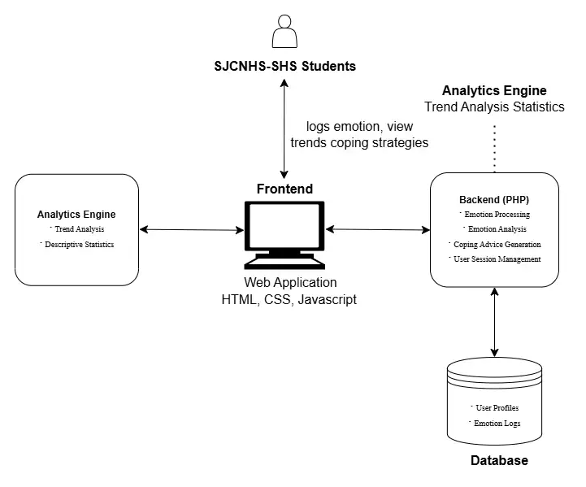

Figure 3: Presents the System Architecture Diagram, highlighting the core components and data flow of the system

Development Tools and Technologies
The development of Emotion Track web application utilizes tools and technologies including PHP, HTML, CSS, and JavaScript for the development phase. For database management, PHPMyAdmin, integrated with XAMPP, will be used. VS Code served as the primary development tool for writing and editing the actual code. Emotion Track will be deployed on a hosting website for deployment. Lastly, the project did not have any specific hardware requirements beyond a standard computer for development.

Implementation Process
The development of Emotion Track web application followed through the Agile Methodology, with 2 weeks per sprint including the elements of Scrum Framework to manage the developmental process. This method allowed the team to be flexible, make iterative development with continuous feedback throughout the project cycle.

Software Development Methodologies
Agile Methodology
Agile is a software development methodology emphasizing iterative development, collaboration, and flexibility in response to change. It involves breaking down projects to smaller, manageable iteration for the development team, with frequent feedback with the collaboration of clients, users, and stakeholders.
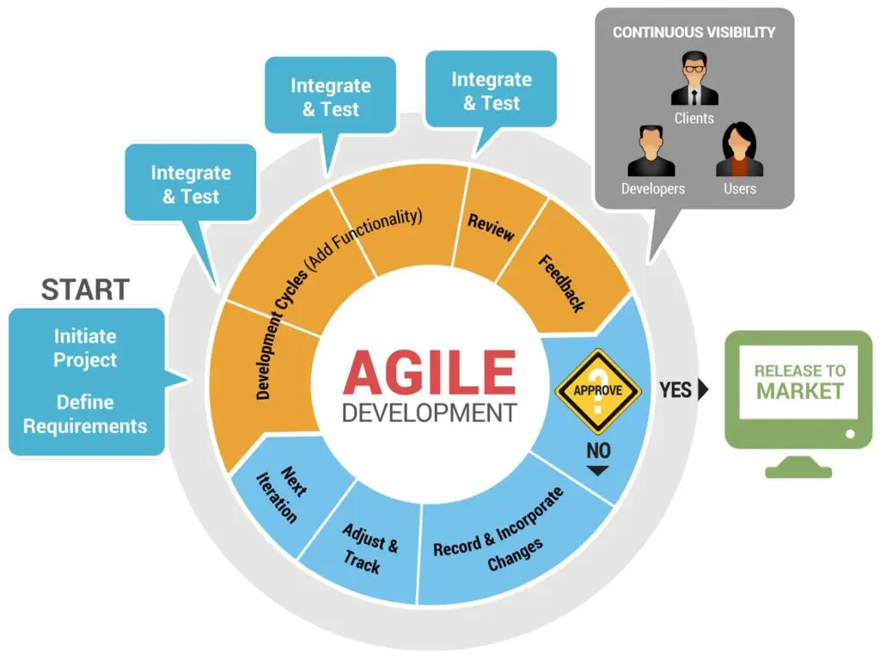
Figure 4: Agile Development Lifecycle (CyberHoot, 2020).

PLANNING
The researchers will conduct interviews within the Guidance Office of San Jose City National High School – Senior High School, where potential administrator users, guidance counselors and staffs will be the respondents. The user will also collaborate with them to identify the key requirements needed for developing the web application, ensuring that Emotion Track will meet the operational needs in SJCNHS – SHS.
Data Collection and Processing
Data will be collected from the San Jose City National High School – Senior High School. The information includes the data of senior high school students, and the guidance office designated guidance counselor. These records are essential for developing features of the system.
Interview Questions:
Guidance Counselors:
- How does the guidance office currently identify senior high students who are experiencing emotional struggles?
- What is the current process for students to seek emotional support from the guidance office?
- How do you track and manage ongoing counseling cases for students with emotional difficulties?
- What information is most crucial for you to record and access when providing emotional counseling to students?
- What are the biggest challenges the guidance office faces in providing timely and effective emotional support to the students at senior high school?
- How do you envision a web application assisting in the day-to-day operations of the guidance office, specifically regarding emotional support and advice for students?
- Are there any specific reporting needs or data points you’d like to easily access regarding student emotional well-being?

SJCNHS Senior High School Students:
- When you are facing emotional struggles, who or what is the first resource you typically turn to for help or support?
- What kind of emotional challenges or stressors do you feel are the most common among senior high school students?
- If there was a way to discreetly let the guidance office know you’re struggling, what would make you feel comfortable and safe using such a system?
- What kind of information or support would be most helpful to you when you’re feeling emotionally overwhelmed?
- What are some of the reasons you might hesitate to seek help from the guidance office or to other adults when facing emotional struggles?
- How do you currently manage or cope with emotional stress related to school, family, friends, or personal life?
- If you had a digital tool to help you with your emotional well-being, what features would you find most useful or important?

Feasibility Study
The developers will identify tasks, estimate the duration, sequence them logically, ensuring resource availability and develop contingency plans. This process will help them to determine the realism of completing the project within the timeframe, considering technical, operational, and economic feasibility.
Technical Feasibility
The developers will evaluate San Jose City National High School – Senior High School’s existing infrastructure and digital software such as student devices and computer laboratories to ensure it can support Emotion Track Web Application. This assessment includes examining the availability and specifications of mobile phones and school-based computers, along with the reliability of internet connectivity, essential for a web-based platform. The goal is to confirm that the school’s current technological environment is sufficient for seamless implementation and operation.
Operational Feasibility
The developers will assess if the SJCNHS – SHS guidance counselors and staff possesses necessary skills and knowledge to efficiently operate and analyze the Emotion Track web application system. This ensures they can successfully handle its core functions, such as logging into Emotion Track accounts, analyzing anonymized data, and managing student emotional support through the system. To gain insights into their computer or digital literacy, the developers will conduct interviews with staff and collect staff profiles to understand their educational backgrounds and capabilities better.
Economic Feasibility
The developers will conduct a comprehensive detailed analysis of the costs and expenses associated with the Emotion Track project, including both tangible (software) and intangible (hardware) benefits, to determine its overall financial viability. This assessment will cover the costs of development, deployment, and ongoing maintenance. It will also evaluate whether SJCNHS – SHS can support and sustain the systems’ long-term usage.
DESIGN
This phase involves developing Use Case Diagram, Context Diagram, Data Flow Diagram, Level 1 DFD, Entity Relationship Diagram, Fishbone Diagram, and a Prototype to illustrate how different users like the Guidance Office counselors and staffs, SJCNHS – SHS students interact with the web application system. The developers will provide a working prototype of the user interface of the Emotion Track to visualize the system’s layout, design, and features.
Use Case Diagram
The developers will create use case diagram to explain the core functionalities of the Emotion Track web application, designed to support students at SJCNHS - SHS in monitoring their emotional well-being. This will show the relationship between actors in the system, and how they will interact with it.
Context Diagram
The developers will create a context diagram to show how Emotion Track interacts with other actors. This includes the interactions between users and the system. This diagram shows how data enters, moves, and passes the system, helping define the system’s boundaries.
Data Flow Diagram
The developers will create a data flow diagram to illustrate the flow of information within the web application. It consists of data sources, data inputs, outputs, and several subprocesses.
Data Flow Diagram Level 1
The developers will also create a level 1 data flow diagram to illustrate the breakdown of a single process from data flow diagram into its sub processes. It will provide more detailed data flow from input to outputs of the Emotion Track web application system.
Entity Relationship Diagram (ERD)
The developers will create an ERD to represent the system’s database structure, highlighting the key entities with their relationships with each other. This diagram will serve for maintaining a logical relationship among stored data.
Fishbone Diagram
The developers will create a fishbone diagram to identify and categorize the possible causes of the problems being encountered by the staff and guidance counselors of San Jose City National High School – Senior High School
System Prototype
The developers will create a prototype for Emotion Track to provide a visualization for the user interface, design, and features for the system. This will be useful for the client’s feedback for improvements before proceeding with the actual development process.
DEVELOPMENT
The developers will follow the Scrum framework within Agile methodology that provides a structured set of roles, events, and artifacts to manage the development process. It focuses on time-boxed iterations called Sprints, daily team collaboration, and continuous improvement through Sprint Reviews and Retrospective.
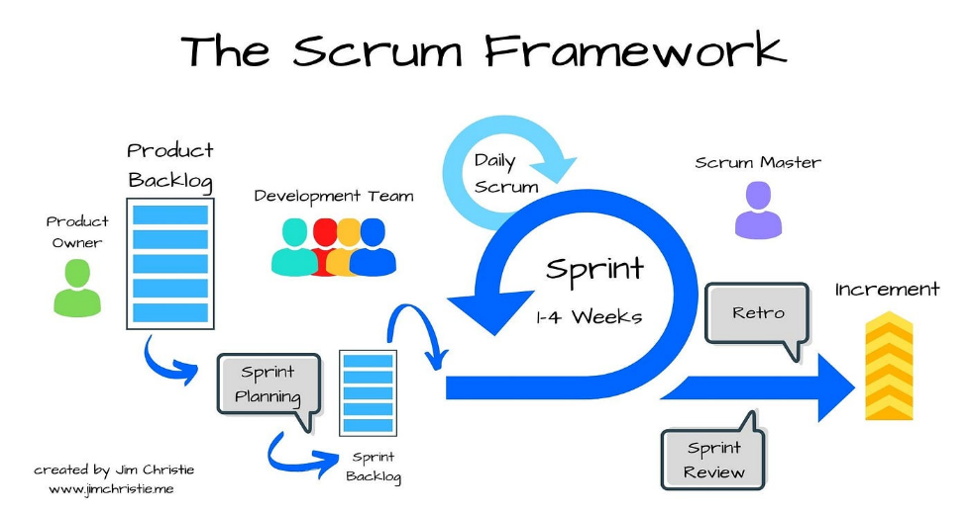

Figure 5: Iterative process of the Scrum Framework (Medium, n.d.).

Scrum Roles
Product Owner: SJCNHS – SHS Designated Guidance Counselor Ma’am Baby Liza L. Ciencia – provides system requirements to the development team and provide feedback to maximize the development process.
Scrum Master: Sigmond Ace D. Petralba – involves the overseeing the entire development process. This ensures the team consistently follows the principles, practices, and framework of Scrum.
Development Team: Raymond S. Luna and Teddy S. Baquiran Jr. – responsible for the overall development of the Emotion Track web application, including coding, designing, testing, and deployment.
Scrum Artifacts
Product Backlog: A prioritized list of features and requirements.
Sprint Backlog: The subset of the Product Backlog selected for the current Sprint.
Increment: The working software developed during a Sprint.
Scrum Events
Sprint: A time-boxed iteration (typically 1-4 weeks) during which a working increment is created.
Sprint Planning: The team plans the work for the current Sprint.
Daily Scrum (Stand-up): A short daily meeting for the development team to coordinate work.
Sprint Review: The team demonstrates the completed work to stakeholders.
Sprint Retrospective: The team reflects on the Sprint and identifies areas for improvement.

Development Timeline
The project will be completed over 10 sprints, which each sprint spanning one week. This supports iterative delivery, regular feedback integration, and continuous progress monitoring throughout the development cycle.

TESTING
The testing phase guarantees that the Emotion Track web application is reliable and error free, making stability and accuracy in data processing. Testing activities include Unit testing to verify individual functions and components. Integration testing to ensure proper interaction between pages or modules, and User Acceptance Testing (UAT) with SJCNHS - SHS students and the Guidance Office counselors to validate usability and effectiveness of the system.
Table 2: Test Cases
Fields | Description
Test Case ID | Unique identifier for the test case
Test Case Description: | Brief description of the test case’s purpose
Pre-conditions | List of conditions before executing the test case
Test Steps | List of actions to be performed during the test.
Test Data | Input data values required to execute the test case.
Expected Result | The anticipated outcome based on the test inputs and conditions.
Post Condition | The state of the system after executing the test.
Actual Result | The outcome observed after performing the test steps.
Status | Indicates whether the test case passed or failed.
Project Name | The title of the project under which the test is conducted.
Module Name | The specific module or component being tested.
Reference Document | Related documents or specifications that support the test case.
Created By | Name of individual who created the test case.
Date of Creation | The date when the test case was written.
Reviewed By | Name of the person who reviewed and validated the test case.
Date of Review | The date when the test case was reviewed.
Executed By | The person who performed the test case execution.
Date of Execution | The actual date the test was executed.
Comments | Additional remarks encountered during testing.

DEPLOYMENT
This phase involved setting up and launching an Emotion Track web application for use. This phase included configuring hosting sites, deploying web application files, and conducting beta testing with a limited group of student users to identify any deployment-related issues during the phase.
SYSTEM REVIEW
The Emotion Track will be tested again during this phase to make sure everything is working as expected. The development team along, along with the scrum master will gather feedback from SJCNHS – SHS guidance counselors and staffs to identify any issues or room for improvements.
SYSTEM LAUNCHING
During this phase, a live demonstration along with future users will be conducted to familiarize them with the Emotion Track web application’s features and guide them through its usage. The team will also provide a user manual to the client and staff. To assist with the transition, the SJCNHS – SHS will post an announcement in their active social account informing students that this will serve as an alternative for face-to-face guidance.

Ethical Considerations
The data that will be gathered from the client and the students will ensure that it is handled with utmost confidentiality and integrity. The process will also comply with the Data Privacy Act of 2012 (Republic Act No. 10173) which ensures protection of personal data and governs the responsible processing of such information.

Summary
This chapter outlined the planning and development process for the Emotion Track web application, emphasizing the Scrum Framework and Agile Methodology. While Scrum organized the development process using defined roles, sprint cycles, and ongoing feedback loops, Agile offered the flexibility and adaptability required for incremental advancement.

REFERENCES
Alqahtani, F., Winn, A., & Orji, R. (2021). Co-Designing a Mobile App to Improve Mental Health and Well-Being: Focus Group Study. JMIR Formative Research, 5(2), e18172. https://doi.org/10.2196/18172
Alqahtani, F., & Orji, R. (2020). Insights from user reviews to improve mental health apps. Health Informatics Journal, 26(3), 1987-2005. https://doi.org/10.1177/1460458219896492
Eisenstadt, M., Liverpool, S., Infanti, E., Ciuvat, R. M., & Carlsson, C. (2021). Mobile Apps That Promote Emotion Regulation, Positive Mental Health, and Well-being in the General Population: Systematic Review and Meta-analysis. JMIR Mental Health, 8(11), e31170. https://doi.org/10.2196/31170
Haque, M. D. R., & Rubya, S. (2023). An Overview of Chatbot-Based Mobile Mental Health Apps: Insights From App Description and User Reviews. JMIR mHealth and uHealth, 11, e44838. https://doi.org/10.2196/44838
Jimu, P., & Mwakiseghire, M. (2024). Mental Health Support App with Mood Tracking and Resources. i-Manager’s Journal on Mobile Applications & Technologies, 11(1), 5-15.
Plotkina, D., Valentini, T., & Castéran, H. (2024). App yourself: A meta-analysis of the effectiveness of mobile apps on employee well-being and mental health. International Journal of Stress Management, 32(1), 31–46. https://doi.org/10.1037/str0000345
Rohani, D. A., Springer, A., Hollis, V., Bardram, J. E., & Whittaker, S. (2021). Recommending Activities for Mental Health and Well-Being: Insights from Two User Studies. IEEE Transactions on Emerging Topics in Computing, 9(3), 1183-1193. https://doi.org/10.1109/TETC.2020.2972007
Samuel, M., & Shirley, C. P. (2023). Mindset, An Android-Based Mental Wellbeing Support Mobile Application. Proceedings of the 3rd International Conference on Pervasive Computing and Social Networking (ICPCSN), 989-996. https://doi.org/10.1109/ICPCSN58827.2023.00169
Szinay, D., Jones, A., Chadborn, T., Brown, J., & Naughton, F. (2020). Influences on the Uptake of and Engagement with Health and Well-Being Smartphone Apps: Systematic Review. Journal of Medical Internet Research, 22(5), e17572. https://doi.org/10.2196/17572S
Williams, J. E., & Pykett, J. (2022). Mental health monitoring apps for depression and anxiety in children and young people: A scoping review and critical ecological analysis. Social Science & Medicine, 297, 114802. https://doi.org/10.1016/j.socscimed.2022.114802
Woodward, K., et al. (2022). Beyond Mobile Apps: A Survey of Technologies for Mental Well-Being. IEEE Transactions on Affective Computing, 13(3), 1216-1235.
Woodward, K., Pyarelal, A. K., O'Neal, E. S., & D'Mello, S. K. (2022). Beyond Mobile Apps: A Survey of Technologies for Mental Well-Being. IEEE Transactions on Affective Computing, 13(3), 1216–1235. https://doi.org/10.1109/TAFFC.2020.3015018
Williams, J. E., & Pykett, J. (2022). Mental health monitoring apps for depression and anxiety in children and young people: A scoping review and critical ecological analysis. Social Science & Medicine, 297, 114802. https://doi.org/10.1016/j.socscimed.2022.114802
Szinay, D., Jones, A., Chadborn, T., Brown, J., & Naughton, F. (2020). Influences on the Uptake of and Engagement with Health and Well-Being Smartphone Apps: Systematic Review. Journal of Medical Internet Research, 22(5), e17572. https://doi.org/10.2196/17572
Nweke, C. M., & Onuoha, B. S. (2023). Mental health education, awareness, and stigma regarding mental illness among college students. Mental Health Journal, 2(1), 1–10. Retrieved from https://www.mentalhealthjournal.org/articles/mental-health-education-awareness-and-stigma-regarding-mental-illness-among-college-students.html
CyberHoot. (2020). Agile Development Lifecycle. Retrieved from https://cyberhoot.com/wp-content/uploads/2020/06/agile-development-diagram1-min-1024x769.jpg
Medium. (n.d.). Iterative process of the Scrum Framework. Retrieved from https://miro.medium.com/v2/resize:fit:1400/1 *pAjNWHhl2kERAU3JzZaN2A.jpeg

APPENDICES
Appendix A

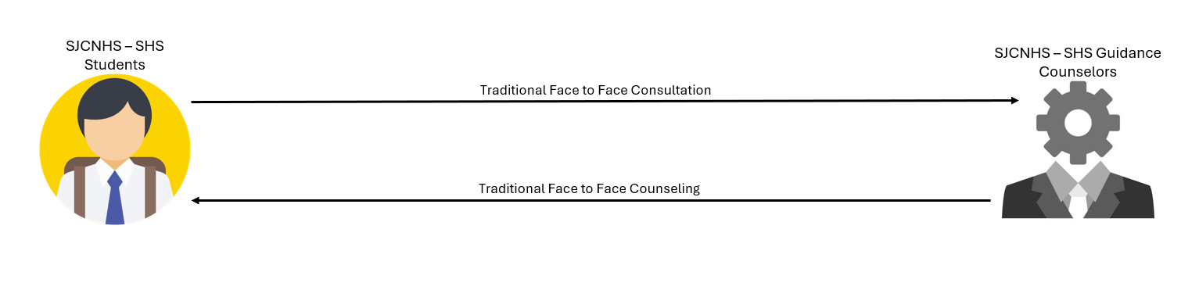
Existing System

Figure 4. Existing System (Conceptual Diagram for Application Process)

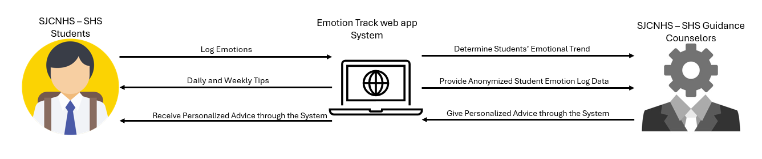
Proposed System

Figure 5. Proposed System (Conceptual Diagram for Application Process)

Appendix B
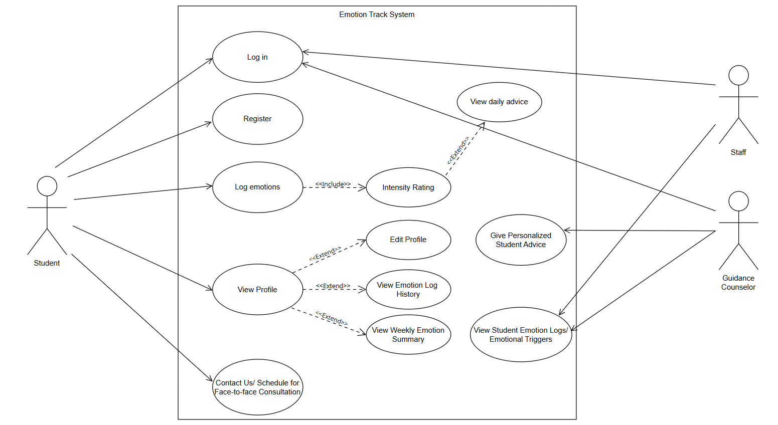
Use Case Diagram

Figure 6. Use Case Diagram

Appendix C
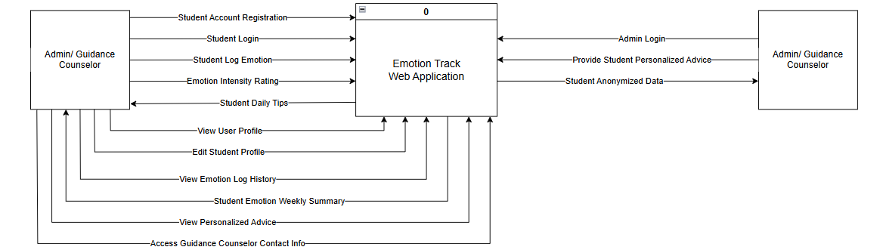
Context Diagram
Figure 7. Context Diagram

Appendix D
Data Flow Diagram
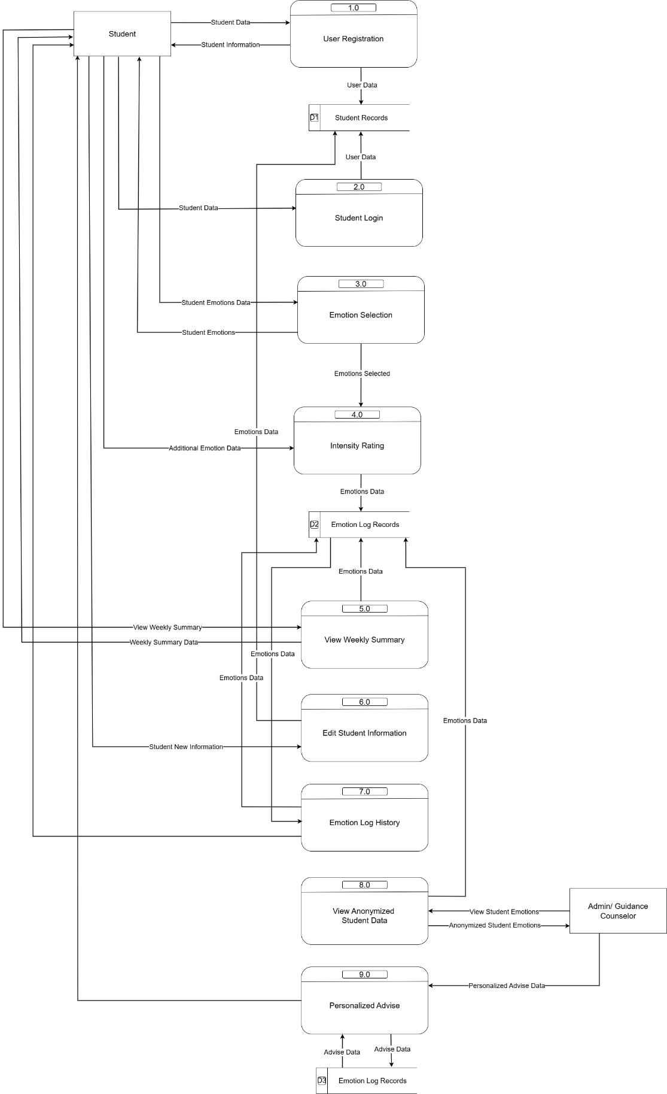
Figure 8: Data Flow Diagram
Appendix E
Level 1 DFD Process 1
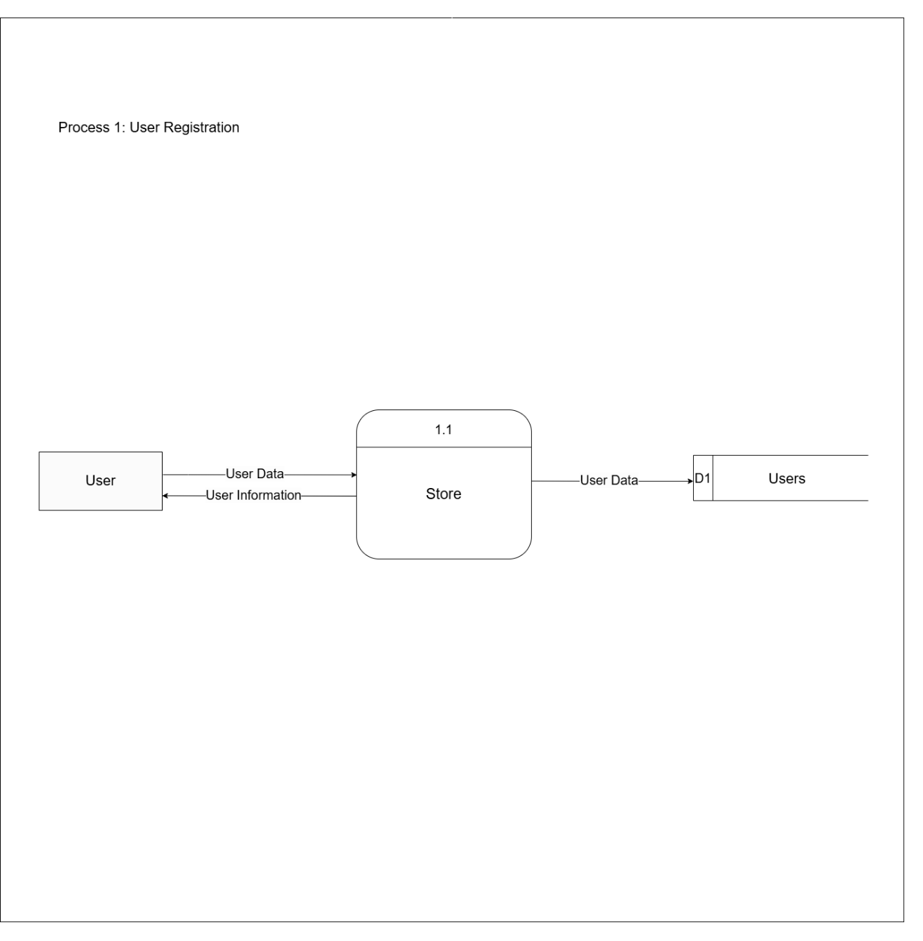
Figure 9: Exploded Data Flow Diagram 1.0

Appendix F
Level 1 DFD Process 2
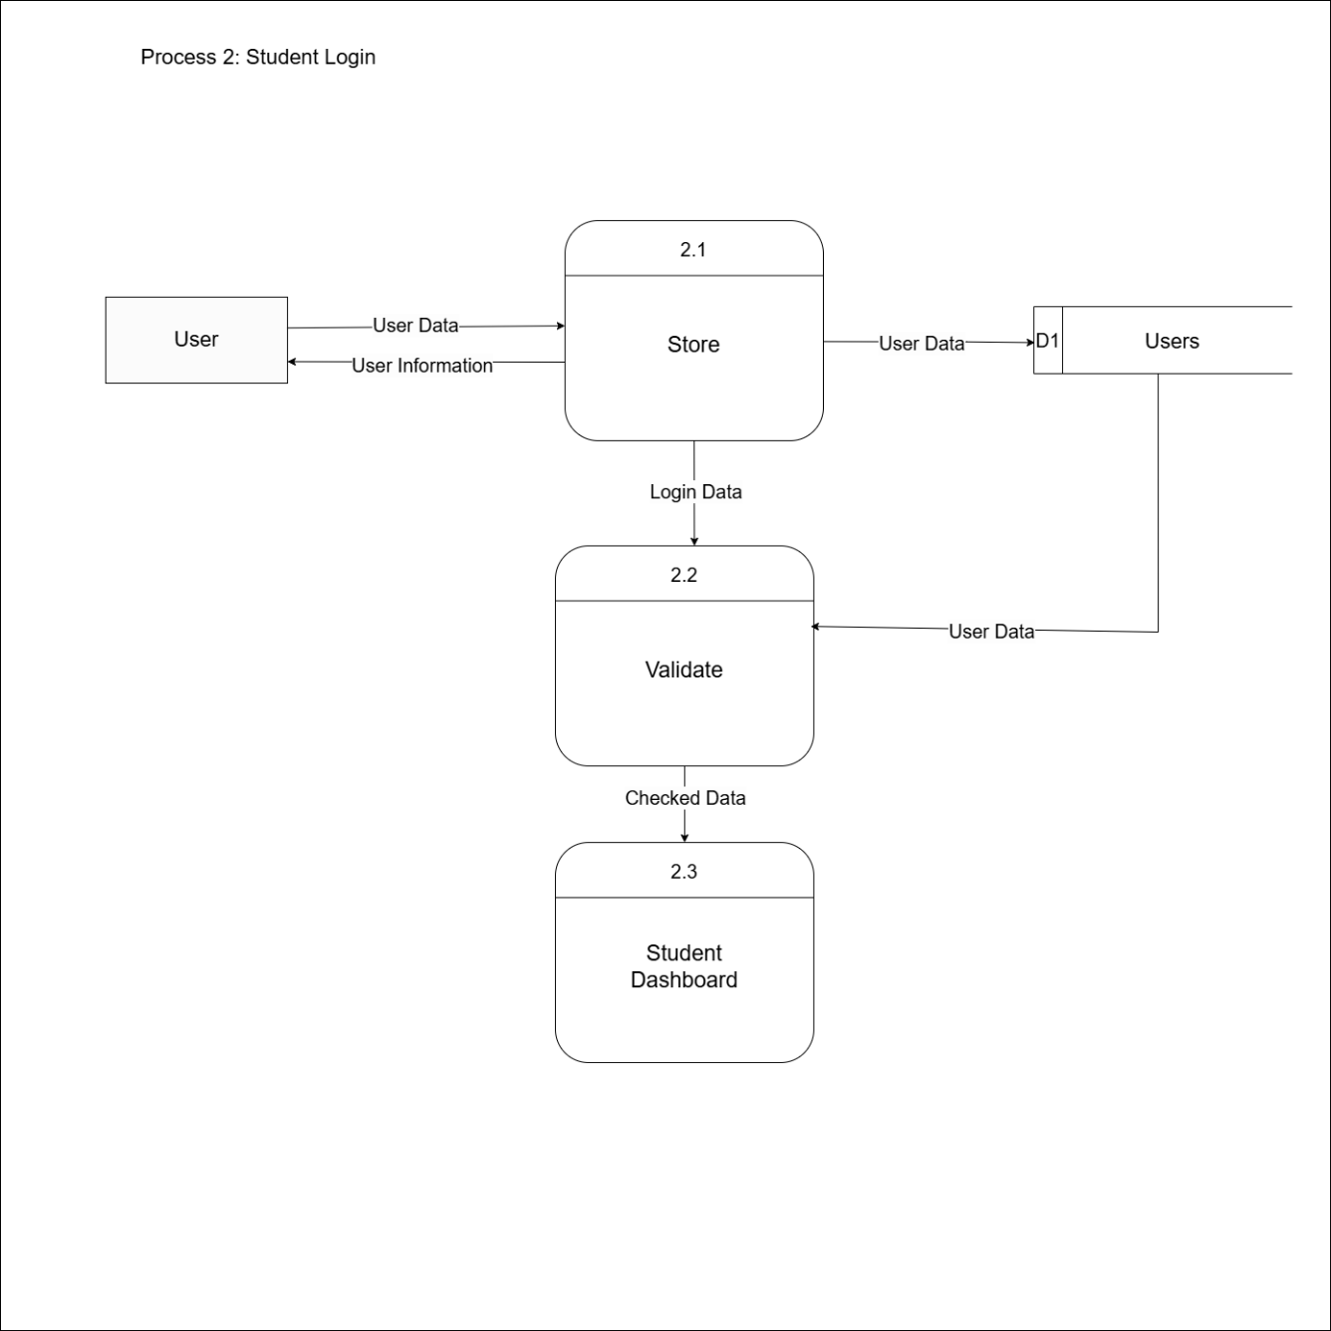
Figure 10: Exploded Data Flow Diagram 2.0

Appendix G
Level 1 DFD Process 3
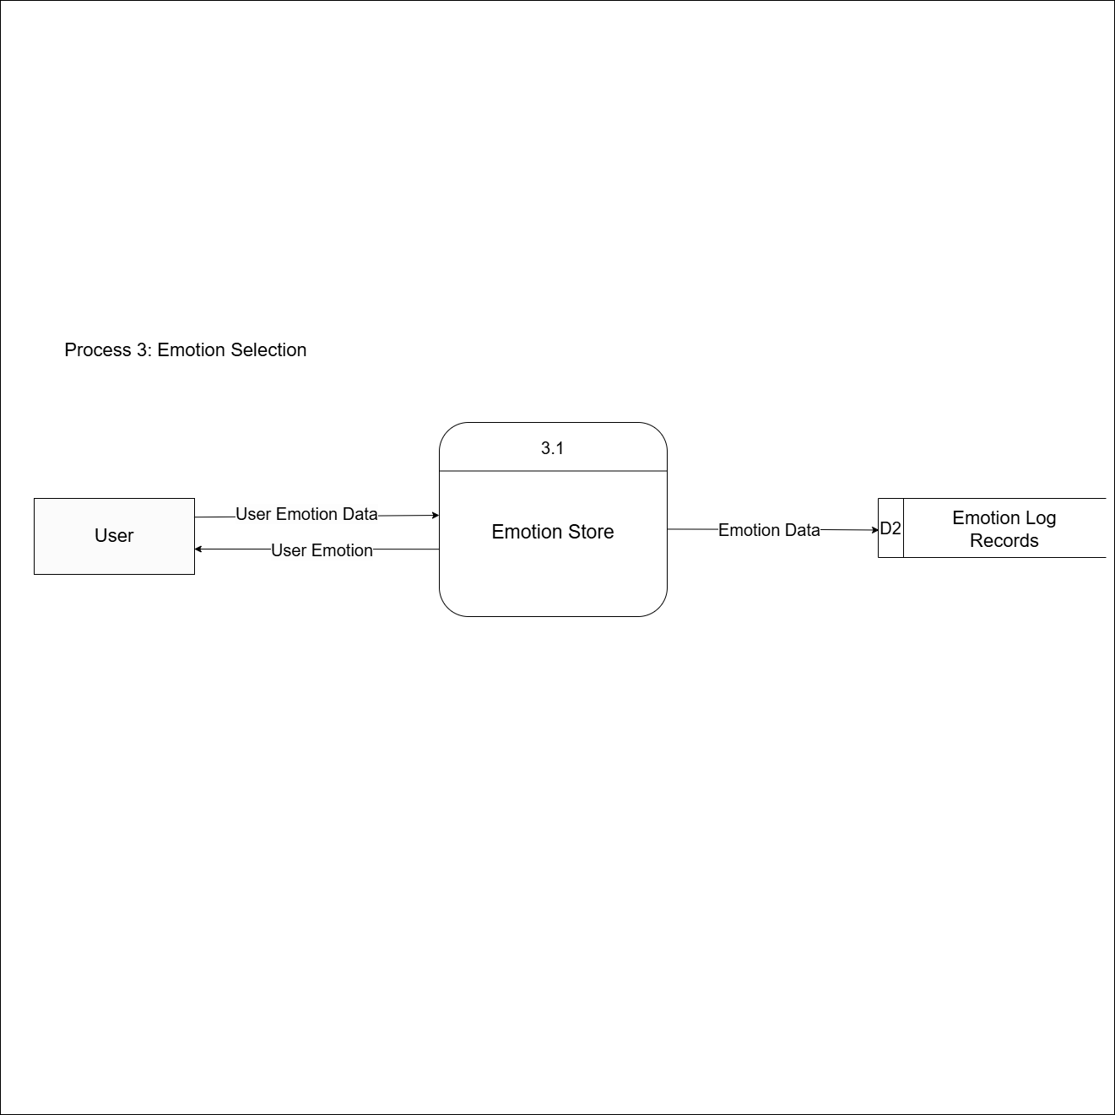
Figure 11: Exploded Data Flow Diagram 3.0

Appendix H
Level 1 DFD Process 4
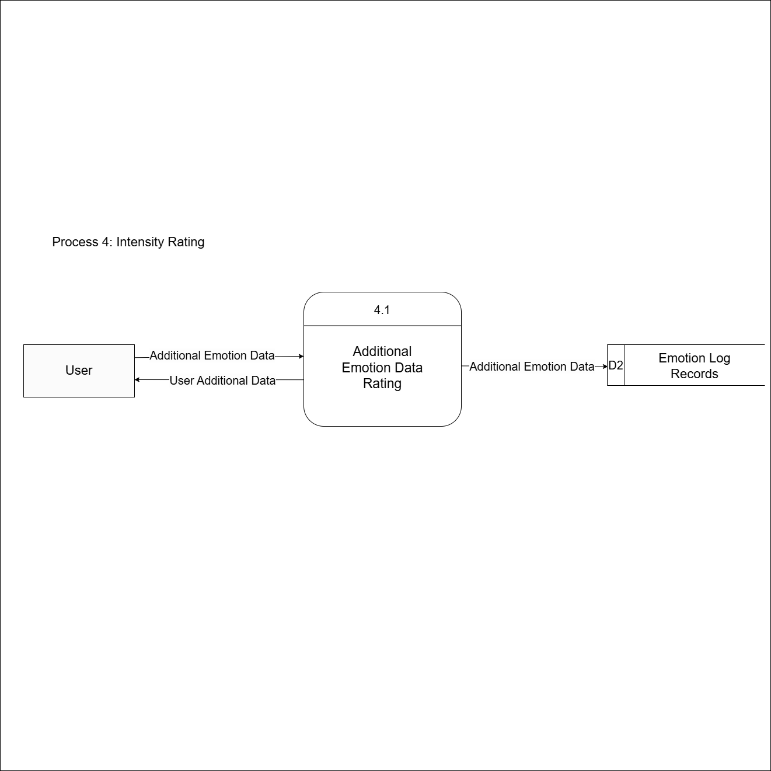
Figure 12: Exploded Data Flow Diagram 4.0

Appendix I
Level 1 DFD Process 5
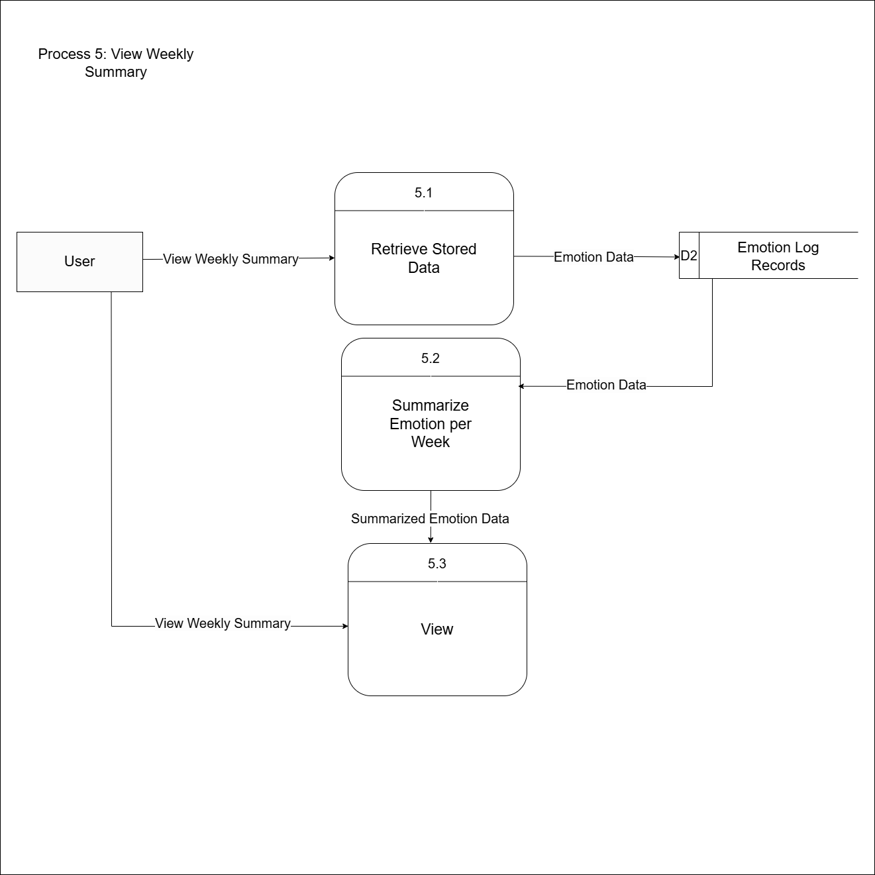
Figure 13: Exploded Data Flow Diagram 5.0

Appendix J
Level 1 DFD Process 6
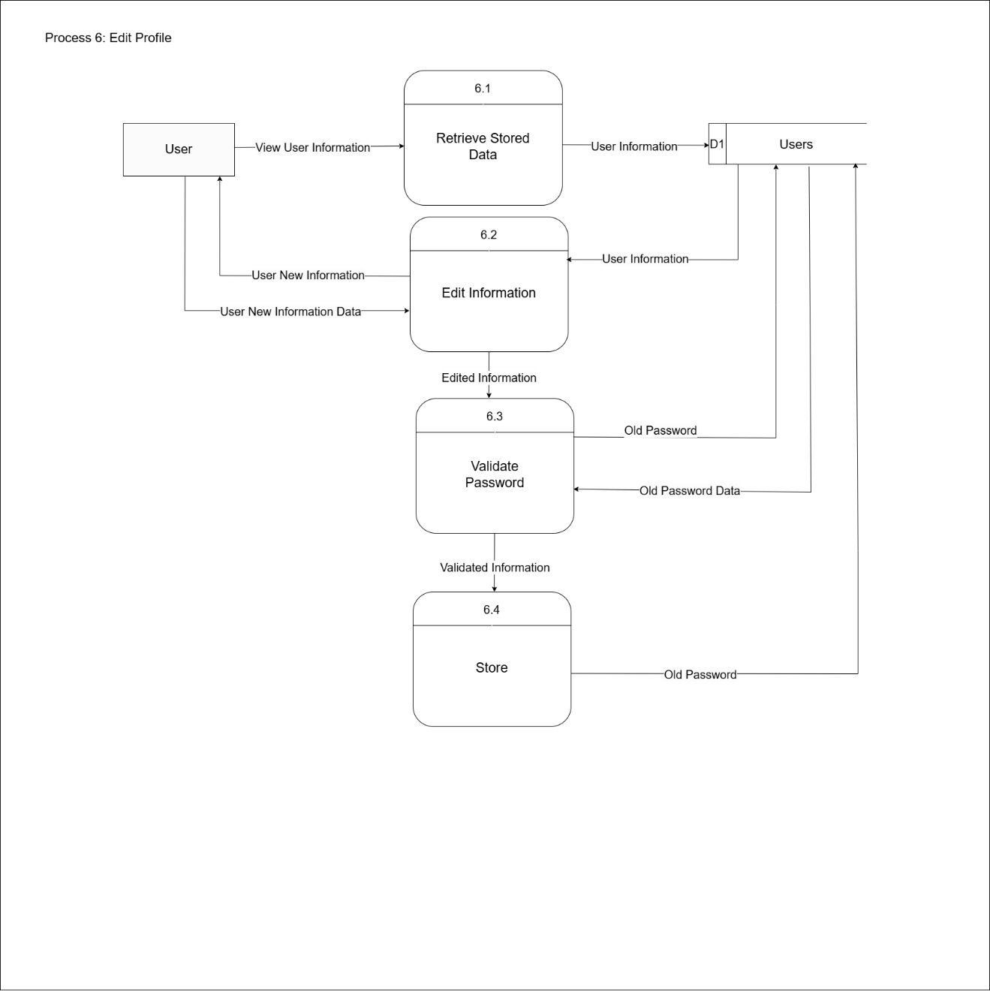
Figure 14: Exploded Data Flow Diagram 6.0

Appendix K
Level 1 DFD Process 7
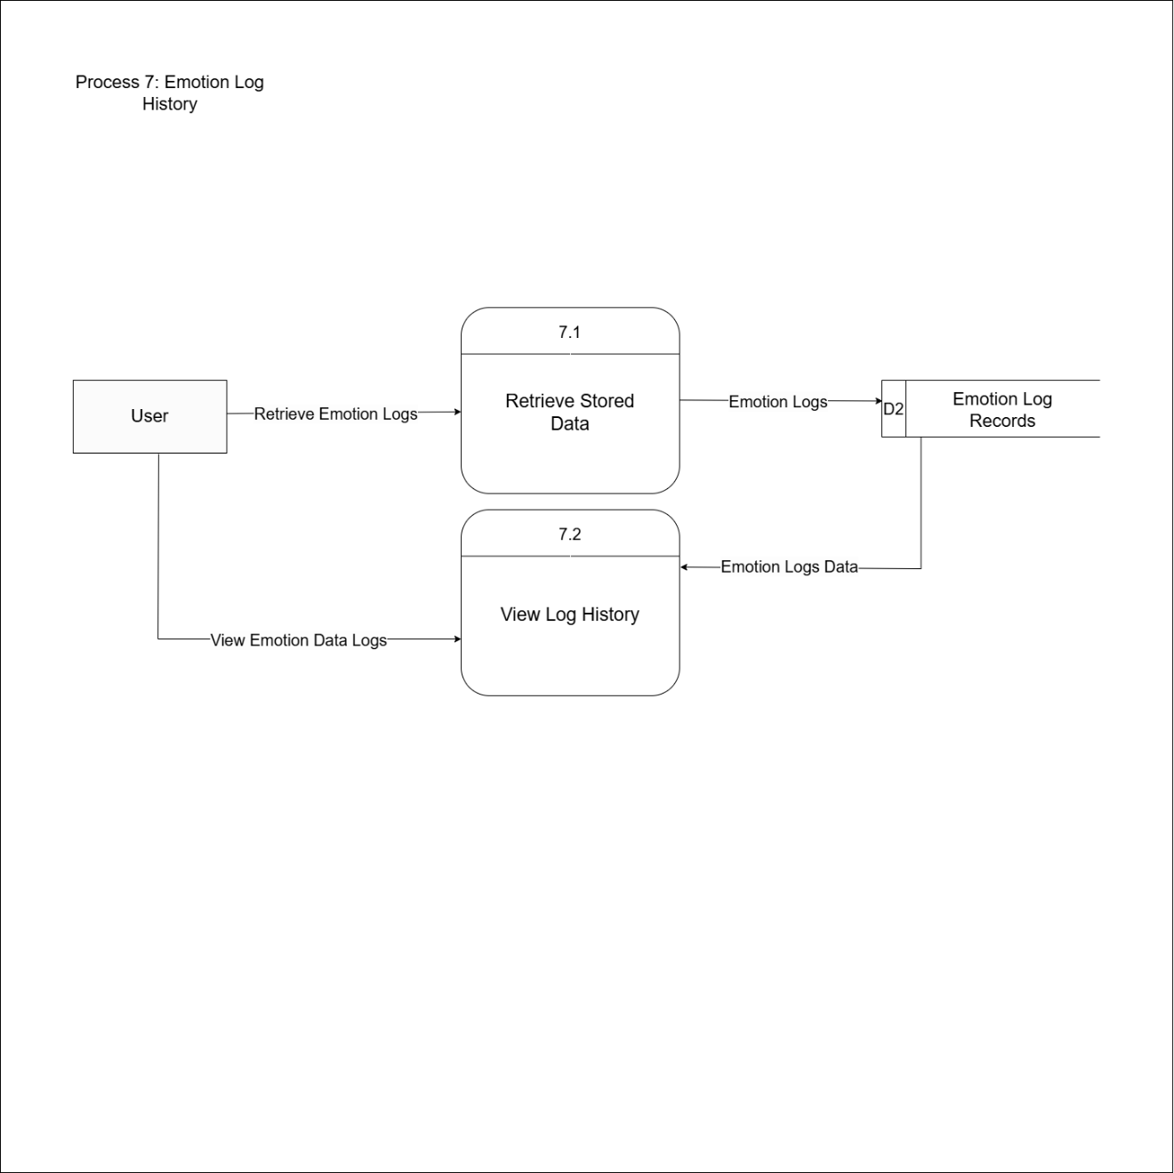
Figure 15: Exploded Data Flow Diagram 7.0

Appendix L
Level 1 DFD Process 8
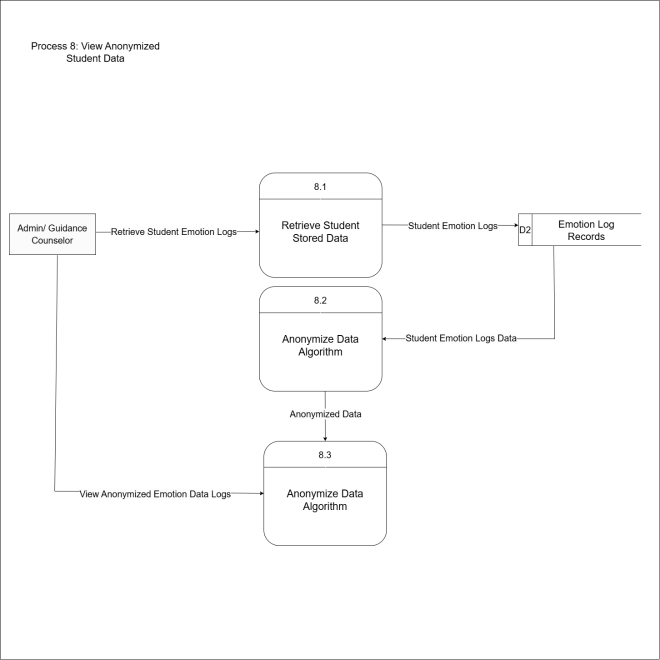
Figure 16: Exploded Data Flow Diagram 8.0

Appendix M
Level 1 DFD Process 9
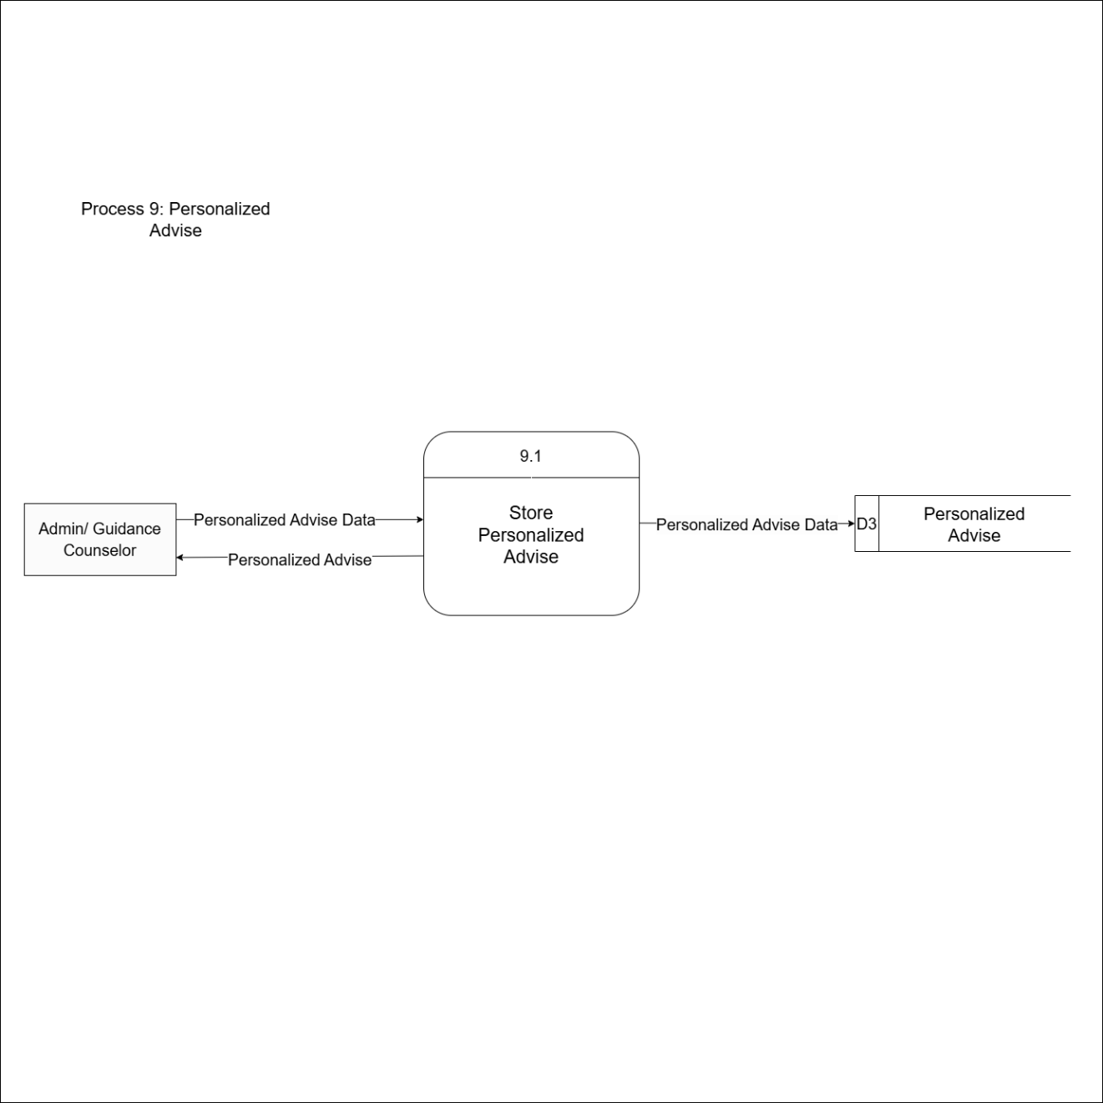
Figure 17: Exploded Data Flow Diagram 9.0

Appendix N
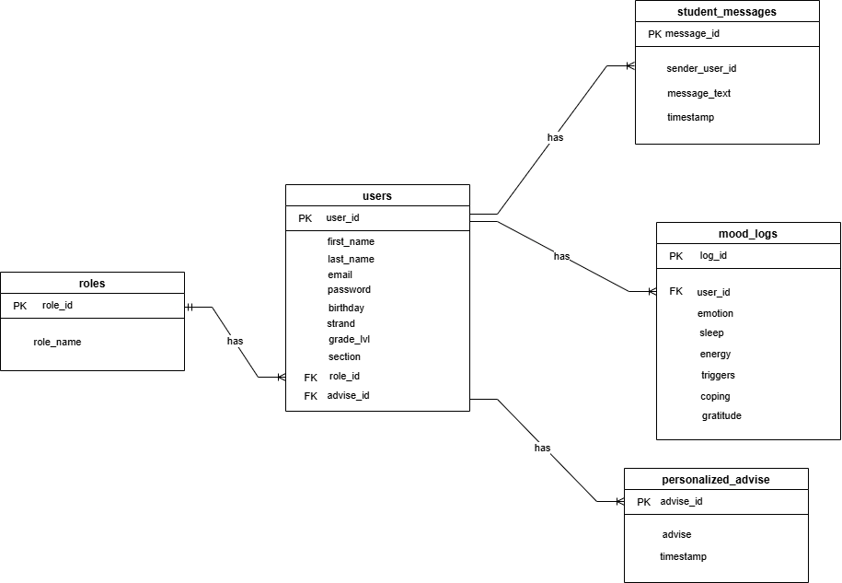
Entity Relationship Diagram
Figure 18: Entity Relationship Diagram

Appendix O
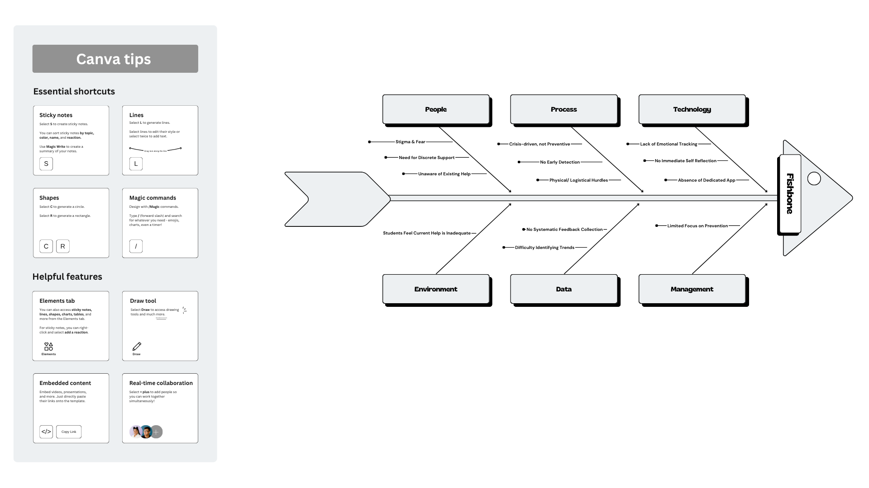
Fishbone Diagram
Figure 19: Fishbone Diagram

Appendix P
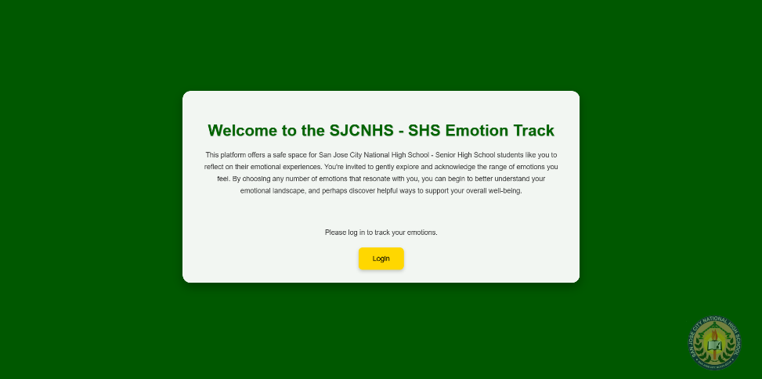
Figure 20: Student Landing Page UI
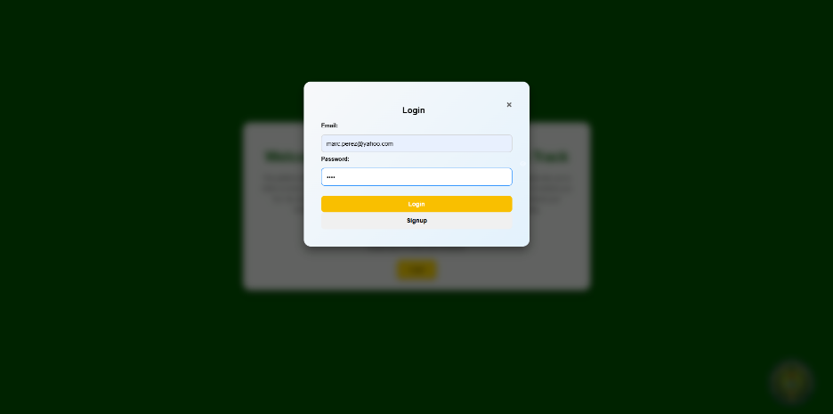
Figure 21: Student Login Page UI

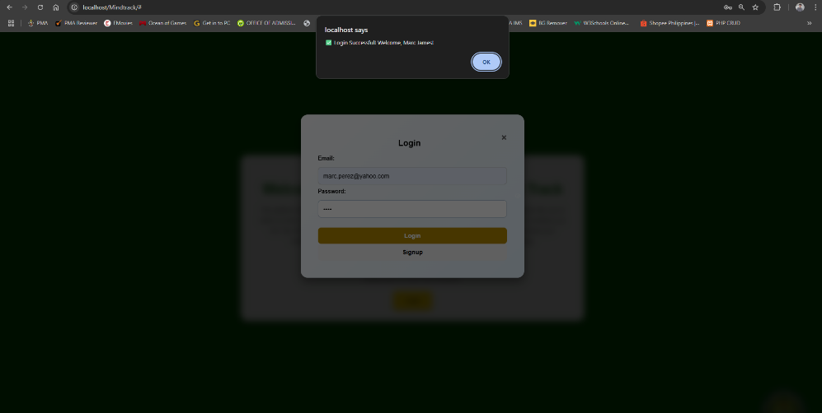
Figure 22: Student Login Page UI
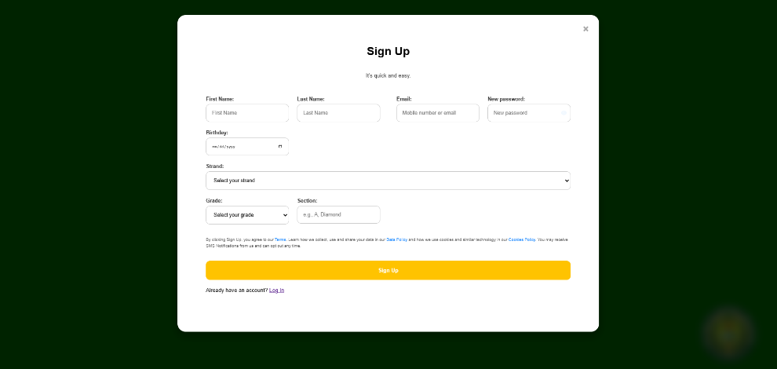
Figure 23: Student Registration Page UI

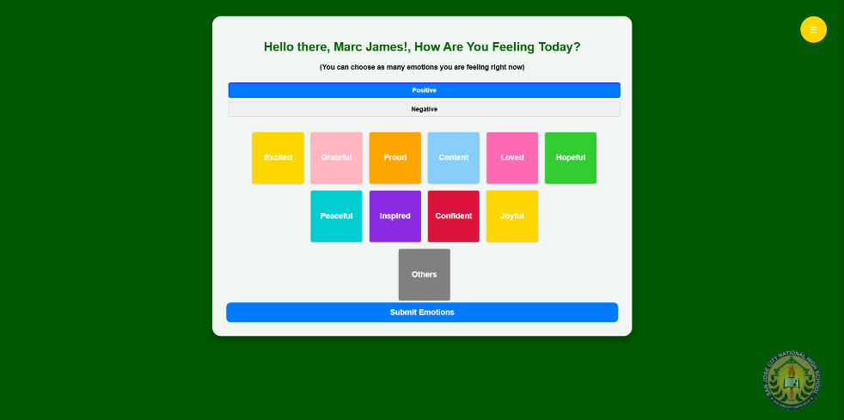
Figure 24: Student Dashboard/ Positive Emotion Selection UI

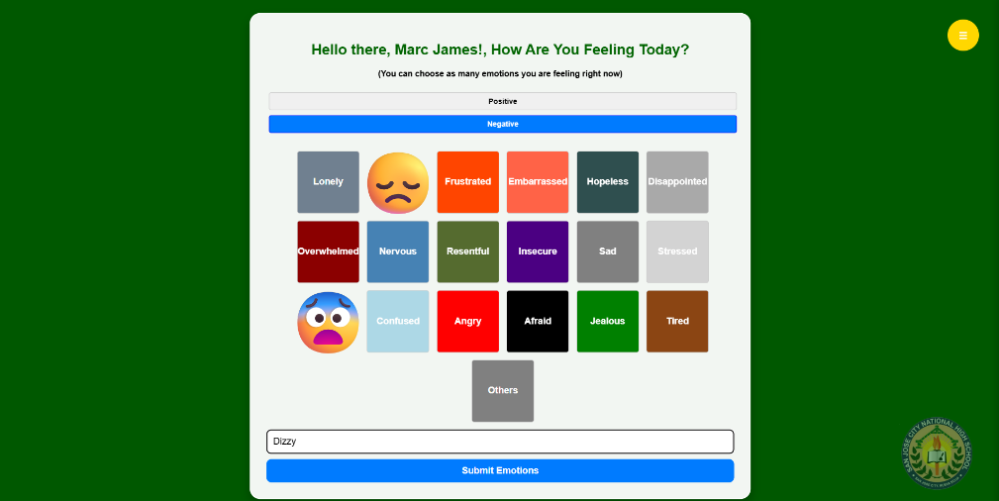
Figure 25: Student Dashboard/ Positive Emotion Selection UI
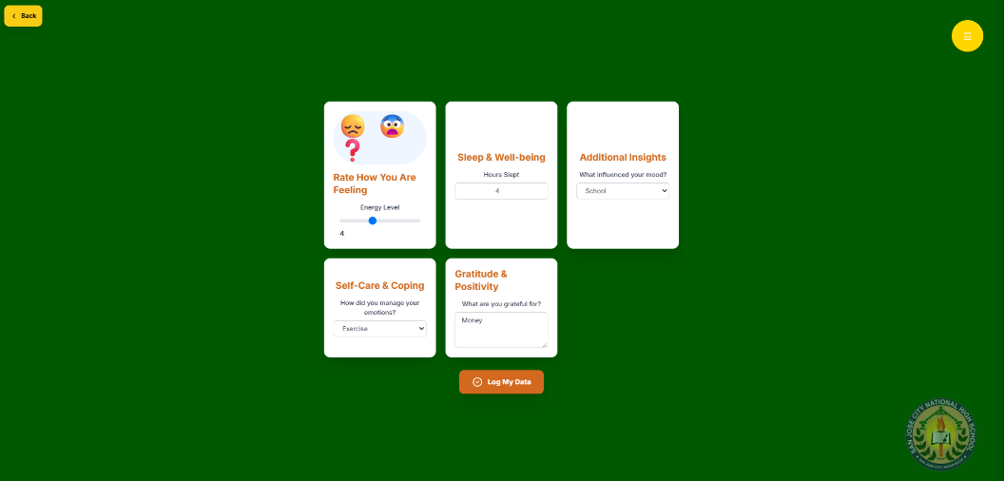
Figure 26: Emotion Intensity Rating UI

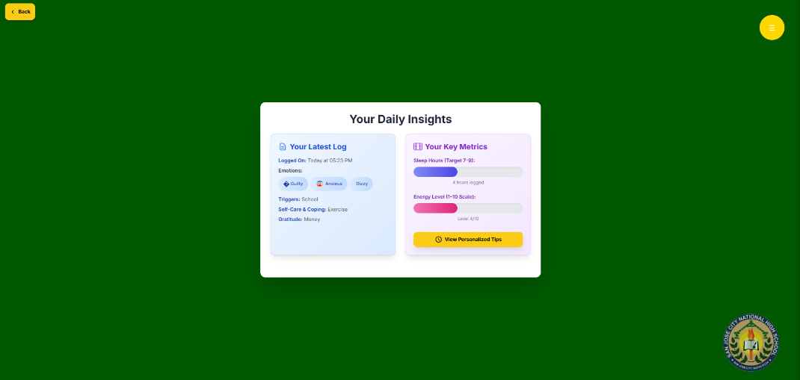
Figure 27: Latest Log Summary UI

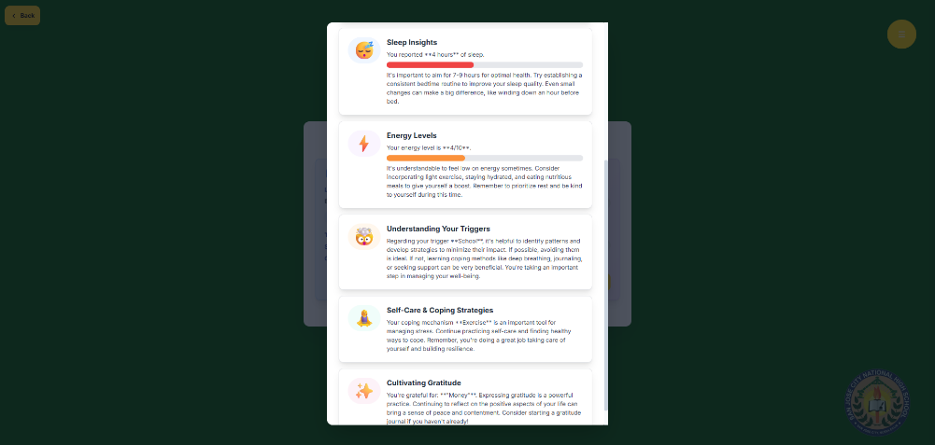
Figure 28: Daily Tips UI
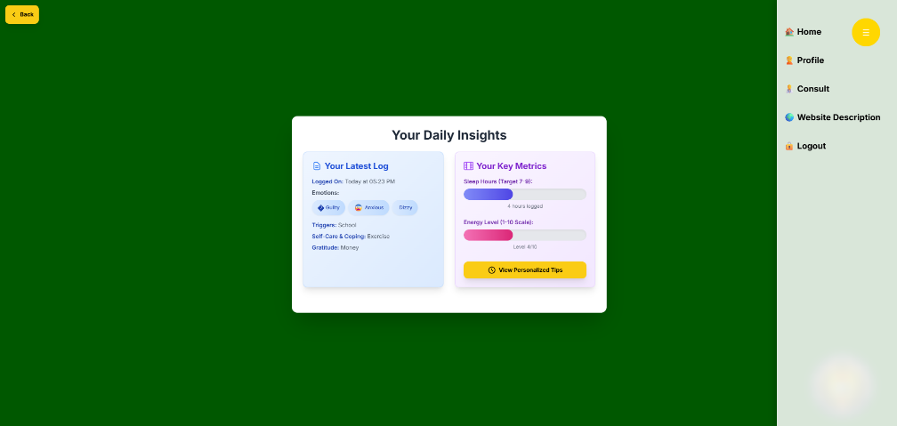
Figure 29: Sidebar UI

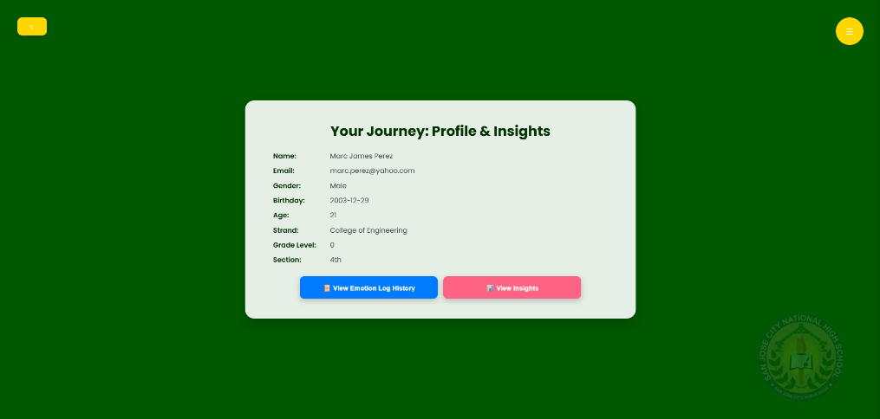
Figure 30: Profile Page UI

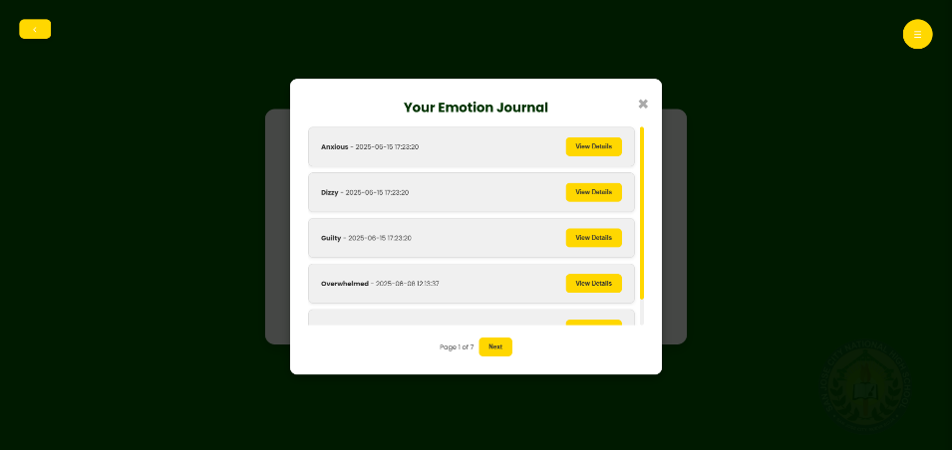
Figure 31: Emotion Log History

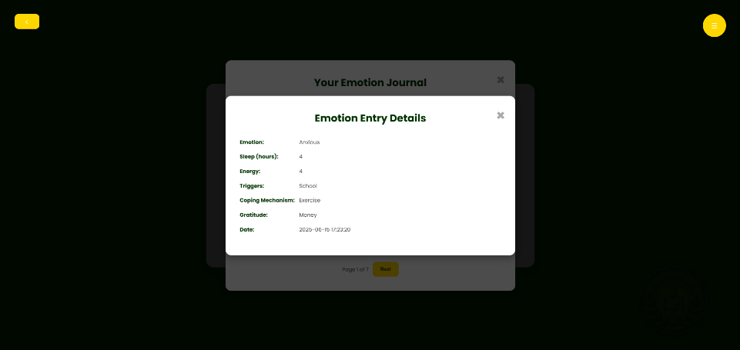
Figure 32: Log History Details UI

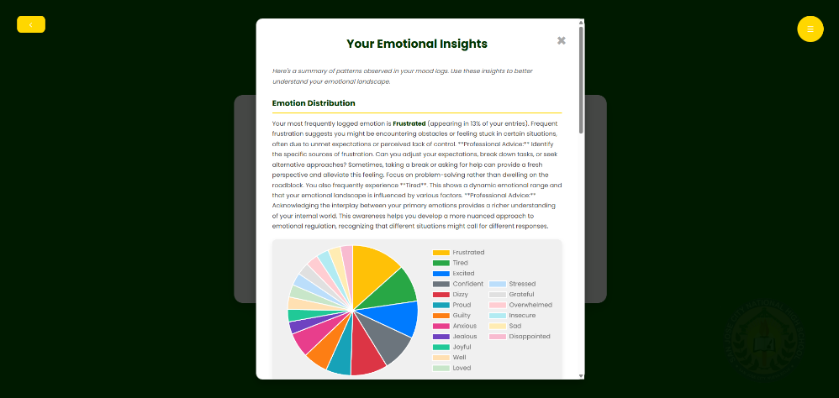
Figure 33: Weekly Emotion Insights UI
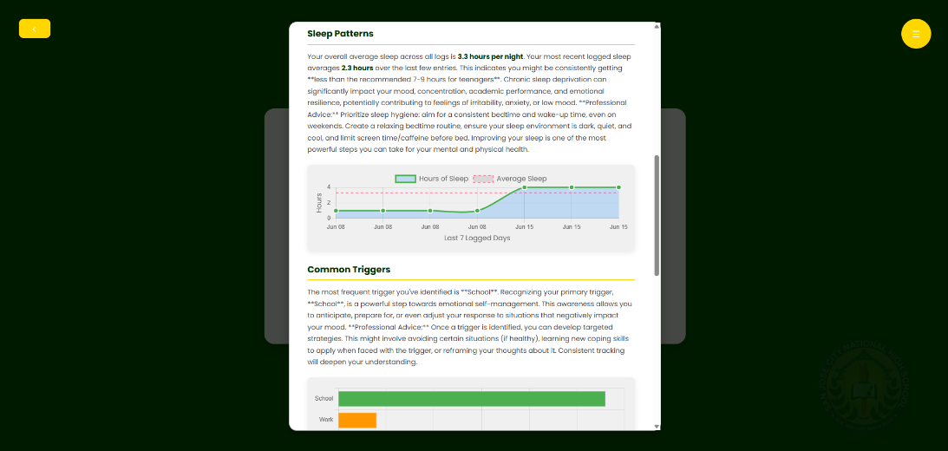
Figure 34: Weekly Emotion Insights continuation. UI

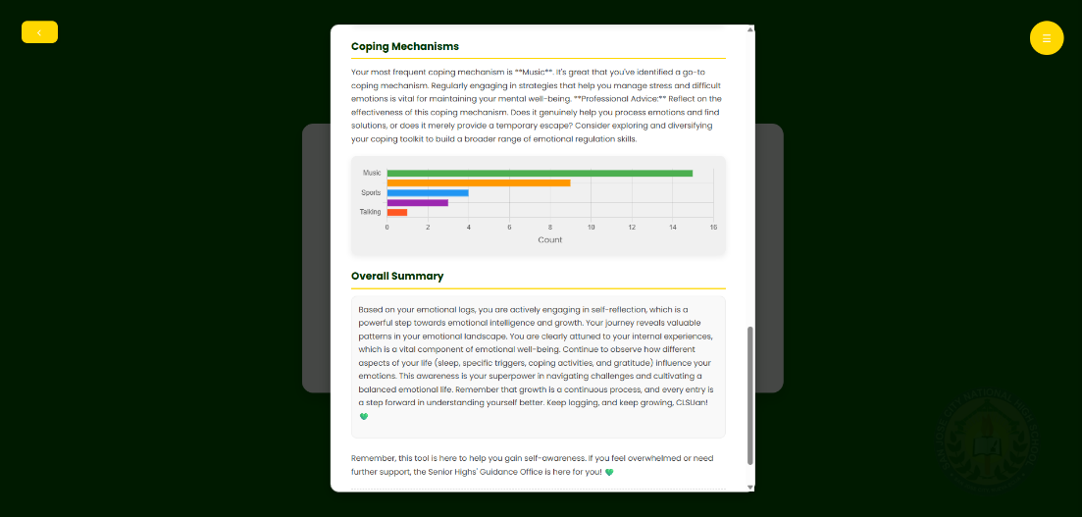
Figure 35: Weekly Emotion Insights continuation. UI

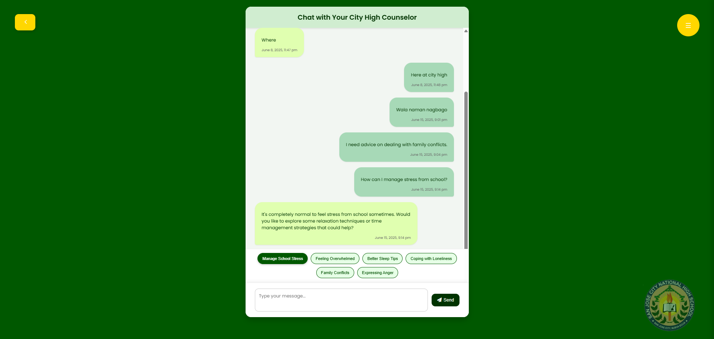
Figure 36: Guidance Office Consultation UI

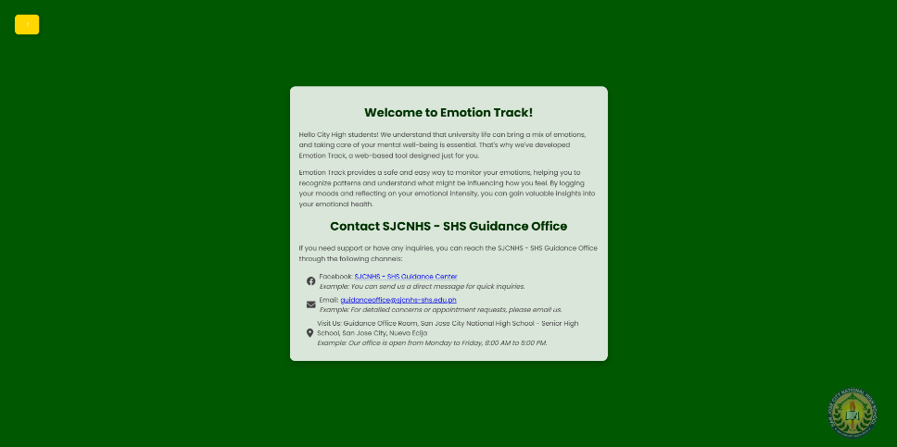
Figure 37: Website Description/ Contacts UI

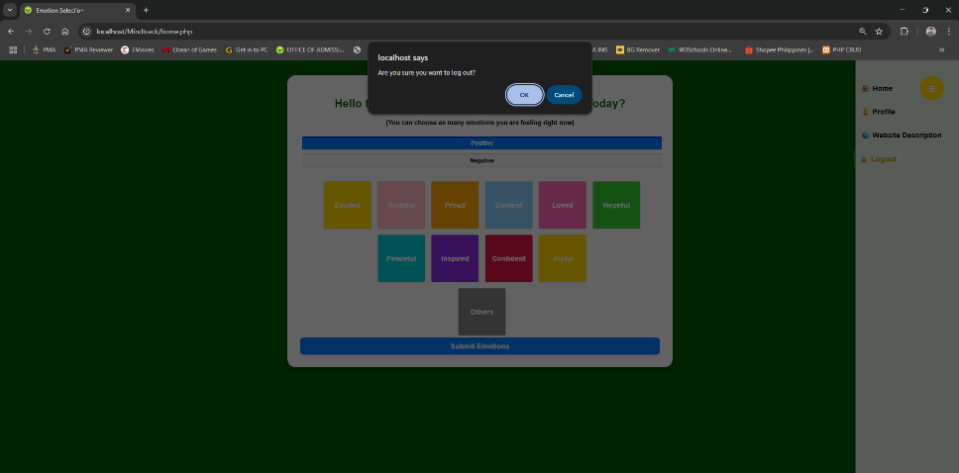
Figure 38: Logout Page UI

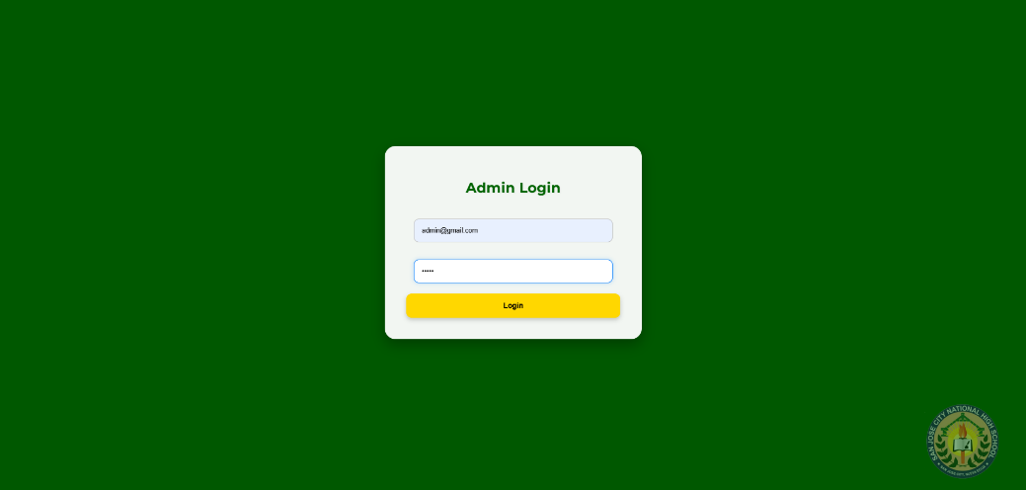
Figure 39: Admin Login UI

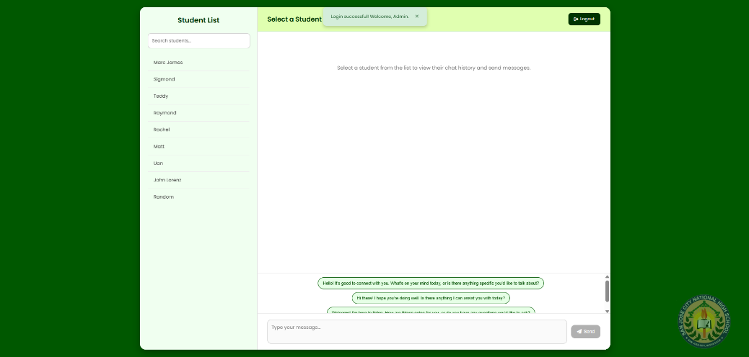
Figure 40: Admin Dashboard UI
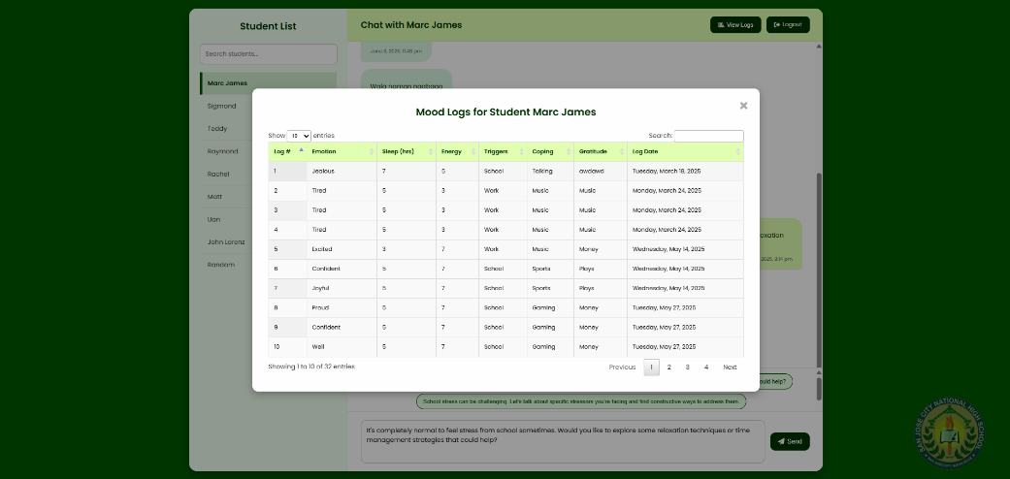
Figure 41: Student Mood Logs Monitoring UI

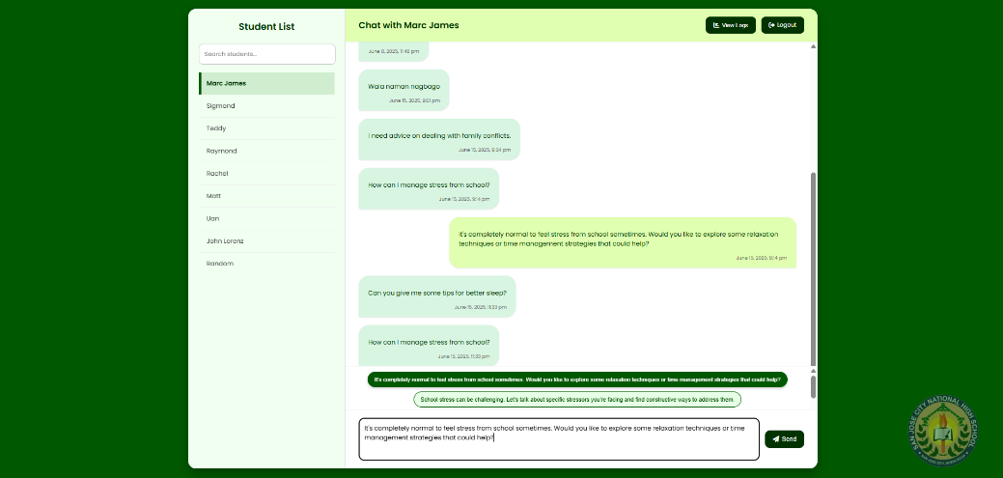
Figure 42: Admin Consultation UI

