# UML Diagrams

## Requirement 1

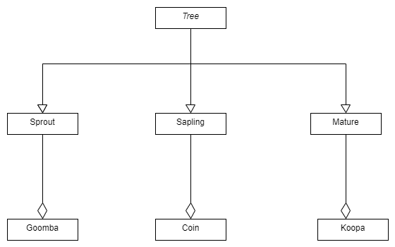

## Requirement 2

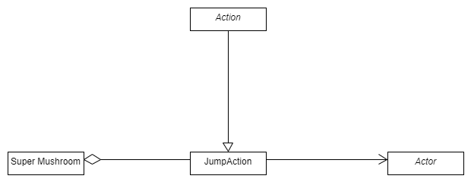

## Requirement 3

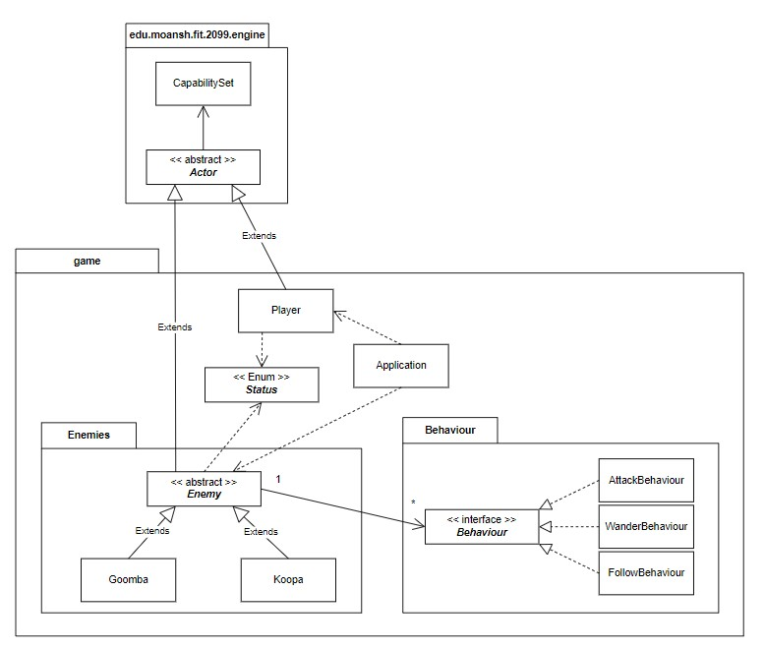

## Requirement 4

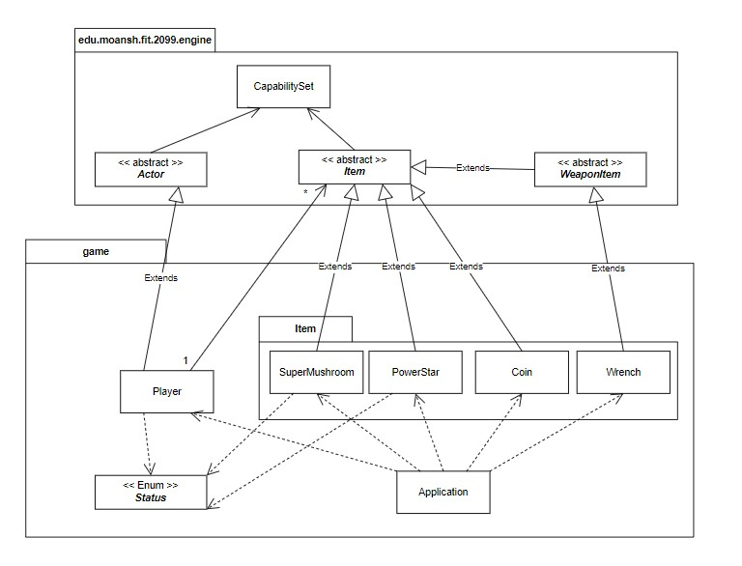

## Requirement 5

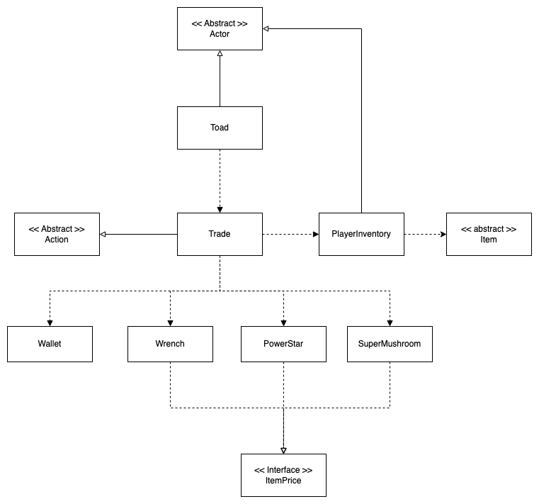

## Requirement 6

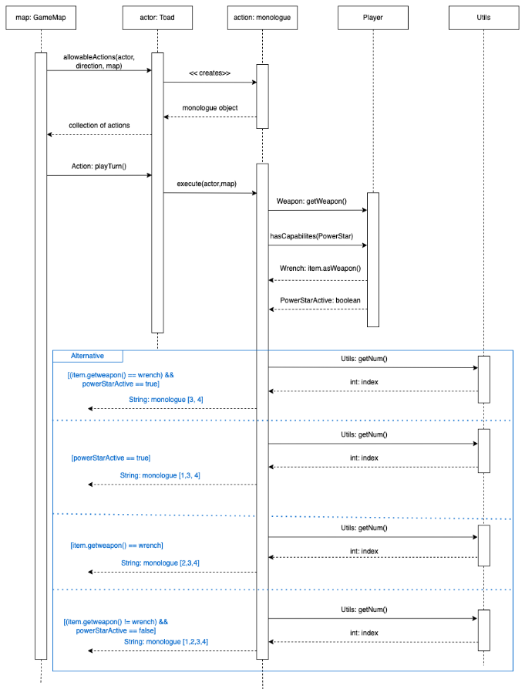

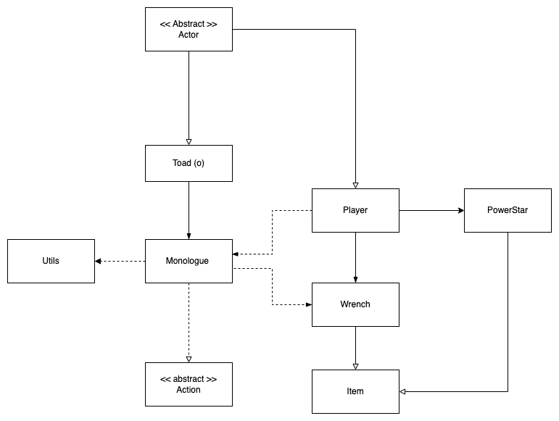

## Requirement 7

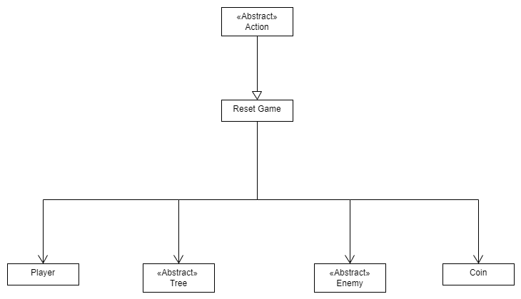

# Work Breakdown Agreement

Each team member is responsible for the deliverable they have been assigned to. This ensures their responsibility in testing that deliverable as well.

However, the whole team is responsible for reviewing the deliverable from each individual and ensuring proper conduct of coding and output.

All team members are expected to complete their respective deliverable 3 days prior to submission date to ensure proper reviewing can be conducted. Testing and Reviews should be completed 24 hours

before deadline to guarantee no late submissions.

I, Neth Botheju, accept this WBA

I agree to this WBA - Jaspar

I agree to this WBA - Cyrus