PCA降维案例：iris

1.手动实施PCA
>>> iris = datasets.load_iris()

>>> col_mean = np.mean(iris.data,axis=0)
>>> col_mean
array([5.84333333, 3.054 , 3.75866667, 1.19866667])

>>> centered_data = iris.data - col_mean

>>> cov_data = np.cov(centered_data.T)
>>> cov_data
array([[ 0.68569351, -0.03926846, 1.27368233, 0.5169038 ],
[-0.03926846, 0.18800403, -0.32171275, -0.11798121],
[ 1.27368233, -0.32171275, 3.11317942, 1.29638747],
[ 0.5169038 , -0.11798121, 1.29638747, 0.58241432]])

>>> w,v = np.linalg.eig(cov_data)
>>> w
array([4.22484077, 0.24224357, 0.07852391, 0.02368303])

>>> v
array([[ 0.36158968, -0.65653988, -0.58099728, 0.31725455],
[-0.08226889, -0.72971237, 0.59641809, -0.32409435],
[ 0.85657211, 0.1757674 , 0.07252408, -0.47971899],
[ 0.35884393, 0.07470647, 0.54906091, 0.75112056]])

>>> np.dot(cov_data,v[:,0])
array([ 1.52765881, -0.34757296, 3.61888075, 1.51605845])
>>> w[0] * v[:,0]
array([ 1.52765881, -0.34757296, 3.61888075, 1.51605845])

>>> data_pca2c = np.dot(centered_data,v[:,0:2])

2.利用sklearn实施PCA
from sklearn.decomposition import PCA

保持4维
pca4c = PCA(n_components=4)
data_pca4c = pca4c.fit_transform(iris.data)
print data_pca4c.shape
(150, 4)
print pca4c.explained_variance_ratio_.sum()
1.0
print pca4c.components_
[[ 0.36158968 -0.08226889 0.85657211 0.35884393]
[-0.65653988 -0.72971237 0.1757674 0.07470647]
[ 0.58099728 -0.59641809 -0.07252408 -0.54906091]
[ 0.31725455 -0.32409435 -0.47971899 0.75112056]]

降至3维
pca3c = PCA(n_components=3)
data_pca3c = pca3c.fit_transform(iris.data)
print data_pca3c.shape
(150, 3)
print pca3c.explained_variance_ratio_.sum()
0.9948169145498101
print pca3c.components_
[[ 0.36158968 -0.08226889 0.85657211 0.35884393]
[-0.65653988 -0.72971237 0.1757674 0.07470647]
[ 0.58099728 -0.59641809 -0.07252408 -0.54906091]]

降至2维
pca2c = PCA(n_components=2)
data_pca2c = pca2c.fit_transform(iris.data)
print data_pca2c.shape
(150, 2)
print pca2c.explained_variance_ratio_.sum()
0.9776317750248033
print pca2c.components_
[[ 0.36158968 -0.08226889 0.85657211 0.35884393]
[-0.65653988 -0.72971237 0.1757674 0.07470647]]

降至1维
pca1c = PCA(n_components=1)
data_pca1c = pca1c.fit_transform(iris.data)
print data_pca1c.shape
(150, 1)
print pca1c.explained_variance_ratio_.sum()
0.9246162071742683
print pca1c.components_
[[ 0.36158968 -0.08226889 0.85657211 0.35884393]]

plt.scatter(data_pca1c[:,0],np.zeros(data_pca1c.shape),c=iris.target)
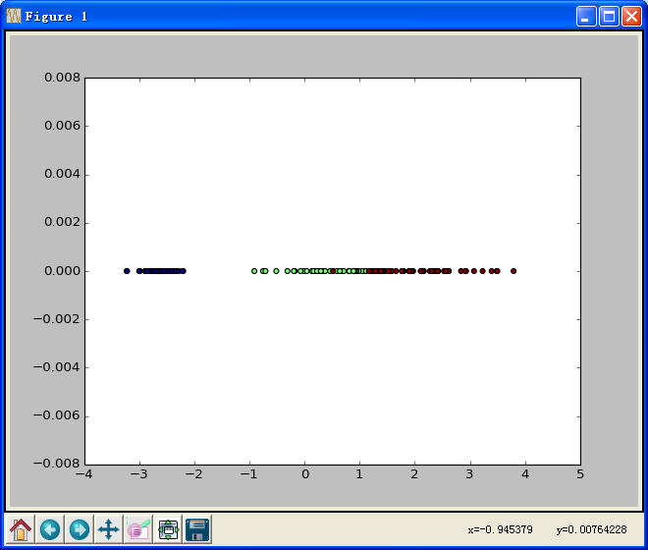

plt.figure(2)
plt.scatter(data_pca2c[:,0],data_pca2c[:,1],c=iris.target)
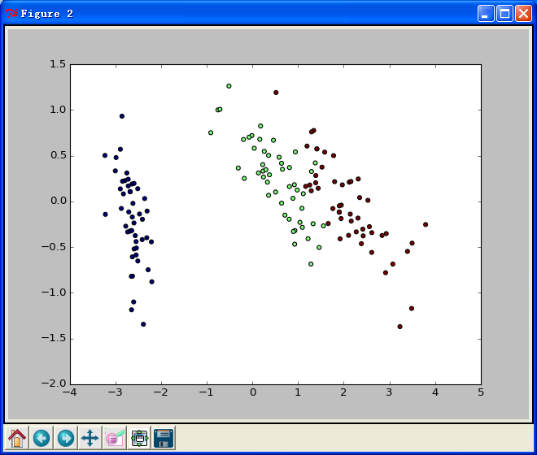

3. RandomizedPCA适合于大数据集

rpca2c = RandomizedPCA(n_components=2)
data_rpca2c = rpca2c.fit_transform(iris.data)
print rpca2c.explained_variance_ratio_.sum()
0.977631775024804 # 随机：每次运行略有不同

plt.figure(3)
plt.scatter(data_rpca2c[:,0],data_rpca2c[:,1],c=iris.target)

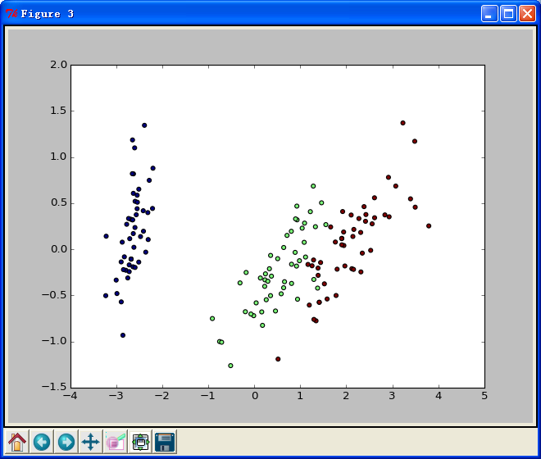

plt.show()

