Exercise 01

# About Myself

My name is Simon Hinterseer. I am currently studying CSE at TU Wien. The only experience with parallel computing, that I have, is from this masters course. This means, we did some multi-threading (with OpenMP) and some multi-processing (with MPI) on x86 machines. In that sense, I have no experience with computational science on many core architectures.

# Expectations

I hope to learn how to do calculations on a GPU. In this regard, I am especially curious about actually experiencing what SIMD means. It would also be an interesting side-track to see how one can make use of SIMD on an x86 architecture.

# Summing Random Numbers in a Lecture Hall

To simplify the problem, I would like to re-formulate it slightly. Each student has one memory position, that can hold an integer. Each student can each turn do one of three things:

1. exchange numbers with a neighbour and add the received number to the number in their memory.

2. exchange numbers with a neighbour and overwrite the memory with the received number.

3. be idle

## One Student knows the Sum

It takes at least 6 turns to make one student hold the sum of all intitial random numbers in their memory. It is not possible, to make that happen in 5 or fewer turns, since there is no student *A*, such that every student has a distance of 5 or less to student *A.* This can be checked by examining Figure 1.

field of students – students in the orange part have a maximum distance to other students of 6, which is the distance between student *X* and student *A*. Students outside the orange part have a larger maximum distance. The distance between student *X* and student *B* is 10.

**Find a strategy** that makes the four students in the orange field hold the sum of random integers in their memory **in 6 turns**:

1. make each of the four students know the sum of their quadrant in 4 turns:

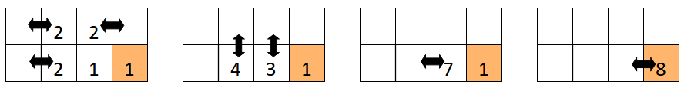Figure 1

1. Reduce the problem size

This problem can be reduced to the problem of student *A* holding the sum of random integers of the right hand side of the field after the fifth turn. Because then in the 6th turn, student *A* and their left side neighbour exchange-add values (meaning, they will exchange values and end up with the sum of their own and their neighbours value in their memory), which will make both of them hold the sum of all random integers.

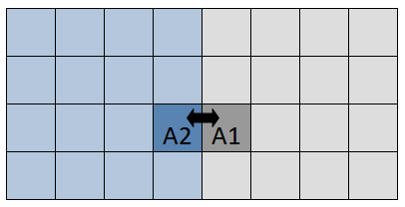Figure 2: reducing the problem size

2. Solve the reduced size problem

The following strategy solves the reduced problem.

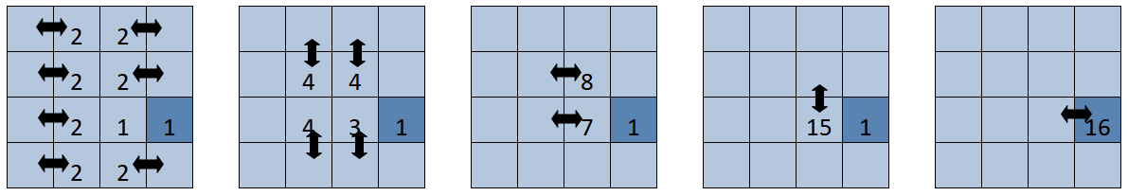

Figure 3: Solution of the reduced problem. The arrows indicate exchange-add operations. No arrow means that the students are idle. The numbers indicate the number of summed random numbers, they hold in their memory.

## All Students know the Sum

Figure 1 shows, that it will take at least 10 turns for all students to know the sum, because the distance between student *X* and student *B* is 10.